Appendix 1
Table 1 Regions Implementing Green Credit Interest Subsidy Policies
Province | City | Year of Policy Implementation
Sichuan Province | Dazhou | 2018
Sichuan Province | Guangyuan | 2018
Sichuan Province | Ya'an | 2018
Sichuan Province | Nanchong | 2018
Sichuan Province | Guang'an | 2018
Sichuan Province | Neijiang | 2018
Sichuan Province | Deyang | 2018
Sichuan Province | Bazhong | 2018
Sichuan Province | Chengdu | 2018
Sichuan Province | Liangshan Yi Autonomous Prefecture | 2022
Fujian Province | Fuzhou | 2018
Fujian Province | Zhangzhou | 2017
Fujian Province | Sanming | 2017
Fujian Province | Putian | 2019
Fujian Province | Quanzhou | 2019
Fujian Province | Xiamen | 2018
Fujian Province | Nanping | 2017
Fujian Province | Longyan | 2019
Fujian Province | Ningde | 2017
Jiangsu Province | Nantong | 2017
Jiangsu Province | Nanjing | 2020
Jiangsu Province | Taixing | 2018
Jiangsu Province | Gaoyou | 2023
Jiangsu Province | Yangzhou | 2021
Jiangsu Province | Suzhou | 2019
Shandong Province | Yantai | 2022
Shandong Province | Weihai | 2022
Shandong Province | Jinan | 2022
Shandong Province | Zaozhuang | 2020
Anhui Province | Hefei | 2021
Anhui Province | Huangshan | 2017
Anhui Province | Anqing | 2018
Anhui Province | Chuzhou | 2023
Gansu Province | Wuwei | 2018
Gansu Province | Lanzhou | 2020
Gansu Province | Tianshui | 2018
Gansu Province | Longnan | 2018
Zhejiang Province | Huzhou | 2017
Zhejiang Province | Lishui | 2019
Zhejiang Province | Quzhou | 2019
Zhejiang Province | Wenzhou | 2020
Hebei Province | Baoding | 2017
Hebei Province | Shijiazhuang | 2017
Hebei Province | Handan | 2018
Guangdong Province | Shenzhen | 2018
Guangdong Province | Guangzhou | 2019
Guangdong Province | Qingyuan | 2018
Guangxi Zhuang Autonomous Region | Hezhou | 2019
Guangxi Zhuang Autonomous Region | Guilin | 2022
Guangxi Zhuang Autonomous Region | Liuzhou | 2019
Jiangxi Province | Fuzhou | 2018
Jiangxi Province | Pingxiang | 2017
Hubei Province | Huangshi | 2018
Hubei Province | Xianning | 2019
Ningxia Hui Autonomous Region | Yinchuan | 2022
Ningxia Hui Autonomous Region | Shizuishan | 2023
Jilin Province | Jilin | 2022
Jilin Province | Siping | 2023
Liaoning Province | Yingkou | 2022
Tianjin Municipality | Tianjin | 2022
Beijing Municipality | Beijing | 2017
Hunan Province | Yongzhou | 2023
Chongqing Municipality | Chongqing | 2017
Shanghai Municipality | Shanghai | 2021
Shaanxi Province | Ankang | 2016
Henan Province | Nanyang | 2018
Shanxi Province | Datong | 2023
Inner Mongolia Autonomous Region | Ordos | 2019
Xinjiang Uygur Autonomous Region | Ili Kazakh Autonomous Prefecture | 2018

Appendix 2
Heterogeneity in Treatment Effects.
Table 2 Bacon Test
Types of Control Groups | Share of Green Patents |  | Share of Green Invention Patents
Types of Control Groups | Weight Estimate | Weight Estimate | Weight Estimate | Weight Estimate
Early treatment group vs. late control group | 0.074 | 0.553 | 0.074 | 0.429
Late treatment group vs. early control group | 0.048 | -0.139 | 0.048 | -0.303
Treatment group vs. never-policy group | 0.757 | 0.592 | 0.757 | 0.659
Treatment group vs. always-policy group | 0.121 | -2.789 | 0.121 | -1.798
DID weighted estimation results | 0.144 |  | 0.298

Appendix 3
Test for parallel trends in a three-difference model.
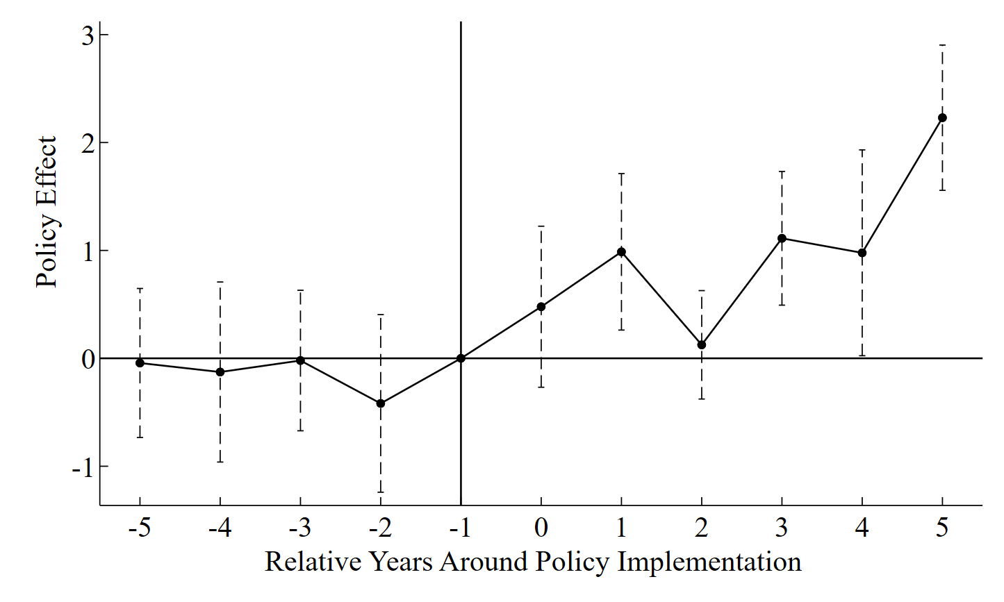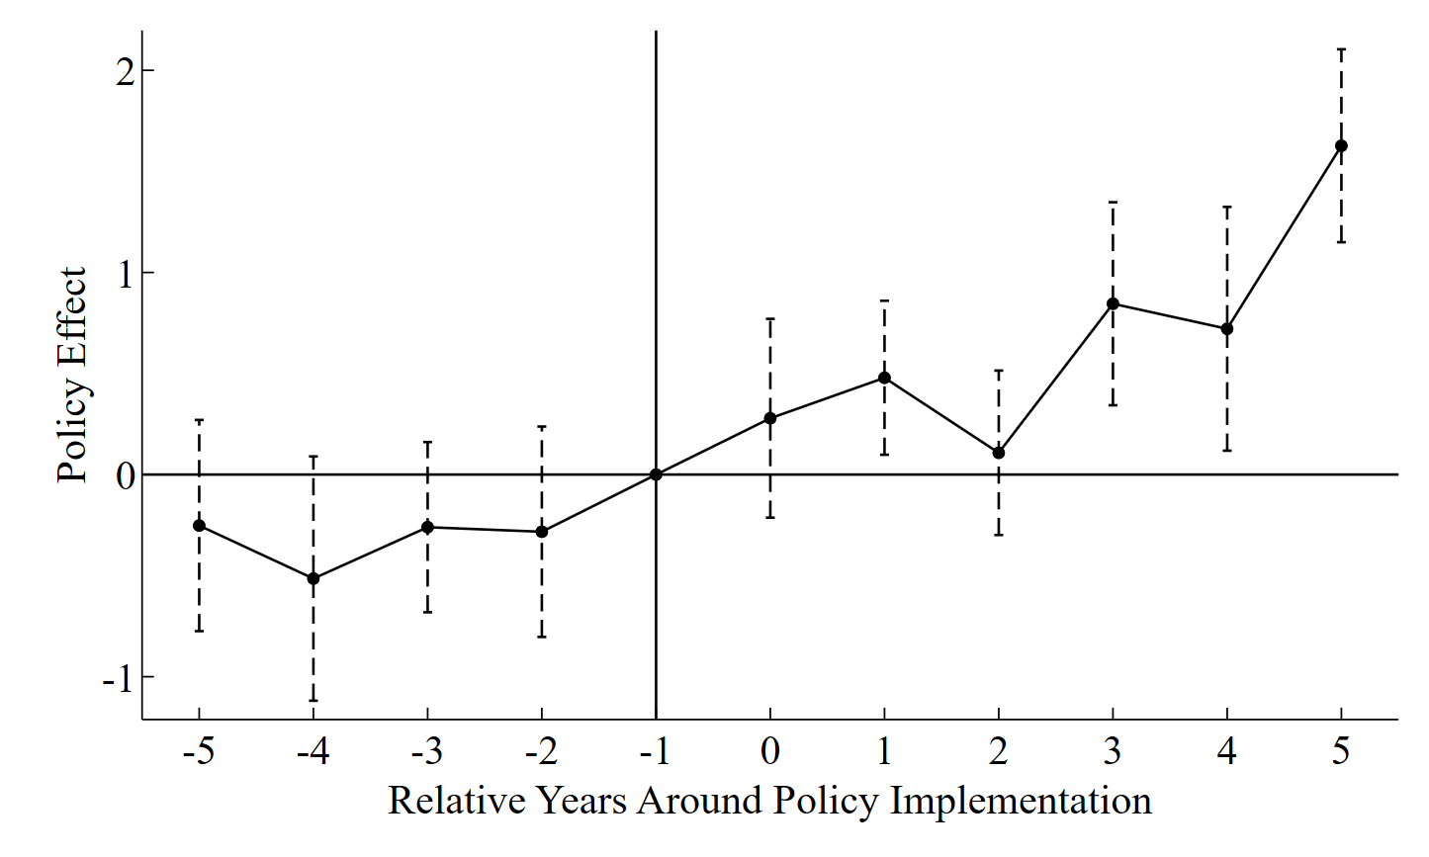
（b）Green Substantive Innovation
（a）Green Innovation

Figure 1

Appendix 4
Table 3 Results of the Balance Test
Variable | Sample | Mean |  | Standard Error (%) | Absolute  Reduction in Standard Error(%) | t-Test
Variable | Sample | Treatment Group | Control Group | Standard Error (%) | Absolute  Reduction in Standard Error(%) | t-Value | p-Value
Size | Unmatched | 8.4499 | 8.3951 | 4.30 | 66.90 | 3.820 | 0
Size | Matched | 8.4360 | 8.4179 | 1.40 | 66.90 | 1.110 | 0.265
Lev | Unmatched | 0.4034 | 0.4107 | -3.70 | 91.50 | -3.320 | 0.001
Lev | Matched | 0.4054 | 0.4048 | 0.30 | 91.50 | 0.250 | 0.801
Roe | Unmatched | 0.0529 | 0.0524 | 0.30 | -80.40 | 0.300 | 0.767
Roe | Matched | 0.0545 | 0.0537 | 0.60 | -80.40 | 0.480 | 0.631
Cash | Unmatched | 0.0484 | 0.0526 | -6.50 | 96.60 | -5.820 | 0
Cash | Matched | 0.0510 | 0.0509 | 0.20 | 96.60 | 0.180 | 0.860
Density | Unmatched | 2.3279 | 2.2120 | 7.70 | 77.10 | 6.860 | 0
Density | Matched | 2.2323 | 2.2588 | -1.80 | 77.10 | -1.430 | 0.151
Growth | Unmatched | 0.1351 | 0.1255 | 3.40 | 83.60 | 3.030 | 0.002
Growth | Matched | 0.1332 | 0.1316 | 0.60 | 83.60 | 0.440 | 0.659
TFP | Unmatched | 8.425 | 8.3200 | 10.30 | 92.90 | 9.230 | 0
TFP | Matched | 8.373 | 8.3654 | 0.70 | 92.90 | 0.590 | 0.558

Probability density distribution of propensity scores after propensity score.
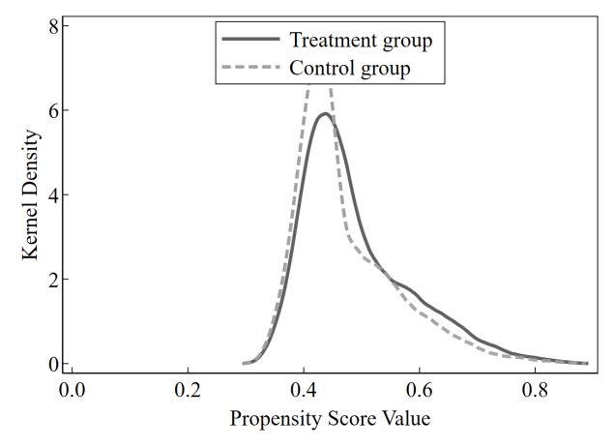
Figure 2 Kernel Density Distribution of Propensity Scores after Propensity Score Matching

Appendix 5
A detailed explanation of how the impact of policies during the same period was excluded.
1. Green Credit Guidelines
Issued by the former China Banking Regulatory Commission in 2012, the Green Credit Guidelines systematically links banks’ credit decisions with firms’ environmental performance, serving as the first official normative document governing green credit businesses.Referring to the Classification Catalogue for Environmental Protection Verification of Listed Companies, Guidelines for Environmental Information Disclosure of Listed Companies and Industry Classification Guidelines for Listed Companies, this study defines restricted industries for green credit as follows: Mining (Industry Code: B06, B07, B08, B09), Manufacturing (Industry Code: C17, C19, C22, C25, C26, C28, C29, C30, C31), and Production and Supply of Electric Power and Heat Power (Industry Code: D44).Listed companies belonging to the above industries are defined as the treatment group of green credit restrictions (Gcres=1), while others are defined as the control group (Gcres=0). Policy is a time dummy variable, which equals 1 for observations in 2012 and thereafter, and 0 otherwise.
- Green Finance Reform and Innovation Pilot Zones
In September 2015, the Central Committee of the Communist Party of China and the State Council issued the Overall Plan for the Reform of the Ecological Civilization System, which firstly proposed the construction of a green financial system. In 2016, seven government departments including the People’s Bank of China jointly released the Guidelines on Building a Green Financial System, making China the world’s first country to promote the development of a green financial system at the central government level.To facilitate policy implementation, eight pilot zones for green finance reform and innovation were officially launched in five provinces (autonomous regions) in June 2017, including Huzhou and Quzhou in Zhejiang Province, Guangzhou in Guangdong Province, Hami, Changji and Karamay in Xinjiang Uygur Autonomous Region, Gui’an New Area in Guizhou Province, and Ganjiang New Area in Jiangxi Province.Treat is a dummy variable equal to 1 if a firm is registered within the pilot zones, and 0 otherwise. Post is a time dummy variable equal to 1 for observations in 2017 and thereafter, and 0 otherwise.

Appendix 6
Descriptive statistics for the mechanism variables; estimates of the mechanism variables' effects on Y.
Table 4 Descriptive Statistics of Mechanism Variables
Variables | Obs | Mean | Std. | Min | Max | Med
FC | 30490 | 0.4849 | 0.2811 | 0.0039 | 0.9520 | 0.5075
Greenwash | 9839 | -0.0066 | 115.8161 | -419.8058 | 580.42 | -5.3972
RiskTake1 | 24998 | 6.0691 | 8.3487 | 0 | 575.2728 | 4.0961
RiskTake2 | 24998 | 2.8668 | 3.5508 | 0 | 145.4827 | 2.22198

Table 5 Regression Results of Financial Constraints and Greenwashing on Green Innovation
 | (1)  GI | (2)  GIi | (1)  GI | (2)  GIi
FC | -1.5040** | -1.6425***
 | (0.6414) | (0.4085)
Greenwash |  |  | -0.0033** | -0.0027***
 |  |  | (0.0014) | (0.0008)
Size | 0.0721 | 0.1316 | 0.2251 | 0.2366
 | (0.3530) | (0.2895) | (0.6848) | (0.4553)
Lev | -0.9785 | -1.0645 | 0.4466 | -0.3086
 | (0.8984) | (0.6908) | (1.5361) | (0.8834)
Roe | 0.3196 | 0.3909 | -0.4782 | 0.2024
 | (0.7663) | (0.5914) | (1.2993) | (0.9108)
Cash | -1.7000 | -0.9210 | -0.4879 | -0.0512
 | (1.2002) | (0.8075) | (2.8043) | (1.4616)
Density | 0.0855 | -0.0642 | -0.0958 | -0.0030
 | (0.1234) | (0.1051) | (0.2879) | (0.1594)
Growth | 0.1820 | -0.1109 | -0.0527 | -0.1713
 | (0.3308) | (0.2130) | (0.5873) | (0.4196)
TFP | -0.1343 | -0.1412 | -0.1251 | 0.1097
 | (0.3728) | (0.3194) | (0.7804) | (0.4881)
HHI | -1.0094 | -3.1589** | -6.0439 | -5.4807**
 | (2.3444) | (1.3909) | (3.7718) | (2.1911)
_cons | 6.6615*** | 4.2763*** | 4.1664 | -0.0937
 | (2.2265) | (1.4828) | (5.0513) | (3.0262)
Year FE | Yes | Yes | Yes | Yes
Firm FE | Yes | Yes | Yes | Yes
adj.R² | 0.4214 | 0.3612 | 0.3439 | 0.3404
N | 30537 | 30537 | 9659 | 9659

Table 6 Regression Results on the Impact of Risk-Taking on Green Innovation

 | (1)  GI | (2)  GIi | (1)  GI | (2)  GIi
RiskTake1 | 0.0844** | 0.0567*
 | (0.0428) | (0.0298)
RiskTake2 |  |  | 0.2130*** | 0.1358**
 |  |  | (0.0748) | (0.0538)
Size | 0.4497 | 0.4440 | 0.5181 | 0.4880
 | (0.4385) | (0.2928) | (0.4390) | (0.3004)
Lev | 2.0395* | 0.5497 | 1.9030 | 0.4543
 | (1.1794) | (0.9073) | (1.1750) | (0.9183)
Roe | 0.6411 | 0.6866 | 0.6662 | 0.6998
 | (0.8454) | (0.5910) | (0.8459) | (0.6025)
Cash | -0.3172 | -0.2175 | -0.3389 | -0.2298
 | (1.4329) | (1.1689) | (1.4336) | (1.1612)
Density | -0.3626** | -0.2640* | -0.2977* | -0.2221*
 | (0.1659) | (0.1372) | (0.1654) | (0.1315)
Growth | 0.0551 | -0.1521 | 0.0679 | -0.1448
 | (0.3343) | (0.2610) | (0.3341) | (0.2562)
TFP | -0.7143* | -0.6055** | -0.6266 | -0.5442**
 | (0.4325) | (0.2811) | (0.4329) | (0.2684)
HHI | -0.0542 | -0.0199 | -0.2564 | -0.1612
 | (5.0110) | (2.8299) | (4.9874) | (2.8480)
_cons | 7.2424** | 4.4636** | 5.7366* | 3.4752*
 | (2.9926) | (1.9393) | (3.0265) | (2.0250)
Year FE | Yes | Yes | Yes | Yes
Firm FE | Yes | Yes | Yes | Yes
adj.R² | 0.4836 | 0.4234 | 0.4837 | 0.4234
N | 24087 | 24087 | 24087 | 24087

Appendix 7
Results of the heterogeneity analysis for the dependent variable green innovation.
Table 7 Heterogeneity analysis at the regional level
 | (1)  regions with higher fiscal pressure | (2)  regions with lower fiscal pressure | (3)  financially developed regions | (4)  financially underdeveloped regions
 | Regional Fiscal Pressure |  | Financial Development Level
GSubsidy | 0.3479* | 0.6440 | 0.8227** | -0.0661
 | (0.1878) | (0.6859) | (0.3872) | (0.2531)
Year FE | Yes | Yes | Yes | Yes
Firm FE | Yes | Yes | Yes | Yes
adj.R² | Yes | Yes | Yes | Yes
N | 0.4705 | 0.3248 | 0.4592 | 0.3729
Year FE | 19954 | 7837 | 18575 | 12396

Table 8 Heterogeneity Analysis at the Industry Level
 | (1)  Non-heavy Pollution | (2)  Heavy Pollution | (3)  Capital-intensive | (4)  Technology-intensive | （5）  Labor-intensive
 | Pollution Characteristics |  | Industry Factor Intensity
GSubsidy | 0.6566** | -0.4290 | 1.0906** | 1.9350*** | 1.2658*
 | (0.2874) | (0.5077) | (0.5197) | (0.2822) | (0.6548)
Year FE | Yes | Yes | Yes | Yes | Yes
Firm FE | Yes | Yes | Yes | Yes | Yes
adj.R² | Yes | Yes | Yes | Yes | Yes
N | 0.4708 | 0.3021 | 0.2482 | 0.5224 | 0.1025
Year FE | 22016 | 9282 | 6462 | 13004 | 2269

Table 9 Heterogeneity Analysis at the Enterprise Level
 | (1)  SOE | (2)  Non-SOE | (3)  Large-sized Enterprises | (4)  Small-sized Enterprises
 | Enterprise Ownership Type |  | Enterprise Size
GSubsidy | 0.2109 | 0.5499* | 0.7019* | -0.0564
 | (0.4861) | (0.3151) | (0.3832) | (0.4631)
Year FE | Yes | Yes | Yes | Yes
Firm FE | Yes | Yes | Yes | Yes
adj.R² | Yes | Yes | Yes | Yes
N | 0.3778 | 0.4594 | 0.4259 | 0.4545
Year FE | 9888 | 21359 | 13534 | 17435

Appendix 8
Explanation of Heavy-Polluting Industries and Non-Heavy-Polluting Industries.
The classification of heavily polluting industries is based on the Industry Classification Guidelines for Listed Companies (revised in 2012) issued by the China Securities Regulatory Commission, the Classification Catalogue for Environmental Protection Verification of Listed Companies (Document No. Huanbanhan [2008] No. 373) and the Guidelines for Environmental Information Disclosure of Listed Companies (Document No. Huanbanhan [2010] No. 78) issued by the former Ministry of Environmental Protection. It covers 16 categories of heavily polluting industries including coal mining, mineral extraction, textile, leather making, papermaking, petrochemical, pharmaceutical, chemical, metallurgy and thermal power. Detailed classifications are presented in the table below.
Table 10 Classification of Heavily Polluting Industries
Industry CodeIndustry Name | Industry CodeIndustry Name
B06 | Coal Mining and Washing
B07 | Extraction of Petroleum and Natural Gas
B08 | Ferrous Metal Ore Mining and Dressing
B09 | Non-Ferrous Metal Ore Mining and Dressing
C17 | Textile Industry
C19 | Leather, Fur, Feather and Related Products, and Footwear
C22 | Papermaking and Paper Products
C25 | Petroleum Processing, Coking and Nuclear Fuel Processing
C26 | Raw Chemical Materials and Chemical Products
C27 | Pharmaceutical Manufacturing
C28 | Chemical Fiber Manufacturing
C30 | Non-Metallic Mineral Products
C31 | Smelting and Pressing of Ferrous Metals
C32 | Smelting and Pressing of Non-Ferrous Metals
C33 | Metal Products
D44 | Production and Supply of Electric Power and Heat Power

