Supplementary Figure
Supplementary Figure 1 Forest plot of univariate analysis results of general clinical characteristics and blood tests for assessing the patients’ survival analysis
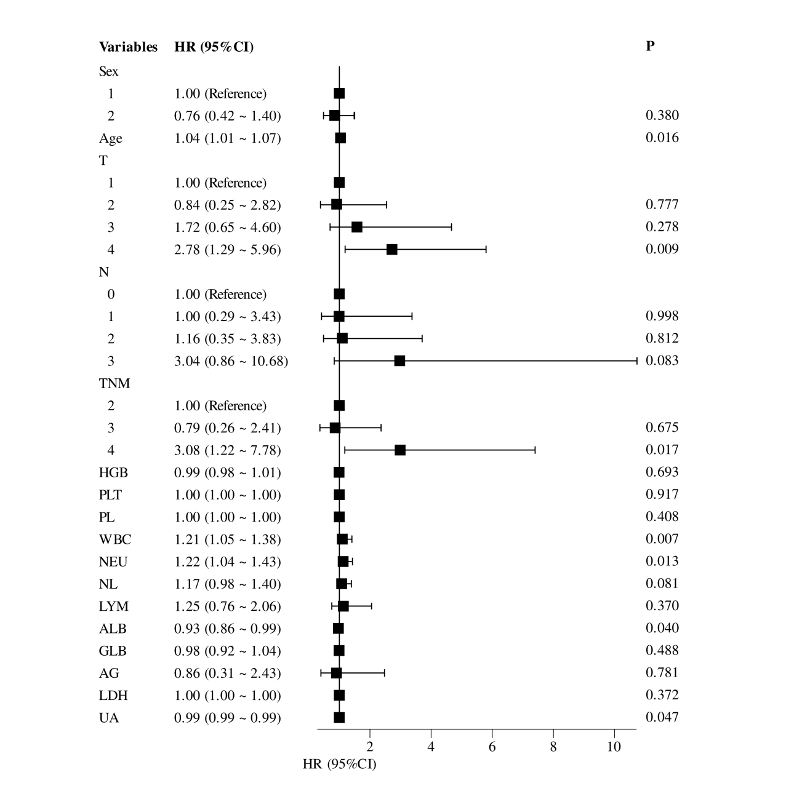

Supplementary Figure 2 Forest plot of multivariate analysis results of general clinical characteristics and blood tests for assessing patients’ survival prognosis
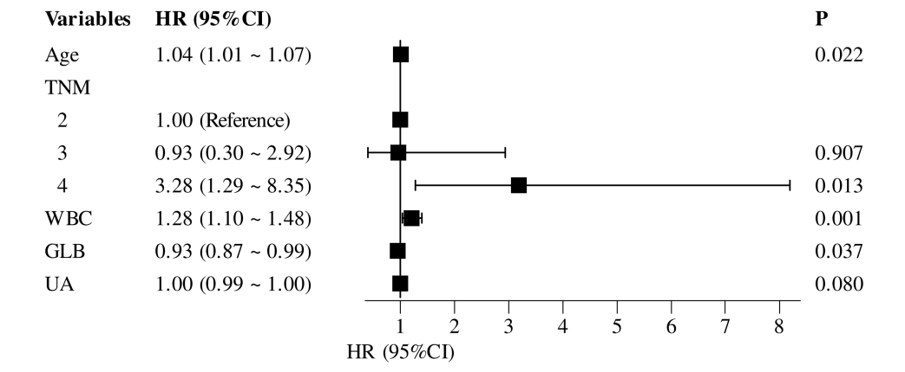

Supplementary Figure 3 Calibration curve of (A–C) training set and (D–F) validation set
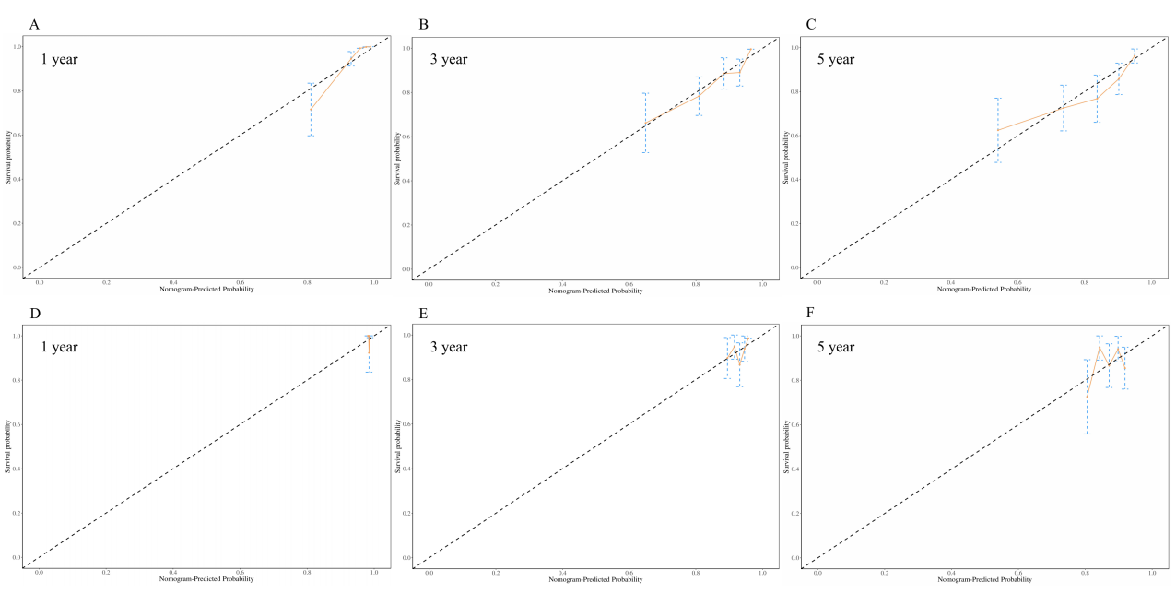

Supplementary Figure 4 DCA curve of (A–C) training set and (D–F) validation set

