Supplemental materials
Soil analysis
Table S1 Physical and chemical characteristics of field-collected soil used in laboratory ecotoxicity assays for EAB-specific dsRNA with Folsomia candida. Evaluated at the University of Kentucky’s Soil laboratory
Parameter | Value | Parameter | Value
pH (1 M KCl) | 4.91 | Silt (%) | 70.1
Soil organic matter (%) | 4.5 | Soil Texture | Silt loam
Total Nitrogen (%) | 0.28 | Phosphorus (mg/kg) | 335
Calculated CEC¹ (meq/100g) | 17.67 | Potassium (mg/kg) | 508
WHC² (%) | 34.15 | Calcium (mg/kg) | 2,117.5
Sand (%) | 15.9 | Magnesium (mg/kg) | 202
Clay (%) | 14.9 | Zinc (mg/kg) | 2.7
¹Cation-exchange capacity, ²Water holding capacity.

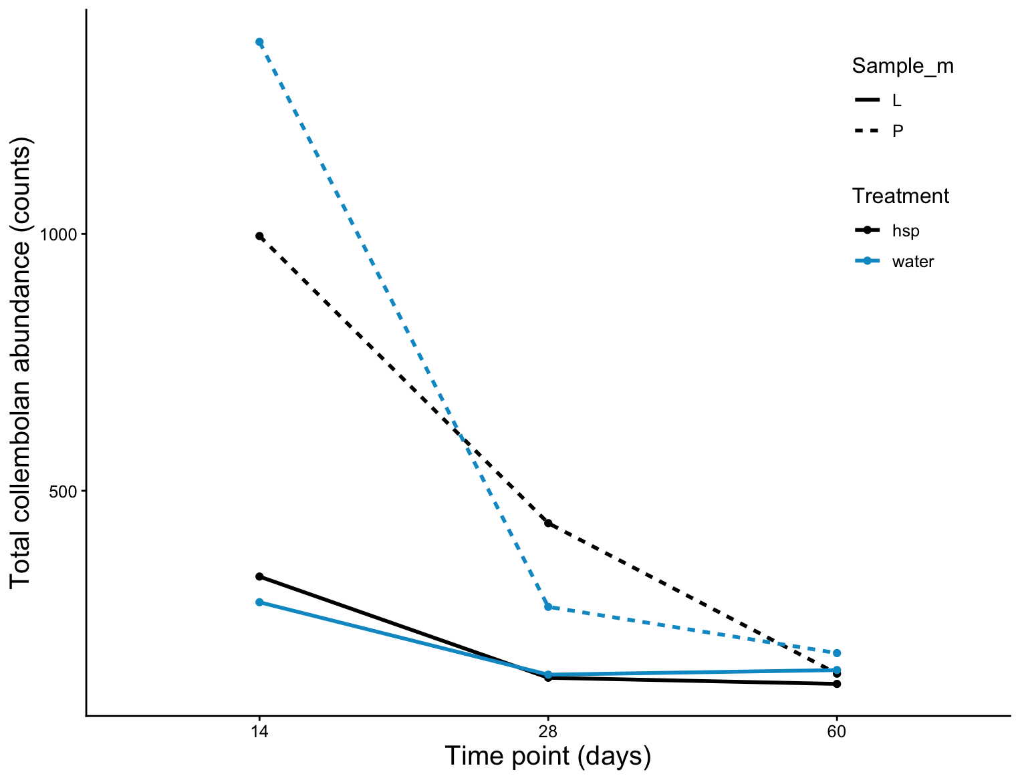
Fig. S1 Total collembolan abundances over time for (P) pitfall traps (dashed lines) and (L) litter samples (solid lines).

