Supporting Information

Mechanistic Insight into CdS/TiO₂ Heterojunctions for Efficient Photocatalytic Degradation of Diesel Oil Contaminants

Chi Huey Ng,^{1,2*} Muhammad Alifaiman Matusin,¹ Siow Hwa Teo,^{3#} Fui San Lee,³ Zhenhua Xu,⁴ Putao Zhang,⁵ Yoshito Ando,⁶ Collin G. Joseph,³ Jidon Janaun,¹ Rosalam Hj Sarbatly^{1,2}
¹Faculty of Engineering, Universiti Malaysia Sabah, Jalan UMS, Kota Kinabalu, 88400, Sabah, Malaysia.
²Membrane and Nanomaterials Technology Research Laboratory, Faculty of Engineering, Universiti Malaysia Sabah, Jalan UMS, Kota Kinabalu, 88400, Sabah, Malaysia.
³Sonophotochemistry Research Group, Faculty of Science and Technology, Universiti Malaysia Sabah, Kota Kinabalu, 88400, Sabah, Malaysia.
⁴School of Materials Science and Engineering, Ningbo Tech University, Ningbo 315100, China.
⁵Henan Key Laboratory of Quantum Materials and Quantum Energy, Henan University, Kaifeng, 475004, Henan, China.
⁶Department of Biological Functions and Engineering, Graduate School of Life Science and Systems Engineering, Kyushu Institute of Technology, 2-4 Hibikino Wakamatsu-ku, Fukuoka, Kitakyushu, 808-0196, Japan.

Corresponding authors:
*CH Ng: chihueyng@ums.edu.my
#SH Teo: tony@ums.edu.my

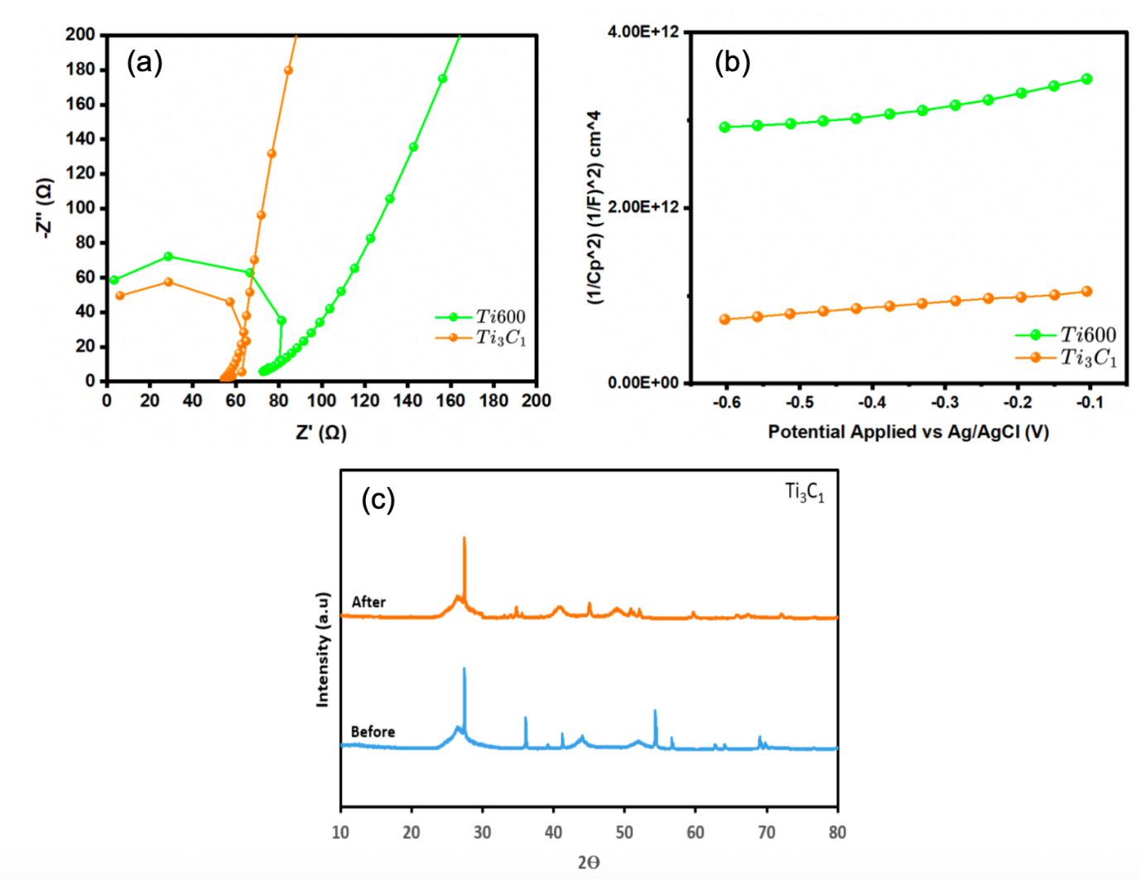Figure S1. (a) EIS and (b) Mott-Schottky of Ti₃C₁ and Ti600, and (c) XRD profile of Ti₃C₁ before and after photodegradtion of diesel.

Table S1. Diesel composition in freshwater before and after 6h photodegradation extracted from GC-analysis.
Parameter | Before | After | Observation
Diethyl Phthalate | 9.37% | 0.31% | 97.19% degraded
Siloxanes (Octasiloxane, Cyclooctasiloxane, etc.) | Present | Completely removed | Successful degradation
Heavy Hydrocarbons (C10-C19 alkanes) | Present | Reduced or transformed | Breakdown of diesel components
New Simpler Hydrocarbons (Decane, Heptane, Tetradecane, Nonadecane, etc.) | Not present | Formed | Indicates degradation of heavier hydrocarbons
Oxidation Products (Hexadecanoic acid methyl ester, 8-Octadecenoic acid methyl ester) | Not present | Present | Partial oxidation occurred
Total Hydrocarbons & Siloxanes | 11.67% | 0.31% | 97.74% degraded

