Alkaloid-Rich Extracts from Ocimum gratissimum and Zanthoxylum zanthoxyloides as Potential Antibiotic Adjuvants Against Resistant Bacterial Pathogens

Samuel Asiamah Obiri¹, Denzel Opoku-Kwabi², Francis Ackah Armah², Yaw Opoku-Boahen¹, and Isaac Asiamah^{1*}
¹Department of Chemistry, School of Physical Sciences, College of Agriculture and Natural Sciences, University of Cape Coast, Cape Coast, Ghana.
²Department of Biomedical Sciences, School of Allied Health Sciences, College of Health and Allied Sciences, University of Cape Coast, Cape Coast, Ghana.

Supplementary Document, S1

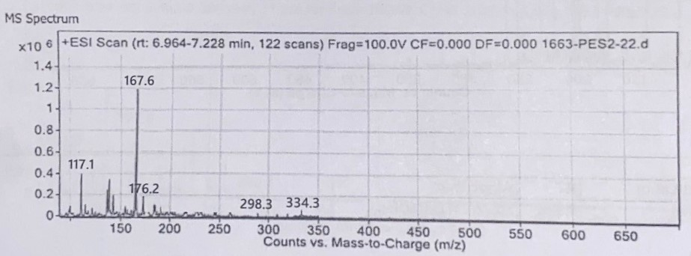
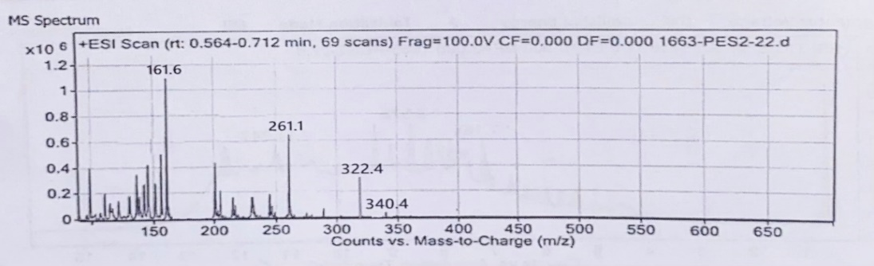
Figure 1: Full Scan LC-ESI-MS Spectrum of Compound A as Zanthoamide I
Figure 2: Full Scan LC-ESI-MS Spectrum of Compound B as Nor-chelerythrine
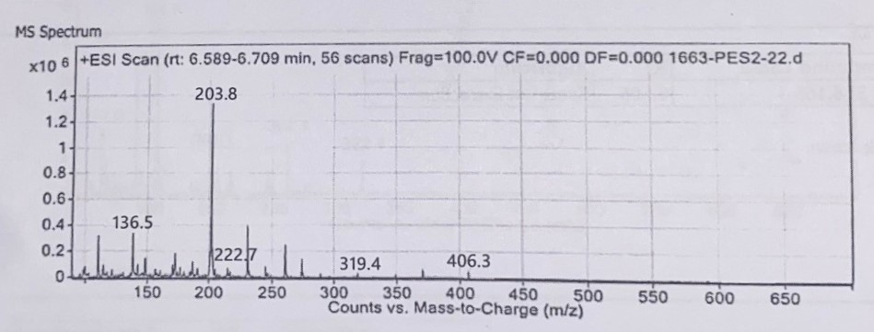
Figure 3: Full Scan LC-ESI-MS Spectrum of Compound C as 8-acetonyldihyro-
chelerythrine

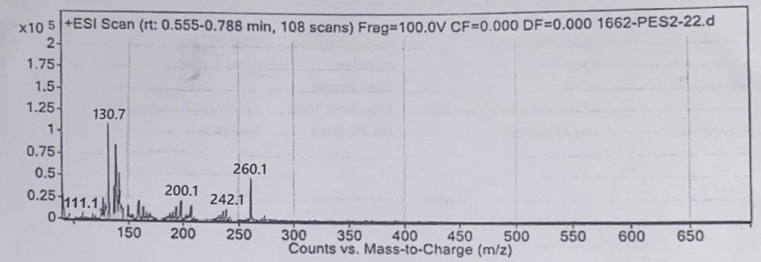
Figure 4: Full Scan LC-ESI-MS Spectrum of Compound D as Skimmianine

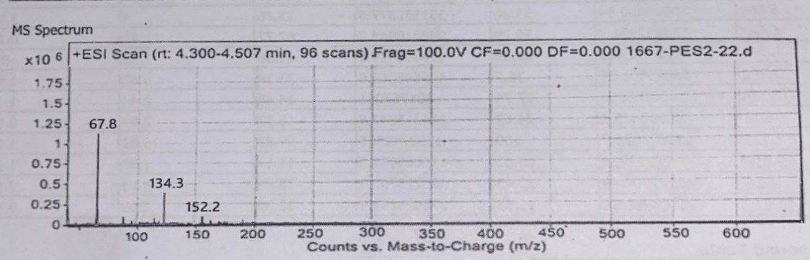
Figure 5: Full Scan LC-ESI-MS Spectrum of Compound E as Benimidazol-5-
amine

