Supplementary information

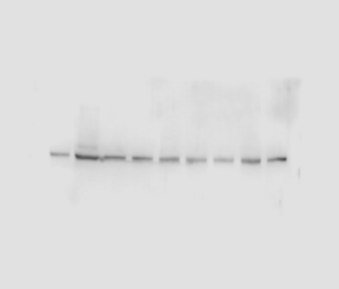
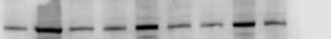
Figure 1a Total TNPO3 β-Actin
CNT
LGMDD2
Gapmer1
CNT
LGMDD2
Gapmer1
CNT
LGMDD2
Gapmer1

- 42
CNT
LGMDD2
Gapmer1
CNT
LGMDD2
Gapmer1
CNT
LGMDD2
Gapmer1

- 100

Gapmer1

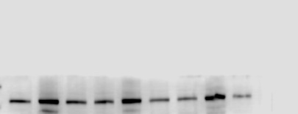
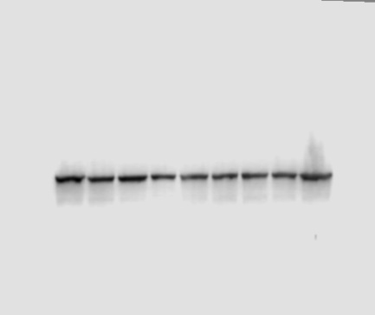
CNT
LGMDD2
Gapmer2
CNT
LGMDD2
Gapmer2
CNT
LGMDD2
Gapmer2

- 100
CNT
LGMDD2
Gapmer2
CNT
LGMDD2
Gapmer2
CNT
LGMDD2
Gapmer2

- 42

Gapmer2

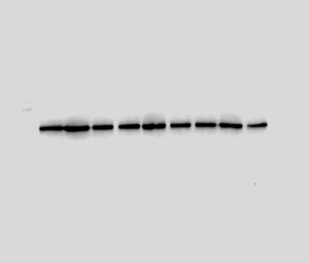
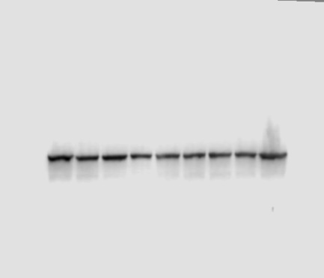
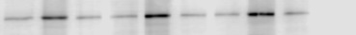
CNT
LGMDD2
Gapmer3
CNT
LGMDD2
Gapmer3
CNT
LGMDD2
Gapmer3

- 42
CNT
LGMDD2
Gapmer3
CNT
LGMDD2
Gapmer3
CNT
LGMDD2
Gapmer3

- 100

Gapmer3

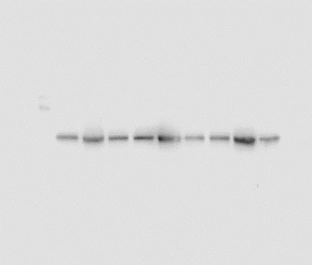
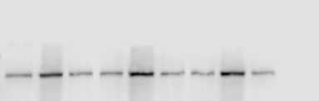
CNT
LGMDD2
Gapmer4
CNT
LGMDD2
Gapmer4
CNT
LGMDD2
Gapmer4

- 42
CNT
LGMDD2
Gapmer4
CNT
LGMDD2
Gapmer4
CNT
LGMDD2
Gapmer4

- 100

Gapmer4

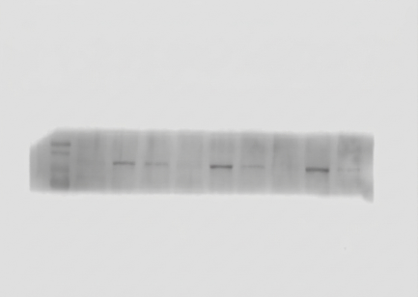
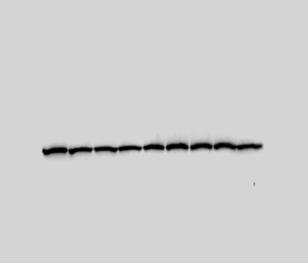
Figure 1b TNPO3 mut β-Actin
CNT
LGMDD2
Gapmer1
CNT
LGMDD2
Gapmer1
CNT
LGMDD2
Gapmer1

- 100
CNT
LGMDD2
Gapmer1
CNT
LGMDD2
Gapmer1
CNT
LGMDD2
Gapmer1

- 42

Gapmer1

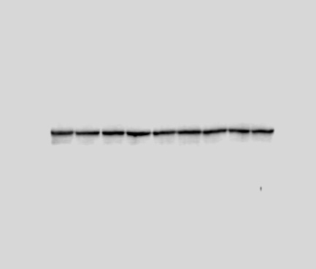
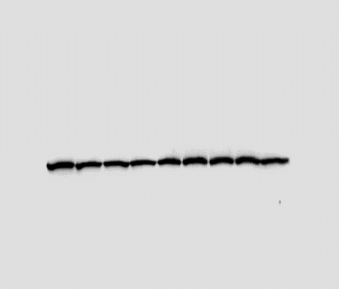
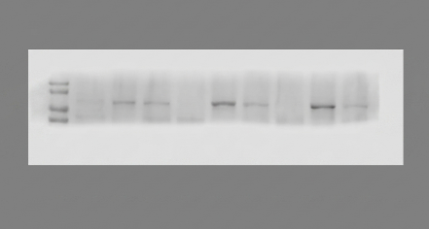
CNT
LGMDD2
Gapmer2
CNT
LGMDD2
Gapmer2
CNT
LGMDD2
Gapmer2

CNT
LGMDD2
Gapmer2
CNT
LGMDD2
Gapmer2
CNT
LGMDD2
Gapmer2

Gapmer2
- 42
- 100

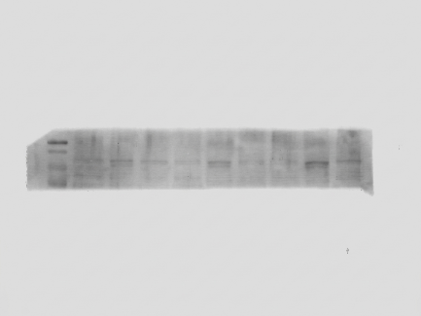
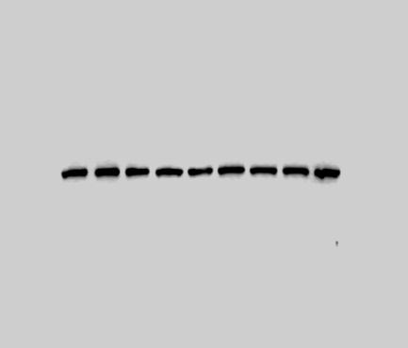
CNT
LGMDD2
Gapmer3
CNT
LGMDD2
Gapmer3
CNT
LGMDD2
Gapmer3

- 100
CNT
LGMDD2
Gapmer3
CNT
LGMDD2
Gapmer3
CNT
LGMDD2
Gapmer3

Gapmer3
- 42

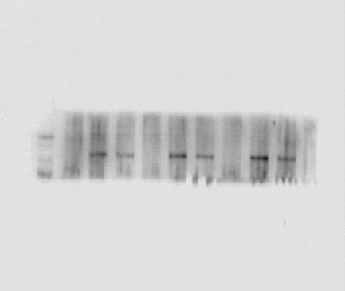
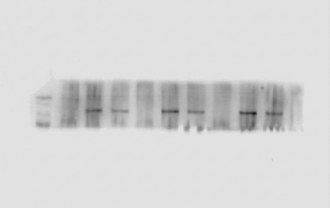
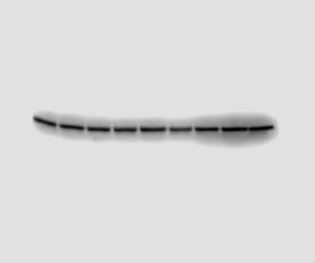
CNT
LGMDD2
Gapmer4
CNT
LGMDD2
Gapmer4
CNT
LGMDD2
Gapmer4

- 100
CNT
LGMDD2
Gapmer4
CNT
LGMDD2
Gapmer4
CNT
LGMDD2
Gapmer4

Gapmer4
- 42

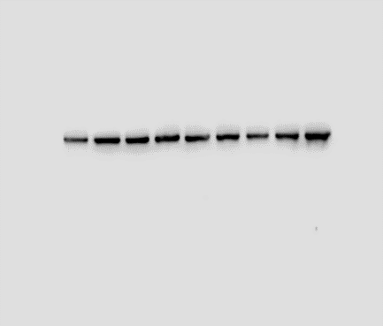
Figure 1c P62 β-Actin
CNT
LGMDD2
Gapmer1
CNT
LGMDD2
Gapmer1
CNT
LGMDD2
Gapmer1

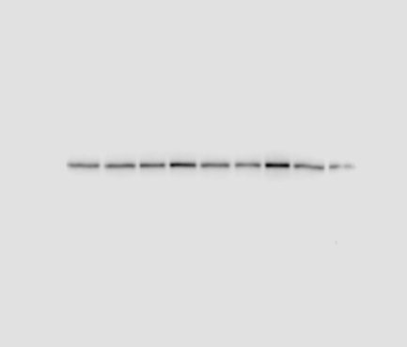
CNT
LGMDD2
Gapmer1
CNT
LGMDD2
Gapmer1
CNT
LGMDD2
Gapmer1

- 62

- 42

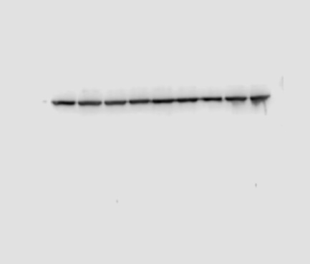
Gapmer1
CNT
LGMDD2
Gapmer2
CNT
LGMDD2
Gapmer2
CNT
LGMDD2
Gapmer2

- 42
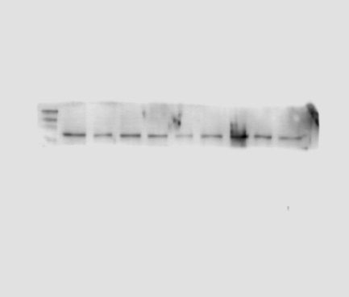
CNT
LGMDD2
Gapmer2
CNT
LGMDD2
Gapmer2
CNT
LGMDD2
Gapmer2

- 62

Gapmer2
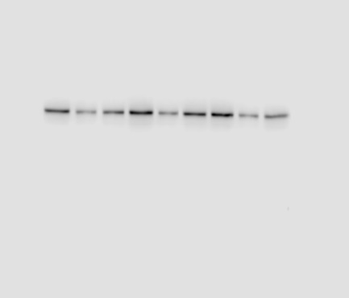
CNT
LGMDD2
Gapmer3
CNT
LGMDD2
Gapmer3
CNT
LGMDD2
Gapmer3

- 42
CNT
LGMDD2
Gapmer3
CNT
LGMDD2
Gapmer3
CNT
LGMDD2
Gapmer3

- 62

Gapmer3

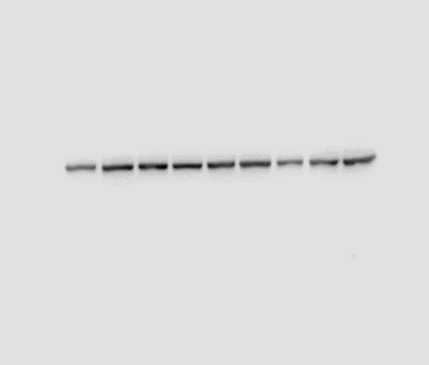
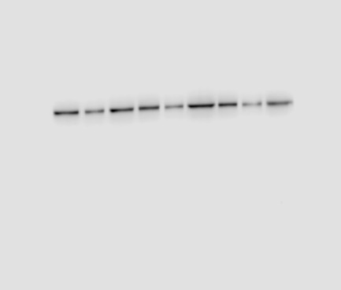
CNT
LGMDD2
Gapmer4
CNT
LGMDD2
Gapmer4
CNT
LGMDD2
Gapmer4

- 42
CNT
LGMDD2
Gapmer4
CNT
LGMDD2
Gapmer4
CNT
LGMDD2
Gapmer4

- 62

Gapmer4

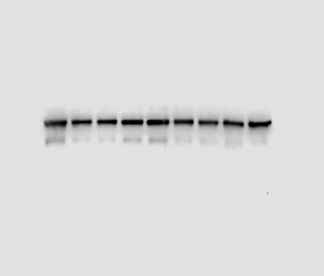
Figure 1d LC3 I/II β-Actin
CNT
LGMDD2
Gapmer1
CNT
LGMDD2
Gapmer1
CNT
LGMDD2
Gapmer1

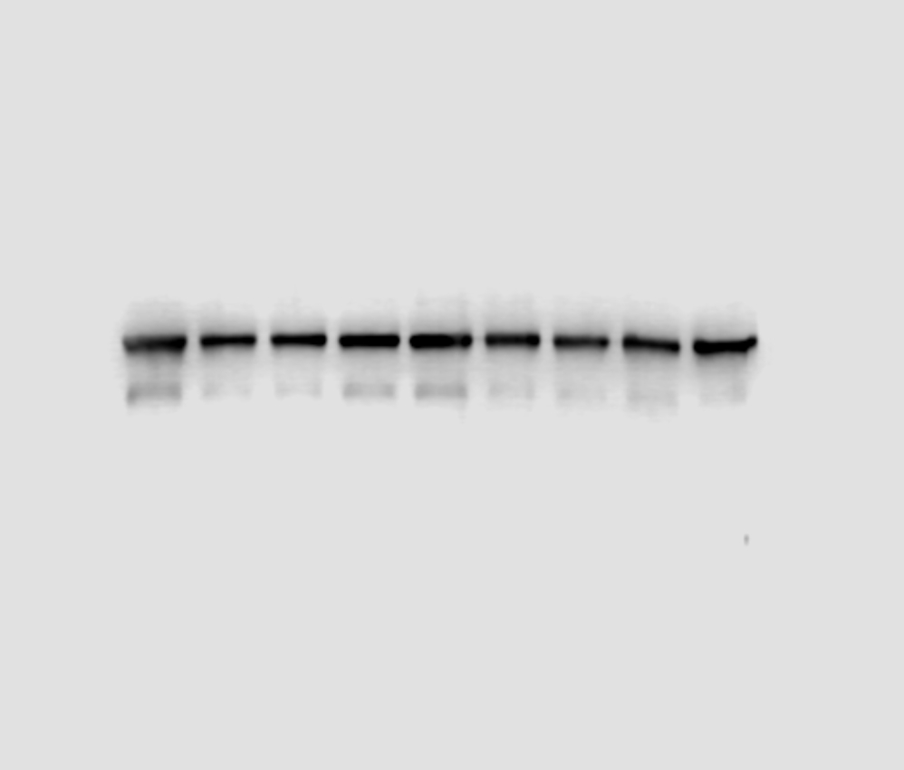
CNT
LGMDD2
Gapmer1
CNT
LGMDD2
Gapmer1
CNT
LGMDD2
Gapmer1

-18

-16
LC3 I -
LC3 II-

Gapmer1
- 42

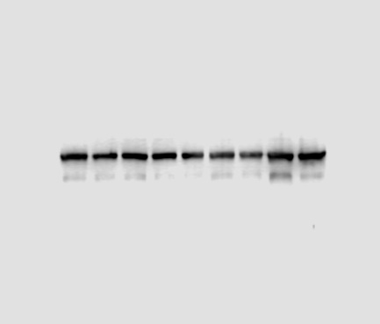
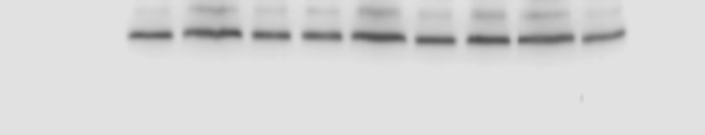
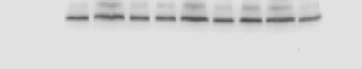
CNT
LGMDD2
Gapmer2
CNT
LGMDD2
Gapmer2
CNT
LGMDD2
Gapmer2

- 42
CNT
LGMDD2
Gapmer2
CNT
LGMDD2
Gapmer2
CNT
LGMDD2
Gapmer2

-18

-16
LC3 I -
LC3 II-

Gapmer2

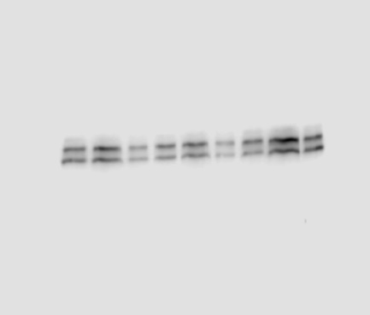
CNT
LGMDD2
Gapmer3
CNT
LGMDD2
Gapmer3
CNT
LGMDD2
Gapmer3

-18

-16
LC3 I -
LC3 II-
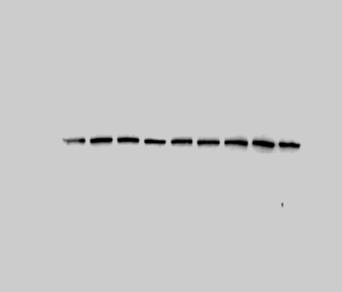
CNT
LGMDD2
Gapmer3
CNT
LGMDD2
Gapmer3
CNT
LGMDD2
Gapmer3

- 42

Gapmer3

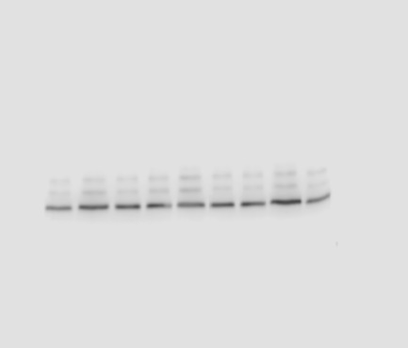
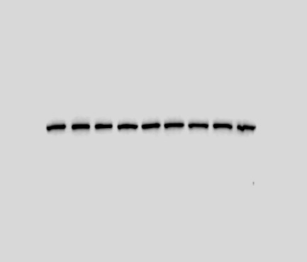
CNT
LGMDD2
Gapmer4
CNT
LGMDD2
Gapmer4
CNT
LGMDD2
Gapmer4

-18

-16
LC3 I -
LC3 II-
CNT
LGMDD2
Gapmer4
CNT
LGMDD2
Gapmer4
CNT
LGMDD2
Gapmer4

- 42

Gapmer4

Supplementary Fig.1 Expression of autophagy-associated proteins and TNPO3 assessed by Western blot in CNT and LGMDD2 cells treated with Gapmers.
The figure shows representative results obtained by Western blot from three independent experimental replicates performed on CNT cells, LGMDD2 cells, and LGMDD2 cells treated with Gapmers. (a) Detection of total TNPO3 protein, showing bands of approximately 100 kDa. (b) Detection of mutant TNPO3 protein, showing bands of approximately 100 kDa. (c) Detection of p62 protein, showing bands of approximately 62 kDa. (d) Detection of LC3-I and LC3-II, showing bands of approximately 18 kDa and 16 kDa, respectively. β-actin was used as an endogenous loading control on all membranes, with bands of approximately 42 kDa observed in all assays. Densitometric analysis of the bands was performed using GelAnalyzer 23.1.1 software.

