Supplementary Materials
Table S1. Best, Worst, and consistency values of the expert panel for green hydrogen
Expert | Best criterion | Worst criterion | Consistency $ξ$
E1 | Levelized cost of H₂, LCOH | Distance to protected areas | 0.0593
E2 | Levelized cost of H₂, LCOH | Distance to settlements and Indigenous territories | 0.1319
E3 | Levelized cost of H₂, LCOH | Distance to innovation clusters | 0.1298
E4 | Renewable resource potential | Distance to innovation clusters | 0.0949
E5 | Levelized cost of H₂, LCOH | Distance to innovation clusters | 0.0723
E6 | Proximity to existing infrastructure | Hydrogen potential from biomass | 0.0517
E7 | Alignment with public policies | Distance to settlements and Indigenous territories | 0.1524
E8 | Electro-renewable hydrogen potential | Hydrogen potential from biomass | 0.1192
E9 | Electro-renewable hydrogen potential | Hydrogen potential from biomass | 0.1251
E10 | Hydrogen potential from biomass | Freshwater availability and water stress index | 0.1322
E11 | Academic and scientific support | Distance to protected areas | 0.1692
E12 | Renewable resource potential | Distance to innovation clusters | 0.0748
E13 | TRL and performance | Distance to innovation clusters | 0.1005
E14 | Renewable resource potential | Distance to innovation clusters | 0.0980
E15 | Levelized cost of H₂, LCOH | Distance to innovation clusters | 0.0950
E16 | Renewable resource potential | Distance to innovation clusters | 0.0870

Note: BWM = Best-Worst Method; TRL = technology readiness level; LCOH = levelized cost of hydrogen. The consistency value $ξ$ corresponds to the maximum deviation obtained in the BWM optimization model for each expert.

Table S2. Individual BWM weights for green hydrogen criteria
Criterion | E1 | E2 | E3 | E4 | E5 | E6 | E7 | E8 | E9 | E10 | E11 | E12 | E13 | E14 | E15 | E16
Renewable resource potential | 0.032 | 0.066 | 0.042 | 0.190 | 0.063 | 0.031 | 0.046 | 0.043 | 0.043 | 0.059 | 0.046 | 0.218 | 0.048 | 0.196 | 0.063 | 0.174
Electro-renewable hydrogen potential | 0.045 | 0.026 | 0.033 | 0.063 | 0.051 | 0.031 | 0.059 | 0.268 | 0.292 | 0.059 | 0.059 | 0.073 | 0.048 | 0.098 | 0.063 | 0.058
Hydrogen potential from biomass | 0.032 | 0.015 | 0.059 | 0.063 | 0.036 | 0.016 | 0.059 | 0.019 | 0.013 | 0.294 | 0.046 | 0.073 | 0.096 | 0.028 | 0.048 | 0.029
Connection infrastructure | 0.045 | 0.026 | 0.042 | 0.095 | 0.127 | 0.107 | 0.046 | 0.065 | 0.054 | 0.074 | 0.059 | 0.098 | 0.032 | 0.039 | 0.063 | 0.035
TRL and performance | 0.111 | 0.044 | 0.042 | 0.095 | 0.063 | 0.036 | 0.059 | 0.055 | 0.062 | 0.059 | 0.046 | 0.098 | 0.288 | 0.049 | 0.038 | 0.035
Levelized cost of H₂, LCOH | 0.163 | 0.198 | 0.166 | 0.095 | 0.181 | 0.107 | 0.059 | 0.049 | 0.062 | 0.042 | 0.046 | 0.049 | 0.041 | 0.065 | 0.190 | 0.087
Proximity to existing infrastructure | 0.074 | 0.066 | 0.059 | 0.063 | 0.084 | 0.214 | 0.046 | 0.055 | 0.072 | 0.147 | 0.059 | 0.033 | 0.032 | 0.033 | 0.048 | 0.044
Distance to protected areas | 0.015 | 0.015 | 0.059 | 0.027 | 0.036 | 0.053 | 0.046 | 0.055 | 0.086 | 0.033 | 0.024 | 0.042 | 0.096 | 0.039 | 0.032 | 0.058
Freshwater availability and water stress index | 0.074 | 0.026 | 0.042 | 0.063 | 0.084 | 0.053 | 0.059 | 0.049 | 0.037 | 0.015 | 0.046 | 0.037 | 0.041 | 0.065 | 0.095 | 0.058
Distance to settlements and Indigenous territories | 0.045 | 0.021 | 0.099 | 0.063 | 0.032 | 0.053 | 0.015 | 0.049 | 0.086 | 0.074 | 0.137 | 0.042 | 0.058 | 0.049 | 0.032 | 0.058
Distance to sensitive ecosystems | 0.045 | 0.015 | 0.042 | 0.048 | 0.032 | 0.053 | 0.046 | 0.043 | 0.086 | 0.033 | 0.059 | 0.073 | 0.058 | 0.039 | 0.048 | 0.058
Academic and scientific support | 0.074 | 0.066 | 0.099 | 0.063 | 0.063 | 0.043 | 0.046 | 0.049 | 0.062 | 0.033 | 0.241 | 0.059 | 0.048 | 0.028 | 0.038 | 0.029
Regulations and incentives | 0.032 | 0.044 | 0.099 | 0.095 | 0.084 | 0.107 | 0.059 | 0.055 | 0.062 | 0.042 | 0.046 | 0.033 | 0.048 | 0.033 | 0.048 | 0.044
Distance to innovation clusters | 0.104 | 0.044 | 0.018 | 0.032 | 0.014 | 0.043 | 0.091 | 0.055 | 0.062 | 0.029 | 0.046 | 0.016 | 0.015 | 0.022 | 0.021 | 0.018
Alignment with public policies | 0.111 | 0.026 | 0.099 | 0.095 | 0.051 | 0.107 | 0.261 | 0.049 | 0.062 | 0.009 | 0.046 | 0.059 | 0.048 | 0.033 | 0.048 | 0.058

Note: The values correspond to the individual criterion weights obtained from the BWM optimization for each expert. The normalized group weights derived from these individual vectors are reported in the main manuscript.

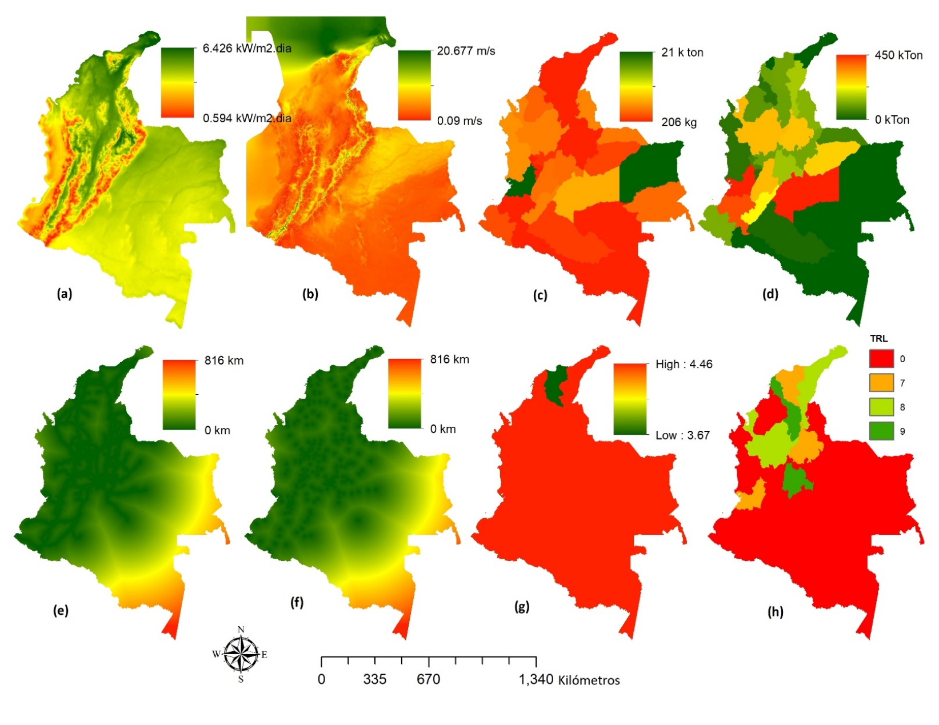
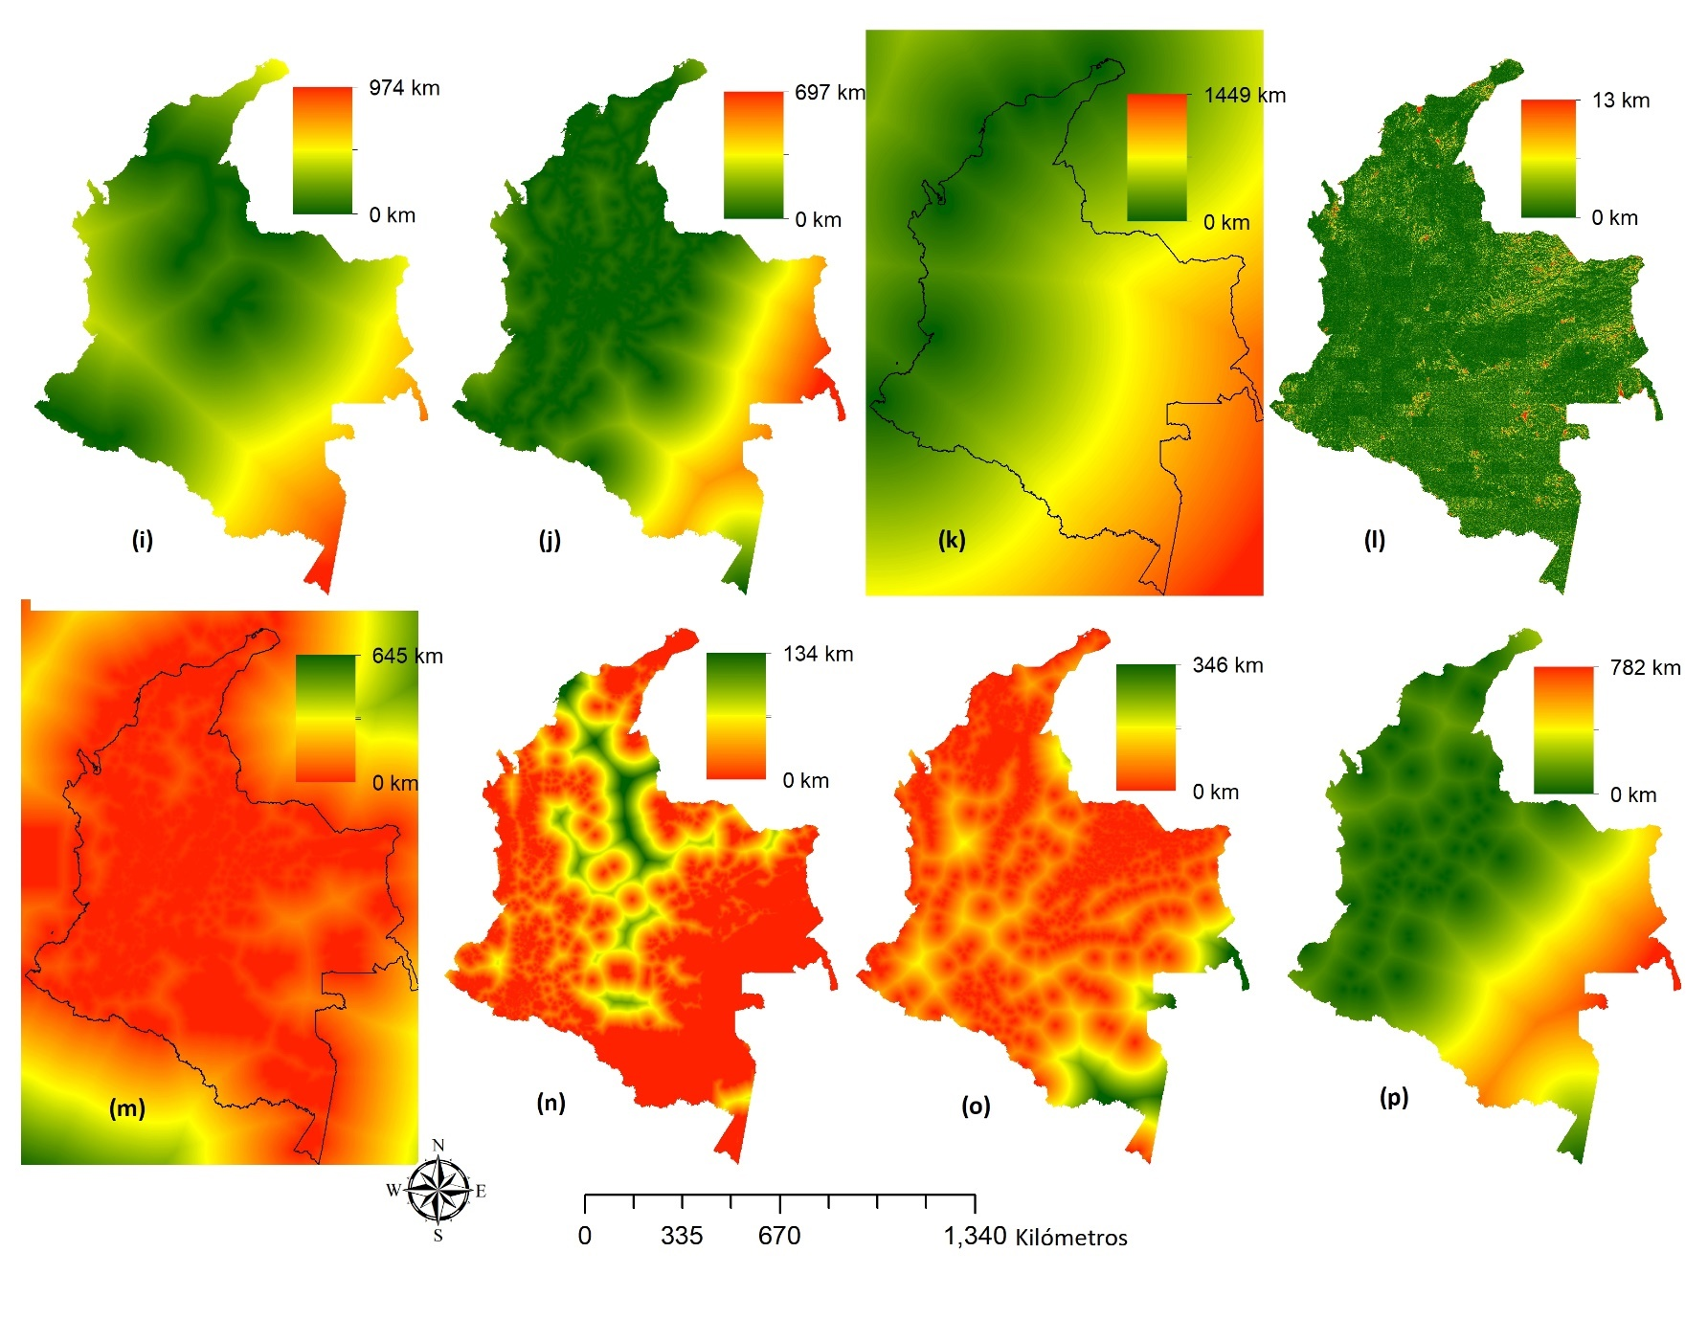
Figure S1. Spatial variables considered in the territorial suitability assessment for green hydrogen deployment in Colombia. Panels (a)–(p) correspond to the spatial criteria used in the GIS-MCDA model.
The maps represent the main input layers used in the GIS-MCDA model, including renewable resource potential, electro-renewable hydrogen potential, hydrogen potential from residual biomass, connection infrastructure, levelized cost of hydrogen, technological readiness and performance, proximity to existing infrastructure, freshwater availability and water stress, protected areas, settlements and Indigenous territories, sensitive ecosystems, academic and scientific support, innovation clusters, regulations and incentives, and alignment with public policies.

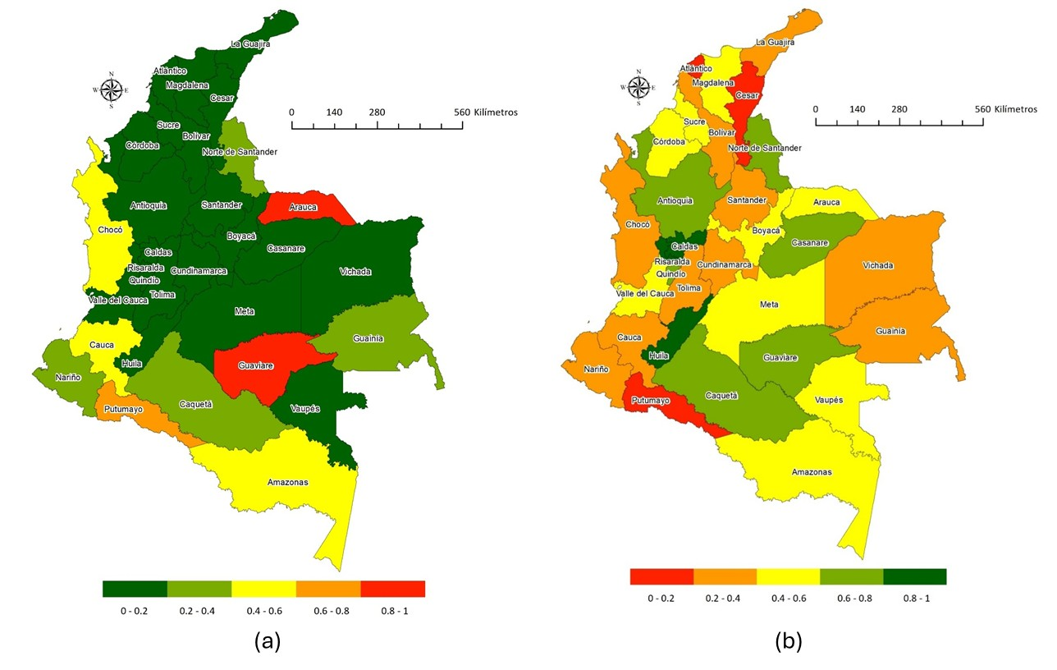
Figure S2. Territorial indices used for post-classification interpretation. (a) National Conflict Index, NCI. (b) National Governance Index, NGI. The indices were used as complementary interpretive layers to contextualize departmental prioritization according to conflict intensity and governance conditions.

Table S3. Departmental normalized values of the National Conflict Index
Department | Normalized NCI
Caldas | 0.023
Caquetá | 0.365
Cundinamarca | 0.000
Huila | 0.102
Meta | 0.107
Quindío | 0.053
Risaralda | 0.055
Santander | 0.016
Tolima | 0.042
Casanare | 0.101
Guaviare | 1.000
Antioquia | 0.077
Boyacá | 0.009
Cauca | 0.561
Cesar | 0.062
Córdoba | 0.065
Chocó | 0.573
La Guajira | 0.099
Magdalena | 0.071
Norte de Santander | 0.249
Sucre | 0.071
Valle del Cauca | 0.085
Arauca | 0.891
Putumayo | 0.618
Amazonas | 0.448
Guainía | 0.265
Vaupés | 0.161
Vichada | 0.145
Nariño | 0.219
Bolívar | 0.059
Atlántico | 0.028
San Andrés, Providencia and Santa Catalina | 0.105

Note: NCI = National Conflict Index. Higher normalized values indicate higher relative territorial conflict intensity. The index was used only as a post-classification interpretive layer and was not included as a weighted criterion in the GIS-MCDA suitability model.

Table S4. Departmental normalized values of the National Governance Index
Department | Normalized NGI
Caldas | 0.947
Caquetá | 0.631
Cundinamarca | 0.211
Huila | 0.874
Meta | 0.510
Quindío | 0.724
Risaralda | 1.000
Santander | 0.255
Tolima | 0.285
Casanare | 0.699
Guaviare | 0.621
Antioquia | 0.670
Boyacá | 0.463
Cauca | 0.239
Cesar | 0.118
Córdoba | 0.582
Chocó | 0.248
La Guajira | 0.391
Magdalena | 0.420
Norte de Santander | 0.665
Sucre | 0.432
Valle del Cauca | 0.469
Arauca | 0.506
Putumayo | 0.000
Amazonas | 0.498
Guainía | 0.364
Vaupés | 0.408
Vichada | 0.260
Nariño | 0.380
Bolívar | 0.266
Atlántico | 0.162
San Andrés, Providencia and Santa Catalina | 0.533

Note: NGI = National Governance Index. Higher normalized values indicate stronger relative governance conditions. The index was used only as a post-classification interpretive layer and was not included as a weighted criterion in the GIS-MCDA suitability model.

Table S5. Departmental mean suitability values for green hydrogen deployment
Rank | Department | Mean suitability
1 | Valle del Cauca | 3.538
2 | Cundinamarca | 3.380
3 | Antioquia | 3.348
4 | Santander | 3.305
5 | Cesar | 3.227
6 | Bolívar | 3.160
7 | Norte de Santander | 3.083
8 | Tolima | 3.066
9 | Atlántico | 3.054
10 | Magdalena | 3.021
11 | Caldas | 2.987
12 | Huila | 2.942
13 | La Guajira | 2.934
14 | Meta | 2.921
15 | Boyacá | 2.868
16 | Cauca | 2.846
17 | Sucre | 2.829
18 | Córdoba | 2.781
19 | Casanare | 2.765
20 | Quindío | 2.762
21 | Nariño | 2.761
22 | Risaralda | 2.723
23 | Arauca | 2.628
24 | Chocó | 2.556
25 | Vichada | 2.534
26 | Caquetá | 2.399
27 | Putumayo | 2.364
28 | Guaviare | 2.168
29 | Guainía | 2.164
30 | Vaupés | 2.137
31 | Amazonas | 2.124
32 | San Andrés, Providencia and Santa Catalina | N/A

Note: Mean suitability values were obtained by averaging the final GIS-MCDA suitability surface within each departmental boundary. San Andrés, Providencia and Santa Catalina is reported as N/A because no valid raster cells were available for this insular territory in the final processed suitability surface.

