Table S1. Multiplicative interaction between TyHGB and CRP for incident CMM.
Model | N | CMM events | Interaction term | HR for multiplicative interaction (95% CI) | P value
Model 1 | 3,857 | 372 | TyHGB × CRP | 0.727 (0.458, 1.154) | 0.176
Model 2 | 3,857 | 372 | TyHGB × CRP | 0.714 (0.449, 1.134) | 0.153
Model 3 | 3,857 | 372 | TyHGB × CRP | 0.677 (0.426, 1.076) | 0.099
Model adjustment was the same as described in Table 2.

Table S2. Additive interaction between TyHGB and CRP for incident CMM.
Model | N | CMM events | Measure | Estimate (95% CI) | P value
Model 1 | 3,857 | 372 | RERI | -0.267 (-1.221, 0.687) | 0.583
Model 1 | 3,857 | 372 | AP | -0.079 (-0.361, 0.203) | 0.583
Model 1 | 3,857 | 372 | SI | 0.899 (0.626, 1.291) | 0.564
Model 2 | 3,857 | 372 | RERI | -0.332 (-1.282, 0.617) | 0.493
Model 2 | 3,857 | 372 | AP | -0.102 (-0.392, 0.189) | 0.492
Model 2 | 3,857 | 372 | SI | 0.872 (0.604, 1.258) | 0.464
Model 3 | 3,857 | 372 | RERI | -0.509 (-1.420, 0.401) | 0.273
Model 3 | 3,857 | 372 | AP | -0.179 (-0.496, 0.138) | 0.269
Model 3 | 3,857 | 372 | SI | 0.784 (0.533, 1.154) | 0.217
Model adjustment was the same as described in Table 2.

Table S3. Internal validation of time-dependent AUC and Harrell C-index for complete-case prediction models.
Method | Model | Metric | Time point | N | Events | Estimate | Delta vs base | Empirical interval | Mean optimism
Apparent | Base model | Time-dependent AUC | 3-year | 2,745 | 289 | 0.688 | 0.000
Apparent | Base + TyHGB | Time-dependent AUC | 3-year | 2,745 | 289 | 0.715 | 0.027
Apparent | Base + CRP | Time-dependent AUC | 3-year | 2,745 | 289 | 0.703 | 0.015
Apparent | Base + TyHGB + CRP | Time-dependent AUC | 3-year | 2,745 | 289 | 0.721 | 0.033
Apparent | Base + joint TyHGB-CRP exposure | Time-dependent AUC | 3-year | 2,745 | 289 | 0.744 | 0.056
Apparent | Base model | Time-dependent AUC | 5-year | 2,745 | 289 | 0.670 | 0.000
Apparent | Base + TyHGB | Time-dependent AUC | 5-year | 2,745 | 289 | 0.691 | 0.021
Apparent | Base + CRP | Time-dependent AUC | 5-year | 2,745 | 289 | 0.673 | 0.003
Apparent | Base + TyHGB + CRP | Time-dependent AUC | 5-year | 2,745 | 289 | 0.691 | 0.021
Apparent | Base + joint TyHGB-CRP exposure | Time-dependent AUC | 5-year | 2,745 | 289 | 0.700 | 0.030
Apparent | Base model | Harrell C-index | Overall | 2,745 | 289 | 0.645 | 0.000
Apparent | Base + TyHGB | Harrell C-index | Overall | 2,745 | 289 | 0.667 | 0.022
Apparent | Base + CRP | Harrell C-index | Overall | 2,745 | 289 | 0.646 | 0.001
Apparent | Base + TyHGB + CRP | Harrell C-index | Overall | 2,745 | 289 | 0.667 | 0.022
Apparent | Base + joint TyHGB-CRP exposure | Harrell C-index | Overall | 2,745 | 289 | 0.686 | 0.041
5x5-fold CV | Base model | Time-dependent AUC | 3-year | 2,745 | 289 | 0.667 | 0.000 | 0.658, 0.680
5x5-fold CV | Base + TyHGB | Time-dependent AUC | 3-year | 2,745 | 289 | 0.692 | 0.025 | 0.684, 0.703
5x5-fold CV | Base + CRP | Time-dependent AUC | 3-year | 2,745 | 289 | 0.680 | 0.012 | 0.670, 0.697
5x5-fold CV | Base + TyHGB + CRP | Time-dependent AUC | 3-year | 2,745 | 289 | 0.697 | 0.030 | 0.689, 0.708
5x5-fold CV | Base + joint TyHGB-CRP exposure | Time-dependent AUC | 3-year | 2,745 | 289 | 0.719 | 0.052 | 0.709, 0.733
5x5-fold CV | Base model | Time-dependent AUC | 5-year | 2,745 | 289 | 0.651 | 0.000 | 0.643, 0.657
5x5-fold CV | Base + TyHGB | Time-dependent AUC | 5-year | 2,745 | 289 | 0.671 | 0.020 | 0.663, 0.674
5x5-fold CV | Base + CRP | Time-dependent AUC | 5-year | 2,745 | 289 | 0.652 | 0.001 | 0.646, 0.661
5x5-fold CV | Base + TyHGB + CRP | Time-dependent AUC | 5-year | 2,745 | 289 | 0.670 | 0.019 | 0.664, 0.675
5x5-fold CV | Base + joint TyHGB-CRP exposure | Time-dependent AUC | 5-year | 2,745 | 289 | 0.679 | 0.028 | 0.674, 0.687
5x5-fold CV | Base model | Harrell C-index | Overall | 2,745 | 289 | 0.624 | 0.000 | 0.619, 0.629
5x5-fold CV | Base + TyHGB | Harrell C-index | Overall | 2,745 | 289 | 0.646 | 0.022 | 0.642, 0.650
5x5-fold CV | Base + CRP | Harrell C-index | Overall | 2,745 | 289 | 0.624 | 0.000 | 0.620, 0.631
5x5-fold CV | Base + TyHGB + CRP | Harrell C-index | Overall | 2,745 | 289 | 0.645 | 0.021 | 0.641, 0.650
5x5-fold CV | Base + joint TyHGB-CRP exposure | Harrell C-index | Overall | 2,745 | 289 | 0.665 | 0.040 | 0.661, 0.669
Bootstrap optimism-corrected | Base model | Time-dependent AUC | 3-year | 2,745 | 289 | 0.666 | 0.000 |  | 0.021
Bootstrap optimism-corrected | Base + TyHGB | Time-dependent AUC | 3-year | 2,745 | 289 | 0.695 | 0.029 |  | 0.020
Bootstrap optimism-corrected | Base + CRP | Time-dependent AUC | 3-year | 2,745 | 289 | 0.679 | 0.013 |  | 0.023
Bootstrap optimism-corrected | Base + TyHGB + CRP | Time-dependent AUC | 3-year | 2,745 | 289 | 0.699 | 0.033 |  | 0.022
Bootstrap optimism-corrected | Base + joint TyHGB-CRP exposure | Time-dependent AUC | 3-year | 2,745 | 289 | 0.724 | 0.058 |  | 0.019
Bootstrap optimism-corrected | Base model | Time-dependent AUC | 5-year | 2,745 | 289 | 0.652 | 0.000 |  | 0.019
Bootstrap optimism-corrected | Base + TyHGB | Time-dependent AUC | 5-year | 2,745 | 289 | 0.673 | 0.021 |  | 0.018
Bootstrap optimism-corrected | Base + CRP | Time-dependent AUC | 5-year | 2,745 | 289 | 0.653 | 0.001 |  | 0.020
Bootstrap optimism-corrected | Base + TyHGB + CRP | Time-dependent AUC | 5-year | 2,745 | 289 | 0.671 | 0.020 |  | 0.019
Bootstrap optimism-corrected | Base + joint TyHGB-CRP exposure | Time-dependent AUC | 5-year | 2,745 | 289 | 0.682 | 0.030 |  | 0.018
Bootstrap optimism-corrected | Base model | Harrell C-index | Overall | 2,745 | 289 | 0.625 | 0.000 |  | 0.020
Bootstrap optimism-corrected | Base + TyHGB | Harrell C-index | Overall | 2,745 | 289 | 0.647 | 0.022 |  | 0.020
Bootstrap optimism-corrected | Base + CRP | Harrell C-index | Overall | 2,745 | 289 | 0.625 | -0.000 |  | 0.021
Bootstrap optimism-corrected | Base + TyHGB + CRP | Harrell C-index | Overall | 2,745 | 289 | 0.645 | 0.020 |  | 0.021
Bootstrap optimism-corrected | Base + joint TyHGB-CRP exposure | Harrell C-index | Overall | 2,745 | 289 | 0.666 | 0.041 |  | 0.020
AUC, area under the receiver operating characteristic curve; CV, cross-validation. Delta vs base was calculated relative to the base model within the same method, metric, and time point. Empirical interval is shown for 5x5-fold CV results.

Table S4. Bootstrap optimism estimates for time-dependent AUC and Harrell C-index.
Model | Metric | Time point | Bootstrap iterations | Mean optimism | Optimism interval
Base model | Time-dependent AUC | 3-year | 500 | 0.021 | -0.072, 0.111
Base model | Time-dependent AUC | 5-year | 500 | 0.019 | -0.035, 0.070
Base model | Harrell C-index | Overall | 500 | 0.020 | -0.010, 0.048
Base + TyHGB | Time-dependent AUC | 3-year | 500 | 0.020 | -0.072, 0.106
Base + TyHGB | Time-dependent AUC | 5-year | 500 | 0.018 | -0.032, 0.071
Base + TyHGB | Harrell C-index | Overall | 500 | 0.020 | -0.012, 0.049
Base + CRP | Time-dependent AUC | 3-year | 500 | 0.023 | -0.070, 0.107
Base + CRP | Time-dependent AUC | 5-year | 500 | 0.020 | -0.029, 0.072
Base + CRP | Harrell C-index | Overall | 500 | 0.021 | -0.009, 0.049
Base + TyHGB + CRP | Time-dependent AUC | 3-year | 500 | 0.022 | -0.073, 0.105
Base + TyHGB + CRP | Time-dependent AUC | 5-year | 500 | 0.019 | -0.029, 0.071
Base + TyHGB + CRP | Harrell C-index | Overall | 500 | 0.021 | -0.010, 0.050
Base + joint TyHGB-CRP exposure | Time-dependent AUC | 3-year | 500 | 0.019 | -0.069, 0.095
Base + joint TyHGB-CRP exposure | Time-dependent AUC | 5-year | 500 | 0.018 | -0.035, 0.067
Base + joint TyHGB-CRP exposure | Harrell C-index | Overall | 500 | 0.020 | -0.011, 0.047
Optimism interval is presented as lower and upper empirical limits from bootstrap resampling.

Table S5. IDI, continuous NRI, and median improvement for complete-case prediction models.
Time point | Comparison | N | Events | Metric | Estimate (95% CI) | P value
3-year | Base + TyHGB vs base model | 2,745 | 289 | IDI | 0.001 (-0.001, 0.004) | 0.208
3-year | Base + TyHGB vs base model | 2,745 | 289 | Continuous NRI | 0.276 (0.033, 0.436) | 0.032
3-year | Base + TyHGB vs base model | 2,745 | 289 | Median improvement | 0.001 (-0.001, 0.002) | 0.072
3-year | Base + CRP vs base model | 2,745 | 289 | IDI | 0.001 (-0.000, 0.004) | 0.180
3-year | Base + CRP vs base model | 2,745 | 289 | Continuous NRI | 0.266 (-0.192, 0.411) | 0.160
3-year | Base + CRP vs base model | 2,745 | 289 | Median improvement | 0.001 (-0.001, 0.002) | 0.076
3-year | Base + TyHGB + CRP vs base model | 2,745 | 289 | IDI | 0.001 (-0.000, 0.006) | 0.104
3-year | Base + TyHGB + CRP vs base model | 2,745 | 289 | Continuous NRI | 0.252 (-0.002, 0.408) | 0.052
3-year | Base + TyHGB + CRP vs base model | 2,745 | 289 | Median improvement | 0.001 (-0.000, 0.003) | 0.052
3-year | Base + joint TyHGB-CRP exposure vs base model | 2,745 | 289 | IDI | 0.004 (0.001, 0.008) | 0.016
3-year | Base + joint TyHGB-CRP exposure vs base model | 2,745 | 289 | Continuous NRI | 0.300 (0.171, 0.408) | <0.001
3-year | Base + joint TyHGB-CRP exposure vs base model | 2,745 | 289 | Median improvement | 0.003 (0.001, 0.008) | 0.004
5-year | Base + TyHGB vs base model | 2,745 | 289 | IDI | 0.004 (0.001, 0.011) | 0.024
5-year | Base + TyHGB vs base model | 2,745 | 289 | Continuous NRI | 0.245 (0.110, 0.330) | <0.001
5-year | Base + TyHGB vs base model | 2,745 | 289 | Median improvement | 0.002 (0.000, 0.003) | 0.012
5-year | Base + CRP vs base model | 2,745 | 289 | IDI | 0.001 (-0.000, 0.006) | 0.311
5-year | Base + CRP vs base model | 2,745 | 289 | Continuous NRI | 0.085 (-0.065, 0.187) | 0.251
5-year | Base + CRP vs base model | 2,745 | 289 | Median improvement | 0.001 (-0.001, 0.002) | 0.196
5-year | Base + TyHGB + CRP vs base model | 2,745 | 289 | IDI | 0.004 (0.001, 0.013) | 0.016
5-year | Base + TyHGB + CRP vs base model | 2,745 | 289 | Continuous NRI | 0.220 (0.090, 0.317) | <0.001
5-year | Base + TyHGB + CRP vs base model | 2,745 | 289 | Median improvement | 0.002 (0.000, 0.005) | 0.004
5-year | Base + joint TyHGB-CRP exposure vs base model | 2,745 | 289 | IDI | 0.006 (0.001, 0.012) | 0.020
5-year | Base + joint TyHGB-CRP exposure vs base model | 2,745 | 289 | Continuous NRI | 0.217 (0.118, 0.305) | <0.001
5-year | Base + joint TyHGB-CRP exposure vs base model | 2,745 | 289 | Median improvement | 0.006 (0.004, 0.017) | <0.001
IDI, integrated discrimination improvement; NRI, net re

Table S6. Sensitivity analysis using complete-case Cox regression.
Model | Exposure group | N | Events | HR (95% CI) | P value
Model_1 | Low TyHGB + Low CRP | 2,745 | 289 | 1.00 (Reference)
Model_1 | High TyHGB + Low CRP | 2,745 | 289 | 2.78 (1.92, 4.01) | <0.001
Model_1 | Low TyHGB + High CRP | 2,745 | 289 | 1.19 (0.75, 1.88) | 0.454
Model_1 | High TyHGB + High CRP | 2,745 | 289 | 3.01 (2.12, 4.26) | <0.001
Model_2 | Low TyHGB + Low CRP | 2,745 | 289 | 1.00 (Reference)
Model_2 | High TyHGB + Low CRP | 2,745 | 289 | 2.75 (1.91, 3.98) | <0.001
Model_2 | Low TyHGB + High CRP | 2,745 | 289 | 1.19 (0.75, 1.88) | 0.455
Model_2 | High TyHGB + High CRP | 2,745 | 289 | 2.95 (2.08, 4.20) | <0.001
Model_3 | Low TyHGB + Low CRP | 2,745 | 289 | 1.00 (Reference)
Model_3 | High TyHGB + Low CRP | 2,745 | 289 | 2.57 (1.78, 3.73) | <0.001
Model_3 | Low TyHGB + High CRP | 2,745 | 289 | 1.18 (0.75, 1.87) | 0.475
Model_3 | High TyHGB + High CRP | 2,745 | 289 | 2.62 (1.83, 3.75) | <0.001
Model adjustment was the same as described in Table 2.

Table S7. Sensitivity analysis excluding incident CMM within 2 years.
Model | Exposure group | N | Events | HR (95% CI) | P value
Model_1 | Low TyHGB + Low CRP | 3,803 | 318 | 1.00 (Reference)
Model_1 | High TyHGB + Low CRP | 3,803 | 318 | 3.09 (2.19, 4.37) | <0.001
Model_1 | Low TyHGB + High CRP | 3,803 | 318 | 1.41 (0.93, 2.13) | 0.107
Model_1 | High TyHGB + High CRP | 3,803 | 318 | 2.99 (2.14, 4.18) | <0.001
Model_2 | Low TyHGB + Low CRP | 3,803 | 318 | 1.00 (Reference)
Model_2 | High TyHGB + Low CRP | 3,803 | 318 | 3.04 (2.15, 4.30) | <0.001
Model_2 | Low TyHGB + High CRP | 3,803 | 318 | 1.41 (0.93, 2.13) | 0.107
Model_2 | High TyHGB + High CRP | 3,803 | 318 | 2.85 (2.04, 4.00) | <0.001
Model_3 | Low TyHGB + Low CRP | 3,803 | 318 | 1.00 (Reference)
Model_3 | High TyHGB + Low CRP | 3,803 | 318 | 2.82 (1.99, 4.00) | <0.001
Model_3 | Low TyHGB + High CRP | 3,803 | 318 | 1.40 (0.93, 2.12) | 0.111
Model_3 | High TyHGB + High CRP | 3,803 | 318 | 2.50 (1.78, 3.53) | <0.001
Model adjustment was the same as described in Table 2.

Table S8. Sensitivity analysis restricted to participants with baseline CMD0.
Model | Exposure group | N | Events | HR (95% CI) | P value
Model_1 | Low TyHGB + Low CRP | 2,689 | 118 | 1.00 (Reference)
Model_1 | High TyHGB + Low CRP | 2,689 | 118 | 2.41 (1.40, 4.14) | 0.002
Model_1 | Low TyHGB + High CRP | 2,689 | 118 | 1.79 (1.04, 3.09) | 0.037
Model_1 | High TyHGB + High CRP | 2,689 | 118 | 2.34 (1.40, 3.92) | 0.001
Model_2 | Low TyHGB + Low CRP | 2,689 | 118 | 1.00 (Reference)
Model_2 | High TyHGB + Low CRP | 2,689 | 118 | 2.38 (1.38, 4.10) | 0.002
Model_2 | Low TyHGB + High CRP | 2,689 | 118 | 1.79 (1.04, 3.09) | 0.037
Model_2 | High TyHGB + High CRP | 2,689 | 118 | 2.27 (1.35, 3.82) | 0.002
Model_3 | Low TyHGB + Low CRP | 2,689 | 118 | 1.00 (Reference)
Model_3 | High TyHGB + Low CRP | 2,689 | 118 | 2.24 (1.30, 3.88) | 0.004
Model_3 | Low TyHGB + High CRP | 2,689 | 118 | 1.79 (1.03, 3.09) | 0.038
Model_3 | High TyHGB + High CRP | 2,689 | 118 | 2.02 (1.19, 3.42) | 0.009
Model adjustment was the same as described in Table 2.

Table S9. Sensitivity analysis excluding participants with CRP > 10 mg/L.
Model | Exposure group | N | Events | HR (95% CI) | P value
Model_1 | Low TyHGB + Low CRP | 3,645 | 352 | 1.00 (Reference)
Model_1 | High TyHGB + Low CRP | 3,645 | 352 | 3.19 (2.29, 4.44) | <0.001
Model_1 | Low TyHGB + High CRP | 3,645 | 352 | 1.50 (1.01, 2.24) | 0.047
Model_1 | High TyHGB + High CRP | 3,645 | 352 | 3.32 (2.41, 4.58) | <0.001
Model_2 | Low TyHGB + Low CRP | 3,645 | 352 | 1.00 (Reference)
Model_2 | High TyHGB + Low CRP | 3,645 | 352 | 3.14 (2.25, 4.37) | <0.001
Model_2 | Low TyHGB + High CRP | 3,645 | 352 | 1.50 (1.00, 2.23) | 0.048
Model_2 | High TyHGB + High CRP | 3,645 | 352 | 3.19 (2.31, 4.40) | <0.001
Model_3 | Low TyHGB + Low CRP | 3,645 | 352 | 1.00 (Reference)
Model_3 | High TyHGB + Low CRP | 3,645 | 352 | 2.92 (2.09, 4.07) | <0.001
Model_3 | Low TyHGB + High CRP | 3,645 | 352 | 1.50 (1.00, 2.23) | 0.048
Model_3 | High TyHGB + High CRP | 3,645 | 352 | 2.82 (2.03, 3.91) | <0.001
Model adjustment was the same as described in Table 2.

Table S10. Sensitivity analysis excluding participants with baseline cancer or liver disease.
Model | Exposure group | N | Events | HR (95% CI) | P value
Model_1 | Low TyHGB + Low CRP | 3,708 | 356 | 1.00 (Reference)
Model_1 | High TyHGB + Low CRP | 3,708 | 356 | 3.21 (2.28, 4.51) | <0.001
Model_1 | Low TyHGB + High CRP | 3,708 | 356 | 1.47 (0.98, 2.20) | 0.062
Model_1 | High TyHGB + High CRP | 3,708 | 356 | 3.43 (2.48, 4.74) | <0.001
Model_2 | Low TyHGB + Low CRP | 3,708 | 356 | 1.00 (Reference)
Model_2 | High TyHGB + Low CRP | 3,708 | 356 | 3.17 (2.25, 4.46) | <0.001
Model_2 | Low TyHGB + High CRP | 3,708 | 356 | 1.46 (0.98, 2.19) | 0.064
Model_2 | High TyHGB + High CRP | 3,708 | 356 | 3.32 (2.39, 4.60) | <0.001
Model_3 | Low TyHGB + Low CRP | 3,708 | 356 | 1.00 (Reference)
Model_3 | High TyHGB + Low CRP | 3,708 | 356 | 2.96 (2.10, 4.17) | <0.001
Model_3 | Low TyHGB + High CRP | 3,708 | 356 | 1.45 (0.97, 2.17) | 0.072
Model_3 | High TyHGB + High CRP | 3,708 | 356 | 2.92 (2.09, 4.07) | <0.001
Model adjustment was the same as described in Table 2.

Table S11. Fine–Gray competing-risk analysis for the association between joint TyHGB–CRP exposure and incident CMM.
Model | Exposure group | N | Events | Competing deaths | SHR (95% CI) | P value | P for overall
Model_1 | Low TyHGB + Low CRP | 3,857 | 372 | 84 | 1.00 (Reference) |  | <0.001
Model_1 | High TyHGB + Low CRP | 3,857 | 372 | 84 | 3.11 (2.25, 4.30) | <0.001 | <0.001
Model_1 | Low TyHGB + High CRP | 3,857 | 372 | 84 | 1.42 (0.97, 2.09) | 0.073 | <0.001
Model_1 | High TyHGB + High CRP | 3,857 | 372 | 84 | 3.24 (2.38, 4.41) | <0.001 | <0.001
Model_2 | Low TyHGB + Low CRP | 3,857 | 372 | 84 | 1.00 (Reference) |  | <0.001
Model_2 | High TyHGB + Low CRP | 3,857 | 372 | 84 | 3.07 (2.22, 4.24) | <0.001 | <0.001
Model_2 | Low TyHGB + High CRP | 3,857 | 372 | 84 | 1.42 (0.97, 2.09) | 0.074 | <0.001
Model_2 | High TyHGB + High CRP | 3,857 | 372 | 84 | 3.13 (2.29, 4.29) | <0.001 | <0.001
Model_3 | Low TyHGB + Low CRP | 3,857 | 372 | 84 | 1.00 (Reference) |  | <0.001
Model_3 | High TyHGB + Low CRP | 3,857 | 372 | 84 | 2.85 (2.06, 3.94) | <0.001 | <0.001
Model_3 | Low TyHGB + High CRP | 3,857 | 372 | 84 | 1.42 (0.97, 2.08) | 0.072 | <0.001
Model_3 | High TyHGB + High CRP | 3,857 | 372 | 84 | 2.76 (2.01, 3.79) | <0.001 | <0.001
Model adjustment was the same as described in Table 2.

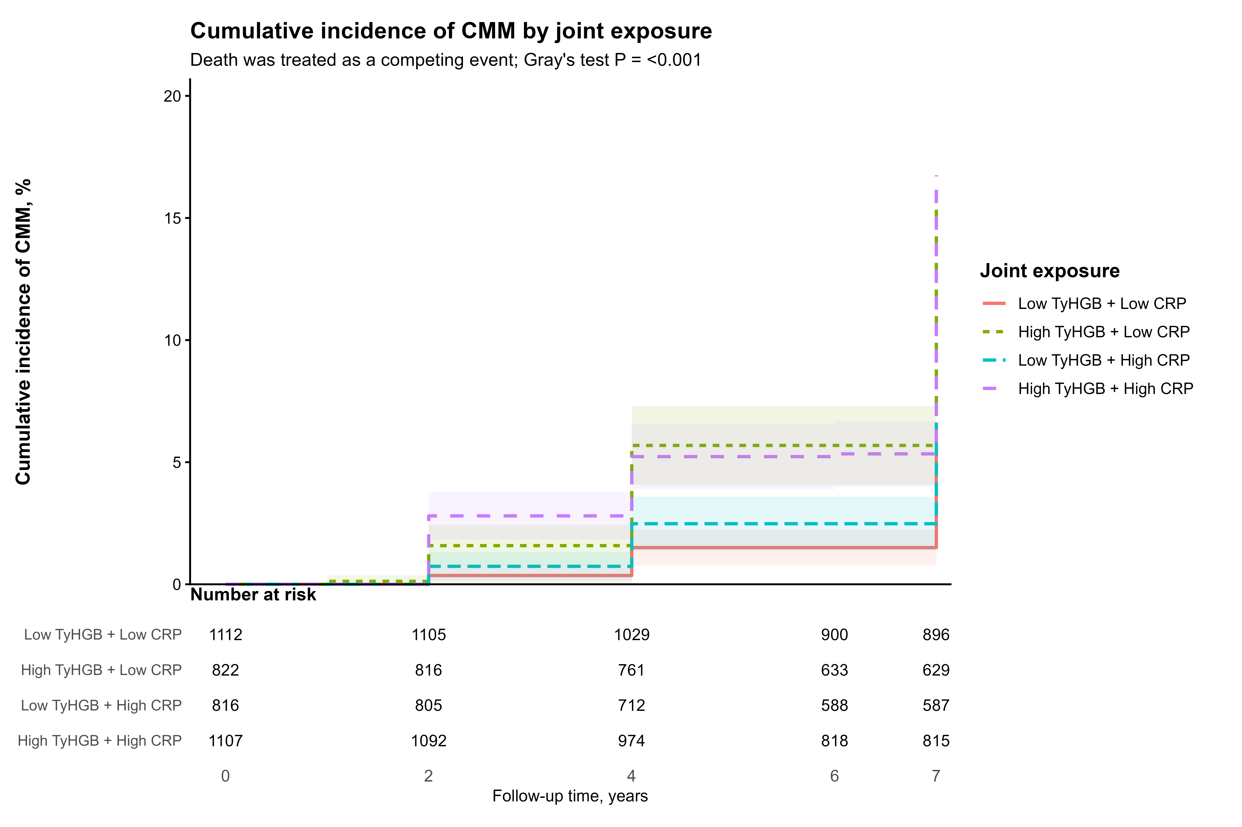
Fig. S1 Cumulative incidence function curves for CMM by combined TyHGB and CRP.CIF curves were plotted across the four joint TyHGB–CRP groups, with death treated as a competing event.
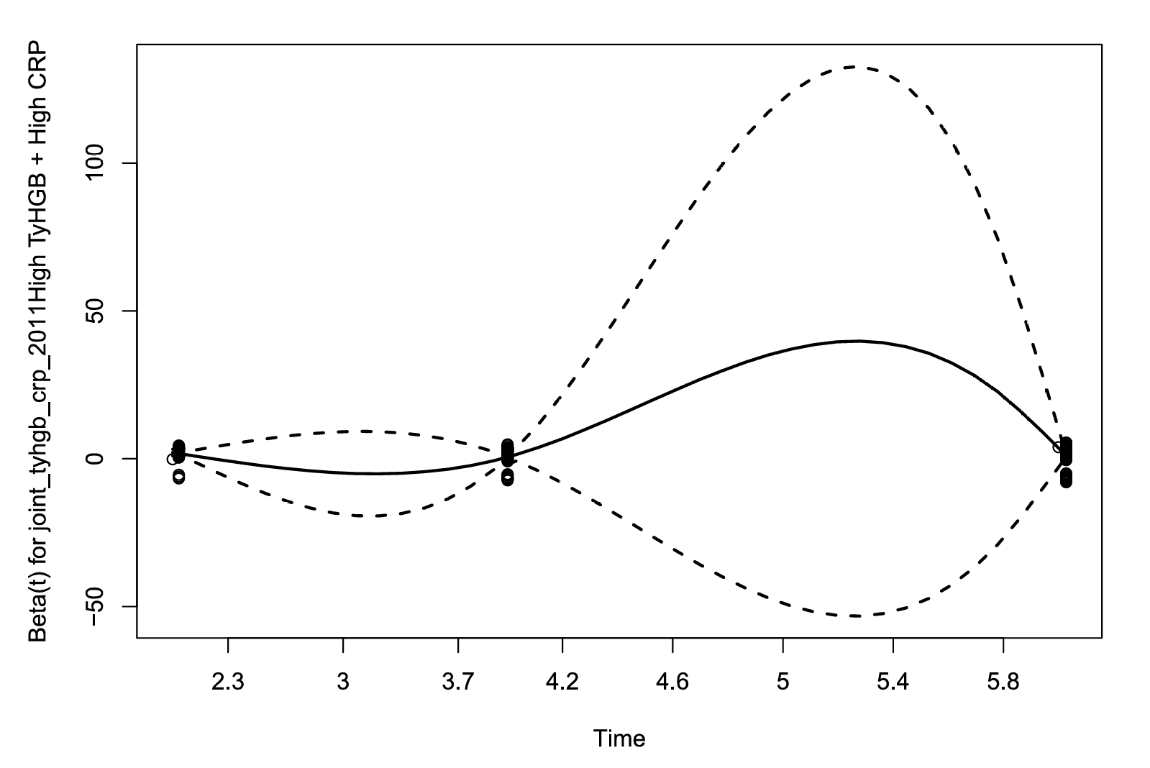
Fig. S2 Schoenfeld residual plots for the proportional hazards assumption.Schoenfeld residual plots were used to evaluate the proportional hazards assumption for the joint TyHGB–CRP exposure in the fully adjusted Cox model.

