Supplementary Figures
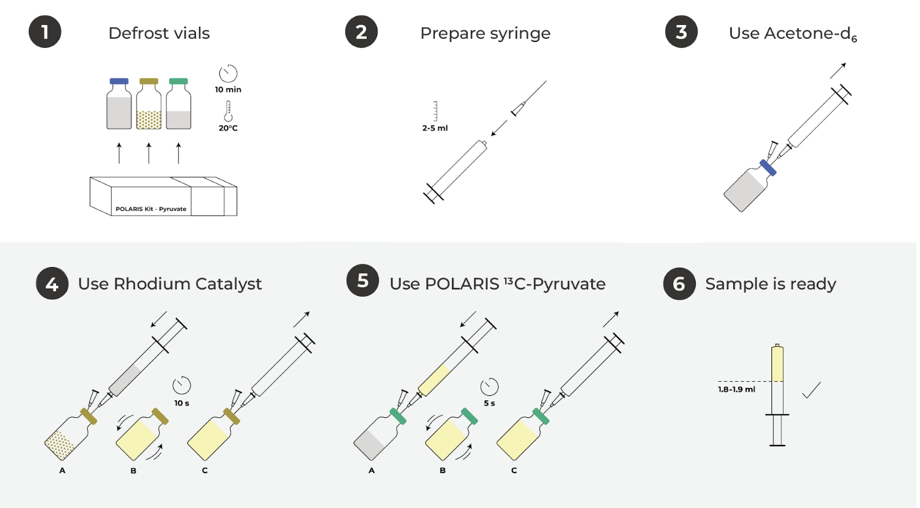
Figure S1. Sample preparation workflow for production of the hyperpolarization precursor solution. Reagent vials stored at −20 °C are first defrosted. A syringe is prepared with the appropriate cannula for sequential reagent transfer. The contents of the acetone-d₆ vial are transferred by syringe into the rhodium catalyst vial and mixed by shaking. The combined solution is then drawn into a syringe and transferred into the vinyl pyruvate ester vial, followed by further mixing. The resulting solution, containing all three reagents, is drawn into a syringe to form the precursor solution, which is subsequently loaded into the POLARIS Preclinical polarizer.

