Table S1. Forward and reverse exploratory mediation analyses in the CID groups

Mediator | a | P | b | P | c | P | c′ | P | Indirect effect [95% CI] | Bootstrap P
Forward exploratory mediation: PSQI → brain metric → SDS
PCU VMHC | 0.009 | 0.096 | -18.724 | <0.001 | 0.606 | 0.024 | 0.770 | 0.003 | -0.164 [-0.398, 0.008] | 0.067
PCU-CAL FC | -0.007 | 0.090 | 14.351 | 0.007 | 0.606 | 0.024 | 0.712 | 0.008 | -0.106 [-0.254, 0.008] | 0.071
PCU-PostC FC | 0.005 | 0.230 | 17.131 | <0.001 | 0.606 | 0.024 | 0.513 | 0.048 | 0.093 [-0.050, 0.268] | 0.197
PCU-DLPFC FC | 0.005 | 0.352 | 12.241 | 0.004 | 0.606 | 0.024 | 0.543 | 0.038 | 0.063 [-0.053, 0.211] | 0.297
PCU-OFC FC | 0.003 | 0.451 | 12.981 | 0.026 | 0.606 | 0.024 | 0.567 | 0.033 | 0.039 [-0.058, 0.165] | 0.441
Reverse exploratory mediation: SDS → brain metric → PSQI
PCU VMHC | -0.006 | <0.001 | 3.909 | 0.009 | 0.063 | 0.024 | 0.088 | 0.003 | -0.025 [-0.050, -0.007] | 0.003
PCU-CAL FC | 0.003 | 0.023 | -3.888 | 0.026 | 0.063 | 0.024 | 0.076 | 0.008 | -0.012 [-0.031, -0.001] | 0.027
PCU-PostC FC | 0.005 | <0.001 | 0.986 | 0.576 | 0.063 | 0.024 | 0.058 | 0.048 | 0.005 [-0.013, 0.023] | 0.562
PCU-DLPFC FC | 0.005 | 0.002 | 0.519 | 0.717 | 0.063 | 0.024 | 0.061 | 0.038 | 0.003 [-0.012, 0.017] | 0.727
PCU-OFC FC | 0.003 | 0.020 | 0.605 | 0.756 | 0.063 | 0.024 | 0.062 | 0.033 | 0.002 [-0.010, 0.014] | 0.746

Note. Forward mediation tested the pathway PSQI → brain metric → SDS; reverse mediation tested the pathway SDS → brain metric → PSQI. a denotes the effect of the predictor on the mediator, b denotes the effect of the mediator on the outcome controlling for the predictor, c denotes the total effect of the predictor on the outcome, and c′ denotes the direct effect after accounting for the mediator. Indirect effects were estimated using bootstrap resampling with 95% confidence intervals, adjusted for age, gender, and education. Bootstrap P values correspond to the two-sided significance test of the indirect effect. Significant indirect effects are shown in bold. Abbreviations: VMHC, Voxel-mirrored homotopic connectivity; BA, Brodmann's area; MNI, Montreal Neurological Institute; MPFC, medial prefrontal cortex; PCU, Precuneus; FC, functional connectivity; DLPFC, drosolateral prefrontal cortex; OFC, orbital frontal cortex; CID, chronic insomnia disorder; PSQI, Pittsburgh Sleep Quality Index; SDS, Self-Rating Depression Scale; CI, confidence interval.

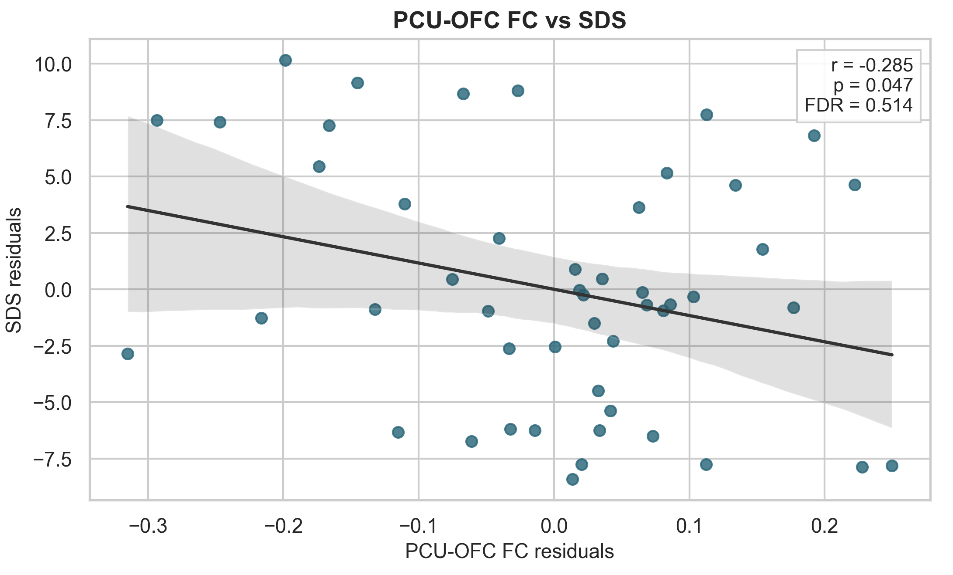
Figure S1. Exploratory subgroup partial correlation within the CID-D group between PCU-OFC functional connectivity and SDS after adjustment for age, gender, and education. The regression line and shaded band indicate the fitted association and its 95% confidence interval. This association reached nominal significance but did not survive FDR correction. Abbreviations: SDS: Self-Rating Depression Scale; PCU, precuneus; OFC, orbitofrontal cortex; FC, functional connectivity.

