Supplementary Materials
Supplementary Table 1. Model development and ablation history for ToxiPred.
Model family | OOF r | RMSE | Optimized hyperparameters
Ridge | 0.666 | 5.47 | alpha in {0.1, 1, 10, 30, 100, 300, 1000}; per-tissue alpha selected by inner CV
LightGBM | 0.686 | 5.29 | 11 hyperparameters tuned with Optuna TPE: learning_rate ∈ [0.005, 0.15] log → 0.009; num_leaves ∈ [15, 255] → 156; max_depth ∈ [4, 12] → 5; min_data_in_leaf ∈ [5, 100] → 8; feature_fraction ∈ [0.4, 1.0] → 0.96; bagging_fraction ∈ [0.5, 1.0] → 0.80; bagging_freq ∈ [0, 10] → 7; reg_alpha ∈ [1e-3, 10] log → 0.08; reg_lambda ∈ [1e-3, 10] log → 8.99; min_gain_to_split ∈ [1e-4, 1] log → 0.0045; max_bin ∈ [63, 255] → 253. Objective = regression_l1; n_estimators per-fold by early stopping (patience 80→200)
Ridge stack | 0.675 | 5.53 | per-tissue base alpha, as above, plus stacker alpha in {0.1, 1, 10, 100}; isotonic-vs-linear stacker selected by inner CV
Factorization machine | 0.716 | 5.09 | rank in {8, 16, 32, 64}; lr in {1e-3, 5e-3}; reg_w in {1e-4, 1e-3}; reg_v in {1e-4, 1e-3}; n_epochs with early stopping
LightGBM residual | 0.698 | 5.31 | same LightGBM Optuna search as above, fit on Ridge residuals; residual-blend weight ∈ {0.5, 0.7, 1.0}
Pathway bottleneck D70 (final) | 0.733 | 5.02 | P = 70, selected by sweep over P in {40, 48, 50, 62, 63, 70, 100, 150, 300, 500}; same encoder-shortcut-decoder topology as D50; SmoothL1 loss; AdamW lr 5e-4, weight_decay 1e-3, dropout 0.3, batch 128, cosine schedule, grad_clip 5, epochs 180; 5-seed ensemble
Pathway bottleneck D70, interaction-operator ablation | 0.723-0.736 | 5.06 | At the deployed P=70 architecture, four drug × tissue interaction operators were compared under matched training: Hadamard (deployed, 0.733), sum interaction (0.736), bilinear (0.734), concat-MLP (0.723). Sum, bilinear and Hadamard tied within seed variance (ΔR < 0.005); concat-MLP overfit on hard folds. The final 70-pathway Hadamard interaction model was selected because it matched the best-performing interaction operators within seed-level variation while preserving direct pathway-wise interpretability.
Pathway bottleneck D70, gene-level ablation | 0.36-0.42 | 6.7-7.07 | Pathway dictionary bypassed and encoder fed raw per-gene LINCS L1000 ∩ Tahoe rank vectors (~875 genes) directly under matched drug-disjoint CV: per-gene cross-interaction (r = 0.416, RMSE = 6.70), per-gene attention concat (r = 0.377, RMSE = 6.91), per-gene attention Hadamard (r = 0.357, RMSE = 7.07). Pathway aggregation outperformed gene-level representations by Δr ≈ +0.30 and ΔRMSE ≈ -1.6 to -2.0. Indicates the curated pathway dictionary is an information-preserving inductive bias, not merely dimensional summary.

Supplementary Table 2 | Antibacterial activity counter-screening across four bacterial isolates. Drug sensitivity scores were measured against E. coli, P. aeruginosa, A. baumannii and S. aureus. DSS_max denotes the maximum bacterial DSS across the four strains.
Drug | E. coli | P. aerug. | A. baum. | S. aur. | DSS_max
Clinafloxacin | 42.2 | 29.9 | 42.4 | 32.7 | 42.4
Ciprofloxacin | 42.1 | 28.3 | 28.0 | 21.2 | 42.1
Rifampicin | 4.0 | 1.4 | 4.6 | 34.4 | 34.4
Rifabutin | 4.0 | 2.6 | 15.0 | 33.4 | 33.4
Levofloxacin | 31.9 | 16.2 | 24.6 | 17.3 | 31.9
Moxifloxacin | 31.0 | 9.8 | 27.4 | 24.7 | 31.0
Cefotetan | 30.9 | 0.0 | 0.0 | 5.5 | 30.9
Marbofloxacin | 30.6 | 6.8 | 24.5 | 9.6 | 30.6
Gatifloxacin | 30.1 | 11.9 | 26.5 | 16.8 | 30.1
Ofloxacin | 29.9 | 7.8 | 18.7 | 13.9 | 29.9
Cefepime | 29.3 | 9.7 | 3.0 | 7.2 | 29.3
Norfloxacin | 29.1 | 8.8 | 4.4 | 10.2 | 29.1
Novobiocin | 1.0 | 0.0 | 0.4 | 27.4 | 27.4
Doxycycline | 14.6 | 0.6 | 21.0 | 14.9 | 21.0
Cefdinir | 20.7 | 0.1 | 6.0 | 17.3 | 20.7
Thiostrepton | 0.0 | 3.2 | 0.5 | 19.5 | 19.5
Colistin | 19.3 | 17.7 | 18.5 | 0.0 | 19.3
Polymyxin | 18.6 | 19.2 | 17.2 | 0.0 | 19.2
Tobramycin | 12.9 | 13.3 | 15.7 | 12.8 | 15.7
Erythromycin | 2.6 | 1.6 | 4.3 | 15.1 | 15.1
Nafcillin | 0.0 | 0.0 | 0.0 | 13.5 | 13.5
Azithromycin | 12.6 | 6.2 | 13.2 | 7.7 | 13.2
Tedizolid | 0.0 | 3.0 | 0.0 | 13.1 | 13.1
Benzylpenicillin | 0.0 | 1.4 | 0.0 | 13.0 | 13.0
Tetracycline | 9.9 | 1.3 | 5.0 | 12.6 | 12.6
Trimethoprim | 12.3 | 0.0 | 2.8 | 0.3 | 12.3
Niclosamide | 0.5 | 0.0 | 0.7 | 12.2 | 12.2
Ritonavir | 0.0 | 0.0 | 0.0 | 7.8 | 7.8
Ampicillin | 2.9 | 1.3 | 0.0 | 6.8 | 6.8
Gramicidin | 0.0 | 0.0 | 0.2 | 5.4 | 5.4
Fidaxomicin | 0.1 | 0.7 | 0.3 | 5.3 | 5.3
Josamycin | 0.0 | 0.0 | 0.1 | 5.0 | 5.0
Hexachlorophene | 0.0 | 2.6 | 4.9 | 3.4 | 4.9
Clotrimazole | 4.7 | 0.0 | 3.1 | 0.5 | 4.7
Linezolid | 0.0 | 0.0 | 0.0 | 4.3 | 4.3
Spectinomycin | 4.0 | 1.2 | 0.7 | 0.0 | 4.0
Mitoxantrone | 3.5 | 0.0 | 0.5 | 0.0 | 3.5
Tazobactam | 0.0 | 2.8 | 3.4 | 0.0 | 3.4
Resveratrol | 0.0 | 0.0 | 0.1 | 3.4 | 3.4
Umifenovir | 0.0 | 0.0 | 0.7 | 3.2 | 3.2
Sunitinib | 0.0 | 3.0 | 0.0 | 0.0 | 3.0
Doxorubicin | 0.0 | 0.0 | 0.0 | 2.9 | 2.9
Bacitracin | 0.0 | 1.9 | 0.0 | 0.0 | 1.9
Gossypol | 0.4 | 0.0 | 1.6 | 0.0 | 1.6
Mycophenolic acid | 1.4 | 0.0 | 0.2 | 0.9 | 1.4
Efavirenz | 0.0 | 1.0 | 0.0 | 0.0 | 1.0
Berberine | 0.0 | 0.8 | 0.0 | 0.0 | 0.8
Vidarabine | <=0.6 | <=0.6 | <=0.6 | <=0.6 | <=0.6
Verapamil | <=0.6 | <=0.6 | <=0.6 | <=0.6 | <=0.6
Valproic acid | <=0.6 | <=0.6 | <=0.6 | <=0.6 | <=0.6
Troglitazone | <=0.6 | <=0.6 | <=0.6 | <=0.6 | <=0.6
Stavudine | <=0.6 | <=0.6 | <=0.6 | <=0.6 | <=0.6
Sirolimus | <=0.6 | <=0.6 | <=0.6 | <=0.6 | <=0.6
Simvastatin | <=0.6 | <=0.6 | <=0.6 | <=0.6 | <=0.6
Seliciclib | <=0.6 | <=0.6 | <=0.6 | <=0.6 | <=0.6
Saracatinib | <=0.6 | <=0.6 | <=0.6 | <=0.6 | <=0.6
Remdesivir | <=0.6 | <=0.6 | <=0.6 | <=0.6 | <=0.6
Raloxifene | <=0.6 | <=0.6 | <=0.6 | <=0.6 | <=0.6
Quercetin | <=0.6 | <=0.6 | <=0.6 | <=0.6 | <=0.6
Prochlorperazine | <=0.6 | <=0.6 | <=0.6 | <=0.6 | <=0.6
Podofilox | <=0.6 | <=0.6 | <=0.6 | <=0.6 | <=0.6
Pinacidil | <=0.6 | <=0.6 | <=0.6 | <=0.6 | <=0.6
Nelfinavir | <=0.6 | <=0.6 | <=0.6 | <=0.6 | <=0.6
Metronidazole | <=0.6 | <=0.6 | <=0.6 | <=0.6 | <=0.6
Methenamine | <=0.6 | <=0.6 | <=0.6 | <=0.6 | <=0.6
Metformin | <=0.6 | <=0.6 | <=0.6 | <=0.6 | <=0.6
Manidipine | <=0.6 | <=0.6 | <=0.6 | <=0.6 | <=0.6
Luteolin | <=0.6 | <=0.6 | <=0.6 | <=0.6 | <=0.6
Leflunomide | <=0.6 | <=0.6 | <=0.6 | <=0.6 | <=0.6
Itraconazole | <=0.6 | <=0.6 | <=0.6 | <=0.6 | <=0.6
Indomethacin | <=0.6 | <=0.6 | <=0.6 | <=0.6 | <=0.6
Indinavir | <=0.6 | <=0.6 | <=0.6 | <=0.6 | <=0.6
Griseofulvin | <=0.6 | <=0.6 | <=0.6 | <=0.6 | <=0.6
Ganciclovir | <=0.6 | <=0.6 | <=0.6 | <=0.6 | <=0.6
Fluoxetine | <=0.6 | <=0.6 | <=0.6 | <=0.6 | <=0.6
Flavopiridol | <=0.6 | <=0.6 | <=0.6 | <=0.6 | <=0.6
Favipiravir | <=0.6 | <=0.6 | <=0.6 | <=0.6 | <=0.6
Emtricitabine | <=0.6 | <=0.6 | <=0.6 | <=0.6 | <=0.6
Eltrombopag | <=0.6 | <=0.6 | <=0.6 | <=0.6 | <=0.6
Darunavir | <=0.6 | <=0.6 | <=0.6 | <=0.6 | <=0.6
Chloroquine | <=0.6 | <=0.6 | <=0.6 | <=0.6 | <=0.6
Cefotaxime | <=0.6 | <=0.6 | <=0.6 | <=0.6 | <=0.6
Camptothecin | <=0.6 | <=0.6 | <=0.6 | <=0.6 | <=0.6
Camostat | <=0.6 | <=0.6 | <=0.6 | <=0.6 | <=0.6
Caffeine | <=0.6 | <=0.6 | <=0.6 | <=0.6 | <=0.6
Bepridil | <=0.6 | <=0.6 | <=0.6 | <=0.6 | <=0.6
Apilimod | <=0.6 | <=0.6 | <=0.6 | <=0.6 | <=0.6
Anisomycin | <=0.6 | <=0.6 | <=0.6 | <=0.6 | <=0.6
Amodiaquine | <=0.6 | <=0.6 | <=0.6 | <=0.6 | <=0.6
Amiloride | <=0.6 | <=0.6 | <=0.6 | <=0.6 | <=0.6
Amantadine | <=0.6 | <=0.6 | <=0.6 | <=0.6 | <=0.6
Acyclovir | <=0.6 | <=0.6 | <=0.6 | <=0.6 | <=0.6
AVN-944 | <=0.6 | <=0.6 | <=0.6 | <=0.6 | <=0.6

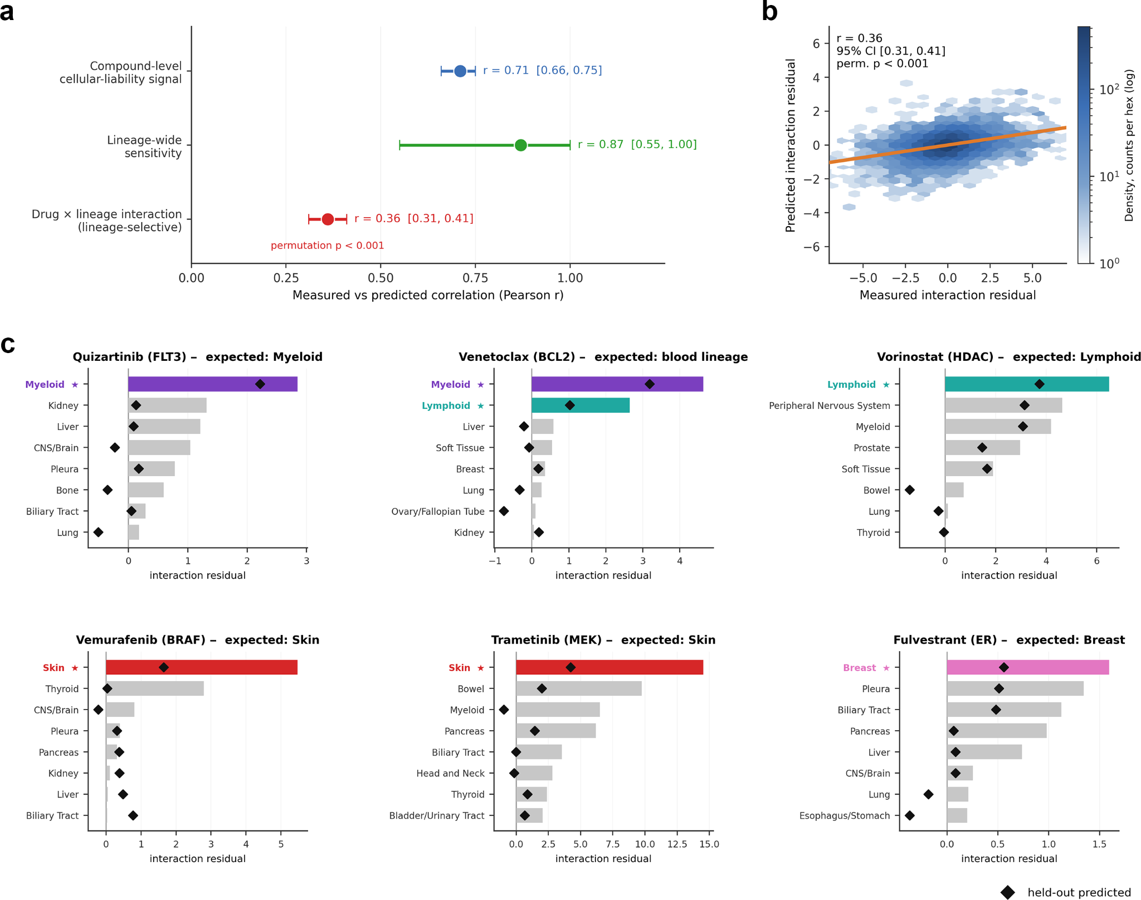
Supplementary Fig. S1 | ToxiPred captures compound-level liability and drug-specific lineage selectivity. (a) Decomposition of drug-disjoint held-out prediction performance into compound-level cellular-liability, lineage-wide sensitivity and residual drug × lineage interaction signals. Points show Pearson correlations between measured and predicted components; error bars show bootstrap 95% confidence intervals. (b) Predicted versus measured drug × lineage interaction residuals after removing additive compound and lineage effects. The residual correlation tests whether ToxiPred captures lineage-selective signal beyond global compound potency and lineage-wide sensitivity. (c) Representative lineage-enriched interaction-residual profiles. Bars show measured interaction residuals and black diamonds show drug-disjoint held-out predictions. Highlighted lineages indicate expected lineage-enriched responses based on established drug biology; grey bars show other lineages.

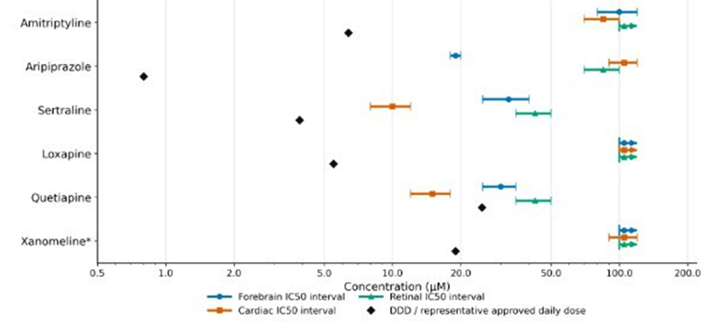Supplementary Fig. S2 | Exposure context for psychotropic organoid toxicity testing. Approximate dose-derived concentration estimates are compared with organoid IC50 intervals for amitriptyline, aripiprazole, loxapine, quetiapine, sertraline and xanomeline. Diamonds indicate simplified dose-derived estimates, bars indicate organoid IC50 intervals, and rightward arrows indicate that IC50 was not reached within the tested concentration range. These estimates are intended only to contextualize the experimental concentration range and do not represent clinical Cmax, free plasma concentration, tissue exposure or prescribing recommendations.

Movies S1-S3. Quetiapine and sertraline stopped visible cardiac organoid contractions at 20 µM under the tested in vitro conditions, indicating acute functional cardiac impairment.

