SUPPLEMENTARY FILES
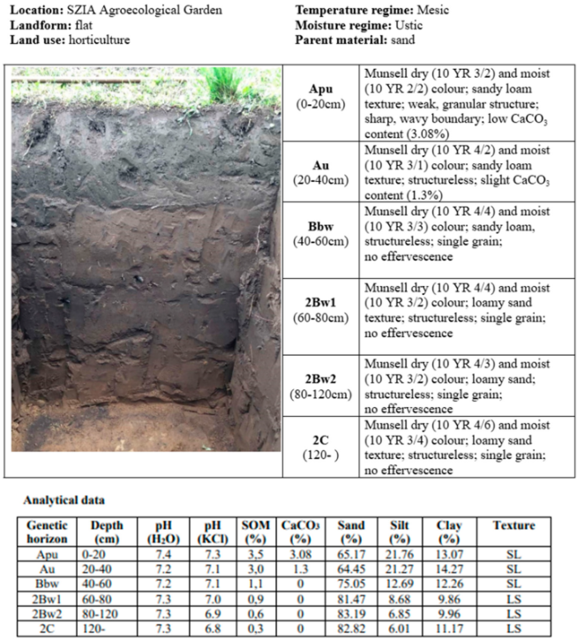
Figure A1: Description and profile of the soil horizons at the experimental site, (Source: MATE Soil Research Team)

Lab. Registration Number | Test Parameter | Test Method | Measurement Uncertainty (±R%)
254207-254218 | pH(H₂O),  pH(KCl)* | MSZ-08-0206-2:1978 2.1. section | ±0.2 pH
254207-254218 | Soil plasticity according to Arany | MSZ-08-0205:1978 5.1. section | ± 3 KA
254207-254218 | Organic matter | MSZ-08-0452:1980 2.2. section, 2.3. section, 3.1.2. section | 10
254207-254218 | CaCO₃ | MSZ-08-0206-2:1978 2.2. section | 10
254207-254218 | All water-soluble salts | MSZ-08-0206-2:1978 2.4. section | 10
254207-254218 | P₂O₅ (AL) | MSZ 20135:1999 5.1. section | 10
254207-254218 | K₂O (AL) | MSZ 20135:1999 5.1. section | 10
254207-254218 | (NO₂⁻ + NO₃⁻) - N  (KCl) | MSZ 20135:1999 5.4.3. section | 10
254207-254218 | Na (AL) | MSZ 20135:1999 5.1. section | 10
254207-254218 | Cu (EDTA) | MSZ 20135:1999 5.1. section | 10
254207-254218 | Mn (EDTA) | MSZ 20135:1999 5.1. section | 10
254207-254218 | Zn (EDTA) | MSZ 20135:1999 5.1. section | 10
254207-254218 | Mg (KCl) | MSZ 20135:1999 5.1. section | 10
254207-254218 | SO₄²⁻(KCl) | MSZ 20135:1999 5.1. section | 10
Table A1: Methods of analysis for soil samples, (Source: Provided by the university laboratory)

Lab. Registration Number | Test Parameter | Test Method
254219-254222 | Moisture content | MSZ ISO 6496:2001
254219-254222 | Phosphorus content | MSZ-08-1783-28:1985
254219-254222 | Calcium content | MSZ-08-1783-26:1985
254219-254222 | Potassium content | MSZ-08-1783-29:1985
254219-254222 | Magnesium content | MSZ-08-1783-27:1985
254219-254222 | Iron content | MSZ-08-1783-31:1985
Table A2: Methods of analysis for lettuce samples, (Source: Provided by the university laboratory)

