Supporting Information for

Azaullazine-driven frontier orbital engineering enables nanosecond-lived singlet MLCT states in Fe(II) NHC complexes
Nour Shalhoub,ª Amani Toumi,ª Florian Molton,^{b} Simon Ali Rincon Celis,^{c} Federico Coppola,^{d,e} Celestino Angeli,^{f} Carole Duboc,^{b} Philippe Pierrat,ª Stefan Haacke,^{c,*} Philippe C. Gros,^{a,b,*} Mariachiara Pastore^{d,*}
ªUniversité de Lorraine, CNRS, L2CM, 54000 Nancy, France
^{b}Université Grenoble Alpes, CNRS, DCM, 38058 Grenoble, France
^{c}Université de Strasbourg, CNRS, IPCMS, 67000 Strasbourg, France
^{d}Université de Lorraine, CNRS, LPCT, F-54000 Nancy, France
^{e}Present address: Scuola Superiore Meridionale, Via Mezzocannone 4, I-80134 Napoli, Italy
^{f}Università di Ferrara, 44121 Ferrara, Italy

Table of contents

1. Synthesis and characterization of product 2
1.1. Synthesis of preligands 2
1.2. Synthesis of complexes 4
2. NMR spectra and LC chromatograms 5
3. UV-VIS 12
4. Cyclic voltammetry and spectroelectrochemistry 12
5. EPR 15
6. Optical characterization 16
6.1. Fluorescence quantum yield of the C2 complex 16
6.2. Streak camera time-resolved luminescence and transient absorption spectroscopy 17
6.3. Details on the analysis of transient absorption spectroscopy data 18
7. Computations 21
7.1. Spin-Orbit Coupling 25
7.2. Selection rules for spin-orbit coupling 28
7.3. C2 non-radiative excited states relaxation pathway 28
8. References 29

Synthesis and characterization of product

Synthesis of preligands
Synthesis of L1H
2,6-dichloro-4-(1H-pyrrol-1-yl)pyridine, 1. 4-aminopyridine (9.2 mmol, 1.5 g) and 2,5-dimethoxytetrahydrofuran (25 mL, 9.7 mmol) were suspended in 12.25 mL of glacial acetic acid and 12.25 mL of dichloromethane. The suspension was heated under reflux for 3h. After cooling at room temperature, water (30 mL) was added and the mixture was extracted with dichloromethane (3 x 30 mL). The combined organic layers were dried with sodium sulfate and filtered, and the solvent was evaporated under reduced pressure. The residue was purified by column chromatography (hexanes/AcOEt, 5:1). The product was obtained as a white solid (1.28 g, 65%). ¹H NMR (400 MHz, chloroform-d, δ ppm): 7.26 (s, 2H), 7.15 (t, 2H, J= 4 Hz), 6.43 (t, 2H, J= 4 Hz). ¹³C NMR (100 MHz, chloroform-d, δ ppm): 152.0, 150.0, 118.6, 113.6, 112.3. ESI-HRMS calcd C₉H₇N₂Cl₂ m/z = 212.9986. Found: 212.9983
2,6-di(1H-imidazol-1-yl)-4-(1H-pyrrol-1-yl)pyridine, 2. In a clean, dry 50 mL two-neck flask containing imidazole (0.325 g, 4.77 mmol), KOH flakes (0.268 g, 4.77 mmol) were added. The mixture was heated to 250°C under high vacuum and then cooled to room temperature, yielding potassium imidazolate. Then, 4-amino-2,6-dichloropyridine (0.498 g, 2.34 mmol) and dry dimethylformamide (15 mL) were added and stirred vigorously under an argon atmosphere at 70°C for 5 hours. The mixture was then poured into cold water, and the resulting precipitate was filtered and dried to isolate the desired compound (67% yield, 0.433 g), which was used in the next step without further purification. ¹H NMR (400 MHz, chloroform-d, δ ppm): 8.52 (s, 2H), 7.92 (t, 2H, J= 1.36 Hz), 7.55-7.54 (m, 2H), 7.53 (s, 2H),7.16 (t, 2H, J= 1.28 Hz), 6.46 (t, 2H, J= 2.22 Hz). ¹³C NMR (100 MHz, chloroform-d, δ ppm): 152.9, 151.3, 137.2, 132.0, 120.9, 118.4, 114.3, 101.3. ESI-HRMS calcd for C₁₅H₁₃N₆ m/z = 277.1202. Found: 277.1200
L1H. Compound 2 (0.300 g, 1.085 mmol) was charged in a 10 mL round bottomed flask and dissolved in 5 mL of dry DMF. Then methyl iodide (0.269 mL, 4.40 mmol) was added and the reaction mixture was heated at 130 °C for 1 h. The desired compound was precipitated upon addition of diethyl ether. Solid was collected by vacuum filtration and washed thrice with diethyl ether and dried under vacuum. Then the solid was dissolved in minimum amount of methanol (ca. 2 mL) and a saturated aqueous solution of NH₄PF₆ was added and stirred until the product precipitated. Ligand L1H was collected by vacuum filtration and washed 3 times with water and then diethyl ether and dried under vacuum (0.441 g, 67% yield). ¹H NMR (400 MHz, chloroform-d, δ ppm): 9.61 (s, 2H), 8.26 (t, 2H, J= 1.96 Hz), 7.91 (s, 2H), 7.63 (t, 2H, J= 1.88 Hz), 7.63 (t, 2H, J= 2.28 Hz), 6.55 (t, 2H, J= 2.28 Hz), 4.02 (s, 6H). ¹³C NMR (100 MHz, chloroform-d, δ ppm): 153.4, 147.9, 136.6, 126.2, 120.6, 120.4, 115.1, 104.7, 37.8. ESI-HRMS calcd for C₁₇H₁₈N₆ m/z = 153.0791. Found: 153.0788 [M-2PF₆].
Synthesis of L2H
3,5-dibromopyridin-4-amine, 3.¹ In 1 L round bottom flask, 4-aminopyridine (9 g, 96 mmol) was dissolved in dichloromethane (600mL). Then, N-bromosuccinimide (39.5 g, 221 mmol) was added portionwise throughout 1 h. After stirring for 18 h at room temperature, the brown orange mixture was washed with a 1M aqueous sodium hydroxide solution (3x 400 mL) then with water (2 x 400 mL). The organic layer was collected, dried over MgSO₄, and purified over silica column (8/2 cyclohexane:EtOAc). The desired product was obtained in 94% yield as a brown solid. ¹HNMR (400 MHz, Chloroform-d) δ 8.33 (s, 2H), 5.08 (s, 2H) ppm.
3,5-dibromo-4-(1H-pyrrol-1-yl)pyridine, 4. ¹A 30 mL microwave vial was charged with 3,5-dibromo-4-aminopyridine (10.32 mmol, 2.6 g), I₂ (0.049 mmol, 0.012 g) and 2,5-dimethoxy tetrahydrofuran (12.39 mmol, 1.638 g) and was heated at 170°C, 60 W for 5 min. The reaction was monitored by TLC until no starting material was observed. To the obtained black solid, methanol was added to transfer it, and then the crude mixture was concentrated under reduced pressure. After that, DCM (60 mL) was added and the mixture was extracted twice with a 0.1 M sodium thiosulfate aqueous solution (50 mL) and once with water (50 mL). The organic layer was collected, dried over MgSO₄, and purified over a silica gel column (9/1 cyclohexane:EtOAc). Compound 4 was obtained in 53% yield as a white solid. ¹H NMR (400 MHz, Chloroform-d) δ 8.77 (s, 1H), 6.73 (t, J= 2.2 Hz,1H), 6.42 (t, J = 2.2 Hz, 1H).
3,5-bis(phenylethynyl)-4-(1H-pyrrol-1-yl)pyridine, 5. ¹ A 30 ml microwave vial was charged with diethylamine (7.5 mL) and DMF (3 mL). The vial was cooled to 0°C in an ice bath and the mixture was degassed by argon bubbling for 30 min. After that, compound 4 (4.96 mmol, 1.5 g), PdCl₂(PPh₃)₂ (0.55 mmol, 0.386 g), CuI (0.55 mmol, 0.105 g), PPh₃ (1.8 mmol, 0.472 g) and phenylacetylene (11 mmol, 1.12 g) were introduced into the vial and the reaction was heated at 120 °C, 60 W for 30 min. The reaction was monitored by TLC until no starting material was observed. Then, the mixture was diluted with DCM (100 mL), filtered over celite, and concentrated under reduced pressure. The residue was taken up in ethylacetate and the organic phase was washed with water (3 x 200 mL) and once with sat. aqueous NaCl solution (200 ml). The organic phases were dried over MgSO₄ and purified over silica gel (95/5 cyclohexane:EtOAc). Compound 5 was obtained in 98% yield as a yellow solid. ¹H NMR (400 MHz, Chloroform-d) δ 8.75 (s, 2H), 7.46-7.43 (m, 4H), 7.37-7.33 (m, 6H), 7.31 (t, J = 2.2 Hz, 2H), 6.42 (t, J = 2.2 Hz 2H) ppm.
5,8-diphenylindolizino[6,5,4,3-ija][1,6]naphthyridine, 6.¹ A 30 mL microwave vial was charged with compound 5 (2.18 mmol, 0.75 g), InCl₃ (6.54 mmol, 1.44 g), and dry o-dichlorobenzene (10 mL) under argon. The reaction mixture was heated at 210°C, 60 W for 40 min. The reaction was monitored by TLC until no starting material was observed. Then, the mixture was diluted in DCM (300 mL) and filtered over celite. The filtrate was washed with 10% NH₄OH (2 x 300 mL) and water (300 mL). The brown-orange filtrate was dried over MgSO₄ and purified over silica gel (first with cyclohexane alone then 98/2 cyclohexane:EtOAc) affording compound 6 in 46% yield. ¹H NMR (400 MHz, Chloroform-d) δ 8.80 (s, 2H), 7.83-7.78 (m, 4H), 7.60-7.46 (m, 6H), 7.31 (s, 2H), 7.19 (s, 2H) ppm.
1,3-dibromo-5,8-diphenylindolizino[6,5,4,3-ija][1,6]naphthyridine, 8.¹ To a 50 mL round bottom flask charged with compound 6 (140 mg, 0.4 mmol) in DMF (5 mL), 1.05 equiv of NBS (76 mg, 0.42 mmol) was added under argon. The reaction was stirred at room temperature for 18 h and it was monitored by TLC. After total conversion of the starting material, a 0.1 M aqueous NaOH solution was added and a yellow brown precipitate was formed. The latter was recovered by filtration and dissolved in DCM. Then, the organic phase was washed twice with a 0.1 M aqueous NaOH solution and once with water. The brownish organic phase was dried over MgSO₄ and purified over silica column (95/5 cyclohexane;EtOAc). Compound 7 was isolated in 45% yield as yellow solid. ¹H NMR (400 MHz, Chloroform-d) δ 8.59 (s, 1H), 7.86 – 7.77 (m, 6H), 7.62 – 7.49 (m, 10H), 7.37 (s, 1H), 7.34 (s, 1H), 7.29 (d, J = 2.2 Hz, 2H). ¹³C NMR (100 MHz, Chloroform-d): δ 138.23, 137.73, 136.16, 135.73, 135.11, 130.64, 129.13, 129.04, 129.01, 128.98, 128.9, 128.47, 128.41, 128.26, 120.77, 120.72, 116.69, 115.81, 109.59, 109.09, 108.52. LC-MS (ESI-TOF) m/z: [M+H]⁺ Calcd for C₂₅H₁₅BrN₂ 422.042; Found: 422.041. To the obtained compound 7 (960 mg, 2.26 mmol) in DMF (75 mL), 1.05 equiv of NBS (420 mg, 2.38 mmol) was added under argon. The reaction was stirred at room temperature for 18 h and it is monitored by tlc. After total conversion of the starting material, a 0.1 M aqueous NaOH solution was added and a yellow brown precipitate was formed which was filtered and dissolved in chloroform. Then, the organic phase was washed twice with a 0.1 M aqueous NaOH solution and once with water. The brownish organic phase was dried over MgSO₄ and purified over silica column (8/2 cyclohexane; dichloromethane). Compound 8 was isolated in 62% yield as yellow solid. ¹H NMR (400 MHz, Chloroform-d) δ 7.83 (d, J = 7.3 Hz, 2H), 7.61 – 7.53 (m, 3H), 7.37 (s, 1H). LC-MS (ESI-TOF) m/z: [M+H]⁺ Calcd for C₂₅H₁₄Br₂N₂ 503.948; Found: 502.9579.
1,3-di(1H-imidazol-1-yl)-5,8-diphenylindolizino[6,5,4,3-ija][1,6]naphthyridine, 9. A Schlenk tube charged with compound 8 (0.5 g, 0.95 mmol), imidazole (0.2 g, 2.98 mmol), Cs₂CO₃ (1.29 g, 3.98 mmol) and Cu₂O (0.02 g, 0.19 mmol) was subjected to three vacuum-Argon cycles. After that, dry DMF (10 mL) was added. The reaction was stirred at 150 °C in a sand bath for 20 h. After cooling, the mixture was dissolved in ethyl acetate containing droplets of methanol and washed twice with ammonia and once with water. The organic phase was dried over MgSO₄ and the solvents were removed under vacuum. Compound 9 was obtained in 91% yield. LC-MS (ESI-TOF) m/z: [M+H]⁺ Calcd for C₃₁H₂₀N₆ 477.178; Found: 477.182. The poor solubility prevented us from obtaining good quality of ¹H-NMR and ¹³C-NMR spectra.
L2H. Compound 9 (0.043 g, 3.65 mmol) was then charged in a 30 mL microwave vial and dissolved in acetonitrile (10 mL). Then, methyl iodide (2.27 mL, 0.0365 mmol) was added and the mixture was heated at 85 °C for 1 h at 60 W. After 1 h, acetonitrile was evaporated and the desired compound was precipitated upon addition of saturated aqueous KPF₆ solution. The solid was collected by vacuum filtration and washed once with water and twice with diethyl ether. L2H was obtained in 67% yield. ¹H NMR (400 MHz, Acetonitrile-d₃) δ 9.16 (s, 2H), 8.03 (t, J = 1.9 Hz, 2H), 7.92 – 7.88 (m, 4H), 7.70 (t, J = 1.8 Hz, 2H), 7.65 (s, 2H), 7.64 – 7.60 (m, 6H), 7.57 (s, 2H), 4.06 (s, 6H). ¹³C NMR (101 MHz, Acetonitrile-d₃) δ 139.07, 138.73, 137.51, 137.46, 132.48, 130.80, 130.23, 129.82, 128.52, 125.66, 123.51, 112.88, 112.38, 37.64. LCMS (ESI-TOF) m/z: Calcd for C₃₃H₂₆N₆ 253.1100; found: 253.1102 [M-2PF₆].

Synthesis of complexes
C1. L1H (100 mg, 0.168 mmol) and FeCl₂ (105 mg, 0.083 mmol) were placed in a Schenck tube under vacuum for 1h before being submitted to three vacuum/Ar cycles. 3 mL of dry and degassed DMF were then added followed by 3 freeze pump cycles. Then, the mixture was stirred under Ar at r.t for 10 min before the addition of KHMDS (168 mg, 0.840 mmol). The mixture was stirred at room temperature for 20 min. A saturated solution of NH₄PF₆ was then added (10 mL). The precipitate was collected by filtration and washed with diethyl ether (5 mL). The complex C1 was obtained as a reddish solid (48 mg, 60% yield). ¹H NMR (400 MHz, CD₃CN): δ 8.07 (d, J= 2.12 Hz, 2H), 7.89 (s, 2H), 7.63 (t, J= 2.20 Hz, 2H), 7.03 (t, J= 2.12 Hz, 2H), 6.54 (t, J= 2.28 Hz, 2H), 2.61 (s, 6H) ppm. ¹³C NMR (100 MHz, CD₃CN): δ 201.7, 154.9, 149.0, 127.2, 120.1, 116.9, 113.7, 96.4, 35.4 ppm. ESI-HRMS calcd for C₃₄H₃₂FeN₁₂ m/z = 332.1108. Found: 332.1117[M-2PF₆].

C2. L2H (50 mg, 0.062 mmol) and FeCl₂ (3.9 mg, 0.030 mmol) were placed in a Schenck tube under vacuum for 1h before being submitted to three vacuum/Ar cycles. 2 mL of dry and degassed DMF were added followed by 3 freeze pump cycles. Then, the mixture was stirred under Ar at r.t for 10 min before the addition of KHMDS (62.5 mg, 0.313 mmol). The reaction mixture was stirred at r.t. for 1 h. Afterwards, H₂O (10 mL) was added followed by 1 mL of a saturated KPF₆ solution. The reaction was vigorously stirred and the formed precipitate was filtered (twice). The solid was washed with H₂O (5 mL) and diethyl ether (3 x 15 mL) and finally recovered by adding acetonitrile After purification by column chromatography using 9:1 CH₂Cl₂: MeOH mixture) and solvents evaporation, C2 was obtained as a reddish powder (36 mg, 40% yield). ¹H NMR (400 MHz, CD₃CN) δ 8.58 (d, J = 2.4 Hz, 2H), 7.99 (d, J = 7.4 Hz, 4H), 7.92 (s, 2H), 7.66 (dt, J = 12.8, 7.1 Hz, 6H), 7.46 (s, 2H), 7.11 (d, J = 2.3 Hz, 2H), 2.54 (s, 6H). ¹³C NMR (100 MHz, CD₃CN) δ 200.8, 143.4, 138.5, 136.6, 130.9, 130.7, 130.0, 128.9, 127.4, 120.1, 112.8, 111.2, 109.4, 36.3. ESI-HRMS Calcd for C₆₆H₄₈FeN₁₂ m/z = 532.1895; Found: 532.1722 [M-2PF₆].

NMR spectra and LC chromatograms
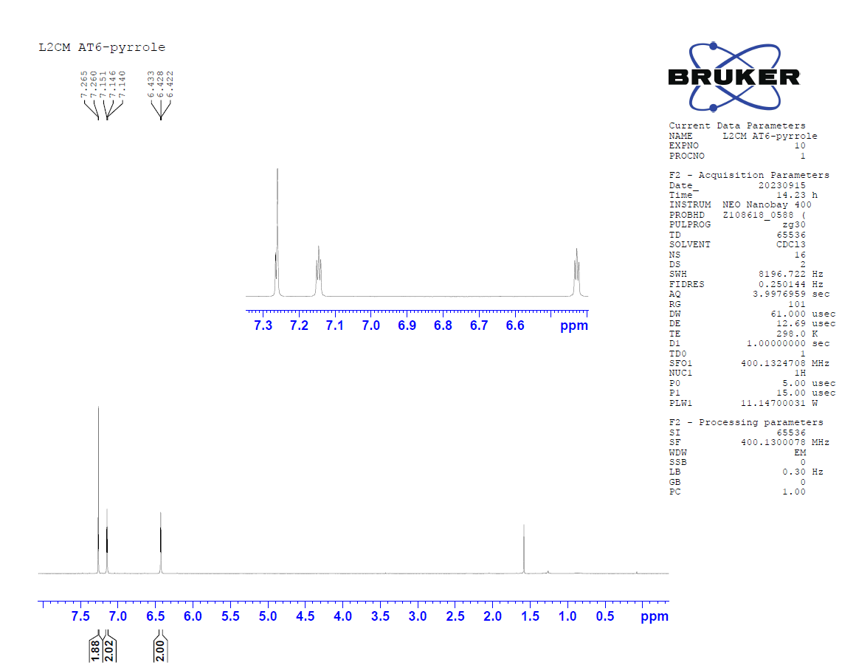

Figure S1. ¹H NMR spectrum of compound 1.
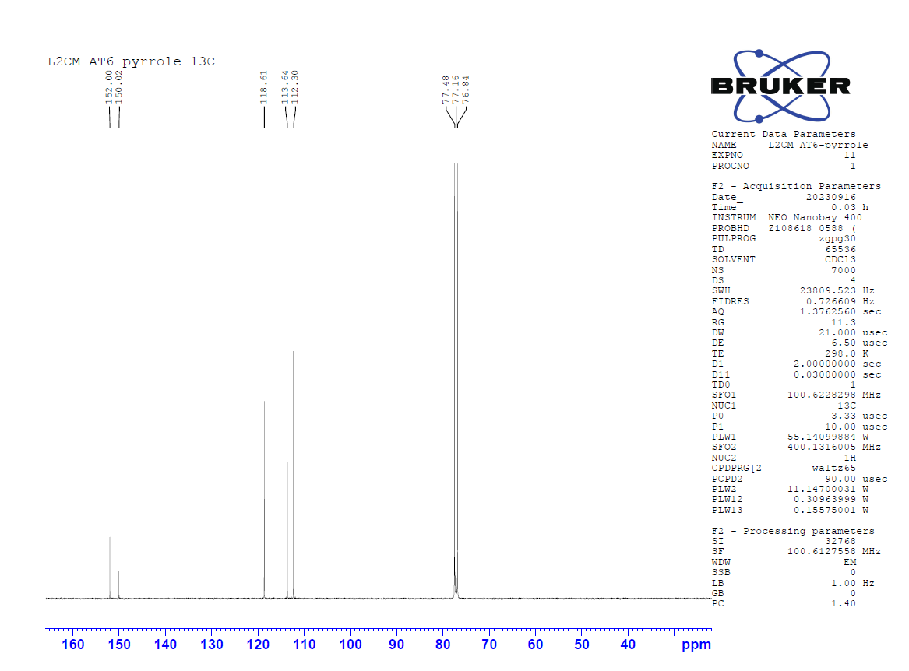
Figure S2. ¹³C NMR spectrum of compound 1.
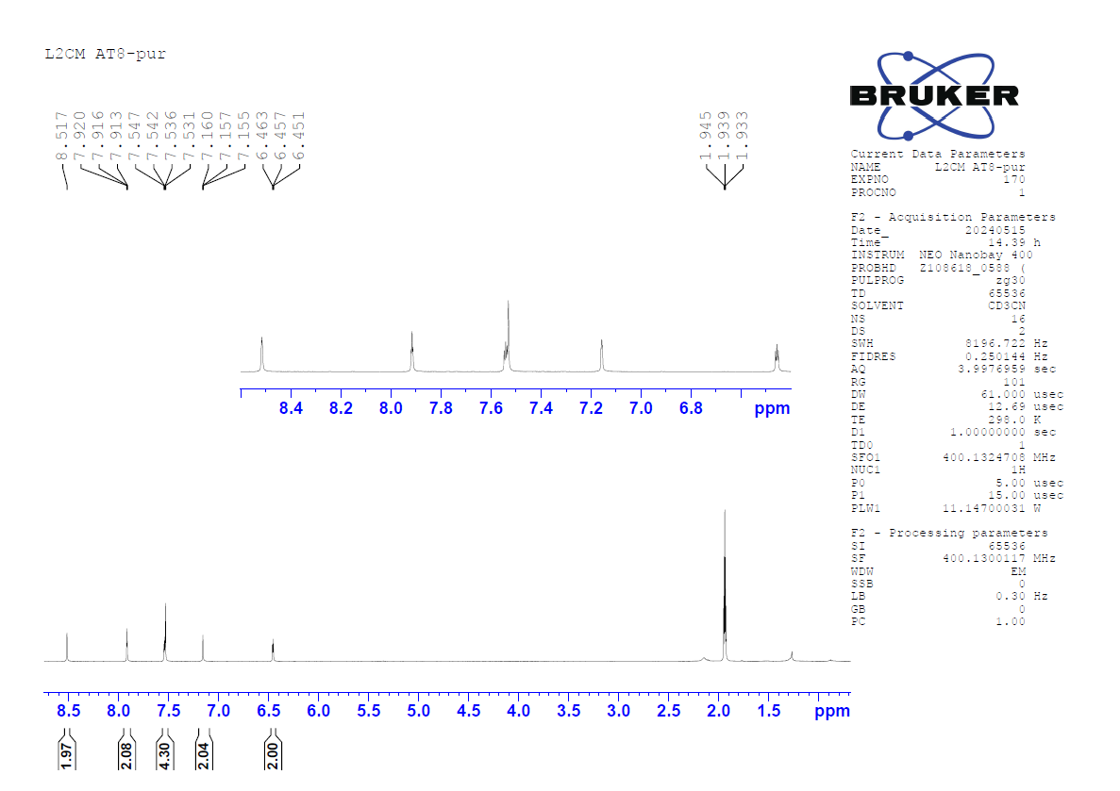
Figure S3.¹H NMR spectrum of compound 2.
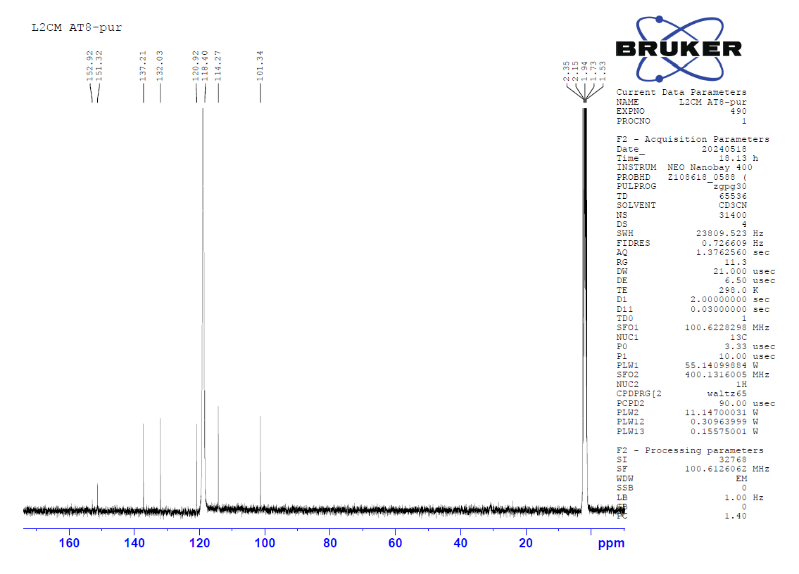
Figure S4. ¹³C NMR spectrum of compound 2.
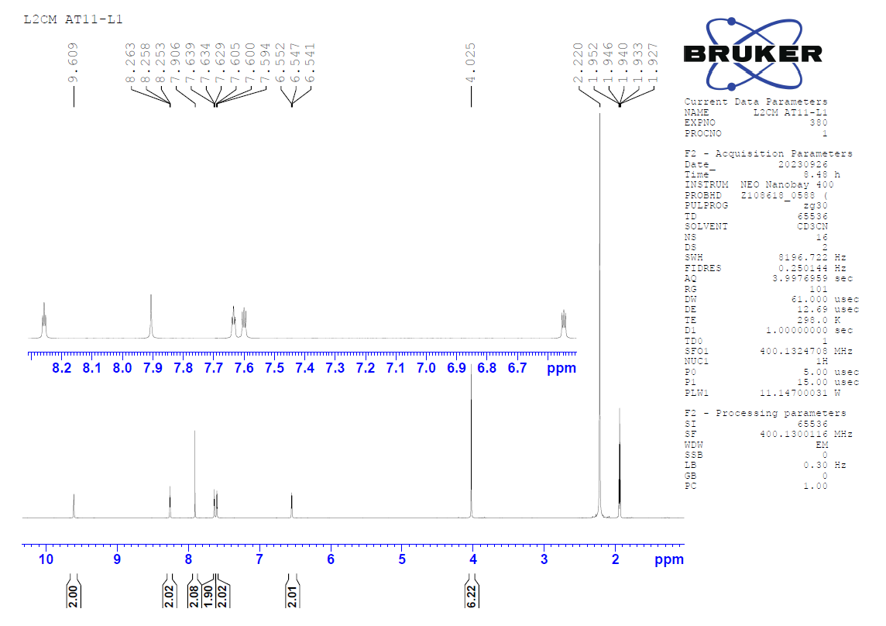
Figure S5. ¹H NMR spectrum of L1H.
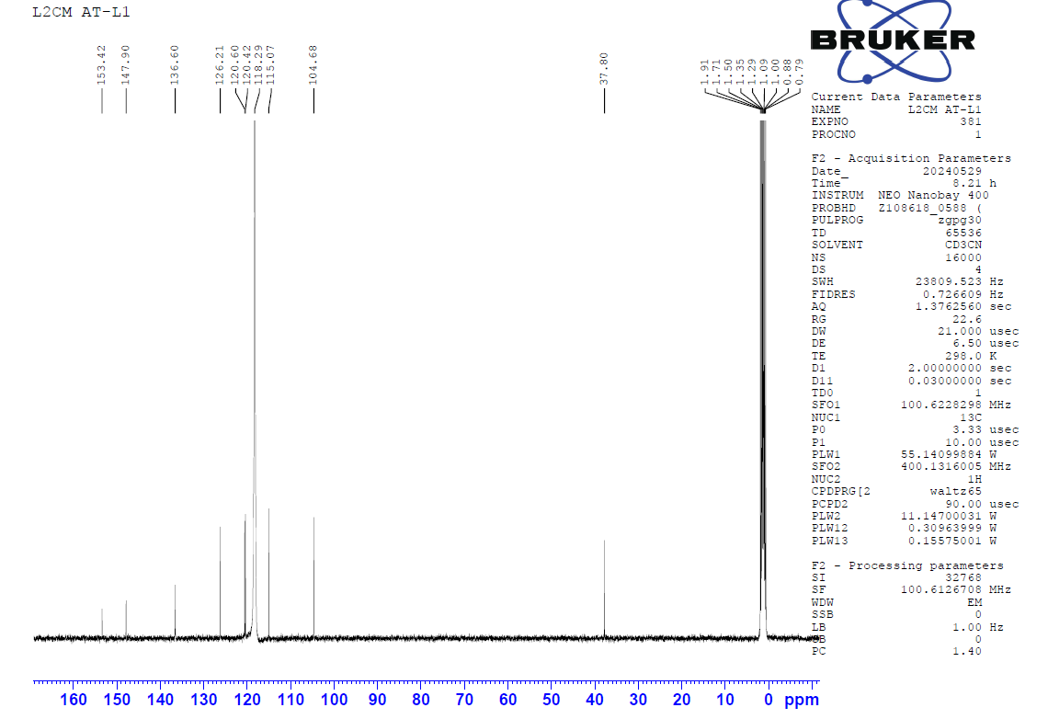
Figure S6. ¹³C NMR spectrum of L1H.
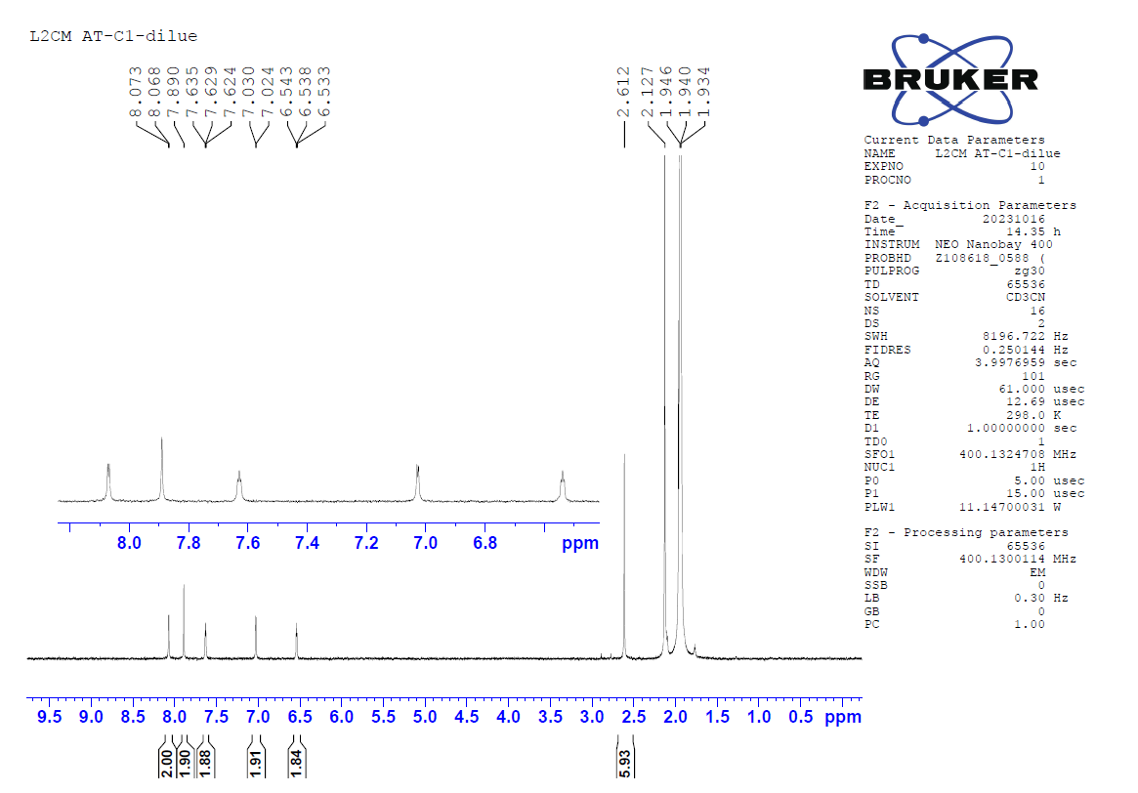
Figure S7. ¹H NMR spectrum of complex C1.
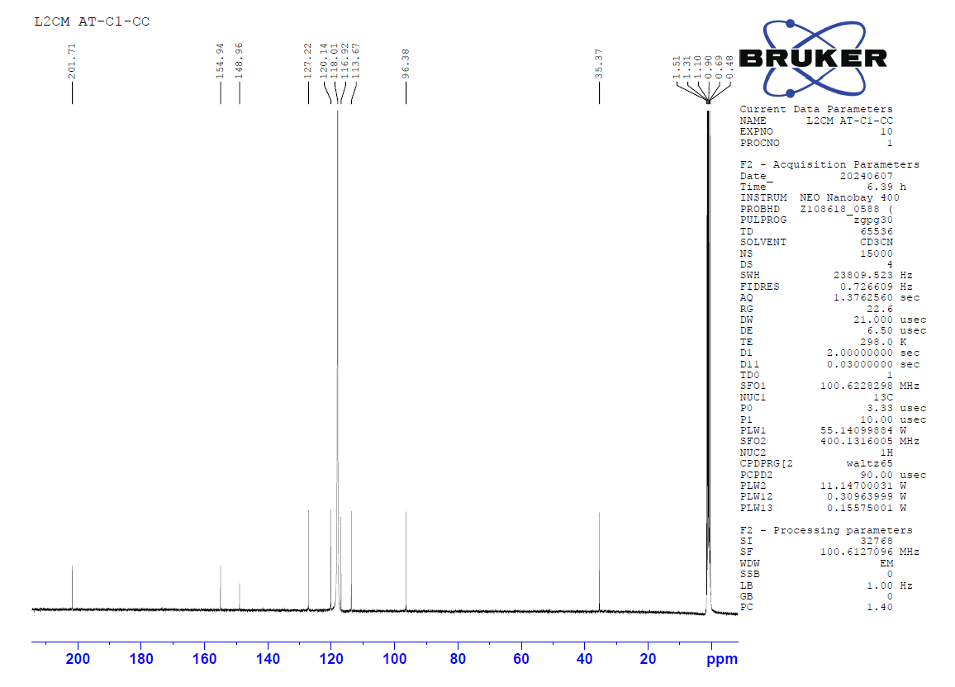
Figure S8. ¹³C NMR spectrum of complex C1.

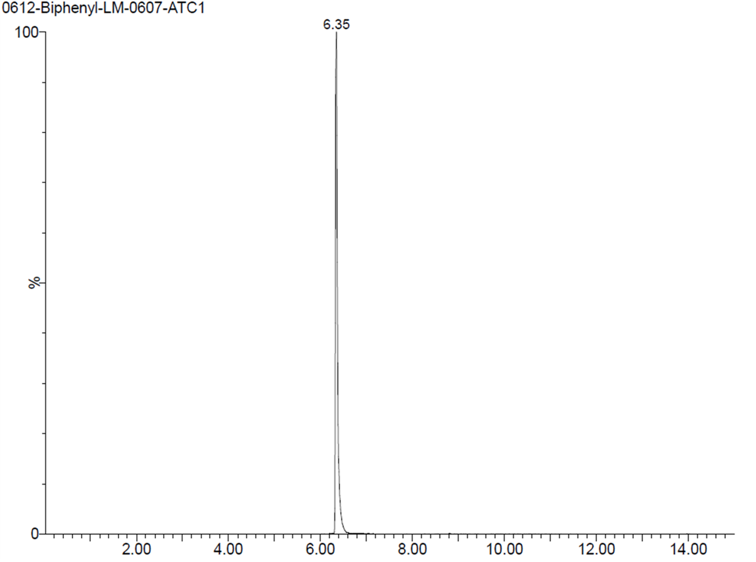
Figure S9. Liquid chromatogram of complex C1.
Figure S10. ¹H NMR spectrum of L2H.
Figure S11. ¹³C NMR spectrum of L2H.
Figure S12. ¹H NMR spectrum of complex C2.
Figure S13. ¹³C NMR spectrum of complex C2.
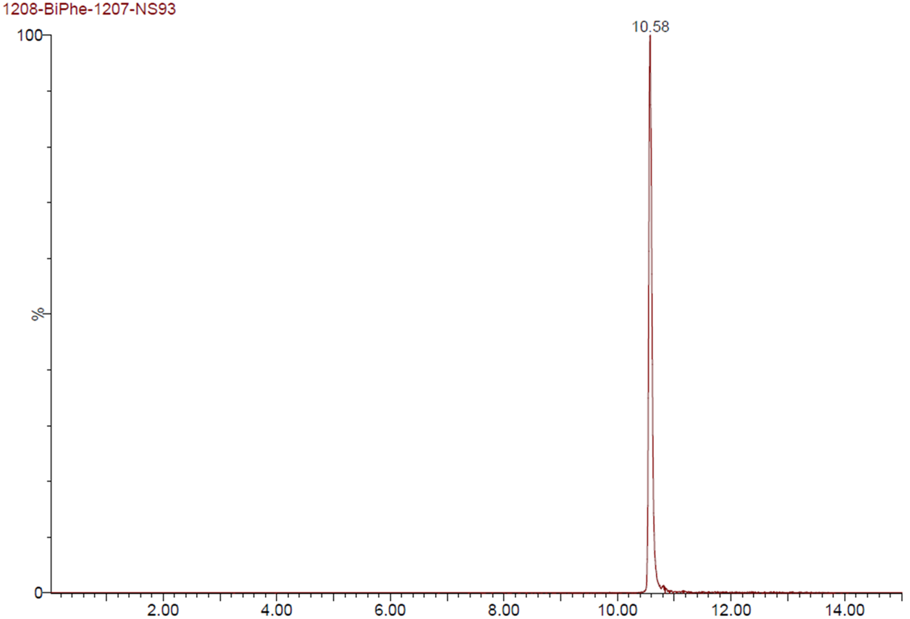
Figure. S14. Liquid chromatogram of complex C2.

UV-VIS
Figure S15. Normalized UV-VIS absorption spectra of HL2 and C2.

Cyclic voltammetry and spectroelectrochemistry

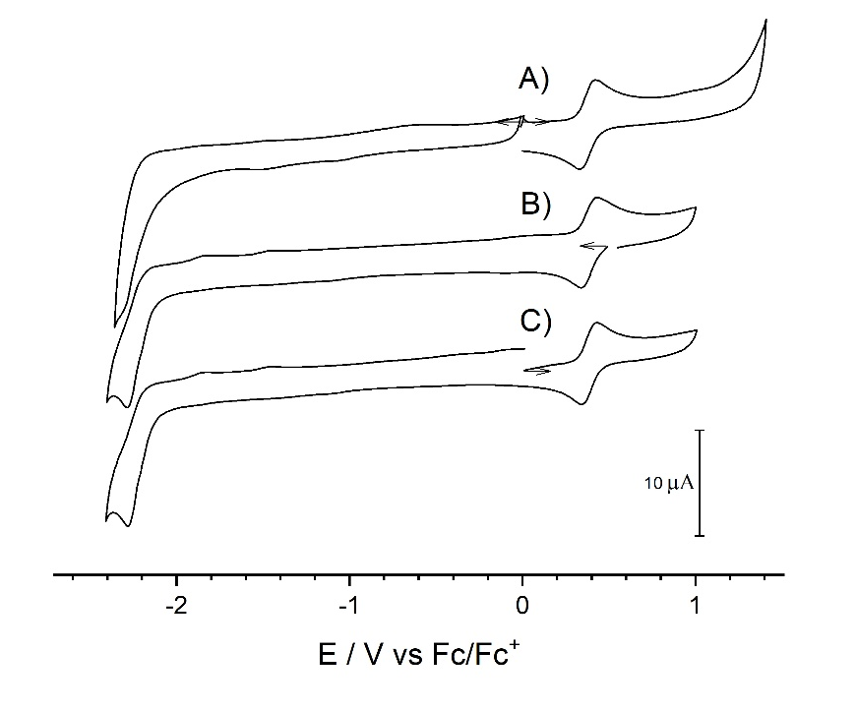

Figure S16. Cyclic voltammetries of C1 (0.25 mM) in an MeCN solution containing 0.1 M TBAPF₆, recorded at v = 100 mVs⁻¹. A) Initial state, B) after exhaustive oxidation at E = 0.42 V vs Fc/Fc⁺, C) after exhaustive reduction at E = -0.09 V vs Fc/Fc⁺ to generate back the initial complex.

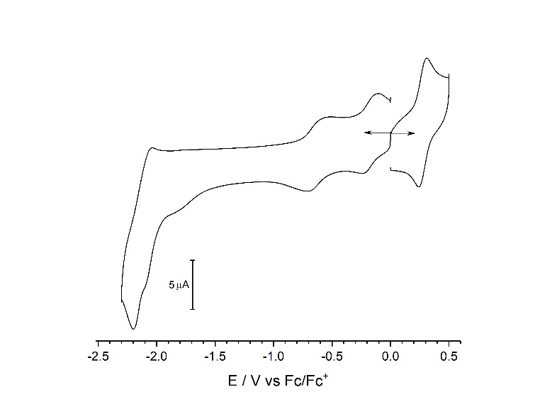

Figure S17. Cyclic voltammogram of C2 (0.35 mM) in a MeCN solution containing 0.1 M TBAPF₆, recorded at v = 100 mVs⁻¹.

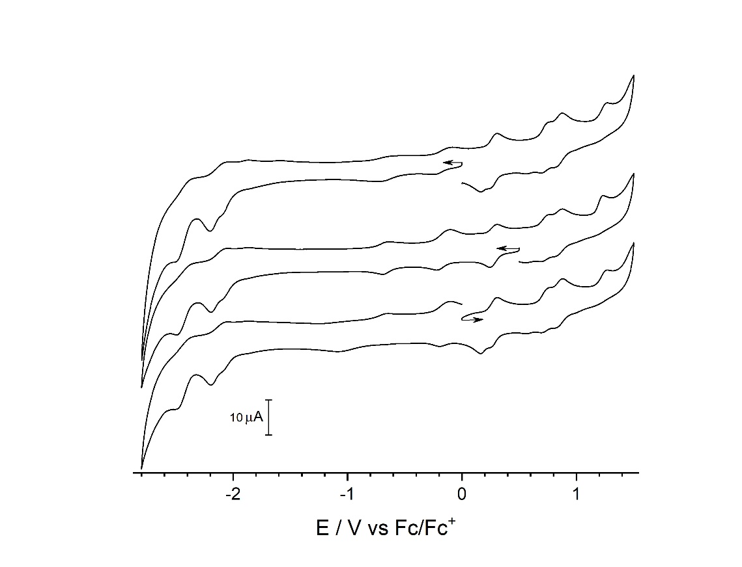

Figure S18. Cyclic voltammetries of C2 (0.35 mM) in an MeCN solution containing 0.1 M TBAPF₆, recorded at v = 100 mVs⁻¹. A) Initial state, B) after exhaustive oxidation at E = 0.42 V vs Fc/Fc⁺, C) after exhaustive reduction at E = -0.09 V vs Fc/Fc⁺ to generate back the initial complex.
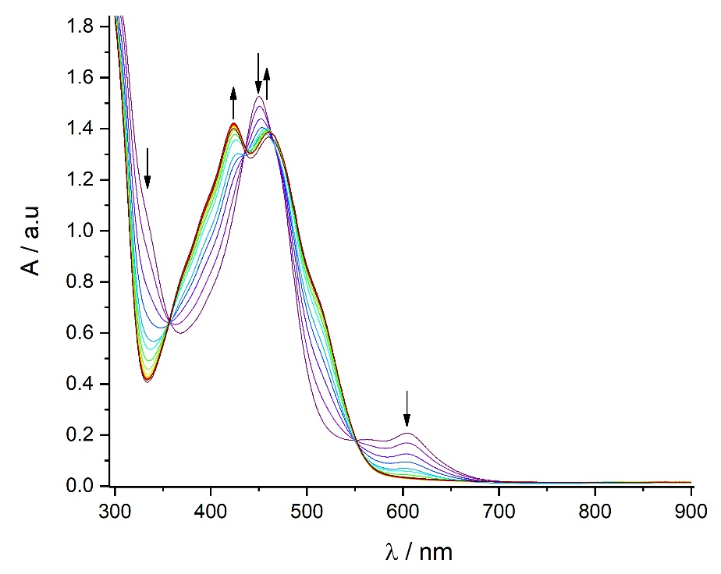

Figure S19. in situ UV-visible spectra of C2 (0.35 mM) in an MeCN solution containing 0.1 M TBAPF₆ during exhaustive reduction at E = -0.09 V vs Fc/Fc⁺ to generate back the initial complex. Pathlength of 1 mm and scan delay of 50 s between two spectra (last scan after 905 s).

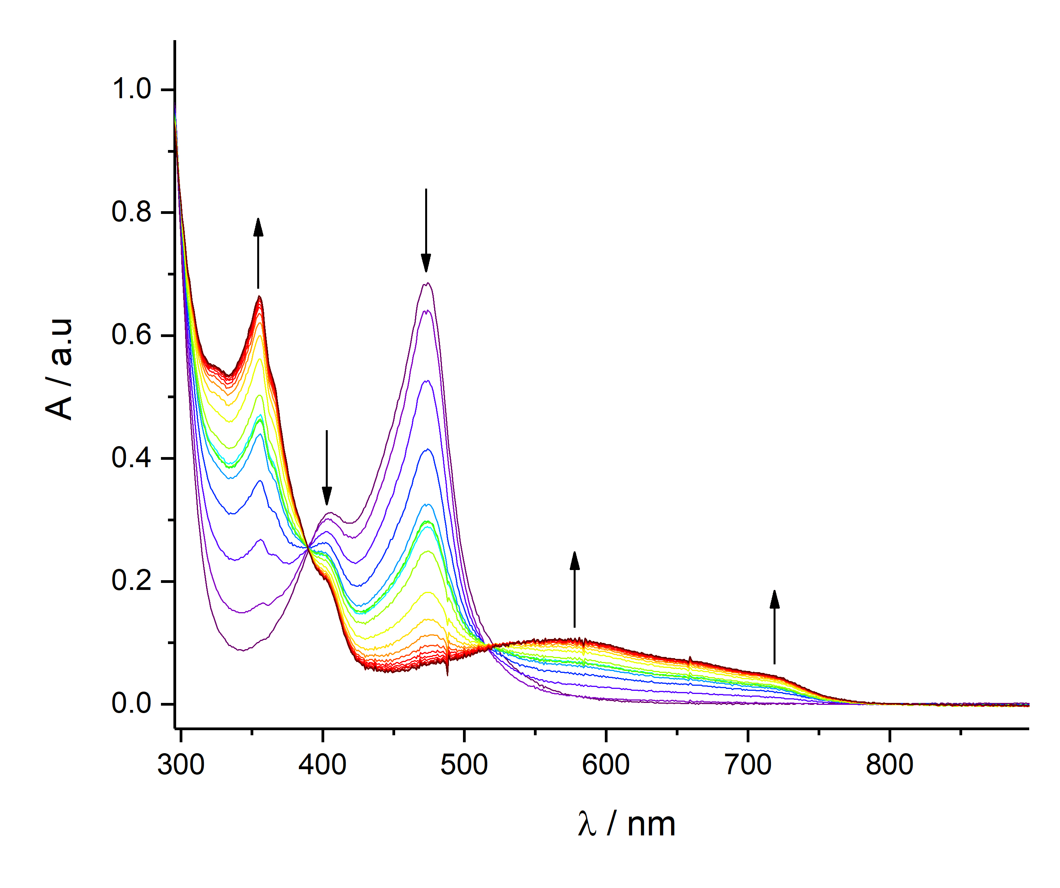
Figure S20. in situ UV-visible spectra of C1 (0.25 mM) in an MeCN solution containing 0.1 M TBAPF₆ during exhaustive oxidation at E = 0.42 V vs Fc/Fc⁺.Pathlength of 1 mm and scan delay of 50 s between two spectra (last scan after 960 s).
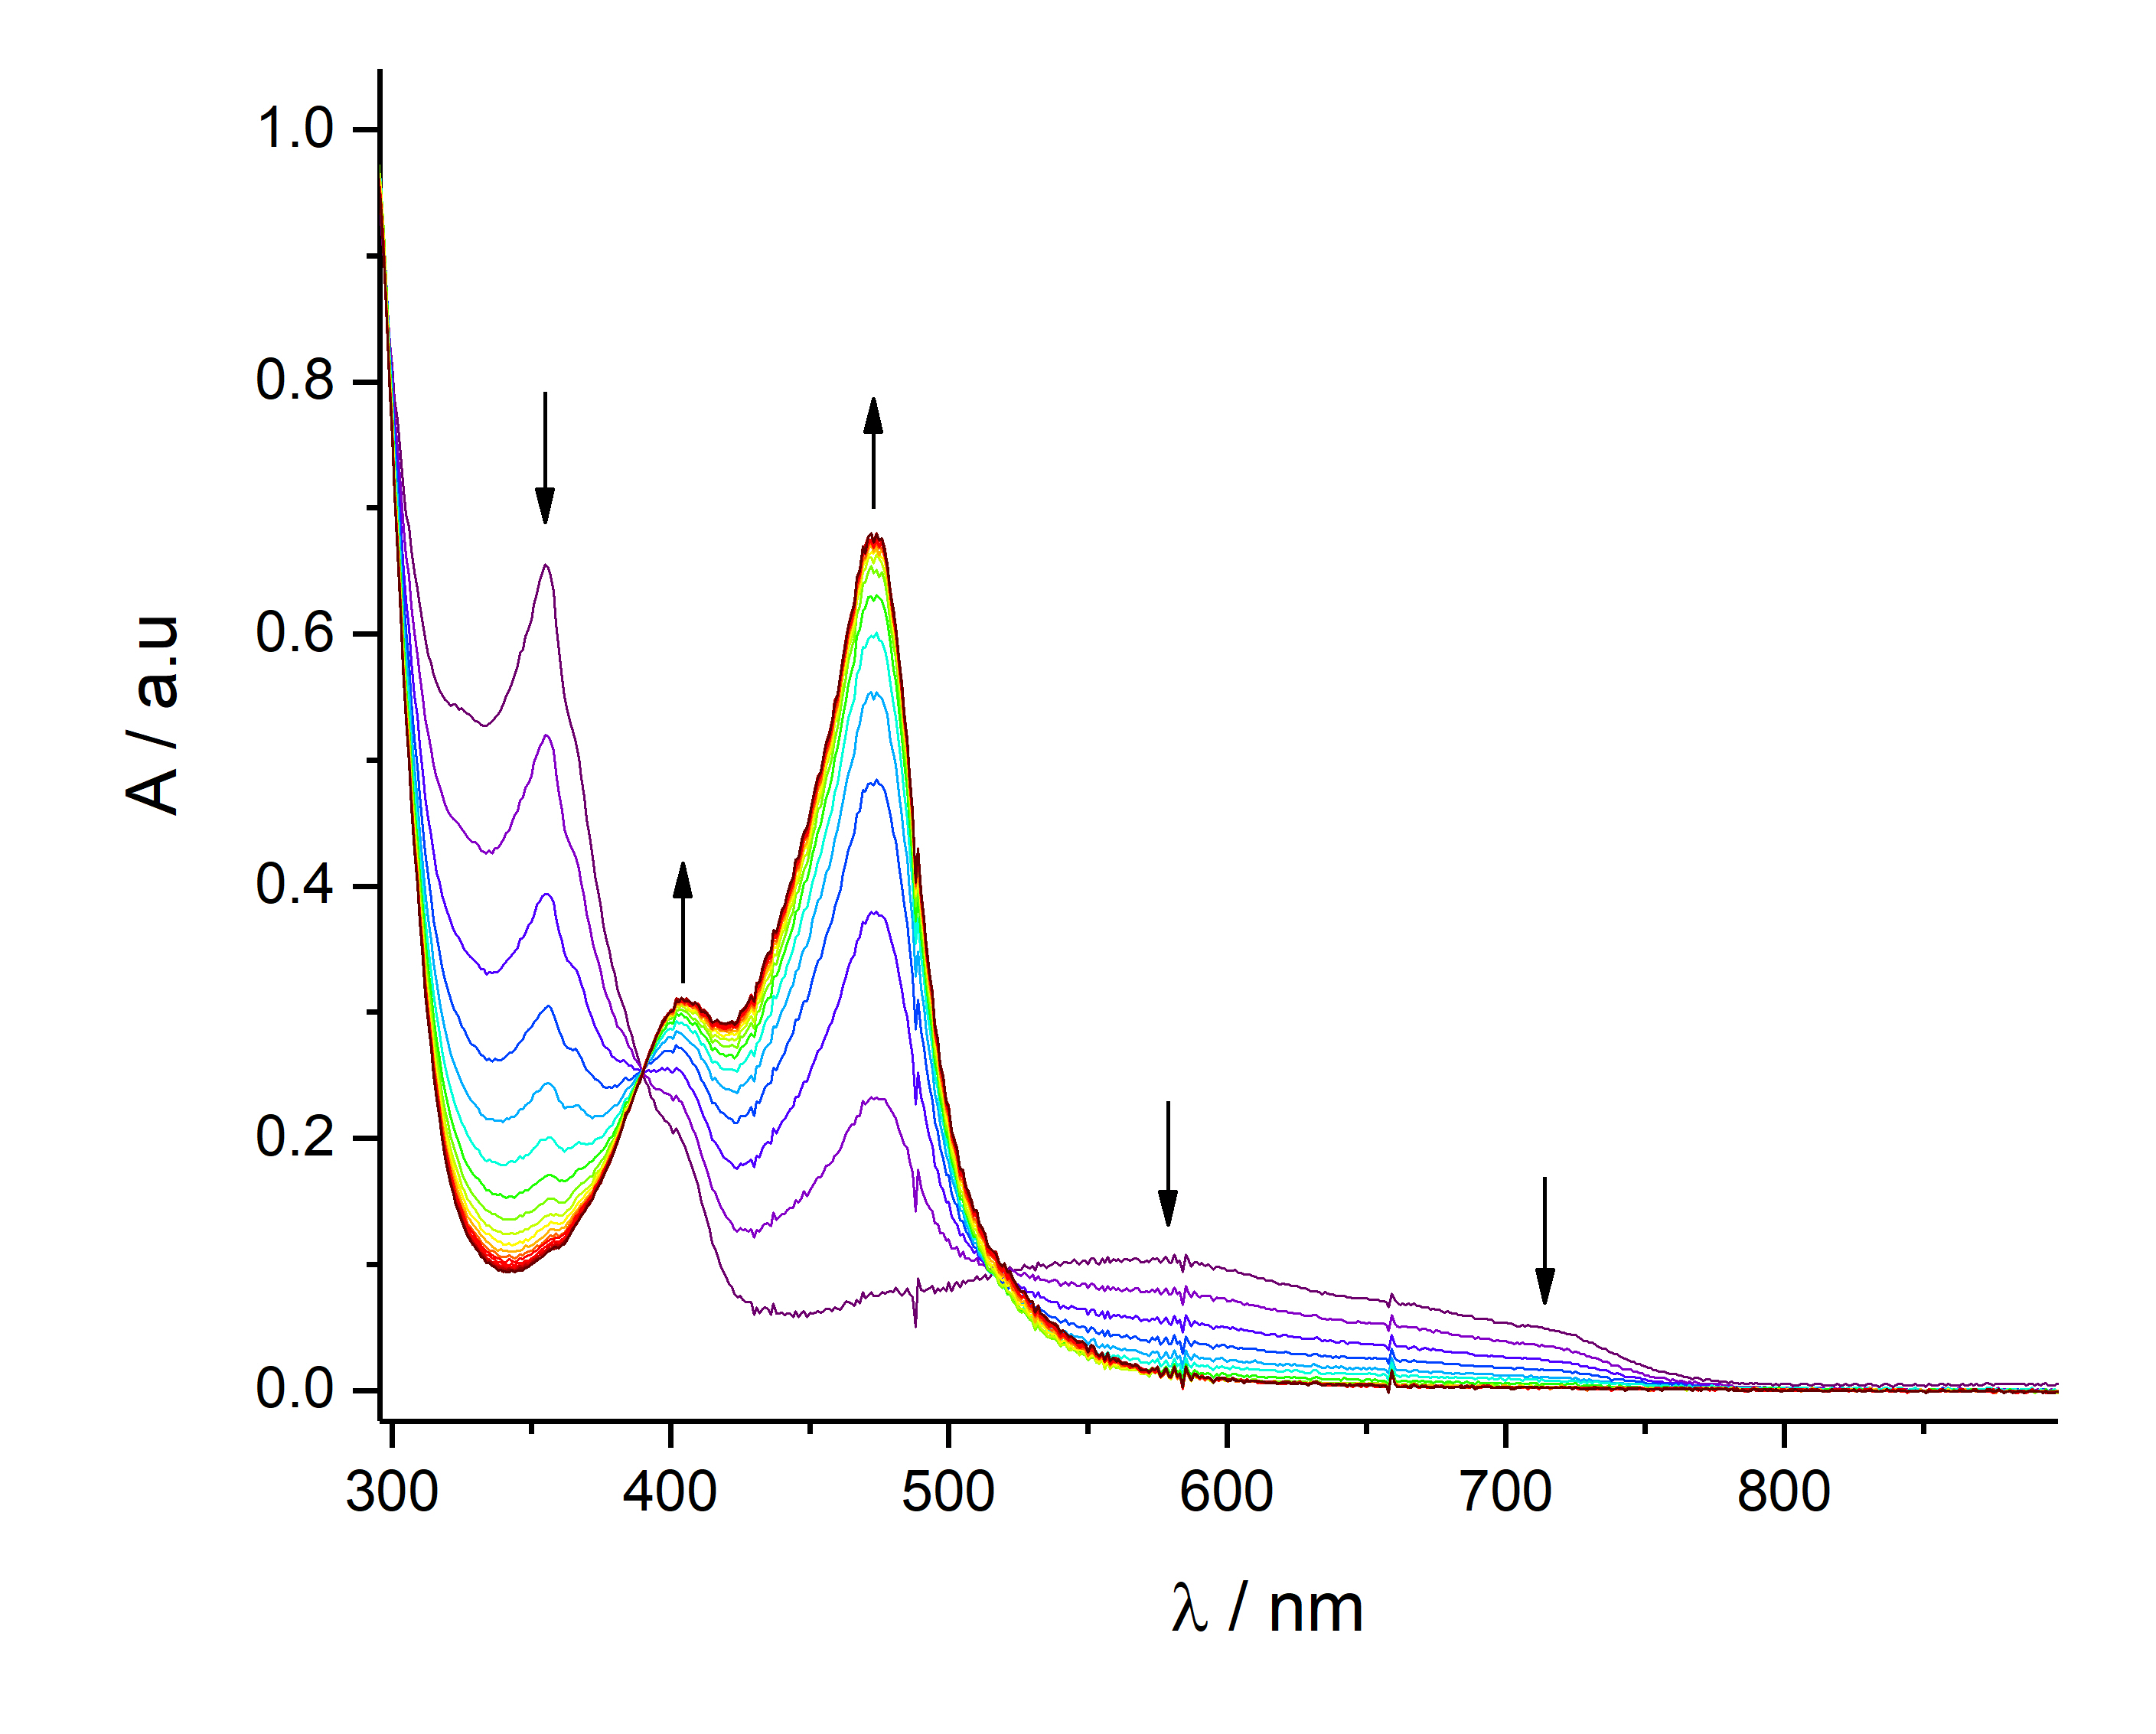
Figure S21. in situ UV-visible spectra of C1 (0.25 mM) in an MeCN solution containing 0.1 M TBAPF₆ during exhaustive reduction at E = -0.09 V vs Fc/Fc⁺ to generate back the initial complex. Pathlength of 1 mm and scan delay of 50 s between two spectra (last scan after 880 s).

EPR
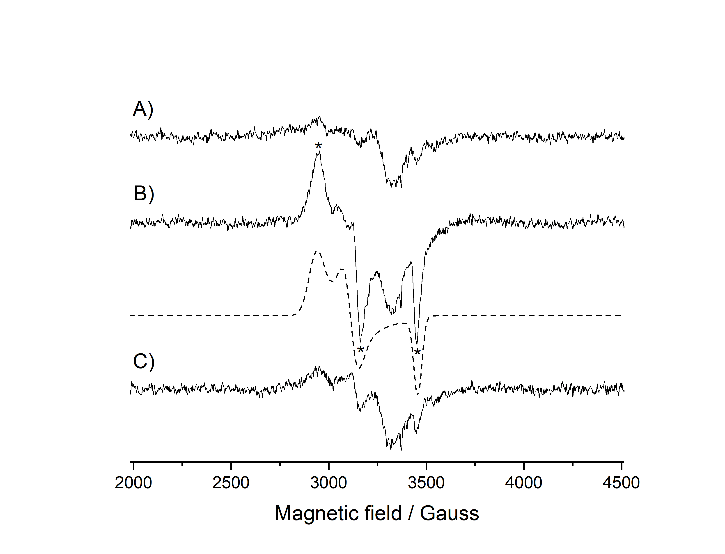
Figure S22. X-band EPR spectra with baseline correction recorded at 100K of C1 (0.25 mM) in an MeCN solution containing 0.1 M TBAPF₆. A) initial Fe^{II} state, B) after exhaustive oxidation at E = 0.42 V vs Fc/Fc⁺. Asterisks indicate the signals of the low spin S = 1/2 Fe^{III} in mixture with degraded products. Simulation of the Fe^{III} species in dash line with a relative weight of ca. 18 % and g_{x} = 2.295, g_{y} = 2.166, g_{z} = 1.950, C) after exhaustive reduction at E = -0.09 V vs Fc/Fc⁺ to generate back the initial complex.
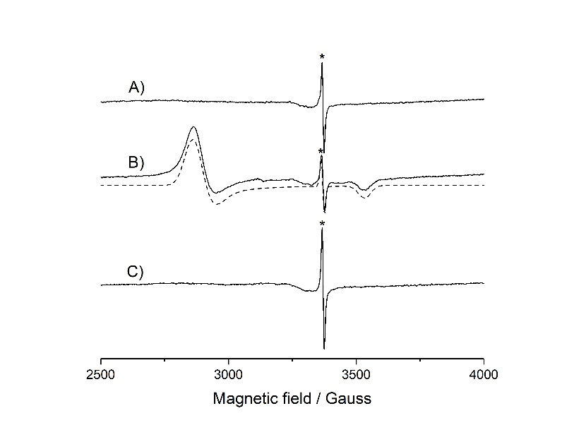
Figure S23. X-band cw-EPR spectra recorded at 100 K of an MeCN solution of C2 (0.35 mM) containing 0.1M TBAPF₆. A) initial Fe(II) complex, B) after exhaustive electrolysis at Eapp = 0.42 V vs Fc/Fc+. Simulation in dash line for a low spin S = 1/2 Fe(III) complex with g_{x} = 2.352, g_{y} = 2.318, g_{z} = 1.907, C) after exhaustive electrolysis at Eapp = -0.09 V vs Fc/Fc+ to generate back the initial Fe(II) complex. The asterisk indicates an organic radical impurity.

Optical characterization

Fluorescence quantum yield of the C2 complex
The fluorescence quantum yield ($Φ_{f}$) measures the efficiency of converting absorbed photons into emitted ones. For the C2 complex, $Φ_{f}$ was measured using a relative method following the procedure outlined by Würth et al.² In relative methods, the unknown quantum yield of a sample is determined by comparing its fluorescence emission spectrum with that of a fluorophore with a known $Φ_{f}$, while maintaining identical conditions in both measurements. $Φ_{f}$ is calculating using eq. (1):
$$Φ_{f}^{u}{=Φ}_{f }^{s}\frac{f_{s}\left(λ_{ex}\right)}{f_{u}\left(λ_{ex}\right)} \frac{\int_{λ_{em}}{F^{u}\left(λ_{em}\right)} }{\int_{λ_{em}}{F^{s}\left(λ_{em}\right)}} \frac{n_{u}^{2}}{n_{s}^{2}} , \left(1\right)$$
where the subscripts u and s correspond to the sample with unknown quantum yield and the standard reference, respectively. The absorption factor $f_{\left(⋅\right)}\left(λ_{ex}\right)$ at the excitation wavelength is given by
$$f_{\left(⋅\right)}\left(λ_{ex}\right)=1-{10}^{-A_{\left(⋅\right)}\left(λ_{ex}\right)}, \left(2\right)$$
with $A_{\left(⋅\right)}\left(λ_{ex}\right)$ being the absorbance at the excitation wavelength. $\int_{λ_{em}}{F^{\left(⋅\right)}\left(λ_{ex}\right)}$ corresponds to the integrated fluorescence and $n_{\left(⋅\right)}$ to the refractive index of the solvent.³ In order to account for the width of the excitation slit while computing $Φ_{f}$, the absorbances are evaluated considering the formalism proposed by Demas:⁴
$${\overline{A}}_{\left(⋅\right)}\left(λ_{ex}\right)=\frac{1}{3}\left[A_{\left(⋅\right)}\left(λ_{ex}\right)+A_{\left(⋅\right)}\left(λ_{ex}+Δλ/2\right)+A_{\left(⋅\right)}\left(λ_{ex}-Δλ/2\right)\right]. \left(3\right)$$
Absorption spectra were recorded on an Analytik Jena Specord UV-VIS spectrometer with a spectral bandwidth and step size of 1 nm. Measurements were performed in a Hellma quartz cuvette with an optical path length of 10 mm. Fluorescence emission spectra were acquired using an Edinburgh FLS1000 spectrofluorometer, with excitation and emission slit widths set to 6 and 2 nm, respectively. The integration time was chosen to be 0.5 s, and two scanned spectra were averaged. Emission data were corrected for the detector’s wavelength-dependent sensitivity using the corresponding correction file, and the detector’s dark count rates.
The fluorophore used as the reference was Rhodamine 6G (Rho 6G, Sigma-Aldrich, batch no. 201324) with a well-known fluorescence quantum yield reported as a standard.² Absorption of C2 in acetonitrile solution was recorded for solutions with maximum optical densities of 0.826 and 0.024. The background was subtracted via a reference measurement of the solvent with the same measurement conditions. The same procedure was followed for measuring the absorption of Rho 6G in ethanol (see Figure S24). The concentration of Rho 6G was adjusted to allow measurements of the reference and the unknown samples under the same parameter conditions for the emission.
The fluorescence quantum yield was calculated by integration of the emission spectra at two different excitation wavelengths: 510 and 520 nm, to directly excite the S₀-S₁ transition of C2. Figure S24.b and Figure S24.c show the corresponding spectra. Background subtraction was applied by the blank measurement of the solvents in the same cuvettes used for measuring each sample. In addition, the absorption of each sample was measured after each emission spectrum was recorded to eliminate the possible photobleaching effect. The overlapping of both absorption and emission spectra for the differently-concentrated C2 solutions when normalized indicates that there is no presence of inner filter and emission reabsorption effects.
Equation 1 was then used to obtain the quantum yield at each excitation wavelength. Given the quantum yield for Rho 6G, $Φ_{f}=0.91±0.04$ and the refraction indexes for ethanol and acetonitrile,^{3,5} and computing the uncertainties via error propagation, the obtained values for the fluorescence quantum yield of C2 are given in Table S1. These values are obtained by averaging the values obtained for each of the two C2 solutions, whose values fall into the reported uncertainties. We can conclude then that the fluorescence quantum yield of C2 is $Φ_{f}=0.01445±0.0005.$
Excitation wavelength (nm) | Fluorescence quantum yield of C2
510 | $$0.0148±0.0005$$
520 | $$0.0141±0.0004$$
Table S1: Fluorescence quantum yield of C2 for different excitation wavelengths.
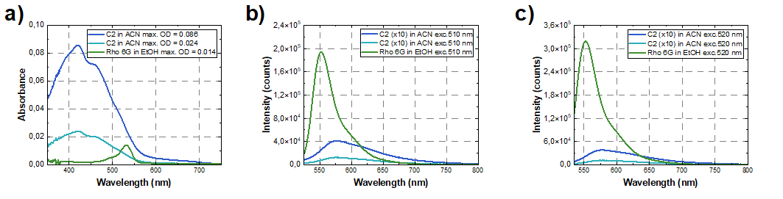
Figure S24. Absorbance spectra of C2 complex in ACN for two different concentrations (blue and cyan curves) and Rhodamine 6G (green curve) in ethanol (a). Optical densities were kept below 0.1 to avoid fluorescence reabsorption and inner filter effects. Fluorescence emission spectra for C2 and Rho 6G are shown for excitation wavelengths at 510 nm (b) and 520 nm (c). Emission intensities for the C2 spectra were multiplied by 10 for comparison with the Rho 6G and plotting purposes.

Streak camera time-resolved luminescence and transient absorption spectroscopy
The averaged kinetic trace in the spectral region [560-620] nm covering the peak of emission of C2 is shown in Figure S25. This kinetic trace was fitted using a 4-exponential decay function convolved with the Gaussian instrument response function. In Table S2, the decay times and their respective amplitudes for the fit are presented. These values lead to an excited state lifetime of 3.5 ± 0.5 ns with the uncertainty estimated via fitting the different measured datasets.
Fitted decay time (ns) | Amplitudes %
0.16 ± 0.03 | 18.4
1.3 ± 0.1 | 18.4
4.52 ± 0.1 | 57.8
10.9 ± 0.5 | 5.4
Table S2. Fitted parameters for the averaged kinetic trace obtained by averaging the kinetic traces for C2 data in the spectral region [560-620] nm.
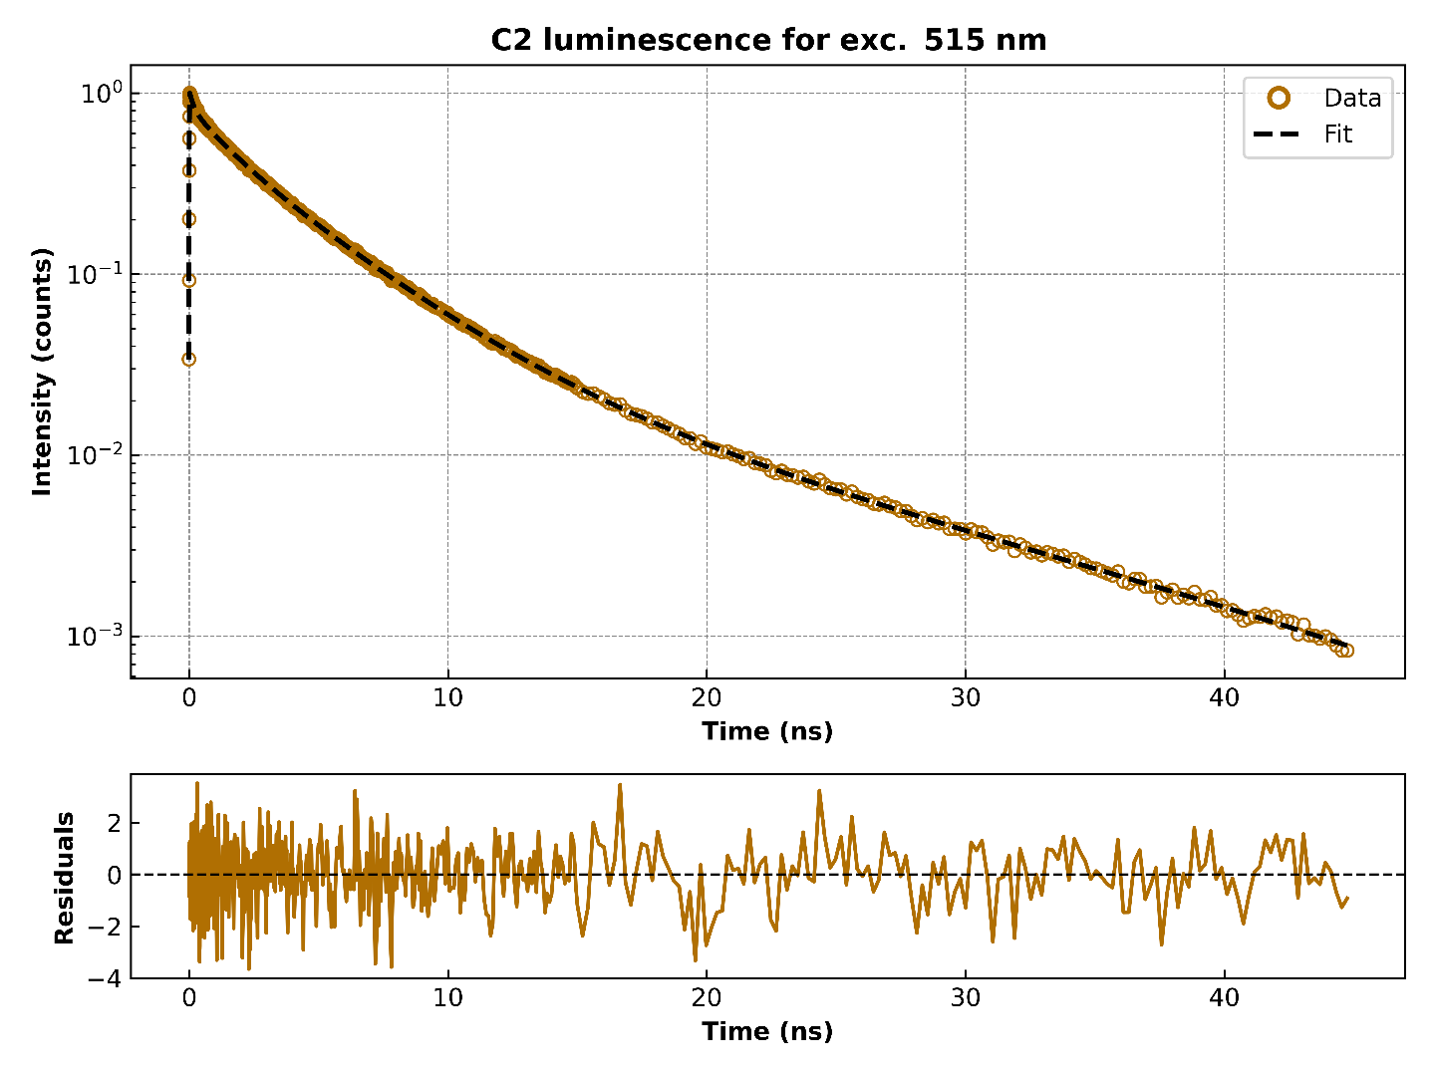Figure S25. Kinetic trace obtained by merging the kinetics in the [560-620] nm interval for the streak camera data of C2 complex excited at 515 nm. Residuals of the four-exponential fitting are shown below.

Details on the analysis of transient absorption spectroscopy data

Transient absorption spectroscopy kinetics were analyzed via single-wavelength fitting and differential associated decay spectra (DADS) for C1 and C2 complexes are shown in Figure S26. Kinetic traces (dotted lines) for C1 are shown in Figure S26.a to illustrate the decay of the signal at selected wavelengths in the different spectral features: 340 nm in the UV-ESA, 400 nm and 460 nm at the GSB, and 600 nm at the VIS-ESA. The 460 and 600 nm traces show an initial rapid decrease, corresponding to the reduction of the VIS-ESA at longer wavelengths, as mentioned in the differential spectra. After this, it continues decaying like the other kinetic traces. Single-wavelength fitting (SWF) of the selected kinetics was performed to provide quantitative results for the fs-TAS data. Fitted curves are plotted on top of the kinetics (solid lines in Figure S26.a). A multiexponential decay function convoluted with the Gaussian instrument response function (IRF) was used for the SWF. For C1, the data can be described by a 3-component exponential decay. The fitting parameters are shown in Table S3. Decay times ranging in the tens of fs, units of ps, and early tens of ps were obtained for the four wavelengths. Knowing the decay times associated with the different spectral signatures and their time scales, global fitting was performed with the same fitting function used for the SWF, providing an equally good fit as the single-wavelength fits. Figure S26.c shows the decay-associated difference spectra (DADS) obtained from the fitting. The spectral profile associated with the first 100-fs component shows a prominent positive amplitude for long wavelengths, consistent with the qualitatively observed reduction of the differential spectra in this region. The two slower components at 3 and 13 ps illustrate the excited state relaxation and population decay back to the ground state, respectively, with the longest one having the strongest contribution to the ESA decay. The time components obtained with the global fitting are consistent with those given by the SWF. The DADS curve for the 3-ps time component is negative just below 500 nm, indicating a rise time for an ESA (ΔA>0), which can also be observed in the raw data, where the VIS-ESA blue-shifts. This shift occurs within the first ps, and is characteristic of excited-state relaxation.

λ (nm) | A₁ | τ₁ (ps) | A₂ | τ₂ (ps) | A₃ | τ₃ (ps)
340 | 2.03 | 0.44 | 3.71 | 9.6 | -0.0148 | 55.0
400 | 0.546 | 0.32 | -1.15 | 2.5 | -3.64 | 12.0
460 | -26.3 | 0.027 | -2.83 | 1.8 | -10.2 | 14.0
600 | 20.9 | 0.027 | 0.822 | 0.24 | 0.817 | 14.0

Table S3. Single-wavelength fitting values of the TAS kinetics for the C1 complex excited at 520 nm. Fitting was done with a 3-component multiexponential decay function.

Figure S26.b shows kinetic traces for C2 at 340 nm (UV-ESA), 400 and 460 nm (GSB), and 620 nm (VIS-ESA). Compared to C1, the differential absorption signal of both ESA regions decays faster in the first 5 ps, but shows a long-lived tail within the hundreds of ps range. SWF was performed, this time using a 4-component exponential decay to account for the long-lived signal (Figure S26.b). The fitted parameters obtained are shown in Table S4. Similar to the results obtained for C1, the kinetic traces of C2 present decay times ranging in the tens of fs, units of ps, and tens of ps. Additionally, the fourth decay time was fixed to 1200 ps at all wavelengths to improve the fitting quality. Global fitting on C2 fs-TAS data was performed by following the same fitting function for the SWF and fixing the fourth component to 1200 ps.

λ (nm) | A₁ (10⁻³) | τ₁ (ps) | A₂ (10⁻³) | τ₂ (ps) | A₃ (10⁻³) | τ₃ (ps) | A₄ (10⁻³) | Τ₄ (ps)
340 | 5.02 | 0.44 | 8.86 | 4.7 | 0.69 | 49.0 | 0.487 | 1200
400 | -1.98 | 0.52 | -7.99 | 5.2 | -1.64 | 35.0 | -0.332 | 1200
460 | 9.68 | 0.41 | -32.6 | 5.7 | -0.29 | 27.0 | 0.87 | 1200
620 | 8.62 | 0.34 | 9.25 | 4.4 | 1.7 | 59.0 | 1.18 | 1200
Table S4. Single-wavelength fitting values of the TAS kinetics for the C2 complex excited at 520 nm. Fitting was done with a 4-component multiexponential decay function.

Figure S26.d shows the decay-associated difference spectra (DADS). The 380-fs spectral profile evidences the initial decay of the ESA signatures and the decrease of a small portion of the GSB band, ranging from 360 to 430 nm. Meanwhile, the GSB ranging from 430 to 500 nm rises further, as well as between 350 and 380 nm (Figure 6.b in the article), because most likely the UV-ESA blue-shifts and the VIS-ESA red-shifts, due to excited state relaxation. The second time decay of 5.2 ps shows the decay of the UV-, VIS-, and GSB signals with a shape similar to the 13 ps component of C1. Indeed, the GSB decay goes in parallel with the ESA decays below 350 nm and above 520 nm. For the third time component of 42 ps, the DADS is very different, with an almost flat VIS-ESA (> 500nm), and a small maximum at 540 nm. Concerning the last 1.2 ns decay time, the DADS has some resemblance to that of 42 ps, except that it is entirely positive and only weakly modulated. It can be visually approximated by an almost constant ΔA ≈ 10⁻³, but reduced to almost zero in the 350-500 nm range, where the SSA is most prominent. Given the obvious differences in the shapes of the 5.2-ps DADS on one hand and the 42-ps and 1.2-ns DADS on the other, it is straightforward to assign the corresponding lifetimes to different electronic states.

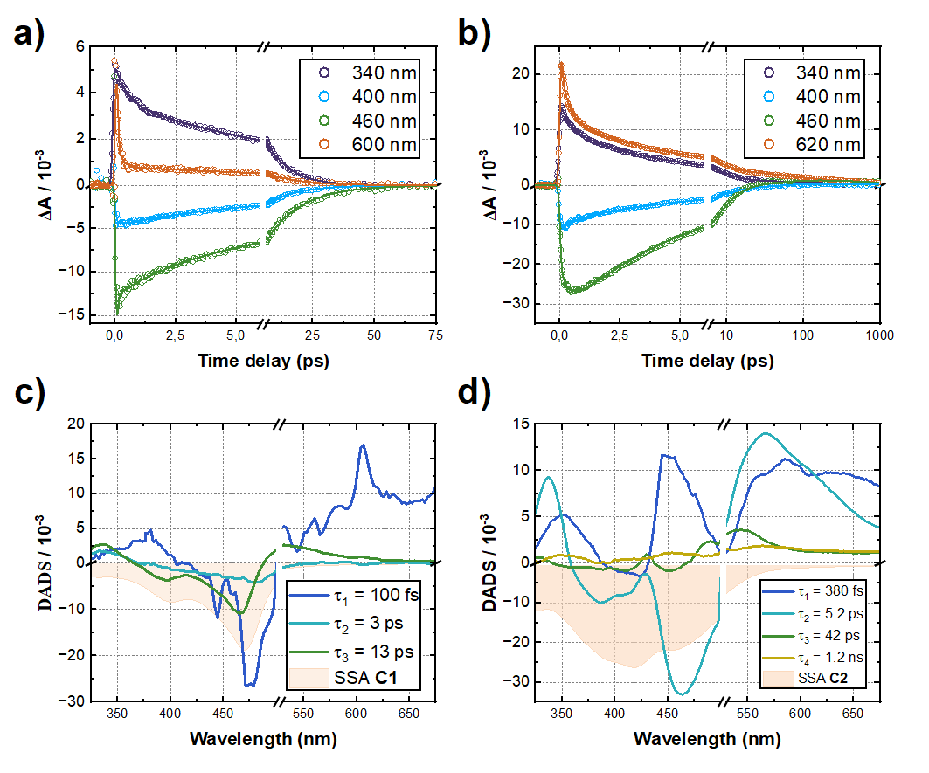
Figure S26. Femtosecond transient absorption spectroscopy (fs-TAS) of C1 and C2 complexes. Fitted kinetics via single wavelength fitting (SWF) and differential associated decay spectra (DADS) for C1 and C2 complexes in ACN.

Computations

Figure S27. Calculated (DFT B3LYP*/6-311G*) energies and isodensity plots (isosurface value 0.025 a.u.) of highest occupied and lowest unoccupied molecular orbitals (HOMOs, LUMOs) of the C2 and C1 ligand (NHC form). The orbitals within the frames have the proper symmetry to mix (in their symmetric combination) with the 3d_{xy} iron atomic orbital.

C2 Absorption Spectrum
Figure S28. Simulated UV–Vis absorption spectrum of C2 in acetonitrile, obtained by Gaussian convolution of TDDFT-calculated vertical excitation energies using the B3LYP* exchange–correlation functional. A Gaussian broadening of 0.17 eV was applied to convolute the vertical TDDFT excitations, which are indicated by vertical sticks and weighted according to their oscillator strengths. The inset highlights the low-energy band arising from the S₁–S₄ excited states that govern the photophysics.

Table S5. Relevant singlet excitations calculated for C2 at the S₀-optimized (Franck–Condon) geometry: state number (n), wavelength (λ), oscillator strength (f), and electron–hole population analysis over the fragments, with the corresponding contributions (%) and excitation character.
State | λ (nm) | f | Fragment | h⁺ | e⁻ | Nature
S₁ | 521 | 0.435 | Fe | 0.422 | 0.019 | MLCT (40%) + LLCT (32%) + LC (25%)
S₁ | 521 | 0.435 | C₃₃ H₂₄ N₆ | 0.281 | 0.576 | MLCT (40%) + LLCT (32%) + LC (25%)
S₁ | 521 | 0.435 | C₃₃ H₂₄ N₆ | 0.299 | 0.407 | MLCT (40%) + LLCT (32%) + LC (25%)
S₂ | 519 | 0.003 | Fe | 0.389 | 0.051 | LC (42%) + MLCT (37%) + LLCT (17%)
S₂ | 519 | 0.003 | C₃₃ H₂₄ N₆ | 0.170 | 0.038 | LC (42%) + MLCT (37%) + LLCT (17%)
S₂ | 519 | 0.003 | C₃₃ H₂₄ N₆ | 0.441 | 0.912 | LC (42%) + MLCT (37%) + LLCT (17%)
S₃ | 517 | 0.003 | Fe | 0.390 | 0.051 | LC (42%) + MLCT (37%) + LLCT (17%)
S₃ | 517 | 0.003 | C₃₃ H₂₄ N₆ | 0.440 | 0.912 | LC (42%) + MLCT (37%) + LLCT (17%)
S₃ | 517 | 0.003 | C₃₃ H₂₄ N₆ | 0.171 | 0.038 | LC (42%) + MLCT (37%) + LLCT (17%)
S₄ | 506 | 0.004 | Fe | 0.425 | 0.043 | MLCT (41%) + LLCT (36%) + LC (20%)
S₄ | 506 | 0.004 | C₃₃ H₂₄ N₆ | 0.298 | 0.395 | MLCT (41%) + LLCT (36%) + LC (20%)
S₄ | 506 | 0.004 | C₃₃ H₂₄ N₆ | 0.278 | 0.564 | MLCT (41%) + LLCT (36%) + LC (20%)
S₁₀ | 444 | 0.169 | Fe | 0.221 | 0.043 | LLCT (40%) + LC (36%) + MLCT (20%)
S₁₀ | 444 | 0.169 | C₃₃ H₂₄ N₆ | 0.372 | 0.930 | LLCT (40%) + LC (36%) + MLCT (20%)
S₁₀ | 444 | 0.169 | C₃₃ H₂₄ N₆ | 0.410 | 0.028 | LLCT (40%) + LC (36%) + MLCT (20%)
S₁₂ | 443 | 0.337 | Fe | 0.041 | 0.030 | LLCT (51%) + LC (43%)
S₁₂ | 443 | 0.337 | C₃₃ H₂₄ N₆ | 0.522 | 0.020 | LLCT (51%) + LC (43%)
S₁₂ | 443 | 0.337 | C₃₃ H₂₄ N₆ | 0.440 | 0.953 | LLCT (51%) + LC (43%)
S₁₄ | 434 | 0.049 | Fe | 0.722 | 0.131 | MLCT (63%) + LLCT (15%) + LC (11%)
S₁₄ | 434 | 0.049 | C₃₃ H₂₄ N₆ | 0.130 | 0.522 | MLCT (63%) + LLCT (15%) + LC (11%)
S₁₄ | 434 | 0.049 | C₃₃ H₂₄ N₆ | 0.148 | 0.348 | MLCT (63%) + LLCT (15%) + LC (11%)
S₁₇ | 411 | 0.738 | Fe | 0.450 | 0.030 | MLCT (43%) + LC (31%) + LLCT (23%)
S₁₇ | 411 | 0.738 | C₃₃ H₂₄ N₆ | 0.286 | 0.561 | MLCT (43%) + LC (31%) + LLCT (23%)
S₁₇ | 411 | 0.738 | C₃₃ H₂₄ N₆ | 0.265 | 0.410 | MLCT (43%) + LC (31%) + LLCT (23%)
S₂₇ | 383 | 0.252 | Fe | 0.695 | 0.006 | MLCT (69%) + LC (21%) + LLCT (9%)
S₂₇ | 383 | 0.252 | C₃₃ H₂₄ N₆ | 0.140 | 0.391 | MLCT (69%) + LC (21%) + LLCT (9%)
S₂₇ | 383 | 0.252 | C₃₃ H₂₄ N₆ | 0.165 | 0.604 | MLCT (69%) + LC (21%) + LLCT (9%)
S₃₄ | 336 | 0.000 | Fe | 0.686 | 0.550 | MC (40%) + MLCT (31%) + LMCT (17%)
S₃₄ | 336 | 0.000 | C₃₃ H₂₄ N₆ | 0.157 | 0.225 | MC (40%) + MLCT (31%) + LMCT (17%)
S₃₄ | 336 | 0.000 | C₃₃ H₂₄ N₆ | 0.159 | 0.227 | MC (40%) + MLCT (31%) + LMCT (17%)
S₃₅ | 320 | 0.234 | Fe | 0.048 | 0.020 | LC (91%) + MLCT (4%)
S₃₅ | 320 | 0.234 | C₃₃ H₂₄ N₆ | 0.931 | 0.964 | LC (91%) + MLCT (4%)
S₃₅ | 320 | 0.234 | C₃₃ H₂₄ N₆ | 0.021 | 0.016 | LC (91%) + MLCT (4%)
S₅₄ | 300 | 0.315 | Fe | 0.010 | 0.038 | LC (68%) + LLCT (28%)
S₅₄ | 300 | 0.315 | C₃₃ H₂₄ N₆ | 0.420 | 0.300 | LC (68%) + LLCT (28%)
S₅₄ | 300 | 0.315 | C₃₃ H₂₄ N₆ | 0.569 | 0.661 | LC (68%) + LLCT (28%)

C1 Absorption Spectrum
The absorption spectra of C1 calculated using the B3LYP* is shown Fig. S29, while the main excited states are listed and characterized in Table S6. For C1, a worse agreement between theory and experiments is obtained, both in term of peaks position and of overall spectral shape. As already reported for analogous Fe-NHC complexes,⁶ B3LYP* tends to yield a blue-shift of the lowest energy MLCT maximum of the order of 0.2-0.3 eV. Here the calculated band maximum is about 400 nm compared to the experimental value of about 470 nm. Concerning the spectral shape, the overall discrepancy between theory and experiment may arise from difficulties in accurately reproducing the oscillator strengths of the various excitations, particularly those responsible for the weaker band observed at approximately 400 nm.
As shown in Fig. S29 and Table S6, the lowest-energy excitations, S₁ (HOMO → LUMO) and S₂ (HOMO → LUMO+1), are calculated at 484 and 482 nm, respectively, and exhibit negligible oscillator strengths. These transitions display predominantly MLCT character (≈59%), with smaller LLCT (16%) and LC (18%) contributions.
S₆ corresponds to a mixed MC–MLCT state arising from the interaction between the MC HOMO–1 → LUMO+6 and MLCT HOMO–1 → LUMO+2 configurations. At higher energies, two bright MLCT states are predicted: S₇ at 419 nm and S₁₀ at 396 nm. These states have mixed character but are mainly described by the HOMO → LUMO+3 transition, with minor contributions from HOMO–1 and HOMO–2 → LUMO/LUMO+1 excitations. As discussed in the main text and illustrated by the molecular orbital plots in Fig. 4b, LUMO+3 is analogous to the LUMO of C2. Owing to the larger Fe contribution to the HOMO of C1 compared with C2, S₇ and S₁₀ exhibit a higher MLCT character than S₁ of C2, along with weaker oscillator strengths.
In addition, a pair of weakly intense ligand-based states, S₂₃ and S₂₄, is predicted at 304 nm. These states, originating from excitations from the fully ligand-localized HOMO–5 to the LUMO and LUMO+1, are characterized by a mixed LC and LLCT nature of about 48% and 44%, respectively, and only minor metal-involving components. At higher energies, the LC band (contribution of 77% accompanied by smaller LLCT) is predicted in the 250–300 nm region.
Figure S29. Simulated UV–Vis absorption spectrum of C1 in acetonitrile, obtained by Gaussian convolution of TDDFT-calculated vertical excitation energies using the B3LYP* exchange–correlation functional. A Gaussian broadening of 0.17 eV was applied to convolute the vertical TDDFT excitations, which are indicated by vertical sticks and weighted according to their oscillator strengths.

Table S6. Relevant singlet excitations calculated for C1 at the S₀-optimized (Franck–Condon) geometry: state number (n), wavelength (λ), oscillator strength (f), and electron–hole population analysis over the fragments, with the corresponding contributions (%) and excitation character.

State | λ (nm) | f | Fragment | h⁺ | e⁻ | Nature
S₁ | 484 | 0.003 | Fe | 0.636 | 0.075 | MLCT (59%) + LC (18%)  + LLCT (16%) + MC (5%)
S₁ | 484 | 0.003 | C₁₇ H₁₆ N₆ | 0.196 | 0.884 | MLCT (59%) + LC (18%)  + LLCT (16%) + MC (5%)
S₁ | 484 | 0.003 | C₁₇ H₁₆ N₆ | 0.168 | 0.043 | MLCT (59%) + LC (18%)  + LLCT (16%) + MC (5%)
S₂ | 482 | 0.002 | Fe | 0.636 | 0.074 | MLCT (59%) + LC (18%)  LLCT (16%) + MC (5%)
S₂ | 482 | 0.002 | C₁₇ H₁₆ N₆ | 0.170 | 0.043 | MLCT (59%) + LC (18%)  LLCT (16%) + MC (5%)
S₂ | 482 | 0.002 | C₁₇ H₁₆ N₆ | 0.194 | 0.884 | MLCT (59%) + LC (18%)  LLCT (16%) + MC (5%)
S₆ | 421 | 0.004 | Fe | 0.793 | 0.514 | MC (42%) + MLCT (38%)  + LMCT (10%) +LLCT (6%)  + LC (5%)
S₆ | 421 | 0.004 | C₁₇ H₁₆ N₆ | 0.106 | 0.236 | MC (42%) + MLCT (38%)  + LMCT (10%) +LLCT (6%)  + LC (5%)
S₆ | 421 | 0.004 | C₁₇ H₁₆ N₆ | 0.103 | 0.251 | MC (42%) + MLCT (38%)  + LMCT (10%) +LLCT (6%)  + LC (5%)
S₇ | 419 | 0.255 | Fe | 0.709 | 0.057 | MLCT (67%) + LC (18%) +  LLCT (10%)
S₇ | 419 | 0.255 | C₁₇ H₁₆ N₆ | 0.142 | 0.426 | MLCT (67%) + LC (18%) +  LLCT (10%)
S₇ | 419 | 0.255 | C₁₇ H₁₆ N₆ | 0.149 | 0.518 | MLCT (67%) + LC (18%) +  LLCT (10%)
S₁₀ | 396 | 0.447 | Fe | 0.648 | 0.022 | MLCT (63%) + LC (18%)  + LLCT (17%)
S₁₀ | 396 | 0.447 | C₁₇ H₁₆ N₆ | 0.178 | 0.490 | MLCT (63%) + LC (18%)  + LLCT (17%)
S₁₀ | 396 | 0.447 | C₁₇ H₁₆ N₆ | 0.176 | 0.489 | MLCT (63%) + LC (18%)  + LLCT (17%)
S₂₃ | 304 | 0.009 | Fe | 0.022 | 0.065 | LC (48%) + LLCT (44%)  + LMCT (6%)
S₂₃ | 304 | 0.009 | C₁₇ H₁₆ N₆ | 0.507 | 0.828 | LC (48%) + LLCT (44%)  + LMCT (6%)
S₂₃ | 304 | 0.009 | C₁₇ H₁₆ N₆ | 0.471 | 0.107 | LC (48%) + LLCT (44%)  + LMCT (6%)
S₂₄ | 304 | 0.009 | Fe | 0.021 | 0.066 | LC (48%) + LLCT (44%) + LMCT (6%) + MLCT (2%)
S₂₄ | 304 | 0.009 | C₁₇ H₁₆ N₆ | 0.466 | 0.107 | LC (48%) + LLCT (44%) + LMCT (6%) + MLCT (2%)
S₂₄ | 304 | 0.009 | C₁₇ H₁₆ N₆ | 0.513 | 0.828 | LC (48%) + LLCT (44%) + LMCT (6%) + MLCT (2%)
S₃₅ | 282 | 0.980 | Fe | 0.052 | 0.063 | LC (77%) + LLCT (11%)  + LMCT (6%) + MLCT (5%)
S₃₅ | 282 | 0.980 | C₁₇ H₁₆ N₆ | 0.577 | 0.574 | LC (77%) + LLCT (11%)  + LMCT (6%) + MLCT (5%)
S₃₅ | 282 | 0.980 | C₁₇ H₁₆ N₆ | 0.371 | 0.364 | LC (77%) + LLCT (11%)  + LMCT (6%) + MLCT (5%)

Spin-Orbit Coupling

Figure S30. Nature and excitation energy of the low-lying singlet and triplet states of C2 in S₀ (Franck-Condon) and S₁ minima.
Table S7: Triplet excited states (T_{m}) below the lowest singlet excited states S₁, S₂, S₃ and S₄, computed at the optimized S₀ geometry (Franck–Condon region) for C2. For each triplet state, the vertical excitation energy (E, in eV), corresponding wavelength (λ, in nm), and percentage weights of the transitions between frontier molecular (FMO) are reported. The electronic character of each triplet state is quantified in terms of metal-centered (MC), ligand-centered (LC), metal-to-ligand charge transfer (MLCT), ligand-to-metal charge transfer (LMCT), and ligand-to-ligand charge transfer (LLCT) components, expressed as percentage contributions obtained from transition density analysis. The spin–orbit coupling matrix elements ⟨S_{n}|Ĥ_{SO}|T_{m}⟩ (in cm⁻¹), evaluated between the lowest singlet states (n=1-4) and each lower-lying triplet state, are also reported.
min  S₀ | E  (eV) | 𝛌 (nm) | FMOs  (%) | Character (%) |  |  |  |  | ⟨S_{n}|Ĥ_{SO}|T_{m}⟩ (cm⁻¹)
 |  |  |  | MC | LC | MLCT | LMCT | LLCT | S₁ | S₂ | S₃ | S₄
T₁ | 1.94 | 641 | H_{–1} → L : 23.0  H → L : 5.5  H → L₊₁ : 71.5 | 1.9 | 71.7 | 19.3 | 2.4 | 4.6 | 0 | 17 | 19 | 2
T₂ | 1.96 | 633 | H_{–1} → L₊₁ : 28.6  H → L : 64.8  H → L₊₁ : 6.6 | 2.4 | 77.6 | 13.8 | 2.0 | 4.2 | 1 | 27 | 25 | 0
T₃ | 2.15 | 576 | H_{–3} → L : 12.0  H_{–3} → L₊₁₄ : 88.0 | 53.8 | 6.8 | 25.8 | 10.7 | 3.0 | 54 | 11 | 1 | 27
T₄ | 2.16 | 576 | H_{–2} → L : 11.7  H_{–2} → L₊₁₄ : 88.3 | 54.0 | 6.6 | 25.8 | 10.7 | 2.9 | 51 | 2 | 11 | 31
T₅ | 2.18 | 570 | H_{–1} → L₊₃ : 18.1  H_{–1} → L₊₄ : 23.5  H → L₊₃ : 23.3  H → L₊₄ : 35.1 | 2.9 | 87.1 | 7.3 | 1.0 | 1.8 | 9 | 5 | 1 | 12
T₆ | 2.19 | 568 | H_{–1} → L₊₂ : 18.2  H_{–1} → L₊₅ : 26.2  H → L₊₂ : 24.5  H → L₊₅ : 31.1 | 1.5 | 89.6 | 6.6 | 0.6 | 1.6 | 7 | 1 | 4 | 9
T₇ | 2.23 | 557 | H_{–1} → L₊₂ : 9.4  H_{–1} → L₊₅ : 6.1  H → L₊₂ : 38.7  H → L₊₅ : 45.8 | 2.6 | 54.8 | 28.6 | 3.9 | 10.2 | 11 | 1 | 16 | 36
T₈ | 2.23 | 556 | H_{–1} → L₊₃ : 8.7  H → L₊₃ : 49.1  H → L₊₄ : 42.2 | 2.5 | 54.9 | 28.6 | 3.8 | 10.2 | 14 | 15 | 1 | 35
T₉ | 2.28 | 544 | H_{–4} → L₊₁ : 30.8  H_{–3} → L₊₅ : 8.4  H_{–2} → L₊₄ : 10.6  H_{–1} → L : 37.5  H → L₊₁ : 12.7 | 5.9 | 29.7 | 43.6 | 2.5 | 18.4 | 1 | 34 | 31 | 5
T₁₀ | 2.31 | 537 | H_{–4} → L : 14.6  H_{–4} → L₊₁₄ : 25.7  H_{–1} → L₊₁ : 18.3  H → L₊₁₄ : 41.4 | 37.6 | 17.3 | 22.7 | 14.4 | 8.0 | 2 | 80 | 82 | 1
Table S8: Triplet excited states (T_{n}) below the lowest singlet excited state S₁, computed at the optimized S₁ minimum geometry for C2. For each triplet state, the vertical excitation energy (E, in eV), corresponding wavelength (λ, in nm), and percentage weights of the transitions between frontier molecular (FMO) are reported. The electronic character of each triplet state is quantified in terms of metal-centered (MC), ligand-centered (LC), metal-to-ligand charge transfer (MLCT), ligand-to-metal charge transfer (LMCT), and ligand-to-ligand charge transfer (LLCT) components, expressed as percentage contributions obtained from transition density analysis. The spin–orbit coupling matrix elements ⟨S₁|Ĥ_{SO}|T_{m}⟩ (in cm⁻¹), evaluated between the lowest singlet state and each lower-lying triplet state, are also reported.
min  S₁ | E  (eV) | 𝛌 (nm) | FMOs (%) | Character (%) |  |  |  |  | ⟨S₁|Ĥ_{SO}|T_{n}⟩ (cm⁻¹)
 |  |  |  | MC | LC | MLCT | LMCT | LLCT | S₁
T₁ | 1.69 | 733 | H_{–1} → L : 31.6  H → L : 68.4 | 1.3 | 76.7 | 15.7 | 1.7 | 4.5 | 6
T₂ | 1.89 | 656 | H_{–1} → L₊₁ : 23.6  H → L₊₁ : 76.4 | 1.9 | 74.6 | 17.0 | 2.1 | 4.4 | 4
T₃ | 2.07 | 599 | H_{–1} → L : 12.9  H_{–1} → L₊₂ : 27.8  H → L₊₂ : 51.9  H → L₊₄ : 7.4 | 4.8 | 68.2 | 17.0 | 1.8 | 8.3 | 15
T₄ | 2.10 | 591 | H_{–3} → L₊₁₄ : 7.1  H_{–2} → L : 10.8  H_{–2} → L₊₁₄ : 82.0 | 51.9 | 7.8 | 27.1 | 9.8 | 3.3 | 46
T₅ | 2.11 | 587 | H_{–3} → L₊₁₄ : 12.1  H_{–1} → L₊₃ : 21.8  H_{–1} → L₊₅ : 11.0  H → L₊₃ : 36.8  H → L₊₅ : 18.3 | 8.3 | 77.3 | 10.6 | 1.8 | 2.0 | 25
T₆ | 2.12 | 585 | H_{–3} → L : 12.5  H_{–3} → L₊₁₄ : 61.8  H_{–2} → L₊₁₄ : 13.9  H → L₊₃ : 11.8 | 42.4 | 21.0 | 25.1 | 8.0 | 3.5 | 40

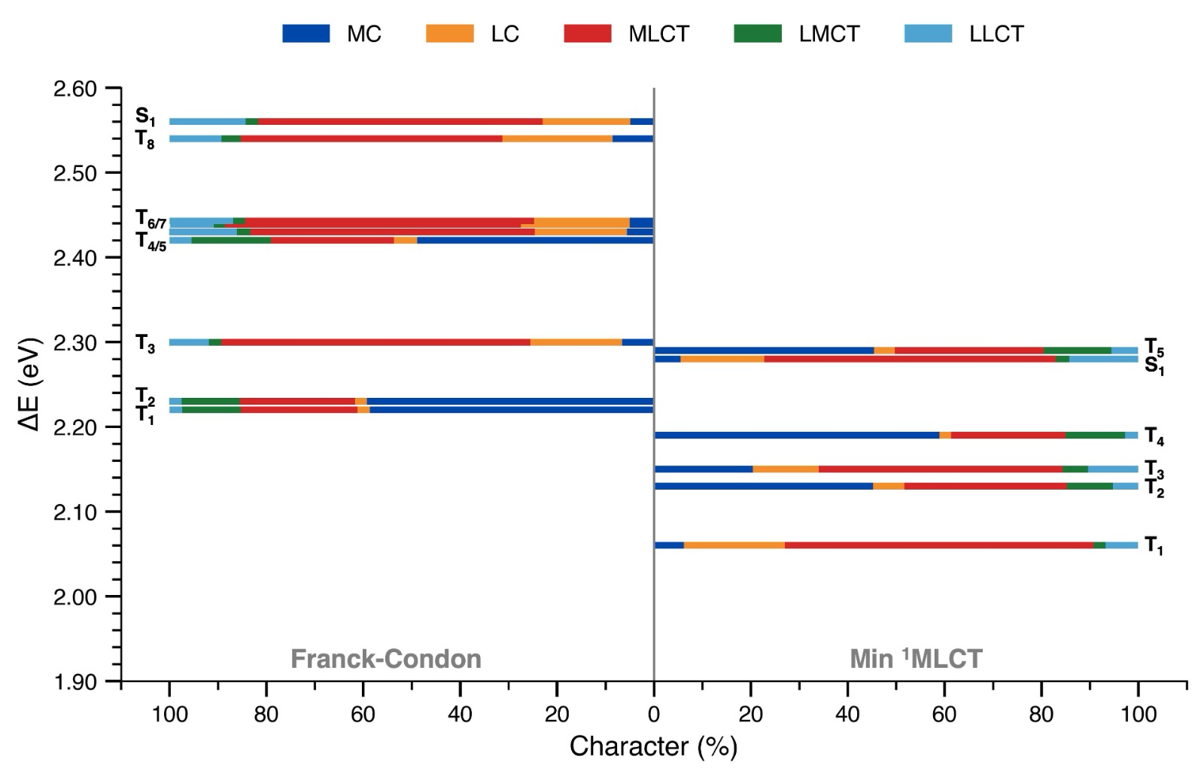
Figure S31. Nature and excitation energy of the low-Lying singlet and triplet states of C1 in S₀ (Franck-Condon) and S₁ minima.
Table S9. Triplet excited states (T_{m}) below the lowest singlet excited state S₁ computed at the optimized S₀ geometry (Franck–Condon region) for C1. For each triplet state, the vertical excitation energy (E, in eV), corresponding wavelength (λ, in nm), and percentage weights of the transitions between frontier molecular (FMO) are reported. The electronic character of each triplet state is quantified in terms of metal-centered (MC), ligand-centered (LC), metal-to-ligand charge transfer (MLCT), ligand-to-metal charge transfer (LMCT), and ligand-to-ligand charge transfer (LLCT) components, expressed as percentage contributions obtained from transition density analysis. The spin–orbit coupling matrix elements ⟨S_{n}|Ĥ_{SO}|T_{m}⟩ (in cm⁻¹), evaluated between the lowest singlet states (n=1-4) and each lower-lying triplet state, are also reported.
min  S₀ | E  (eV) | 𝛌 (nm) | FMOs (%) | Character (%) |  |  |  |  | ⟨S₁|Ĥ_{SO}|T_{m}⟩ (cm⁻¹)
 |  |  |  | MC | LC | MLCT | LMCT | LLCT | ⟨S₁|Ĥ_{SO}|T_{m}⟩ (cm⁻¹)
T₁ | 2.22 | 557 | H_{–1} → L₊₆ : 87.6 | 58.7 | 2.5 | 24.1 | 12.1 | 2.6 | 10
T₂ | 2.23 | 556 | H_{–2} → L₊₆ : 89.0 | 59.3 | 2.4 | 23.8 | 12.0 | 2.6 | 13
T₃ | 2.30 | 539 | H_{–2} → L : 34.8  H_{–1} → L : 5.8  H_{–1} → L₊₁ : 35.8  H → L₊₂ : 14.2 | 6.6 | 18.9 | 63.8 | 2.6 | 8.2 | 82
T₄ | 2.42 | 512 | H → L₊₆ : 82.1 | 48.9 | 4.8 | 25.4 | 16.4 | 4.5 | 129
T₅ | 2.43 | 510 | H → L : 56.6  H → L₊₁ : 33.6 | 5.6 | 19.0 | 58.7 | 2.8 | 14.0 | 38
T₆ | 2.44 | 508 | H_{–2} → L : 10.9  H_{–2} → L₊₁ : 26.0  H_{–1} → L : 27.0  H_{–1} → L₊₁ : 11.3  H → L : 14.3  H → L₊₁ : 6.3 | 5.0 | 22.5 | 61.1 | 2.3 | 9.0 | 80
T₇ | 2.44 | 507 | H_{–2} → L₊₁ : 7.3  H_{–1} → L : 6.5  H → L : 21.5  H → L₊₁ : 54.0 | 5.0 | 19.8 | 59.6 | 2.5 | 13.1 | 52
T₈ | 2.54 | 488 | H_{–2} → L : 7.8  H_{–1} → L₊₁ : 5.4  H → L₊₂ : 72.9  H → L₊₇ : 5.1 | 8.6 | 22.7 | 54.0 | 4.0 | 10.7 | 57

Table S10. Triplet excited states (T_{m}) below or isoenergetic with the lowest singlet excited state S₁, computed at the optimized S₁ minimum geometry for C1. For each triplet state, the vertical excitation energy (E, in eV), corresponding wavelength (λ, in nm), and percentage weights of the transitions between frontier molecular (FMO) are reported. The electronic character of each triplet state is quantified in terms of metal-centered (MC), ligand-centered (LC), metal-to-ligand charge transfer (MLCT), ligand-to-metal charge transfer (LMCT), and ligand-to-ligand charge transfer (LLCT) components, expressed as percentage contributions obtained from transition density analysis. The spin–orbit coupling matrix elements ⟨S₁|Ĥ_{SO}|T_{m}⟩ (in cm⁻¹), evaluated between the lowest singlet state and each lower-lying triplet state, are also reported.
min  S₁ | E  (eV) | 𝛌 (nm) | FMOs (%) | Character (%) |  |  |  |  | ⟨S₁|Ĥ_{SO}|T_{m}⟩ (cm⁻¹)
 |  |  |  | MC | LC | MLCT | LMCT | LLCT | ⟨S₁|Ĥ_{SO}|T_{m}⟩ (cm⁻¹)
T₁ | 2.06 | 601 | H_{–2} → L : 90.2 | 6.2 | 20.8 | 63.8 | 2.4 | 6.7 | 130
T₂ | 2.13 | 582 | H_{–1} → L₊₆ : 65.3  H → L : 25.9 | 45.2 | 6.5 | 33.6 | 9.4 | 5.3 | 2
T₃ | 2.15 | 576 | H_{–1} → L₊₆ : 23.4  H → L : 70.7 | 20.4 | 13.6 | 50.4 | 5.2 | 10.4 | 5
T₄ | 2.19 | 567 | H_{–2} → L₊₆ : 89.3 | 58.9 | 2.4 | 23.7 | 12.2 | 2.7 | 17
T₅ | 2.29 | 540 | H_{–1} → L : 16.4  H → L₊₆ : 73.6 | 45.4 | 4.3 | 30.8 | 13.9 | 5.5 | 170

Selection rules for spin-orbit coupling
The spin-orbit couplings in molecular systems can be obtained with most computational chemistry codes, but understanding the effects that govern their magnitude is generally non-trivial. Nevertheless, simple selection rules can be derived based on some approximations. First of all, an important simplification is introduced considering the one electron spin-orbit Hamiltonian with effective nuclear charges,^{7,8} and operator that contains a spatial part (the cartesian components of the angular momentum) and a spin part (the components of the spin momentum) for each atom in the molecule. In transition metal complexes, the transition metal atom plays a predominant role. As for the spatial part, the monoelectronic nature of the operator leads to focus on the integrals of the angular momentum components between the two molecular orbitals making a difference in the electronic configuration of the two states of interest. Considering a concrete example discussed in the article, the spin-orbit coupling between S₁ (HOMO-LUMO) and T₁₀ (HOMO->LUMO+14), depends on the integrals
$$\left\langle P_{M}ϕ_{LUMO }\left|{\hat{L}}_{i}\right|P_{M}ϕ_{LUMO+14}\right\rangle$$
where $P_{M}$ extracts from the MO the component on the metal and the index i runs over the cartesian components (x, y, or z). From this relation, one promptly notes that the integral is different from zero only if both MOs have a non-vanishing component on the metal.
In the idealized limit of a free Fe ion the spin-orbit couplings are dominated by the integrals of the three components of the angular momentum vector between two of the 3d Fe atomic orbitals. These matrix elements are non-zero only when the two orbitals are the same (${\hat{L}}_{z}$ operator) or when their magnetic quantum numbers m differ by one (Δm = ±1, corresponding to the ${\hat{L}}_{x}$ and ${\hat{L}}_{y}$ operators). The integral involving the ${\hat{L}}_{z}$ operator is not interesting, given that it multiplies the integral of ${\hat{S}}_{z}$ over the spin coordinates and this integral is vanishing between states of different spin. By noticing that $d_{z^{2}}$ has m=0, $d_{xz}$ and $d_{yz}$ are linear combination of d₁ and d₋₁ (the d orbitals with m=1 and -1, respectively), while $d_{x^{2}-y^{2}}$ and $d_{xy}$ are linear combination of d₂ and d₋₂, one can obtain that the integral involving $d_{xy}$ or $d_{x^{2}-y^{2}}$ and $d_{z^{2}}$ are vanishing. The same can be easily verified also in the reduced D_{2d} symmetry, where the integrals of the ${\hat{L}}_{x}$ and ${\hat{L}}_{y}$operators (belonging to the e irrep) involving the $d_{xy}$ (b₂ irrep) or $d_{x^{2}-y^{2}}$ (b₁ irrep) and $d_{z^{2}}$ (a₁ irrep) orbitals are zero.
Summarizing, for the aspect relevant to our problem, one can say that the spin-orbits coupling depends on the weight and nature of the iron d orbital components of the two molecular orbitals making a difference between the electronic configurations of the two states of interest. Indeed, these coupling are vanishing if the metal orbitals are absent in one of the two MOs or if one MO contains the $d_{z^{2}}$ iron atomic orbital and the other contains $d_{xy}$. On the other hand, the coupling is allowed if one MO contains the $d_{xz}$ or $d_{yz}$ iron orbitals and the other the $d_{z^{2}}$, $d_{xy}$, or $d_{x^{2}-y^{2}}$ iron orbitals.

C2 non-radiative excited states relaxation pathway
Once T₁₀ is populated, the subsequent relaxation into lower-lying MC states can be followed by monitoring the evolution of the energies and characters of the triplet-state manifold along Fe–N bond elongation (Figure S32), which represents the typical reaction pathway toward the MC-state minima. Although this analysis is complicated within the adiabatic TDDFT framework, a qualitative a posteriori diabatic reconstruction of the adiabatic triplet states (grey dotted lines in Figure S32) along the relaxed scan can be achieved by tracking, at each point, the dominant electronic configurations associated with MC, LC, and MLCT excitations (coloured markers overlaid in Figure S32). The T₁₀ state at the Franck–Condon geometry exhibits a strongly mixed character (Figure S30 and Table S7), with major contributions from MC (HOMO/HOMO–4 → LUMO+14), LC (HOMO–1 → LUMO+1), and MLCT (HOMO–4 → LUMO) excitations. Upon Fe–N bond elongation, the MC character of this state increases, accompanied by a decrease in its energy, as expected. This behavior is illustrated by the magenta markers in Figure S32, which track the evolution of T₁₀ along the Fe-N distance scan. Around 2.017 Å, MC states (T₃ and T₄, red markers) become nearly degenerate with LC triplet states (T₁ and T₂, yellow markers), while the MC character of the initially mixed state (T₁₀) further increases as its energy decreases. Further elongation induces state mixing and character switching between LC and MC states. Between 2.057 and 2.117 Å, an avoided crossing occurs between mixed MC/LC and LC states (orange markers). In this region, the lowest-energy LC configuration (HOMO → LUMO+1) is strongly coupled to a nearly isoenergetic MC excitation (HOMO → LUMO+14). While the electronic population is expected to predominantly relax into the stabilizing MC state (red markers) and then non-radiatively relax to the ground state, this region of strong electronic coupling may also provide a pathway for populating a long-lived emissive triplet state of LC character (yellow markers).
Figure S32. TDDFT–calculated vertical excitation energies of the lowest ten triplet states (grey dotted lines) and the low-lying singlet states (S₁–S₄) along Fe–N bond elongation (1.957–2.237 Å, in 0.02 Å increments) obtained from a ground-state relaxed scan. The diabatic character of the states along the reaction coordinate, estimated by tracking the dominant electronic configurations contributing to the TDDFT adiabatic states along the scan, is indicated by coloured markers overlaid on the grey dotted lines: red, MC; yellow, LC; orange MC/LC avoided crossing; magenta, MC/MLCT/LC.

References

(1) Ibrahim, D.; Boulet, P.; Gros, P. C.; Pierrat, P. Efficient Access to Arylated Aza‐ullazines by Regioselective Functionalization of Their Pyridine Ring by H−Li Exchange and Electrophilic Substitution. Eur. J. Org. Chem. 2021, 2021 (22), 3331–3339. https://doi.org/10.1002/ejoc.202100333.
(2) Würth, C.; Grabolle, M.; Pauli, J.; Spieles, M.; Resch-Genger, U. Relative and Absolute Determination of Fluorescence Quantum Yields of Transparent Samples. Nat. Protoc. 2013, 8 (8), 1535–1550. https://doi.org/10.1038/nprot.2013.087.
(3) Rurack, K.; Spieles, M. Fluorescence Quantum Yields of a Series of Red and Near-Infrared Dyes Emitting at 600−1000 Nm. Anal. Chem. 2011, 83 (4), 1232–1242. https://doi.org/10.1021/ac101329h.
(4) Demas, J. N. Luminescence Quantum Yields. Analysis of Finite Excitation Bandpass Errors. Anal. Chem. 1973, 45 (6), 992–994. https://doi.org/10.1021/ac60328a014.
(5) Chang, H.-J.; Munera, N.; Lopez-Zelaya, C.; Banerjee, D.; Beadie, G.; Stryland, E. W. V.; Hagan, D. J. Refractive Index Measurements of Liquids from 0.5 to 2 Μm Using Rayleigh Interferometry. Opt. Mater. Express 2024, 14 (5), 1253–1267. https://doi.org/10.1364/OME.519907.
(6) Reddy Marri, A.; Marchini, E.; Cabanes, V. D.; Argazzi, R.; Pastore, M.; Caramori, S.; Gros, P. C. Record Power Conversion Efficiencies for Iron( ii )-NHC-Sensitized DSSCs from Rational Molecular Engineering and Electrolyte Optimization. J. Mater. Chem. A 2021, 9 (6), 3540–3554. https://doi.org/10.1039/D0TA10841C.
(7) Marian, C. M. Spin–Orbit Coupling and Intersystem Crossing in Molecules. WIREs Comput. Mol. Sci. 2012, 2 (2), 187–203. https://doi.org/10.1002/wcms.83.
(8) Heinemann, C.; Koch, W.; Schwarz, H. An Approximate Method for Treating Spin-Orbit Effects in Platinum. Chem. Phys. Lett. 1995, 245 (4–5), 509–518. https://doi.org/10.1016/0009-2614(95)01042-8.

