Supplementary material
Landscape structure outweighs climate in shaping the diet composition of the maned wolf (Chrysocyon brachyurus, Illiger, 1815) in human-modified landscapes of the Atlantic Forest (southeastern Brazil)
Jean P. Silva¹²³, Lisandra Mendes Louzada-Camilo¹³, Marjory Cristina de Magalhães-Fernandes¹³, Lênim Faber-Lopes¹, Pedro M. Villa¹³
¹ Federal University of Juiz de Fora (UFJF), Graduate Program in Biodiversity and Nature Conservation, Juiz de Fora, Minas Gerais, Brazil
² REDI Itabapoana, Itabapoana River Basin, Bom Jesus do Norte, Espírito Santo, Brazil
³ Associação para a Conservação da Biodiversidade, Viçosa, Minas Gerais, Brazil

Supplementary Table S1; Results of the environmental fitting analysis (envfit) applied to the Principal Component Analysis (PCA) of maned wolf (Chrysocyon brachyurus) latrines. The table presents the coordinates of each variable on PCA axes 1 and 2, the coefficient of determination (R²), significance level (p-value), and the quality of representation in the ordination space (cos²). Climatic predictors, landscape metrics, and dietary variables significantly associated with the ordination contribute to the interpretation of the main environmental and trophic gradients structuring the samples.
Variável | Dim1 | Dim2 | R² | p_value | Dim.1 | Dim.2 | Dim.3 | Dim.4 | Dim.5
TAR | 0.998161743 | -0.060606386 | 0.988074338 | 0.001 | 0.987243279 | 0.000831059 | 0.000237292 | 7.35867E-06 | 9.16155E-05
AP | 0.926465689 | -0.376379232 | 0.984930017 | 0.001 | 0.949161125 | 0.035768892 | 0.005107181 | 4.00028E-05 | 0.000398062
MinTCM | -0.950980324 | 0.309251393 | 0.984233587 | 0.001 | 0.961028174 | 0.023205413 | 0.006479406 | 5.60814E-06 | 0.000786506
MeTWetQ | -0.918810877 | 0.394698076 | 0.981157597 | 0.001 | 0.941487326 | 0.039670271 | 0.008784822 | 3.25263E-05 | 0.000989065
PDriQ | 0.742202302 | -0.670175905 | 0.967129405 | 0.001 | 0.815339046 | 0.151790359 | 0.02183731 | 0.000304128 | 7.28908E-05
TEMP_S | 0.439527718 | 0.898229027 | 0.960811755 | 0.001 | 0.491811413 | 0.469000342 | 0.006324313 | 0.001283519 | 0.00314162
PS | -0.354493428 | 0.935058506 | 0.928858757 | 0.001 | 0.358816768 | 0.57004199 | 0.043434384 | 0.001436729 | 0.000729305
Mac_tin | -0.960027186 | 0.279906772 | 0.909356594 | 0.001 | 0.892041778 | 0.017314815 | 0.014718355 | 0.013654863 | 0.003531191
Cor_mag | -0.246679884 | -0.96909702 | 0.864256996 | 0.001 | 0.191036846 | 0.67322015 | 0.023703101 | 0.004271679 | 0.015024945
Syz_cum | -0.96079029 | 0.27727607 | 0.85751864 | 0.001 | 0.841515593 | 0.016003046 | 0.016938897 | 0.010281071 | 0.002692748
pland | 0.467536113 | 0.883973972 | 0.843877249 | 0.001 | 0.464626941 | 0.379250308 | 0.000400584 | 0.000195415 | 0.010619945
ai | 0.756642197 | 0.653829172 | 0.830677961 | 0.001 | 0.709678831 | 0.120999129 | 0.004746816 | 0.002648447 | 0.004474873
lsi | 0.990039435 | -0.140790332 | 0.80744432 | 0.001 | 0.803733025 | 0.003711294 | 0.075373649 | 0.001322242 | 0.055519034
ed | 0.990192514 | -0.139709647 | 0.806921081 | 0.001 | 0.803269778 | 0.003651303 | 0.075448262 | 0.001304174 | 0.056197304
Small_mam | 0.791302388 | 0.611425 | 0.782253782 | 0.001 | 0.688406953 | 0.093846829 | 0.012738154 | 2.70932E-05 | 0.063071494
Gen_ame | -0.999441786 | -0.033408336 | 0.727289551 | 0.001 | 0.727104043 | 0.000185509 | 0.007235983 | 1.0205E-05 | 0.000958462
Sya_rom | 0.651488415 | 0.758658583 | 0.724918521 | 0.001 | 0.553526471 | 0.17139205 | 0.083883762 | 0.003501231 | 0.045536719
Sol_lyc | 0.341770236 | -0.939783542 | 0.678332795 | 0.001 | 0.248794862 | 0.429537933 | 0.205022999 | 0.012713496 | 0.031484403
Insects | -0.936737209 | 0.350033429 | 0.613646723 | 0.001 | 0.594686455 | 0.018960268 | 0.002430427 | 0.195318938 | 0.004148788
np | 0.999649715 | 0.026465949 | 0.477272123 | 0.001 | 0.477195748 | 7.63746E-05 | 0.236247321 | 0.01523544 | 0.085428562
enn | 0.976615588 | 0.214993007 | 0.41662969 | 0.002 | 0.412069897 | 0.004559793 | 0.0141406 | 8.37237E-05 | 0.352776583
Fishes | -0.836344026 | 0.548204952 | 0.127445953 | 0.119 | 0.11605995 | 0.011386003 | 0.00479609 | 0.438425665 | 0.000688061
Birds | -0.999848773 | 0.017390536 | 0.123887378 | 0.168 | 0.12387882 | 8.55711E-06 | 0.00676598 | 0.593079717 | 0.002353014
AMT | 0.88920104 | 0.457516679 | 0.01828214 | 0.998 | 0.017240004 | 0.001042136 | 0.777996027 | 0.01163456 | 0.101383825

Supplementary Table S2. Results of generalized linear models (GLMs) assessing the effects of climatic and landscape predictors on the occurrence of dietary items in maned wolf fecal samples. For each food item, the table presents the predictor variable, model effect estimate (± standard error), p-value, and significance level.
food_item | predictor | effect | p_value | significance
Birds | AMT | 11.94 ± 24.45 | 0.629 | ns
Birds | MDR | 2.08 ± 22.88 | 0.928 | ns
Birds | TAR | -169.79 ± 0.38. | 0.997 | ns
Birds | ED | -0.04 ± 0.08 | 0.611 | ns
Birds | LSI | -0.71 ± 1.39 | 0.615 | ns
Birds | NP | 0.04 ± 0.14 | 0.798 | ns
Cor_mag | AMT | -0.23 ± 0.31 | 0.452 | ns
Cor_mag | MDR | -1.21 ± 1.92 | 0.534 | ns
Cor_mag | TAR | 0.20 ± 1.25 | 0.873 | ns
Cor_mag | ED | 0.00 ± 0.01 | 0.574 | ns
Cor_mag | LSI | 0.05 ± 0.09 | 0.574 | ns
Cor_mag | NP | 0.01 ± 0.02 | 0.739 | ns
Fishes | AMT | 1.12 ± 17.19 | 0.948 | ns
Fishes | MDR | 26.50 ± 19.26 | 0.180 | ns
Fishes | TAR | -169.15 ± 37837.29 | 0.996 | ns
Fishes | ED | 0.03 ± 0.06 | 0.606 | ns
Fishes | LSI | 0.58 ± 1.07 | 0.593 | ns
Fishes | NP | -0.44 ± 0.18 | 0.0188 | *
Gen_ame | AMT | 3.05 ± 3.01 | 0.320 | ns
Gen_ame | MDR | -0.71 ± 7.81 | 0.928 | ns
Gen_ame | TAR | 4.01 ± 4.56 | 0.387 | ns
Gen_ame | ED | 0.00 ± 0.02 | 0.952 | ns
Gen_ame | LSI | -0.02 ± 0.39 | 0.949 | ns
Gen_ame | NP | 0.02 ± 0.06 | 0.730 | ns
Insects | AMT | -0.56 ± 5.31 | 0.917 | ns
Insects | MDR | -1.36 ± 7.67 | 0.860 | ns
Insects | TAR | 1.10 ± 4.79 | 0.820 | ns
Insects | ED | -0.01 ± 0.02 | 0.520 | ns
Insects | LSI | -0.26 ± 0.40 | 0.514 | ns
Insects | NP | -0.03 ± 0.05 | 0.503 | ns
Mac_tin | AMT | -2.64 ± 1.65 | 0.121 | ns
Mac_tin | MDR | 2.61 ± 2.52 | 0.311 | ns
Mac_tin | TAR | 2.55 ± 1.49 | 0.0991 | .
Mac_tin | ED | 0.01 ± 0.01 | 0.0332 | *
Mac_tin | LSI | 0.26 ± 0.11 | 0.0328 | *
Mac_tin | NP | 0.05 ± 0.01 | 0.00261 | **
Small_mam | AMT | -0.01 ± 0.01 | 0.157 | ns
Small_mam | MDR | 2.93 ± 2.77 | 0.301 | ns
Small_mam | TAR | 1.69 ± 1.36 | 0.224 | ns
Small_mam | ED | 0.01 ± 0.01 | 0.365 | ns
Small_mam | LSI | 0.11 ± 0.12 | 0.365 | ns
Small_mam | NP | 0.00 ± 0.02 | 0.881 | ns
Sol_lyc | AMT | 0.05 ± 0.01 | 3.49e-05 | ***
Sol_lyc | MDR | 6.28 ± 7.02 | 0.379 | ns
Sol_lyc | TAR | 4.56 ± 4.18 | 0.285 | ns
Sol_lyc | ED | 0.04 ± 0.02 | 0.0226 | *
Sol_lyc | LSI | 0.69 ± 0.28 | 0.0224 | *
Sol_lyc | NP | 0.19 ± 0.07 | 0.0163 | *
Sya_rom | AMT | -0.01 ± 0.01 | 0.0251 | *
Sya_rom | MDR | -5.73 ± 2.76 | 0.0477 | *
Sya_rom | TAR | -3.61 ± 1.32 | 0.0109 | *
Sya_rom | ED | -0.02 ± 0.01 | 0.0019 | **
Sya_rom | LSI | -0.37 ± 0.11 | 0.00187 | **
Sya_rom | NP | -0.05 ± 0.02 | 0.0516 | .
Syz_cum | AMT | -4.01 ± 2.43 | 0.110 | ns
Syz_cum | MDR | 3.00 ± 3.86 | 0.443 | ns
Syz_cum | TAR | 4.13 ± 2.16 | 0.0662 | .
Syz_cum | ED | 0.00 ± 0.01 | 0.662 | ns
Syz_cum | LSI | 0.09 ± 0.19 | 0.657 | ns
Syz_cum | NP | 0.06 ± 0.02 | 0.021 | *

Supplementary Figure S1. Correlation matrix among climatic and landscape predictor variables included in the generalized linear models (GLMs. Color gradients indicate the strength and direction of pairwise correlations, ranging from negative (blue) to positive (red) values, and were used to assess multicollinearity among predictors prior to model fitting.
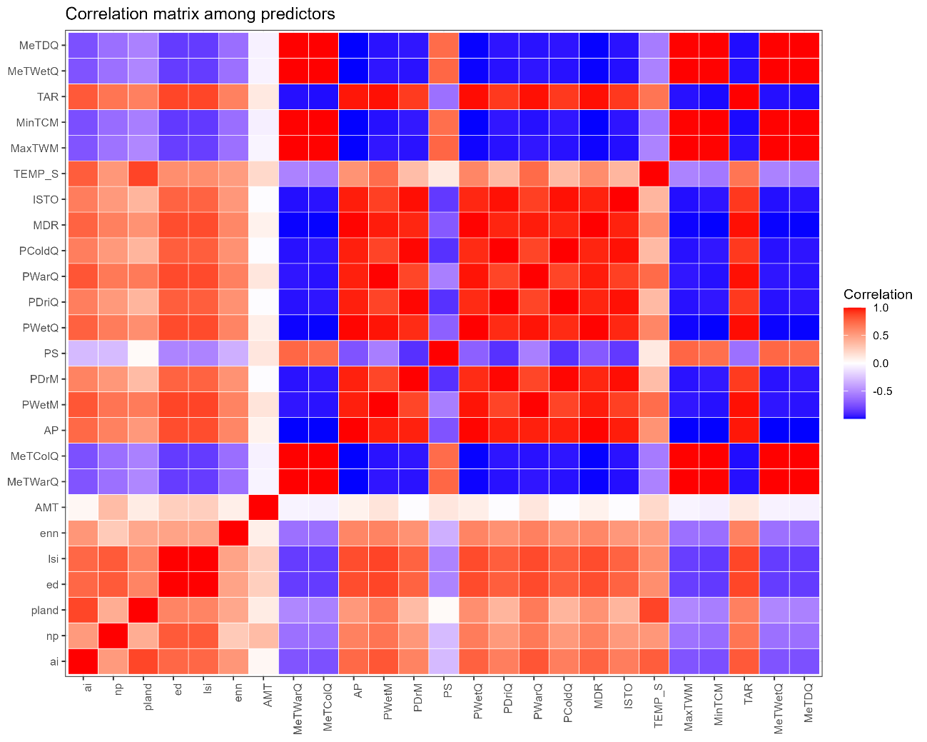
Supplementary Figure S2. Relative importance of climatic and landscape predictors in quasibinomial generalized linear models (GLMs) evaluating the occurrence of dietary items in maned wolf fecal samples. Importance scores represent the relative contribution of each predictor across models, with higher values indicating greater explanatory influence.
