Supplementary Information
Genome-wide evidence for differential selection between urban and non-urban habitats in a bird of prey

Gianluca Damiani^{1,2,*}, Giulia Gentile^{1,*}, Paolo Franchini¹, Simone Messina¹, Giacomo Dell’Omo² and David Costantini^{1,2}

1: Department of Ecological and Biological Sciences, University of Tuscia, Largo dell'Università, 01100 Viterbo, Italy
2: Ornis italica, Piazza Crati 15, 00199 Rome, Italy

*These authors contributed equally to this work.

Corresponding author: Gianluca Damiani, gianluca.damiani@unitus.it.

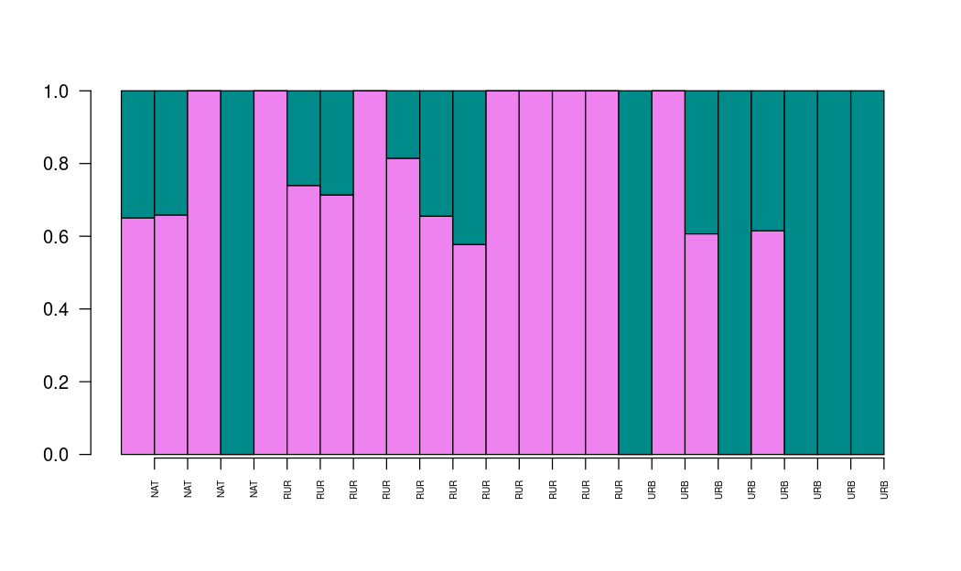

Figure S1. Admixture analysis barplot (K = 2) showing no clear genetic structure among RUR, NAT and URB groups.

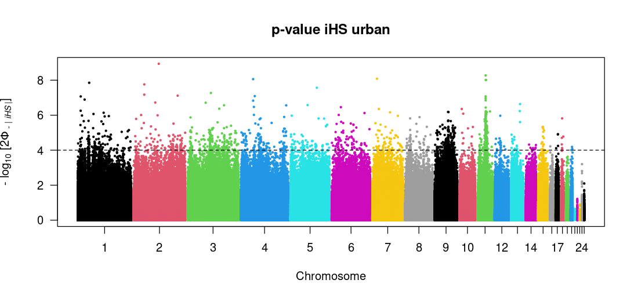

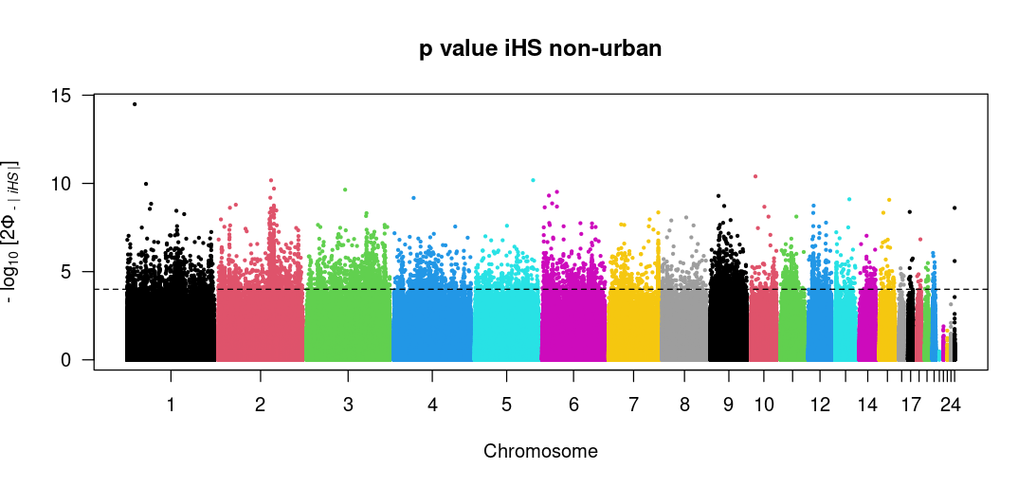

Figure S2. Genome-wide Manhattan plots showing −log₁₀(p) values of the Integrated Haplotype Score (iHS) for urban (top) and non-urban (bottom) populations.

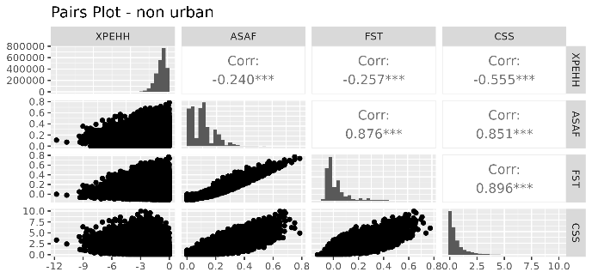
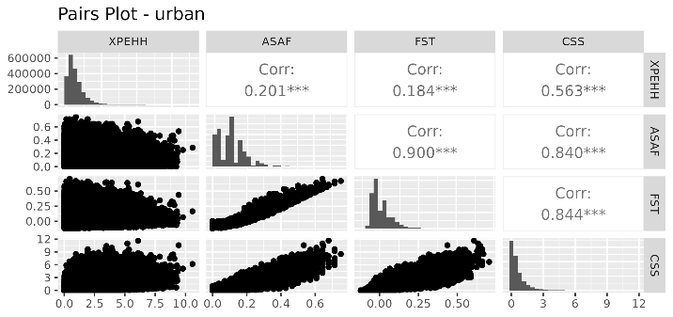

Figure S3. Pairwise correlations among XP-EHH, ΔSAF, FST, and CSS statistics in urban (left panel) and non-urban (right panel) groups. All statistics are derived from the same pairwise comparison between urban and non-urban populations, and panels reflect the direction of the selection signal. Correlations are computed across SNPs and reflect concordance among selection statistics. For each matrix, the lower diagonal shows scatter plots of SNP-wise values, the diagonal displays the distribution of each statistic (histograms), and the upper diagonal reports Pearson correlation coefficients. Asterisks indicate significance levels (*** p < 0.001).

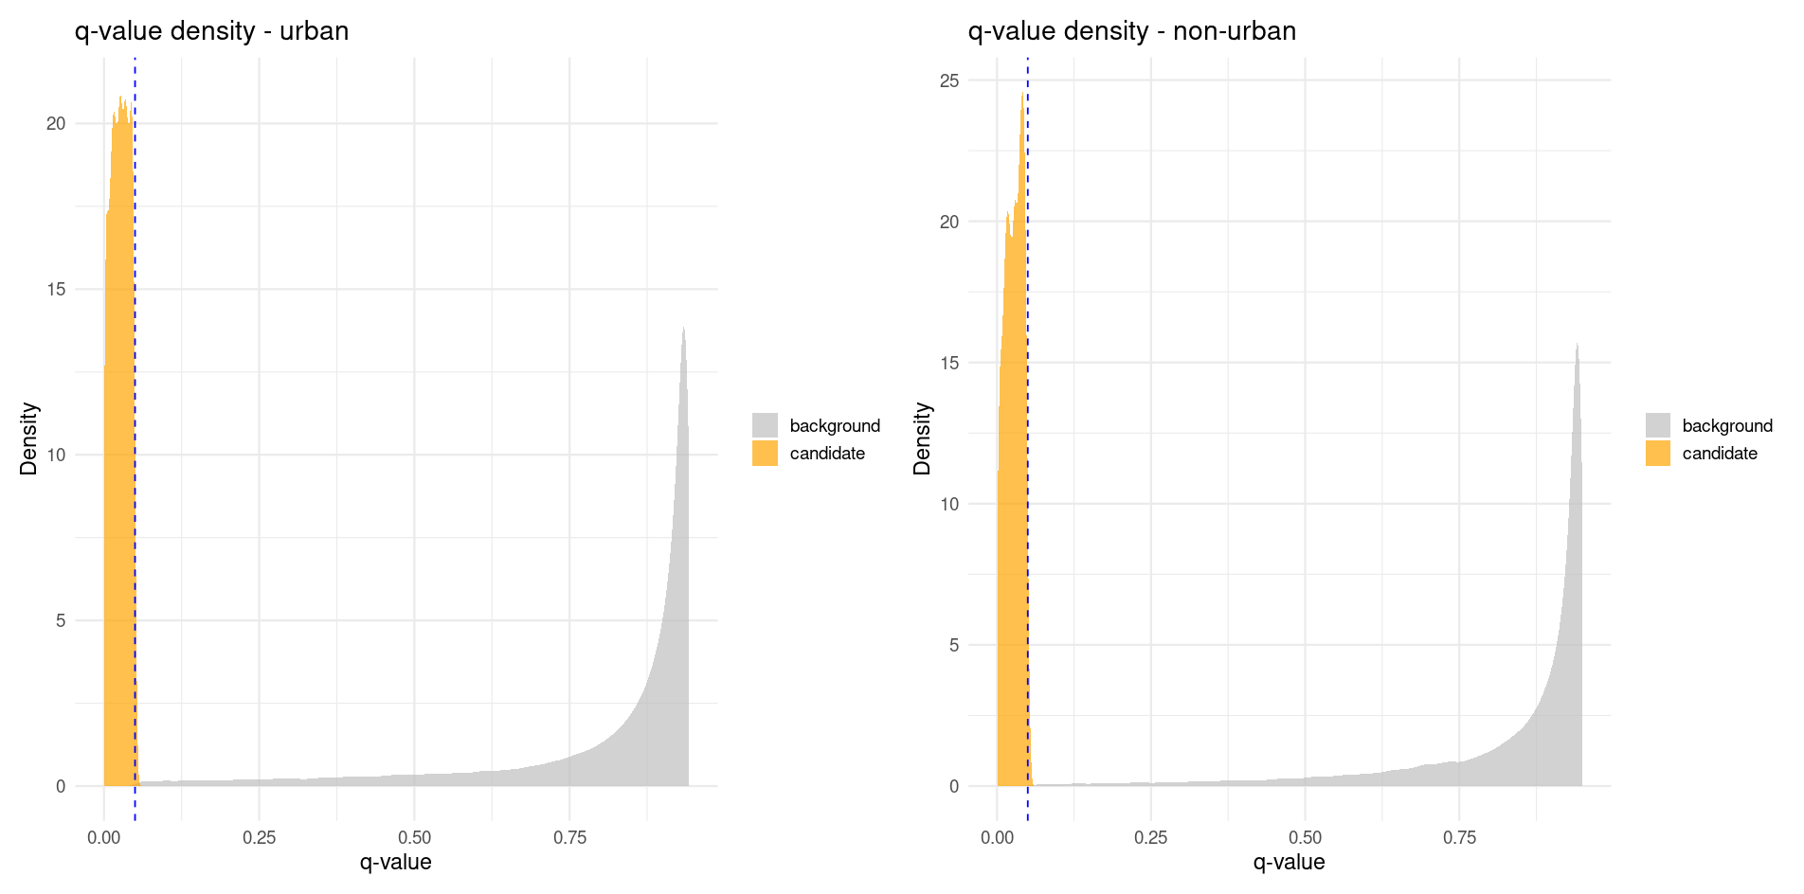

Figure S4. Density plots of false discovery rate (q-value) distributions for SNPs in significant clusters (orange) and genome-wide background SNPs (gray). The dashed line marks the q = 0.05 (FDR) threshold.

ID | O(HOM) | E(HOM) | N(NM) | F | Population
A217 | 39626 | 4,17E+07 | 68920 | -0.07658 | non urban
A223 | 271979 | 2.81e+05 | 460716 | -0.05029 | non urban
A224 | 277918 | 2,83E+08 | 464382 | -0.02951 | non urban
A237 | 274714 | 2.84e+05 | 465679 | -0.05138 | non urban
A225 | 276816 | 2,83E+08 | 464187 | -0.03488 | non urban
A226 | 275440 | 2,83E+08 | 464199 | -0.04259 | non urban
A227 | 275516 | 2,84E+08 | 464985 | -0.0447 | non urban
A228 | 274658 | 2,83E+08 | 464697 | -0.04851 | non urban
A229 | 275190 | 2,84E+08 | 465312 | -0.04752 | non urban
A230 | 274515 | 2,84E+08 | 464729 | -0.04938 | non urban
A238 | 272964 | 2,83E+08 | 463150 | -0.05283 | non urban
A231 | 273902 | 2,84E+08 | 465733 | -0.05603 | non urban
A232 | 275779 | 2,84E+08 | 465844 | -0.04606 | non urban
A233 | 275277 | 2,82E+08 | 462753 | -0.03869 | non urban
A234 | 275814 | 2,84E+08 | 465822 | -0.0458 | non urban
A216 | 275977 | 2,84E+08 | 464932 | -0.04194 | urban
A218 | 274741 | 2,84E+08 | 465166 | -0.0496 | urban
A219 | 275844 | 2,84E+08 | 465118 | -0.0433 | urban
A220 | 278423 | 2,84E+08 | 465146 | -0.02923 | urban
A221 | 273405 | 2,84E+08 | 465233 | -0.05714 | urban
A222 | 272423 | 2,82E+08 | 462826 | -0.05474 | urban
A235 | 276302 | 2,84E+08 | 464874 | -0.03995 | urban
A236 | 32804 | 3,33E+07 | 55016 | -0.02137 | urban

Table S1. Individual inbreeding coefficients (F) were estimated across the whole population using PLINK v1.9, based on the observed (O(HOM)) and expected (E(HOM)) numbers of homozygous genotypes. N(NM) represents the number of non-missing SNPs used per individual.

CHR | start | end | n_snps | n_candidates | recomb_rate | recomb_class
1 | 5985000 | 6117999 | 796 | 127 | 0.0000000022095532 | 3
1 | 6118000 | 6250999 | 629 | 115 | 0.0000000022848657 | 3
1 | 16891000 | 17023999 | 856 | 6 | 0.0000000030743860 | 4
1 | 53599000 | 53731999 | 197 | 5 | 0.0000000009490813 | 2
2 | 49140000 | 49274999 | 98 | 10 | 0.0000000003186365 | 1
2 | 62640000 | 62774999 | 117 | 9 | 0.0000000002090038 | 1
5 | 76475000 | 76635999 | 646 | 48 | 0.0000000014904251 | 2
5 | 76636000 | 76796999 | 363 | 29 | 0.0000000012982922 | 2
5 | 76314000 | 76474999 | 172 | 26 | 0.0000000003257488 | 1
5 | 76153000 | 76313999 | 695 | 12 | 0.0000000020754823 | 3
13 | 6960000 | 7104999 | 439 | 13 | 0.0000000006394796 | 1
13 | 7105000 | 7249999 | 679 | 8 | 0.0000000019611645 | 3
13 | 6815000 | 6959999 | 1036 | 6 | 0.0000000025005856 | 3
15 | 9086000 | 9239999 | 293 | 14 | 0.0000000003448396 | 1
15 | 9548000 | 9701999 | 400 | 7 | 0.0000000017256960 | 3

Table S2. Genomic windows identified as candidate regions based on the number of candidate SNPs. For each window, chromosome (CHR), genomic coordinates (start–end), total number of SNPs (n_snps), number of candidate SNPs (n_candidates), mean recombination rate (recomb_rate), and recombination class (recomb_class) are reported. Candidate windows were defined as those containing more than five candidate SNPs.

