Supplementary Information: Using decadal forecasts to refine the first few years of climate projections of modes of variability

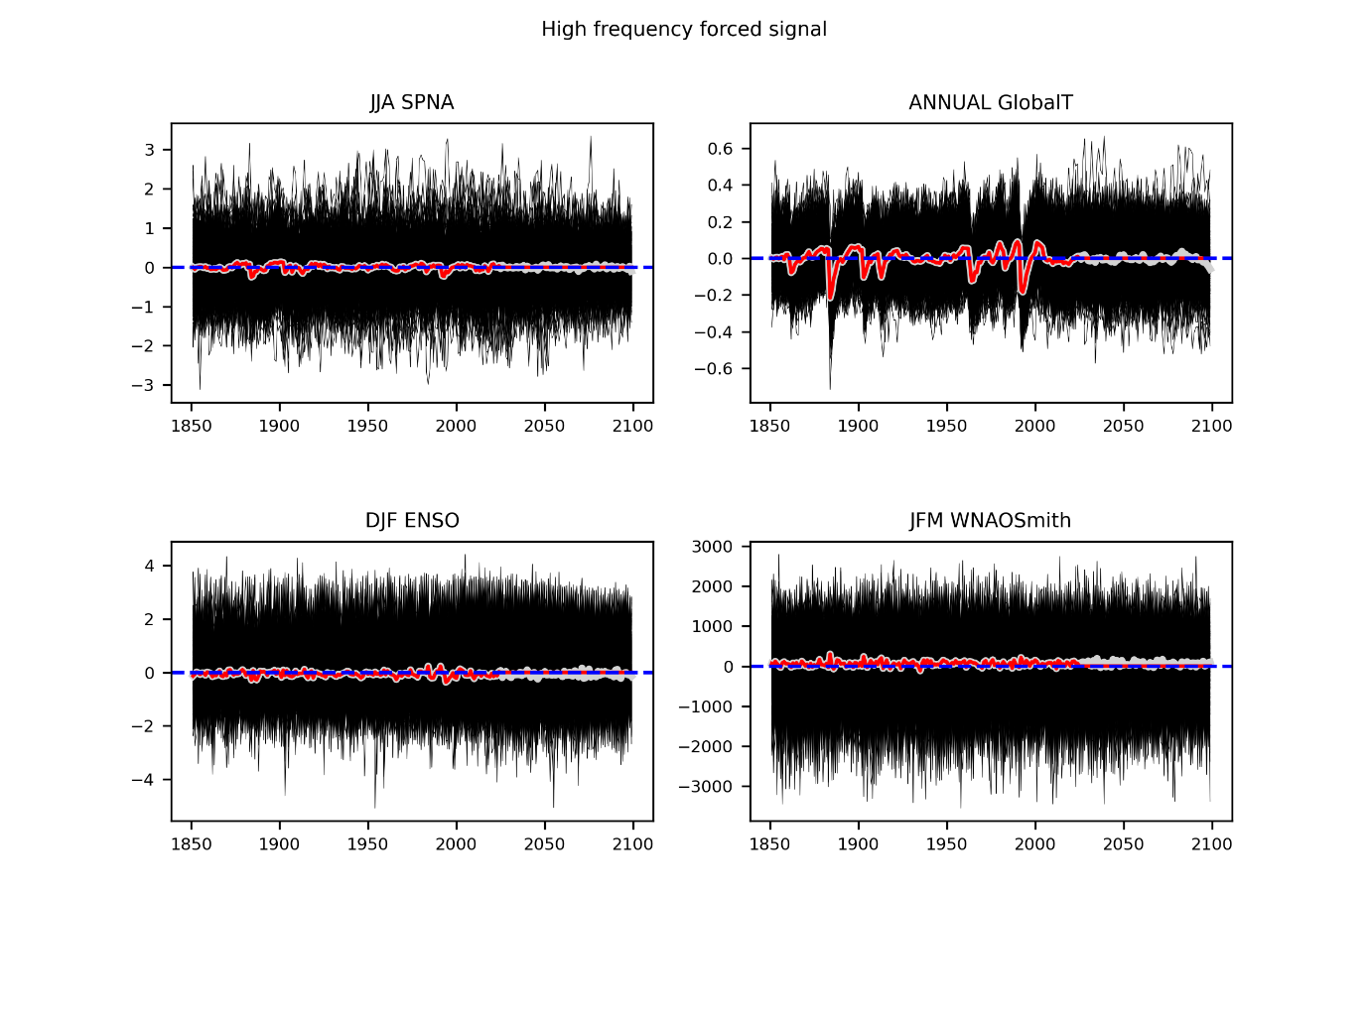
Fig. S1 Estimation of the high frequency forced signal (grey line) from the set of deviations about each long term forced signal for each realisation (black lines). The red line is the same as the grey except values after 2016 are set to zero

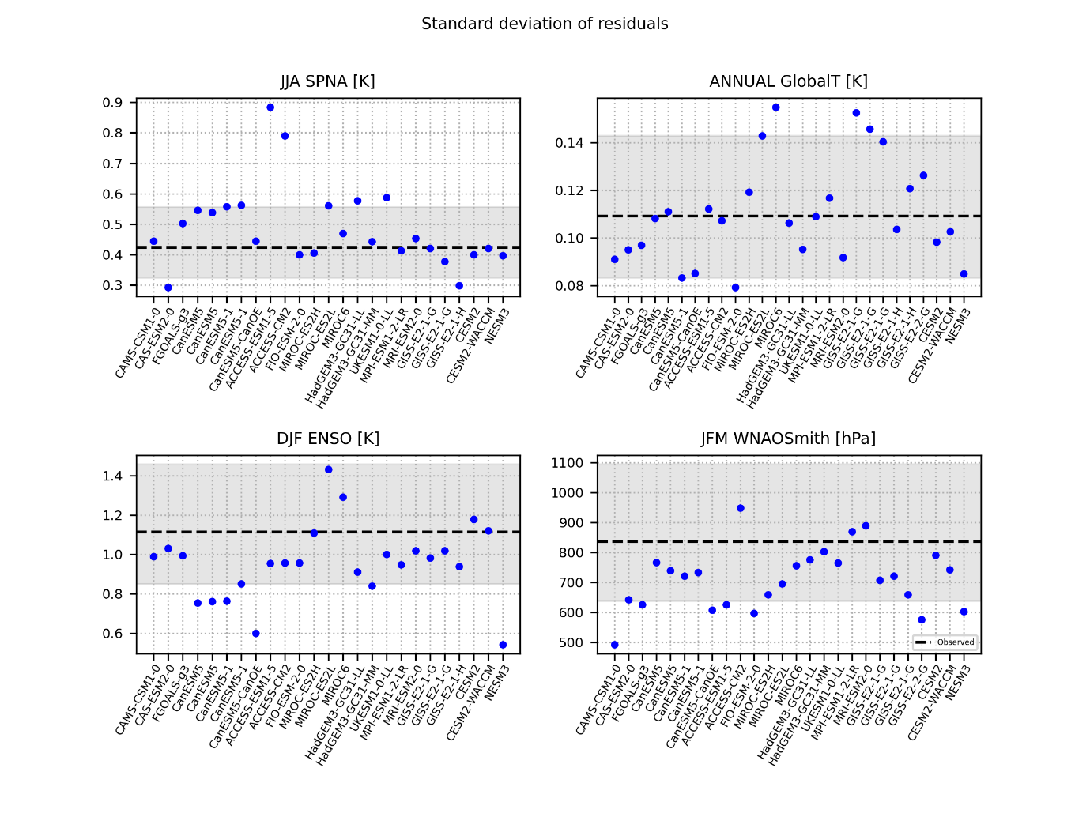

Fig. S2 Evaluation of the standard deviation of the deviations in the projections in comparison to the residual variance in the reanalysis once the forced signal has been regressed out

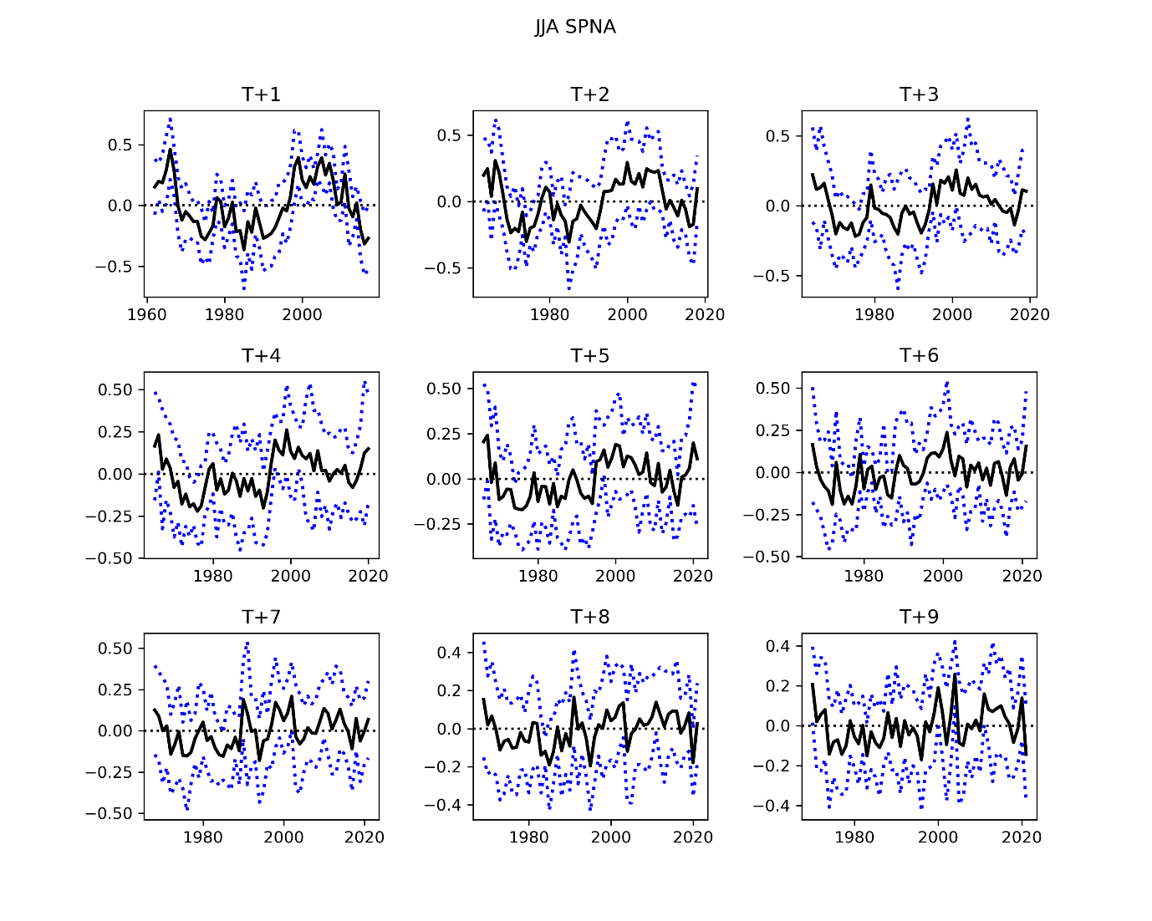
Fig. S3 The average pooled forecast signal for summer SPNA (black line) and the spread in the forecast for each lead time

