Supplementary Information
for
Light-dependent aggregate formation and photosynthetic acclimation during biofilm development in Synechocystis sp. PCC 6803

Mariann Kis¹, Attila W. Kovács¹ and Gábor Bernát¹

¹HUN-REN Balaton Limnological Research Institute, Tihany, 8237, Hungary

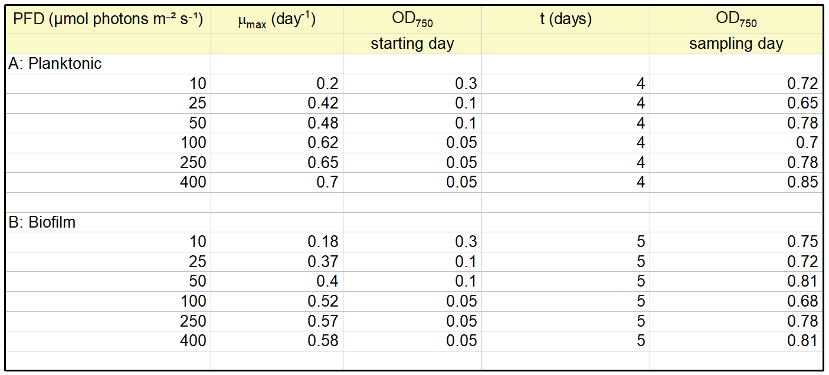
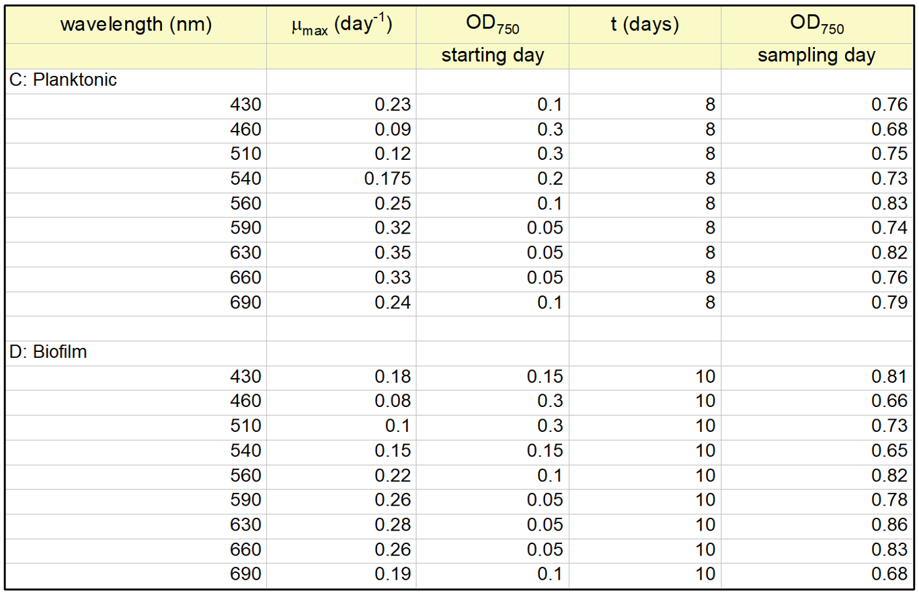
Supplementary Table: Growth characteristics of planktonic (A, C) and biofilm (B, D) cultures of Synechocystis sp. PCC 6803 GT-L exposed to different light intensities (PFD: 10-400 µmol photons m⁻² s⁻¹) and wavelengths (430–690 nm). The specific growth rate (μ_{max}, day⁻¹) was calculated from OD₇₅₀​​ values using the exponential growth equation. The initial optical density (OD₇₅₀​) was adjusted based on previous growth rate data. Final OD₇₅₀​​ values measured on the sampling day are also shown for each treatment.

Fiji – Image J macro code
// Synechocystis Cell Size and Shape Analyzer
// --- Parameters ---
minSize = 3 ; // Minimum cell size (µm2)
maxSize =3000 ; // Maximum cell size (µm2)
// --- Start ---
run("8-bit");
run("Set Measurements...", "area mean min centroid center perimeter bounding fit shape feret's add redirect=None decimal=3");
// Threshold & binarize
setOption("BlackBackground", false);
run("Convert to Mask");
// Optional: Fill holes and separate touching cells
run("Fill Holes");
run("Watershed");
// Analyze particles
run("Analyze Particles...", "size="+minSize+"-"+maxSize+" show=Outlines display exclude clear");
// Save results
saveAs("Results", getDirectory("current") + "Synechocystis_Cell_Measurements.csv");

References: ImageJ user guide: https://imagej.net/imaging/particle-analysis

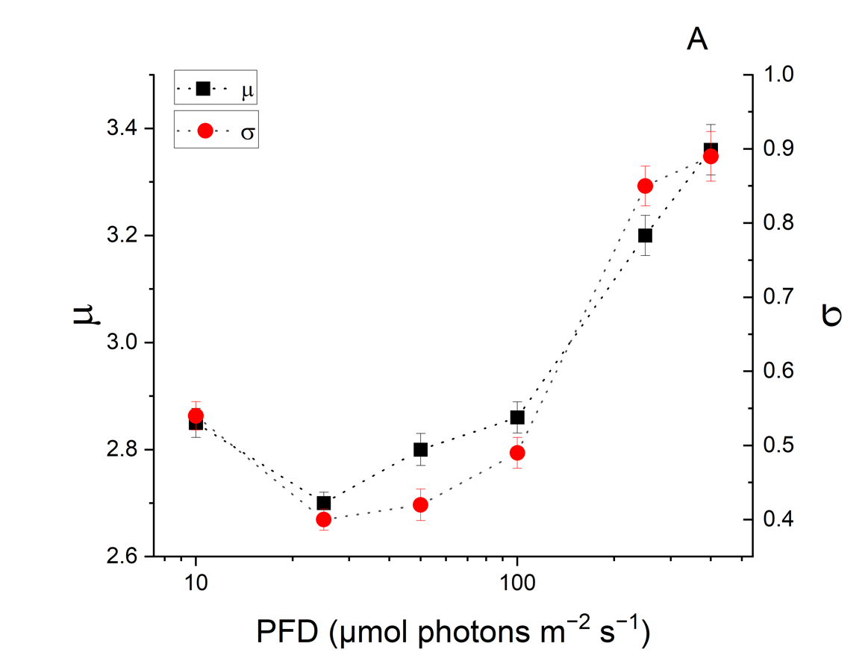
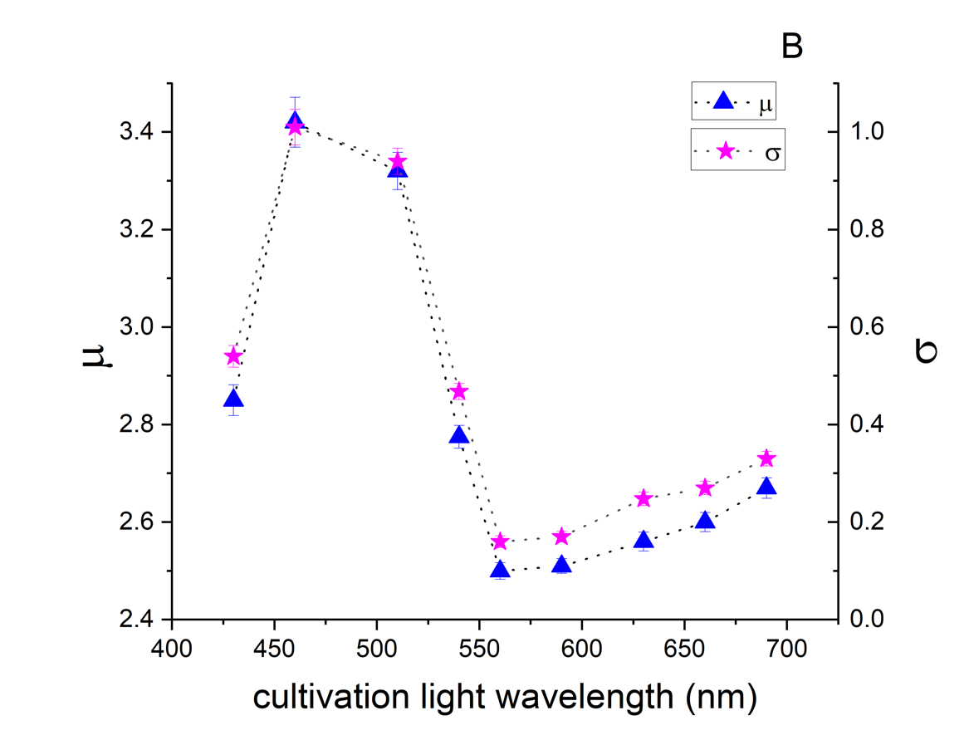
Supplementary Figure 1. Log-normal scale (μ) and shape (σ) parameters as a function of PFD and monochromatic cultivation wavelength. The μ parameter reflects the central tendency of aggregate size, while σ describes distribution breadth and heterogeneity. In all analyses, small objects (<10 µm²; single cells and early 3–5-cell microcolonies) were excluded. Per treatment, 1000–3000 raw objects were initially detected, yielding 200–600 aggregates suitable for log-normal modeling. Percentile trimming (the upper 5%, retaining the lower 95%) were used to exclude merged aggregates.

