Supplementary Table 1. Quantity of each colour solution (Arcos®, Brazil) diluted in 100 mL of water.
Colour |  | Hexadecimal code | Name of Food colouring | Quantity (µL)
Red |  | #FF0000 | Red | 200
Blue |  | #0000FF | Purple | 20
Blue |  | #0000FF | Turquoise blue | 20
Yellow |  | #FFFF00 | Yellow | 200
Brown |  | #800000 | Brown | 200
Brown |  | #800000 | Red | 20
Green |  | #008000 | Green Lemon | 50
Green |  | #008000 | Turquoise blue | 20
Purple |  | #800080 | Purple | 20
Purple |  | #800080 | Maple’’Bordo | 50
Pink |  | #FF99CC | Pink | 20

Supplementary Table 2. Dietary intake in the 24 h prior to each condition in Experiment 3.
 | Control | Colourless | CS | IS | p-value
Calories (kcal) | 2283 ± 1014 | 2249 ± 795 | 2416 ± 765 | 2317 ± 810 | 0.9
Carbohydrates (g/kg) | 3.62 ± 2.04 | 3.69 ± 1.45 | 4.0 ± 1.53 | 3.82 ± 1.58 | 0.6
Protein (g/kg) | 1.67 ± 0.83 | 1.52 ± 0.71 | 1.78 ± 0.89 | 1.44 ± 0.59 | 0.6
Lipids (g/kg) | 1.12 ± 0.59 | 1.13 ± 0.48 | 1.13 ± 0.38 | 1.16 ± 0.44 | >0.9
Fiber (g) | 22 ± 13 | 20 ± 10 | 23 ± 18 | 21 ± 10 | >0.9
CS = Congruent solution; IS = Incongruent solution.

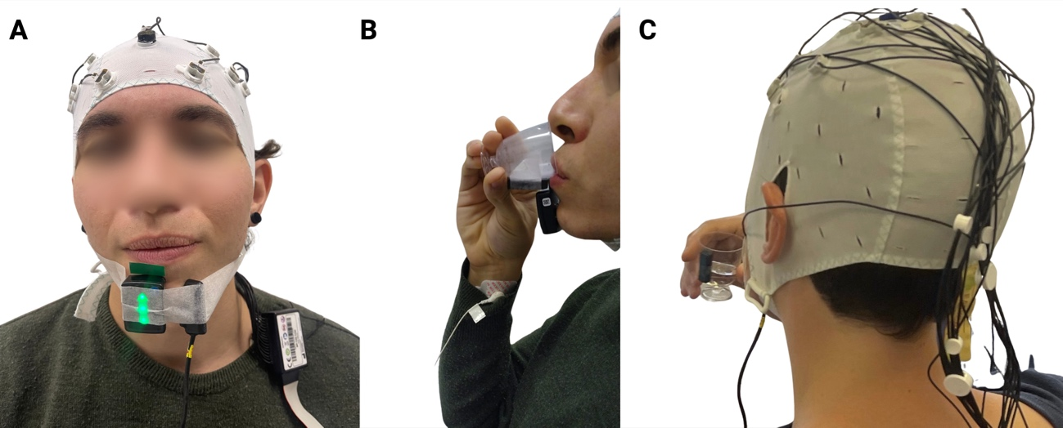
Supplementary Fig. 1. Experimental trigger setup for timing control during mouth-rinse administration.
Representative images illustrating the experimental trigger system used to precisely identify the timing of solution contact with the tongue and solution removal. A) Frontal view showing the trigger sensor positioned on the mentalis muscle to detect facial muscle activation at mouth opening. B) Lateral view depicting the participant bringing the cup to the mouth, with activation of the cup-mounted trigger sensor indicating solution delivery. C) Posterior view highlighting the trigger sensor attached to the cup. This setup allowed for precise temporal synchronization of electrophysiological recordings with mouth-rinse events in the within-subject crossover design. Created in https://BioRender.com
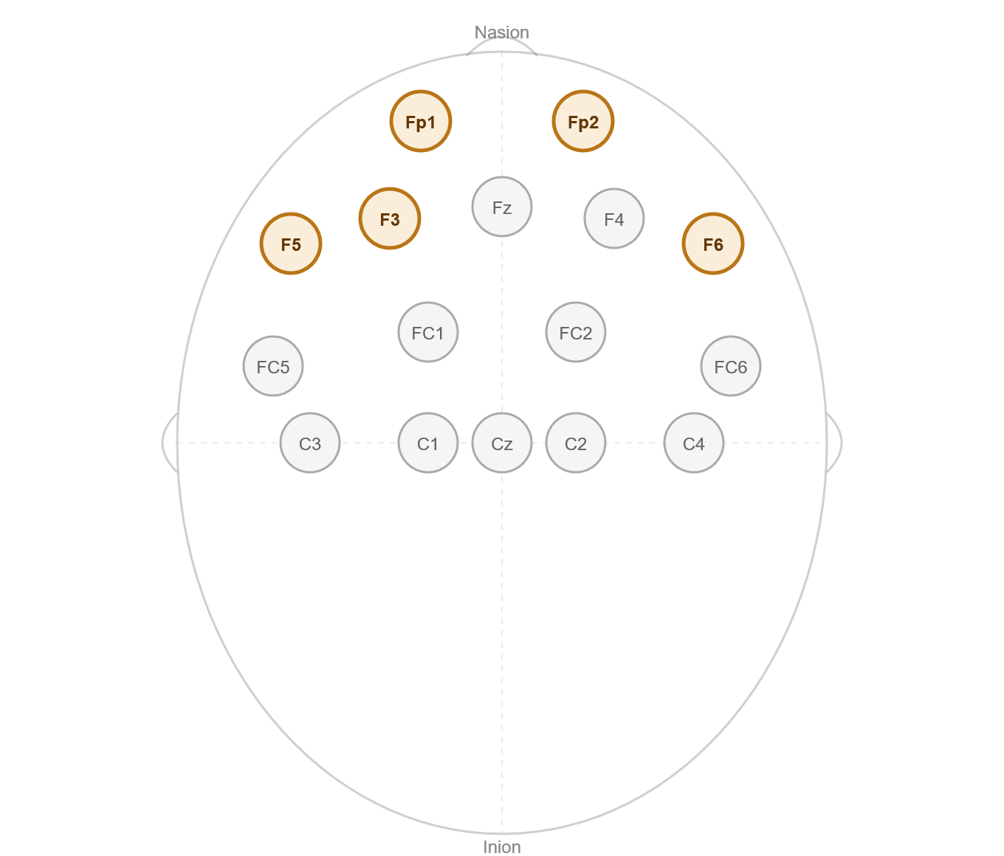
Supplementary Fig. 2. Schematic representation of EEG electrode placement according to the international 10–20 system. Prefrontal and frontal electrodes analysed in the present study (Fp1, Fp2, F3, F5, and F6) are highlighted in orange. Remaining electrodes represent the full 16-channel recording montage. Created in https://BioRender.com

