SUPPLEMENTAL MATERIALS
Point‑of‑Care Ultrasound Accurately Detects COPD:
A Multicenter Prospective Diagnostic Accuracy Study

Roy Rafael Dayan^{1,2}, Itamar Ben Shitrit^{1,3}, Ofri Karni¹, Lev Freidkin^{4,5}, Jonathan Taylor⁶, Omer Babayan¹, Roni Jedwab¹, Tomer Gat¹, Roie Carmel¹, Lior Fuchs^{1,7#}, Michael Kassirer^{1,8#}

¹ Faculty of Health Sciences, Ben-Gurion University of the Negev, Israel
² Department of Intensive Care Medicine, Tel-Aviv Medical Center, Israel
³ Clinical Research Center, Soroka University Medical Center, Israel
⁴ Gray School of Medicine, Faculty of Medical and Health Sciences, Tel Aviv University, Tel Aviv, Israel
⁵ Pulmonary division, Rabin Medical Center, Petah Tikva, Israel
⁶ Division of Respirology, University Health Network, Toronto, Ontario, Canada
⁷ Department of Intensive Care Medicine, Soroka University Medical Center, Israel
⁸ Pulmonary Institute, Soroka University Medical Center, Israel

Table of Contents
Table S1 – Demographic, background medical history, mMRC Dyspnea Scale and POCUS examination stratified by recruiting center 3
Table S2 . POCUS as a predictor of PFT metrics 6
Figure S1 – Lung ultrasound 7
Figure S2 – Cardiac Ultrasound 8
Figure S3 - Pulmonary Function Test Parameters per Combined Parasternal-subcostal US score 9
Figure S4 - ROC Curves Analysis for Isolated Apical, Parasternal, and Subcostal Views for Detecting COPD 10

Table S1 – Demographic, background medical history, mMRC Dyspnea Scale and POCUS examination stratified by recruiting center
 | Soroka University Medical Center |  | Rabin University Medical Center
Characteristic | No COPD | COPD | No COPD | COPD
Characteristic | N = 183 (73%) | N = 68 (27%) | N = 38 (76%) | N = 12 (24%)
Demographics
Age (years), Mean (SD) | 62 (16) | 62 (16) | 56 (19) | 63 (9)
Sex (Male), No. (%) | 83 (47%) | 29 (44%) | 15 (41%) | 9 (69%)
Ethnicity (Jewish), No. (%) | 163 (90%) | 58 (87%) | 38 (100%) | 10 (77%)
BMI (kg/m²), Mean (SD) | 29 (11) | 26 (5) | 26.4 (4.7) | 27.1 (6.5)
Smoking History, No. (%) | 74 (54%) | 59 (94%) | 30 (79%) | 12 (92%)
Pack Years, Mean (SD) | 13 (21) | 43 (17) | 13 (19) | 40 (18)
Background Medical History
Hospitalizations due to Lung Disease, No. (%) | 16 (8.7%) | 9 (13%) | 3 (7.9%) | 5 (38%)
Use of Bronchodilators, No. (%) | 53 (29%) | 53 (79%) | 6 (16%) | 11 (85%)
Home Oxygen Use, No. (%) | 2 (1.1%) | 8 (12%) | 0 (0%) | 0 (0%)
Home BPAP Use, No. (%) | 6 (3.3%) | 5 (7.5%) | 0 (0%) | 0 (0%)
Myocardial Infarction, No. (%) | 15 (8.2%) | 6 (9.0%) | 4 (11%) | 1 (7.7%)
Congestive Heart Failure, No. (%) | 19 (10%) | 6 (9.0%) | 4 (11%) | 1 (7.7%)
Peripheral Vascular Disease, No. (%) | 31 (17%) | 11 (16%) | 8 (21%) | 2 (15%)
Cerebrovascular Disease, No. (%) | 39 (21%) | 8 (12%) | 5 (13%) | 2 (15%)
Dementia, No. (%) | 0 (0%) | 0 (0%) | 0 (0%) | 0 (0%)
Rheumatologic Disease, No. (%) | 25 (14%) | 9 (13%) | 4 (11%) | 0 (0%)
Peptic Ulcer Disease, No. (%) | 15 (8.2%) | 9 (13%) | 3 (7.9%) | 1 (7.7%)
Mild Liver Disease, No. (%) | 33 (18%) | 15 (22%) | 7 (18%) | 4 (31%)
Diabetes, No. (%) | 77 (42%) | 29 (43%) | 10 (26%) | 5 (38%)
Diabetes with Complications, No. (%) | 5 (2.7%) | 0 (0%) | 1 (2.6%) | 0 (0%)
Hemiplegia or Paraplegia, No. (%) | 5 (2.7%) | 0 (0%) | 1 (2.6%) | 1 (7.7%)
Renal Disease, No. (%) | 21 (11%) | 5 (7.5%) | 2 (5.3%) | 0 (0%)
Any Malignancy, No. (%) | 44 (24%) | 16 (24%) | 3 (7.9%) | 2 (15%)
Moderate/Severe Liver Disease, No. (%) | 1 (0.5%) | 1 (1.5%) | 1 (2.6%) | 0 (0%)
Metastatic Solid Tumor, No. (%) | 8 (4.4%) | 3 (4.5%) | 0 (0%) | 0 (0%)
AIDS, No. (%) | 2 (1.1%) | 0 (0%) | 0 (0%) | 0 (0%)
Charlson Comorbidity Index, Mean (SD) | 3 (3) | 3 (3) | 2 (3) | 2 (2)
Age-Adjusted CCI, Mean (SD) | 5 (3) | 5 (3) | 4 (3) | 4 (3)
Asthma, No. (%) | 43 (23%) | 0 (0%) | 7 (18%) | 0 (0%)
Bronchiectasis, No. (%) | 4 (2.2%) | 0 (0%) | 6 (16%) | 0 (0%)
Cystic Fibrosis, No. (%) | 1 (0.5%) | 0 (0%) | 0 (0%) | 0 (0%)
Empyema, No. (%) | 0 (0%) | 0 (0%) | 1 (2.6%) | 0 (0%)
Hypoplastic Lung, No. (%) | 0 (0%) | 0 (0%) | 1 (2.6%) | 0 (0%)
Interstitial Lung Disease, No. (%) | 0 (0%) | 0 (0%) | 6 (16%) | 0 (0%)
Restrictive Disease, No. (%) | 0 (0%) | 0 (0%) | 2 (5.3%) | 0 (0%)
Sarcoidosis, No. (%) | 0 (0%) | 0 (0%) | 1 (2.6%) | 0 (0%)
Pulmonary function tests during visit
FVC % predicted, Mean (SD) | 86 (21) | 61 (8) | 88 (18) | 62 (9)
Oxygen Saturation (%), Mean (SD) | 97 (2) | 96 (3) | NA (NA) | NA (NA)
FEV1 % predicted, Mean (SD) | 84 (23) | 50 (13) | 85 (22) | 54 (24)
FEV1/FVC ratio, Mean (SD) | 80 (10) | 57 (10) | 78(10) | 56 (9)
FEF25-75 % predicted, Mean (SD) | 72 (34) | 35 (23) | 70 (31) | 35 (18)
TLC % predicted, Mean (SD) | 94 (8) | 127 (6) | 93 (6) | 131 (14)
RV % predicted, Mean (SD) | 92 (10) | 164 (21) | 92 (6) | 177 (16)
RV/TLC %, Mean (SD) | 29 (4) | 52 (10) | 30 (5) | 53 (4)
DLCO % predicted, Mean (SD) | 78 (21) | 61 (24) | 77 (19) | 65 (17)
KCO % predicted, Mean (SD) | 98 (27) | 78 (25) | 96 (28) | 83 (21)
mMRC Dyspnea Scale, No. (%)
0 | 54 (30%) | 4 (6.0%) | 20 (53%) | 1 (7.7%)
1 | 35 (19%) | 5 (7.5%) | 8 (21%) | 3 (23%)
2 | 31 (17%) | 11 (16%) | 5 (13%) | 3 (23%)
3 | 40 (22%) | 34 (51%) | 5 (13%) | 6 (46%)
4 | 23 (13%) | 13 (19%) | 0 (0%) | 0 (0%)
Hands-on POCUS examination
A lines, Mean (SD) | 6.07 (2.03) | 6.43 (2.08) | 2.89 (1.83) | 2.61(2.89)
B lines, Mean (SD) | 0.33 (1.28) | 0.71 (2.05) | 1.105 (1.79) | 1.53 (2.20)
Parasternal, No. (%)
High-quality view | 96 (52%) | 3 (4.5%) | 22 (58%) | 1 (7.7%)
Acceptable view | 64 (35%) | 28 (42%) | 8 (21%) | 6 (46%)
Poor-quality view | 23 (13%) | 36 (54%) | 8 (21%) | 6 (46%)
Subcostal, No. (%)
Poor-quality view | 34 (19%) | 2 (3.0%) | 4 (11%) | 0 (0%)
Acceptable view | 64 (35%) | 20 (30%) | 8 (21%) | 1 (7.7%)
High-quality view | 85 (46%) | 45 (67%) | 26 (68%) | 12 (92%)
Apical, No. (%)
High-quality view | 89 (49%) | 31 (46%) | 24 (63%) | 7 (54%)
Acceptable view | 53 (29%) | 16 (24%) | 8 (21%) | 2 (15%)
Poor-quality view | 41 (22%) | 20 (30%) | 6 (16%) | 4 (31%)

Table S2 . POCUS as a predictor of PFT metrics

Composite Parasternal–Subcostal Ultrasound Score (range 0–4) | FVC % Predicted |  | FEV1 % Predicted |  | FEV1/FVC Ratio |  | FEF25-75 % Predicted |  | TLC % Predicted |  | RV % Predicted |  | RV/TLC% |  | DLCO % Predicted |  | KCO % Predicted
Composite Parasternal–Subcostal Ultrasound Score (range 0–4) | Beta (95% CI) | p-value | Beta (95% CI) | p-value | Beta (95% CI) | p-value | Beta (95% CI) | p-value | Beta (95% CI) | p-value | Beta (95% CI) | p-value | Beta (95% CI) | p-value | Beta (95% CI) | p-value | Beta (95% CI) | p-value
0 (Reference level) | — | <0.001 | — | <0.001 | — | <0.001 | — | <0.001 | — | <0.001 | — | <0.001 | — | <0.001 | — | 0.6 | — | 0.2
1 | 0.30 (-11, 12) |  | -1.0 (-14, 12) |  | -4.9 (-12, 2.4) |  | -9.3 (-28, 9.4) |  | 0.66 (-8.4, 9.7) |  | -0.66 (-21, 20) |  | -1 (6,-7_ |  | 3.6 (-11, 19) |  | 2.3 (-16, 20)
2 | 3.8 (-6.4, 14) |  | -0.15 (-12, 12) |  | -5.9 (-12, 0.69) |  | -14 (-31, 3.3) |  | 5.8 (-2.3, 14) |  | 8.4 (-9.7, 26) |  | 2 (8,-4) |  | 5.4 (-8.3, 19) |  | -3.0 (-20, 14)
3 | -8.1 (-19, 2.6) |  | -13 (-26, -0.41) |  | -13 (-20, -6.5) |  | -27 (-44, -9.0) |  | 21 (13, 29) |  | 42 (24, 61) |  | 13 (19,7) |  | 0.02 (-14, 14) |  | 0.54 (-17, 18)
4 | -10 (-22, 0.80) |  | -18 (-32, -5.0) |  | -18 (-25, -11) |  | -32 (-51, -14) |  | 24 (15, 33) |  | 48 (28, 69) |  | 14 (20,7) |  | -1.2 (-16, 14) |  | -13 (-31, 4.9)
¹Coefficients represent mean differences from the reference group (composite score of 0). Global p-values test overall group differences.
²CI = Confidence Interval

The table shows how combined parasternal-subcostal cardiac POCUS scores (on a scale of 0-4) correlate with different lung function metrics (PFT parameters). DLCO: diffusing capacity of the lungs for carbon monoxide, DLCO= Diffusing Capacity of the Lungs for Carbon Monoxide, FEF25-75%= Forced Expiratory Flow at 25-75, FEV1= Forced Expiratory Volume in one Second, FVC= forced vital capacity, KCO= carbon monoxide transfer coefficient, RV= Residual Volume. TLC= Total Lung Capacity.

Figure S1 – Lung ultrasound
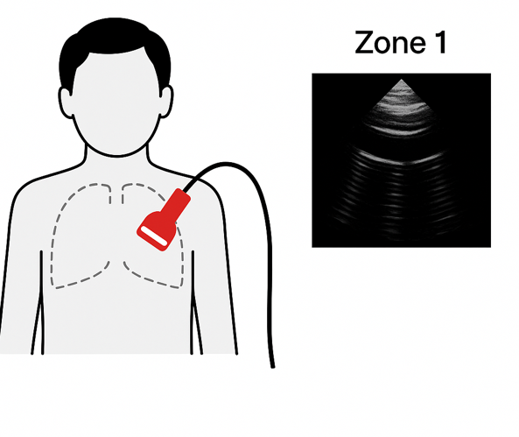
Figure S1. The ultrasound probe is placed at zone 1 on the anterior chest

Figure S2 – Cardiac Ultrasound
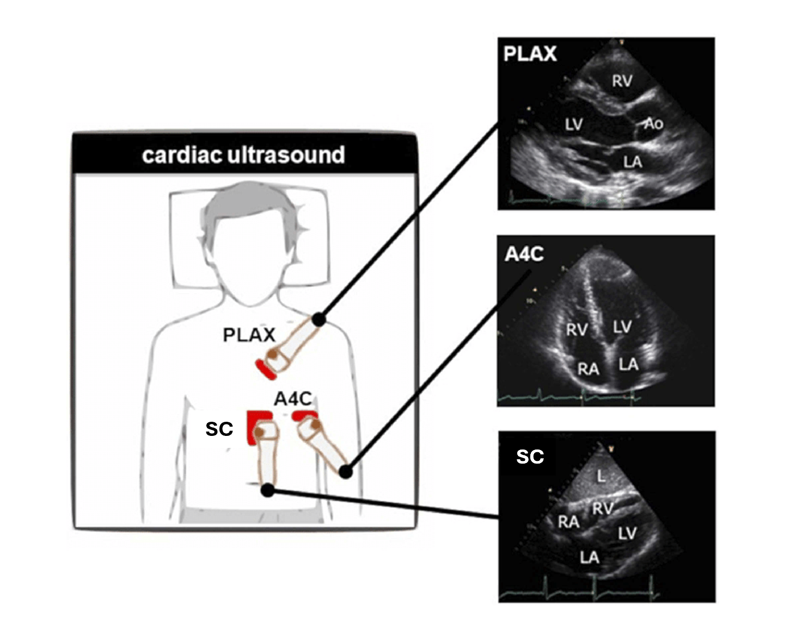

Figure S2. The formal 3-part cardiac exam (Parasternal, Apical, and the subcostal views)

Figure S3 - Pulmonary Function Test Parameters per Combined Parasternal-subcostal US score
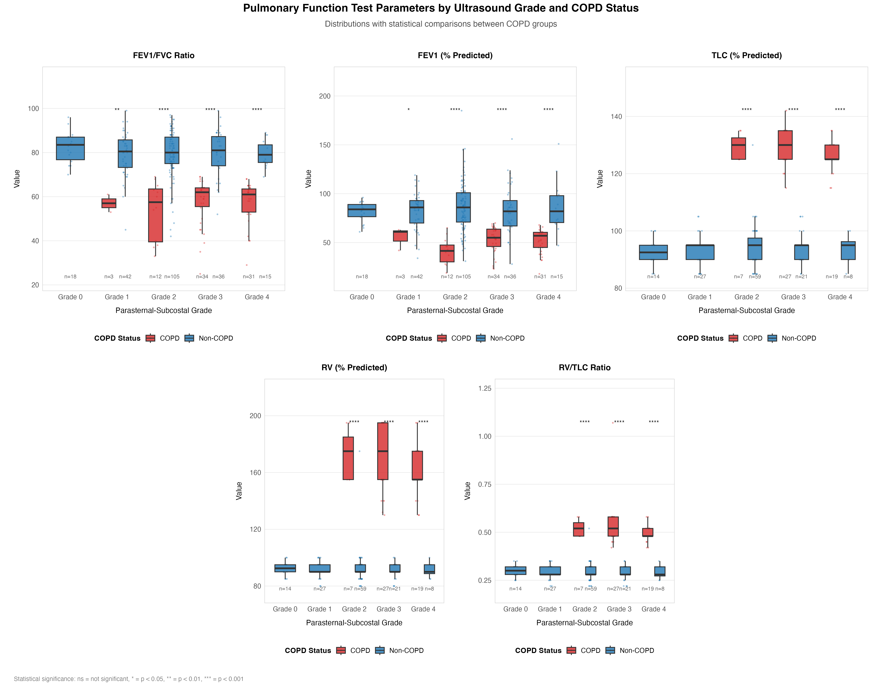
Figure S3. Pulmonary function test parameters by parasternal-subcostal ultrasound grade and COPD status. Red boxes represent patients with COPD, blue boxes represent patients without COPD. Statistical significance: * = p < 0.05, ** = p < 0.01, *** = p < 0.001. FEV1 = forced expiratory volume in 1 second; FVC = forced vital capacity; TLC = total lung capacity; RV = residual volume.

Figure S4 - ROC Curves Analysis for Isolated Apical, Parasternal, and Subcostal Views for Detecting COPD

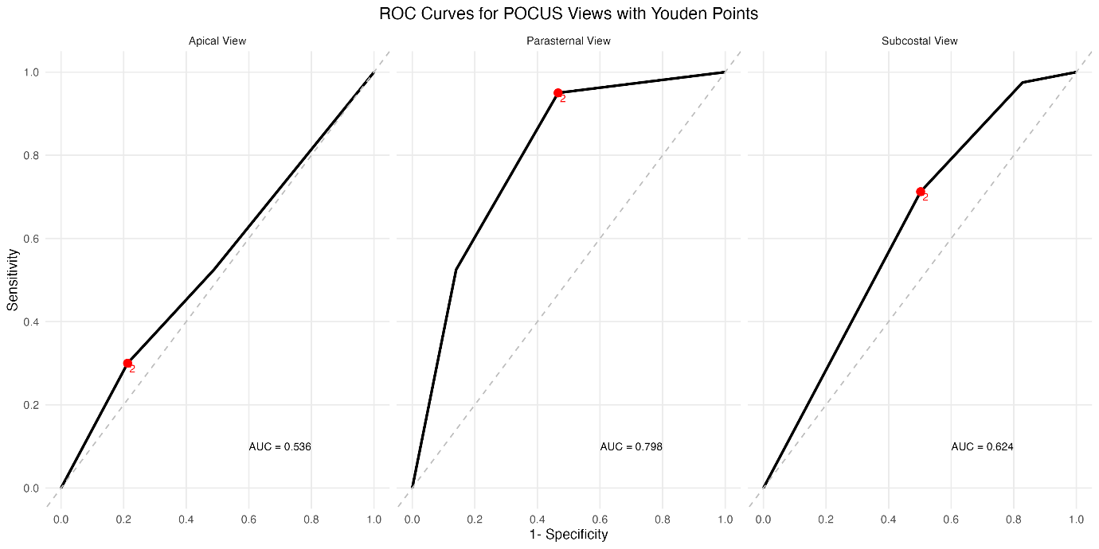

Figure S4. Receiver Operating Characteristic (ROC) curves for three Point-of-Care Ultrasound (POCUS) views in COPD diagnosis. The black solid lines represent ROC curves for the Apical view (0=High-quality view , 1=Acceptable view, 2=Poor-quality view), Parasternal view (0=High-quality view , 1=Acceptable view, 2=Poor-quality view), and Subxiphoid view (0=Poor-quality view, 1=Acceptable view, 2=High-quality view ). Their respective Area Under the Curve (AUC) values are 0.536, 0.798, and 0.624. Red dots indicate optimal cutoff points for each view based on Youden's index. The dashed diagonal line represents the reference line of no discrimination (AUC = 0.5).

ROC Analysis Results:
Metric | Parasternal View | Subcostal View | Apical View
AUC | 0.798 | 0.624 | 0.536
Optimal cutoff (Youden) | 1 (Acceptable view) | 2 (Poor-quality view) | 2 (High-quality view
Sensitivity | 95.00% | 71.25% | 30.00%
Specificity | 53.39% | 49.77% | 78.73%
PPV | 57.54% | 66.07% | 66.20%
NPV | 3.28% | 17.29% | 24.35%

