Electronic supporting information
Dracocephalum kotschyi Boiss.: Phytochemical profiling, green synthesis of silver nanoparticles, molecular docking, and antibacterial evaluation
Ali Bekhradianª, Bahador Karami^{a, *}, Hamid Reza Rajabi^{a, *}, Valiollah Keshavarz^{b}
ª Chemistry Department, Yasouj University, Yasouj, 75918-74831, Iran
^{b} Medical Plants Research Center, Basic Health Sciences Institute, Shahrekord University of Medical Sciences, Shahrekord, Iran
*Corresponding authors. Tel. /Fax: +987431004126.
E-mail address: karami@yu.ac.ir (B. Karami), h.rajabi@mail.yu.ac.ir, hr.rajabi@gmail.com (H.R. Rajabi).

Table S1. Identified compounds, images, and isolated major compounds from the genus Dracocephalum.
References | Major compounds identification and isolation in Dracocephalum genus | Plant the picture | Dracocephalum genus name
[1, 2] | caffeic and ferulic acids, lutcolin-7-O-glucoside, rosmarinic acid, luteolin and apigenin | 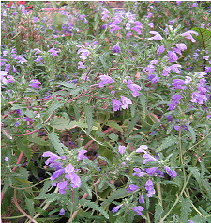 | D. moldavica
[3] | Luteolin, Caffeic acid, Apigenin, Caftaric acid, Luteolin 3′-O-glucoside | 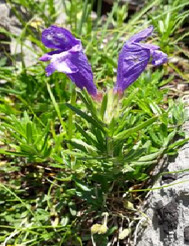 | D. austriacum
[4] | Luteolin, Apigenin, apigenin 7-O-glucoside, Caftaric acid, Caffeic acid, Luteolin 3′-O-glucoside | 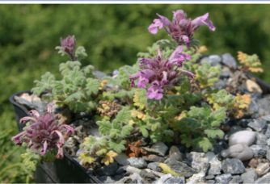 | D. botryoides
[5] | calycopterin, xanthomicrol, isokaempferide, luteolin and apigenin | 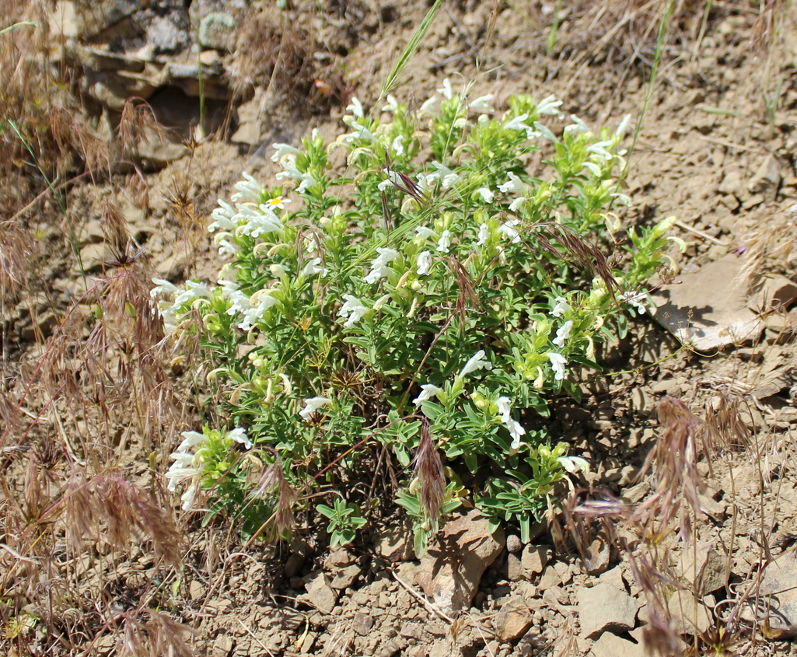 | D. subcapitatum
[6] | cinnamic acid, ferulic acid , caffeic acid, diosmetin, luteolin (7), 5,3',4'-trihydroxy-3,7-dimethoxyflavone, eriodictyol, kaempferol, quercetin, acacetin-7-O-glcopyranoside glucopyranoside, luteolin-7-O-glucopyranoside, kaempferide-3-O-rhamnopyranoside, quercitrin, kaempferol-3-O-glucopyranoside, prunasin, quercetin-7-O-glucopyranoside, quercetin-3-O-glucopyranoside, plantaginin, linarin, luteolin-7-O-rutinoside, and chlorogenic acid | 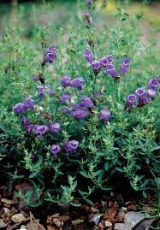 | D. peregrinum
[7, 8] | Luteolin -7-O-β-D-glucopyranoside and Luteolin 7-O-β-D-glucosiduronate, luteolin 7-O-rutinoside, Luteolin 7-O-glucoside, acylated luteolin, Apigenin 7-O-glucoside | 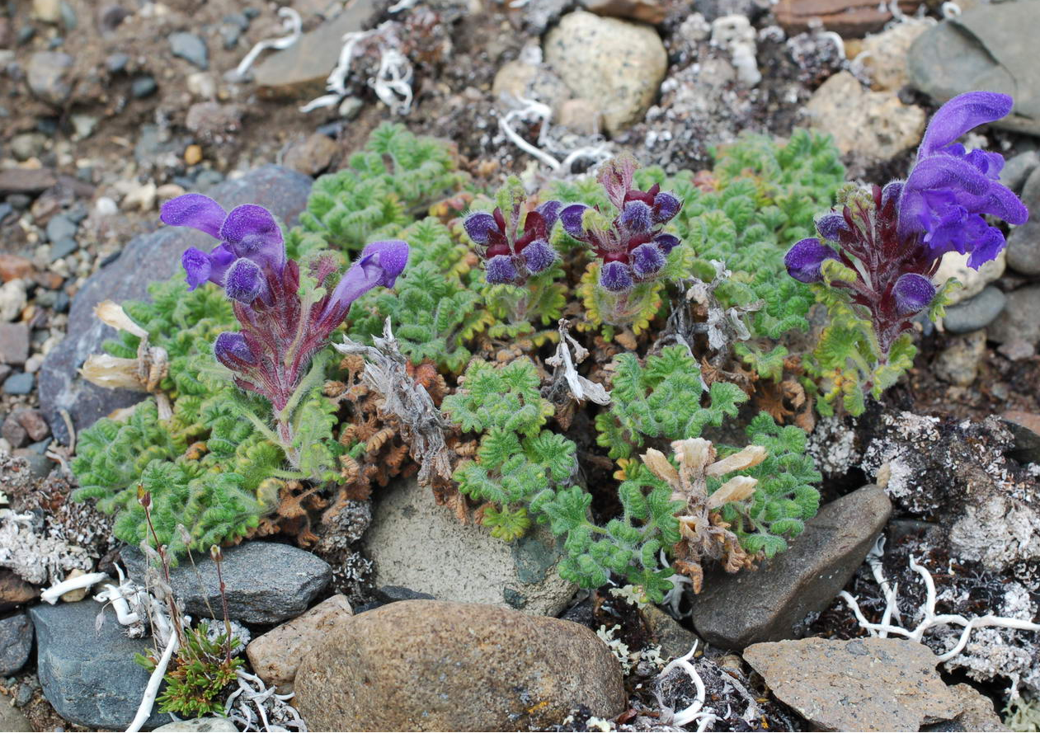 | D. palmatum
[9, 10] | 5,7-dihydroxychromone, eriodictyol-7-O-beta-d-glucoside, luteolin-7-O-beta-d-glucoside, naringenin-7-O-beta-d-glucoside, apigenin-7-O-beta-d-glucoside, eriodictyol, luteolin, naringenin and apigenin. | 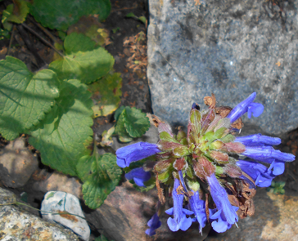 | D. rupestre
[11] | Luteolin 7-O-glucoside, Apigenin 7-O-glucoside, ladanetin-6-O-β-(6″-O-acetyl)glucoside, and pedalitin-3'-O-β-glucoside | 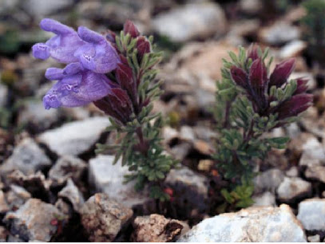 | D. tanguticum
[13] | Luteolin 30 -O-glucoside, | 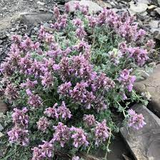 | D. thumiﬂorum
[14] | Luteolin, apigenin, xanthomicrol, calycopterin, ermanin, circilineol, 5-demethylsinenstin, cirsimaritin and 5,7,4´-trihydroxy 3,3´-dimethoxyflavone | 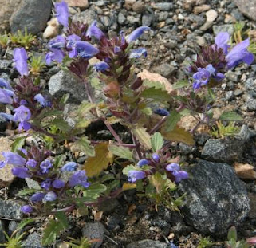 | D. oligadenium
[15] | Apigenin | 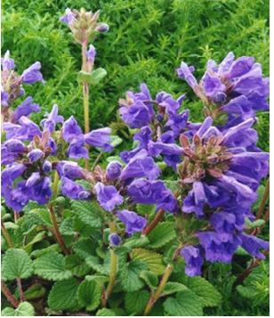 | D. polychaetum

Refrences
1. Dastmalchi K, Dorman D, Kosar M, Hiltunen R,(2007). Chemical composition and in vitro antioxidant evaluation of a water-soluble Moldavian balm (Dracocephalum moldavica L.) extract. LWT-Food Science and Technology, 40(2), 239-28.
2. Yang LN, Xing JG, He CH, Wu T (2014). The phenolic compounds from Dracocephalum moldavica L. Biochemical Systematics and Ecology , 54, 19-22.
3. Kashchenko NI, Jafarova GS, Isaev JI, Olennikov DN, Chirikova NK (2022). Caucasian Dragonheads: Phenolic Compounds,Polysaccharides, and Bioactivity of Dracocephalum austriacum and Dracocephalum botryoides. plants, 11, 1-23.
4. Saeidnia S, Gohari AR, Hadjiakhoondi A, Shafiee A (2007). Bioactive compounds of the volatile oil of Dracocephalum kotschyi. Zeitschrift für Naturforschung C, 62, 793-796. doi:https://doi.org/10.1515/znc-2007-11-1203
5. Dai LM, Zhao CC, Jin HZ, Tang J, Shen YH, Li HL, Peng CY, Zhang WD (2008). A new ferulic acid ester and other constituents from Dracocephalum peregrinum. Archives of Pharmacal Research, 31, 1325-1329.
6. Olennikov DN, Chirikova NK, Kashchenko NI, Gornostai TG, Selyutina IY, Zilfikarov IN (2017). Effect of Low Temperature Cultivation on the Phytochemical Profile and Bioactivity of Arctic Plants: A Case of Dracocephalum palmatum. International Journal of Molecular Sciences , 18(12), 2579.
7. Olennikov DN, Chirikova K, Kim E, Kim SW, Zul′fugarov IS (2018). New Glycosides of Eriodictyol from Dracocephalum palmatum. Chemistry of Natural Compounds, 54(5), 860-863.
8. Ren DM, Lou HX, Ma B, Ji M (2004). Determination of luteolin-7-O-glycoside in the herb of Dracocephalum rupestra by HPLC. zhongguo zhong yao za zhi, 29(9), 860-862.
9. Ren DM, Qu Z, Wang XN, Shi J, Lou HX (2008). Simultaneous determination of nine major active compounds in Dracocephalum rupestre by HPLC. Journal of Pharmaceutical and Biomedical Analysis, 48(5), 141-1445.
10. Wang ShQ, Han XZ, Li X, Ren DM, Wang XN, Lou HX (2010). Flavonoids from Dracocephalum tanguticum and their cardioprotective effects against doxorubicin-induced
11. Litvinenko V (1965). A new flavonoid glycoside from Dracocephalum thumiflorum L. Chemistry of Natural Compounds, 1, 108-109.
12. Ashrafian Sh, Farimani MM, Sonboli A, Ashrafian H (2022). Simultaneous characterization of nine isolated flavonoids in Iranian Dracocephalum species and in silico study of their inhibitory properties against MTH1 enzyme. South African Journal of Botany, 146(1), 254-261.
13. Pouraboli I, Nazari S, Sabet N, Sharififar F, Jafari M (2016). Antidiabetic, antioxidant, and antilipid peroxidative activities of Dracocephalum polychaetum shoot extract in streptozotocin-induced diabetic rats: In vivo and in vitro studies. Pharmaceutical Biology, 54(2), 272-278.

Table S2. Antibacterial activity of standard antibiotics (gentamicin and rifampin) used as positive controls.

Gentamicin |  | Rifampin |  | Antibiotics
MIC | DD | MIC | DZ | Antibiotics
7.8 | 20 | 7.8 | 11 | Escherichia coli  (ATCC 25922)
500 | 21 | 250 | 10 | Staphylococcus aureus (ATCC 29737)
3.90 | 30 | 31.25 | 19 | Bacillus subtilis  (ATCC 6633)
7.81 | 20 | 31.25 | NA | pseudomonas aeruginosa  (ATCC 27853)

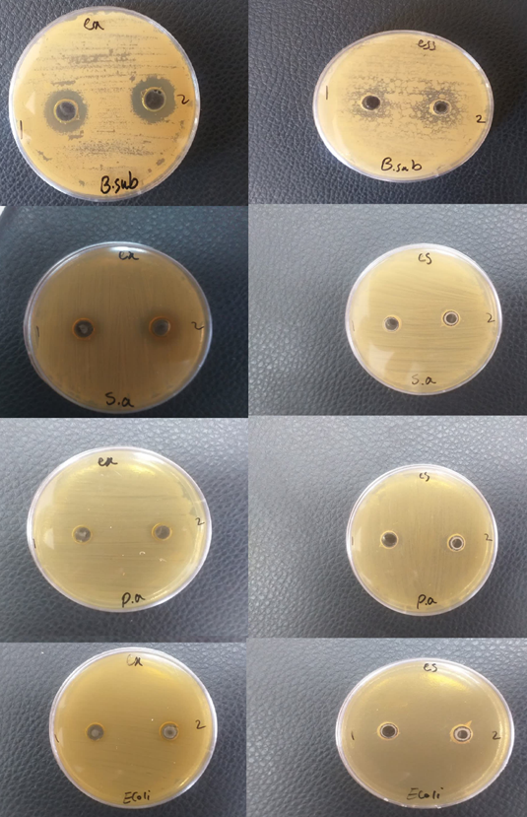
Fig. S1. Agar plate diffusion assay for antibacterial activity of D. kotschyi extract and essential oil against Bacillus subtilis, Staphylococcus aureus, Escherichia coli, and Pseudomonas aeruginosa.
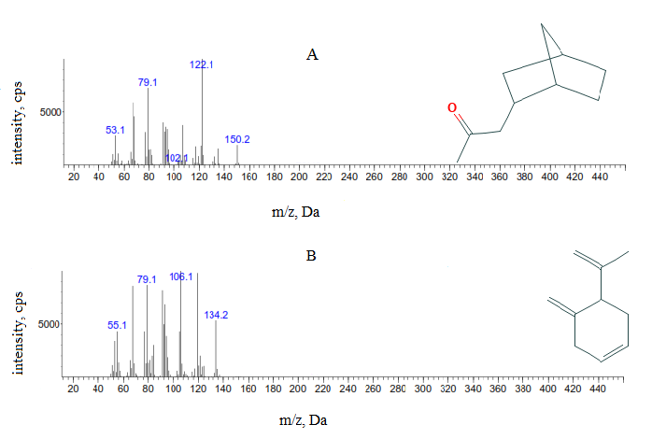
Fig. S2. Mass spectra and proposed structures of compounds identified in the essential oil of the genus Dracocephalum: (A) 2-propanone,1-bicyclo[2.2.1]hept-2-yl; (B) 1(7),4,8-O-menthatriene.

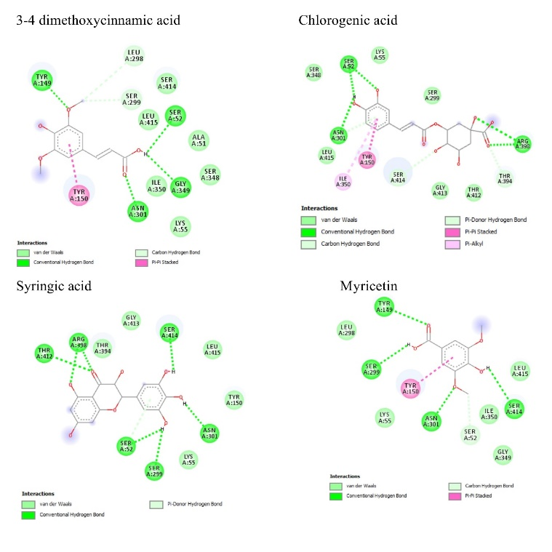
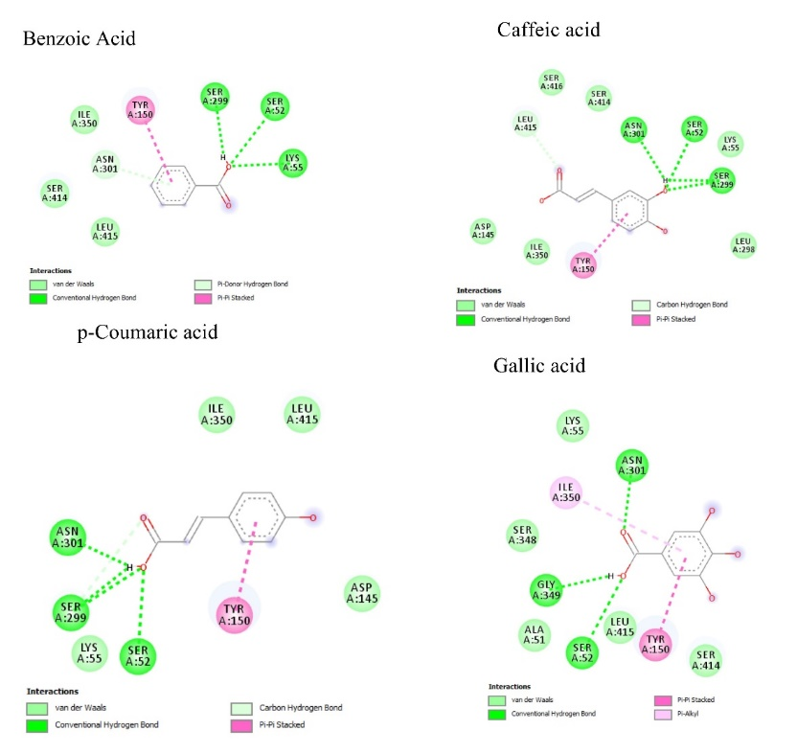
Fig. S3. Two-dimensional structures and involved residues in the active site of 2J9P for compounds extracted from D. kotschyi.

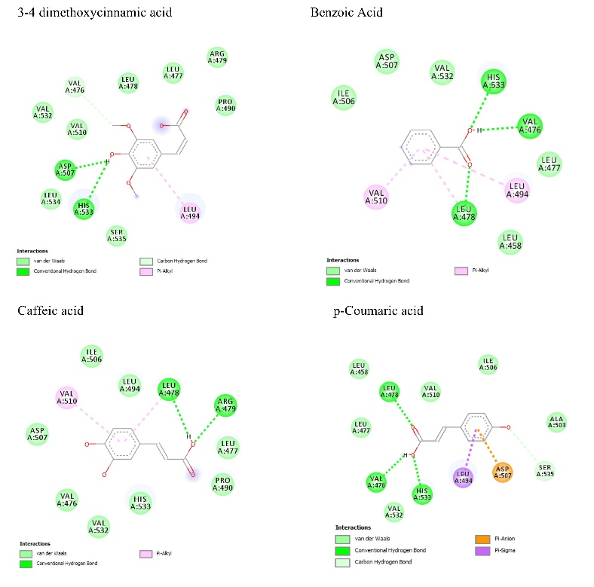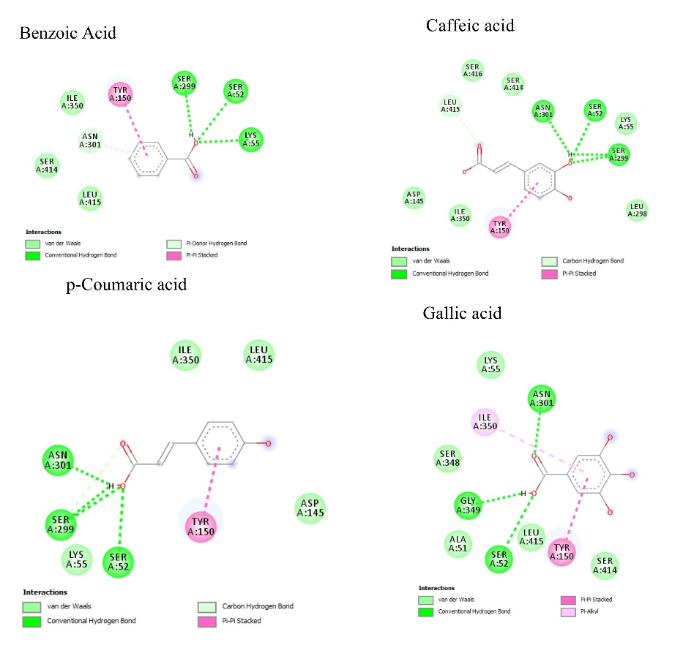
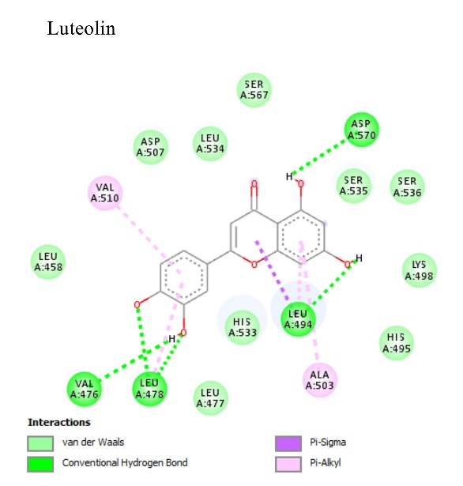
Fig. S4. Two-dimensional structures and involved residues in the active site of 3HV8 for compounds extracted from D. kotschyi.

