Supplementary material
SM. 1: A recent synthesis of studies published up to 2022 examining coral temperature-stress responses (n = 562, Bay et al. 2023) shows that 44 (7%) studies evaluate the effects of temperature stress on either embryos or larvae. From these 44 studies (Yakovleva and Hidaka 2004, Meyer et al. 2009, Voolstra et al. 2009, Polato et al. 2010, Putnam et al. 2010, Meyer et al. 2011, Schnitzler et al. 2012, Baums et al. 2013, Polato et al. 2013, Putnam et al. 2013, Dixon et al. 2015, Kenkel et al. 2015, Putnam and Gates 2015, Foster and Gilmour 2016, Howells et al. 2016, Humanes et al. 2016, Kwok et al. 2016, Gajigan and Conaco 2017, Jiang et al. 2017, Rivest et al. 2017, Serrano et al. 2017, Kirk et al. 2018, Puisay et al. 2018, Bellworthy et al. 2019a, Bellworthy et al. 2019b, Chan et al. 2019, Buerger et al. 2020, Cleves et al. 2020, Quigley et al. 2020, Howells et al. 2021, McRae et al. 2021, Puisay et al. 2021, Williamson et al. 2021, Wong et al. 2021, Alexander et al. 2022, Drury et al. 2022, Elder et al. 2022, Howells et al. 2022, Jiang et al. 2022a, Jiang et al. 2022b, Matsuda et al. 2022, Quigley and van Oppen 2022, Sun et al. 2022) only one (2%) study (Humanes et al. 2016) evaluated the effects of embryonic exposure to temperature and subsequently assessed larval settlement success. Among these 44 studies, only 11 (38%) assessed settlement outcomes following larval exposure to temperature stress, and just one (2%) (Anlauf et al. 2011) of these additionally measured post-settlement mortalities over a 42-day period.

SM. 2: Comparison of heat stress conditions between experimental tanks in terms of degree heating hours (DHH). Heat stress tanks are shown in different colours with tanks 2, 4 and 6 being the ambient control and tanks 1, 3 and 5 being the heat stress.

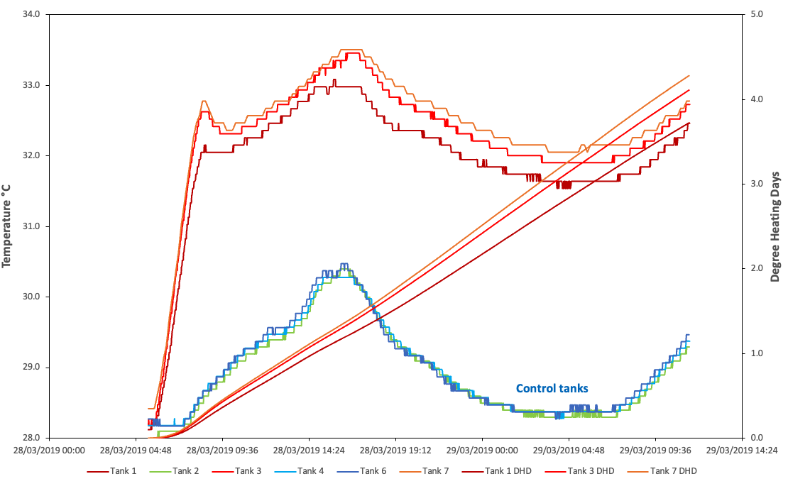

SM. 3: Model selection results for settlement, survivorship and recruit growth. Candidate mixed‑effects models include combinations of maternal, paternal and cross BMI_{ED50} values, their interactions with temperature treatment, and relevant random effects. Models are ranked by AIC, with lower values indicating better support. ΔAIC values are shown relative to the best‑supported model for each trait.
Trait | Factors in the model | AIC | df | ΔAIC
Survivorship | Mother_BMIED50 * Treatment + Father_BMIED50 * Treatment + (1|Father_ID) + (1|Mother_ID) + (1|Tank.night) | 4206 | 9 | 0.0
 | Mother_BMIED50 * Treatment + (1|Father_ID) + (1|Mother_ID) + (1|Tank.night) | 4208 | 7 | 1.8
 | Cross_BMIED50 * Treatment + (1|Father_ID) + (1|Mother_ID) + (1|Tank.night) | 4208 | 7 | 2.6
 | Father_BMIED50 * Treatment + (1|Father_ID) + (1|Mother_ID) + (1|Tank.night) | 4228 | 7 | 21.7
 | Treatment + (1|Father_ID) + (1|Mother_ID) + (1|Tank.night) | 4257 | 5 | 51.6
 | (1|Father_ID) + (1|Mother_ID) + (1|Tank.night) | 4259 | 4 | 53.1
 | Father_BMIED50 * Treatment + (1|Tank.night) | 4406 | 5 | 200.5
 | Mother_BMIED50 * Treatment + (1|Tank.night) | 4439 | 5 | 233.2
 | Treatment + (1|Tank.night) | 4503 | 3 | 297.3
Settlement | Mother_BMIED50 * Treatment + Father_BMIED50 * Treatment + (1|Father_ID) + (1|Mother_ID) + (1|Tank.night) | 10456 | 9 | 0.0
 | Mother_BMIED50 * Treatment + (1|Father_ID) + (1|Mother_ID) + (1|Tank.night) | 10456 | 7 | 0.0
 | Cross_BMIED50 * Treatment + (1|Father_ID) + (1|Mother_ID) + (1|Tank.night) | 10505 | 7 | 49.0
 | Father_BMIED50 * Treatment + (1|Father_ID) + (1|Mother_ID) + (1|Tank.night) | 10600 | 7 | 143.6
 | Treatment + (1|Father_ID) + (1|Mother_ID) + (1|Tank.night) | 10627 | 5 | 170.8
 | (1|Father_ID) + (1|Mother_ID) + (1|Tank.night) | 10839 | 4 | 383.3
 | Mother_BMIED50 * Treatment + (1|Tank.night) | 10898 | 5 | 441.4
 | Father_BMIED50 * Treatment + (1|Tank.night) | 11251 | 5 | 794.7
 | Treatment + (1|Tank.night) | 11330 | 3 | 874.3
Recruit growth | Treatment | -979 | 3 | 0.0
 | (1|Father_ID) + (1|Mother_ID) + (1|Tank.night) | -977 | 4 | 2.1
 | Treatment + (1|Father_ID) + (1|Mother_ID) + (1|Tank.night) | -976 | 5 | 3.2
 | Mother_BMIED50 * Treatment | -976 | 5 | 3.3
 | Father_BMIED50 * Treatment | -976 | 5 | 3.5
 | Mother_BMIED50 * Treatment + (1|Father_ID) + (1|Mother_ID) + (1|Tank.night) | -972 | 7 | 6.9
 | Cross_BMIED50 * Treatment + (1|Father_ID) + (1|Mother_ID) + (1|Tank.night) | -972 | 7 | 6.9
 | Father_BMIED50 * Treatment + (1|Father_ID) + (1|Mother_ID) + (1|Tank.night) | -972 | 7 | 7.1
 | Mother_BMIED50 * Treatment + Father_BMIED50 * Treatment + (1|Father_ID) + (1|Mother_ID) + (1|Tank.night) | -968 | 9 | 10.8

SM. 4: Recruit growth under control and temperature stress treatments. Predicted monthly growth rates (mm per month) from the best-supported model (Growth_mm_month ~ Treatment) are shown for each treatment level. White points represent with black outlines represent observed treatment means, with vertical bars indicating 95% confidence intervals. Small semi-transparent points show individual recruit growth measurements, jittered horizontally for visibility.

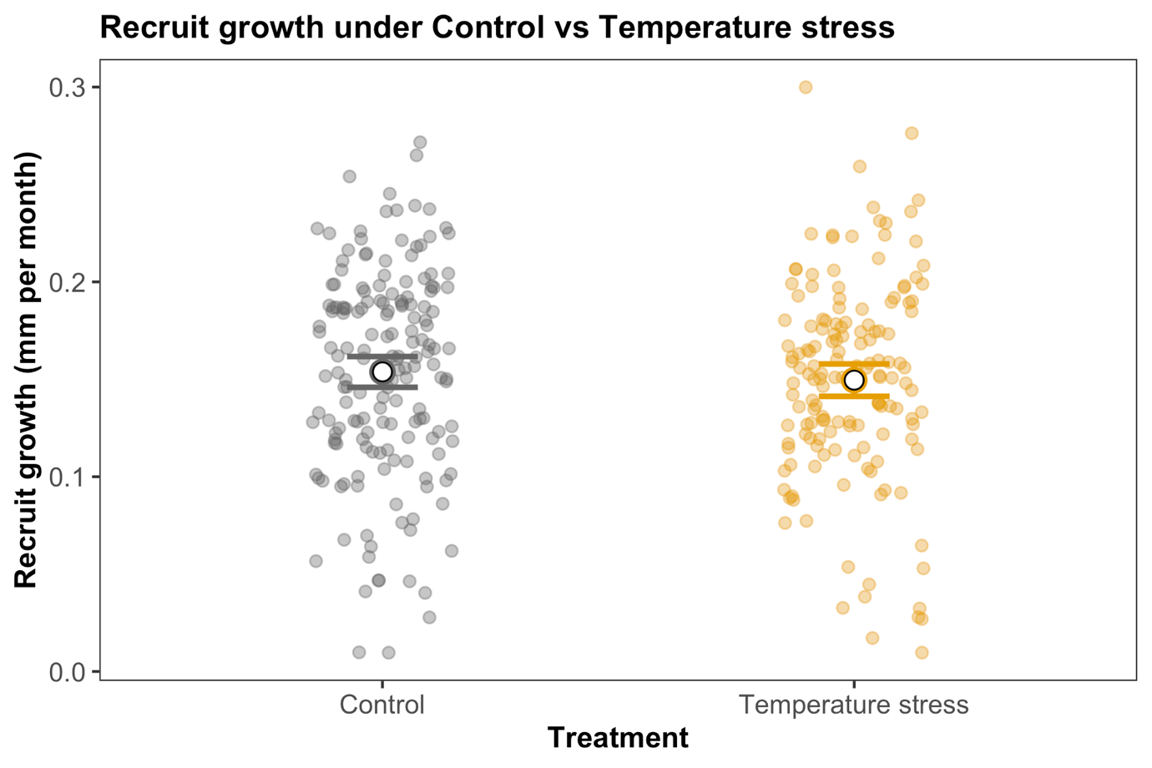

References

Alexander, G., J. R. Hancock, A. S. Huffmyer, and S. B. Matsuda. 2022. Larval thermal conditioning does not improve post-settlement thermal tolerance in the dominant reef-building coral, Montipora capitata. Coral Reefs 41:333-342.
Anlauf, H., L. D'Croz, and A. O'Dea. 2011. A corrosive concoction: The combined effects of ocean warming and acidification on the early growth of a stony coral are multiplicative. Journal of Experimental Marine Biology and Ecology 397:13-20.
Baums, I., M. Devlin-Durante, N. Polato, D. Xu, S. Giri, N. Altman, D. Ruiz, J. Parkinson, and J. Boulay. 2013. Genotypic variation influences reproductive success and thermal stress tolerance in the reef building coral, Acropora palmata. Coral Reefs 32:703-717.
Bay, L. K., J. C. Ortiz, A. Humanes, and H. J. Scharfenstein. 2023. Natural adaptation and assisted evolution of corals to heat stress.in A. I. o. M. Science, editor.
Bellworthy, J., M. Menoud, T. Krueger, A. Meibom, and M. Fine. 2019a. Developmental carryover effects of ocean warming and acidification in corals from a potential climate refugium, the Gulf of Aqaba. Journal of Experimental Biology 222:12.
Bellworthy, J., J. E. Spangenberg, and M. Fine. 2019b. Feeding increases the number of offspring but decreases parental investment of Red Sea coral Stylophora pistillata. Ecology and Evolution 9:12245-12258.
Buerger, P., C. Alvarez-Roa, C. W. Coppin, S. L. Pearce, L. J. Chakravarti, J. G. Oakeshott, O. R. Edwards, and M. J. H. van Oppen. 2020. Heat-evolved microalgal symbionts increase coral bleaching tolerance. Science Advances 6:eaba2498.
Chan, W. Y., L. M. Peplow, and M. J. H. van Oppen. 2019. Interspecific gamete compatibility and hybrid larval fitness in reef-building corals: Implications for coral reef restoration. Sci Rep 9:4757.
Cleves, P. A., A. I. Tinoco, J. Bradford, D. Perrin, L. K. Bay, and J. R. Pringle. 2020. Reduced thermal tolerance in a coral carrying CRISPR-induced mutations in the gene for a heat-shock transcription factor. Proc Natl Acad Sci U S A 117:28899-28905.
Dixon, G. B., S. W. Davies, G. V. Aglyamova, E. Meyer, L. K. Bay, and M. V. Matz. 2015. Genomic determinants of coral heat tolerance across latitudes. Science 348:1460-1462.
Drury, C., N. K. Bean, C. I. Harris, J. R. Hancock, J. Huckeba, C. M. H, T. N. F. Roach, R. A. Quinn, and R. D. Gates. 2022. Intrapopulation adaptive variance supports thermal tolerance in a reef-building coral. Commun Biol 5:486.
Elder, H., V. Weis, J. Montalvo-Proano, V. J. L. Mocellin, A. H. Baird, E. Meyer, and L. K. Bay. 2022. Genetic variation in heat tolerance of the coral Platygyra daedalea indicates potential for adaptation to ocean warming. Frontiers in Marine Science:925845.
Foster, T., and J. P. Gilmour. 2016. Seeing red: Coral larvae are attracted to healthy‑looking reefs. Marine Ecology Progress Series 559:65-71.
Gajigan, A. P., and C. Conaco. 2017. A microRNA regulates the response of corals to thermal stress. Molecular Ecology 26:3472-3483.
Howells, E. J., D. Abrego, Y. J. Liew, J. A. Burt, E. Meyer, and M. Aranda. 2021. Enhancing the heat tolerance of reef-building corals to future warming. Science Advances 7:eabg6070.
Howells, E. J., D. Abrego, E. Meyer, N. L. Kirk, and J. A. Burt. 2016. Host adaptation and unexpected symbiont partners enable reef-building corals to tolerate extreme temperatures. Glob Chang Biol 22:2702-2714.
Howells, E. J., M. Hagedorn, M. J. H. Van Oppen, and J. A. Burt. 2022. Challenges of sperm cryopreservation in transferring heat adaptation of corals across ocean basins. Peerj 10:21.
Humanes, A., S. Noonan, B. L. Willis, K. E. Fabricius, and A. P. Negri. 2016. Cumulative effects of nutrient enrichment and elevated temperature compromise the early life history stages of the coral Acropora tenuis. PLoS One 11:e0161616.
Jiang, L., C. Y. Liu, G. X. Cui, L. T. Huang, X. L. Yu, Y. F. Sun, H. Y. Tong, G. W. Zhou, X. C. Yuan, Y. S. Hu, W. L. Zhou, M. Aranda, P. Y. Qian, and H. Huang. 2022a. Rapid shifts in thermal reaction norms and tolerance of brooded coral larvae following parental heat acclimation. Molecular Ecology 32:1098-1116.
Jiang, L., Y.-F. Sun, Y.-Y. Zhang, G.-W. Zhou, X.-B. Li, L. J. McCook, J.-S. Lian, X.-M. Lei, S. Liu, L. Cai, P.-Y. Qian, and H. Huang. 2017. Impact of diurnal temperature fluctuations on larval settlement and growth of the reef coral <i>Pocillopora damicornis</i&gt. Biogeosciences 14:5741-5752.
Jiang, L., Y. F. Sun, G. W. Zhou, H. Y. Tong, L. T. Huang, X. L. Yu, C. Y. Liu, Y. Y. Zhang, X. C. Yuan, P. Y. Qian, and H. Huang. 2022b. Ocean acidification elicits differential bleaching and gene expression patterns in larval reef coral Pocillopora damicornis under heat stress. Science of the Total Environment 842:12.
Kenkel, C. D., S. P. Setta, and M. V. Matz. 2015. Heritable differences in fitness-related traits among populations of the mustard hill coral, Porites astreoides. Heredity 115:509-516.
Kirk, N. L., E. J. Howells, D. Abrego, J. A. Burt, and E. Meyer. 2018. Genomic and transcriptomic signals of thermal tolerance in heat-tolerant corals (Platygyra daedalea) of the Arabian/Persian Gulf. Molecular Ecology 27:5180-5194.
Kwok, C. K., K. Y. Lam, S. M. Leung, A. P. Y. Chui, and P. O. Ang. 2016. Copper and thermal perturbations on the early life processes of the hard coral Platygyra acuta. Coral Reefs 35:827-838.
Matsuda, S. B., L. J. Chakravarti, R. Cunning, A. S. Huffmyer, C. E. Nelson, R. D. Gates, and M. J. H. van Oppen. 2022. Temperature-mediated acquisition of rare heterologous symbionts promotes survival of coral larvae under ocean warming. Global Change Biology 28:2006-2025.
McRae, C. J., A. B. Mayfield, W. B. Huang, I. M. Cote, and T. Y. Fan. 2021. Contrasting Proteomic Responses of Adult and Larval Coral to High Temperatures. Frontiers in Marine Science 8:7.
Meyer, E., G. V. Aglyamova, and M. V. Matz. 2011. Profiling gene expression responses of coral larvae (Acropora millepora) to elevated temperature and settlement inducers using a novel RNA-Seq procedure. Molecular Ecology 20:3599-3616.
Meyer, E., S. Davies, S. Wang, B. L. Willis, D. Abrego, T. E. Juenger, and M. V. Matz. 2009. Genetic variation in responses to a settlement cue and elevated temperature in the reef-building coral Acropora millepora. Marine Ecology Progress Series 392:81-92.
Polato, N. R., N. S. Altman, and I. B. Baums. 2013. Variation in the transcriptional response of threatened coral larvae to elevated temperatures. Mol Ecol 22:1366-1382.
Polato, N. R., C. R. Voolstra, J. Schnetzer, M. K. DeSalvo, C. J. Randall, A. M. Szmant, M. Medina, and I. B. Baums. 2010. Location-specific responses to thermal stress in larvae of the reef-building coral Montastraea faveolata. PLoS One 5:e11221.
Puisay, A., N. Elleaume, L. Fouqueau, Y. Lacube, C. Goiran, C. Sidobre, M. Metian, and L. Hedouin. 2021. Parental bleaching susceptibility leads to differences in larval fluorescence and dispersal potential in Pocillopora acuta corals. Marine environmental research 163:11.
Puisay, A., R. Pilon, C. Goiran, and L. Hedouin. 2018. Thermal resistances and acclimation potential during coral larval ontogeny in Acropora pulchra. Marine environmental research 135:1-10.
Putnam, H. M., P. J. Edmunds, and T.-Y. Fan. 2010. Effect of a fluctuating thermal regime on adult and larval reef corals. Invertebrate Biology 129:199-209.
Putnam, H. M., and R. D. Gates. 2015. Preconditioning in the reef-building coral Pocillopora damicornis and the potential for trans-generational acclimatization in coral larvae under future climate change conditions. Journal of Experimental Biology 218:2365-2372.
Putnam, H. M., A. B. Mayfield, T. Y. Fan, C. S. Chen, and R. D. Gates. 2013. The physiological and molecular responses of larvae from the reef-building coral Pocillopora damicornis exposed to near-future increases in temperature and pCO(2). Marine Biology 160:2157-2173.
Quigley, K. M., L. K. Bay, and M. J. H. van Oppen. 2020. Genome-wide SNP analysis reveals an increase in adaptive genetic variation through selective breeding of coral. Mol Ecol.
Quigley, K. M., and M. J. H. van Oppen. 2022. Predictive models for the selection of thermally tolerant corals based on offspring survival. Nature Communications 13:13.
Rivest, E. B., C.-S. Chen, T.-Y. Fan, H.-H. Li, and G. E. Hofmann. 2017. Lipid consumption in coral larvae differs among sites: a consideration of environmental history in a global ocean change scenario. Proceedings of the Royal Society B: Biological Sciences 284.
Schnitzler, C. E., L. L. Hollingsworth, D. A. Krupp, and V. M. Weis. 2012. Elevated temperature impairs onset of symbiosis and reduces survivorship in larvae of the Hawaiian coral, Fungia scutaria. Marine Biology 159:633-642.
Serrano, X. M., M. W. Miller, J. C. Hendee, B. A. Jensen, J. Z. Gapayao, C. Pasparakis, M. Grosell, and A. C. Baker. 2017. Effects of thermal stress and nitrate enrichment on the larval performance of two Caribbean reef corals. Coral Reefs 37:173-182.
Sun, Y. F., L. Jiang, S. Q. Gong, G. Diaz-Pulido, X. C. Yuan, H. Y. Tong, L. T. Huang, G. W. Zhou, Y. Y. Zhang, and H. Huang. 2022. Changes in physiological performance and protein expression in the larvae of the coral Pocillopora damicornis and their symbionts in response to elevated temperature and acidification. Science of the Total Environment 807:10.
Voolstra, C. R., J. Schnetzer, L. Peshkin, C. J. Randall, A. M. Szmant, and M. Medina. 2009. Effects of temperature on gene expression in embryos of the coral Montastraea faveolata. BMC genomics 10:627.
Williamson, O. M., C. E. Allen, D. E. Williams, M. W. Johnson, M. W. Miller, and A. C. Baker. 2021. Neighboring colonies influence uptake of thermotolerant endosymbionts in threatened Caribbean coral recruits. Coral Reefs 40:867-879.
Wong, K. H., G. Goodbody-Gringley, S. J. de Putron, D. M. Becker, A. Chequer, and H. M. Putnam. 2021. Brooded coral offspring physiology depends on the combined effects of parental press and pulse thermal history. Global Change Biology 27:3179-3195.
Yakovleva, I., and M. Hidaka. 2004. Differential recovery of PSII function and electron transport rate in symbiotic dinoflagellates as a possible determinant of bleaching susceptibility of corals. Marine Ecology Progress Series 268:43-53.

