Supplementary table 1.
Supplementary table 2.

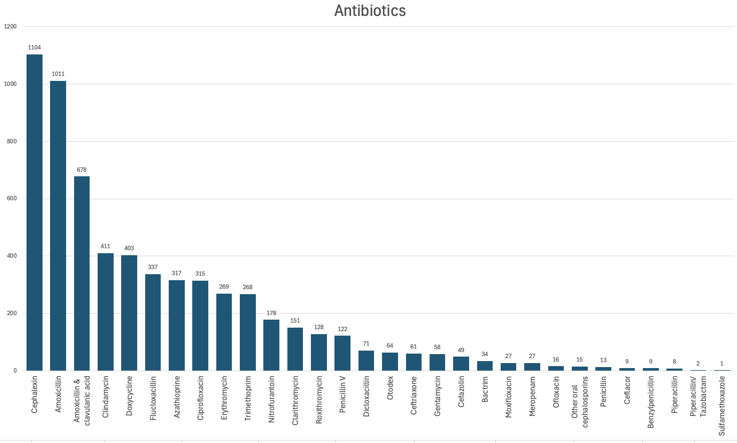
Supplementary table 3.

