Supplementary Materials 1
Genome-wide identification and integrative analysis of the WRKY gene family reveal candidate regulators involved in biotic stress responses in Hass avocado
- Xiafei Wang¹⁺, Zekun Shi²⁺, Bo Yuan¹, Liang Tao¹, Yangmei Zhang¹, Zhonghua Wu¹, Hongchang A¹, Guoyuan Zhu¹, Liyue Xu¹, Yongke Zhang¹* and Jinqiang Wang¹*

⁺Xiafei Wang and Zekun Shi contributed equally to this work.
*Correspondence:
Yongke Zhang
zhangyongke99@163.com
Jinqiang Wang
wjinq@126.com

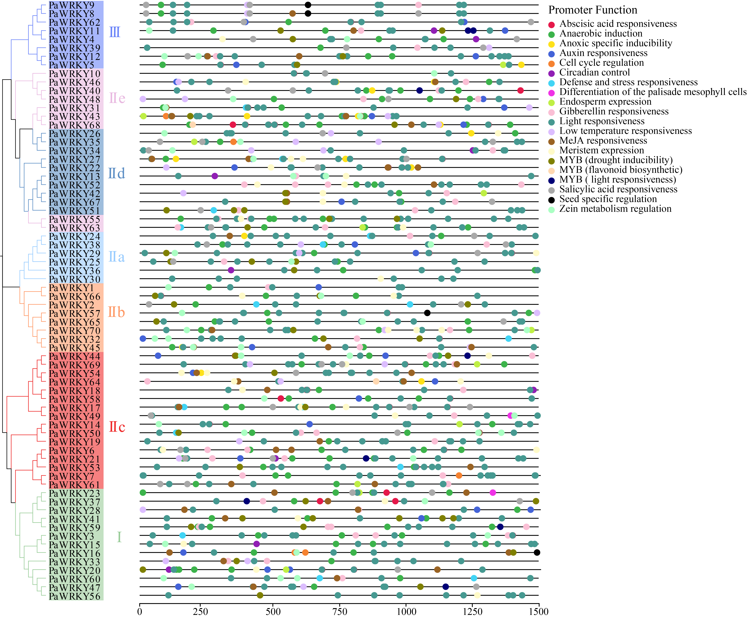
Fig. S1 Distribution of cis-acting elements identified in the promoter regions of Hass avocado PaWRKY genes. The positions of cis-acting elements in the 1.5 kb upstream promoter regions of all 70 PaWRKY genes were analyzed. The phylogenetic tree on the left shows the classification of the PaWRKY gene family into Groups I, II, and III, with Group II further divided into five subgroups: IIa, IIb, IIc, IId, and IIe. Different types of cis-acting elements are indicated by different colors.

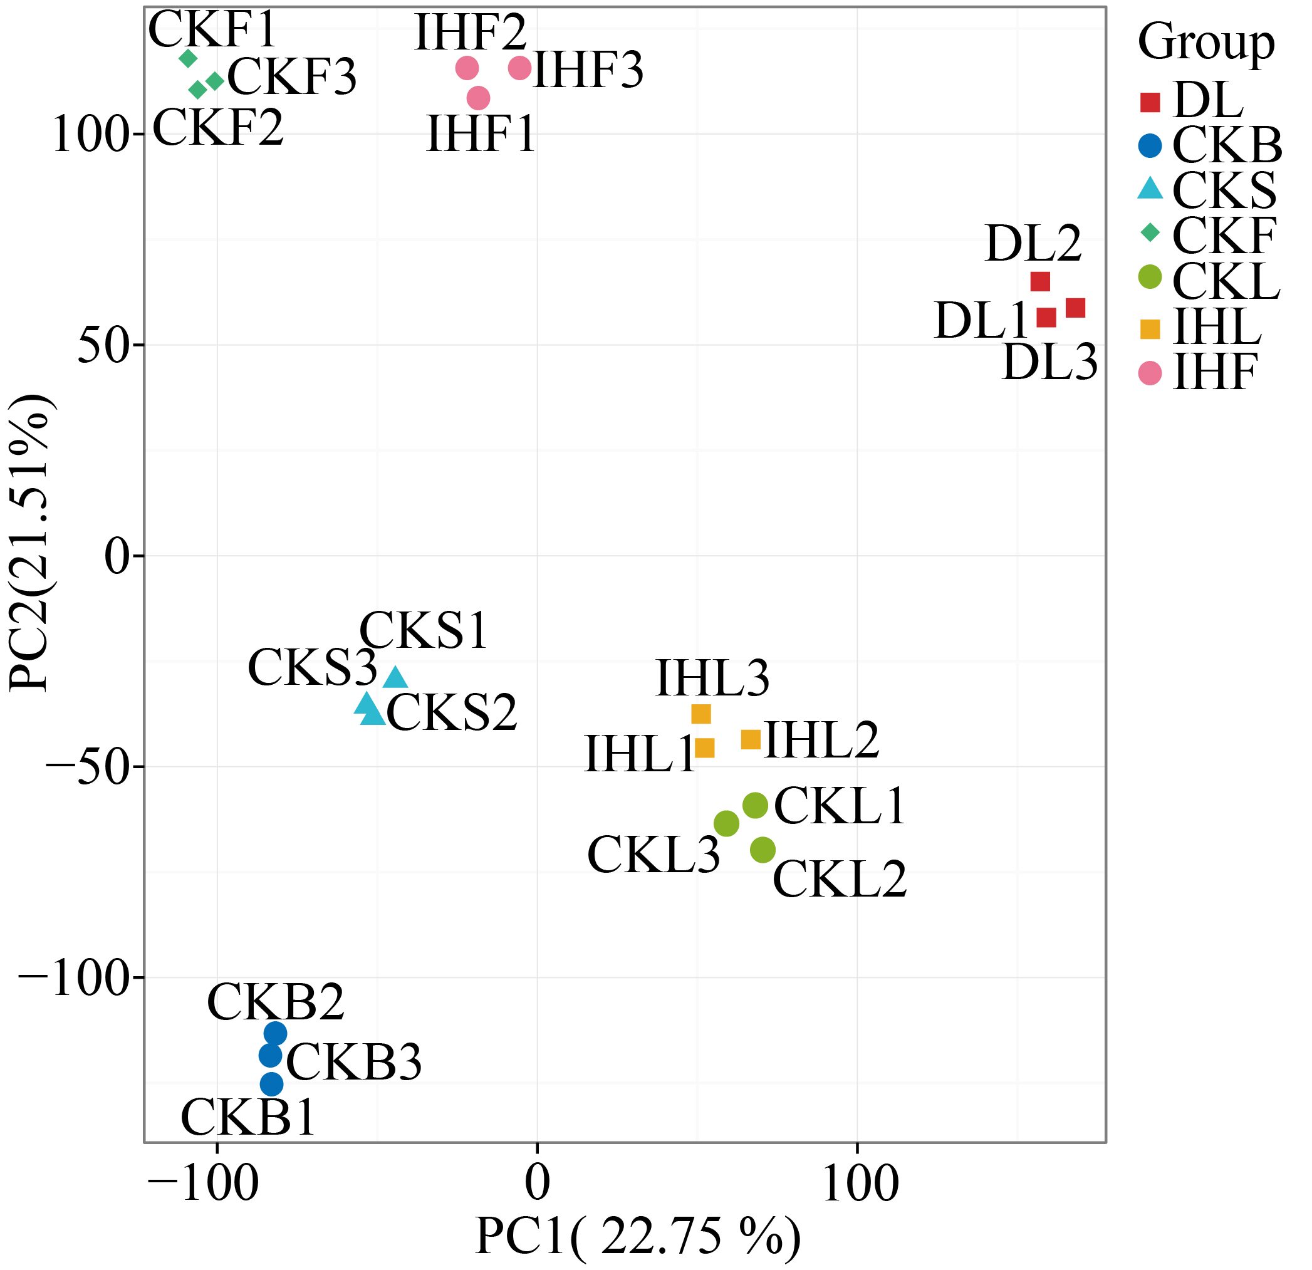
Fig. S2 Principal component analysis of transcriptome samples from different tissues and biotic stress conditions. Different colors and symbols represent different sample groups, including CKB, healthy buds; CKS, healthy stems; CKL, healthy leaves; IHL, insect-infested leaves; DL, diseased leaves; CKF, healthy fruits; and IHF, insect-bored fruits. Three biological replicates were analyzed for each treatment. The first and second principal components, PC1 and PC2, explained 22.75% and 21.51% of the total variance, respectively.

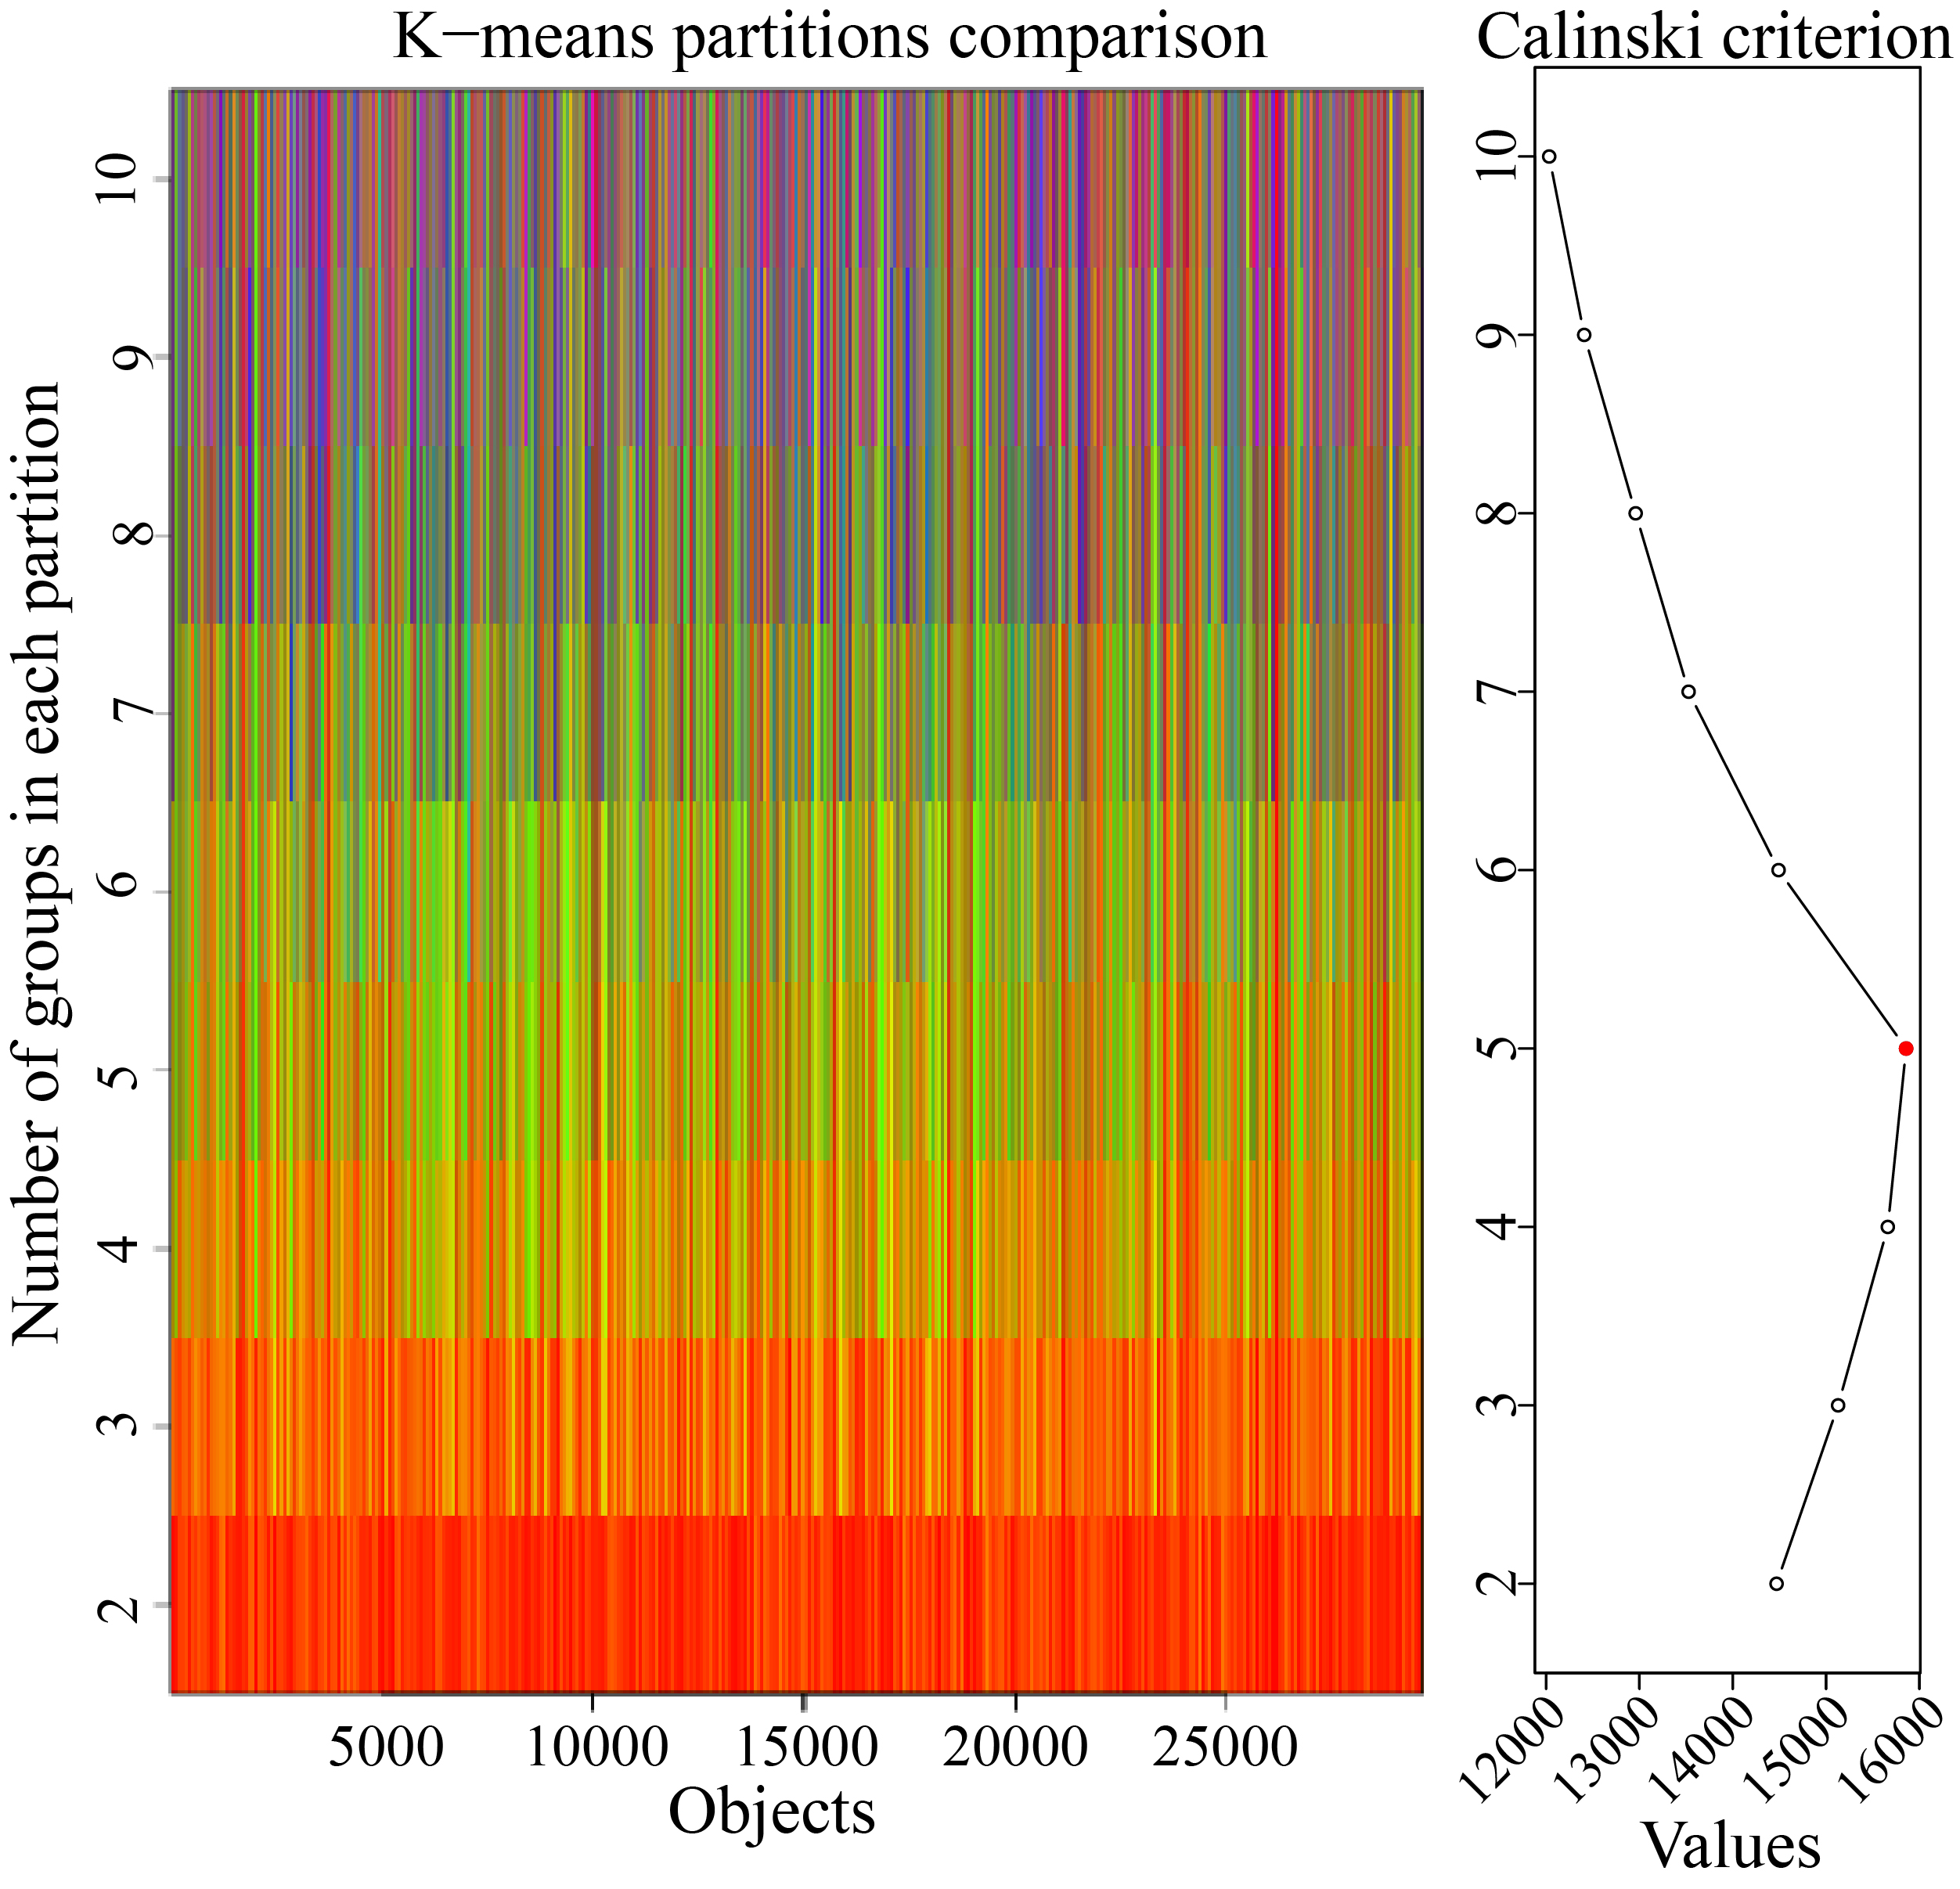
Fig. S3 Determination of the optimal number of clusters for K-means clustering analysis. The optimal cluster number was evaluated using the cascadeKM function in the vegan package. The left panel shows comparisons of K-means partitions under different cluster numbers, and the right panel shows the Calinski criterion values for different partitions. The highest score was obtained at K = 5, marked by the red point, indicating that five clusters were selected for subsequent K-means analysis.

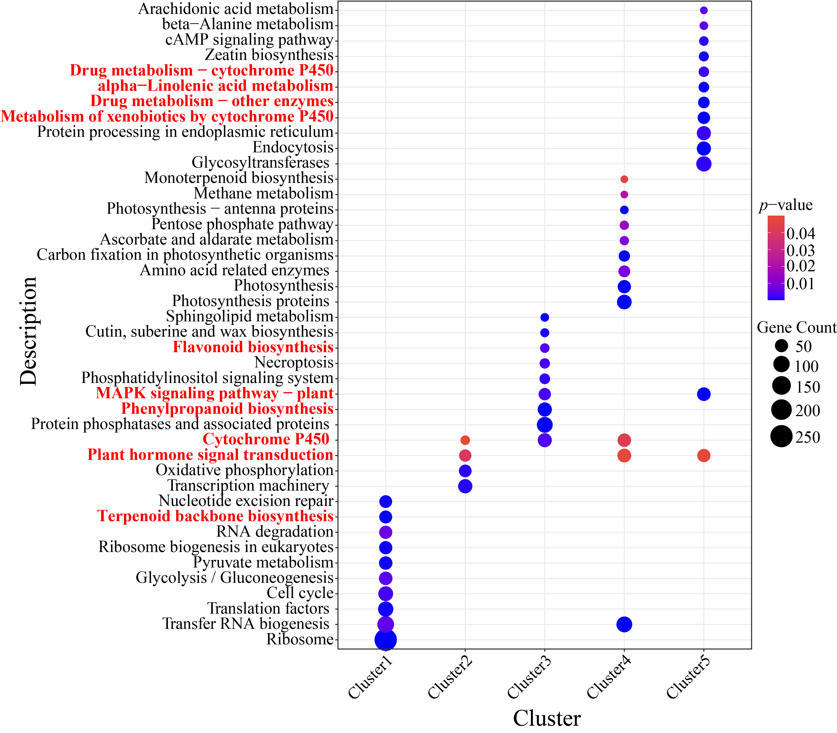
Fig. S4 KEGG enrichment analysis of genes in different K-means clusters. The x-axis represents different cluster numbers, and the y-axis indicates the enriched KEGG pathways. Bubble size represents the number of genes enriched in each pathway, and bubble color indicates statistical significance (p value). Only pathways significantly enriched in each cluster are shown (p < 0.05).

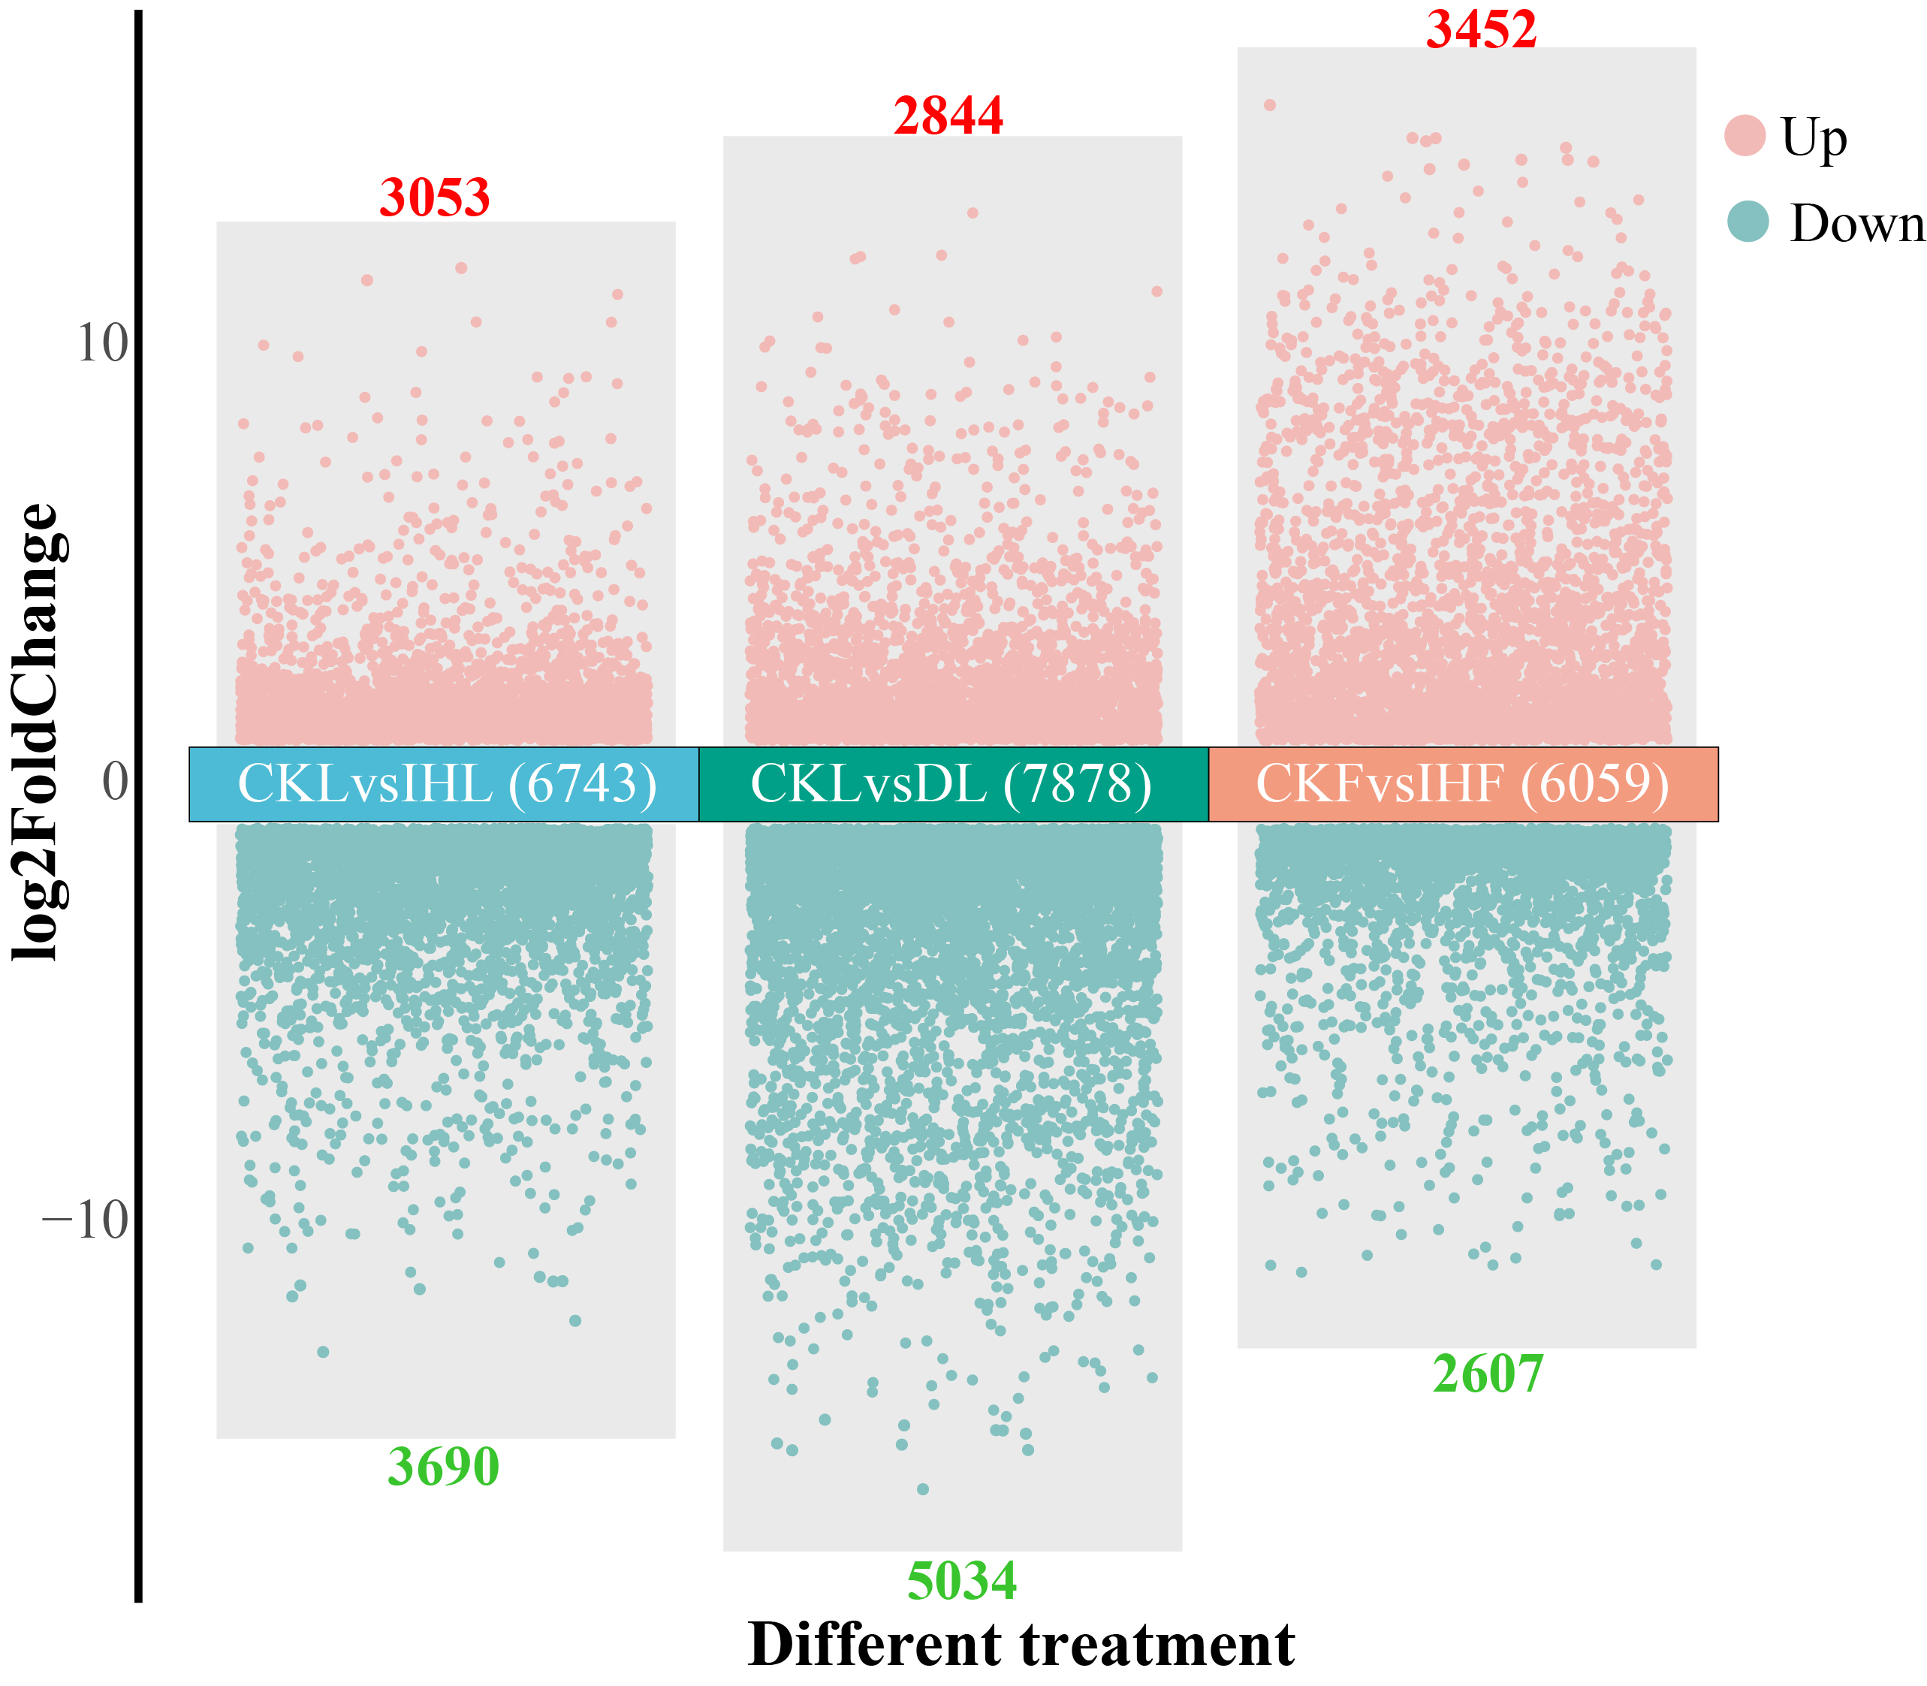
Fig. S5 Numbers of differentially expressed genes under different biotic stresses. Up-regulated and down-regulated genes are indicated by pink and green dots, respectively. The numbers above and below represent the numbers of up-regulated and down-regulated DEGs, respectively.

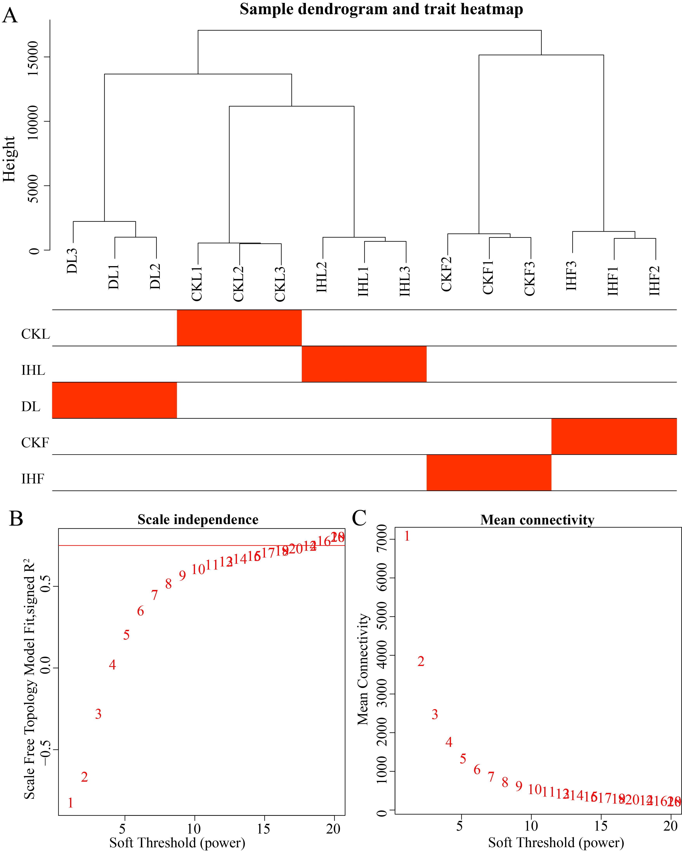
Fig. S6 Sample clustering and soft-threshold selection for WGCNA. (A) Hierarchical clustering dendrogram of all samples used for WGCNA. The red heatmap below the dendrogram represents different sample groups, including CKL, IHL, DL, CKF, and IHF. (B) Analysis of the scale-free topology fit index under different soft-thresholding powers. The optimal β value (16) was selected using the sft$powerEstimate function to ensure a scale-free network topology for WGCNA. (C) Analysis of mean connectivity under different soft-thresholding powers.

