Electronic Supplementary Material
Title: CT-Based Radiological Score (AMESI CT-Score) for Severity of Bowel Injury in Acute Mesenteric Ischemia
Methods, supplementary materials
- STROBE Statement
- Definitions and diagnostic criteria of AMI subtypes
- Definitions for reversible and irreversible bowel injury
Results, supplementary materials
- Figure S1. Distribution of patients with AMESI CT score <2 and irreversible bowel injury
- Table S1. Description of groups according to the presence and severity of AMI
- Table S2. Patient allocation to study groups and inclusion of radiological data in the final analysis
- Table S3. Variability in CT findings between reviewers
- Table S4. Interobserver agreement for assessment of radiological signs
- Table S5. Prevalence of assessed radiological signs in patients without AMI, and with AMI with reversible bowel damage and irreversible bowel damage
- Table S6. Regression coefficients from univariable logistic models with binary grouping as the dependent variable and radiological sign as the predictor
- Table S7. Distribution of bowel signs in patients without AMI and in patients with AMI stratified by reversibility and aetiology

STROBE Statement—Checklist of items that should be included in reports of cohort studies
 | Item No | Recommendation | Reported on page
Title and abstract | 1 | (a) Indicate the study’s design with a commonly used term in the title or the abstract | 2
Title and abstract | 1 | (b) Provide in the abstract an informative and balanced summary of what was done and what was found | 2
Introduction
Background/rationale | 2 | Explain the scientific background and rationale for the investigation being reported | 4
Objectives | 3 | State specific objectives, including any prespecified hypotheses | 4
Methods
Study design | 4 | Present key elements of study design early in the paper | 5-8
Setting | 5 | Describe the setting, locations, and relevant dates, including periods of recruitment, exposure, follow-up, and data collection | 5, Figure 1
Participants | 6 | (a) Give the eligibility criteria, and the sources and methods of selection of participants. Describe methods of follow-up | 5-6, Figure 1
Participants | 6 | (b) For matched studies, give matching criteria and number of exposed and unexposed | 5-6, Table S2
Variables | 7 | Clearly define all outcomes, exposures, predictors, potential confounders, and effect modifiers. Give diagnostic criteria, if applicable | 6-8, Table 1, Table S2
Data sources/ measurement | 8* | For each variable of interest, give sources of data and details of methods of assessment (measurement). Describe comparability of assessment methods if there is more than one group | Table S2, Table S3, Table 1
Bias | 9 | Describe any efforts to address potential sources of bias | 6
Study size | 10 | Explain how the study size was arrived at | 5, Figure 1
Quantitative variables | 11 | Explain how quantitative variables were handled in the analyses. If applicable, describe which groupings were chosen and why | 6-8
Statistical methods | 12 | (a) Describe all statistical methods, including those used to control for confounding | 6-8
Statistical methods | 12 | (b) Describe any methods used to examine subgroups and interactions | 7
Statistical methods | 12 | (c) Explain how missing data were addressed | 5
Statistical methods | 12 | (d) If applicable, explain how loss to follow-up was addressed | -
Statistical methods | 12 | (e) Describe any sensitivity analyses | 7, Table 2
Results
Participants | 13* | (a) Report numbers of individuals at each stage of study—e.g. numbers potentially eligible, examined for eligibility, confirmed eligible, included in the study, completing follow-up, and analysed | 5, 8, Figure 1
Participants | 13* | (b) Give reasons for non-participation at each stage | 8, Figure 1
Participants | 13* | (c) Consider use of a flow diagram | Figure 1
Descriptive data | 14* | (a) Give characteristics of study participants (e.g. demographic, clinical, social) and information on exposures and potential confounders | 8, Table S1
Descriptive data | 14* | (b) Indicate number of participants with missing data for each variable of interest | 8, Table S2
Descriptive data | 14* | (c) Summarise follow-up time (e.g., average and total amount) | -
Outcome data | 15* | Report numbers of outcome events or summary measures over time | 9-11, Table S5
Main results | 16 | (a) Give unadjusted estimates and, if applicable, confounder-adjusted estimates and their precision (e.g., 95% confidence interval). Make clear which confounders were adjusted for and why they were included | 9-11, Table S6, Table 2
Main results | 16 | (b) Report category boundaries when continuous variables were categorized | -
Main results | 16 | (c) If relevant, consider translating estimates of relative risk into absolute risk for a meaningful time period | -
Other analyses | 17 | Report other analyses done—e.g. analyses of subgroups and interactions, and sensitivity analyses | 9-10, Table 2
Discussion
Key results | 18 | Summarise key results with reference to study objectives | 11-12
Limitations | 19 | Discuss limitations of the study, taking into account sources of potential bias or imprecision. Discuss both direction and magnitude of any potential bias | 13-14, Table S4
Interpretation | 20 | Give a cautious overall interpretation of results considering objectives, limitations, multiplicity of analyses, results from similar studies, and other relevant evidence | 11-14
Generalisability | 21 | Discuss the generalisability (external validity) of the study results | 14
Other information
Funding | 22 | Give the source of funding and the role of the funders for the present study and, if applicable, for the original study on which the present article is based | 1, 5, Declarations

Definitions and diagnostic criteria of AMI and subtypes
Definitions and diagnostic criteria established in the original AMESI study¹ were also applied in the present study. They are as follows:

Acute mesenteric ischemia (AMI) was defined as the occurrence of an abrupt cessation of the mesenteric blood flow with an acute onset of symptoms.

Subtypes of AMI were defined as follows:
Occlusive intestinal ischemia: Decreased mesenteric blood flow due to acute thromboembolic high-grade stenosis or occlusion of mesenteric vessels with further subdivision:
- arterial embolism
- arterial thrombosis
- venous thrombosis

Non-occlusive intestinal ischemia (NOMI): Acute severe ischemia of the intestine developing without an acute thromboembolic high-grade stenosis or occlusion.

Intestinal ischemia in specific conditions or via unclear mechanisms:
- AMI due to abdominal compartment syndrome
- AMI after abdominal aortic aneurysm repair
- AMI due to aortic dissection
- AMI in patients with intra-aortic balloon counter pulsation or another mechanical cardiac support device
- Acute-on chronic mesenteric ischaemia (chronic mesenteric ischaemia that led to emergency admission due to an acute ischaemic event with intestinal infarction)
- Intestinal infarction due to any other cause or an unclear mechanism

Suspicion of AMI was raised based on a clinical decision by local investigators, including general guidance such as the following: abdominal pain (usually diffuse and strong) without an obvious non-AMI diagnosis, or critically ill patients with suspicion of NOMI.

Confirmation of AMI was verified by one or more of the following:
- CT-scan
- mesenteric angiography
- endoscopy
- surgery
- histology
- autopsy

Definitions for reversible and irreversible bowel injury
Bowel injury was defined reversible if the patient:
- was treated endovascularly without requiring secondary bowel resection,
- underwent surgical revascularization without bowel resection (initially or secondarily),
- underwent explorative laparoscopy or laparotomy without the need for bowel resection (initially or secondarily), or
- received conservative treatment without the need for secondary bowel resection.
Patients were classified as having irreversible bowel injury if they:
- underwent initial or secondary bowel resection,
- did not undergo bowel resection due to the bowel being deemed non-salvageable,
- were transitioned to palliative care due to progression of ischemia after any initial curative-intent treatment (including endovascular or conservative approaches) or were assigned to end-of-life care as an initial management decision.
Patients with available histological data were stratified for sensitivity analysis according to whether transmural bowel wall necrosis had been described.

Figure S1. Sensitivity analysis of transmural bowel wall necrosis documented in the cohort of patients with histological data.
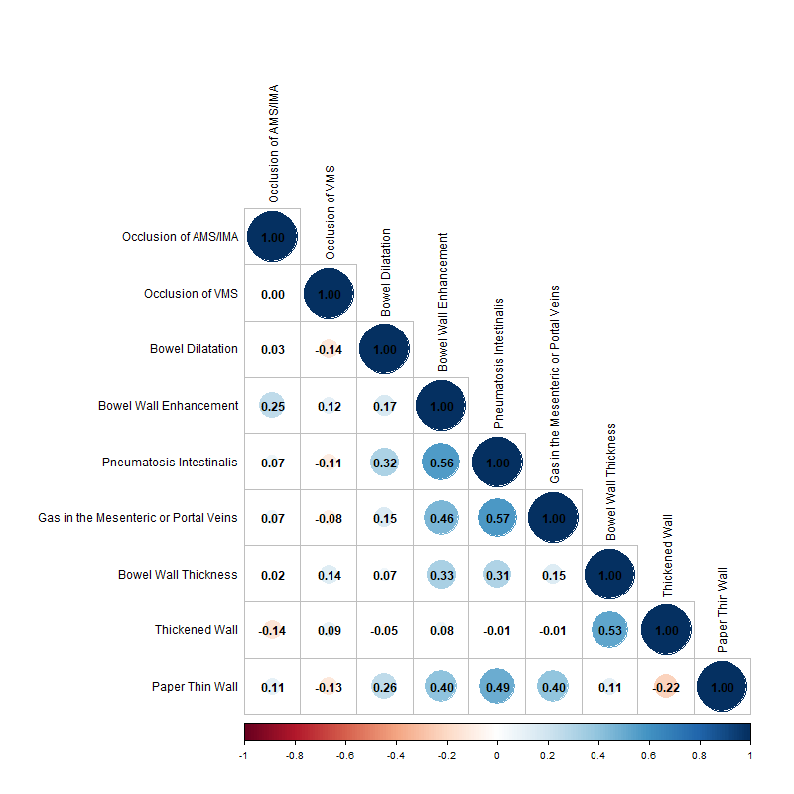

Table S1. Description of groups according to the presence and severity of AMI. Severity scores, comorbidities, and organ support were documented at baseline (time of suspicion/diagnosis of AMI). Data are presented as median (IQR), unless otherwise specified.

Variable | No AMI (n=46) | Reversible (n=31) | Irreversible  (n=80) | P value  No AMI vs rever-sible | P value  No AMI vs irre-versible | P value  Rever-sible vs irrever-sible
Age | 68 (56-77) | 72 (67-82) | 75 (67-80) | 0.296 | 0.018 | 0.536
Female, n (%) | 20 (43.5) | 12 (38.7) | 30 (37.5) | 0.814 | 0.572 | 1
aCCI | 5 (2-7) | 4 (3-7) | 5 (4-6) | 0.745 | 0.813 | 0.448
APACHE II | 12 (6-17) | 12 (8-23) | 17 (11-23) | 0.552 | 0.015 | 0.160
SOFA | 3 (0-6) | 2 (1-7) | 6 (2-10) | 0.975 | 0.001 | 0.033
New AF, n (%) | 2 (4.3) | 6 (19.4) | 8 (10.0) | 0.055 | 0.324 | 0.209
Mechanical ventilation, n (%) | 11 (23.9) | 7 (22.6) | 31 (38.8) | 1 | 0.117 | 0.124
Vasopressors, n (%) | 10 (21.7) | 3 (9.7) | 25 (31.2) | 0.222 | 0.304 | 0.027
AMI type  Arterial  Venous  NOMI  Other* | - | 18 (58.1)  9 (29.0)  4 (12.9)  - | 48 (60.0)  2 (2.5)  20 (25.0)  10 (12.5) | - | - | <0.001
In-hospital mortality, n (%) | 12 (26.1) | 6 (19.4) | 53 (66.2) | 0.589 | <0.001 | <0.001

aCCI – age-adjusted Charlson Comorbidity Index
APACHE II – Acute Physiology and Chronic Health Evaluation II
SOFA – Sequential Organ Failure Assessment
AF – Atrial fibrillation
* – includes intestinal ischemia in specific conditions or via unclear mechanisms

Table S2. Patient allocation to study groups and inclusion of radiological data in the final analysis.

 | Group description | No of pt | Included in final analysis (n)
1. | Patients with suspected, but not confirmed AMI (Group 1) | 51 | 46
2. | Patients with confirmed AMI (Group 2) | 126 | 111
2.1 | Patients with confirmed AMI, reversible injury (Group 2.1) | 33 | 31
2.1.1 | treated endovascularly and did not undergo bowel resection secondarily | 7 | 6
2.1.2 | received surgical revascularization without bowel resection (initial or secondary) | 11 | 10
2.1.3 | received explorative laparoscopy or laparotomy without the need for bowel resection (initially or secondarily) | 4 | 4
2.1.4 | received conservative treatment without the need for secondary bowel resection | 11 | 11
2.2 | Patients with confirmed AMI, irreversible injury (Group 2.2) | 93 | 80
2.2.1 | underwent bowel resection initially | 26 | 22
2.2.2 | underwent bowel resection secondarily | 22 | 19
2.2.3 | did not undergo bowel resection because non-salvageable bowel | 6 | 6
2.2.4 | were changed to palliation due to the progression of ischemia after any initial treatment with curative intention (including endovascular and conservative) | 28 | 22
2.2.5 | end-of-life care as initial management | 11 | 11
 | Total | 177 | 157

Table S3. Variability in CT findings between reviewers. The number of observations in each category is shown, with percentages in brackets.
Variable | Category | Reviewer 1 | Reviewer 2 | Consensus
Occlusion of SMA/IMA | Not evaluated* | 2 (1.3) | 0 (0.0) | 0 (0.0)
Occlusion of SMA/IMA | 0 = no | 95 (60.5) | 92 (58.6) | 96 (61.1)
Occlusion of SMA/IMA | 1 = yes | 60 (38.2) | 65 (41.4) | 61 (38.9)
Occlusion of SMV | Not evaluated* | 3 (1.9) | 2 (1.3) | 0 (0.0)
Occlusion of SMV | 0 = no | 135 (86.0) | 133 (84.7) | 139 (88.5)
Occlusion of SMV | 1 = yes | 19 (12.1) | 22 (14.0) | 18 (11.5)
Bowel dilatation | Not evaluated* | 2 (1.3) | 0 (0.0) | 0 (0.0)
Bowel dilatation | 0 = no | 81 (51.3) | 61 (38.9) | 83 (52.9)
Bowel dilatation | 1 = uncertain | 8 (5.1) | 21 (13.4) | 0 (0.0)
Bowel dilatation | 2 = yes | 66 (42.3) | 75 (47.8) | 74 (47.1)
Bowel wall enhancement | Not evaluated* | 2 (1.3) | 1 (0.6) | 0 (0.0)
Bowel wall enhancement | 0 = normal | 69 (43.9) | 12 (7.6) | 81 (51.6)
Bowel wall enhancement | 1 = uncertain | 30 (19.1) | 43 (27.4) | 0 (0.0)
Bowel wall enhancement | 2 = hyperenhanced | 1 (0.6) | 3 (1.9) | 0 (0.0)
Bowel wall enhancement | 3 = decreased | 37 (23.6) | 65 (41.4) | 50 (31.8)
Bowel wall enhancement | 4 = non enhanced | 18 (11.5) | 33 (21.0) | 26 (16.6)
Pneumatosis intestinalis | Not evaluated* | 2 (1.3) | 0 (0.0) | 0 (0.0)
Pneumatosis intestinalis | 1 = no | 106 (67.5) | 56 (35.7) | 112 (71.3)
Pneumatosis intestinalis | 2 = uncertain | 17 (10.8) | 26 (16.6) | 0 (0.0)
Pneumatosis intestinalis | 3 = possible | 13 (8.3) | 52 (33.1) | 21 (13.4)
Pneumatosis intestinalis | 4 = clearly detected | 19 (12.1) | 23 (14.6) | 24 (15.3)
Gas in the mesenteric or portal veins | Not evaluated* | 2 (1.3) | 0 (0.0) | 0 (0.0)
Gas in the mesenteric or portal veins | 0 = no | 134 (85.4) | 118 (75.2) | 136 (86.6)
Gas in the mesenteric or portal veins | 1 = uncertain | 7 (4.5) | 17 (10.8) | 0 (0.0)
Gas in the mesenteric or portal veins | 2 = clearly detected | 14 (8.9) | 22 (14.0) | 21 (13.4)
Bowel wall thickness | Not evaluated* | 5 (3.2) | 1 (0.6) | 0 (0.0)
Bowel wall thickness | 0 = normal | 87 (55.4) | 35 (22.3) | 46 (29.3)
Bowel wall thickness | 1 = abnormal | 24 (15.3)# | 42 (26.8) # | 76 (48.4) §
Bowel wall thickness | 2 = paper thin wall | 41 (26.1) | 79 (50.3) | 52 (33.1)

* technical limitations and not possible to evaluate
# includes only thickened bowel wall
§ includes both thickened and thinned bowel wall

Table S4. Interobserver agreement for assessment of radiological signs, expressed as kappa statistics (95% CI).

Variable | Kappa
Occlusion of SMA/IMA | 0.75 (0.64; 0.85)
Occlusion of SMV | 0.48 (0.28; 0.69)
Bowel dilatation | 0.63 (0.51; 0.75)
Bowel wall enhancement | 0.40 (0.28; 0.51)
Pneumatosis intestinalis | 0.36 (0.24; 0.48)
Gas in the mesenteric or portal veins | 0.69 (0.51; 0.87)
Bowel wall thickness | 0.30 (0.17; 0.44)

Table S5. Prevalence of assessed radiological signs in patients without AMI, and with AMI with reversible bowel damage and irreversible bowel damage.

Variable | Category | No AMI | Reversible AMI | Irreversible AMI
Occlusion of SMA/IMA | No | 41 (89.1) | 15 (48.4) | 40 (50.0)
Occlusion of SMA/IMA | Yes | 5 (10.9) | 16 (51.6) | 40 (50.0)
Occlusion of SMV | No | 44 (95.7) | 22 (71.0) | 73 (91.2)
Occlusion of SMV | Yes | 2 (4.3) | 9 (29.0) | 7 (8.8)
Bowel dilatation | No | 25 (54.3) | 25 (80.6) | 33 (41.2)
Bowel dilatation | Yes | 21 (45.7) | 6 (19.4) | 47 (58.8)
Bowel wall enhancement | Normal | 38 (82.6) | 15 (48.4) | 28 (35.0)
Bowel wall enhancement | Decreased | 6 (13.0) | 12 (38.7) | 32 (40.0)
Bowel wall enhancement | No enhancement | 2 (4.3) | 4 (12.9) | 20 (25.0)
Pneumatosis intestinalis | No | 41 (89.1) | 26 (83.9) | 45 (56.2)
Pneumatosis intestinalis | Possible pneumatosis or mimicked | 2 (4.3) | 3 (9.7) | 16 (20.0)
Pneumatosis intestinalis | Yes | 3 (6.5) | 2 (6.5) | 19 (23.8)
Gas in the mesenteric or  portal veins | No | 44 (95.7) | 28 (90.3) | 64 (80.0)
Gas in the mesenteric or  portal veins | Yes | 2 (4.3) | 3 (9.7) | 16 (20.0)
Paper thin wall | No | 37 (80.4) | 26 (83.9) | 42 (54.2)
Paper thin wall | Yes | 9 (19.6) | 5 (16.1) | 38 (45.8)
Thickened wall | No | 27 (58.7) | 14 (45.2) | 40 (50.0)
Thickened wall | Yes | 19 (41.3) | 17 (54.8) | 40 (50.0)

SMA – superior mesenteric artery, IMA – inferior mesenteric artery, SMV – superior mesenteric vein. All evaluation with the category “uncertain of technically difficult to evaluate” (ex. pneumatosis) were considered as “no” according to consensual evaluation by two radiologists.

Table S6. Regression coefficients from univariable logistic models with binary grouping as the dependent variable and radiological sign as the predictor

Variable | No AMI vs AMI (46 vs 111) | Reversible AMI vs irreversible AMI (28 vs 83) | No Irreversible* vs irreversible AMI (74 vs 83) | No irreversible vs irreversible arterial occlusive AMI (61 vs 51)
Occlusion of SMA/IMA = Yes | 2.1 | 0.1 | 1.1 | 1.7
Occlusion of SMV = Yes | 1.3 | -1.3 | -0.4 | 1.4
Bowel dilatation= Yes | 0.1 | 1.8 | 0.9 | 1.0
Bowel wall enhancement=Decreased  Bowel wall enhancement=No enhacement | 1.9  2.4 | 0.3  0.8 | 1.2  1.7 | 1.4  2.0
Pneumatosis intestinalis=Possible  Pneumatosis intestinalis=Yes | 1.7  1.4 | 0.9  1.5 | 1.5  1.6 | 1.4  2.0
Gas in the mesenteric or portal veins=Yes | 1.5 | 0.7 | 1.2 | 1.4
Paper thin wall=Yes (uncertain=no) | 1.0 | 1.7 | 1.4 | 1.2
Thickened wall=Yes | 0.4 | -0.3 | 0.1 | -0.3

No Irreversible* groups together patients with no AMI and reversible AMI

Table S7. Distribution of bowel related CT signs in patients without AMI and in patients with AMI stratified by reversibility and aetiology.

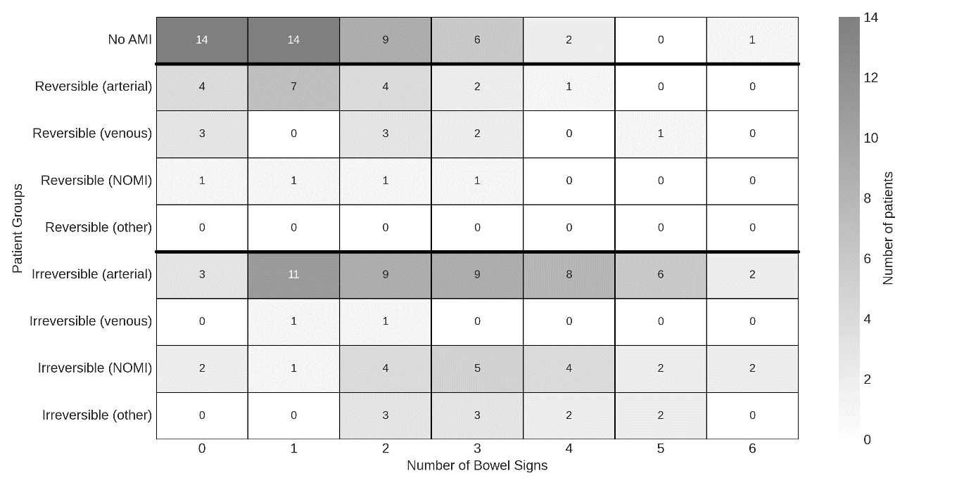
Considered bowel related CT signs according to Table 1: bowel dilatation, abnormal bowel wall enhancement (decreased or absent), pneumatosis of bowel wall, gas in mesenteric or portal veins, bowel wall thickening, and bowel wall thinning with paper-thin wall.

