Supplemental

Effect of pipernonaline from Piper retrofractum on memory disorder in mice and neurite outgrowth activity of PC12 cells
Runa Fujimoto^{b}, Yuzuki Irie ^{b}, Tohru Mitsunaga^{a, b, d}, Kosei Yamauchi^{a, b, c, d}*

a Faculty of Applied Biological Sciences, Gifu University, Gifu, Gifu 501-1193, Japan
b Graduate School of Natural Science and Technology, Gifu University, Gifu, Japan, Gifu University, 1-1 Yanagido 501-1193, Gifu, Japan
c Center for One Medicine Innovative Translational Research (COMIT), Institute for Advanced Study, Gifu University, Gifu, Japan
d The United Graduate School of Agricultural Science, Gifu University, 1-1 Yanagido, Gifu-shi, Gifu, 501-1193, Japan

Corresponding Author
*Dr. Kosei Yamauchi,
Faculty of Applied Biological Sciences, Gifu University, Gifu, Japan, Gifu University, 1-1 Yanagido 501-1193, Gifu, Japan
Tel.: +81 58 293 2897
E-mail: yamauchi.kosei.p2@f.gifu-u.ac.jp

Fig.S1 Photomicrographs of PC12 cells treated with P.retrofractum extracts and NGF

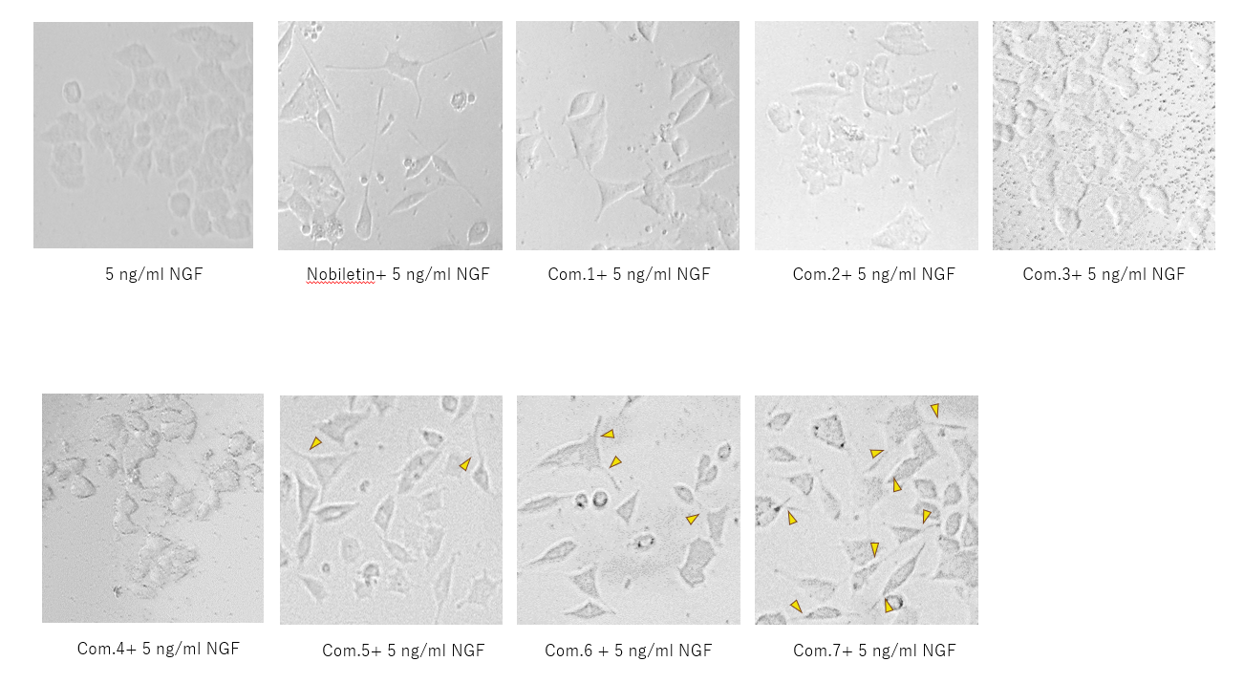Fig.S2 Photomicrographs of PC12 cells treated with 1-7 from P.retrofractum extracts and NGF
The arrows indicated dendritic outgrowths by addition of the samples.

A
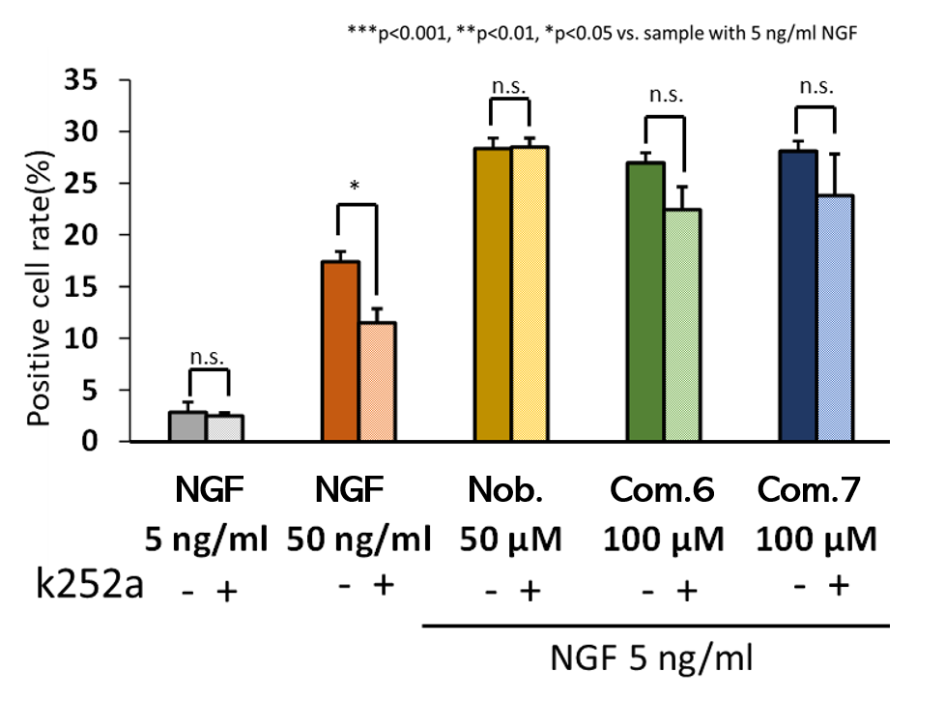
B
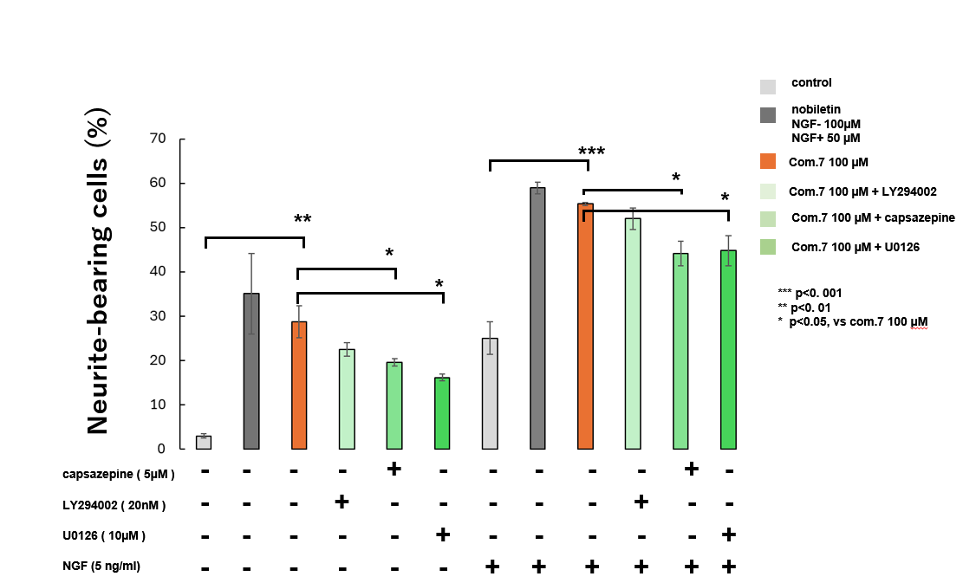
Fig.S3 Neurite Outgrowth positive cells treated with 7 and inhibitors.
A: Inhibitory test using k252a, a inhibitor of TrakA. B: Inhibitory test using capsazepine (TRPV1 inhibitor), LY294002 (PI3K inhibitor), and U0126 (MEK inhibitor). Significance was analyzed using analysis of Dunnett’s test by EZR ***P<0.001, **P<0.01 and *P<0.05 n=3

NMR and MALDI-TOF-MS Spectrum of isolated compounds

Fig. S4 ¹H NMR spectrum (CDCl₃) of piperine (1)
Fig. S5 ¹³C NMR spectrum (CDCl₃) of piperine (1)
Fig. S6 MALDI-TOF-MS spectrum (CDCl₃) of piperine (1)

Fig. S7 ¹H NMR spectrum (CDCl₃) of Methyl piperate (2)
Fig. S8 ¹³C NMR spectrum (CDCl₃) of Methyl piperate (2)
Fig. S9 MALDI-TOF-MS spectrum (CDCl₃) of Methyl piperate (2)
Fig. S10 ¹H NMR spectrum (CDCl₃) of pipercide (3)
Fig. S11 ¹³C NMR spectrum (CDCl₃) of pipercide (3)
Fig. S12 MALDI-TOF-MS spectrum (CDCl₃) of pipercide (3)
Fig. S13 ¹H NMR spectrum (CDCl₃) of guineesine(4)
Fig. S14 ¹³C NMR spectrum (CDCl₃) of guineesine(4)
Fig. S15 MALDI-TOF-MS spectrum (CDCl₃) of guineesine(4)

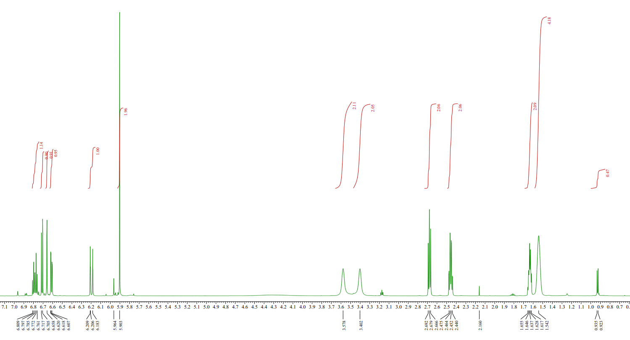
Fig. S16 ¹H NMR spectrum (CDCl₃) of piperanine(5)

Fig. S17 ¹³C NMR spectrum (CDCl₃) of piperanine(5)

Fig. S18 MALDI-TOF-MS spectrum (CDCl₃) of piperanine(5)

Fig. S19 ¹H-¹H COSY NMR spectrum (CDCl₃) of dehydropipernonaline (6)

Fig. S20 ¹³C NMR spectrum (CDCl₃) of dehydropipernonaline (6)

Fig. S21 MALDI-TOF-MS spectrum (CDCl₃) of dehydropipernonaline (6)
Fig. S22 ¹H NMR spectrum (CDCl₃) of pipernonaline (7)
Fig. S23 ¹³C NMR spectrum (CDCl₃) of pipernonaline (7)
Fig. S24 MALDI-TOF-MS spectrum (CDCl₃) of pipernonaline (7)

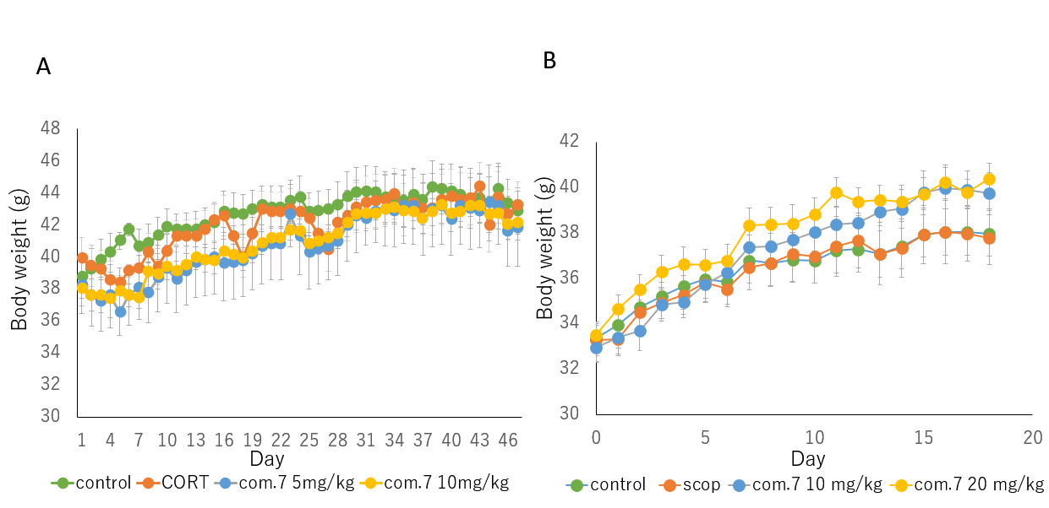
Fig. S25 Body weight change of mice treated with corticosterone (CORT)(A) and scopolamine (scop)(B)

