Additional file 1: Supplementary materials
Development and Psychometric Validation of the CaregiverCPP Scale for Caregivers of Children With Central Precocious Puberty: A Multicenter Study in China
This Additional file 1 provides supplementary materials supporting the development and psychometric validation of the CaregiverCPP. It contains four supplementary tables (S1–S4) and eight supplementary figures (S1–S8). Tables and figures are organized by analytical theme: content validity (Table S1), exploratory factor analysis (Table S2 and Figure S1), item response theory analyses (Table S3 and Figures S2–S7), and differential item functioning (Table S4 and Figure S8).
Table S1. Summary of the Delphi expert consultation process and content validity decisions (Phase I)
Phase / component | Key principle / standard practice | Implementation in this study | Outcome / decision
Initial item pool | Integration of literature, qualitative data, and clinical input | Literature review + semi-structured caregiver interviews + expert recommendations | Initial pool: 57 items
Expert composition | Multidisciplinary coverage of target conceptual domains | 10 experts: pediatric endocrinology, child health care, psychology, nursing, etc. | Ensured conceptual coverage and semantic applicability
Round 1 evaluation | Dual-dimension assessment: importance and clarity | Five-point Likert scale + qualitative suggestions for modification | Items flagged for discussion based on I-CVI threshold of 0.78
Round 2 consensus | Focus on controversial items and wording consistency | Online consensus meeting: item splitting, unification of voice, and refinement of wording on economic burden | Item refinement and structural optimization
Cognitive interviews & intelligibility | “Think-aloud” method to verify consistency of understanding | Identified discrepancies in terminology understanding and ambiguity in frequency descriptors | Added terminological annotations; clarified time frames and response reference points
Pilot version formation | Finalized usable version prior to quantitative validation | Integration of feedback from both rounds and post-meeting revisions | Pilot version: 38 items (proceeded to Phase II)
Note. CVI, content validity index; I-CVI, item-content validity index.
Table S2. Exploratory factor analysis: full factor loading matrix and communalities for the CaregiverCPP (Sample A, n = 738)
Item | F1 | F2 | F3 | F4 | F5 | F6 | Communality (h²) | Primary factor | Primary loading
q34 | 0.80 |  |  |  |  |  | 0.67 | F1 | 0.80
q32 | 0.76 |  |  |  |  |  | 0.60 | F1 | 0.76
q35 | 0.74 |  |  |  |  |  | 0.57 | F1 | 0.74
q33 | 0.71 |  |  |  |  |  | 0.58 | F1 | 0.71
q31 | 0.71 |  |  |  |  |  | 0.52 | F1 | 0.71
q36 | 0.65 |  |  |  |  |  | 0.47 | F1 | 0.65
q30 | 0.55 |  |  |  |  |  | 0.34 | F1 | 0.55
q22 |  | 0.86 |  |  |  |  | 0.81 | F2 | 0.86
q24 |  | 0.82 |  |  |  |  | 0.68 | F2 | 0.82
q21 |  | 0.82 |  | 0.35 |  |  | 0.83 | F2 | 0.82
q18 |  | 0.80 |  |  |  |  | 0.66 | F2 | 0.80
q23 |  | 0.73 |  |  |  |  | 0.55 | F2 | 0.73
q20 |  | 0.67 |  |  |  |  | 0.49 | F2 | 0.67
q19 |  | 0.48 |  |  |  |  | 0.32 | F2 | 0.48
q17† |  |  |  |  |  |  | 0.28 | F2 | 0.28†
q2 |  |  | 0.73 |  |  |  | 0.54 | F3 | 0.73
q7 |  |  | 0.77 |  |  |  | 0.59 | F3 | 0.77
q3 |  |  | 0.67 |  |  |  | 0.46 | F3 | 0.67
q8 |  |  | 0.66 |  |  |  | 0.45 | F3 | 0.66
q6 |  |  | 0.65 |  |  |  | 0.45 | F3 | 0.65
q4 |  |  | 0.61 |  |  |  | 0.41 | F3 | 0.61
q5 |  |  | 0.60 |  |  |  | 0.38 | F3 | 0.60
q1 |  |  | 0.54 |  |  |  | 0.34 | F3 | 0.54
q37 | 0.34 |  |  | 0.66 |  |  | 0.55 | F4 | 0.66
q28 |  |  |  | 0.65 |  |  | 0.50 | F4 | 0.65
q29 | 0.31 |  |  | 0.65 |  |  | 0.51 | F4 | 0.65
q16 |  |  |  | 0.61 |  |  | 0.47 | F4 | 0.61
q38 | 0.48 |  |  | 0.48 |  |  | 0.47 | F4 | 0.48
q9 |  |  |  |  | 0.67 |  | 0.68 | F5 | 0.67
q11 |  |  |  |  | 0.66 | 0.35 | 0.69 | F5 | 0.66
q12 |  |  |  |  | 0.59 |  | 0.39 | F5 | 0.59
q10 |  |  |  |  | 0.57 |  | 0.36 | F5 | 0.57
q26 | 0.32 |  |  |  | 0.47 |  | 0.45 | F5 | 0.47
q25 |  |  |  |  | 0.47 |  | 0.35 | F5 | 0.47
q27 |  |  |  |  | 0.40 |  | 0.38 | F5 | 0.40
q15 |  |  |  |  |  | 0.63 | 0.43 | F6 | 0.63
q14 |  |  |  |  |  | 0.63 | 0.43 | F6 | 0.63
q13 |  |  |  |  |  | 0.55 | 0.39 | F6 | 0.55
Note. Extraction by principal axis factoring with Promax oblique rotation. Standardized factor loadings and communalities (h²) are reported for all 38 items across the six latent factors. Loadings below 0.30 are suppressed for readability. The primary factor for each item is shown with its loading; cross-loadings ≥0.30 are displayed where present. † Item q17 was retained based on content validity despite a primary loading below 0.30 (see main text for rationale).
Figure S1. Heatmap of standardized factor loadings from the exploratory factor analysis with Promax rotation (Sample A, n = 738).
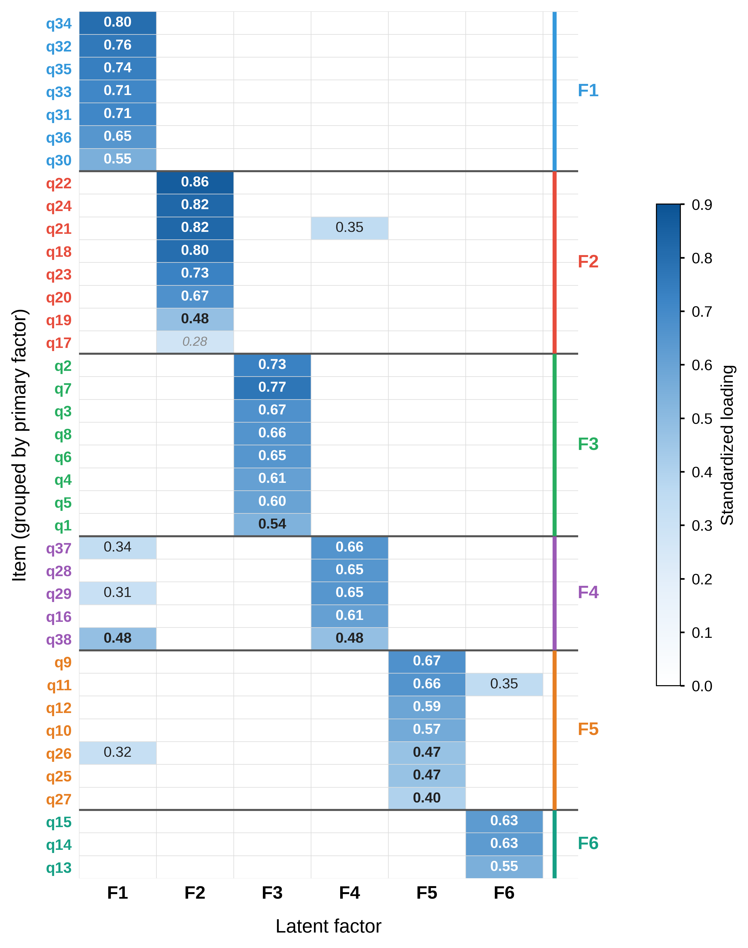
Note. Rows represent items (q1–q38) grouped by their primary factor (F1–F6); columns represent the six latent factors. Color intensity encodes the magnitude of the standardized loading; loadings below 0.30 are shown in pale shades for readability. The block-diagonal pattern visualizes the simple structure underlying the six-factor solution.
Table S3. Item parameter estimates from the item response theory (IRT) graded response model (GRM) (Sample A, n = 738)
No. | Item content | Factor | a | b₁ | b₂ | b₃ | b₄
1 | How well do you understand the possible causes of central precocious puberty (CPP)? | F3 | 1.97 | 0.006 | — | — | —
2 | How well do you understand how CPP is diagnosed? | F3 | 1.96 | -0.069 | — | — | —
3 | Do you understand the role of “bone age” in diagnosis and treatment? | F3 | 2.36 | -0.127 | — | — | —
4 | What do you consider to be the primary goal of administering GnRHa (“suppression shots”) to your child? | F3 | 2.24 | -0.051 | — | — | —
5 | Aside from height, are you aware that CPP may also impact your child’s future psychological health? | F3 | 1.89 | -0.034 | — | — | —
6 | Do you understand that the main difference between types of “suppression shots” (e.g., monthly vs. quarterly) lies in injection frequency and convenience? | F3 | 1.78 | -0.046 | — | — | —
7 | Are you aware that common, mild side effects (e.g., redness or pain at the injection site) may occur during treatment? | F3 | 1.73 | 0.042 | — | — | —
8 | Do you know the appropriate course of action if your child experiences a mild local reaction after an injection? | F3 | 1.57 | -0.007 | — | — | —
9 | I believe “suppression shots” are necessary for children with CPP. | F5 | 2.79 | -1.103 | -0.519 | 0.032 | 0.792
10 | I am worried about potential unknown risks associated with the “suppression shots.” | F5 | 1.87 | -0.620 | -0.105 | 0.514 | 1.167
11 | I believe the “suppression shots” are crucial for improving my child’s final height. | F5 | 2.14 | -1.062 | -0.477 | 0.021 | 0.720
12 | I feel stressed about managing the daily routine of my child’s CPP treatment (e.g., timely injections, regular check-ups). | F5 | 1.58 | -0.202 | 0.326 | 0.860 | 1.486
13 | In the past month, I have regularly monitored and recorded changes in my child’s growth (height, weight, sexual development). | F6 | 2.27 | -0.637 | -0.191 | 0.309 | 0.878
14 | In the past month, I have proactively sought more information about CPP via the internet or books. | F6 | 2.24 | -0.456 | 0.006 | 0.436 | 0.993
15 | In the past month, I have tried to talk to my child about their condition and injections in a way they can understand. | F6 | 2.29 | -0.628 | -0.180 | 0.294 | 0.898
16 | In the past month, I have strictly followed the doctor’s instructions to ensure my child receives every treatment. | F4 | 1.88 | -0.822 | -0.225 | 0.293 | 0.843
17 | In the past month, I felt challenged in helping my child overcome the fear of injections. | F2 | 1.55 | -0.213 | 0.324 | 0.890 | 1.490
18 | In the past month, I felt depressed or anxious because of my child’s condition. | F2 | 1.78 | -0.292 | 0.240 | 0.787 | 1.410
19 | In the past month, I have discussed this matter deeply with others because of my child’s condition. | F2 | 1.51 | -0.120 | 0.399 | 0.955 | 1.576
20 | In the past month, I felt that family life was affected by my child’s condition. | F2 | 1.86 | -0.462 | 0.041 | 0.534 | 1.091
21 | In the past month, I was very worried that my child’s final height would not be ideal. | F2 | 2.14 | -0.642 | -0.162 | 0.313 | 0.851
22 | In the past month, I was very worried about unknown long-term side effects of the treatment. | F2 | 2.27 | -0.711 | -0.226 | 0.265 | 0.813
23 | In the past month, I was very worried that my child would be bullied or isolated at school due to early development. | F2 | 2.11 | -0.566 | -0.082 | 0.409 | 0.986
24 | In the past month, I was very worried that my child is not psychologically prepared for premature development. | F2 | 2.22 | -0.649 | -0.162 | 0.325 | 0.890
25 | Expenses for various tests (e.g., ultrasound, bone age, labs, MRI) are a significant expenditure for my family. | F5 | 1.70 | -0.930 | -0.372 | 0.180 | 0.774
26 | Travel and accommodation costs for frequent hospital visits place an extra economic strain on my family. | F5 | 1.88 | -0.438 | 0.085 | 0.576 | 1.091
27 | I feel the total cost of treating my child’s condition exceeds my family’s financial capacity. | F5 | 1.71 | -0.096 | 0.421 | 0.937 | 1.513
28 | Ability to effectively control the child’s sexual development. | F4 | 1.61 | -1.190 | -0.585 | -0.020 | 0.583
29 | Maximizing improvement in the child’s future height. | F4 | 1.58 | -1.303 | -0.643 | -0.071 | 0.547
30 | The likelihood of treatment causing weight gain. | F1 | 1.64 | -0.440 | 0.096 | 0.621 | 1.146
31 | The type and probability of potential side effects (e.g., local site reactions). | F1 | 1.60 | -0.778 | -0.203 | 0.329 | 0.917
32 | Ability to minimize the frequency of hospital visits. | F1 | 1.76 | -1.079 | -0.514 | 0.051 | 0.634
33 | Minimal interference with daily activities like school and sports. | F1 | 1.67 | -0.874 | -0.333 | 0.201 | 0.772
34 | Lower injection frequency (e.g., every three months vs. monthly). | F1 | 1.77 | -0.872 | -0.322 | 0.205 | 0.754
35 | The child’s level of fear regarding different injection methods. | F1 | 1.63 | -0.471 | 0.055 | 0.568 | 1.142
36 | Which treatment regimen has lower costs. | F1 | 1.60 | -0.435 | 0.095 | 0.614 | 1.145
37 | The doctor’s professional recommendation. | F4 | 1.72 | -1.231 | -0.593 | 0.021 | 0.630
38 | Alignment between injection frequency and check-up frequency. | F4 | 1.63 | -0.919 | -0.343 | 0.206 | 0.784
Note. a, discrimination parameter; b₁–b₄, threshold parameters (number varies by response categories per item; em dashes indicate non-applicable values). Parameters were estimated using the graded response model (GRM), with the latent trait θ standardized (mean = 0, SD = 1). Items 1–8 (F3, disease-knowledge) were estimated under a dichotomous-equivalent specification, hence only b₁ is reported.
Figure S2. Information functions from the graded response model (GRM) for Factor 1 (Treatment burden & convenience).
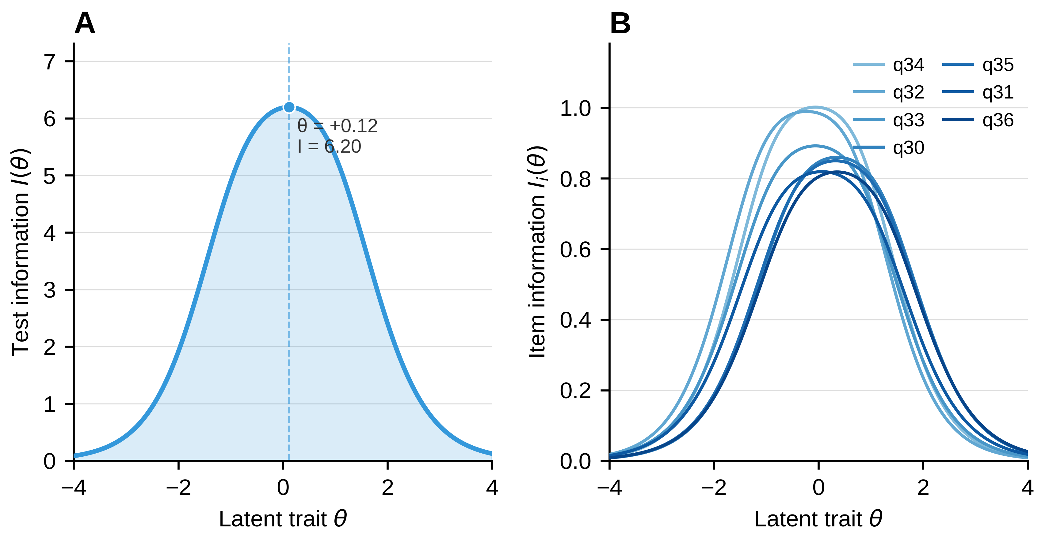
Note. (A) Test information function (TIF) for Factor 1. The x-axis represents the latent trait level (θ); the y-axis represents the magnitude of test information. (B) Item information functions (IIFs) for items in this factor (q30–q36); curves correspond to the item numbers indicated in the legend. Information is primarily concentrated in the intermediate range of θ, indicating optimal measurement precision at mild-to-moderate levels of the latent trait.
Figure S3. Information functions from the GRM for Factor 2 (Psychosocial & daily-life impact).
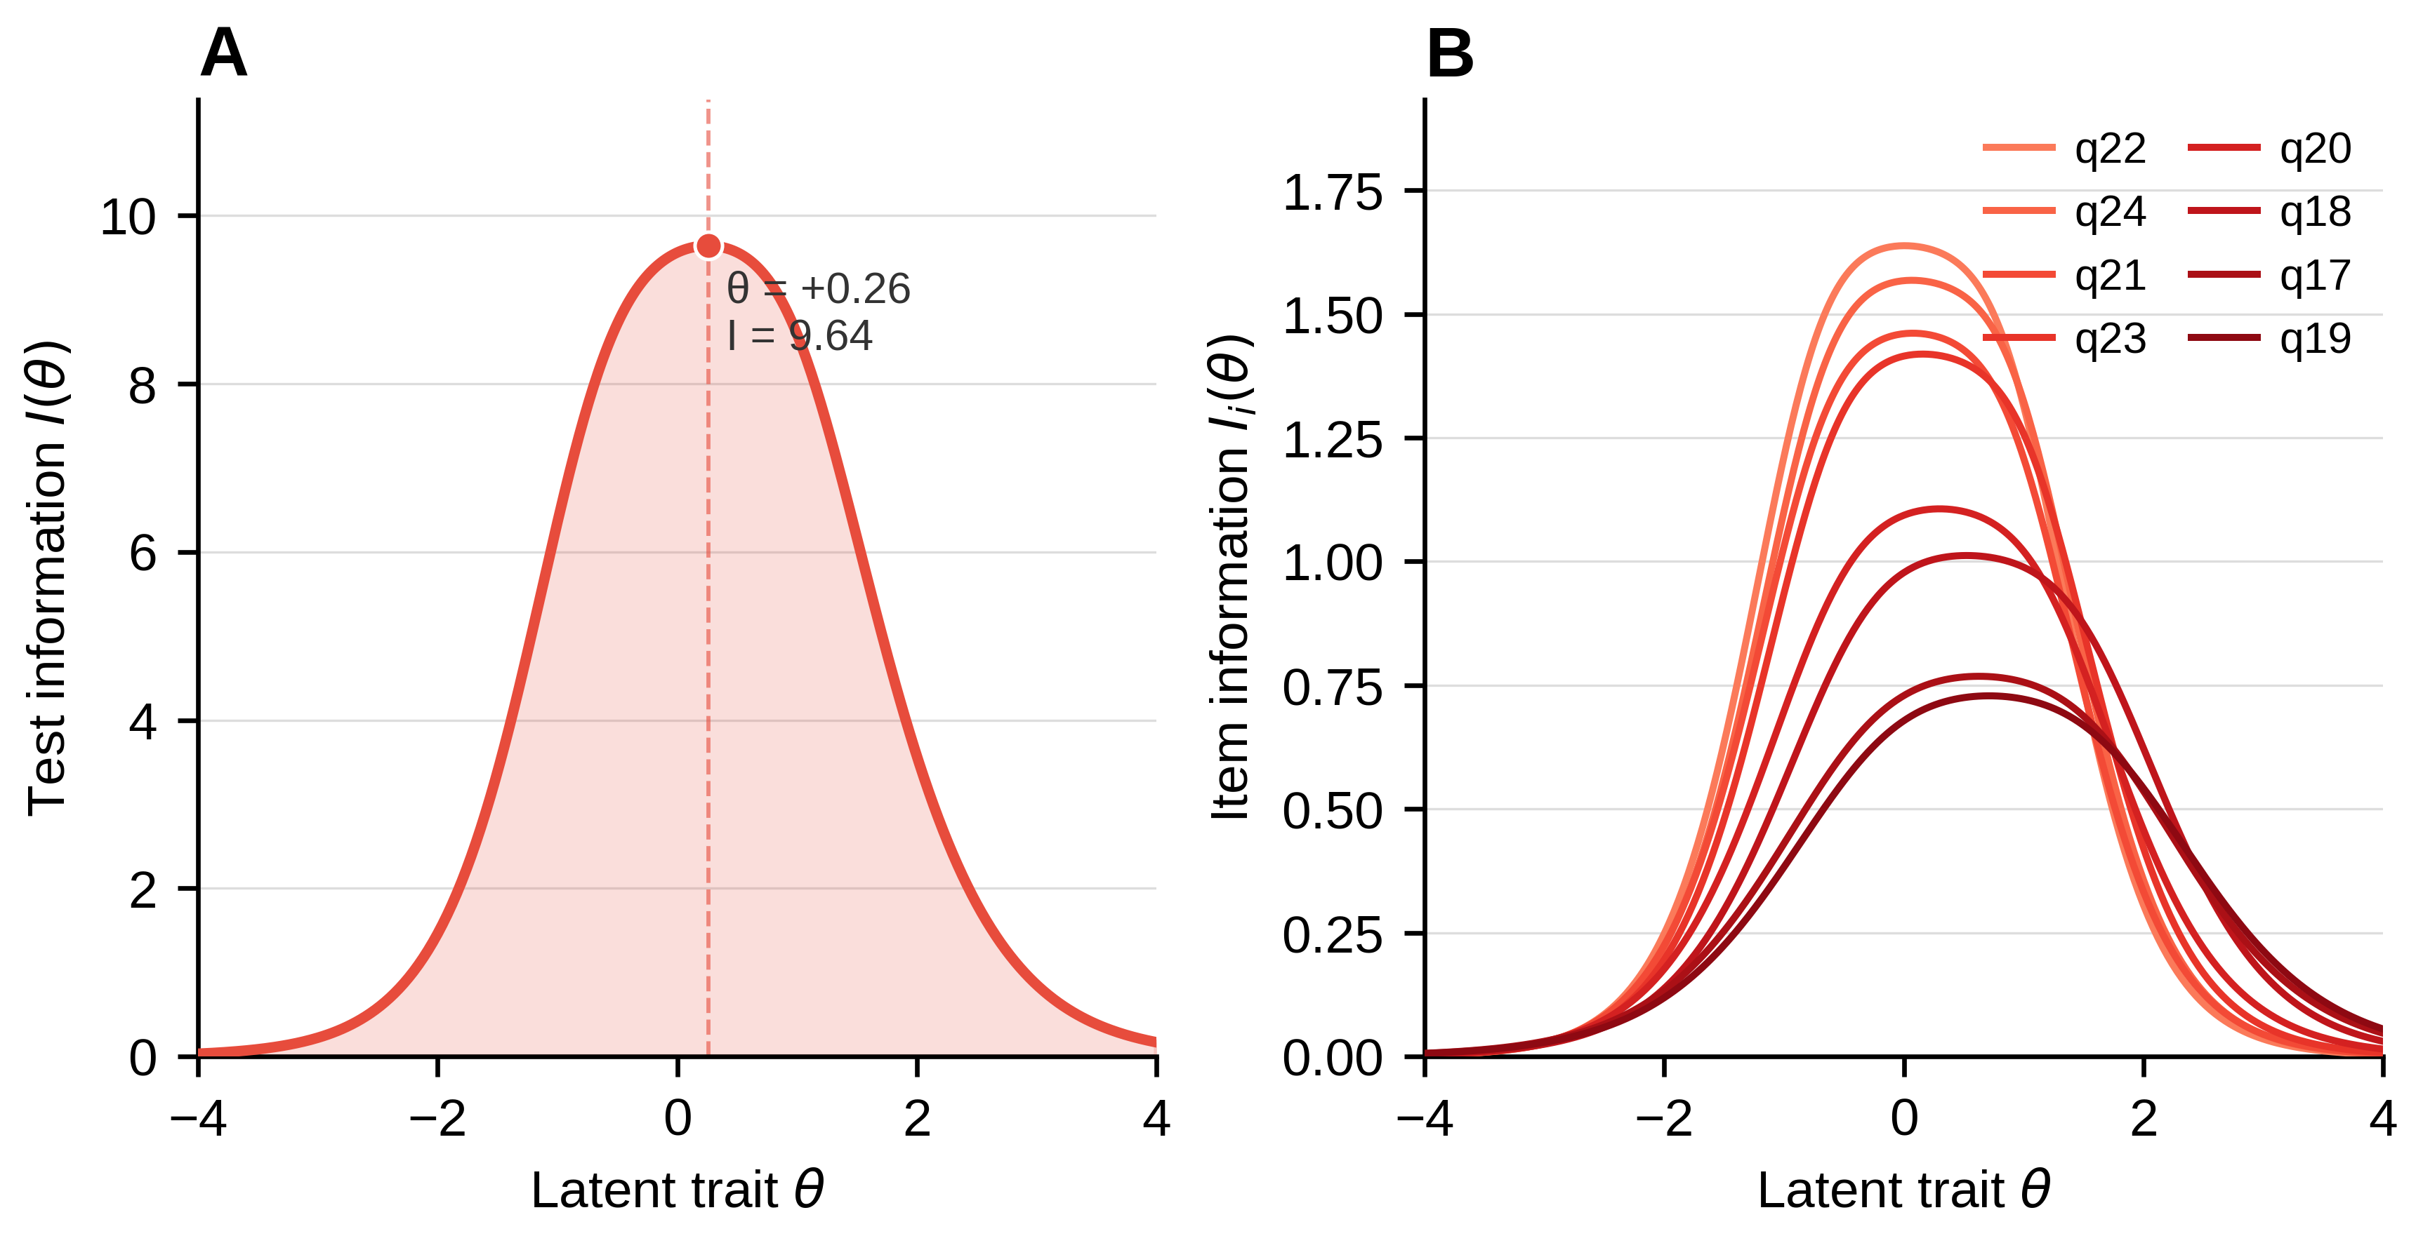
Note. Panels and conventions as in Figure S2. IIFs are shown for items q17–q24.
Figure S4. Information functions from the GRM for Factor 3 (Disease knowledge & understanding).
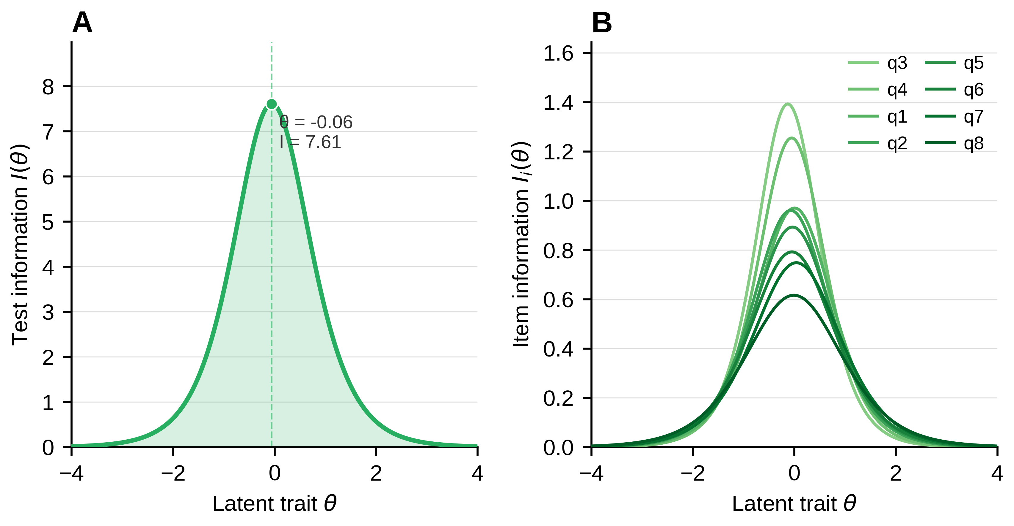
Note. Panels and conventions as in Figure S2. IIFs are shown for items q1–q8. Items in this factor were estimated under a dichotomous-equivalent specification (single threshold b₁).
Figure S5. Information functions from the GRM for Factor 4 (Preference & decision drivers).
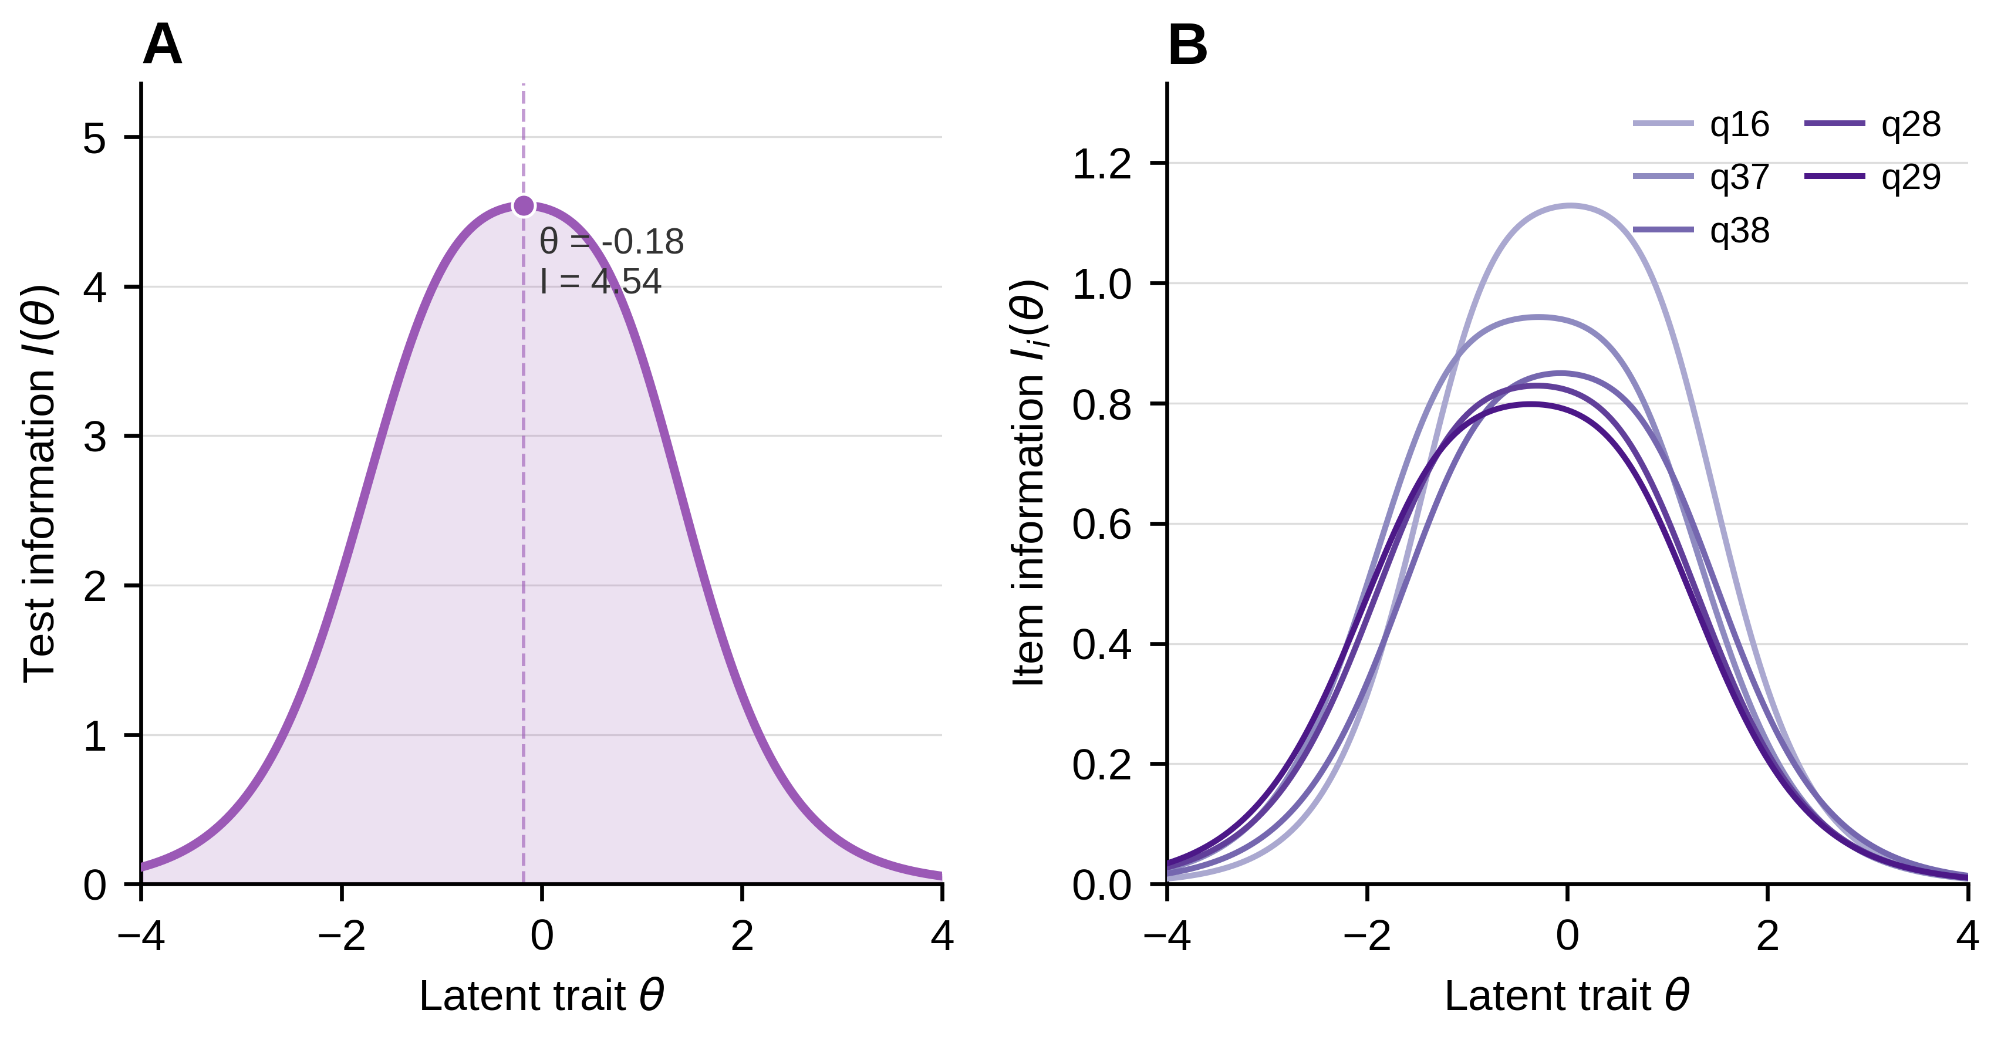
Note. Panels and conventions as in Figure S2. IIFs are shown for items q16, q28–q29, q37–q38.
Figure S6. Information functions from the GRM for Factor 5 (Attitudes & economic burden).
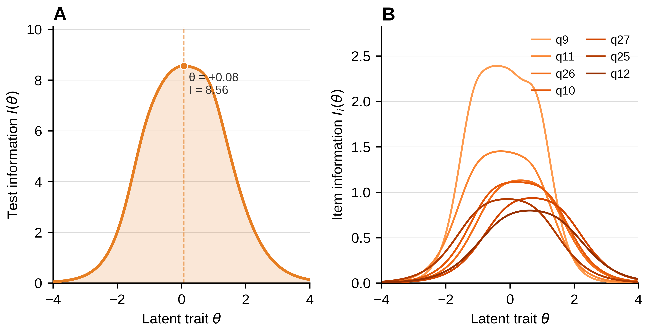
Note. Panels and conventions as in Figure S2. IIFs are shown for items q9–q12, q25–q27.
Figure S7. Information functions from the GRM for Factor 6 (Caregiving practice).
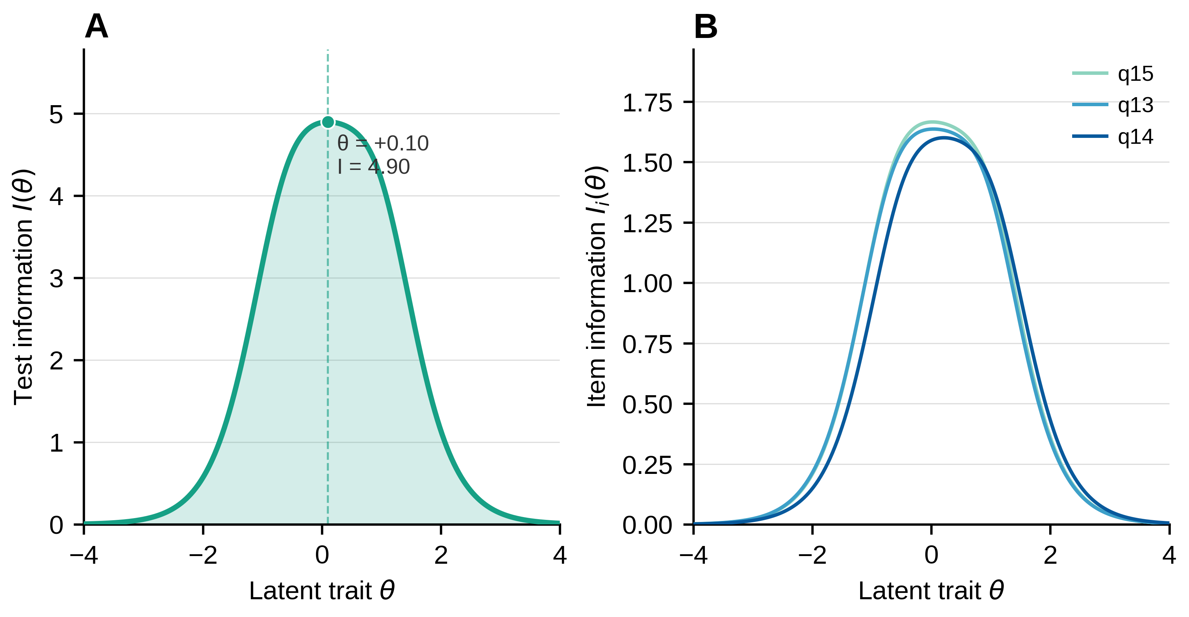
Note. Panels and conventions as in Figure S2. IIFs are shown for items q13–q15.
Table S4. Results of differential item functioning (DIF) analysis: effect sizes and statistical significance stratified by child sex
No. | Item content | ΔR² (uniform) | ΔR² (non-uniform) | ΔR² (total) | Significant DIF?
1 | How well do you understand the possible causes of central precocious puberty (CPP)? | 0.000 | 0.000 | 0.000 | No
2 | How well do you understand how CPP is diagnosed? | 0.000 | 0.000 | 0.000 | No
3 | Do you understand the role of “bone age” in diagnosis and treatment? | 0.000 | 0.000 | 0.000 | No
4 | What do you consider to be the primary goal of administering GnRHa (“suppression shots”) to your child? | 0.000 | 0.000 | 0.000 | No
5 | Aside from height, are you aware that CPP may also impact your child’s future psychological health? | 0.000 | 0.000 | 0.000 | No
6 | Do you understand that the main difference between types of “suppression shots” (e.g., monthly vs. quarterly) lies in injection frequency and convenience? | 0.000 | 0.000 | 0.000 | No
7 | Are you aware that common, mild side effects (e.g., redness or pain at the injection site) may occur during treatment? | 0.000 | 0.000 | 0.000 | No
8 | Do you know the appropriate course of action if your child experiences a mild local reaction after an injection? | 0.000 | 0.000 | 0.000 | No
9 | I believe “suppression shots” are necessary for children with CPP. | 0.001 | 0.002 | 0.003 | No
10 | I am worried about potential unknown risks associated with the “suppression shots.” | 0.001 | 0.002 | 0.003 | No
11 | I believe the “suppression shots” are crucial for improving my child’s final height. | 0.002 | 0.003 | 0.005 | No
12 | I feel stressed about managing the daily routine of my child’s CPP treatment (e.g., timely injections, regular check-ups). | 0.001 | 0.002 | 0.003 | No
13 | In the past month, I have regularly monitored and recorded changes in my child’s growth (height, weight, sexual development). | 0.001 | 0.003 | 0.004 | No
14 | In the past month, I have proactively sought more information about CPP via the internet or books. | 0.001 | 0.003 | 0.004 | No
15 | In the past month, I have tried to talk to my child about their condition and injections in a way they can understand. | 0.001 | 0.003 | 0.004 | No
16 | In the past month, I have strictly followed the doctor’s instructions to ensure my child receives every treatment. | 0.006 | 0.011 | 0.017 | No
17 | In the past month, I felt challenged in helping my child overcome the fear of injections. | 0.003 | 0.006 | 0.009 | No
18 | In the past month, I felt depressed or anxious because of my child’s condition. | 0.002 | 0.005 | 0.007 | No
19 | In the past month, I have discussed this matter deeply with others because of my child’s condition. | 0.002 | 0.004 | 0.006 | No
20 | In the past month, I felt that family life was affected by my child’s condition. | 0.003 | 0.006 | 0.009 | No
21 | In the past month, I was very worried that my child’s final height would not be ideal. | 0.002 | 0.004 | 0.006 | No
22 | In the past month, I was very worried about unknown long-term side effects of the treatment. | 0.002 | 0.004 | 0.006 | No
23 | In the past month, I was very worried that my child would be bullied or isolated at school due to early development. | 0.002 | 0.004 | 0.006 | No
24 | In the past month, I was very worried that my child is not psychologically prepared for premature development. | 0.002 | 0.004 | 0.006 | No
25 | Expenses for various tests (e.g., ultrasound, bone age, labs, MRI) are a significant expenditure for my family. | 0.001 | 0.002 | 0.003 | No
26 | Travel and accommodation costs for frequent hospital visits place an extra economic strain on my family. | 0.001 | 0.002 | 0.003 | No
27 | I feel the total cost of treating my child’s condition exceeds my family’s financial capacity. | 0.001 | 0.002 | 0.003 | No
28 | Ability to effectively control the child’s sexual development. | 0.002 | 0.004 | 0.006 | No
29 | Maximizing improvement in the child’s future height. | 0.002 | 0.004 | 0.006 | No
30 | The likelihood of treatment causing weight gain. | 0.002 | 0.004 | 0.006 | No
31 | The type and probability of potential side effects (e.g., local site reactions). | 0.002 | 0.004 | 0.006 | No
32 | Ability to minimize the frequency of hospital visits. | 0.002 | 0.004 | 0.006 | No
33 | Minimal interference with daily activities like school and sports. | 0.002 | 0.004 | 0.006 | No
34 | Lower injection frequency (e.g., every three months vs. monthly). | 0.002 | 0.004 | 0.006 | No
35 | The child’s level of fear regarding different injection methods. | 0.002 | 0.004 | 0.006 | No
36 | Which treatment regimen has lower costs. | 0.002 | 0.004 | 0.006 | No
37 | The doctor’s professional recommendation. | 0.002 | 0.004 | 0.006 | No
38 | Alignment between injection frequency and check-up frequency. | 0.002 | 0.004 | 0.006 | No
Note. A nested-model framework was used to sequentially test uniform and non-uniform DIF using ordinal logistic regression. A threshold of ΔR²_{total} ≥ 0.020 defined “substantial DIF.” All ΔR²_{total} values were well below this threshold (maximum 0.017), supporting measurement invariance across child sex.
Figure S8. Distribution of DIF effect sizes (ΔR²total) stratified by child sex, with reference threshold.
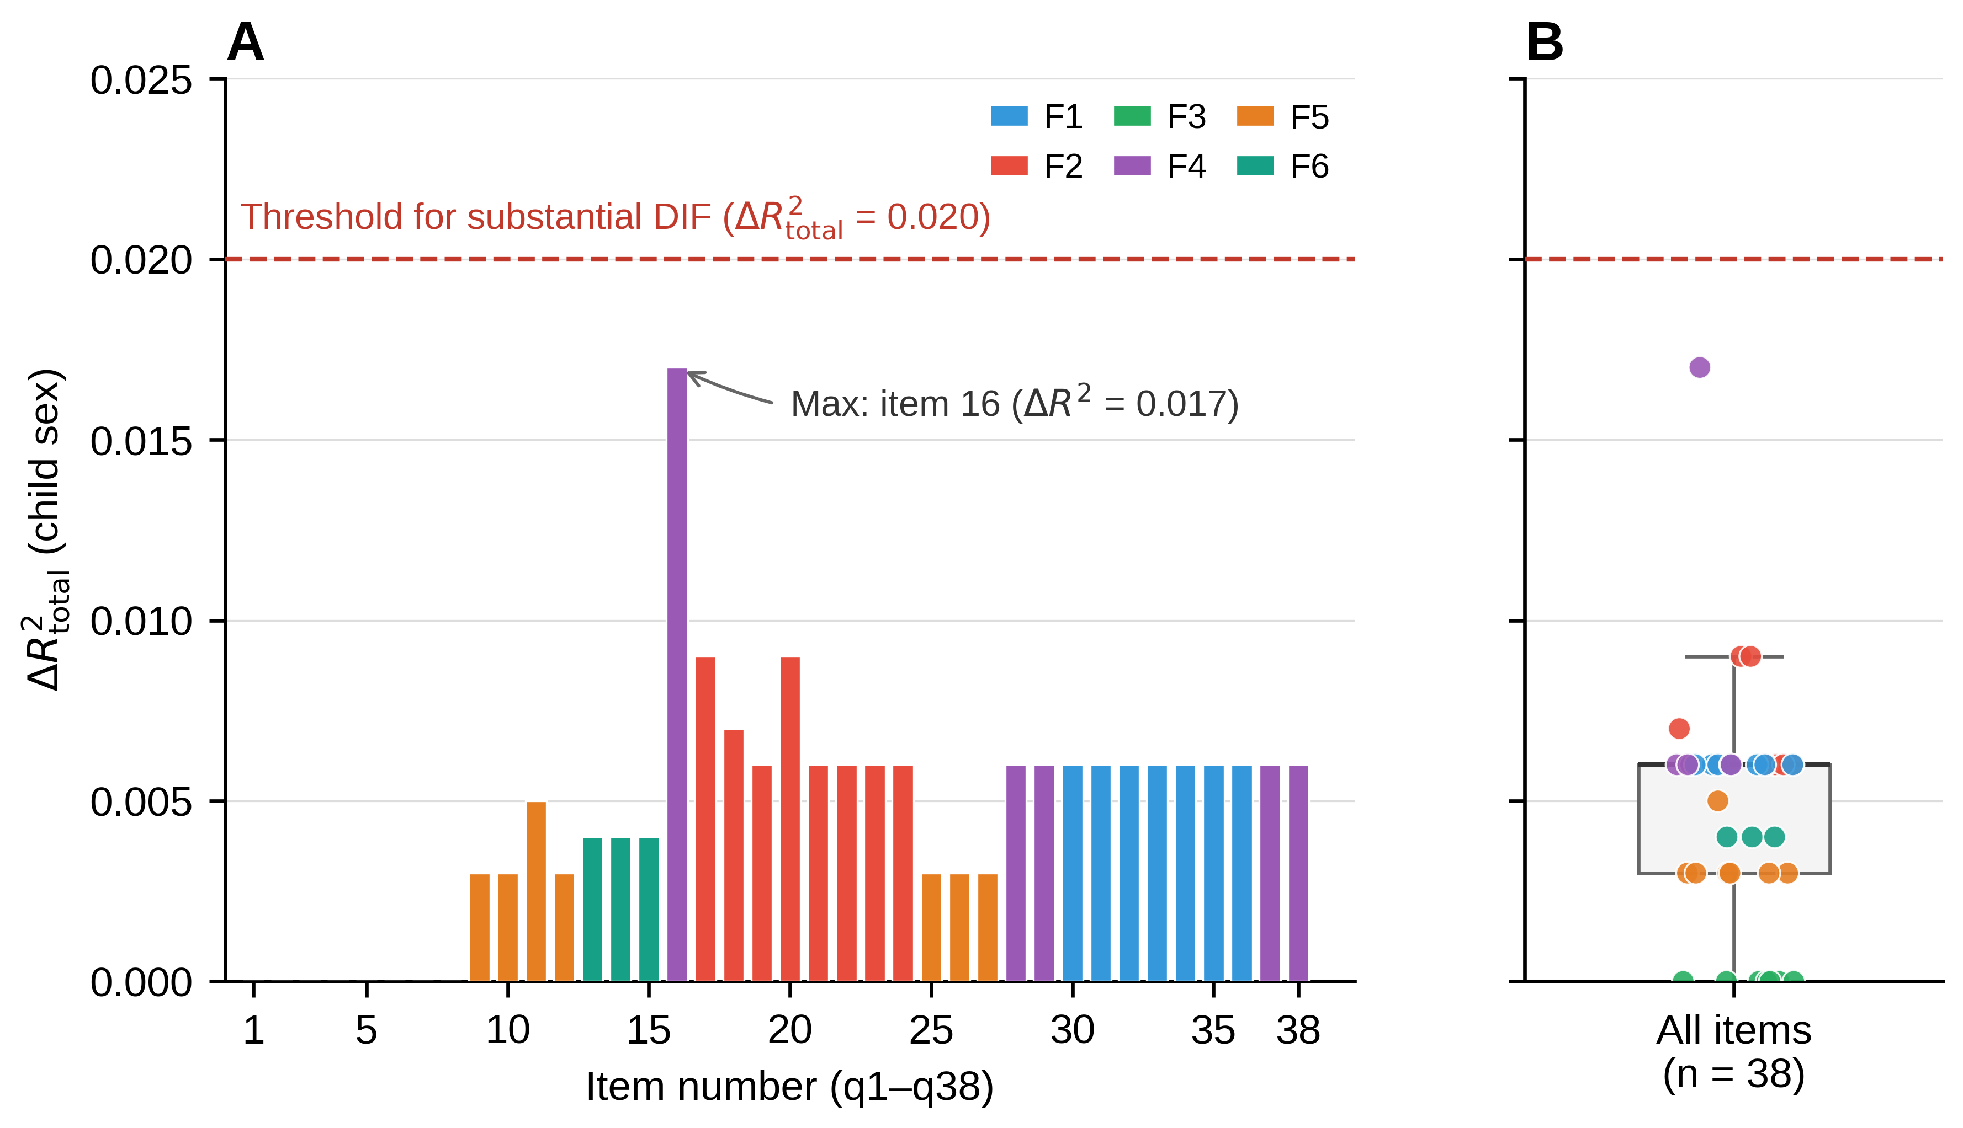
Note. (A) Per-item bar chart of ΔR²total values for the 38 items, color-coded by primary factor (F1–F6). The red dashed line indicates the threshold for substantial DIF (ΔR²total = 0.020). (B) Distribution summary (box plot with jittered scatter) across all 38 items. All items remained below the threshold (maximum = 0.017; item q16), supporting measurement invariance across child sex (Sample A, n = 738).

