Sulfonyl-Substituted Pyrazolone-Based Metal Complexes as Anticancer and Antimicrobial Scaffolds: Design, Synthesis, Spectral Characterization, and DFT Investigations
Parth H. Gajiwalaª, Mitesh B. Solanki^{b}, Pooja A. Chauhanª, Tarulata N. Chhowalaª*
^{a,a}*Department of Chemistry, Veer Narmad South Gujarat University,
Surat, 395007 (Gujarat), India
^{b}Department of Physics, Parul Institute of Applied Sciences, Parul University,
Vadodara, 391760 (Gujarat), India
Corresponding Author Email id: tnchhowala@vnsgu.ac.in

Supplementary Information
Table of Contents:
- Synthetic Procedures
- General Characterization Compounds 3 & 4 (Table 2.1-2.3)
- General Characterization of ligand 6 and Complexes 6a-e
- ¹H-NMR of compound 3 & 4
- ¹H,¹³C and IR Spectral data of ligand 6 and corresponding metal complexes
- UV Spectral data of ligand 6 and corresponding metal complexes
- Mass Spectral Analysis
- Thermogravimetric Analysis Plots

- Synthetic Procedure:

      - Synthesis of 3 & 4

Figure 1: Synthesis of Intermediates 3&4
The intermediates 3 and 4 were synthesised via a sequential microwave-assisted process in order to prepare the ligand. Using ceric ammonium sulphate as a catalyst, the Knoevenagel reaction between malononitrile and 4-nitrobenzaldehyde produced the intermediate 2-(4-nitrobenzylidine)malononitrile 3. Under appropriate reaction conditions, the nitro-substituted product 3 was reduced to create the amine-functionalized intermediate 2-(4-aminobenzylidine)malononitrile 4. To shorten the reaction time and improve efficiency, the synthetic processes were carried out under microwave irradiation [1,2] (Figure 1).

      - Synthesis of ligand (6) 2-(4-((5-hydroxy-1-(4-((2-hydroxyethyl)sulfonyl)
phenyl)-3-methyl-1H-pyrazol-4-yl)diazenyl)benzylidene)malononitrile (HESPPM) (L)

Scheme 1: Synthesis of ligand (6) HESPPM
The targeted azo-group attached to the pyrazolone-based ligand was produced via an in-situ diazotization-coupling method. The ammine functionalized intermediate 4 (10 mmol, 1.69g), was dissolved in an aqueous hydrochloric solution (a solution of 50 ml dist. Water and 5 ml Conc. HCl) under constant stirring by maintaining the reaction temperature of 0 °C in an ice-bath. Followed by, a previously cooled sodium nitrite solution (0.012mol, 0.828g of NaNO₂ in 10 mL water) was added slowly to produce the corresponding diazonium salt. For the next 45 mins, the reaction mixture was stirred at 0 °C to ensure the diazonium species formation.
Separately, the coupling component 1-(4-((2-hydroxyethyl)sulfonyl)phenyl)-3-methyl-1H-pyrazol-5-ol (10 mmol, 2.82g) was dissolved in 10% W/V KOH solution and cooled to 0 °C. The diazonium solution was then added to the freshly prepared alkaline pyrazolone coupler solution with continuous stirring by maintaining the temperature at 0-5 °C. The pH of the reaction medium was kept at 7.0 using 10% W/V Na₂CO₃ solution. The reaction was continued for three hours at 0-5 °C to facilitate the coupling. Upon completion of a reaction, a 10% W/V NaCl solution was added gradually to precipitate the product in a solid form. The precipitated ligand 6 was then separated from the reaction mixture and washed several times with DMSO and hot water to eliminate the additional impurities. Further, the product 6 was recrystallized using hot DMSO to ensure additional purification and higher yield. Yield: 4.07g (88%), Melting Point:- 285 °C, Colour: Dark orange crystals, FTIR (KBr, cm⁻¹) νmax: 3455 br(OH), 3170(C-H, alkane), 1595 (C=N, pyrazole), 1384 (C-N, bend), 1516 (N=N, diazo), 1433 (C=C aromatic), 840 (C-H bend). ¹H NMR (400 MHz, DMSO) δ 14.74 (s, 1H, -OH), 8.45 (s,
1H, =CH-Ar), 8.36 (d, 2H, J = 8.8 Hz, -Ar), 8.19 (d, 2H, J = 8.8 Hz, -Ar), 8.05 (d,
2H, J=8.8 Hz, Ar), 7.92 (d, 2H, J=5.6 Hz, -CH₃), 3.64 (t, 2H, J=6.4 Hz, -CH₂), 3.40 (d,
2H, J= 6.4Hz, -CH₂), 2.38 (s, 1H, -OH), 2.21 (s, 3H, -CH₃) λ_{max(nm):} 311, ¹³C NMR
(100 MHz, DMSO) δ (ppm) 163.09, 160.60, 152.56, 152.35, 150.30, 144.30, 144.25,
143.80, 138.06, 135.76, 135.67, 132.04, 129.71, 129.65, 124.66, 117.86, 117.79, 58.34,
55.58, 17.82 ; ESI-MS (m/z) [M+1]⁺: cal. C₂₂H₁₈N₆O₄S, 462.48, found 463.13
    - Metal Complexation
Scheme 2: Metal complexation of ligand (HESPPM) to synthesize (1:2 complexes)

The complexation was performed between the obtained ligand (HESPPM) (L) (20 mmol, 7.76g) and its corresponding transition metal salt solutions (10 mmol) to form the complexes in a 1:2 stoichiometric ratio under reflux conditions. To initiate the procedure, first, the ligand was dissolved in dioxane, followed by the dropwise addition of metal salt solutions with constant stirring. To ensure the proper complexation between ligand and the metal salts, the pH of the solution was maintained at 8.0 by adding 10% W/V NaOAc (sodium acetate) solution. The obtained reaction mixture was refluxed for three hours to afford the formation of the complexes. On cooling, the coloured [M(II)-(HESPPM)₂] (6 a-e) complexes were formed corresponding to Cu(II), Mn(II), Ni(II), Fe(II), and Co(II) metal ions. The isolation of the formed products was carried out by filtration, washing with dioxane, and hot distilled water (Scheme 2).

- Characterization of Compounds 3 & 4

  - Physical Characterization:

Intermediate | %Yield | M.P (⁰C) | Colour
3 | 96% | 160⁰C | Brown-red
4 | 89% | 143⁰C | Yellowish-orange
Table 2.1: Physical Characterization of compounds 3,4

  - ¹H-NMR Spectral Characterization of Intermediate (3)

No. Of Protons | Multiplicity | Chemical Shift | Prediction
1H | Singlet | 8.72 | Olefinic H
2H | Doublet | 8.44 | Aromatic H
2H | Doublet | 8.14 | Aromatic H
Table 2.2: ¹H-NMR of compound 3

  - ¹H-NMR Spectral Characterization of Intermediate (4)

No. Of Protons | Multiplicity | Chemical Shift | Prediction
1H | Singlet | 5.23 | Olefinic H
2H | Doublet | 8.28 | Aromatic H
2H | Doublet | 7.67 | Aromatic H
2H | Singlet | 3.54 | -NH₂ (H)
Table 2.3: ¹H-NMR of compound 4

- General Characterization of ligand 6 and complexes 6a-e

Characterization of ligand (6)

6
Yield: 3.22 g (83%), Melting Point: 294 °C, Color: Yellowish-orange crystals, FTIR (KBr, cm−1) νmax: 3448 br(OH), 3116 (C-H, alkane), 1592 (C=N, pyrazole), 1334 (C-N, bend), 1522 (N=N, diazo), 1442 (C=C aromatic), 848 (C-H bend). 1H NMR (400 MHz, DMSO) δ 14.70 (s, 1H, -OH), 8.49 (s, 1H, =CH-Ar), 8.39 (d, 2H, J = 8.0 Hz, -Ar), 8.23 (d, 2H, J = 8.4 Hz, -Ar), 7.48-7.64 (m, 4H, Ar), 2.37 (s, 3H, -CH3), λmax (nm): 317, 13C NMR (100 MHz, DMSO) δ (ppm) 159.18, 152.43, 150.86, 147.41, 145.55, 144.32, 144.06, 143.71, 143.65, 142.30, 125.63, 125.58, 125.32, 117.81, 117.55, 116.38, 17.07; HRMS (m/z) [M+H]+: cal. C₂₀H₁₃N₆OCl, 388.80, found 389.03
  - Characterization of complexes 6 (a-e)

6 a-e

[Cu(II)-(HESPPM)₂] (6a)
Blue-green colour, Yield: 8.45g (83%), FTIR (KBr, cm⁻¹) νmax: 3404 br(OH), 3116(C-
H, alkane), 1580 (C=N, pyrazole), 1316 (C-N, bend), 1492 (N=N, diazo), 1373 (C=C
aromatic), 583 (M-O), 434 (M-N) λ_{max}(nm): 410; ESI-MS (m/z) [M+1]⁺: cal.
C₄₄H₃₈N₁₂O₁₀S₂Cu, 1022.52, found 1023.60
[Mn(II)-(HESPPM)₂] (6b)
Light-green colour, Yield: 8.24g (81%), FTIR (KBr, cm⁻¹) νmax: 3209 br(OH),
2918(C-H, alkane),1549 (C=N, pyrazole), 1295 (C-N, bend), 1468 (N=N, diazo), 1338
(C=C aromatic), 585 (M-O), 476 (M-N). λ_{max}(nm): 320; ESI-MS
(m/z) [M+1]⁺: cal. C₄₄H₃₈N₁₂O₁₀S₂Mn, 1013.91, found. 1014.07
[Ni(II)-(HESPPM)₂] (6c)
Dark green colour, Yield: 8.35g (82%), FTIR (KBr, cm⁻¹) νmax: 3408 br(OH),
2928(C-H, alkane), 1584 (C=N, pyrazole), 1354 (C-N, bend) 1488 (N=N, diazo), 1407
(C=C aromatic), 589 (M-O), 440 (M-N). λ_{max}(nm): 374; ESI-MS
(m/z) [M+2]⁺: cal. C₄₄H₃₈N₁₂O₁₀S₂Ni, 1017.67, found 1019.91
[Fe(II)-(HESPPM)₂] (6d)
Brown colour, Yield: 8.29g (82%), FTIR (KBr, cm⁻¹) νmax: 3411 br(OH),
2936 (C-H, alkane),1572 (C=N, pyrazole), 1335 (C-N, bend), 1489 (N=N, diazo), 1395
(C=C aromatic), 547 (M-O), 456 (M-N). λ_{max}(nm): 319; ESI-MS
(m/z) [M]⁺: cal. C₄₄H₃₈N₁₂O₁₀S₂Fe, 1014.82, found. 1014.07
[Co(II)-(HESPPM)₂] (6e)
Brown-colour, Yield: 7.98g (78%), FTIR (KBr, cm⁻¹) νmax: 3403 br(OH),
3096 (C-H, alkane),1578 (C=N, pyrazole), 1332 (C-N, bend), 1486 (N=N, diazo), 1385
(C=C aromatic), 545 (M-O), 425 (M-N). λ_{max}(nm): 411; ESI-MS
(m/z) [M+2]⁺: cal. C₄₄H₃₈N₁₂O₁₀S₂Co, 1017.91, found. 1019

- ¹H-NMR of compound 3 & 4

  - ¹H-NMR of compound 3

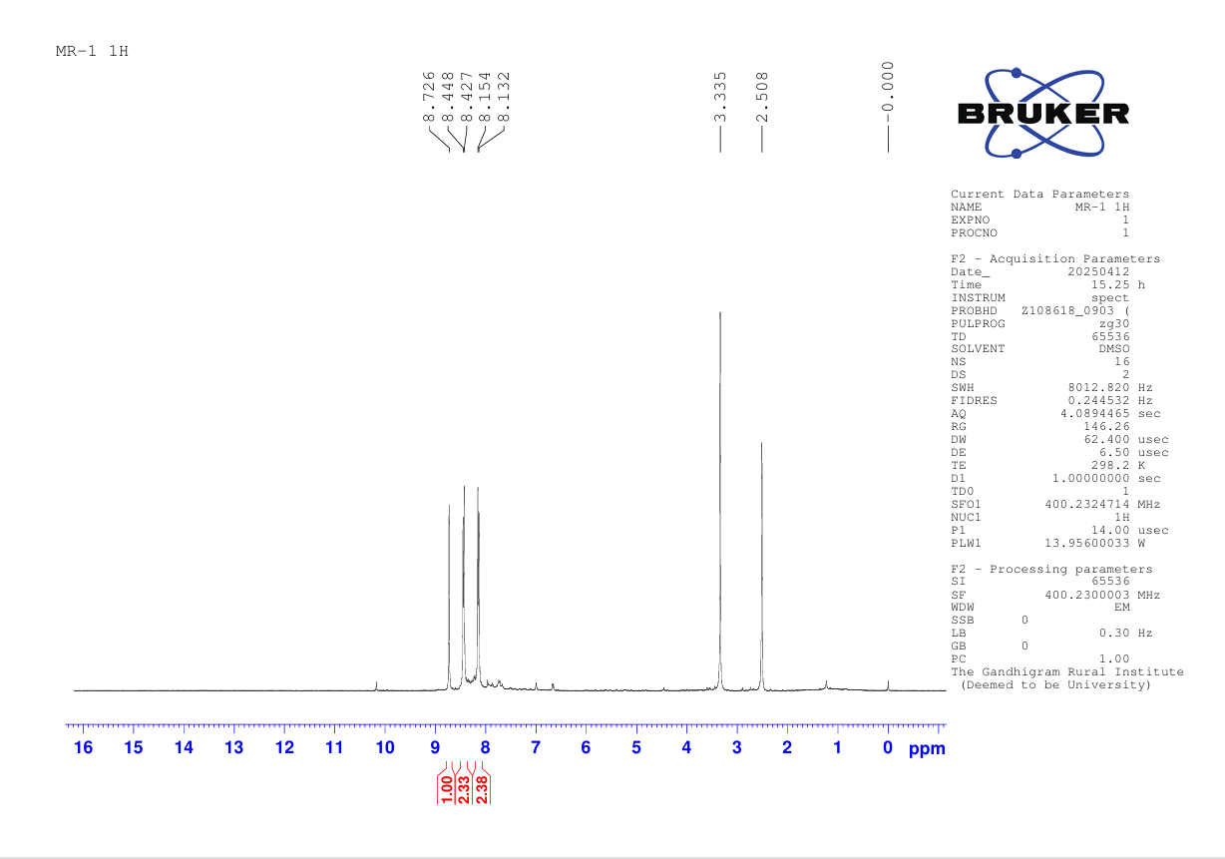
Figure 2: ¹H-NMR of 2-(4-nitrobenzylidene)malononitrile (3)

  - ¹H-NMR of compound 4

Figure 3: ¹H-NMR of 2-(4-aminobenzylidene)malononitrile (4)

- ¹H,¹³C and IR Spectral data of ligand 6 and corresponding metal complexes (Figure 4-11)

  - ¹H-NMR of ligand HESPPM (6)

¹H-NMR of ligand HESPPM (6)
Figure 4: ¹H-NMR of ligand (6)

  - ¹³C-NMR of ligand HESPPM (6)

Figure 5: ¹³C-NMR of ligand (6)

  - IR Spectral Analysis:
Ligand (6)
Figure 6: IR Spectra of Ligand
Figure 7: IR Spectra of [Cu(II)-(HESPPM)₂] (6a)

Figure 8: IR Spectra of [Mn(II)-(HESPPM)₂] (6b)

Figure 9: IR Spectra of [Ni(II)-(HESPPM)₂] (6c)

Figure 10: IR Spectra of [Fe(II)-(HESPPM)₂] (6d)

Figure 11: IR Spectra of [Co(II)-(HESPPM)₂] (6e)
- UV Spectral data of ligand 6 and corresponding metal complexes

Figure 12: UV Spectral analysis of ligand and corresponding metal complexes

- Mass Spectral Analysis (Figure 13-18):
Figure 13: Mass Spectral Analysis of Compound (6)
Mass Spectral Analysis of 1:2 Complexes:
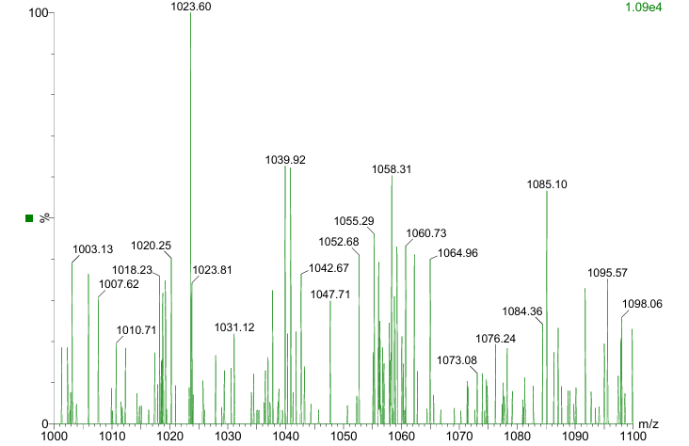
Figure 14: Mass Spectral Analysis of Complex [Cu(II)-(HESPPM)₂] (6a)

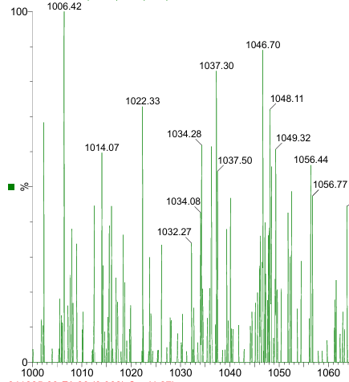
Figure 15: Mass Spectral Analysis of Complex [Mn(II)-(HESPPM)₂] (6b)

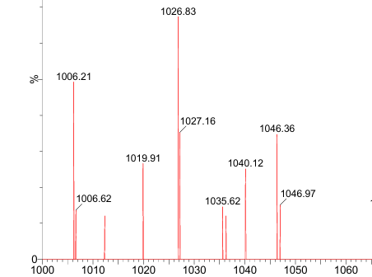
Figure 16: Mass Spectral Analysis of Complex [Ni(II)-(HESPPM)₂] (6c)

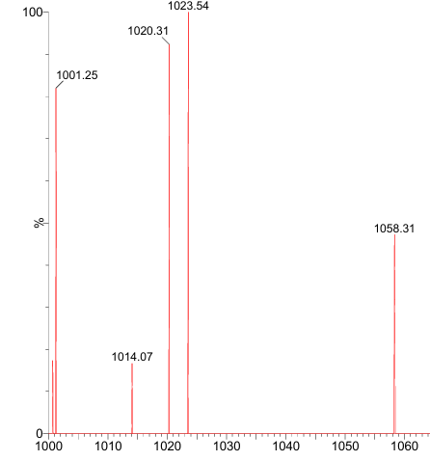
Figure 17: Mass Spectral Analysis of Complex [Fe(II)-(HESPPM)₂] (6d)
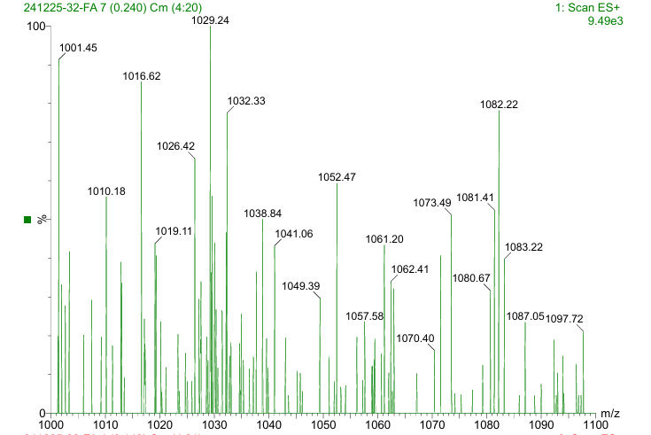
Figure 18: Mass Spectral Analysis of Complex [Co(II)-(HESPPM)₂] (6e)

- Thermogravimetric Analysis Plots (Figure 18-22):

Thermal Analysis:
Thermal Analysis of 1:2 Complexes
Figure 19: TGA plot of [Cu(II)-(HESPPM)₂] (6a)
Figure 20: TGA plot of [Mn(II)-(HESPPM)₂] (6b)
Figure 21: TGA plot of [Ni(II)-(HESPPM)₂] (6c)

Figure 22: TGA plot of [Fe(II)-(HESPPM)₂] (6d)

Figure 23: TGA plot of [Co(II)-(HESPPM)₂] (6e)

References:
- Gajiwala, P. H., Solanki, M. B., and Chhowala, T. N. (2025). Pyrazolone based metal complex azo dyes:-Synthesis, Characterization, DFT analysis and in-vitro Anti-microbial Assessment. Journal of Molecular Structure, 144345. https://doi.org/10.1016/j.molstruc.2025.144345
- Gajiwala, P. H., Solanki, M. B., Chauhan, P. A., and Chhowala, T. N. (2026). Synthesis, structural elucidation, DFT calculations of pyrazolone-derived complexes: evaluation of these complexes as anti-microbial agents. Structural Chemistry, 1-17. https://doi.org/10.1007/s11224-026-02759-9

