Supplementary Materials

Post-discharge Prognosis Across Clinical Subtypes of Suspected Infection in Hospitalized Older Adults: A Retrospective Cohort Study Using a Large Administrative Claims Database in Japan

Toshihiro Tsukatani, MHS; Yukari Yamada, PhD; Tomoyuki Akita, PhD; Shingo Fukuma, MD, PhD

Supplementary Figure 1. Study design diagram
Supplementary Table 1. Codes used to define serious infection and acute organ dysfunction for clinical subtype classification
Supplementary Table 2. ICD-10 codes used to define cardiovascular and infectious disease outcomes
Supplementary Table 3. ICD-10 codes used to calculate the Charlson Comorbidity Index
Supplementary Table 4. ICD-10 codes used to define site of infection and procedure code used to identify ICU admission
Supplementary Figure 2. Cardiovascular disease subtypes
Supplementary Figure 3. Infectious disease subtypes
Supplementary Figure 4. Sensitivity analyses
Supplementary Figure 5. Subgroup analyses

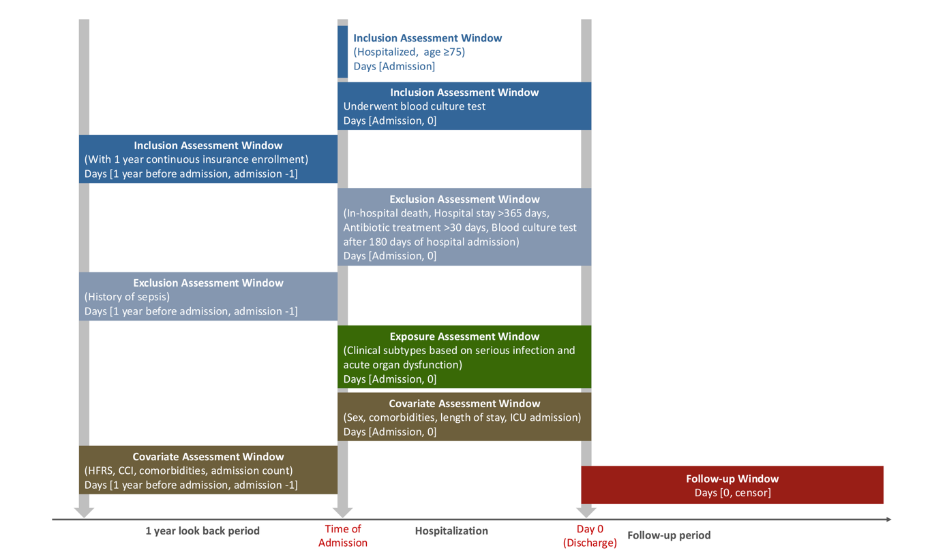
Supplementary Figure 1. Study design diagram

Schematic representation of the assessment windows used in this study. The 1-year look-back period before admission was used to assess continuous insurance enrollment, history of sepsis, and pre-admission covariates. During the index hospitalization, eligibility, exclusion criteria, exposure (clinical subtypes based on serious infection and acute organ dysfunction), and hospitalization-period covariates were assessed. Day 0 was defined as the date of discharge, and the follow-up period extended until the outcome of interest, death, loss of insurance enrollment, or the end of the study period, whichever occurred first.
CCI, Charlson Comorbidity Index; HFRS, Hospital Frailty Risk Score; ICU, intensive care unit.

Supplementary Table 1. Codes used to define serious infection and acute organ dysfunction for clinical subtype classification
Patients were classified into four clinical subtypes based on the presence or absence of serious infection (SI) and acute organ dysfunction (AOD): SI+/AOD+, SI+/AOD−, SI−/AOD+, and SI−/AOD−. SI was defined by the combination of a blood culture test and newly initiated antibiotic treatment as specified in Step 1. AOD was identified if a patient met any of the eight criteria listed in Step 2 (three treatment-based criteria and five diagnosis-based criteria). The assessment window for organ-specific treatments differed by SI status: in the SI+ groups, treatments initiated within ±2 calendar days of the blood culture test were counted; in the SI− groups, treatments initiated at any time during the index hospitalization were counted. Diagnostic codes were assessed during the entire hospitalization period in both groups.
Key condition | Definitions
Step 1: Definition of serious infection (SI), meeting both of the following criteria
Procedure
Blood culture testª | 160058610
Medication
Antibiotics^{b} | All oral and injectable antibiotics
Step 2: Definition of acute organ dysfunction (AOD), meeting any of the following criteria
Treatment-based criteria
Circulatory dysfunction (vasopressor therapy)^{c} | Dopamine (C01CA04), dobutamine (C01CA07), epinephrine (C01CA24), norepinephrine (C01CA03)
Respiratory dysfunction (mechanical ventilation or oxygen therapy)ª | Artificial respiration (J045), intermittent positive pressure inhalation (J026), nasal mask-assisted ventilation (J026-02), extracorporeal negative pressure ventilator therapy (J026-03), high-flow therapy (J026-04)
Renal dysfunction  (renal replacement therapy)ª | Artificial kidney (140057810, 140057910, 140058010, 140058110, 140058210, 140058310, 140058410, 140058510, 140058610,140007710);  peritoneal perfusion (140008510, 140008810)
Diagnosis-based criteria
Renal^{d} | N00.9, N10, N17.0, N17.1, N17.8, N17.9
Hepatic^{d} | K72.0, K72.9, K76.8 (Shock liver)
Thrombocytopenia^{d} | D69.5, D69.6
Coagulopathy^{d} | D65, D68.9
Acidosis^{d} | E87.2
ª Defined by the codes for medical procedures in Japanese claim databases
^{b} The information on antibiotics is sourced from the Japanese Antibiotic Mask website (https://amrcrc.ncgm.go.jp/surveillance/030/20181128172757.html).
^{c} Defined by the codes of the Anatomical Therapeutic Chemical (ATC) classification system
^{d} Defined by the codes of the International Classification of Diseases, 10th Edition
Note: For Step 1, antibiotic treatment was required to begin within ±2 calendar days of the blood culture test, to be administered for at least four consecutive days (with shorter courses permitted if the patient was discharged during this period), and to include at least one intravenous antibiotic.
Supplementary Table 2. ICD-10 codes used to define cardiovascular and infectious disease outcomes
Cardiovascular disease (CVD) and infectious disease were assessed as secondary outcomes during the post-discharge follow-up period. For each outcome category, the three most frequent disease subtypes were analyzed in detailed analyses (Methods, Results). The date of outcome occurrence was defined as the treatment start date recorded for the corresponding diagnosis in the claims data. The first post-discharge occurrence was assessed for all secondary outcomes.
Outcomes | Subtypes | ICD-10 codes
Cardiovascular diseaseª | Heart failure | I50.0, I50.1, I50.9, I11.0
Cardiovascular diseaseª | Stroke | I63.0, I63.1, I63.2, I63.3, I63.4, I63.5, I63.6, I63.8, I63.9, I60.0, I60.1, I60.2, I60.3, I60.4, I60.5, I60.6, I60.7, I60.8, I60.9, I61.0, I61.1, I61.3, I61.4, I61.5, I61.6, I61.9, I62.9, G45.9
Cardiovascular diseaseª | Angina pectoris | I20.0, I20.1, I20.8, I20.9
Cardiovascular diseaseª | Myocardial infarction | I21.0, I21.1, I21.2, I21.3, I21.4, I21.9
Infectious disease^{b} | Respiratory | A15–A16, J00–J06, J09–J18, J20–J22, J31–J32, J35–J37, J39.0, J39.1, J85–J86
Infectious disease^{b} | Urogenital | A18.1, A51.0, A54.0–A54.2, A56.0–A56.2, A59.0, A60.0, N30.0, N30.8, N39.0, N41.0–N41.3, N45, N49.0–N49.2, N70–N77, O23
Infectious disease^{b} | Abdominal | A00–A09, A18.3, A42.1, A74.8, K35–K38, K57.0, K57.2, K57.4, K57.8, K61, K63.0, K63.1, K65, K67, K75.0, K80.0, K80.1, K80.3, K80.4, K81, K83.0
Infectious disease^{b} | Bone and soft tissue | A18.0, A18.4, A26.0, A28.1, A31.1, A31.8, A32.0, A36.3, A42.2, A43.1, A46, A48.0, L00-L08, M00, M01.0, M46.3, M46.5, M49.1–M49.3, M60.0, M86.0, M86.1, M86.65, M86.66, M86.69, M86.99
Infectious disease^{b} | Blood | A19, A40.0, A49.0, A49.1, A49.9
Infectious disease^{b} | Meninges/brain/spinal cord | G00–G09
Abbreviations: ICD-10, International Classification of Diseases, 10th Revision.
ᵃ Cardiovascular disease subtypes were defined according to a coding algorithm previously used in Japanese administrative claims studies (1).
ᵇ Infectious disease subtypes were defined according to a coding algorithm previously used in Japanese administrative claims studies (2), which corresponds to the same coding scheme used to identify the site of infection during the index hospitalization (Supplementary Table 4).
1. Kamon T, Kaneko H, Itoh H, Okada A, Matsuoka S, Kiriyama H, et al. Sex difference in the association between lipid profile and incident cardiovascular disease among young adults. J Atheroscler Thromb. 2022;29(10):1475–86.
2. Ge S, Zha L, Tanaka A, Narii N, Shimomura Y, Komatsu M, et al. Post-discharge functional outcomes in older patients with sepsis. Crit Care. 2024;28(1):281.
Supplementary Table 3. ICD-10 codes used to calculate the Charlson Comorbidity Index
Comorbidity | ICD-10 codes
Myocardial infarction | I21, I22, I25.2
Congestive heart failure | I09.9, I11.0, I13.0, I13.2, I25.5, I42.0, I42.5–I42.9, I43, I50, P29.0
Peripheral vascular disease | I70, I71, I73.1, I73.8, I73.9, I77.1, I79.0, I79.2, K55.1, K55.8, K55.9, Z95.8, Z95.9
Cerebrovascular disease | G45, G46, H34.0, I60–I69
Dementia | F00–F03, F05.1, G30, G31.1
Chronic pulmonary disease | I27.8, I27.9, J40–J47, J60–J67, J68.4, J70.1, J70.3
Rheumatic disease | M05, M06, M31.5, M32–M34, M35.1, M35.3, M36.0
Peptic ulcer disease | K25–K28
Mild liver disease | B18, K70.0–K70.3, K70.9, K71.3–K71.5, K71.7, K73, K74, K76.0, K76.2–K76.4, K76.8, K76.9, Z94.4
Diabetes without chronic complication | E10.0, E10.l, E10.6, E10.8, E10.9, E11.0, E11.1, E11.6, E11.8, E11.9, E12.0, E12.1, E12.6, E12.8, E12.9, E13.0, E13.1, E13.6, E13.8, E13.9, E14.0, E14.1, E14.6, E14.8, E14.9
Diabetes with chronic complication | E10.2–E10.5, E10.7, E11.2–E11.5, E11.7, E12.2–E12.5, E12.7, E13.2–E13.5, E13.7, E14.2–E14.5, E14.7
Hemiplegia or paraplegia | G04.1, G11.4, G80.1, G80.2, G81, G82, G83.0–G83.4, G83.9
Renal disease | I12.0, I13.1, N03.2–N03.7, N05.2–N05.7, N18, N19, N25.0, Z49.0–Z49.2, Z94.0, Z99.2
Any malignancy except malignant neoplasm of skin | C00–C26, C30–C34, C37–C41, C43, C45–C58, C60–C76, C81–C85 C88, C90–C97
Moderate or severe liver disease | I85.0, I85.9, I86.4, I98.2, K70.4, K71.1, K72.1, K72.9, K76.5, K76.6, K76.7
Metastatic solid tumor | C77–C80
AIDS/HIV | B20–B22, B24
AIDS, acquired immunodeficiency syndrome; CCI, Charlson Comorbidity Index; HIV, human immunodeficiency virus; ICD-10, International Classification of Diseases, 10th Revision.
The comorbidities listed in this table were identified if the relevant ICD-10 codes were recorded at least once during the one-year look-back period before admission. The CCI was calculated based on these comorbidities, in accordance with the original methodology (1).
1. Charlson ME, Pompei P, Ales KL, MacKenzie CR. A new method of classifying prognostic comorbidity in longitudinal studies: development and validation. J Chronic Dis. 1987;40(5):373–83.

Supplementary Table 4. ICD-10 codes used to define site of infection and procedure code used to identify ICU admission
Covariates | Definitions
Focus of infection
Respiratoryª | A15–A16, J00–J06, J09–J18, J20–J22, J31–J32, J35–J37, J39.0, J39.1, J85–J86
Urogenitalª | A18.1, A51.0, A54.0–A54.2, A56.0–A56.2, A59.0, A60.0, N30.0, N30.8, N39.0, N41.0–N41.3, N45, N49.0–N49.2, N70–N77, O23
Abdominalª | A00–A09, A18.3, A42.1, A74.8, K35–K38, K57.0, K57.2, K57.4, K57.8, K61, K63.0, K63.1, K65, K67, K75.0, K80.0, K80.1, K80.3, K80.4, K81, K83.0
Bone and soft tissueª | A18.0, A18.4, A26.0, A28.1, A31.1, A31.8, A32.0, A36.3, A42.2, A43.1, A46, A48.0, L00-L08, M00, M01.0, M46.3, M46.5, M49.1–M49.3, M60.0, M86.0, M86.1, M86.65, M86.66, M86.69, M86.99
Bloodª | A19, A40.0, A49.0, A49.1, A49.9
Meninges/brain/spinal cordª | G00–G09
Procedure
ICU admission^{b} | A301
ICD-10, International Classification of Diseases, 10th Revision; ICU, intensive care unit.
ᵃ Defined by ICD-10 codes.
ᵇ Defined by procedure codes used in Japanese administrative claims databases.

Supplementary Figure 2. Cardiovascular disease subtypes
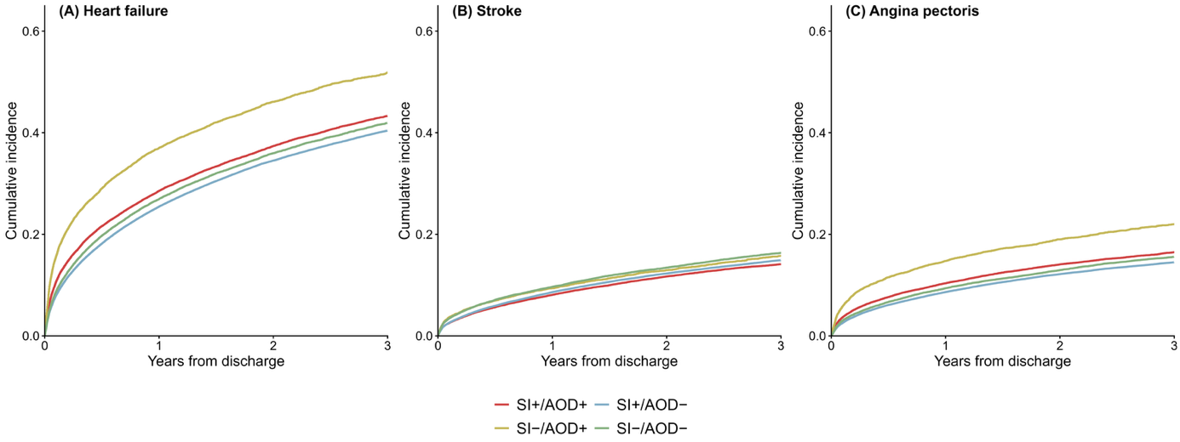
2-1. Cumulative incidence of cardiovascular disease subtypes after hospital discharge

Cumulative incidence of (A) heart failure, (B) stroke, and (C) angina pectoris was estimated using the Aalen–Johansen estimator, with death treated as a competing risk. Subtype labels (SI+/AOD+, SI+/AOD−, SI−/AOD+, SI−/AOD−) indicate the presence (+) or absence (−) of serious infection (SI) and acute organ dysfunction (AOD). For each cardiovascular disease subtype, only events of the corresponding subtype were counted as events of interest; occurrences of other cardiovascular subtypes were neither counted as events nor treated as competing risks, and follow-up was continued through these events. Follow-up time was calculated from the discharge date to the first occurrence of the corresponding subtype, death, or the end of observation, whichever occurred first.
SI, serious infection; AOD, acute organ dysfunction.

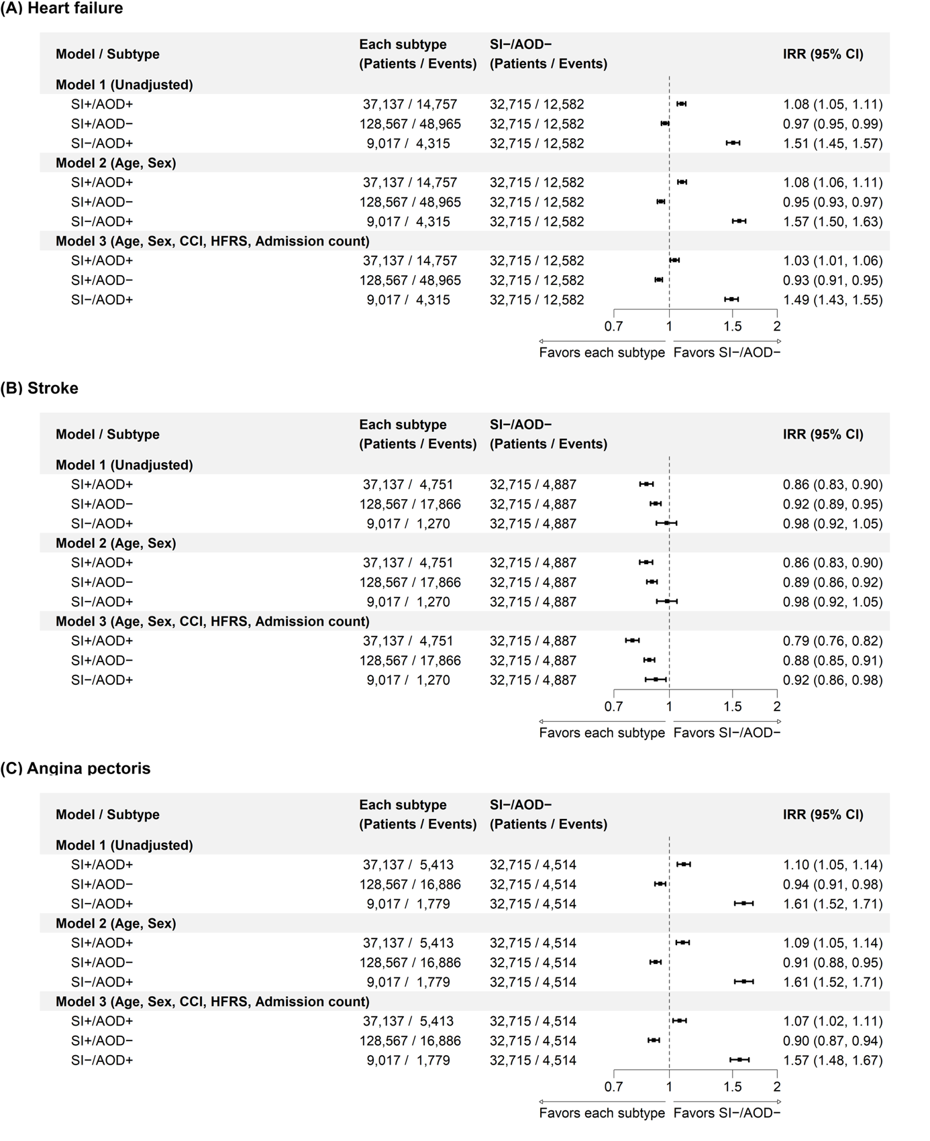
2-2. Incidence rate ratios of post-discharge cardiovascular disease subtype

Panels show incidence rate ratios for post-discharge (A) heart failure, (B) stroke, and (C) angina pectoris. The reference group was SI−/AOD−. Incidence rate ratios (IRRs) were estimated using Poisson regression with log-transformed follow-up time as an offset. Robust (sandwich) variance estimators were used to compute 95% confidence intervals to account for potential overdispersion. For each outcome, follow-up time was calculated from the discharge date to the first subtype-specific cardiovascular event, the end of observation, or death, whichever occurred first. Three sequential models were fitted: Model 1 was unadjusted; Model 2 was adjusted for age and sex; and Model 3 was further adjusted for Charlson Comorbidity Index (CCI), Hospital Frailty Risk Score (HFRS), and number of hospitalizations within the past year.
SI, serious infection; AOD, acute organ dysfunction; CI, confidence interval.

Supplementary Figure 3. Infectious disease subtypes
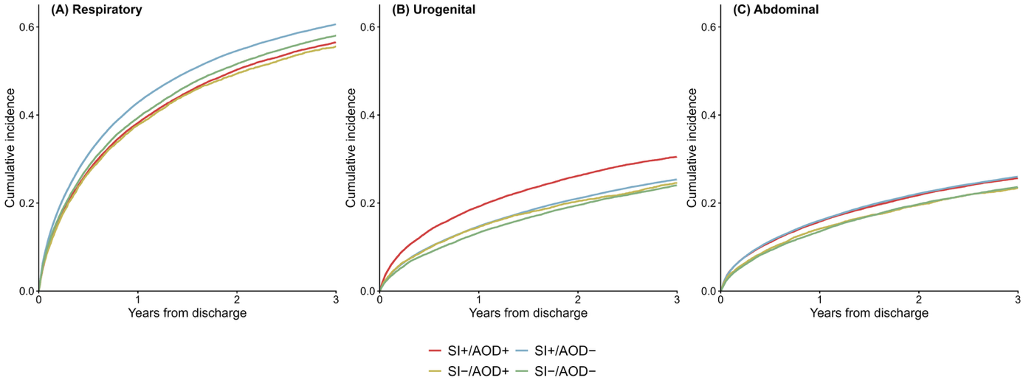
3-1. Cumulative incidence of infectious disease subtypes after hospital discharge

Cumulative incidence of (A) respiratory, (B) urogenital, and (C) abdominal infections was estimated using the Aalen–Johansen estimator, with death treated as a competing risk. Subtype labels (SI+/AOD+, SI+/AOD−, SI−/AOD+, SI−/AOD−) indicate the presence (+) or absence (−) of serious infection (SI) and acute organ dysfunction (AOD). For each infectious disease subtype, only events of the corresponding subtype were counted as events of interest; occurrences of other infectious disease subtypes were neither counted as events nor treated as competing risks, and follow-up was continued through these events. Follow-up time was calculated from the discharge date to the first occurrence of the corresponding subtype, the occurrence of death, or the end of observation, whichever occurred first.
SI, serious infection; AOD, acute organ dysfunction.

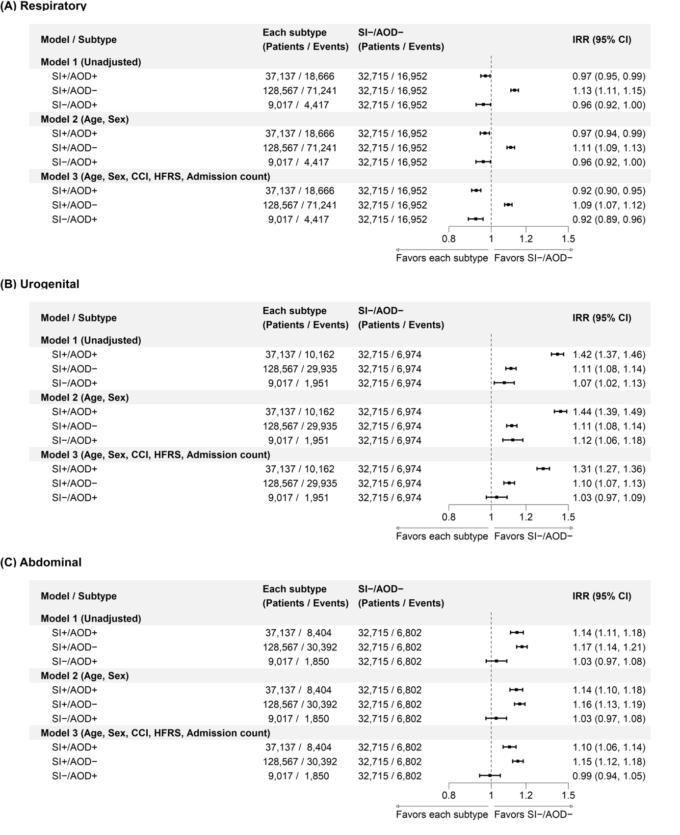
3-2. Incidence rate ratios of post-discharge infectious disease subtypes

Panels show incidence rate ratios for post-discharge (A) respiratory, (B) urogenital, and (C) abdominal infection. The reference group was SI−/AOD−. Incidence rate ratios (IRRs) were estimated using Poisson regression with log-transformed follow-up time as an offset. Robust (sandwich) variance estimators were used to compute 95% confidence intervals to account for potential overdispersion. For each outcome, follow-up time was calculated from the discharge date to the first site-specific infection event, the end of observation, or death, whichever occurred first. Three sequential models were fitted: Model 1 was unadjusted; Model 2 was adjusted for age and sex; and Model 3 was further adjusted for Charlson Comorbidity Index (CCI), Hospital Frailty Risk Score (HFRS), and number of hospitalizations within the past year.
SI, serious infection; AOD, acute organ dysfunction; CI, confidence interval.

Supplementary Figure 4. Sensitivity analyses
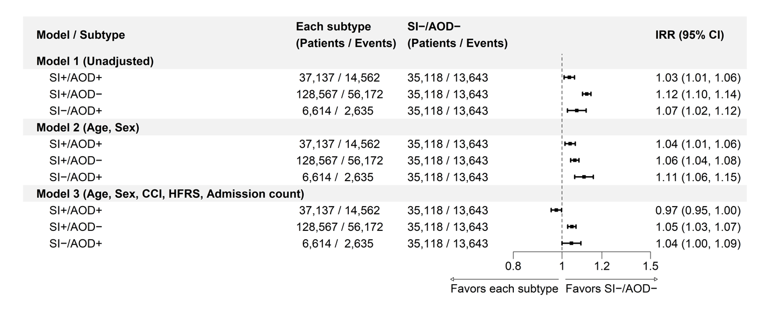
4-1. Sensitivity analysis using an alternative subtype definition: Incidence rate ratios of all-cause mortality

To examine the robustness of the primary outcome to the definition of clinical subtypes, AOD in the SI− groups was re-defined within the ±2 calendar-day window surrounding the blood culture test, consistent with the SI+ groups, rather than during the entire hospitalization period. The reference group was SI−/AOD−. Incidence rate ratios (IRRs) were estimated using Poisson regression with log-transformed follow-up time as an offset. Robust (sandwich) variance estimators were used to compute 95% confidence intervals to account for potential overdispersion. Follow-up time was calculated from the discharge date to death or the end of observation, whichever occurred first. Three sequential models were fitted: Model 1 was unadjusted; Model 2 was adjusted for age and sex; and Model 3 was further adjusted for Charlson Comorbidity Index (CCI), Hospital Frailty Risk Score (HFRS), and number of hospitalizations within the past year.
SI, serious infection; AOD, acute organ dysfunction; CI, confidence interval.

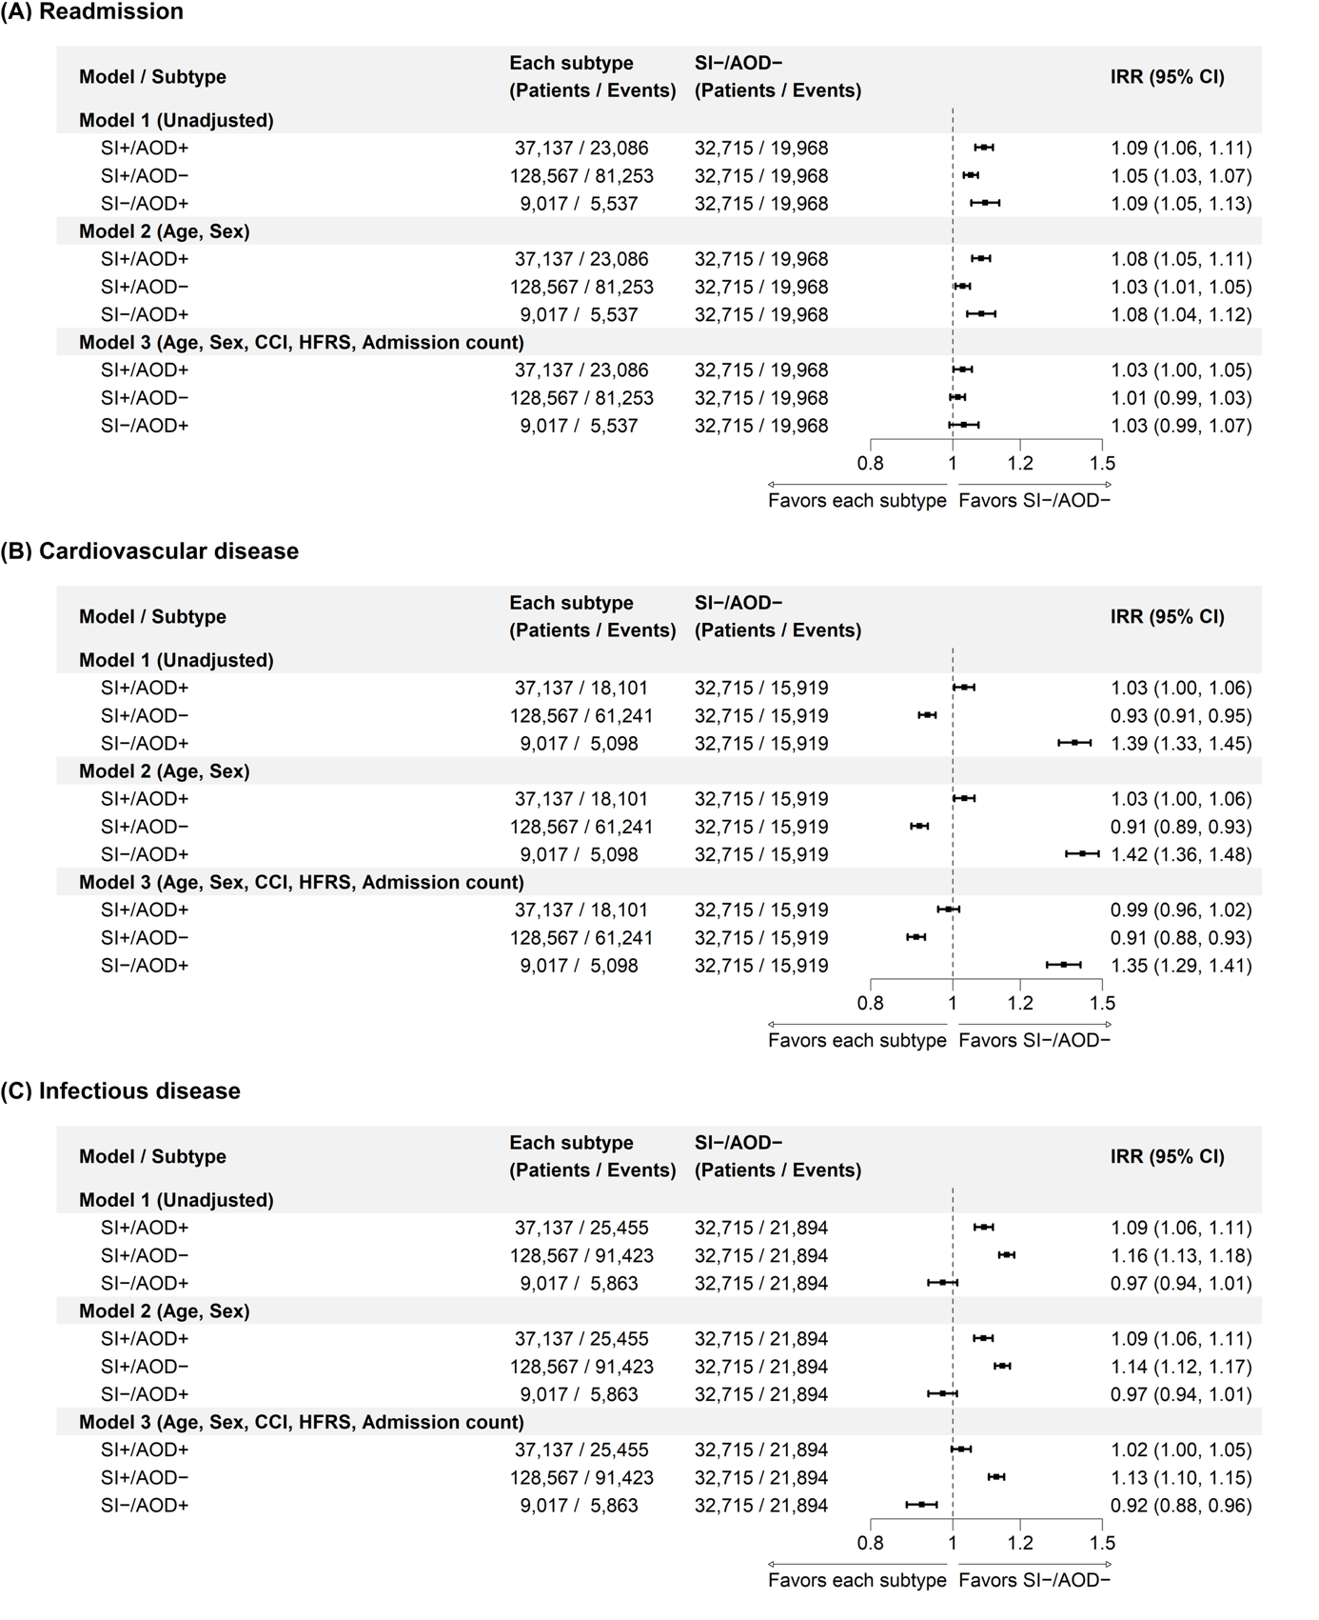
4-2. Sensitivity analysis with IPCW for secondary outcomes accounting for competing risk of death

Panel (A) shows incidence rate ratios for all-cause readmission, panel (B) for post-discharge cardiovascular disease, and panel (C) for post-discharge infectious disease. To account for death as a competing risk, the Poisson regression analyses were repeated using inverse probability of censoring weighting (IPCW). The probability of being censored by death was estimated using a Cox proportional hazards model that included clinical subtype, pre-admission characteristics (the Charlson Comorbidity Index [CCI], the Hospital Frailty Risk Score [HFRS], and the number of hospitalizations within the past year), and hospitalization-period characteristics (sex, age, length of stay, ICU admission, site of infection, acute organ dysfunction, and comorbidities identified during hospitalization). The inverse of the estimated survival probability at each individual's follow-up time was used as a weight, trimmed at the 99th percentile. Weighted incidence rate ratios (IRRs) were estimated using survey-weighted quasi-Poisson regression with robust (sandwich) variance estimators and log-transformed follow-up time as an offset, applying the same three-model structure as the main analyses: Model 1 was unadjusted; Model 2 was adjusted for age and sex; and Model 3 was further adjusted for CCI, HFRS, and number of hospitalizations within the past year. The numbers of patients and events shown represent unweighted observed counts.
SI, serious infection; AOD, acute organ dysfunction; CI, confidence interval; IPCW, inverse probability of censoring weighting; ICU, intensive care unit.
Supplementary Figure 5. Subgroup analyses
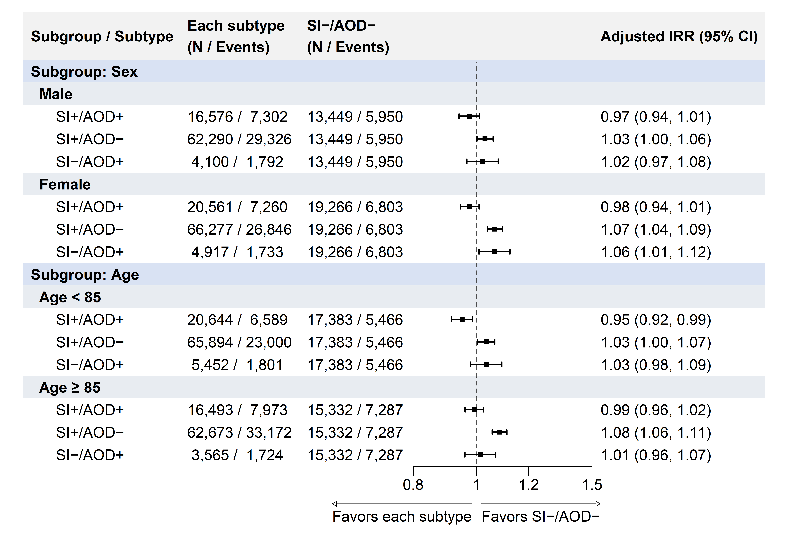
5-1. Adjusted incidence rate ratios of all-cause mortality

Incidence rate ratios (IRRs) were estimated using Poisson regression with log-transformed follow-up time as an offset. Robust (sandwich) variance estimators were used to compute 95% confidence intervals to account for potential overdispersion. Models were adjusted for age, sex, Charlson Comorbidity Index (CCI), Hospital Frailty Risk Score (HFRS), and number of hospitalizations within the past year. In sex-stratified analyses, sex was excluded from the covariates; in age-stratified analyses, age was excluded.
SI, serious infection; AOD, acute organ dysfunction; CI, confidence interval.

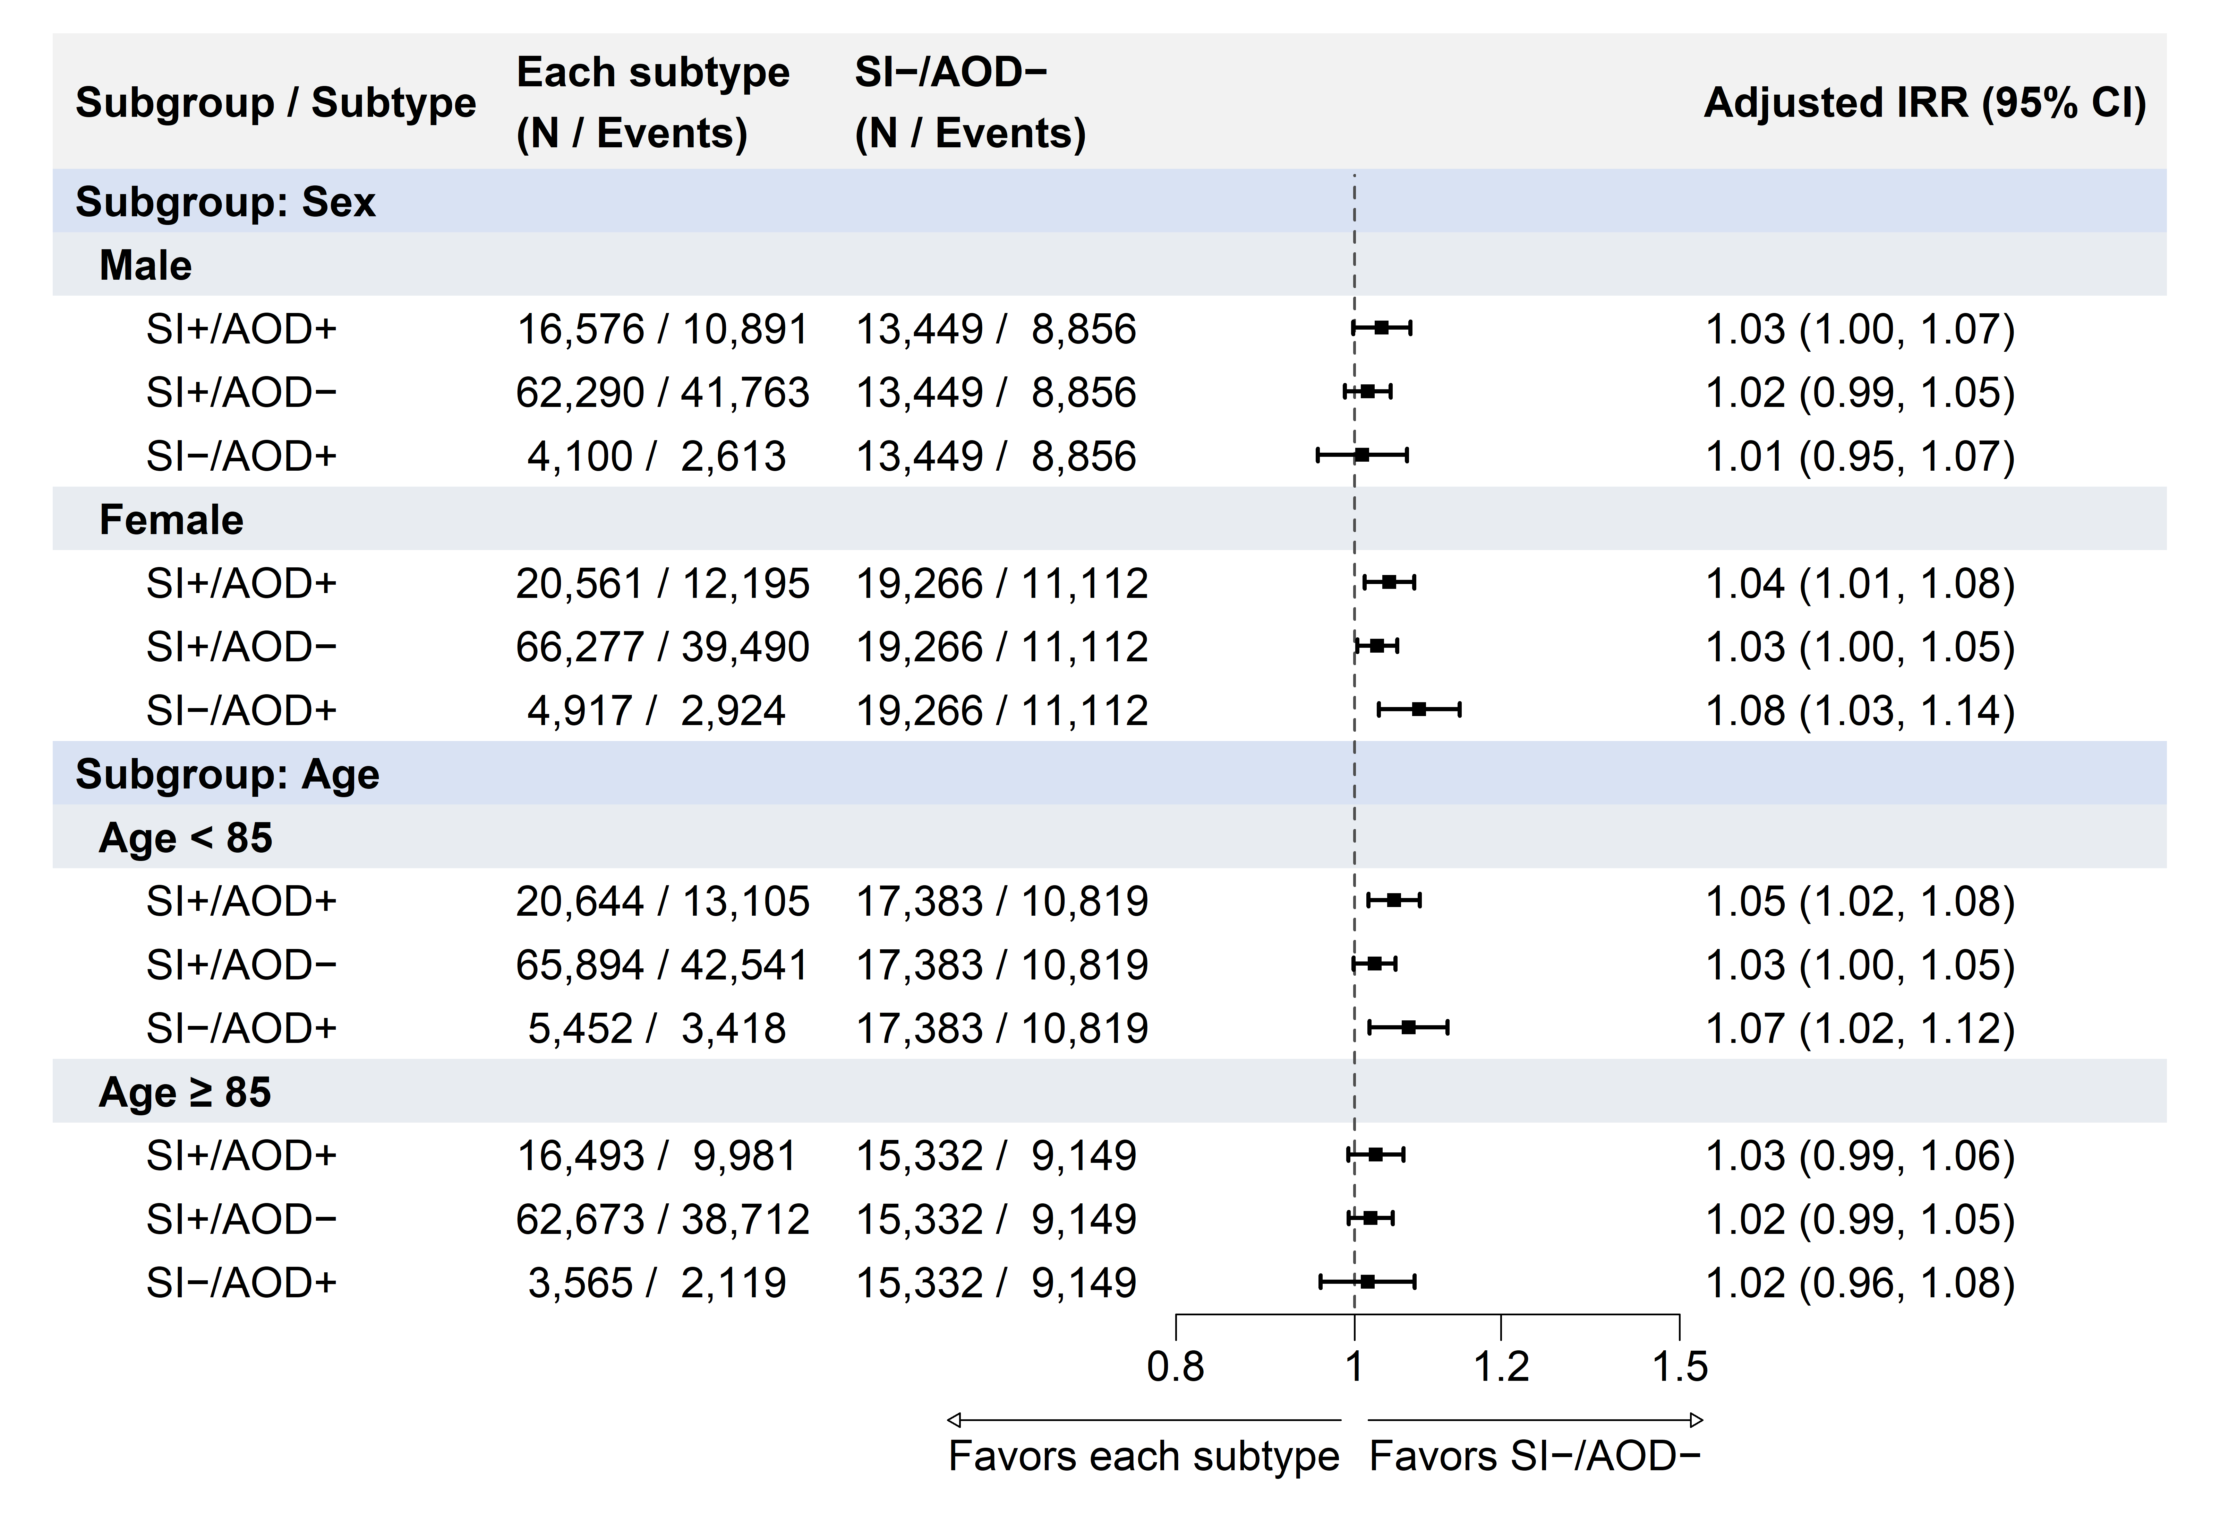
5-2. Adjusted incidence rate ratios of all-cause readmission

Incidence rate ratios (IRRs) were estimated using Poisson regression with log-transformed follow-up time as an offset. Robust (sandwich) variance estimators were used to compute 95% confidence intervals to account for potential overdispersion. Follow-up time was calculated from the discharge date to the first readmission, the end of observation, or death, whichever occurred first. Models were adjusted for age, sex, Charlson Comorbidity Index (CCI), Hospital Frailty Risk Score (HFRS), and number of hospitalizations within the past year. In sex-stratified analyses, sex was excluded from the covariates; in age-stratified analyses, age was excluded.
SI, serious infection; AOD, acute organ dysfunction; CI, confidence interval.

5-3. Adjusted incidence rate ratios of post-discharge cardiovascular disease

Incidence rate ratios (IRRs) were estimated using Poisson regression with log-transformed follow-up time as an offset. Robust (sandwich) variance estimators were used to compute 95% confidence intervals to account for potential overdispersion. Follow-up time was calculated from the discharge date to the first post-discharge cardiovascular event, the end of observation, or death, whichever occurred first. Models were adjusted for age, sex, Charlson Comorbidity Index (CCI), Hospital Frailty Risk Score (HFRS), and number of hospitalizations within the past year. In sex-stratified analyses, sex was excluded from the covariates; in age-stratified analyses, age was excluded. In-hospital cardiovascular comorbidity was defined according to the cardiovascular components of the Charlson Comorbidity Index, comprising the presence of any of the following diagnoses during the index hospitalization: myocardial infarction, congestive heart failure, peripheral vascular disease, or cerebrovascular disease.
SI, serious infection; AOD, acute organ dysfunction; CI, confidence interval.
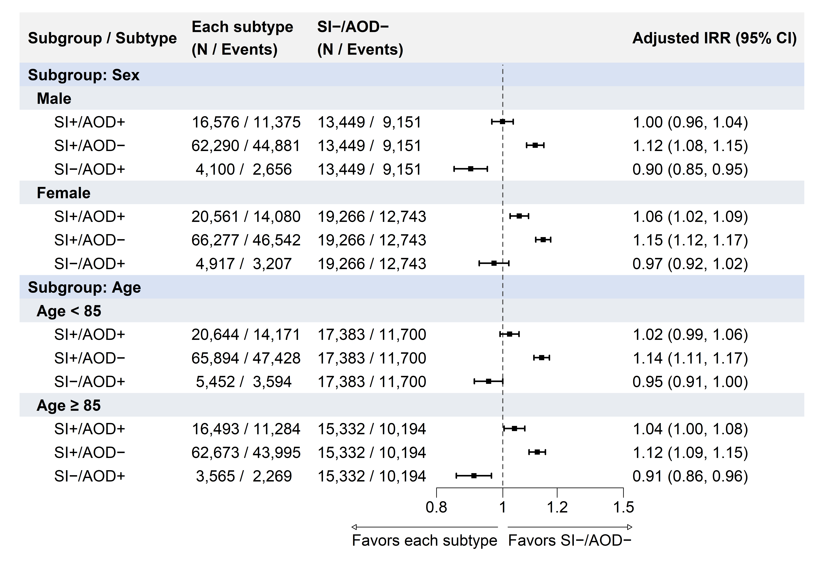
5-4. Adjusted incidence rate ratios of post-discharge infectious disease

Incidence rate ratios (IRRs) were estimated using Poisson regression with log-transformed follow-up time as an offset. Robust (sandwich) variance estimators were used to compute 95% confidence intervals to account for potential overdispersion. Follow-up time was calculated from the discharge date to the first post-discharge infection event, the end of observation, or death, whichever occurred first. Models were adjusted for age, sex, Charlson Comorbidity Index (CCI), Hospital Frailty Risk Score (HFRS), and number of hospitalizations within the past year. In sex-stratified analyses, sex was excluded from the covariates; in age-stratified analyses, age was excluded.
SI, serious infection; AOD, acute organ dysfunction; CI, confidence interval.

