Supplementary File 4: MAUDEMetrics Deployment Tutorial and Interface Guide
MAUDEMetrics is distributed as a downloadable, signed-binary desktop application for macOS and Windows. Docker and Python source-code deployments are also available for advanced users who require containerized or scripted workflows. This file describes both routes.
Part 1. Recommended: One-Click Desktop Installer (No Docker, No Code)
This is the recommended deployment for clinical researchers, regulatory professionals, and any user who does not require a containerized or scripted workflow.
Step 1 — Download the installer.
Open the project release page in any browser:
https://github.com/MohamedMaroufMD/MAUDEMetrics/releases/latest
Download the asset matching your operating system: MAUDEMetrics-<version>-arm64.dmg for Apple Silicon Macs, MAUDEMetrics-<version>-x64.dmg for Intel Macs, or MAUDEMetrics-Setup-<version>.exe for Windows 10/11 (64-bit).
Step 2 — Install.
macOS: open the .dmg, drag MAUDEMetrics to the Applications folder, and launch from Launchpad.
macOS Security Troubleshooting.
• “Unverified developer” warning: right-click (or Control-click) the application icon and select Open. Confirm in the dialog that appears. This is required only on the first launch on a new system.
• “Application is damaged” warning: this message can appear on some macOS versions due to Gatekeeper quarantine attributes applied during download. Open Terminal (Applications → Utilities → Terminal) and run the following command, then try launching the application again:
xattr -rd com.apple.quarantine /Applications/MAUDEMetrics.app
Windows: run MAUDEMetrics-Setup.exe and follow the standard installer prompts. The installer creates a Start-menu shortcut and registers the application for automatic update checks.
Windows Security Troubleshooting.
• Windows SmartScreen warning (“Windows protected your PC”): click “More info” and then “Run anyway.” This prompt appears for independently packaged applications that have not yet accumulated a large install-base signature and does not indicate malicious content.
• Antivirus false positive: independently packaged open-source Electron applications occasionally trigger antivirus heuristic flags. If MAUDEMetrics.exe is quarantined, restore it using the steps below for the relevant product:
Windows Defender: Windows Security → Virus & threat protection → Protection history → locate the MAUDEMetrics entry → Allow on device.
McAfee: McAfee Security → Quarantined files → locate MAUDEMetrics → Restore and exclude.
Norton: Norton → Security → History → locate MAUDEMetrics → Restore and exclude.

Step 3 — Use the application.
Launching MAUDEMetrics opens its graphical interface; no browser, terminal, or environment configuration is required. Construct queries on the Home page, execute extraction, and download the standardized Excel and CSV outputs from the Results page. The application checks for new releases on launch and notifies the user when an update is available.
System Requirements.
macOS 12 or later (Apple Silicon or Intel) or Windows 10/11 (64-bit); 2 GB RAM (8 GB recommended for queries exceeding 20,000 records); and an active internet connection.
Part 2. Interface Overview
• Home page (Query Formulation). Allows users to construct complex queries without writing API syntax. Users can search by Brand Name, Product Code, Manufacturer, Device Problem, Patient Problem, or exact Date Ranges; preview the live record count before extraction; and apply optional filters for event type.
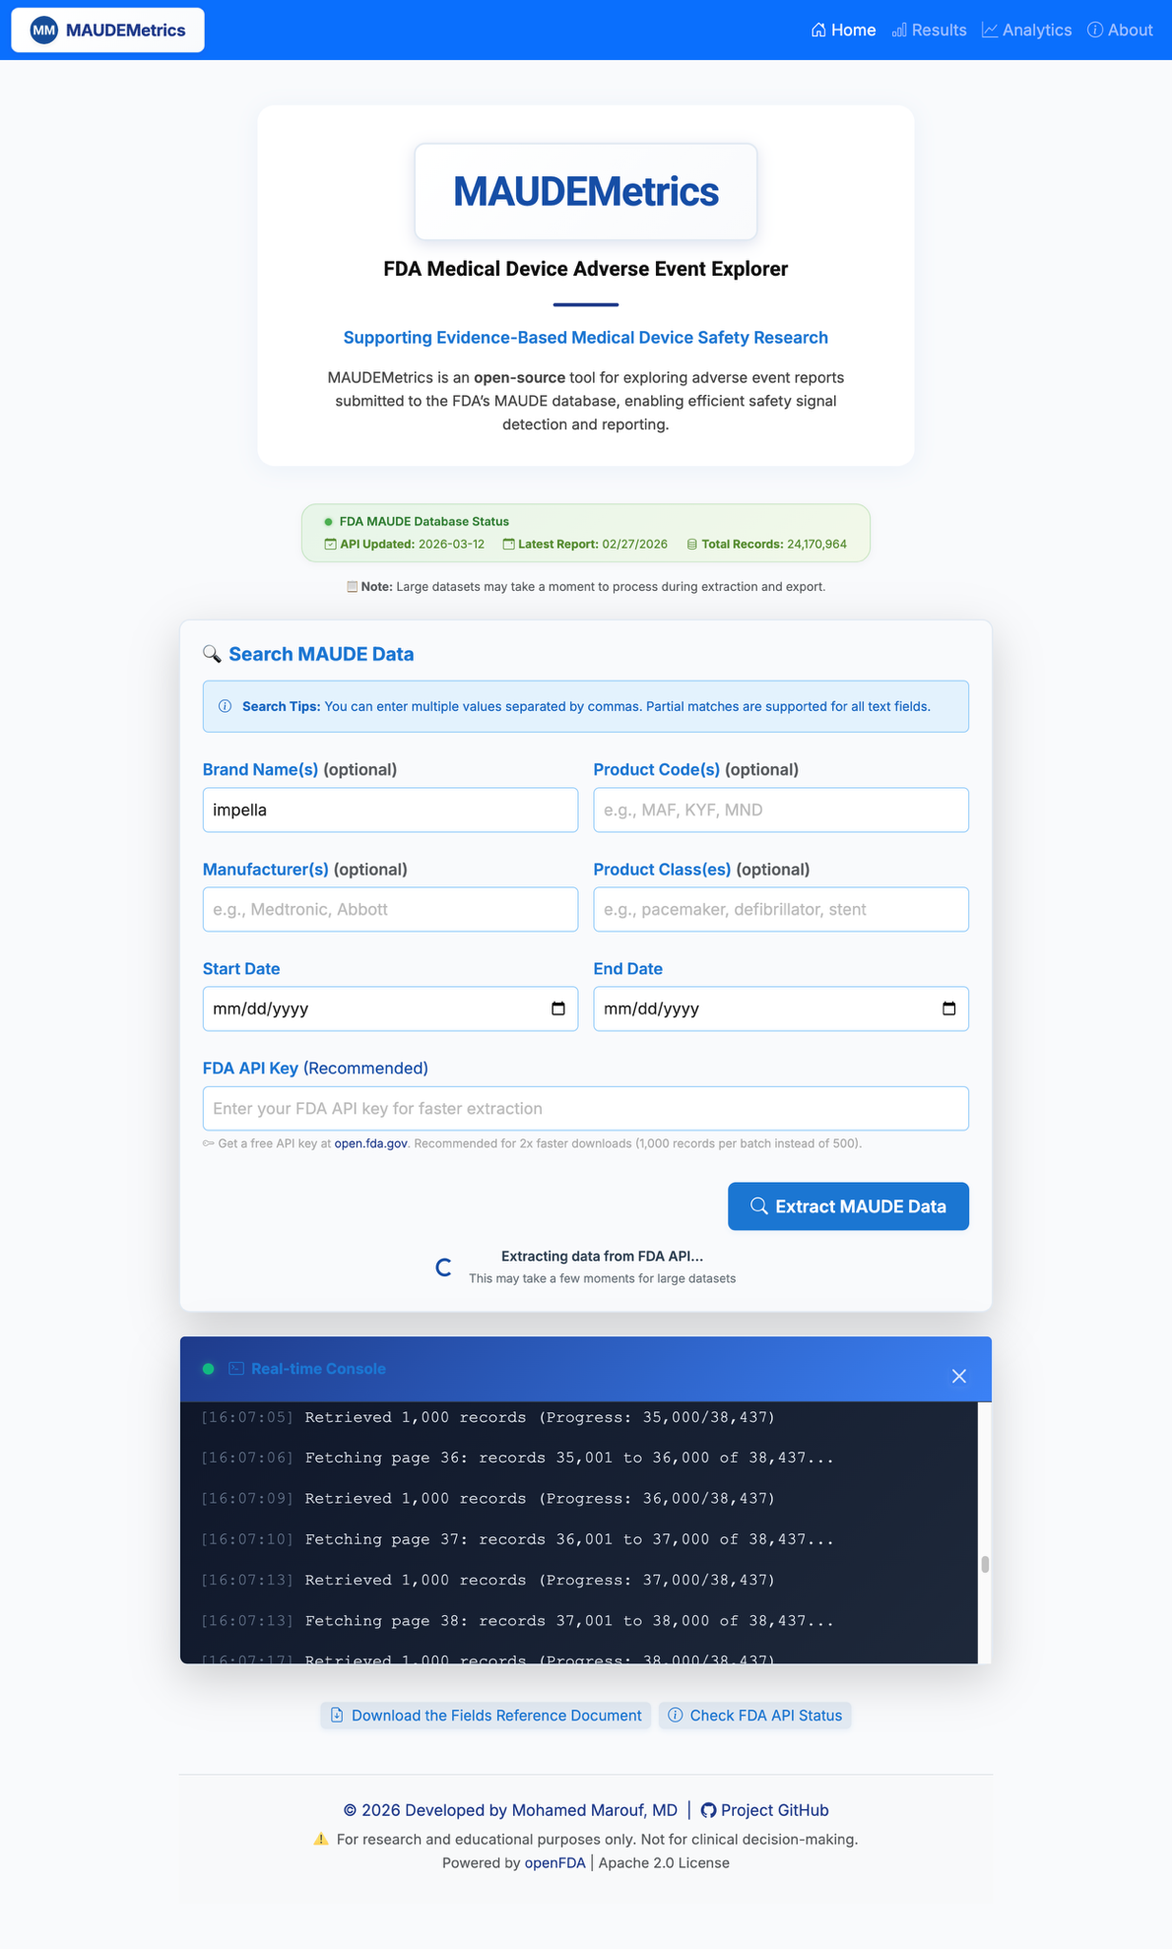
• Results page (Extraction & Download). Displays extraction metrics (records retrieved, cursor pages traversed, and wall-clock time) and offers download options: Optimized Excel Export (event-level and summary-statistics tabs), Raw Data ZIP (CSV + JSON), and the run manifest.
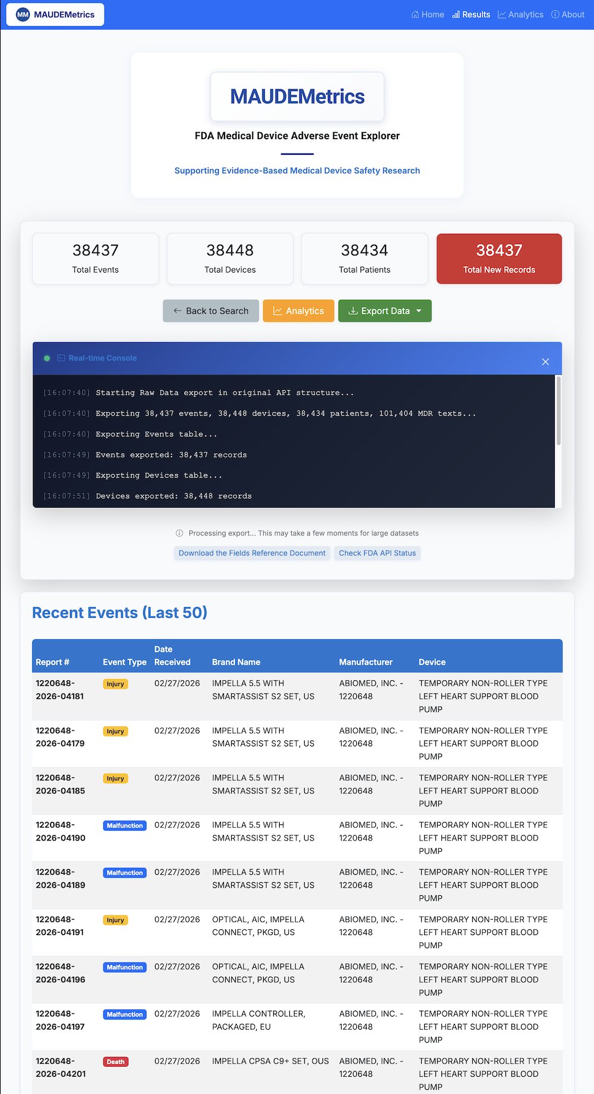
• Analytics dashboard. Provides immediate visual summaries of the extracted dataset, including temporal trends and frequency charts for device problems and patient outcomes.
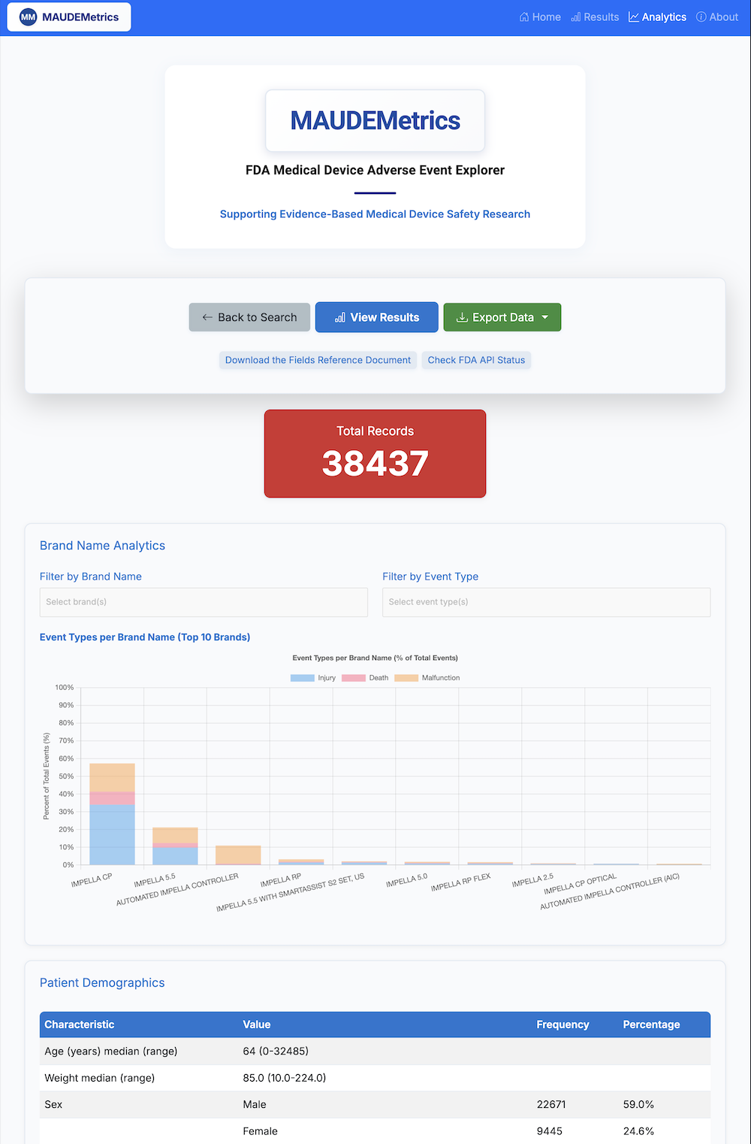
• Optimized Excel output. Provides a multi-sheet workbook with flattened demographics, integrated narratives, and a summary-statistics tab ready for epidemiological analysis. A run-manifest tab records the query string, openFDA snapshot timestamp, and MAUDEMetrics version.
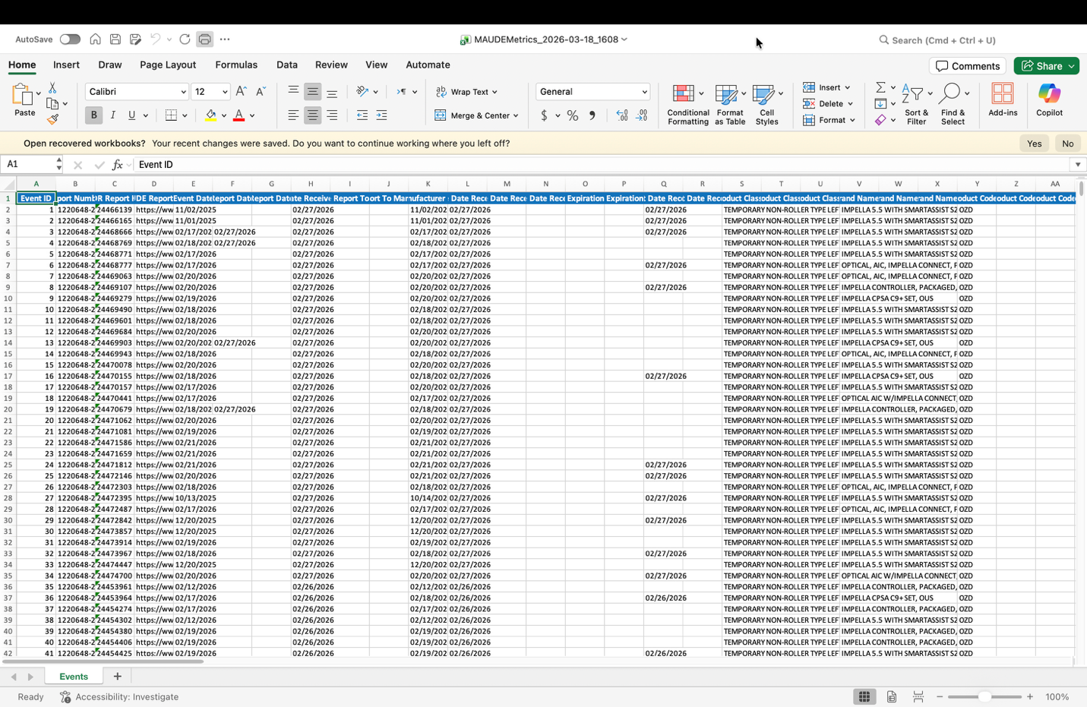

Part 3. Advanced: Docker Deployment
Investigators who require a containerized environment (e.g., reproducible deployment in shared institutional infrastructure or CI/CD integration) may deploy MAUDEMetrics via Docker. This route assumes basic familiarity with terminal commands and Docker.
Step 1 — Install Docker Desktop.
Docker Desktop is available free of charge from docker.com.
Step 2 — Clone the repository.
git clone https://github.com/MohamedMaroufMD/MAUDEMetrics.git
Step 3 — Launch the container.
cd MAUDEMetrics && docker compose up --build
Step 4 — Access the GUI.
Open a browser and navigate to http://localhost:5005.
Part 4. Advanced: Python Source
For developers extending MAUDEMetrics or integrating it into a custom pipeline, the application can be run directly from source under Python 3.11 or later. Clone the repository as in Part 3, create a virtual environment, install dependencies via pip install -r requirements.txt, and launch with python app.py. The graphical interface is then available at http://localhost:5005.

