Supplemental Material

Decentering and Self-Esteem Regulation in Depression: Self-Affirmation and Self-Protection as Regulatory Strategies
L. Rader, V. Mainz, M. Beetz, S. Gauggel & B. Drueke

Figures
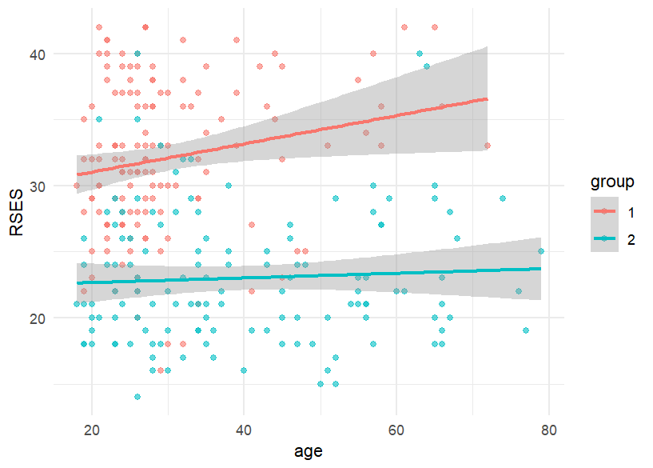
Figure S1. Association between age and self-esteem (RSES) per group (1 = healthy participants, 2 = patients with depression)
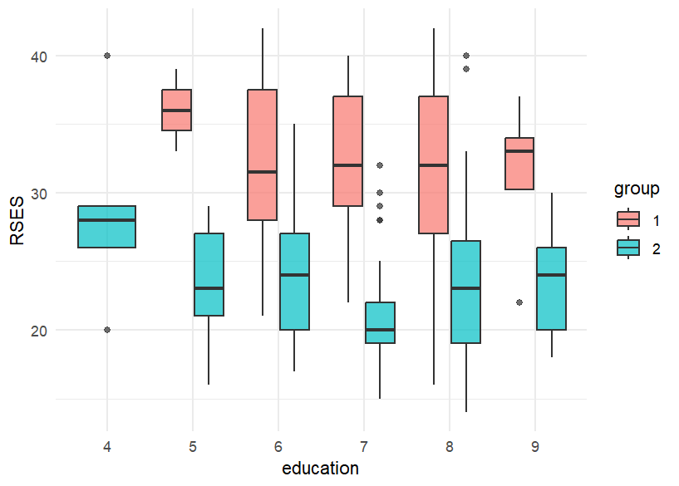

Note. 4 = basic secondary education, 5 = intermediate secondary education, 6 = university entrance qualification, 7 = vocational training, 8 = bachelor’s/master’s degree, 9 = other
Figure S2. Association between education and self-esteem (RSES) per group (1 = healthy participants, 2 = patients with depression)
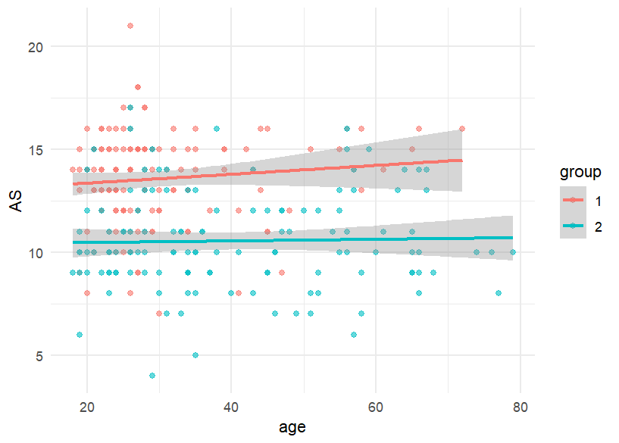
Figure S3. Association between age and accepting self-perception (AS) per group (1 = healthy participants, 2 = patients with depression)

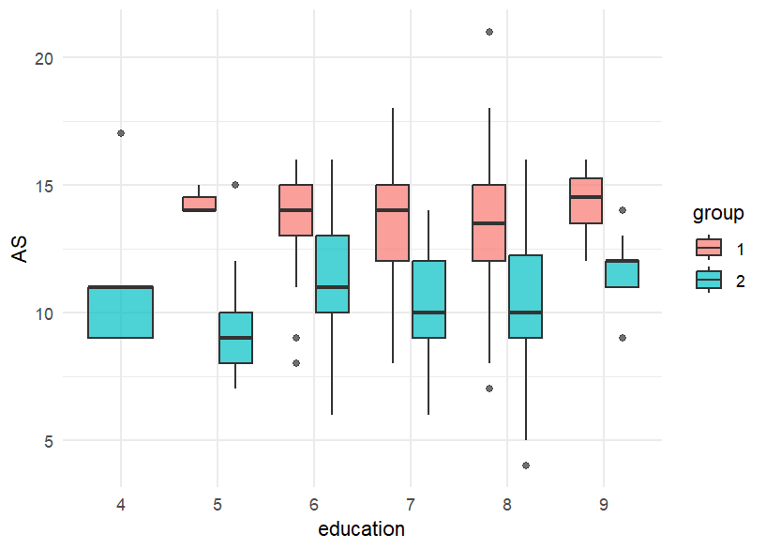
Note. 4 = basic secondary education, 5 = intermediate secondary education, 6 = university entrance qualification, 7 = vocational training, 8 = bachelor’s/master’s degree, 9 = other
Figure S4. Association between education and accepting self-perception (AS) per group (1 = healthy participants, 2 = patients with depression)

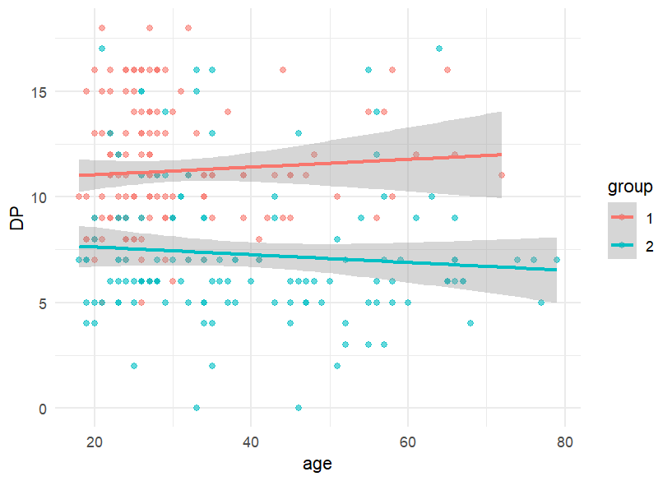
Figure S5. Association between age and distanced perspective (DP) per group (1 = healthy participants, 2 = patients with depression)

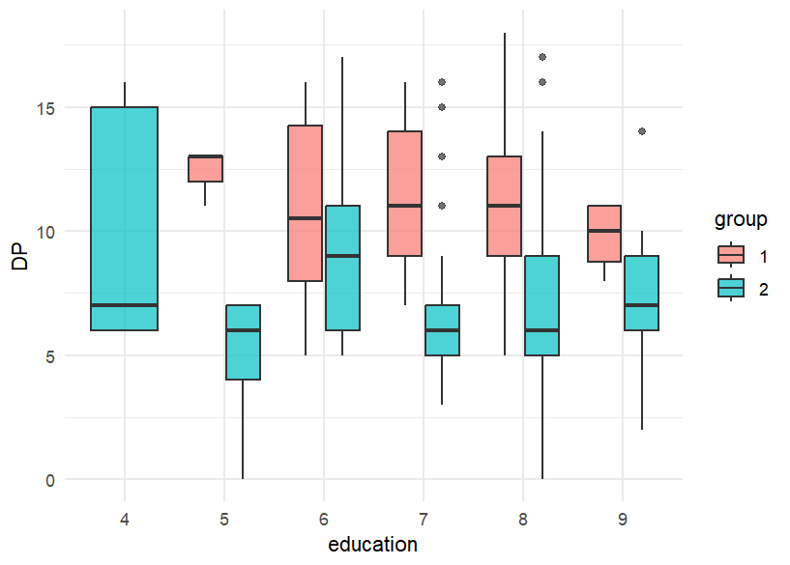
Note. 4 = basic secondary education, 5 = intermediate secondary education, 6 = university entrance qualification, 7 = vocational training, 8 = bachelor’s/master’s degree, 9 = other
Figure S6. Association between education and distanced perspective (DP) per group (1 = healthy participants, 2 = patients with depression)

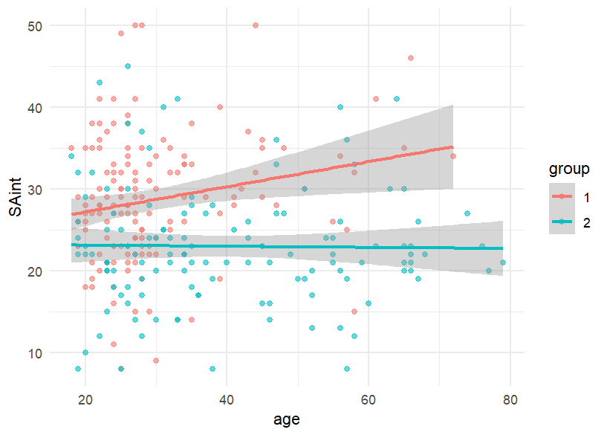
Figure S7. Association between age and self-affirmation with internal resources (SAint) per group (1 = healthy participants, 2 = patients with depression)

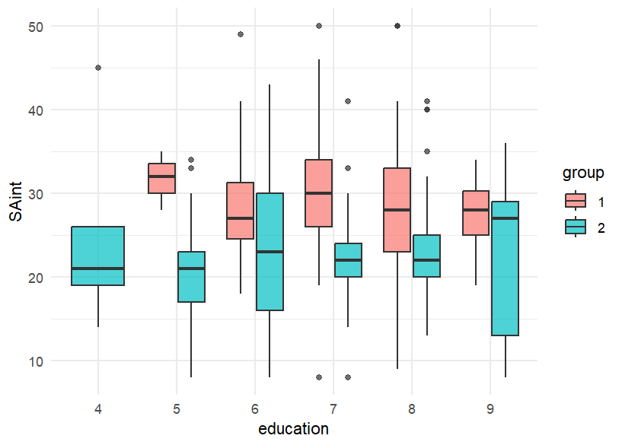
Note. 4 = basic secondary education, 5 = intermediate secondary education, 6 = university entrance qualification, 7 = vocational training, 8 = bachelor’s/master’s degree, 9 = other
Figure S8. Association between education and self-affirmation with internal resources (SAint) per group (1 = healthy participants, 2 = patients with depression)

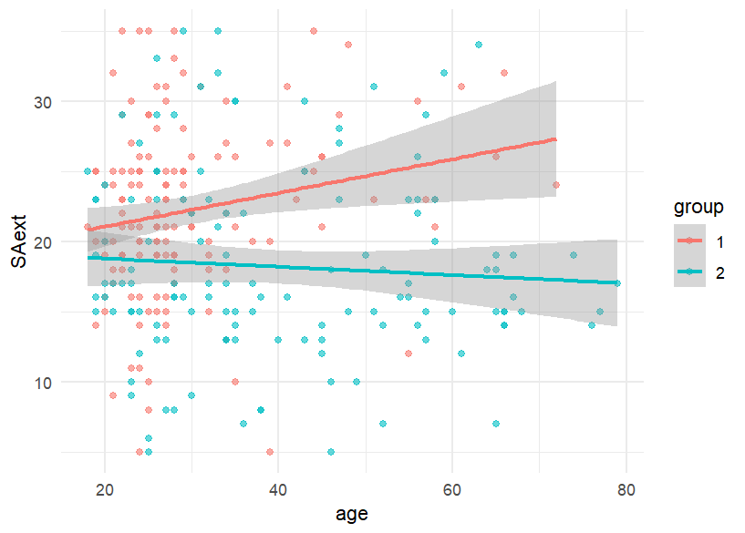
Figure S9. Association between age and self-affirmation with external resources (SAext) per group (1 = healthy participants, 2 = patients with depression)

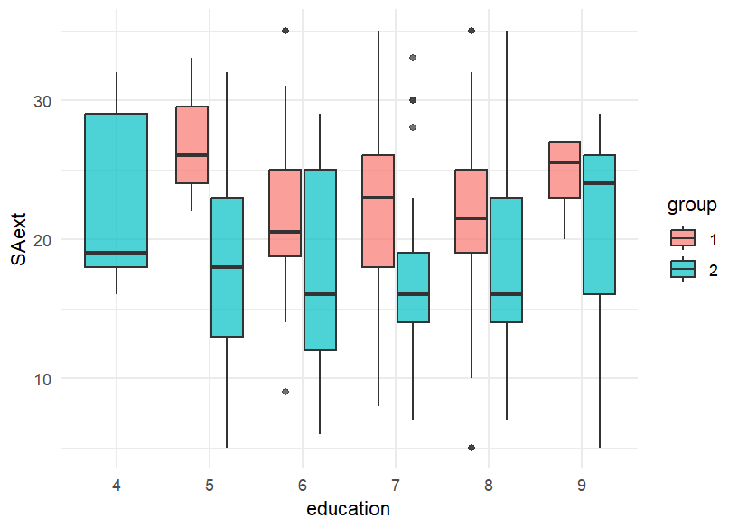
Note. 4 = basic secondary education, 5 = intermediate secondary education, 6 = university entrance qualification, 7 = vocational training, 8 = bachelor’s/master’s degree, 9 = other
Figure S10. Association between education and self-affirmation with external resources (SAext) per group (1 = healthy participants, 2 = patients with depression)

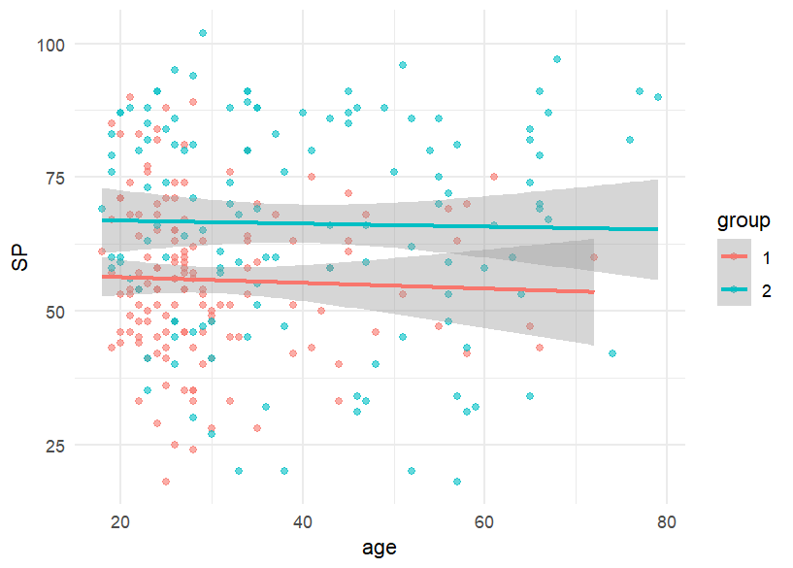
Figure S11. Association between age and self-protection (SP) per group (1 = healthy participants, 2 = patients with depression)

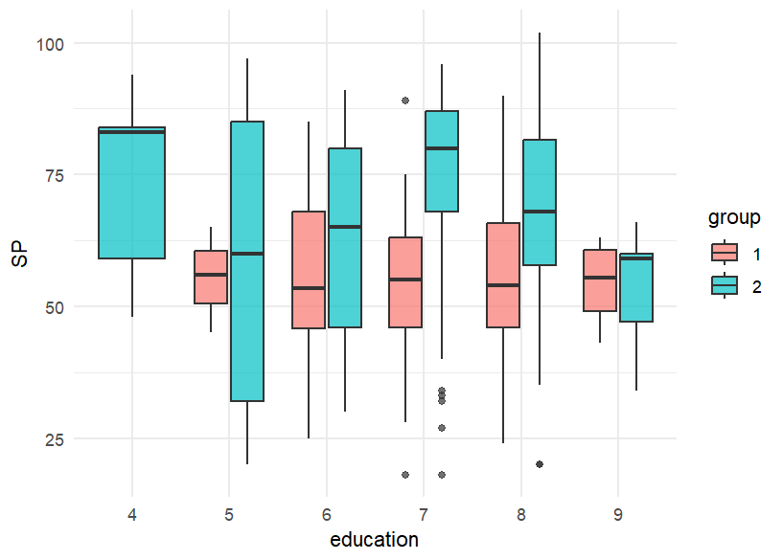
Note. 4 = basic secondary education, 5 = intermediate secondary education, 6 = university entrance qualification, 7 = vocational training, 8 = bachelor’s/master’s degree, 9 = other
Figure S12. Association between education and self-protection (SP) per group (1 = healthy participants, 2 = patients with depression)

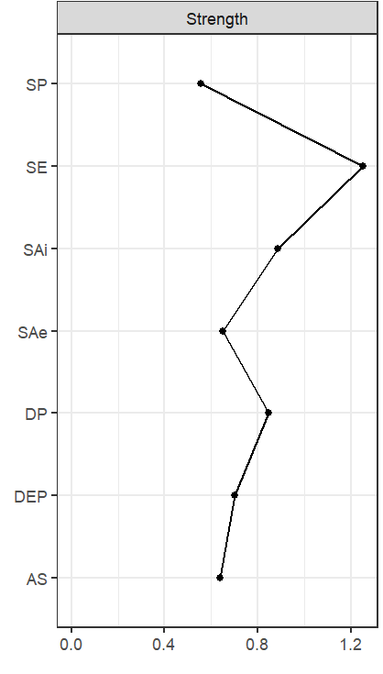
Figure S13. Centrality plot of the network with healthy participants (n = 140) showing the node strength

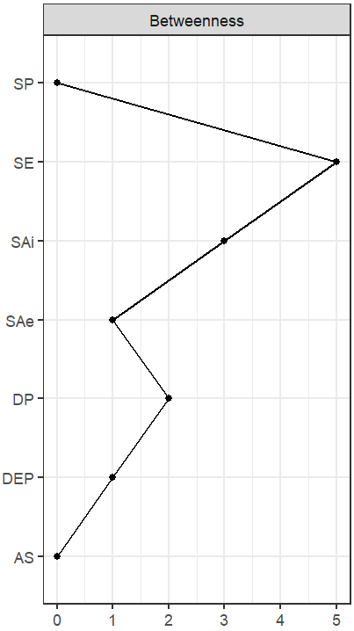
Figure S14. Centrality plot of the network with healthy participants (n = 140) showing the node betweenness

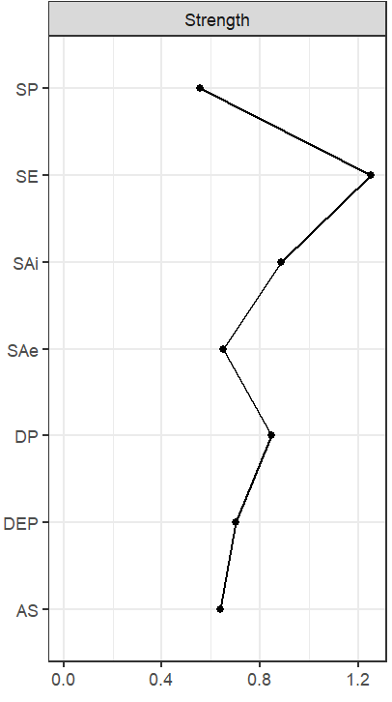
Figure S15. Centrality plot of the network with patients with depression (n = 129) showing the node strength

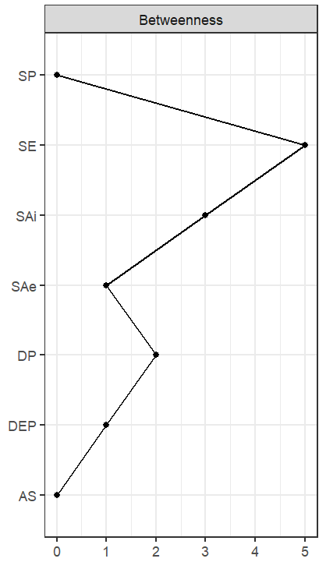
Figure S16. Centrality plot of the network with patients with depression (n = 129) showing the node betweenness
Tables
Table S1
Results of path analysis on the mediating role of decentering on the association between self-esteem and the regulative strategies in healthy participants
Criterion variable | Predictor variable | Path | Est | SE | b | p | 95% CI
 |  |  |  |  |  |  | Lower | Upper
AS | Se | a1 | .172 | .030 | .452 | <.001 | .112 | .232
DP | Se | a2 | .224 | .039 | .439 | <.001 | .143 | .297
Sa (int) | AS | b1 | -.172 | .328 | -.050 | .600 | -.813 | .494
 | DP | b2 | .498 | .254 | .193 | .050 | -.041 | .948
 | Se | c | .244 | .139 | .185 | .080 | -.021 | .502
 | Se*AS | a1*b1 | -.030 | .057 | -.022 | .606 | -.148 | .082
 | Se*DP | a2*b2 | .112 | .062 | .085 | .069 | -.008 | .237
 |  | c+a1*b1 | .214 | .128 | .163 | .093 | -.028 | .456
 |  | c+a2*b2 | .356 | .141 | .270 | .076 | .076 | .620
Sa (ext) | AS | b1 | -.080 | .287 | -.029 | .780 | -.607 | .538
 | DP | b2 | .589 | .197 | .287 | .003 | .178 | .956
 | Se | c | -.131 | .102 | -.125 | .198 | -.333 | .057
 | Se*AS | a1*b1 | -.014 | .050 | -.013 | .783 | -.108 | .084
 | Se*DP | a2*b2 | .132 | .049 | .126 | .007 | .037 | .229
 |  | c+a1*b1 | -.145 | .094 | -.138 | .121 | -.328 | .038
 |  | c+a2*b2 | .001 | .103 | .001 | .994 | -.215 | .194
Sp | AS | b1 | -.716 | .681 | -.111 | .293 | -2.084 | .618
 | DP | b2 | -.553 | .492 | -.115 | .261 | -1.506 | .432
 | Se | c | -.333 | .292 | -.135 | .254 | -.922 | .212
 | Se*AS | a1*b1 | -.123 | .120 | -.050 | .307 | -.375 | .108
 | Se*DP | a2*b2 | -.124 | .113 | -.050 | .270 | -.361 | .088
 |  | c+a1*b1 | -.456 | .257 | -.185 | .077 | -.980 | .013
 |  | c+a2*b2 | -.457 | .264 | -.186 | .084 | -.990 | .052
Note. AS = Accepting Self-perception, DP = Distanced Perspective, Se = Self-esteem, Sa (int) = Self-affirmation (internal resource), Sa (ext) = Self-affirmation (external resources), Sp = Self-protection, Est = unstandardized regression coefficient, SE = standard error, b = standard regression coefficient, 95% CI = 95% confidence interval.

Table S2
Results of regression analysis on the moderating role of depressive symptoms on the association between decentering and self-affirmation resp. self-protection in patients with depression
Criterion | Coefficients | Est | SE | t | p
SA(int) | AS | 2.411 | 0.627 | 3.852 | <.001
 | DESC | 0.538 | 0.335 | 1.607 | .110
 | AS*DESC | -0.067 | 0.031 | -2.116 | .036
SA(int) | DP | 1.319 | 0.399 | 3.300 | .001
 | DESC | -0.024 | 0.161 | -0.151 | .880
 | DP*DESC | -0.022 | 0.018 | -1.191 | .235
SA(ext) | AS | 2.569 | 0.619 | 4.145 | <.001
 | DESC | 0.963 | 0.330 | 2.913 | .004
 | AS*DESC | -0.089 | 0.031 | -2.890 | .004
SA(ext) | DP | 1.176 | 0.399 | 2.944 | .003
 | DESC | 0.174 | 0.160 | 1.087 | .279
 | DP*DESC | -0.022 | 0.018 | -1.192 | .235
SP | AS | -8.355 | 1.821 | -4.587 | <.001
 | DESC | -4.186 | 0.971 | -4.309 | <.001
 | AS*DESC | 0.330 | 0.091 | 3.617 | <.001
SP | DP | -5.029 | 1.187 | -4.237 | <.001
 | DESC | -2.158 | 0.478 | -4.525 | <.001
 | DP*DESC | 0.203 | 0.056 | 3.616 | <.001
Note. AS = Accepting Self-perception, DP = Distanced, DESC = Depressive Symptoms, Sa (int) = Self-affirmation (internal resource), Sa (ext) = Self-affirmation (external resources), Sp = Self-protection, Est = unstandardized regression coefficient, SE = standard error, t = t-value, p = p-value

