Supplementary Information

Supplementary Figure 1. Sensitivity analysis across eight depression-related outcomes.
Supplementary Figure 2. Additive associations of polygenic scores and wave 4 key variables with late-life depressive symptoms.
Supplementary Figure 3. Additive associations of polygenic scores and wave 5 key variables with late-life depressive symptoms.
Supplementary Figure 4. Forest plot of interaction effects between neuroticism PGS and key variables (wave 4).
Supplementary Figure 5. Forest plot of interaction effects between neuroticism PGS and key variables (wave 5).
Supplementary Figure 6. Interaction between neuroticism PGS and key variables (wave 4).
Supplementary Methods

Supplementary Figure 1. Sensitivity analysis across eight depression-related outcomes. SHAP summary plots (left) and domain-level R² (right) from gradient boosting machine (GBM) models fitted for each outcome. Models were trained using all 426 variables (full model) to derive SHAP values and separately within each domain to estimate domain-specific R².
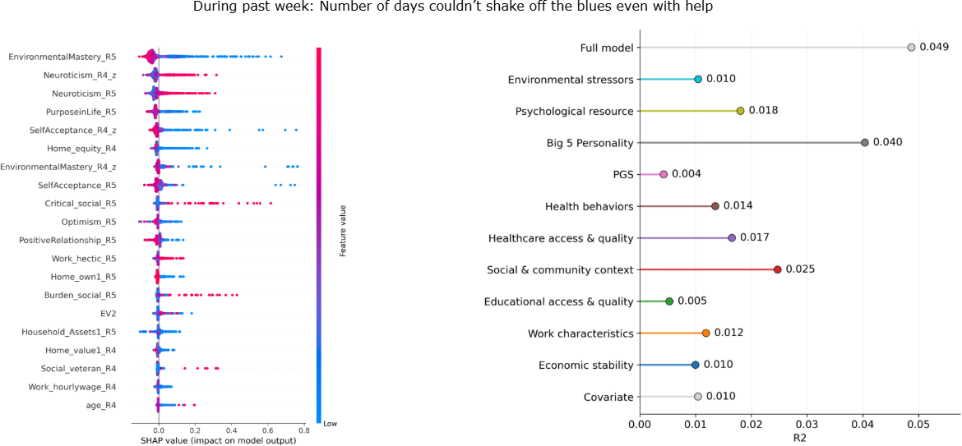

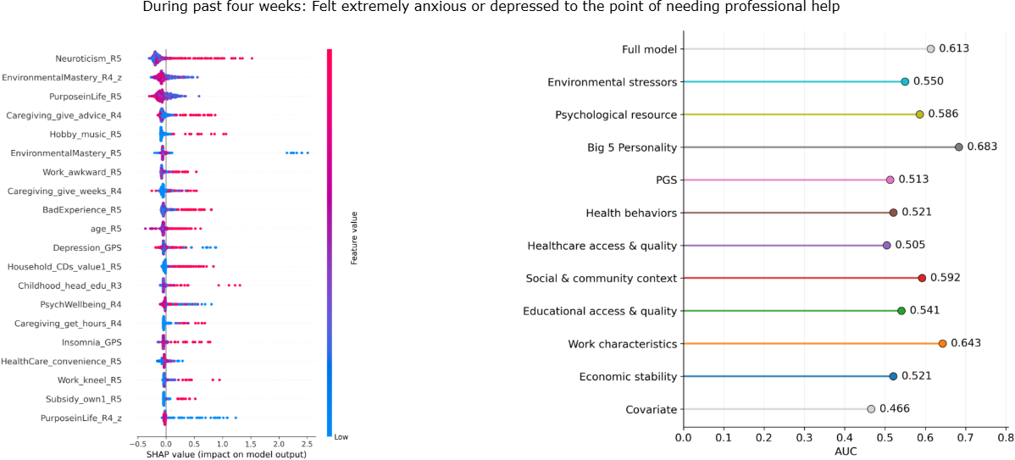

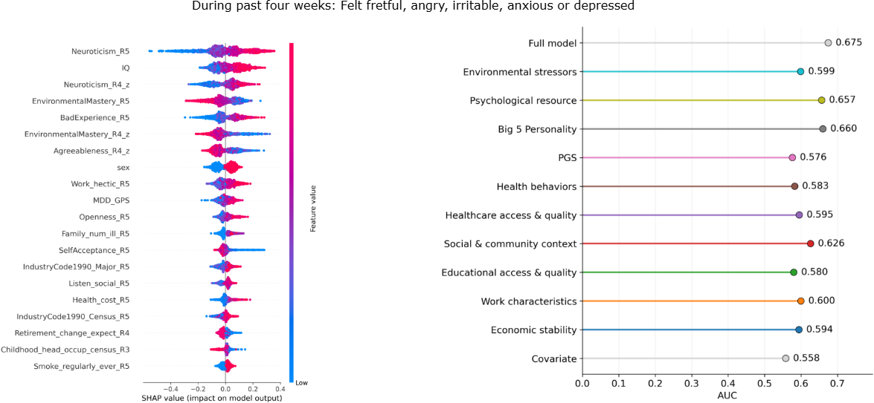

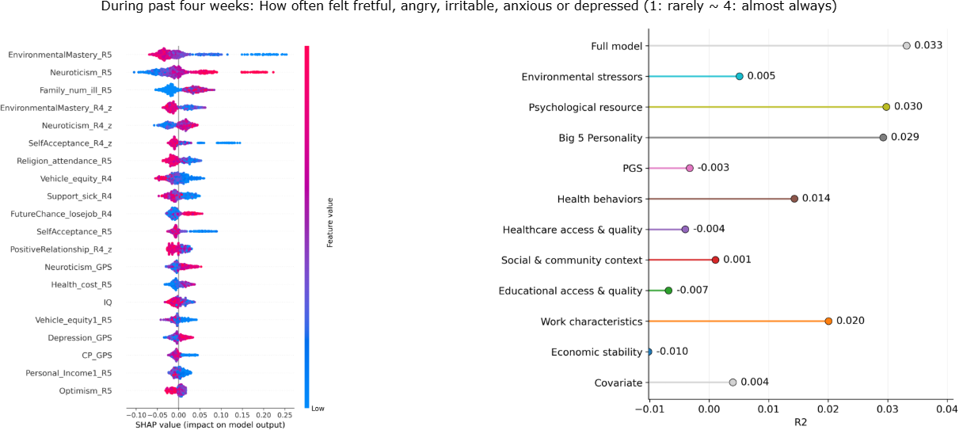

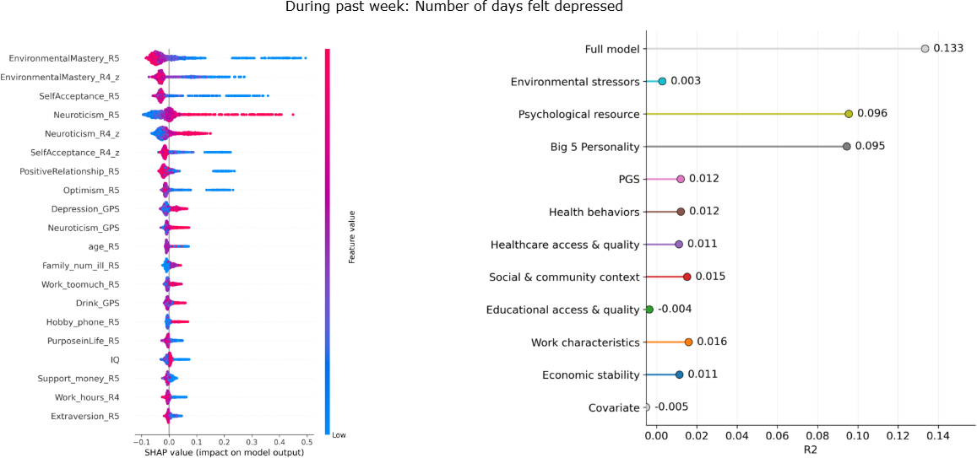

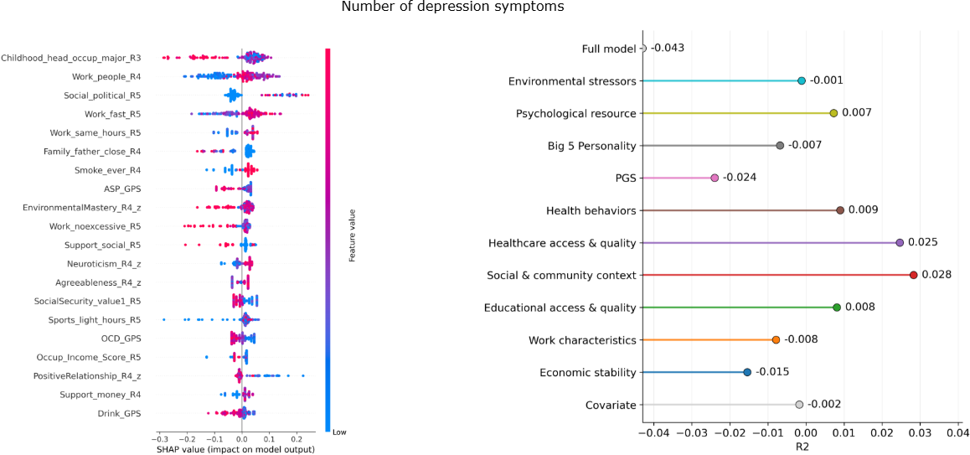

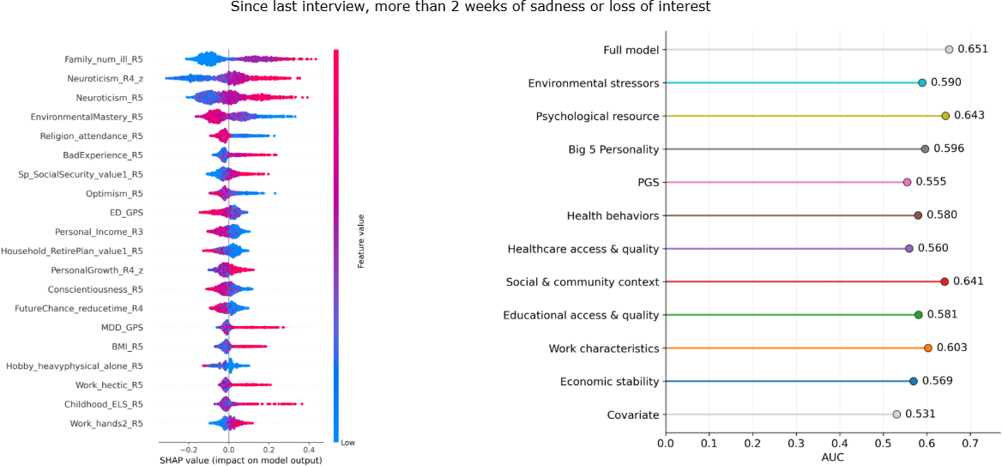

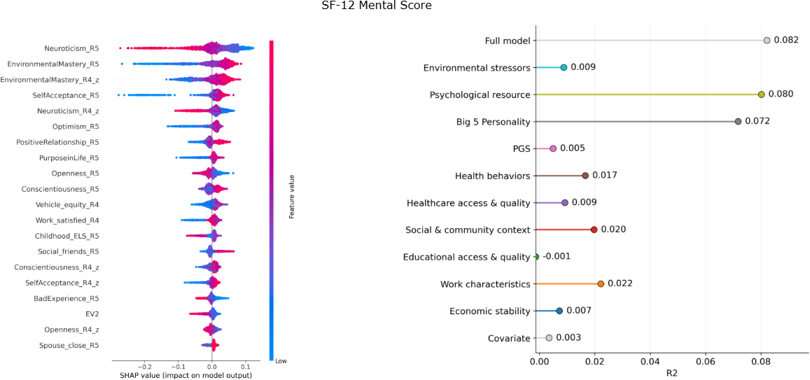

Supplementary Figure 2. Additive associations of polygenic scores and wave 4 key variables with late-life depressive symptoms. Standardized regression coefficients (β) are shown for key independent variables (blue) and polygenic scores (PGS; red) from models including both sets of predictors simultaneously. Points indicate effect estimates and error bars denote 95% confidence intervals. Filled points indicate statistical significance (p < 0.05), with gradation in size reflecting p-value thresholds as indicated. AD, alcohol dependence; ASP, automobile speeding propensity; CP, cognitive performance; EA, educational attainment; MDD, major depressive disorder; PTSD, post-traumatic stress disorder.
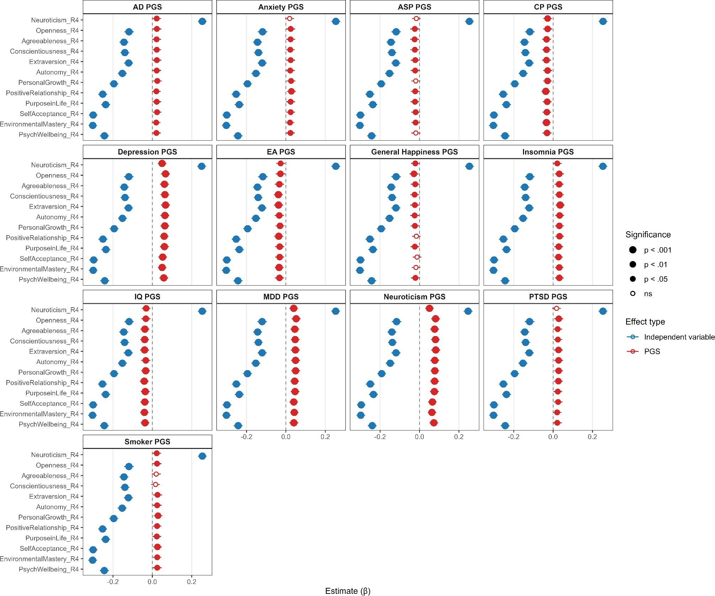

Supplementary Figure 3. Additive associations of polygenic scores and wave 5 key variables with late-life depressive symptoms. Standardized regression coefficients (β) are shown for key independent variables (blue) and polygenic scores (PGS; red) from models including both sets of predictors simultaneously. Points indicate effect estimates and error bars denote 95% confidence intervals. Filled points indicate statistical significance (p < 0.05), with gradation in size reflecting p-value thresholds. AD, alcohol dependence; ASP, automobile speeding propensity; CP, cognitive performance; EA, educational attainment; MDD, major depressive disorder; PTSD, post-traumatic stress disorder.
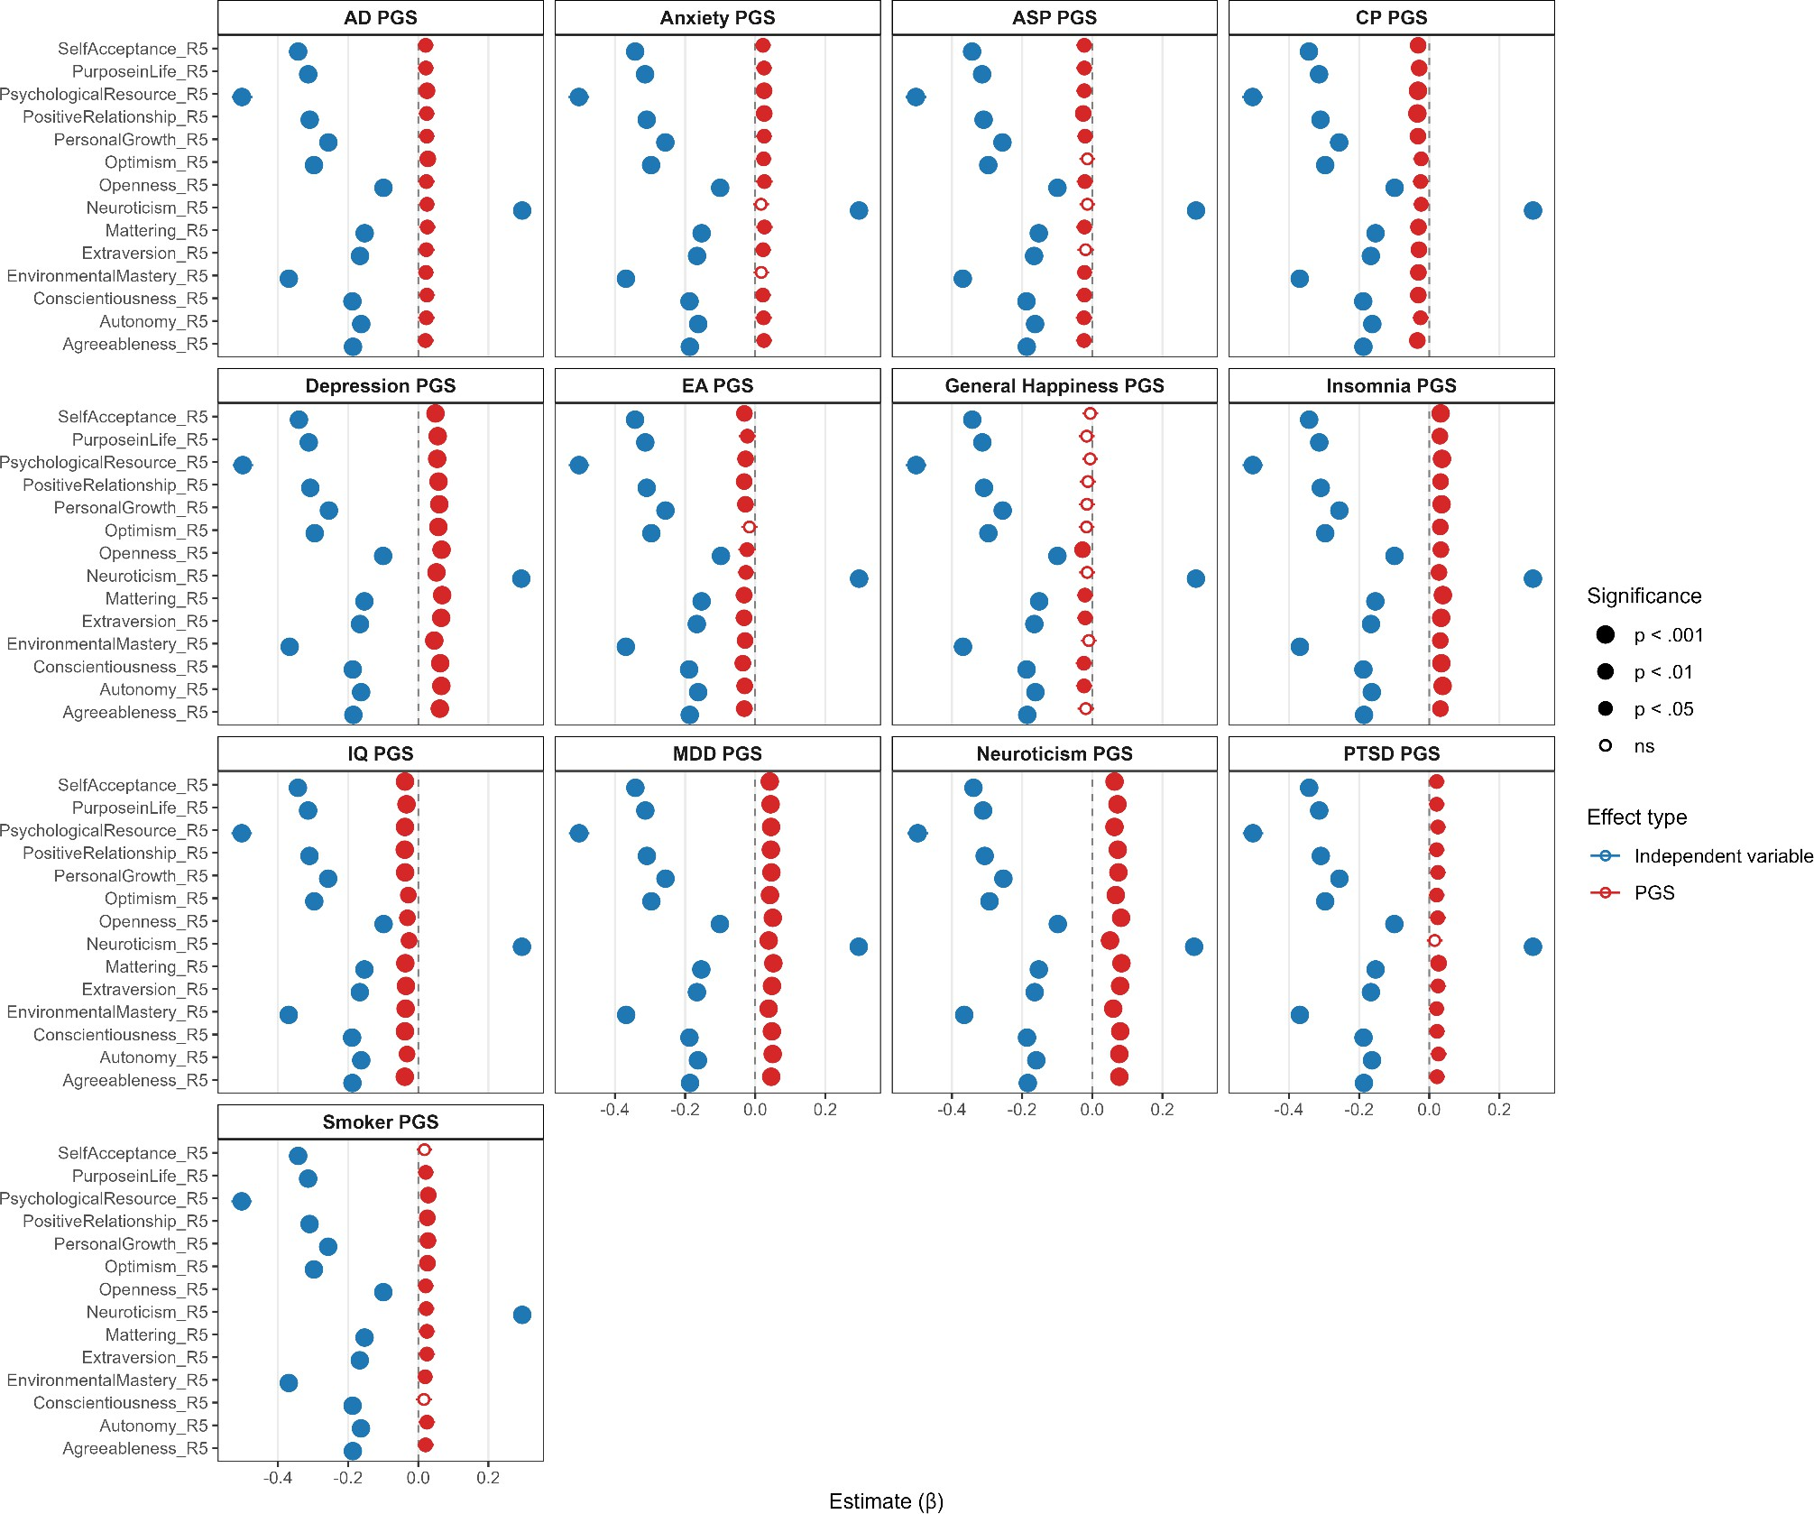

Supplementary Figure 4. Forest plot of interaction effects between neuroticism PGS and key variables (wave 4). Points represent standardized regression coefficients (β) for the interaction terms, and horizontal bars denote 95% confidence intervals. P values were corrected for multiple testing using the Benjamini–Hochberg false discovery rate (FDR) procedure; no interaction effects survived FDR correction. Significance levels are denoted as *** p-FDR<0.001, ** p-FDR<0.01, * p-FDR<0.05. AD, alcohol dependence; ASP, automobile speeding propensity; CP, cognitive performance; EA, educational attainment; MDD, major depressive disorder; PTSD, post-traumatic stress disorder.
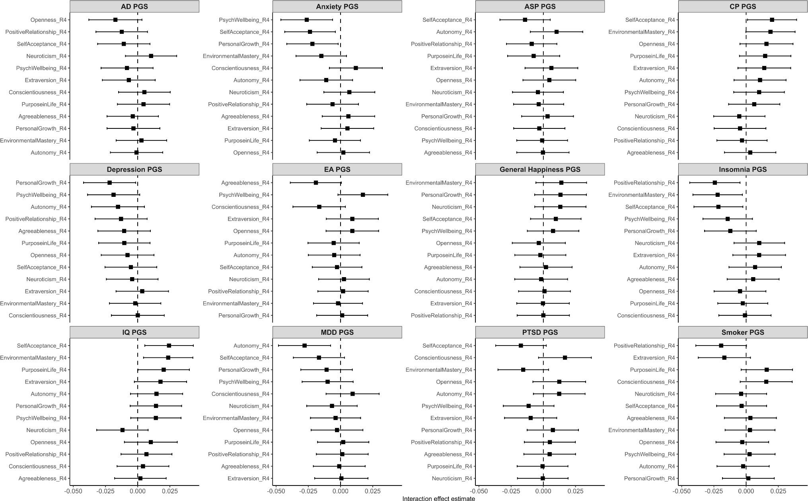

Supplementary Figure 5. Forest plot of interaction effects between neuroticism PGS and key variables (wave 5). Points represent standardized regression coefficients (β) for the interaction terms, and horizontal bars denote 95% confidence intervals. P values were corrected for multiple testing using the Benjamini–Hochberg false discovery rate (FDR) procedure; no interaction effects survived FDR correction. Significance levels are denoted as *** p-FDR<0.001, ** p-FDR<0.01, * p-FDR<0.05. AD, alcohol dependence; ASP, automobile speeding propensity; CP, cognitive performance; EA, educational attainment; MDD, major depressive disorder; PTSD, post-traumatic stress disorder.
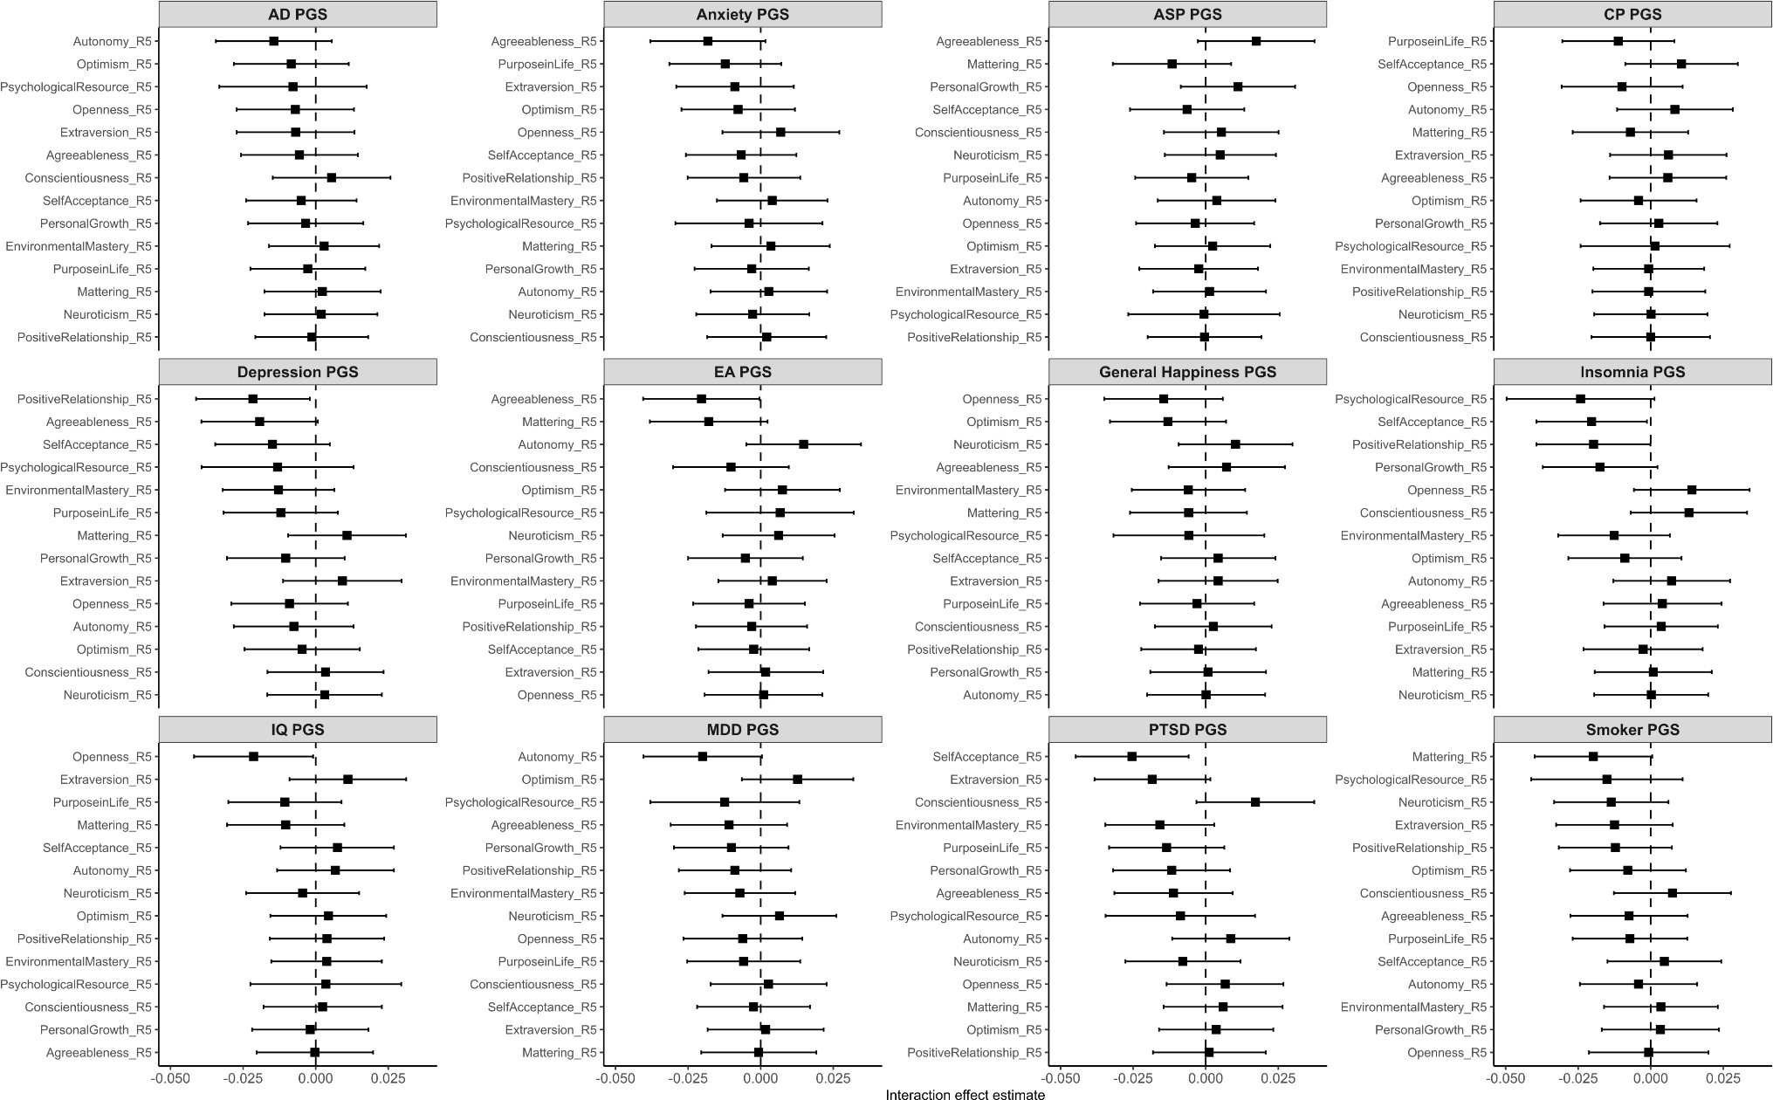

Supplementary Figure 6. Interaction between neuroticism PGS and key variables (wave 4). Forest plot (left) of interaction effects between neuroticism PGS and key variables, and interaction plot (right) illustrating predicted late-life depressive symptoms across levels of personal growth. Participants were stratified by low (10th), middle (10–90th), and high (90th) percentiles of neuroticism PGS. Black arrows mark the difference in predicted scores between the high- and low-PGS groups at the minimum and maximum personal growth values. Shaded areas represent 95% confidence intervals. *** p-FDR<0.001, ** p-FDR<0.01, * p-FDR<0.05.
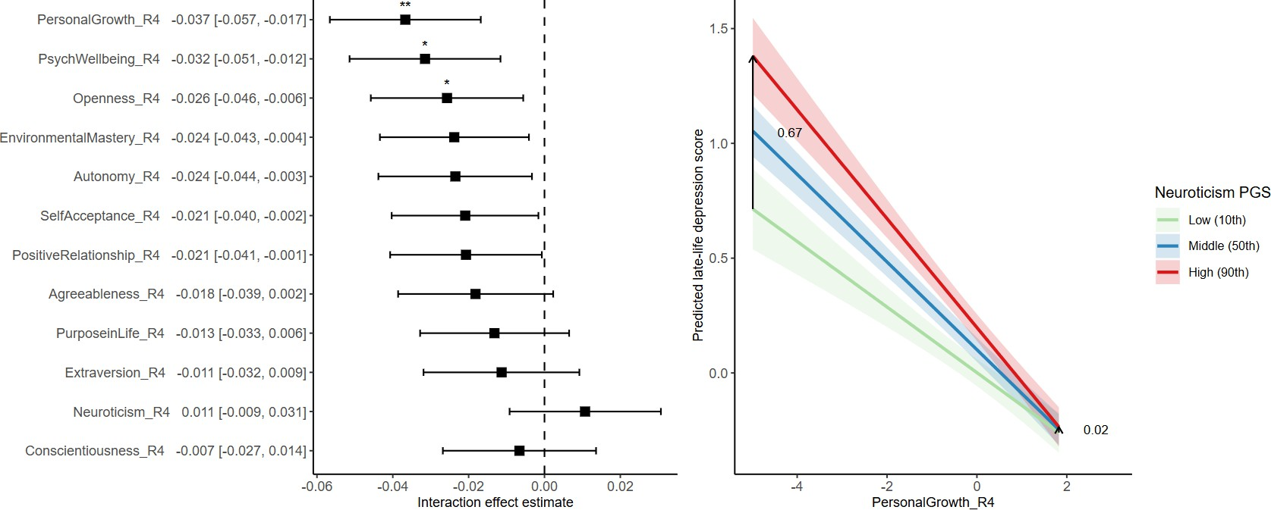

Supplementary Methods

Generalized structured component analysis

Generalized structured component analysis (GSCA) integrates three sub-models—measurement, structural, and weighted relation model— into a single equation and estimates parameters using the alternating least squares algorithm. In the weighted-relation model, a component is derived as weighted sums of observed variables.

The weights are obtained in such a way that the component explains the maximum variance of the observed variables, reflected by loadings in the measurement model. This allows aggregation of heterogeneous indicators that may capture different facets of a construct, in contrast to factor-based SEM, which assumes that observed variables are highly correlated and reflect a single underlying latent factor. Prior research has shown that GSCA outperforms partial least squares path modeling (PLSPM), another component-based SEM, in estimating component interaction effects,¹ supporting its use for testing interactions between components.
Model fit was evaluated using four overall fit indices. FIT, analogous to R², and AFIT, similar to adjusted R², indicates how much variance of all indicators and components are explained by the specified model, and has a range from 0 to 1. There is no rule-of-thumb cutoff for FIT. The goodness-of-fit index (GFI) and standardized root mean square residual index (SRMR) assess the correspondence between model-implied and observed covariance matrices, with GFI closer to 1 and SRMR closer to 0 indicating good fit. Out-of-sample prediction error (OPE) shows the prediction power of the model, with values less than 1 indicating that the model outperforms a null model. For sample sizes greater than 100, recommended cutoffs are GFI ≥ 0.93 and SRMR ≤ 0.08.² As GSCA does not produce exact p-values, the statistical significance of weights, loadings, and path coefficients were evaluated using 1000 bootstrap samples deriving 95% confidence intervals.
References

- Shen, Z., Cho, G. & Hwang, H. Comparison of Component-Based Structural Equation Modeling Methods in Testing Component Interaction Effects. Struct. Equ. Model. Multidiscip. J. 32, 753–765 (2025).
- Cho, G., Hwang, H., Sarstedt, M. & Ringle, C. M. Cutoff criteria for overall model fit indexes in generalized structured component analysis. J. Mark. Anal. 8, 189–202 (2020).

