Staining light elements for X-ray imaging
Authors: Limin Tao¹, Yusheng Ye^{1,2,3,4*}, Rong Wang⁵, Biao Huang^{1, 5*}, Rong Xu⁶, Qianya Li², Hao Liu², Ruixing Li², Yongxin Zhang¹, Yilizhati Kelimu¹, Jiaxin Li², Xiaolingtong Ma¹, Yuying Jiao⁷, Yongji Gong⁷, Li Li^{1,2,3,4}, Renjie Chen^{1,2,3,4*}
Affiliations:
- Energy and Transportation Hub, Beijing Institute of Technology, Zhuhai 519088, China.
- Beijing Key Laboratory of Environmental Science and Engineering, School of Materials Science and Engineering, Beijing Institute of Technology, Beijing 100081, China.
- Shandong Key Laboratory of Advanced Chemical Energy Storage and Intelligent Safety, Advanced Technology Research Institute, Beijing Institute of Technology, Jinan 250300, China.
- Collaborative Innovation Center of Electric Vehicles in Beijing, Beijing 100081, China.
- School of Mechanical Engineering, Beijing Institute of Technology, Beijing 100081, China.
- State Key Lab for Strength and Vibration of Mechanical Structures, Department of Engineering Mechanics, Xi’an Jiaotong University, Xi’an 710049, PR China
- School of Materials Science and Engineering, Beihang University, Beijing 100191, China.
Email: ysye@bit.edu.cn; huangbiao@bit.edu.cn; chenrj@bit.edu.cn

Methods
Chemical Staining Process
Five electrolyte formulations were evaluated into the Li||Cu coin cells. After depositing 0.88 mAh cm⁻² of Li at a constant current density of 0.88 mA cm⁻² and cycling for 35 cycles, the cells were disassembled, and the residual Li/SEI samples on the Cu foil were washed with anhydrous DME in an Ar-filled glovebox. The samples were then immersed in a 0.1 wt.% Zn(TFSI)₂/DME solution for 10 s, followed by rinsing three times with DME and drying. This procedure yielded electrodes containing Zn-stained isolated Li trapped within the residual SEI.
X-ray CT Imaging via Zn Staining and Image Processing
X-ray tomography measurements were performed at a synchrotron using a collimated, coherent X-ray beam. Samples were mounted on a rotation stage and rotated through at least 180° during acquisition. As the X-rays traversed the sample, they were partially attenuated according to the local composition and density. The transmitted X-rays were converted into visible light by a scintillator, optically magnified, and recorded using a CCD/CMOS detector to generate two-dimensional projection images. Projection images were acquired at angular increments smaller than 1° (typically >1000 projections in total) and reconstructed using a tomographic algorithm to obtain the three-dimensional distribution of X-ray attenuation within the sample.
Contrast in the reconstructed volumes arises from differences in the linear attenuation coefficients (μ) among internal regions, such as active materials, Zn-stained “isolated” lithium, and pores. The linear attenuation coefficient is related to the material density (ρ) according to:
$μ≈ρμ$_{m} (1)
where μ_{m} is the mass attenuation coefficient (units: cm² g⁻¹), which depends primarily on the elemental composition and X-ray energy. At a fixed X-ray energy, regions with higher density generally exhibit larger μ values and therefore stronger X-ray attenuation. The reconstructed attenuation coefficients were rendered as grayscale values to visualize the internal structure: high-attenuation regions (for example, metal current collectors and Zn-stained “isolated” Li) appear bright, whereas low-density regions appear dark. Three-dimensional spatial information of the residual phases was obtained through tomographic reconstruction, followed by standard image processing and segmentation to quantify phase distributions.
The relative density distribution within the electrode was analyzed based on X-ray computed tomography (CT) data using Avizo software. The grayscale values, visualized using the colormap function in Avizo, correspond to the linear X-ray attenuation coefficients of the materials. For the light-element system composed of lithium, copper, solid-electrolyte interphase (SEI), and electrolyte investigated in this work, the grayscale intensity is positively correlated with the local mass density under identical scanning conditions. Therefore, the grayscale distribution can be used to qualitatively represent the relative density variation within the electrode.
To eliminate variations in grayscale intensity arising from differences in X-ray CT scanning parameters and sample-dependent imaging conditions, min-max normalization was applied to all reconstructed CT slices. The original grayscale value I of each voxel was normalized to the range [0,1] according to:
$I_{norm}≈\frac{I-I_{min}}{I_{max}-I_{min}}$ (2)
where I_{min} and I_{max} represent the minimum and maximum grayscale values of the original CT dataset, respectively. After normalization, the grayscale distributions of different samples were mapped onto the same scale, enabling subsequent comparative segmentation and quantitative analysis of identical phases across multiple samples.
X-ray tomography measurements were performed using a ZEISS Xradia 520 Versa system.

Supplementary Table 1. Full names and abbreviations of lithium salts and solvents.
Full name | Abbreviation
lithium hexafluorophosphate | LiPF₆
lithium bis(trifluoromethanesulfonyl)imide | LiTFSI
lithium nitrate | LiNO₃
lithium bis(fluorosulfonyl)imide | LiFSI
lithium difluoro(oxalato)borate | LiDFOB
lithium tetrafluoroborate | LiBF₄
diethyl carbonate | DEC
ethylene carbonate | EC
fluoroethylene carbonate | FEC
1,3-dioxolane | DOL
1,2-dimethoxyethane | DME
1,1,2,2-tetrafluoroethyl-2,2,3,3-tetrafluoropropyl ether | TTE

Supplementary Table 2. Summary of electrolyte compositions
Electrolyte | Salt | Solvent
EL1 | 1 M LiPF₆ | DEC/EC (1:1, v/v)
EL2 | 1 M LiPF₆ | DEC/EC/FEC (9:9:2, v/v/v)
EL3 | 0.6 M LiDFOB + 0.6 M LiBF₄ | FEC/DEC (1:2, v/v)
EL4 | 1.38 M LiTFSI + 0.7 M LiNO₃ | DOL/DME (1:1, v/v)
EL5 | 1.68 M LiFSI | DME/TTE (1:1, v/v)

Materials
All cells were assembled in an argon-filled glovebox (O₂, H₂O < 0.1 ppm). The five electrolyte formulations used in this work were divided into commercially purchased and laboratory-prepared systems. Three electrolytes were directly purchased from Duoduo Reagent, including 1 M LiPF₆ in DEC:EC (1:1, v/v), 1 M LiPF₆ in DEC:EC:FEC (9:9:2, v/v/v), and 1.68 M LiFSI in DME:TTE (1:1, v/v), which is a localized high-concentration electrolyte (LHCE). A 1.38 M LiTFSI + 0.7 M LiNO₃ electrolyte in DOL:DME (1:1, v/v) was purchased from Macklin Reagent. The dual-salt electrolyte was prepared in the laboratory with a formulation of 0.6 M LiDFOB + 0.6 M LiBF₄ in FEC:DEC (1:2, v/v). All lithium salts (LiDFOB and LiBF₄) and solvents (FEC and DEC) used for the electrolyte preparation were purchased from Duoduo Reagent. NMC622 cathodes with a mass loading of 10.0 ± 0.2 mg cm⁻² and a nominal specific capacity of 168 mAh g⁻¹, CR2016 and CR2025 coin-cell cases, and lithium foils (12 mm diameter × 1 mm thickness) were supplied by Canrud (Dongguan, China).
Cell Assembly and Electrochemical Measurements.
CR2016 and CR2025 coin cells were assembled using a single layer of Celgard 2500 separator. Electrolyte volumes were 40 μL and 60 μL for Li||Cu cells (CR2016) and Li||NMC622 cells (CR2025), respectively. To prevent corrosion of the stainless-steel cell casing by LiFSI-based electrolytes, a thin aluminum sheet was inserted into the positive casing. Galvanostatic charge-discharge tests were conducted using multichannel battery testing systems (LAND, Wuhan, China; Neware, Shenzhen, China). Galvanostatic Li plating/stripping tests were performed in Li||Cu cells at a current density of 0.88 mA cm⁻² with a deposition capacity of 0.88 mAh cm⁻² and a stripping cutoff voltage of 1.0 V vs. Li/Li⁺. All cells were tested at 25 °C in a temperature-controlled chamber. The full-cell performance of the five electrolytes (EL1–EL5) was evaluated using Li||NMC622 cells. All cells underwent two formation cycles at 0.05 C and were subsequently cycled at 0.5 C within a voltage window of 3.0-4.0 V.
Material Characterizations
After cycling, the Li||Cu coin cells were disassembled in an argon-filled glovebox. The retrieved electrodes were rinsed with DME and dried prior to characterization. Surface morphology was examined by scanning electron microscopy (SEM, Hitachi S-4800). Interphase structure was analyzed by cryogenic transmission electron microscopy (cryo-TEM, JEOL JEM-2100Plus) with samples maintained at -173 °C to preserve the native interphase. Energy-dispersive X-ray spectroscopy (EDS) was performed using an Oxford Instruments system.
After cycling, the Li||Cu coin cells were disassembled in an argon-filled glovebox. The retrieved Cu electrodes were rinsed with anhydrous DME and dried in the glovebox prior to characterization. Surface morphology was examined using scanning electron microscopy (SEM, Hitachi S-4800, Japan). Interphase structures were characterized by cryogenic transmission electron microscopy (cryo-TEM, JEOL JEM-2100Plus) with the samples maintained under cryogenic conditions (-173 °C) to preserve the native interphase structure. Elemental analysis was conducted using energy-dispersive X-ray spectroscopy (EDS, Oxford Instruments) attached to the SEM system.
Titration Gas Chromatography
Titration gas chromatography (TGC) was used to quantify the amount of “isolated” metallic lithium (Li⁰) after cell cycling. After 35 Li plating/stripping cycles, the coin cells were disassembled in an argon-filled glovebox. The unwashed electrode residues were sealed in a vessel equipped with a gas-tight rubber septum. The vessel was then removed from the glovebox, and 1.0 mL of water was injected to react with the isolated Li⁰. After complete reaction, 1.0 mL of the evolved gas was collected using a gas-tight syringe and injected into a gas chromatograph (GC) to determine the H₂ concentration. The amount of metallic Li⁰ was subsequently quantified using a pre-established H₂ calibration curve (Supplementary Fig. 7).

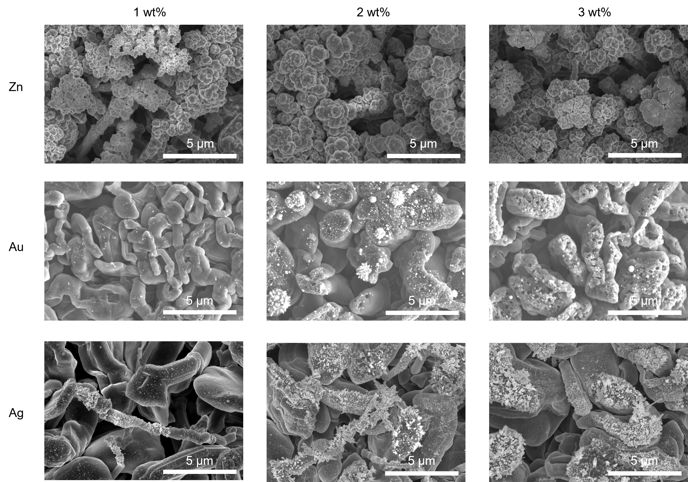
Supplementary Fig. 1 | Morphological evolution of lithium dendrites after treatment with different metal ions and ion concentrations. The surface morphologies were characterized by SEM.
To elucidate how reactions between metal ions and lithium dendrites regulate dendrite morphology, metal salt solutions with different concentrations were prepared, including Zn(TFSI)₂ in 1,2-dimethoxyethane (DME), AuCl₃ in DME, and AgCl in diethyl ether, each at concentrations of 1, 2, and 3 wt%. Comparative analysis of the reaction products and resulting morphologies showed that Zn²⁺ treatment generated a relatively uniform and dense surface structure on lithium. In contrast, Au³⁺ and Ag⁺ treatments produced locally aggregated deposits and induced progressively more severe corrosion of the lithium substrate at higher concentrations, resulting in pronounced pore formation. These results highlight the ion-specific effects of metal ion-lithium reactions in regulating dendrite surface reconstruction and defect evolution.

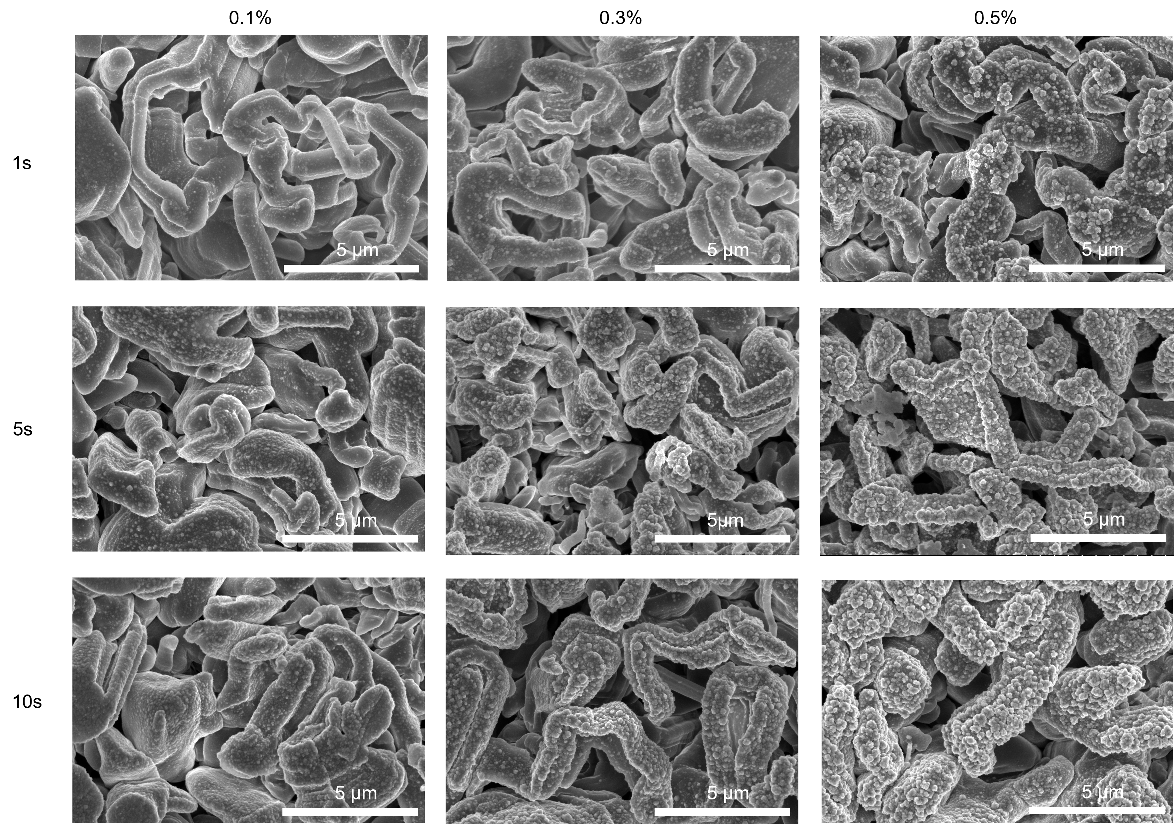
Supplementary Fig. 2 | Optimization of Zn²⁺ staining conditions for lithium dendrites.
To identify reaction parameters that enable uniform and dense surface modification while preserving the native morphology of lithium dendrites, Zn(TFSI)₂ solutions in DME with concentrations of 0.1, 0.3, and 0.5 wt% were evaluated at immersion times of 1, 5, and 10 s. SEM analysis revealed that treatment with a 0.1 wt% solution for 10 s yielded the most uniform surface modification, producing a conformal interfacial layer while maintaining the original dendritic architecture. This concentration-time combination was therefore selected as the standard condition for all subsequent experiments.

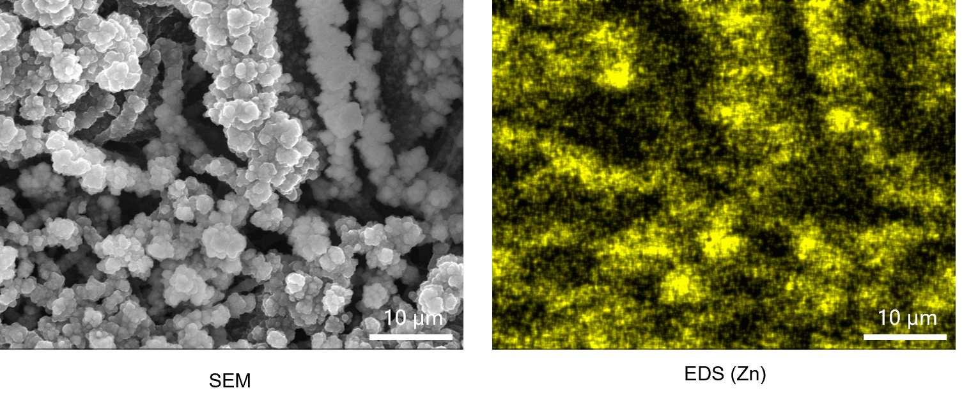
Supplementary Fig. 3 | SEM and EDS characterization of Zn²⁺-stained lithium dendrites.
SEM imaging showed that the dendritic morphology was preserved after Zn²⁺ staining, while EDS mapping confirmed the uniform distribution of Zn on the dendrite surface, indicating successful conformal surface modification

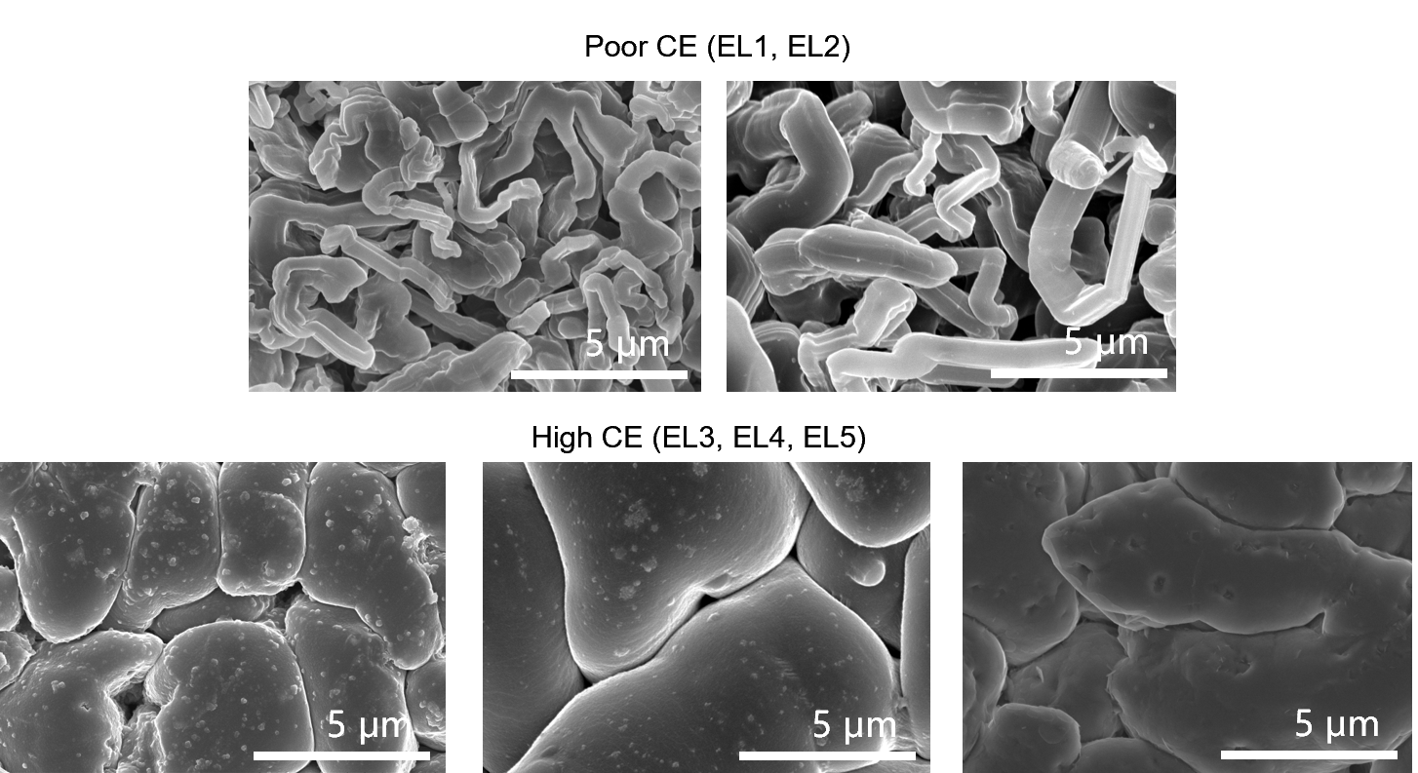
Supplementary Fig. 4 | Electrolyte-dependent lithium deposition morphologies.
SEM images (10,000× magnification) of lithium deposits formed in different electrolytes showed that EL1 and EL2 produced dendritic lithium structures, whereas EL3–EL5 generated predominantly granular and planar deposits with suppressed dendrite formation, highlighting the strong influence of electrolyte chemistry on lithium growth behavior.

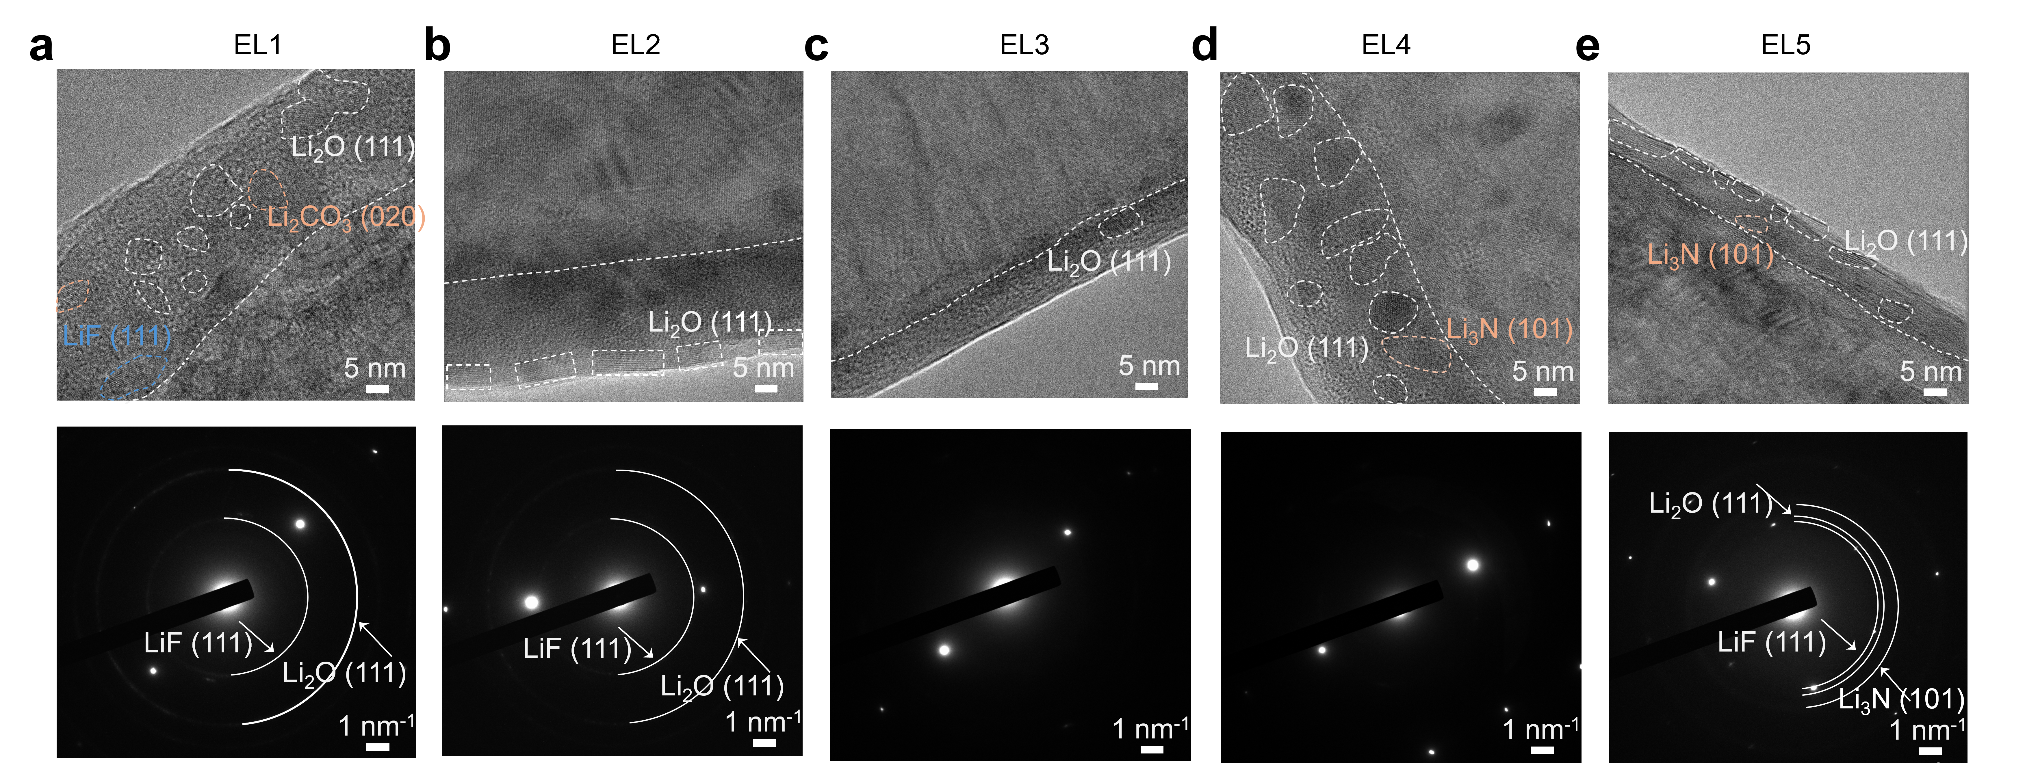
Supplementary Fig. 5 | Cryo-TEM characterization of SEI structures formed in different electrolytes (EL1–EL5).
SEI layers formed on Li⁰ deposits plated onto Cu TEM grids (0.88 mA cm⁻², 0.35 mAh cm⁻²) were analyzed by cryo-TEM and electron diffraction.
Cryo-TEM characterization reveals pronounced electrolyte-dependent variations in SEI thickness, composition, and microstructure. In the baseline carbonate electrolyte (EL1), the SEI is relatively thick and heterogeneous, containing irregularly distributed inorganic nanocrystals embedded within an amorphous matrix. Lattice fringes corresponding to LiF, Li₂CO₃, and Li₂O can be identified, indicating the coexistence of multiple inorganic decomposition products and a mosaic-like interphase structure. With the introduction of FEC (EL2), the SEI becomes more uniform and develops a distinct bilayer morphology. The outer region contains finely distributed crystalline Li₂O domains, while electron diffraction confirms the coexistence of LiF and Li₂O phases. Compared with EL1, the interphase exhibits improved structural uniformity, although crystalline inorganic domains remain clearly observable. In contrast, EL3 forms a substantially thinner and more homogeneous SEI with no obvious aggregation of crystalline inorganic nanoparticles. The predominantly amorphous morphology suggests a different interfacial passivation pathway from those observed in the carbonate-based electrolytes. For the ether-based electrolyte containing LiNO₃ (EL4), the SEI remains relatively thick but is characterized by a high density of uniformly distributed nanocrystalline Li₂O and Li₃N domains. Despite its larger thickness, the inorganic phases are more evenly dispersed throughout the interphase, resulting in a structurally continuous SEI. By comparison, the high-concentration LiFSI electrolyte (EL5) produces the thinnest and most compact interphase, consisting of finely dispersed Li₂O/Li₃N nanocrystals embedded within a highly uniform matrix. The absence of large crystalline aggregates and the reduced SEI thickness indicate effective suppression of interphase growth while maintaining interfacial homogeneity.

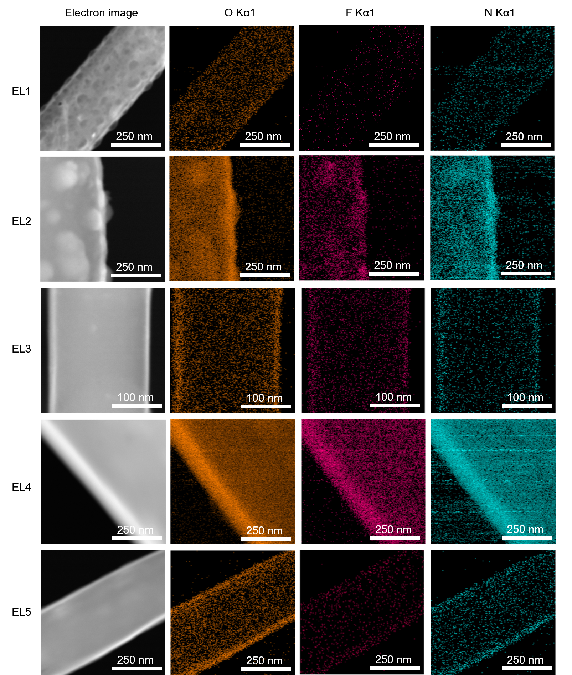
Supplementary Fig. 6 | Cryo-TEM images and corresponding EDS elemental mappings of O, F, and N for SEI layers formed in different electrolytes.
Elemental mapping further reveals pronounced electrolyte-dependent differences in SEI composition and spatial distribution. EL1 exhibits relatively weak and heterogeneous fluorine signals, consistent with the absence of FEC and the non-uniform distribution of inorganic species observed by cryo-TEM. In contrast, EL2 shows strong fluorine enrichment within the interphase, indicating extensive incorporation of fluorinated decomposition products derived from FEC. Notably, EL4 exhibits a continuous interphase enriched in O-, F-, and N-containing species. The uniform distribution of these elements throughout the SEI is consistent with the densely dispersed inorganic nanodomains observed by cryo-TEM, suggesting the formation of a chemically homogeneous and structurally continuous interphase. Despite its larger thickness relative to EL2, the SEI in EL4 remains compact and uniform, which may contribute to improved interfacial stability and more homogeneous lithium stripping. Compared with EL4, EL5 forms a thinner interphase while maintaining a similarly uniform distribution of O-, F-, and N-containing species. The combination of reduced thickness and high compositional homogeneity is consistent with the superior reversibility and minimal isolated-lithium formation observed in this electrolyte system.
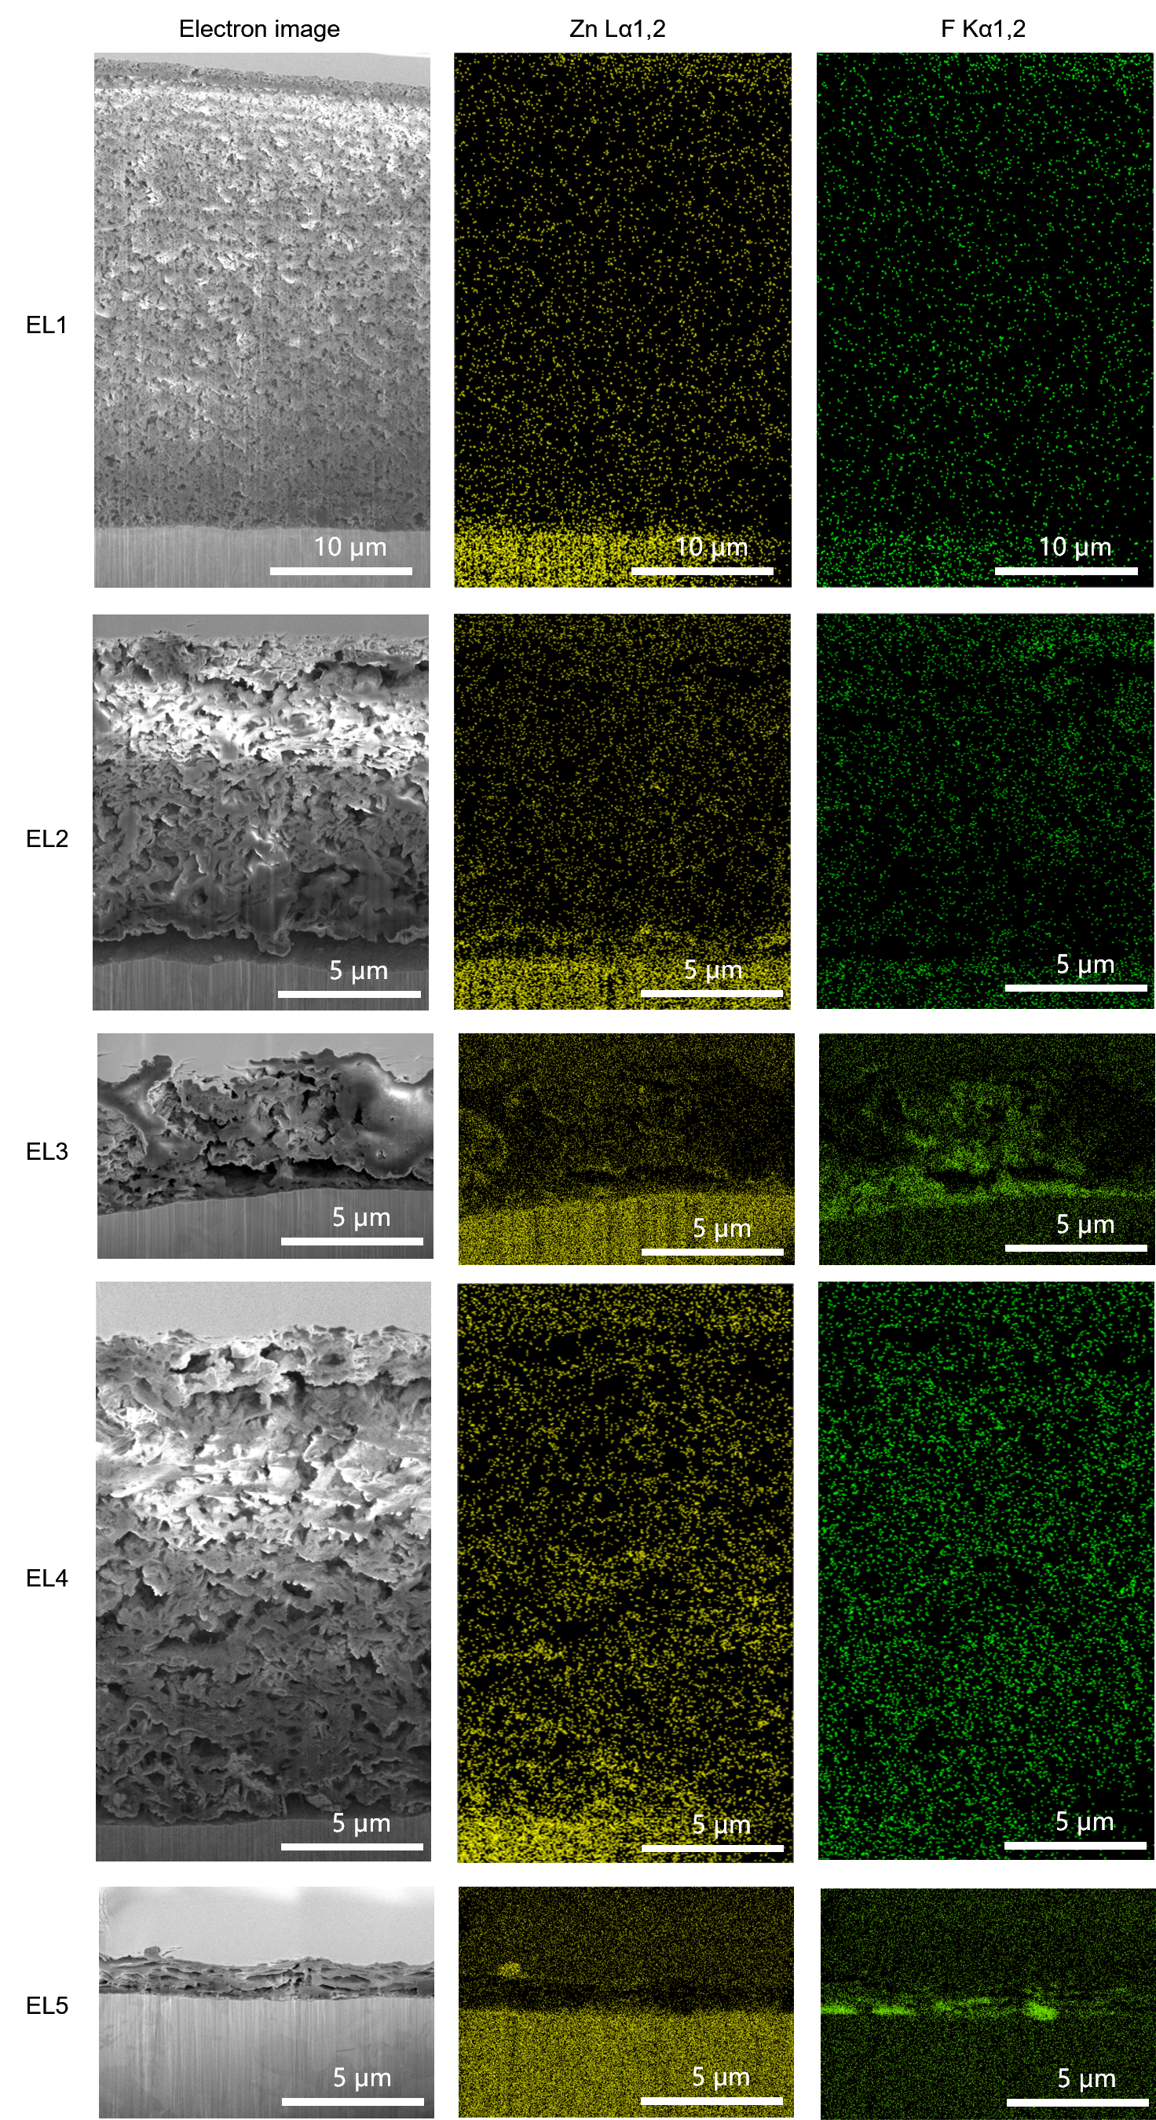
Supplementary Fig. 7 | FIB-SEM cross-sectional microstructures and EDS elemental mappings of residual lithium in different electrolytes.
Residual lithium deposits formed at 0.88 mA cm⁻² for 35 cycles were examined. Cross-sectional images revealed distinct morphologies, while EDS mapping showed the spatial distribution of Zn (yellow) and F (green), providing insight into metal-staining products and electrolyte-derived species.
Supplementary Fig. 8 | TGC calibration of hydrogen evolution versus lithium mass.
A linear calibration curve correlating the amount of electrically isolated Li⁰ (m_{Li}) with the detected H₂ peak area was established, yielding a slope of 5.84767. This curve enables quantitative determination of lithium content from measured hydrogen evolution.

