SUPPLEMENTAL INFORMATION
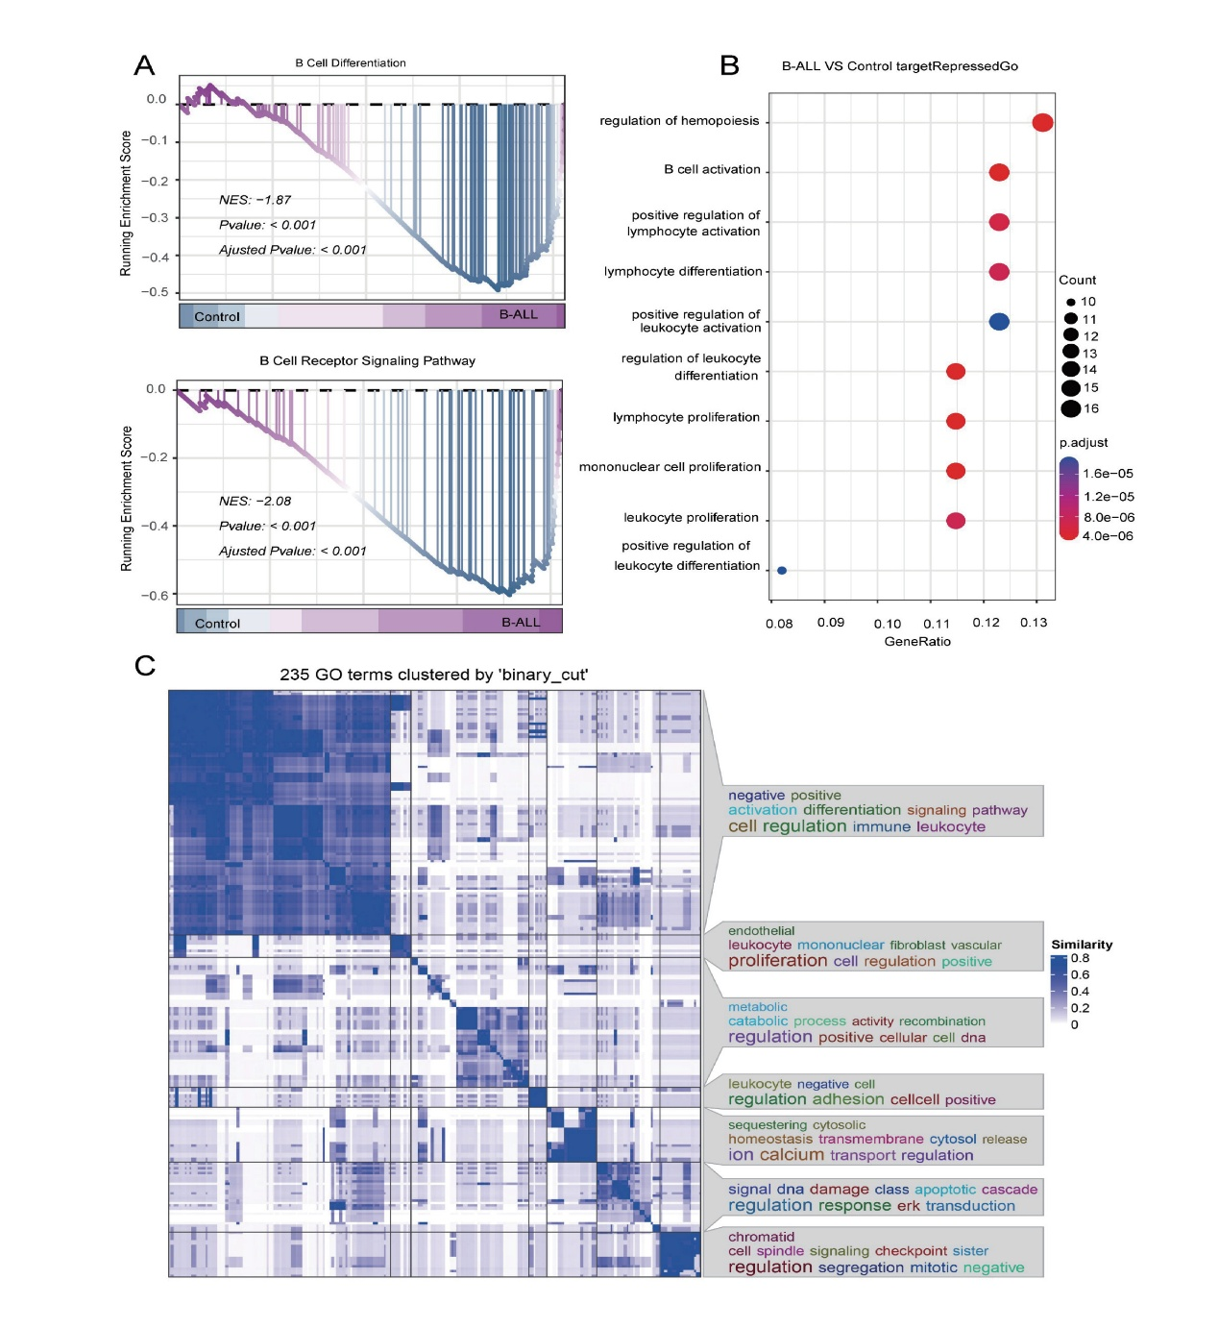
Supplemental Figure 1. Analysis of B-cell differentiation in acute lymphoblastic leukemia. (A) Gene set enrichment analysis (GSEA) of B-cell differentiation. (B) Gene Ontology (GO) analysis of B-cell differentiation. (C) Semantic similarity analysis of 235 significantly enriched terms. Related to Figure 1.

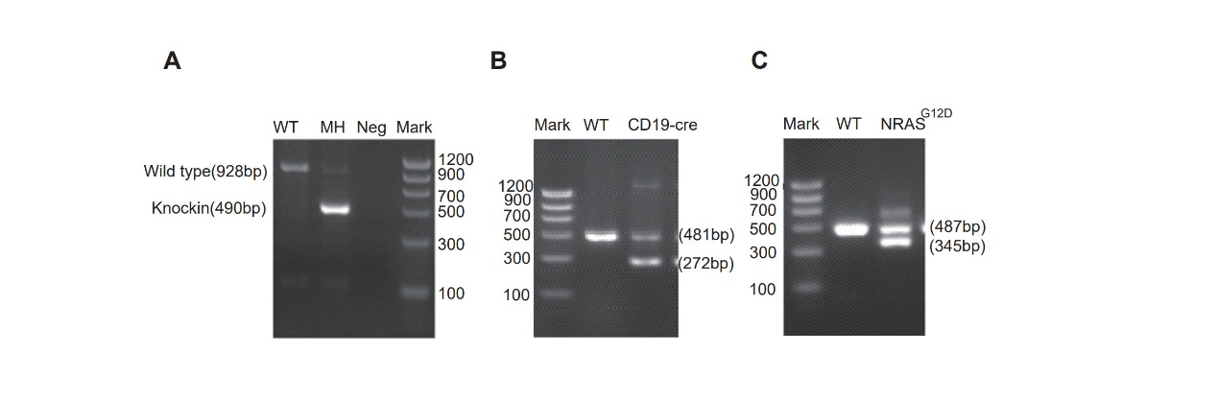
Supplemental Figure 2. Genotype Identification of MH/Cd19/NRAS^{G12D}. (A) Representative PCR gel image for MH genotyping. (B) Representative PCR gel image for Cd19-Cre genotyping. (C) Representative PCR gel image for Nras^{G12D} genotyping. Related to Figure 5.

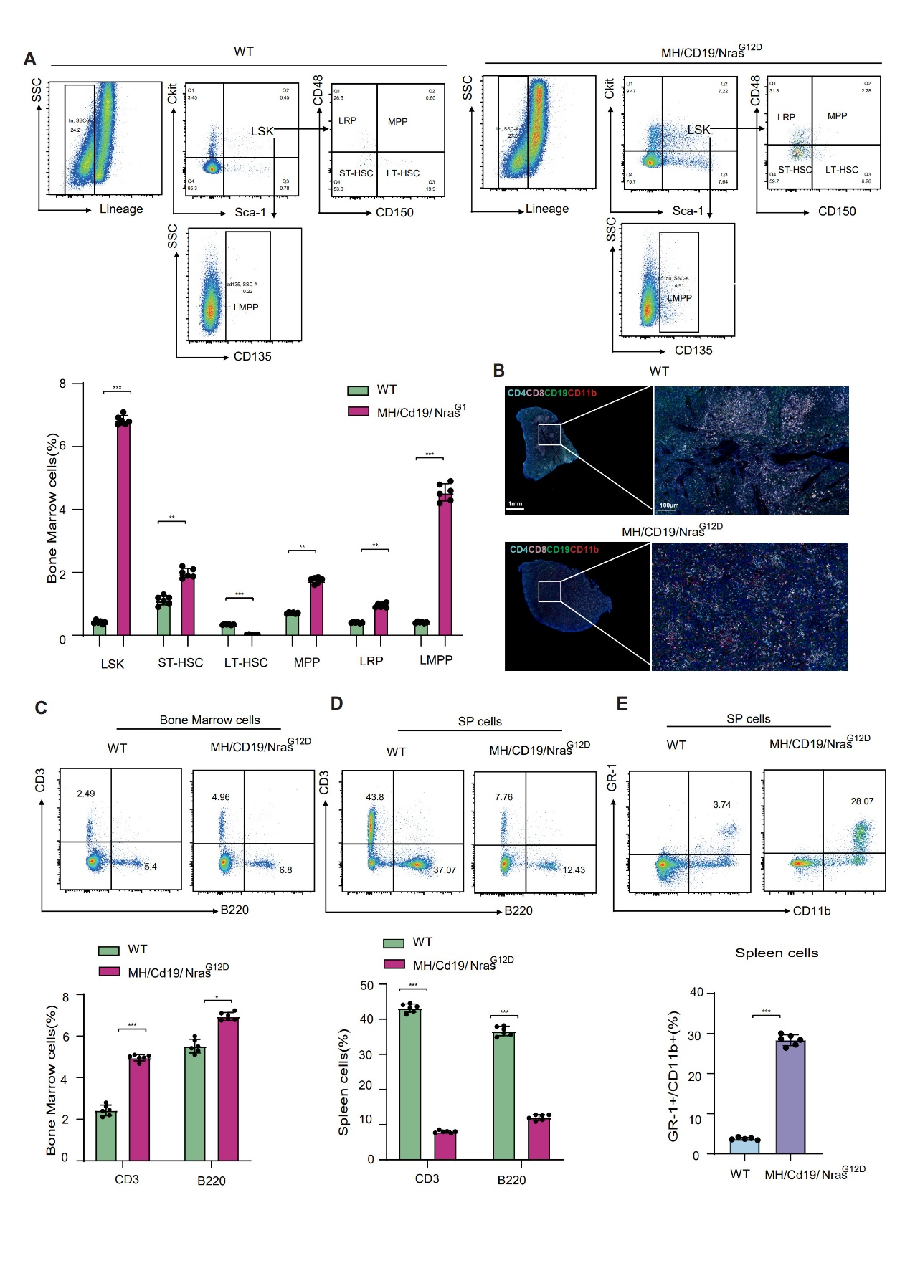
Supplemental Figure 3. Pathological changes in the bone marrow and spleen of MH/Cd19/NRAS^{G12D} mice. (A) Proportions of LSK hematopoietic stem and progenitor cells (Lin⁻Sca-1⁺c-Kit⁺) in the bone marrow of MH/Cd19/NRAS^{G12D} and WT mice, including hematopoietic stem cells (HSCs), long-term HSCs (LT-HSCs), short-term HSCs (ST-HSCs), multipotent progenitors (MPPs), lymphoid-primed progenitors (LRPs), and lymphoid-primed multipotent progenitors (LMPPs). (B) Multiplex immunofluorescence staining of spleen sections showing CD4 (blue), CD8 (pink), CD19 (green), and CD11b (red). (C) Flow cytometric analysis of CD3 and B220 in mouse bone marrow. (D) Flow cytometric analysis of CD3 and B220 in mouse spleen. (E) Flow cytometric analysis of GR-1 and CD11b in mouse spleen. The data were presented as mean ± standard deviation (SD) from n ≥ 5 mice per group. *, P < 0.05. **, P < 0.01. ***, P < 0.001. Related to Figure 5.

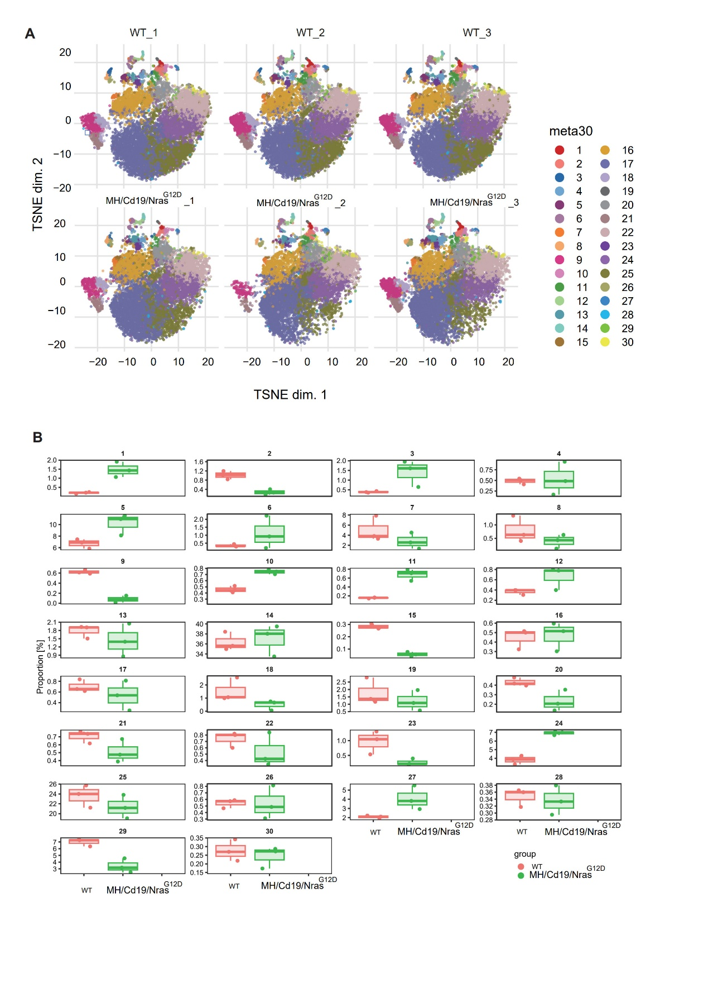
Supplemental Figure 4. Unsupervised clustering of bone marrow cells by mass cytometry (CyTOF). (A) t-SNE visualization of cell clusters in the bone marrow of MH/Cd19/NRAS^{G12D} and WT mice. (B) Boxplots showing the relative abundance of cell clusters in the bone marrow of MH/Cd19/NRAS^{G12D} and WT mice. Related to Figure 6.

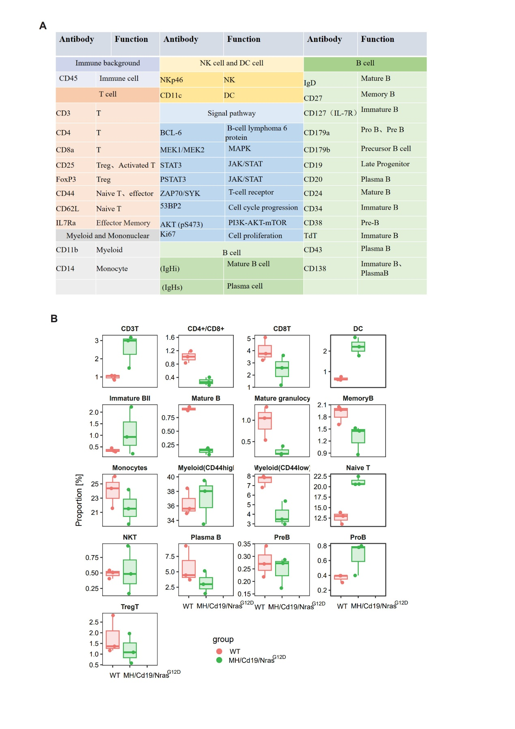
Supplemental Figure 5. Annotation of CyTOF-defined cell subsets based on marker expression. (A) Marker panel used for cell subset annotation. (B) Boxplots showing the relative abundance of annotated cell subsets in the bone marrow of MH/Cd19/NRAS^{G12D} and WT mice. Related to Figure 6.

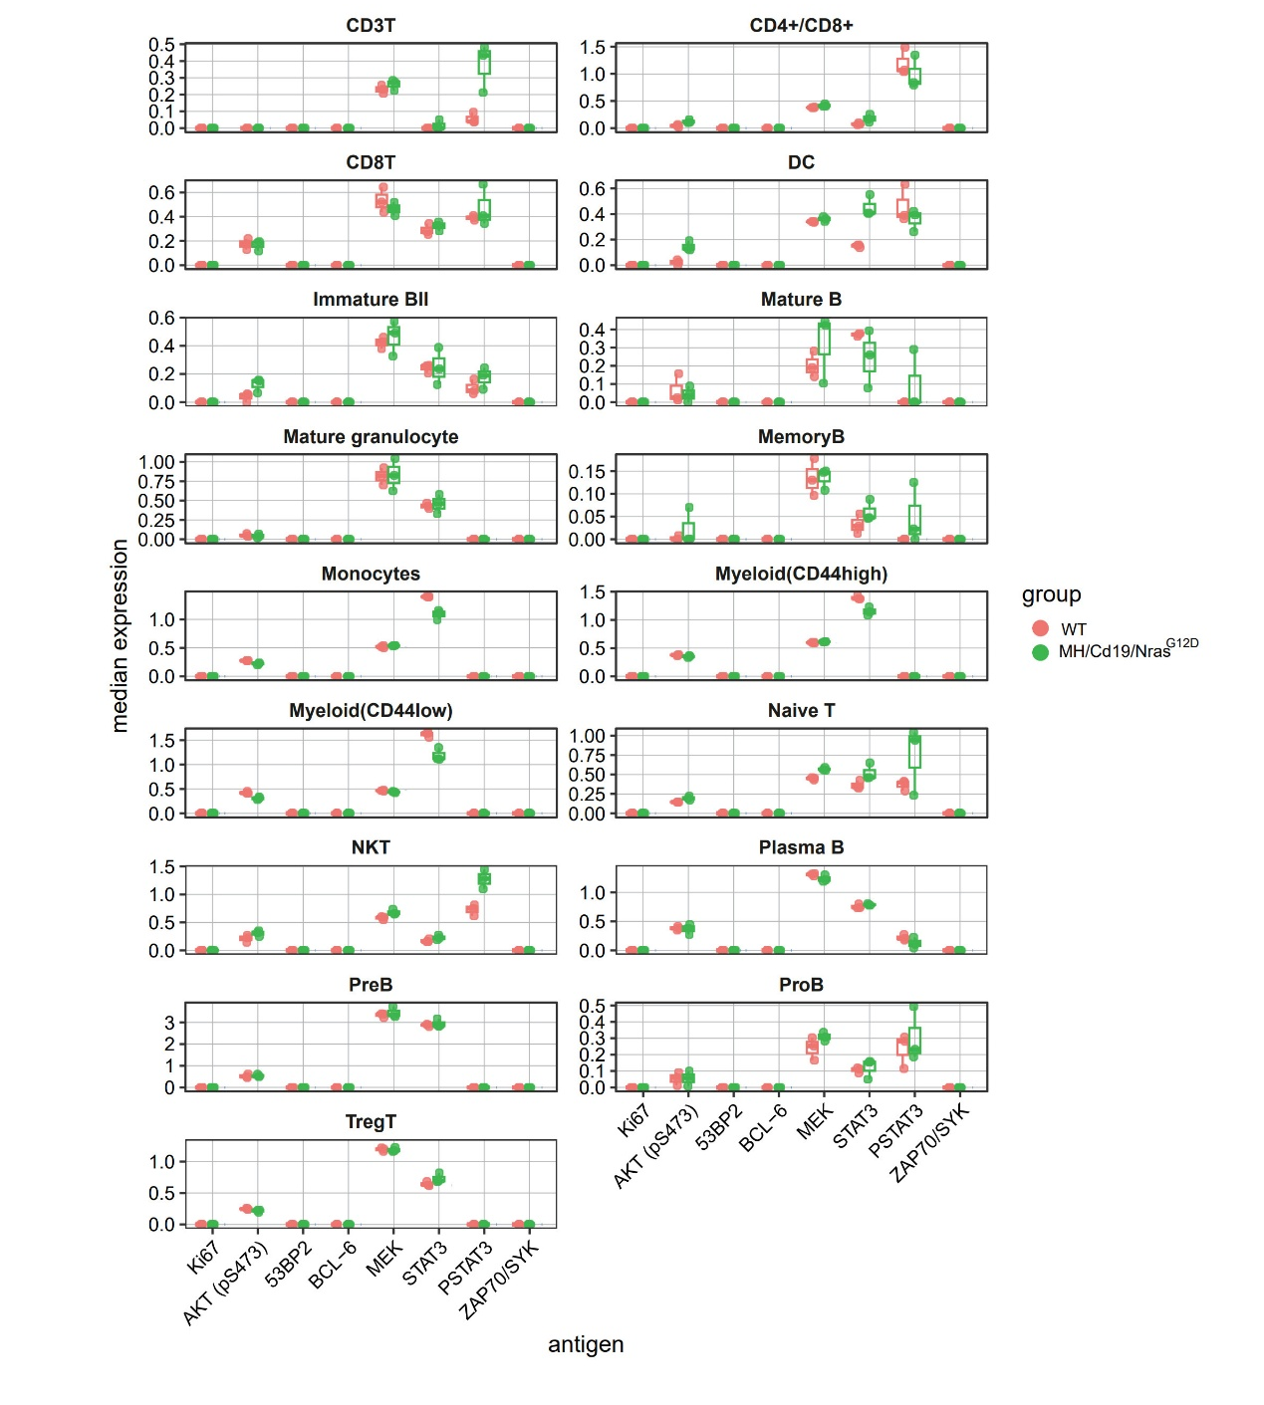
Supplemental Figure 6. Pathway analysis of annotated CyTOF-defined cell subsets. Related to Figure 6.

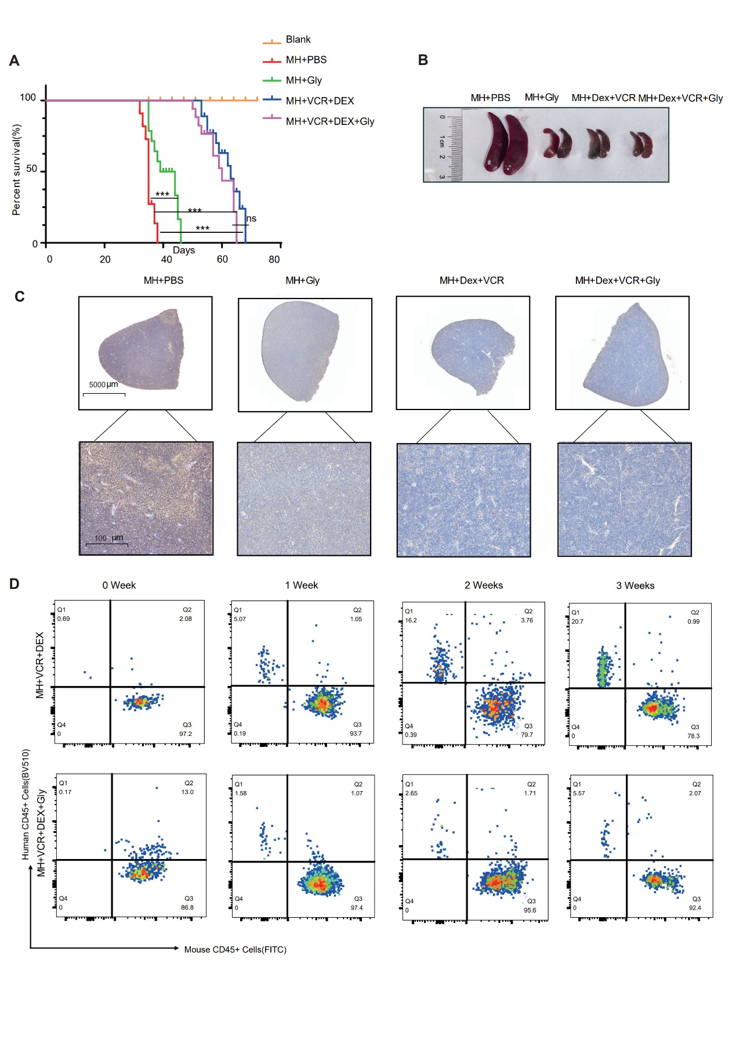
Supplemental Figure 7. Combination therapy in a human MH patient-derived xenograft (PDX) model. (A-B) Survival curves of treated mice and corresponding representative images of spleen morphology. (C) Immunohistochemical analysis of human CD45 expression in the spleen. (D) Flow cytometric analysis of human and mouse CD45 expression in peripheral blood after treatment withdrawal. The data were presented as mean ± standard deviation (SD) from n ≥ 5 mice per group. *, P < 0.05. **, P < 0.01. ***, P < 0.001. Related to Figure 7.

