SUPPLEMENTARY TABLE 1. Treatment efficacy comparison in recurrent patients (N=13 )
 | n | Average survival time after recurrence, months
Surgery | 1 | 12
SRS + Target therapy | 1 | 12
Target therapy | 2 | 11.5±7.8
SRS | 4 | 27±25.4
No treatment | 5 | 6±4.2

SUPPLEMENTARY TABLE 2. Characteristics of patients with cranial metastases of ATC or MTC (N = 5)
Patient | Age, sex | Histology | Location | Single or multiple | Therapy | Status | Survival time
1 (2017) | 54, M | MTC | Right temporal lobe and basal ganglia | Multiple | Surgery, SRS | Dead | 10
2 (2019) | 75, F | MTC | Right temporal lobe | Single | SRS | Dead | 20
3 (2019) | 81, M | MTC | Left occipital and parietal lobe | Multiple | SRS | Dead | 12
4 (2020) | 72, M | ATC | Bilateral frontal lobe | Multiple | Surgery | Dead | 3
5 (2020) | 63, F | ATC | Right frontal and temporal lobe | Multiple | Surgery, TT | Dead | 15
Abbreviations: MTC, medullary thyroid cancer; ATC, anaplastic thyroid cancer

SUPPLEMENTARY TABLE 3. Survival and recurrence comparisons in DTC patients with isolated skull metastasis, non-isolated skull metastasis, and brain metastasis
 | n | Ki67 index > 10% | Average survival time | Average recurrence time
Isolated Skull Metastasis | 4 | 0 | 99.8±53.6 | 84.2±59.3
Non-isolated skull Metastasis | 5 | 3 | 16.2±6.8 | 13.8±9.2
Brain metastasis | 23 | 9 | 34.6±23.4 | 29.8±19.4

SUPPLEMENTARY TABLE 4. Radiological characteristics of intracranial thyroid metastases
Pre-operative diagnosis | n | Radiologic characteristic | Average survival time
Glioma/Malignant tumor | 17 | enhancement after contrast, high Cho/NAA ratio | 23.5±19.1
Meningioma/Benign tumor | 7 | low T1, enhancement after contrast | 48.3±28.5
Hemangioma Cavernosum | 3 | high density on CT, low and uneven signal on T2 | 34±13.1
Hemangioblastoma | 1 | enhanced solid nodules after contrast | 16
Skull Neoplasms | 9 | bone destruction on CT, enhancement after contrast | 53.4±55

SUPPLEMENTARY FIGURE 1. Kaplan-Meier survival curves were compared across three groups: Isolated skull metastasis, non-isolated skull metastasis, and brain metastasis.
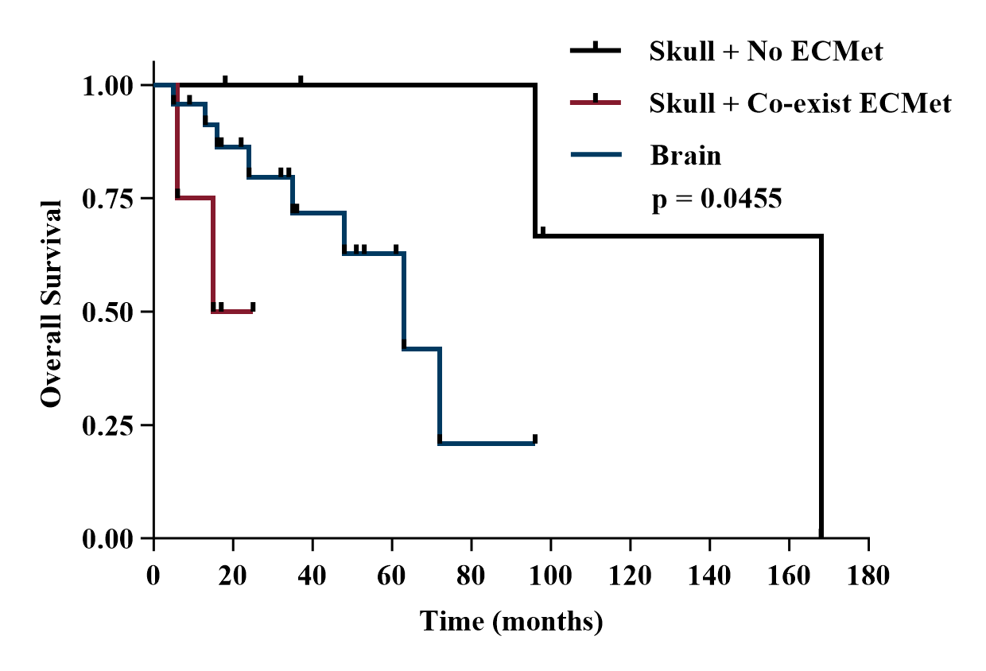
SUPPLEMENTARY FIGURE 2. Comparison of survival between treated and untreated recurrent patients
SUPPLEMENTARY FIGURE 3. Comparison of recurrence rates after different treatments in 32 DTC patients
