Figure S1 Line plot showed the standard read counts of MAGs obtained directly from the third-generation samples. The y-coordinate is standard read count, and the x-coordinate is the MAGs ordered by the standard read count from largest to smallest in all third-generation samples.

Figure S2 The schematic diagram showed the summary of different carbon and nitrogen sources composition.

Figure S3 Barplot showed the relative abundance of gut microbes under different carbon and nitrogen source at class level.

Figure S4 The presence or absence of core genes or enzyme that can metabolize formaldehyde. The novel species were colored with red font.

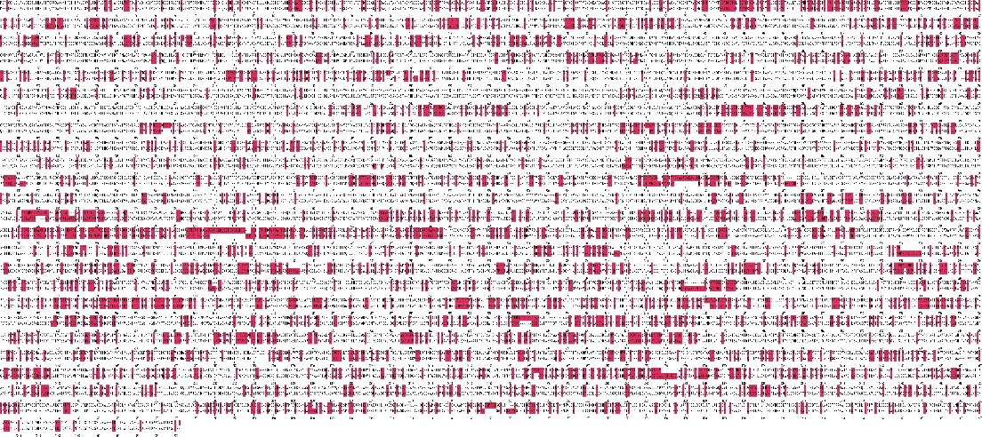
Figure S5 The plot showed the different pairwise sites of 40 COG genes between MAG-sp.nov.364_1 and Sphingomicrobium lutaoense. The red represented different sites.

Figure S6 The heatmap of the reference genomes from Sphingomicrobium genus based on ANI distance matrix. The unweighted pair-group method with arithmetic means (UPGMA) was used to cluster the similar genomes.

