Flexible hydrogel fiber-coupled SERS sensor for remote in situ food inspection
Chen Shi ^{1,#}, Fengjun Tian ^{1,#}, Xinghua Yang ^{1,*}, Li Li ^{2,*}, Nikolay V. Petrov ^{2,3,*}, Pingping Teng ¹, Jun Yang ⁴, Jianzhong Zhang ¹, Yang Zhang ¹, Jinhui Shi ¹, Adam Jones ⁵, Kang Li ⁵, Xiaoyu Li ¹, Rui Wang ¹, Nan Lu ¹, Libo Yuan ⁶
- Key Laboratory of In-Fiber Integrated Optics, Ministry of Education, Harbin Engineering University, Harbin 150001, Heilongjiang, China.
- School of Physics, Harbin Institute of Technology, Harbin 150001, Heilongjiang, China.
- ITMO University, St. Petersburg 191002, Russia.
- School of Information Engineering, Guangdong University of Technology, Guangzhou 510006, Guangdong, China.
- Faculty of Computing, Engineering & Science, University of South Wales, Pontypridd CF37 1DL, United Kingdom.
- Photonics Research Center, Guilin University of Electronic Technology, Guilin 541004, Guangxi, China.

- Materials and Reagents
Silver nitrate (AgNO₃, 99.8%), trisodium citrate (C₆H₅Na₃O₇, 98%), sodium hydroxide (NaOH, 98%), Rhodamine 6G (C₂₈H₃₁N₂O₃Cl, 95%), anhydrous ethanol (C₂H₅OH, 99.9%), sodium alginate (C₆H₇NaO₆, 99%), and thiram (C₆H₁₂N₂S₄, 97%) were purchased from Aladdin Biochemical Technology Co., Ltd. (Shanghai, China). Anhydrous calcium chloride (CaCl₂, 99.99%) was obtained from Macklin Biochemical Co., Ltd. (Shanghai, China). A graded-index multimode optical fiber (SI 60/125-22/250) was purchased from Changfei Optical Fiber and Cable Co., Ltd. Deionized water used for sample preparation was laboratory-made, with a resistivity of 18.25 MΩ·cm.
- Synthesis of Silver Sol
First, prepare 100 mL of a 0.3 mg/mL silver nitrate (AgNO₃) aqueous solution and place it in a three-necked flask. Prepare another 2 mL of a 10 mg/mL sodium citrate aqueous solution as a reducing agent. Place the flask containing the silver nitrate solution in a heating apparatus and heat it to boiling while continuously stirring. Then, using a syringe, slowly add about 0.3 mL of the sodium citrate solution to the boiling solution. After continuing to heat for 2 minutes, rapidly add the remaining sodium citrate solution all at once into the three-necked flask. Allow the reaction to continue under vigorous boiling for 8 minutes to ensure complete reduction of the silver nitrate. After the reaction, stop heating and maintain the reaction temperature using residual heat for 20 minutes. Finally, transfer the resulting gray-green silver sol to a beaker, place it immediately on a magnetic stirrer, and continue stirring to cool it rapidly and evenly to room temperature. Store the product in a brown bottle, keeping it away from light for future experiments.
- Pre-treatment of Optical Fiber
A graded-index multimode optical fiber (SI-60) with a core diameter of 60 μm and a cladding diameter of 125 μm is selected. First, remove the coating layer from both ends of the fiber for approximately 2 cm and perform a clean, flat cut on the bare fiber ends. Since the surface of the bare fiber is smooth, the adhesion of the hydrogel is poor, making it prone to detachment. In contrast, the coated surface is rougher and provides better adhesion, which enhances the bonding between the hydrogel and the fiber. Therefore, during the processing, leave about 1 mm of distance between the bare fiber end at the right side and the coating layer. Clean the fiber using deionized water and ethanol to remove any residual cladding on the bare fiber. Finally, perform ultrasonic cleaning on the fiber to remove contaminants from the surface of the coating layer.
4. Sensor Testing Device Platform
Based on the designed flexible hydrogel fiber-coupled optical fiber (HF-COF) sensor, a remote in-situ SERS sensing testing device platform was constructed, as shown in Fig. S8. The laser probe is held on the left fixture of the three-dimensional micro-motion stage, and the laser probe is connected to a 785 nm Raman spectrometer (Raman-Plus, B&W TEK Opto-Electronics, U.S.). The spectrometer is then connected to a computer for collecting and transmitting Raman signals for data processing (laser power: 150 mW, scan time: 5s, cycle: 1 time). The right fixture of the three-dimensional micro-motion stage holds the quartz fiber part of the HF-COF sensor, with the hydrogel fiber end extending to the object to be tested. The remote detection distance is determined by the fiber length, while in-situ detection is achieved by covering the hydrogel fiber on the object’s surface, directly detecting the substance to be tested. Adjust the knob of the three-dimensional micro-motion stage to ensure precise alignment between the laser probe and the center of the fiber. Also, adjust the distance between the two to focus the laser on the fiber core, thereby enhancing the transmission efficiency and detection accuracy of the laser.
5. Rsoft and FDTD simulations of the HF-COF Sensor
(1)Rsoft simulation
To study the light beam transmission in the HF-COF SERS sensor, the light transmission path in the hydrogel fiber region is simulated using Rsoft software. The core diameter of the SI-60 is set to 60 μm, and the cladding diameter is set to 125 μm, with core refractive indices of 1.4645 and 1.4613, respectively. The fiber optic front-end hydrogel fiber has a diameter of 125 μm, with a refractive index of 1.4825. The randomly distributed bubble pores have diameters ranging from 20 to 60 μm (Fig. S6) and a refractive index of 1. The light source is set to a Gaussian source.
(2)FDTD simulation
As shown in Fig. 2c, a model of randomly distributed AgNPs in three-dimensional space was generated. The diameter of the AgNPs is 80 nm, and the distance between adjacent AgNPs is approximately 10 nm (Fig. S7). The laser wavelength was set to 785 nm, with the fundamental mode input (E₀ = 1 V/m) propagating along the X direction. The optical fiber core diameter was 60 μm, and the simulation plane was arranged to be perpendicular to and tangential with the fiber core. The refractive indices of the core and cladding were 1.465 and 1.4613, respectively, while the refractive index of the hydrogel fiber was 1.4825. Monitors are set on the XY, XZ, and YZ planes to capture hotspots between the spatially distributed AgNPs.
6. Analysis of the Effect of Different SA Concentrations on the hydrogel fiber Morphology
The concentration of sodium alginate (SA) affects its viscosity. Therefore, controlling the amount of SA is crucial for the film formation quality of the hydrogel fiber. When the SA content is 0.8 g, the viscosity is relatively low, causing the SA@AgNPs to wrap unevenly on the fiber surface. This leads to a discontinuous bead-chain structure in the prepared hydrogel fiber, with discontinuous film layers and poor adhesion. When the SA content increases to 1.4 g, the viscosity becomes too high, reducing the fluidity of the solution, which results in localized aggregation and clumping during the coating process, causing uneven film thickness. Through a comprehensive comparison, it was found that when the SA content is controlled within the range of 1.0–1.2 g, the viscosity of SA@AgNPs is moderate, allowing for the formation of a continuous and uniform coating on the fiber surface, thereby achieving a hydrogel fiber structure with good repeatability.
7. Calculation of enhancement factor (EF) and Limit of Detection (LOD)
(1) EF calculation for R6G
The detailed calculation of the EF is as follows ¹:
EF = $\frac{{\text{I}}_{\text{SERS}}\text{×}{\text{N}}_{\text{bulk}}}{{\text{I}}_{\text{bulk}}\text{×}{\text{N}}_{\text{SERS}}}$ (1)
N_{SERS} denotes the number of R6G molecules within the SERS excitation volume on the flexible hydrogel fiber front-end substrate, while N_{bulk} represents the number of molecules within the laser-excited region when directly probing the bulk R6G solution. I_{SERS} and I_{bulk} are the Raman intensities at the 1363 cm⁻¹ characteristic band collected under 785nm excitation using the HF-COF sensor and by direct laser interrogation of the R6G solution, respectively.
The calculation process for N_{SERS} is as follows:
In the experiment, 10 μL (V₁) of R6G solution with a concentration of 10⁻¹¹ M (C₁) is deposited onto a fiber-like hydrogel fiber substrate with a diameter of 300 μm (d₁) and a length of 1 cm (l₁). The substrate volume is calculated as V_{sub}=(d₁/2)²×π×l₁. The laser spot diameter transmitted from the optical fiber tip to the flexible hydrogel fiber substrate is 60 μm (d₂), with a transmission depth of 0.8 cm (l₂), so the scanned volume is V_{scan}=(d₂/2)²×π×l₂. N_{A} (6.02 × 10²³/mol) is Avogadro's constant. The number of probe molecules within the laser-illuminated region is calculated using the following formula:
N_{SERS}$\text{=(}\frac{{\text{V}}_{\text{scan}}}{{\text{V}}_{\text{sub}}}\text{)×}{\text{V}}_{\text{1}}\text{×}{\text{C}}_{\text{1}}\text{×}{\text{N}}_{\text{A}}$ (2)
The calculation process of N_{bulk}:
In the reference Raman measurement, the laser can completely penetrate a 10⁻² M (C₂) solution of R6G. The laser head is equipped with an objective lens having a numerical aperture of 0.55 (NA) and a confocal depth of 1.4 μm (h) with a 50x magnification. The spot size (d) of the laser after being focused through this objective lens, with a 785 nm (λ) laser, is given by the formula d = 1.22λ/NA. The number of excited probe molecules under this condition is calculated by the following formula:
N _{bulk} =$\text{h×}\text{d}\text{×}{\text{C}}_{\text{2}}\text{×}{\text{N}}_{\text{A}}$ (3)
Based on the above parameters and formula, the EF of the SERS substrate can be systematically calculated.
EF=$\frac{{\text{I}}_{\text{SERS}}\text{×}{\text{N}}_{\text{bulk}}}{{\text{I}}_{\text{bulk}}\text{×}{\text{N}}_{\text{SERS}}}\text{=}\frac{\text{235.39× 2.44×}{\text{10}}^{\text{-2}}}{\text{ 542.84× }{\text{4×10}}^{\text{-12}}}\text{=}{\text{2.65×10}}^{\text{9}}$ (4)
(2) LOD calculation for R6G
To better characterize the performance of the HF-COF sensor under study, we used another parameter for measurement. The LOD is calculated as the sample blank value plus three standard deviations (s.d.), as shown below².
$\text{LOD}\left(\text{y}\right)\text{=mean of blank+3×s.d. of blank}$ (5)
The equation y=3678.57x+40699.87 obtained from the linear regression curve (Fig. 5b) and the LOD (y) is converted to LOD (-lg C_{R6G}). After calculation, the LOD (-lg C_{R6G}) is as low as 8.63 × 10⁻¹² M.
(3) LOD calculation for thiram
The equation y=2407.19lgx+6732.78 obtained from the linear regression curve (Fig. 6d) and the LOD (y) is converted to LOD (-lg C_{thiram}). After calculation, the LOD (-lg C_{thiram}) is as low as 1.6 × 10⁻³ mg/L.
8. Figures
Fig. S1 SERS spectra of RG solution (10⁻⁵ M) tested using HF-COF sensor and AgNPs substrate respectively.
Fig. S2 SERS spectra of R6G molecules with concentrations of 10⁻¹¹ M.
Fig. S3 Raman spectra of thiram powder testing and SERS overlay spectra of thiram with a sensing probe testing concentration of 20 mg/L.
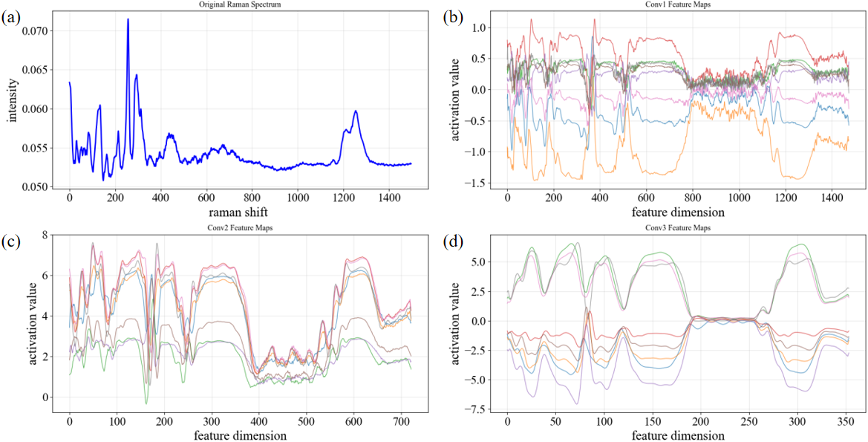
Fig. S4 One-dimensional convolutional neural network feature maps. a Original Raman spectral features. b First-layer convolutional feature map. c Second-layer convolutional feature map. d Third-layer convolutional feature map.
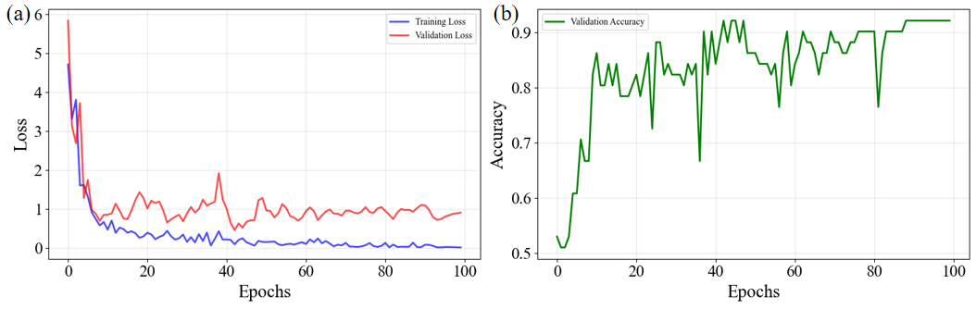
Fig. S5 a Training iteration curve. b Accuracy curve.
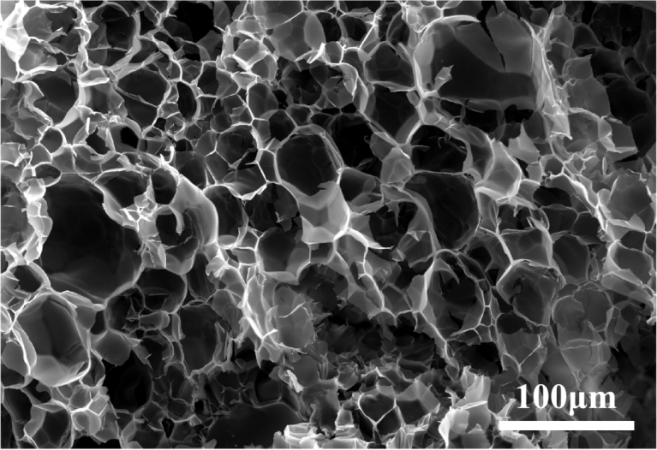
Fig. S6 SEM image of SA hydrogel.
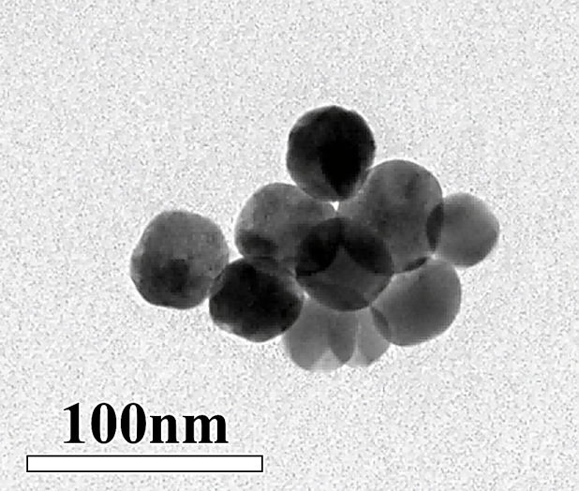
Fig. S7 TEM image of single-layer silver nanoparticles.
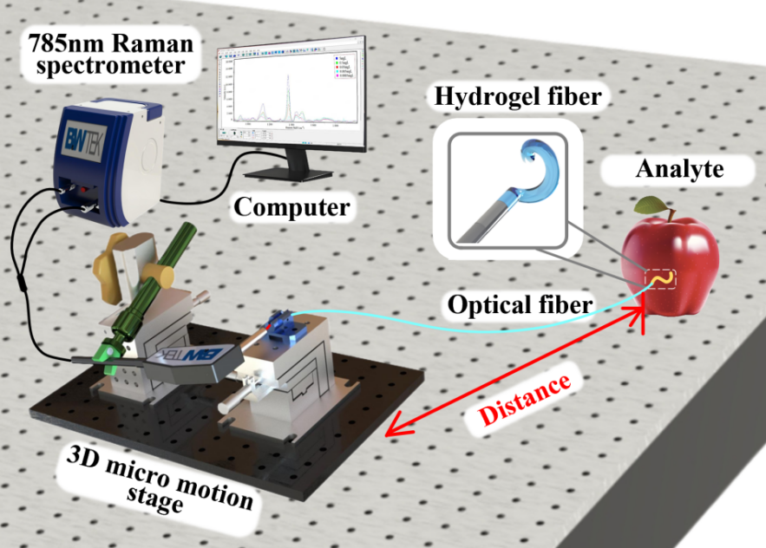
Fig. S8 Test Platform Construction.

9. Tables
Table. S1 1D-CNN Classification Result Report.
Concentration Level | Precision | Recall | F1-score
0 | 1.00 | 1.00 | 1.00
1 | 1.00 | 1.00 | 1.00
2 | 1.00 | 1.00 | 1.00
3 | 0.91 | 1.00 | 0.95
4 | 1.00 | 0.90 | 0.95

References
1. Li, J. et al. Three-dimensional flexible SERS substrate based on bacterial cellulose membrane for detection of glutathione in serum. Cellulose. 30, 5187-5200 (2023).
2. Liu, R. et al. Three-dimensional Ag NPs-cellulose fiber/polyacrylamide hydrogels as a novel SERS platform for the efficient determination of thiram in fruits and juice. Colloids and Surfaces A: Physicochemical and Engineering Aspects. 677 (2023).

