ADDITIONAL FILE 1
Retained methodological specification and aggregate exploratory machine-learning results
Associated manuscript: A wearable multi-task prefrontal functional near-infrared spectroscopy methodology for studying mild traumatic brain injury: a human-subject pilot implementation
Purpose. Part I consolidates technical details preserved in the retained manuscript and thesis documentation. Part II preserves the aggregate machine-learning results for transparency. This combined file does not reconstruct missing participant-level data, executable code, quality-control decisions, fold assignments, or the complete 864-column feature dictionary.

Part I. Retained methodological specification

Table M1. Wearable fNIRS system specification
Parameter | Retained specification
Modality | Continuous-wave fNIRS
Source module | Marubeni America L4*730/4*805/4*850-40Q96; 730 and 850 nm used
Reported optical output | Approximately 2-4 mW average output; retained document reports 7-V drive
Detector | Texas Instruments OPT101 monolithic photodetector with integrated operational amplifier; photosensitive area 2.29 × 2.29 mm²
Source-detector separation | 30 mm, fixed
Channels and locations | Four channels, approximately F7, Fp1, Fp2, and F8 (international 10-20 system)
Sampling rate | 17 Hz
Controller and data link | ESP32 microcontroller; Bluetooth transmission to laptop
Host software functions | Connection control, source-intensity adjustment, real-time signal display, task selection/control, and CSV storage with task timing
Headform | Padded modified commercial VR headset with adjustable rear dial and elastic straps; exact base model, dimensions, weight, and setup time not retained
Power | Mobile power supply through micro-USB, 5 V; retained documentation also identifies HW-183 boost and TLC5916 driver modules
Not retained | ADC resolution, absolute calibration protocol, quantitative coupling comparison, channel-yield criteria, artifact burden, and setup time

Figure M1. Retained wearable system layout
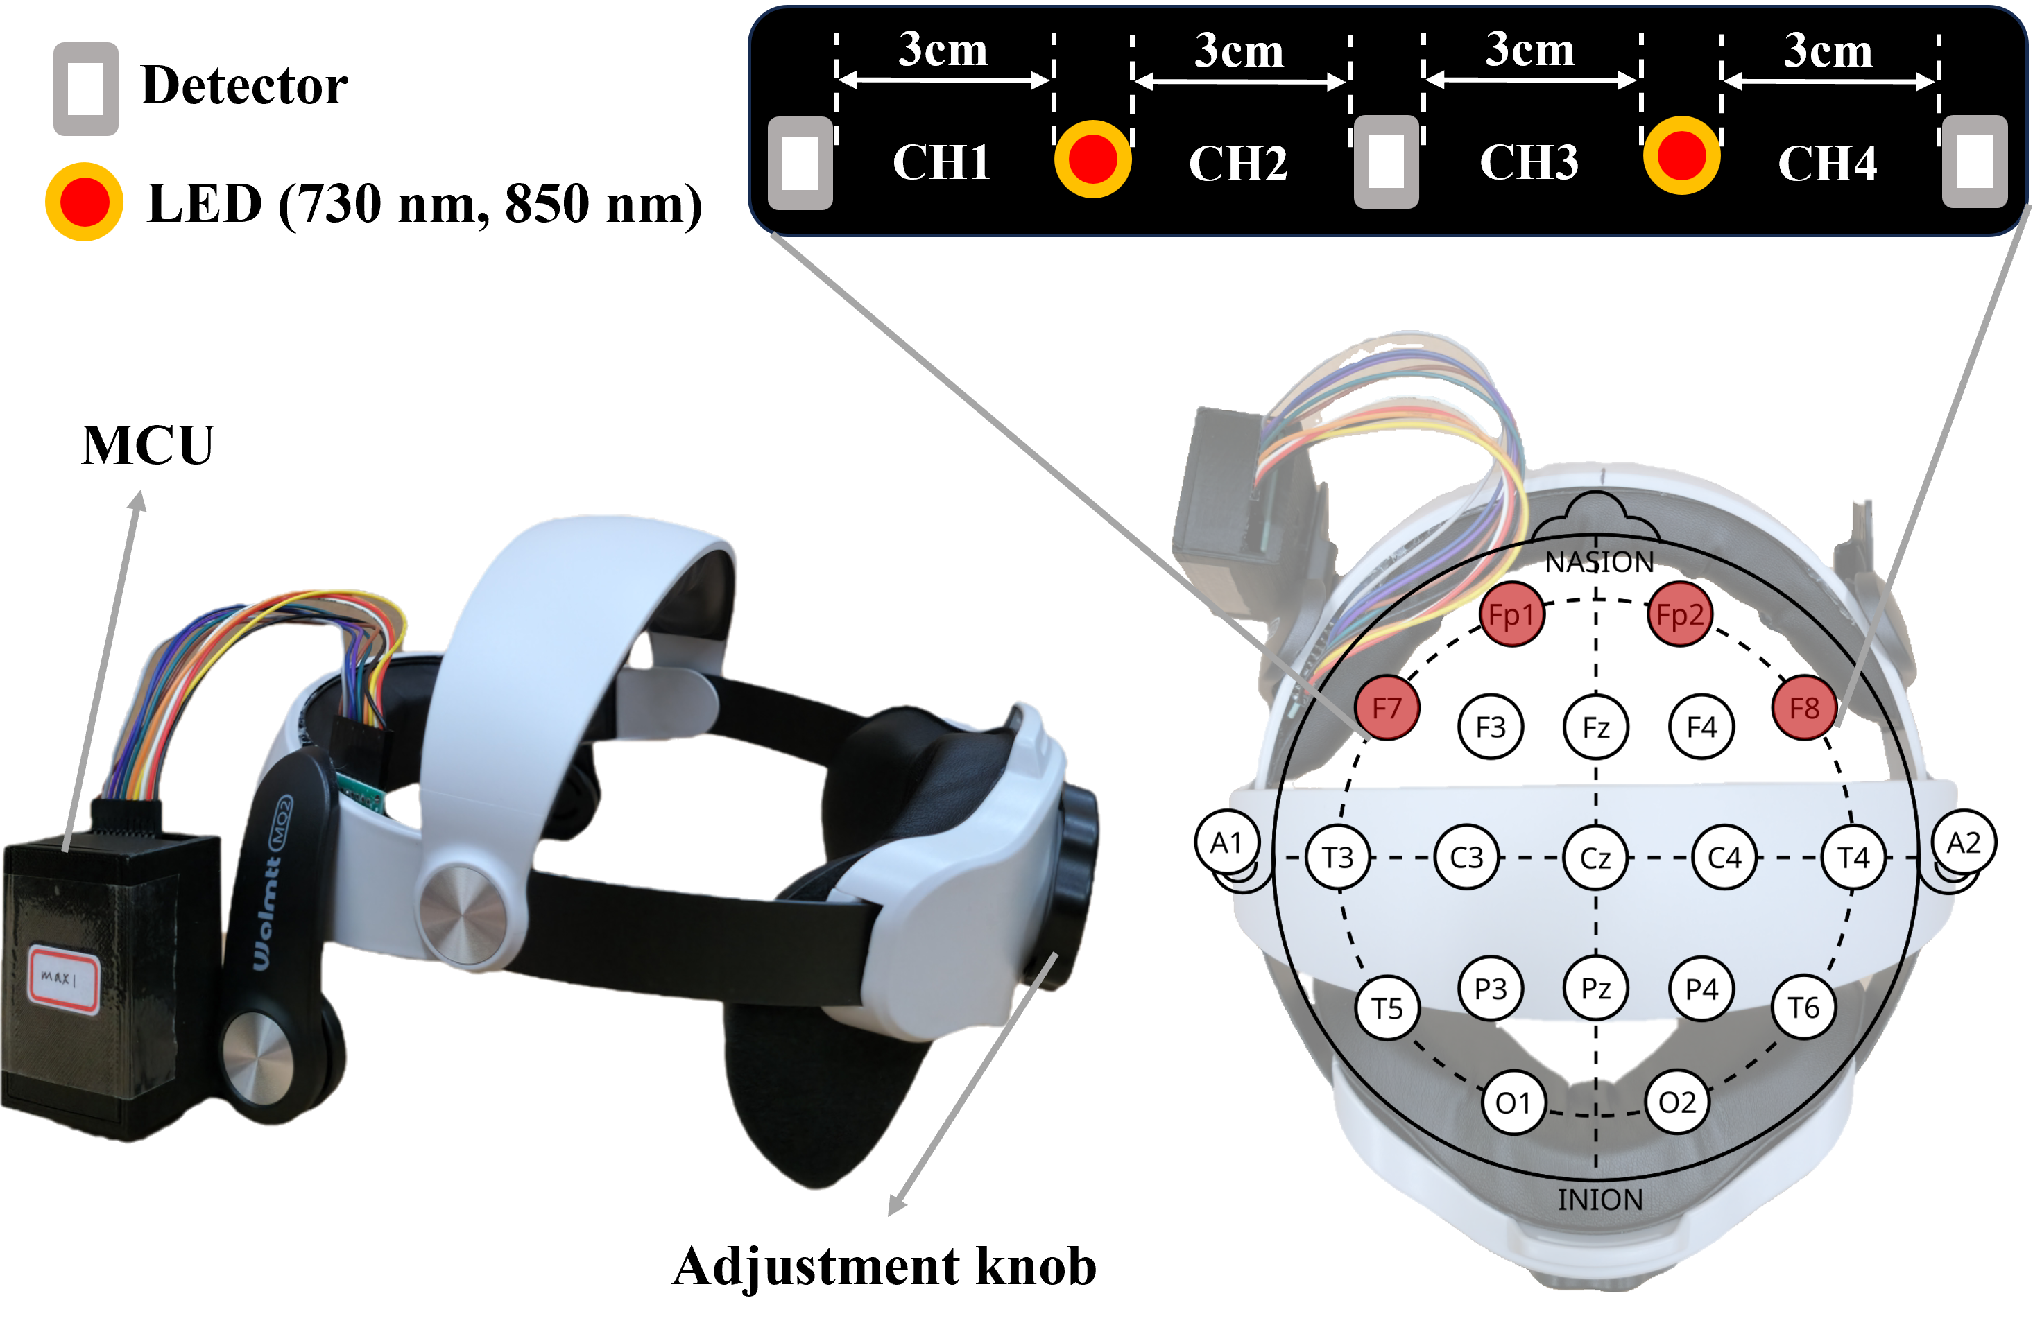
Retained engineering image showing the modified VR-headset structure, four 30-mm source-detector channels, and approximate prefrontal locations. The structure was designed to support fit and contact; no comparative artifact-reduction or signal-quality claim is made.

Table M2. Programmed four-task cognitive protocol
Task | Programmed timing | Stimulus and response details
VFT | 30-s eyes-closed rest; 60-s task; 70-s eyes-closed recovery (160 s) | Three 20-s overt phonetic-cue periods. One cue was selected from each of three retained Bopomofo phonetic pools. Participants generated as many words as possible; a 3-s auditory warning preceded the task.
CT | Five rounds × 60 s: 5-s eyes-open rest; 30-s task; 5-s reinforcement; 20-s eyes-closed recovery (300 s) | An airplane moved across the screen; its height was mapped to frontal ΔHbO2. A rise threshold of 0.25 μM above the resting mean caused ascent. Participants attempted to maintain the airplane in the upper third. A green circle or red cross provided reinforcement; a 3-s piano cue marked the end of recovery.
MAT | 30-s eyes-closed rest; 180-s task; 60-s eyes-closed recovery (270 s) | Three-digit ± two-digit multiple-choice arithmetic. Each item comprised 1-s display, 3-s thinking/countdown, 1-s left/right response, and immediate green-circle, red-cross, or question-mark feedback.
SSST | Six rounds × 50 s: 5-s fixation; 30-s task; 15-s eyes-closed recovery (300 s) | Participants clicked randomly positioned numbered targets in order. The first two rounds used 4 and 6 targets; the remaining four used 8. Correct selections produced an auditory cue; repeated or incorrect selections were logged. A 3-s piano cue marked the end of recovery.
Session total | 1030 s (approximately 17.2 min), excluding setup and transitions | Retained documentation describes the sequence VFT, CT, MAT, and SSST. Setup time, inter-task transition time, tolerability measures, and complete behavioral-performance data were not retained.

Table M3. Stage-aware processing and representation workflow
Step | Retained method | Reproducibility boundary
1 | Raw optical intensity → optical density | Exact software implementation not retained
2 | TDDR motion correction [1] applied to optical density | Quality-control thresholds and channel-rejection decisions not retained
3 | Modified Beer-Lambert law → ΔHbO2 and ΔHHb; 30-mm distance; DPF 6.0172 at 730 nm and 4.9399 at 850 nm | Extinction-coefficient table and exact code not retained
4 | Fourth-order Butterworth low-pass at 0.1 Hz using forward-backward zero-phase filtering | No separate high-pass filter is documented
5 | Baseline correction by subtracting the mean of the corresponding pre-task rest interval | Defined in retained documentation
6 | Min-max normalization: (x − xmin)/(xmax − xmin), with extrema described across the analysed time series | Exact participant/channel/task grouping used by the original software not retained
7 | Reconstructable vector-derived signals [2,3]: ΔCBV=(ΔHHb+ΔHbO2)/√2; ΔCOE=(ΔHHb−ΔHbO2)/√2; |L|=√[(ΔCOE)²+(ΔCBV)²]. The retained thesis also records Angle K=arctan(ΔCOE/ΔCBV). | Angle K cannot be fully reconstructed: the positive-ΔO reference-axis conversion, quadrant handling, phase assignment, and behavior at ΔCBV=0 were not preserved.
8 | Stage segmentation: rest, task, reinforcement where applicable, and recovery | Programmed timing retained in Table M2
9 | Documented feature families were applied to ΔHbO2, ΔHHb, ΔCBV, ΔCOE, |L|, and the legacy Angle K feature across four channels. | The original manuscript reports 864 candidates, but the Angle K implementation and a one-to-one 864-column map cannot be reconstructed.
10 | Secondary exploratory univariate screen and classifier evaluation | Participant-level data, executable pipeline, seeds, folds, grids, versions, and fully nested validation unavailable

Reproducibility statement
The retained records permit partial methodological reconstruction of the acquisition hardware, programmed task timing, principal signal-processing sequence, and the ΔCBV, ΔCOE, and |L| equations. They do not permit reconstruction of Angle K phase handling or computational reproduction of the participant-level machine-learning analysis. The feature count of 864 is preserved as an aggregate result and is not presented as a reconciled column-level dictionary.

References supporting the retained processing description
1. Fishburn FA, Ludlum RS, Vaidya CJ, Medvedev AV. Temporal derivative distribution repair (TDDR): a motion correction method for fNIRS. NeuroImage. 2019;184:171-179.
2. Oka N, Yoshino K, Yamamoto K, et al. Greater activity in the frontal cortex on left curves: a vector-based fNIRS study of left and right curve driving. PLoS One. 2015;10(5):e0127594.
3. Nazeer H, Naseer N, Khan RA, et al. Enhancing classification accuracy of fNIRS-BCI using features acquired from vector-based phase analysis. J Neural Eng. 2020;17(5):056025.

Part II. Retained aggregate exploratory machine-learning results
The following results are preserved from the original exploratory analysis. Feature and model selection was not fully nested, the holdout set contained only four participants, and participant-level scores were unavailable for reanalysis. These results do not establish model superiority, diagnostic validation, or incremental value beyond demographics.

Table S1. Task-wise retained descriptive performance
Task | Retained model | Train (%) | Validation (%) | Holdout (%)
VFT | SVM | 100 +/- 0 | 67 +/- 17 | 75
CT | SVM | 100 +/- 0 | 78 +/- 5 | 50
MAT | XGB | 90 +/- 5 | 67 +/- 8 | 75
SSST | MLP | 85 +/- 12 | 81 +/- 13 | 50
VFT, CT, MAT | KNN | 99 +/- 2 | 72 +/- 5 | 50
VFT, CT, MAT, SSST | MLP | 93 +/- 9 | 75 +/- 0 | 75
All holdout percentages are based on four participants. Model and task-combination selection was not nested within an independent evaluation framework. The retained record did not specify whether the “+/-” values represented standard deviation or another dispersion measure; they are reproduced descriptively as originally reported.

Table S2. Retained combined-task MLP internal-validation results
Fold | Accuracy (%) | Precision (%) | Recall (%) | F1-score (%) | AUC
1 | 75 | 83 | 75 | 73 | 0.75
2 | 75 | 76 | 75 | 75 | 0.69
3 | 75 | 83 | 75 | 73 | 0.81
Each fold contained 12 participants (6 control and 6 mTBI); 9/12 were correctly classified in each fold (exact 95% CI for accuracy, 42.8%-94.5%). Pooled out-of-fold accuracy was 27/36 (75%; exact 95% CI, 57.8%-87.9%). Precision, recall, and F1-score in Table S2 are macro-averaged across the two classes, as reconstructed from the retained confusion matrices.

Table S3. Retained aggregate combined-task MLP performance
Dataset | Accuracy (%) | Precision (%) | Recall (%) | F1-score (%)
Train | 93 +/- 9 | 93 +/- 8 | 93 +/- 9 | 93 +/- 9
Validation | 75 +/- 0 | 75 +/- 0 | 75 +/- 0 | 74 +/- 1
4-participant holdout | 75 | Not reconstructable | Not reconstructable | Not reconstructable
The holdout accuracy was 3/4 (75%; exact 95% CI, 19.4%-99.4%). Holdout precision, recall, and F1-score could not be reconstructed and are therefore not reported. For the train and validation rows, the retained record did not specify whether the “+/-” values represented standard deviation or another dispersion measure; they are reproduced descriptively as originally reported.

Figure S1. Retained fold-level confusion matrices
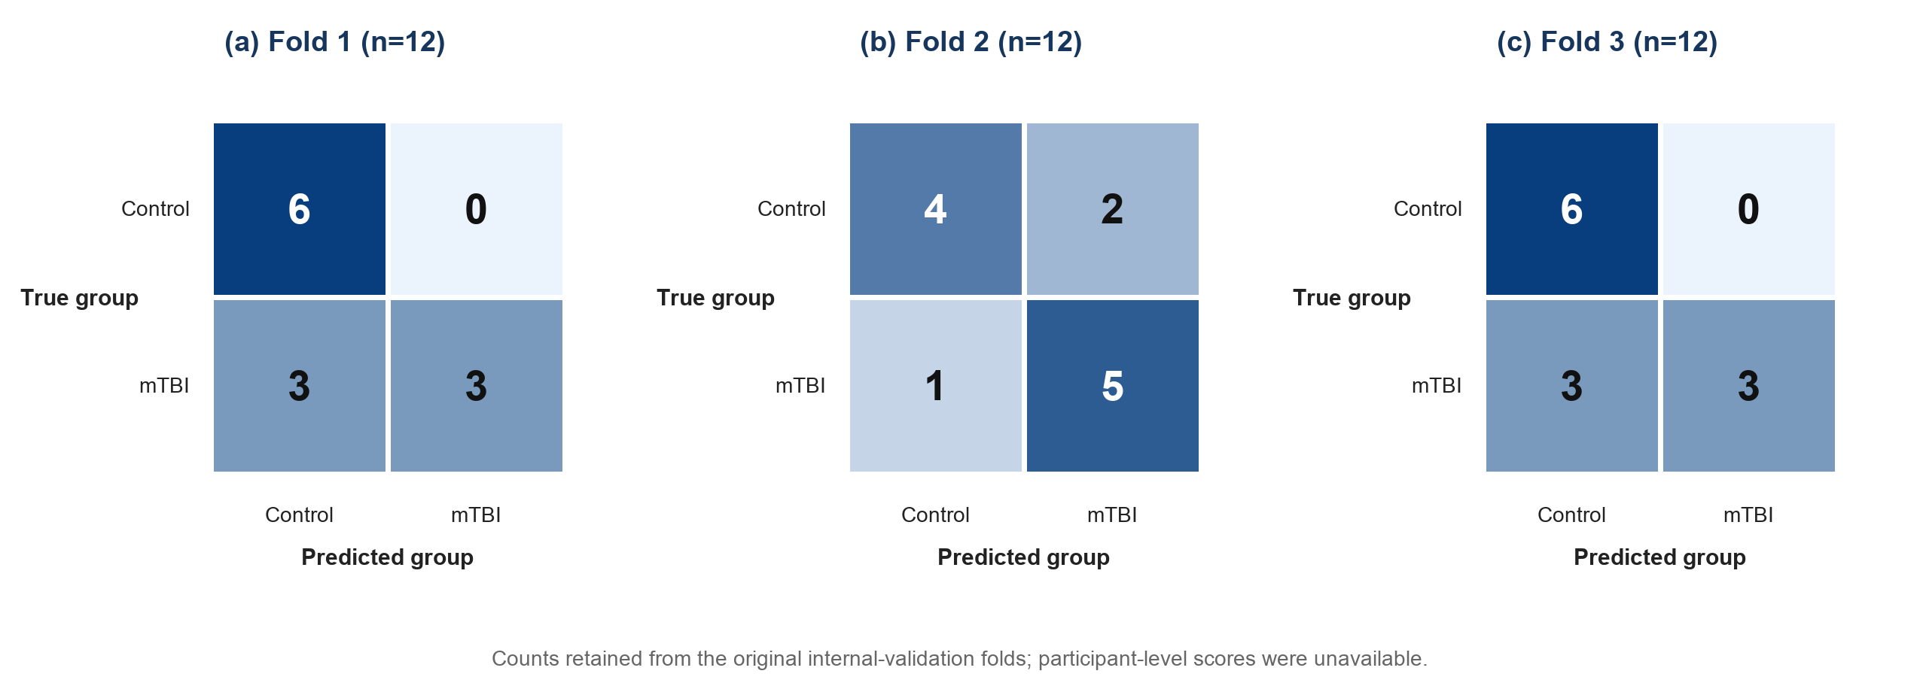
Aggregate confusion matrices for the three original internal-validation folds, relabelled using “Control” rather than “Normal.” Each fold contained 12 participants and 9/12 correct classifications. Retained fold-specific AUC values reported in the original analysis were 0.75, 0.69, and 0.81; these values could not be independently reconstructed because participant-level scores were unavailable. ROC curves were therefore removed.

