Supplementary A
1 Diagnostic criteria for ACS
Diagnostic criteria: ACS are typically caused by the disruption (rupture or ero- sion) of an unstable coronary artery atherosclerotic plaque with associated partial or complete coronary artery throm- bosis and/or microemboli, resulting in diminished blood flow to the myocardium and subsequent myocardial isch- emia (Fig. A.1). ACS includes 3 related clinical condi- tions that exist along a continuum of severity: (1) unstable angina, (2) non–ST-segment elevation myocardial infarc- tion (NSTEMI), and (3) STEMI. The initial diagnosis and classification of ACS should be based on the clinical his- tory and symptomatology, interpretation of the ECG (Table A.3), and assessment of cardiac troponin (cTn). Unstable an- gina is defined by transient myocardial ischemia leading to diminished flow in the absence of significant myonecrosis detected by circulating troponin. In contrast, patients with more prolonged or severe myocardial ischemia are diag- nosed with MI and have elevated biomarkers of myonecro- sis. Patients with NSTEMI may have a partially occluded coronary artery leading to subendocardial ischemia, while those with STEMI typically have a completely occluded vessel leading to transmural myocardial ischemia and in- farction (Fig. A.2). The pathophysiology of ACS can be dynamic and thus patients can rapidly progress from one clinical condition (eg, unstable angina, NSTEMI, STEMI) to another during the course of their presentation and initial evaluation and treatment. Other, less common causes of myocardial ischemia, among others, include coronary ar- tery spasm, embolism, and dissection.
This guideline will focus on the acute management of ACS, including unstable angina, NSTEMI, and STEMI, which are presumed to result from atherosclerotic plaque rupture or plaque erosion and subsequent thrombosis. Under the Universal Definition of MI, these MI events would be classified as type 1 MI events (Table A.4). The diagnostic evaluation of chest pain and the management of type 2 MI, spontaneous coronary artery dissection, and MINOCA (MI with nonobstructive coronary artery disease) are covered in separate documents. A detailed descrip- tion of the approach to the evaluation of patients with chest pain can be found in the 2021 AHA/ACC/ASE/ CHEST/SAEM/SCCT/SCMR Chest Pain Guideline.
Progressive lipid accumulation and inflammation within an atherosclerotic plaque may lead to plaque instability. Rupture of the atherosclerotic plaque and exposure of plaque contents to the circulation may then culminate in activation of the coagulation cascade and subsequent thrombosis. The presence of thrombus may compromise flow to the myocardium, leading to myocar- dial ischemia and eventual myonecrosis. Since early ini- tiation of therapy is imperative for patients with ACS, a high index of suspicion is warranted for those who pres- ent with signs and symptoms that could be consistent with myocardial ischemia .
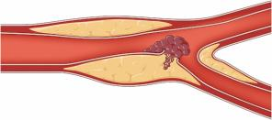
Fig. A.1 Pathobiology of a Type 1 Myocardial Infarction Due to Atherosclerotic Plaque Disruption

Progressive lipid accumulation and inflammation within an atherosclerotic plaque may lead to plaque instability. Rupture or erosion of the atherosclerotic plaque and exposure of plaque contents to the circulation may then culminate in activation of the coagulation cascade and subsequent thrombosis. When this occurs in the epicardial vessels of the coronary circulation, the presence of thrombus may compromise flow to the myocardium, leading to myocardial ischemia and eventual myonecrosis. Illustration by Patrick Lane, ScEYEnce Studios. Copyright 2025 American College of Cardiology Foundation, and American Heart Association, Inc.
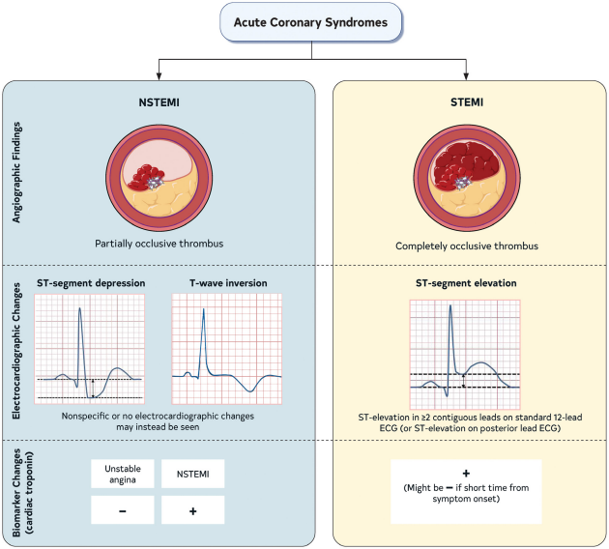
Fig. A.2 Types and Classification of Acute Coronary Syndromes

NSTEMI indicates non–ST-segment elevation myocardial infarction; and STEMI, ST-segment elevation myocardial infarction. Illustration by Patrick Lane, ScEYEnce Studios. Copyright 2025 American College of Cardiology Foundation, and the American Heart Association, Inc. The details are shown in Table A.1.
Table A.1 Electrocardiographic Interpretation for Patients With Suspected Acute Coronary Syndromes.

 | NSTE-ACS | STEMI
Electrocardiographic  evidence of ischemia | New or presumed new and usually dynamic horizontal or down-sloping ST-segment depression ≥0.5 mm in ≥2 contiguous leads and/or T-wave inversion >1 mm in ≥2 contiguous leads with prom- inent R wave or R/S ratio >1 or transient ST-segment elevation. | New or presumed new ST-elevation of ≥ 1 mm in ≥2 anatomically contiguous leads (measured at the J-point) in all leads other than V2-V3 and ≥2 mm in men ≥40 y, ≥2.5 mm in men <40 y, and ≥ 1.5 mm in women regardless of age in leads V2-V3.
Other observed  electrocardiographic changes | Many patients with NSTE-ACS have either nonspecific ST-segment or T-wave changes or a normal ECG. The absence of elec- trocardiographic evidence of ischemia does not exclude ACS. | Posterior leads (V7-V9) should be obtained in patients with  suspected left circumflex occlusion particularly in the setting of isolated ST-segment depression ≥0.5 mm in leads V1-V3.

Adapted with permission from Thygesen et al. Copyright 2018 The European Society of Cardiology, American College of Cardiology Foundation, American Heart Association, Inc., and the World Heart Federation. Adapted from Kontos et al. Copyright 2022 American College of Cardiology Foundation.
ST-segment changes may be observed in other conditions including acute pericarditis, left ventricular hypertrophy, LBBB, Brugada syndrome, right ventricular pacing, Takotsubo syndrome, and early repolarization that may obscure the diagnosis of STEMI. New or presumably new LBBB at presentation occurs infrequently and should not be considered diagnostic of AMI in isolation; clinical correlation is required. A new LBBB in an asymptomatic patient does not constitute a STEMI equivalent.
ACS indicates acute coronary syndromes; AMI, acute myocardial infarction, LBBB, left bundle branch block; NSTE-ACS, non–ST-segment elevation ACS; and STEMI, ST-segment elevation MI (Rao et al., 2025).
2 Detailed information for Rhodiola crenulata injection and the criteria for evaluating total clinical efficacy and electrocardiographic efficacy.
Table A.2 Detailed information for Rhodiola crenulata injection
Type | Ingredients | Specifications | Usage and dosage | Indication
Rhodiola crenulata injection | Rhodiola crenulata injection. The main components are Rhodiola crenulate | 5ml/10ml | Intravenous drip, 5ml/10ml at a time, diluted in 250ml of 5 glucose injection and administered slowly. 1 time a day. | Activating blood and resolving stasis. Used for Stable Exertional Angina Pectoris due to Coronary Heart Disease.

The following are the criteria for evaluating total clinical efficacy:
Significantly Effective: The patient's symptoms and signs have fully recovered.
Effective: The patient's symptoms and signs have been effectively alleviated.
Ineffective: The patient's symptoms and signs have not returned to normal or clinical deterioration.
Total clinical efficacy rate = (effective cases / total cases) × 100%.
The following are the criteria for evaluating electrocardiographic efficacy:
Significantly Effective: ST-segment deviations return to normal, or the electrocardiogram reverts to near-normal; e.g., ischemic ST depression/elevation resolves to baseline, and ischemic T-wave changes normalize.
Effective: Ischemic changes improve but do not return to normal; e.g., ST-segment shift moves toward baseline by ≥ 0.05 mV, or an inverted T wave becomes shallower by ≥ 25% or turns upright in the principal ischemic leads.
Ineffective/Worse: No meaningful improvement or deterioration; e.g., ST-segment deviation remains essentially unchanged or worsens by ≥ 0.05 mV, or the inverted T wave deepens by ≥ 25%, or new ischemic changes appear.
Electrocardiographic efficacy rate = (significantly effective + effective) / total × 100%.

3 Search Queries
The search queries for China National Knowledge Infrastructure Database (CNKI), VIP Database for Chinese Technical Periodicals (VIP), Wanfang Database (Wanfang), Chinese Biomedical Literature Database (SinoMed), Web of Science, Pubmed, Embase, and Cochrane Library are shown in Table A.3.

Table A.3 Search queries for each database
Database | Search query
CNKI | ( TKA = '急性冠脉综合征' OR TKA = '急性冠脉综合症' OR TKA = '冠状动脉综合征' OR TKA = '急性冠状动脉综合症' OR TKA = '急性冠状动脉综合征' OR TKA = '急性冠状动脉功能不全' OR TKA = '不稳定性心绞痛' OR TKA = '冠心病不稳定型心绞痛' OR TKA = '不稳定型心绞病' OR TKA = '不稳定心绞痛' OR TKA = '不稳定型心绞痛' OR TKA = '非st段抬高心肌梗死' OR TKA = '非st段抬高心肌梗塞' OR TKA = '非st段抬型高心肌梗塞' OR TKA = '非st段抬高型心肌梗死' OR TKA = 'st段抬高心肌梗死' OR TKA = 'st段抬高心肌梗塞' OR TKA = 'st段抬高性心肌梗塞' OR TKA = 'st段抬高性心肌梗死' OR TKA = '狭心症' OR TKA = '心绞痛' OR TKA = '急性心肌梗死' OR TKA = '急性心肌硬死' OR TKA = '心梗' OR TKA = '急性心梗' OR TKA = '心肌梗塞' OR TKA = '心肌梗死'OR TKA = '心肌梗塞' OR TKA = '急性心肌梗塞') AND (TKA = '红景天注射液' OR TKA = '红景天') AND FT = '随机'
VIP | M = (急性冠脉综合征 OR 急性冠脉综合症 OR 冠状动脉综合征 OR 急性冠状动脉综合症 OR 急性冠状动脉综合征 OR 急性冠状动脉功能不全 OR 不稳定性心绞痛 OR 冠心病不稳定型心绞痛 OR 不稳定型心绞病 OR 不稳定心绞痛 OR 不稳定型心绞痛 OR 非ST段抬高心肌梗死 OR 非ST段抬高心肌梗塞 OR 非ST段抬型高心肌梗塞 OR 非ST段抬高型心肌梗死 OR ST段抬高心肌梗死 OR ST段抬高心肌梗塞 OR ST段抬高性心肌梗塞 OR ST段抬高性心肌梗死 OR 狭心症 OR 心绞痛 OR 急性心肌梗死 OR 急性心肌硬死 OR 心梗 OR 急性心梗 OR 心肌梗塞 OR 心肌梗死 OR 急性心肌梗塞) AND M = (红景天注射液 OR 红景天) AND U = 随机
Wanfang | 主题:(急性冠脉综合征 OR 急性冠脉综合症 OR 冠状动脉综合征 OR 急性冠状动脉综合症 OR 急性冠状动脉综合征 OR 急性冠状动脉功能不全 OR 不稳定性心绞痛 OR 冠心病不稳定型心绞痛 OR 不稳定型心绞病 OR 不稳定心绞痛 OR 不稳定型心绞痛 OR 非ST段抬高心肌梗死 OR 非ST段抬高心肌梗塞 OR 非ST段抬型高心肌梗塞 OR 非ST段抬高型心肌梗死 OR ST段抬高心肌梗死 OR ST段抬高心肌梗塞 OR ST段抬高性心肌梗塞 OR ST段抬高性心肌梗死 OR 狭心症 OR 心绞痛 OR 急性心肌梗死 OR 急性心肌硬死 OR 心梗 OR 急性心梗 OR 心肌梗塞 OR 心肌梗死 OR 急性心肌梗塞) AND 主题:(红景天注射液 OR 红景天) AND 全部:(随机)
SinoMed | ("随机"[全部字段:智能]) AND ("红景天注射液"[常用字段:智能] OR "红景天"[常用字段:智能]) AND ("急性冠脉综合征"[常用字段:智能] OR "急性冠脉综合症"[常用字段:智能] OR "冠状动脉综合征"[常用字段:智能] OR "急性冠状动脉综合症"[常用字段:智能] OR "急性冠状动脉综合征"[常用字段:智能] OR "急性冠状动脉功能不全"[常用字段:智能] OR "不稳定性心绞痛"[常用字段:智能] OR "冠心病不稳定型心绞痛"[常用字段:智能] OR "不稳定型心绞病"[常用字段:智能] OR "不稳定心绞痛"[常用字段:智能] OR "不稳定型心绞痛"[常用字段:智能] OR "非ST段抬高心肌梗死"[常用字段:智能] OR "非ST段抬高心肌梗塞"[常用字段:智能] OR "非ST段抬型高心肌梗塞"[常用字段:智能] OR "非ST段抬高型心肌梗死"[常用字段:智能] OR "ST段抬高心肌梗死"[常用字段:智能] OR "ST段抬高心肌梗塞"[常用字段:智能] OR "ST段抬高性心肌梗塞"[常用字段:智能] OR "ST段抬高性心肌梗死"[常用字段:智能] OR "狭心症"[常用字段:智能] OR "心绞痛"[常用字段:智能] OR "急性心肌梗死"[常用字段:智能] OR "急性心肌硬死"[常用字段:智能] OR "心梗"[常用字段:智能] OR "急性心梗"[常用字段:智能] OR "心肌梗塞"[常用字段:智能] OR "心肌梗死"[常用字段:智能] OR "急性心肌梗塞"[常用字段:智能])
Web of Science | #1 TS=("Acute Coronary Syndrome" OR "Acute Coronary Syndromes" OR "Coronary Syndrome, Acute" OR "Coronary Syndromes, Acute" OR "Syndrome, Acute Coronary" OR "Syndromes, Acute Coronary" OR "STEMI" OR "ST Segment Elevation Myocardial Infarction" OR "ST Elevated Myocardial Infarction" OR "NSTEMI" OR "Non ST Elevated Myocardial Infarction" OR "Non-ST-Elevation Myocardial Infarction" OR "Infarction, Non-ST-Elevation Myocardial" OR "Infarctions, Non-ST-Elevation Myocardial" OR "Myocardial Infarction, Non-ST-Elevation" OR "Myocardial Infarctions, Non-ST-Elevation" OR "Non ST Elevation Myocardial Infarction" OR "Non-ST-Elevation Myocardial Infarctions" OR "Angina, Unstable" OR "Anginas, Unstable" OR "Unstable Anginas" OR "Angina at Rest" OR "Angina, Preinfarction" OR "Anginas, Preinfarction" OR "Preinfarction Angina" OR "Preinfarction Anginas" OR "Unstable Angina" OR "Angina Pectoris, Unstable" OR "Myocardial Preinfarction Syndrome" OR "Myocardial Preinfarction Syndromes" OR "Preinfarction Syndrome, Myocardial" OR "Preinfarction Syndromes, Myocardial" OR "Syndrome, Myocardial Preinfarction" OR "Syndromes, Myocardial Preinfarction")  #2 TS=("Rhodiola crenulata" OR "Rhodiola rosea" OR "Roseroot" OR "Roseroots" OR "Hongjingtian" OR "Hong jing tian")  #3 ALL=("randomized controlled trial" OR "randomized clinical trial" OR "randomized trial" OR "clinical trial" OR "randomized" OR "randomized"RCT)  #4 = #1 AND #2 AND #3
Pumbed | #1 "Acute Coronary Syndrome" [MeSH Terms] OR "Acute Coronary Syndromes" [Title/Abstract] OR "Coronary Syndrome, Acute" [Title/Abstract] OR "Coronary Syndromes, Acute" [Title/Abstract] OR "Syndrome, Acute Coronary" [Title/Abstract] OR "Syndromes, Acute Coronary" [Title/Abstract] OR "STEMI" [Title/Abstract] OR "ST Segment Elevation Myocardial Infarction" [Title/Abstract] OR "ST Elevated Myocardial Infarction" [Title/Abstract] OR "NSTEMI" [Title/Abstract] OR "Non ST Elevated Myocardial Infarction" [Title/Abstract] OR "Non-ST-Elevation Myocardial Infarction" [Title/Abstract] OR "Infarction, Non-ST-Elevation Myocardial" [Title/Abstract] OR "Infarctions, Non-ST-Elevation Myocardial" [Title/Abstract] OR "Myocardial Infarction, Non-ST-Elevation" [Title/Abstract] OR "Myocardial Infarctions, Non-ST-Elevation" [Title/Abstract] OR "Non ST Elevation Myocardial Infarction" [Title/Abstract] OR "Non-ST-Elevation Myocardial Infarctions" [Title/Abstract] OR "Angina, Unstable" [Title/Abstract] OR "Anginas, Unstable" [Title/Abstract] OR "Unstable Anginas" [Title/Abstract] OR "Angina at Rest" [Title/Abstract] OR "Angina, Preinfarction" [Title/Abstract] OR "Anginas, Preinfarction" [Title/Abstract] OR "Preinfarction Angina" [Title/Abstract] OR "Preinfarction Anginas" [Title/Abstract] OR "Unstable Angina" [Title/Abstract] OR "Angina Pectoris, Unstable" [Title/Abstract] OR "Angina Pectori, Unstable" [Title/Abstract] OR "Unstable Angina Pectori" [Title/Abstract] OR "Unstable Angina Pectoris" [Title/Abstract] OR "Myocardial Preinfarction Syndrome" [Title/Abstract] OR "Myocardial Preinfarction Syndromes" [Title/Abstract] OR "Preinfarction Syndrome, Myocardial" [Title/Abstract] OR "Preinfarction Syndromes, Myocardial" [Title/Abstract] OR "Syndrome, Myocardial Preinfarction" [Title/Abstract] OR "Syndromes, Myocardial Preinfarction" [Title/Abstract]  #2 "Rhodiola crenulata" [MeSH Terms] OR "Rhodiola rosea" [Title/Abstract] OR "Roseroot" [Title/Abstract] OR "Roseroots" [Title/Abstract] OR "Hongjingtian" [Title/Abstract] OR "Hong jing tian" [Title/Abstract]  #3 "randomized controlled trial" [Publication type] OR "randomized clinical trial" [Publication type] OR "randomized trial" [Publication type] OR "clinical trial" [Publication type] OR "randomized controlled trial" [Title/Abstract] OR "randomized clinical trial" [Title/Abstract] OR "randomized trial" [Title/Abstract] OR "clinical trial" [Title/Abstract]  #4 #1 AND #2 AND #3
Embase | #1 'Acute Coronary Syndrome':ti,ab,kw OR 'Acute Coronary Syndromes':ti,ab,kw OR 'Coronary Syndrome, Acute':ti,ab,kw OR 'Coronary Syndromes, Acute':ti,ab,kw OR 'Syndrome, Acute Coronary':ti,ab,kw OR 'Syndromes, Acute Coronary':ti,ab,kw OR 'STEMI':ti,ab,kw OR 'ST Segment Elevation Myocardial Infarction':ti,ab,kw OR 'NSTEMI':ti,ab,kw OR 'Non ST Elevated Myocardial Infarction':ti,ab,kw OR 'Non-ST-Elevation Myocardial Infarction':ti,ab,kw OR 'Unstable Angina':ti,ab,kw OR 'Angina, Unstable':ti,ab,kw OR 'Preinfarction Angina':ti,ab,kw OR 'Myocardial Preinfarction Syndrome':ti,ab,kw  #2 'Rhodiola crenulata'/exp OR 'Rhodiola rosea':ti,ab,kw OR 'Roseroot':ti,ab,kw OR 'Roseroots':ti,ab,kw OR 'Hongjingtian':ti,ab,kw OR 'Hong jing tian':ti,ab,kw  #3 'randomized controlled trial'/exp OR 'randomized controlled trial':ti,ab,kw OR 'randomized clinical trial':ti,ab,kw OR 'randomized trial':ti,ab,kw OR 'clinical trial':ti,ab,kw  #4 = #1 AND #2 AND #3
The Cochrane Library | #1 MeSH descriptor: [Acute Coronary Syndrome] explode all trees  #2 (Acute Coronary Syndrome OR Acute Coronary Syndromes OR Coronary Syndrome, Acute OR Coronary Syndromes, Acute OR Syndrome, Acute Coronary OR Syndromes, Acute Coronary OR STEMI OR ST Segment Elevation Myocardial Infarction OR NSTEMI OR Non ST Elevated Myocardial Infarction OR Non-ST-Elevation Myocardial Infarction OR Unstable Angina OR Angina, Unstable OR Preinfarction Angina OR Myocardial Preinfarction Syndrome):ti,ab,kw  #3 = #1 OR #2  #4 MeSH descriptor: [Rhodiola crenulata] explode all trees  #5 (Rhodiola crenulata OR Rhodiola rosea OR Roseroot OR Roseroots OR Hongjingtian OR Hong jing tian):ti,ab,kw  #6 = #4 OR #5  #7 MeSH descriptor: [Randomized Controlled Trial] explode all trees  #8 (randomized controlled trial OR randomized clinical trial OR randomized trial OR clinical trial):ti,ab,kw  #9 = #7 OR #8  #10 = #3 AND #6 AND #9
Abbreviation: CNKI, China National Knowledge Infrastructure Database, VIP, VIP Database for Chinese Technical Periodicals, Wanfang, Wanfang Database, SinoMed, Chinese Biomedical Literature Database

4 Rules for Assessment of the Risk of bias and Certainty of Evidence
Bias was evaluated using predetermined signaling questions across five domains: 1) randomization process (selection bias); 2) deviations from the intended interventions (performance bias); 3) missing outcome data (attrition bias); 4) measurement of the outcome (detection bias); 5) selection of the reported outcome (reporting bias). For each domain, the risk of bias was characterized as “low risk”, “some concerns”, or “high risk”. The total risk of bias assessment for each study was formulated based on the evaluation of bias risk across each domain. Two researchers compared their findings and addressed any disagreements through discussion or by seeking input from a third researcher.
The assessment of certainty of evidence was divided into five elements: study design, inconsistency, indirectness, imprecision, and publication bias, each with their respective criteria for downgrade as shown in Table A.4.

Table A.4 Rules for assessment of the certainty of evidence
Element | Criteria for downgrade
Study design | If the majority of the information based on the revised Cochrane Risk of Bias tool assessment was rated as moderate, the evidence was downgraded by one level. If the majority was rated as high, the evidence was downgraded by two levels
Inconsistency | If heterogeneity tests showed I² exceeding 75%, the evidence was downgraded by two levels. If I² was exceeding 50% and less than 75%, the evidence was downgraded by one level
Indirectness | Assessment included several components: Population differences, Intervention differences, Outcome measurement differences, and Indirect comparisons. If there was a serious suspicion regarding the directness of the evidence, the evidence was downgraded by one level. If there was a very serious suspicion regarding the directness of the evidence, the evidence was downgraded by two levels
Imprecision | If the 95% confidence interval crossed the null line, the evidence was downgraded by one level. With a total sample size of less than 300 for categorical variables and less than 400 for continuous variables included in all studies, the evidence was downgraded by one level
Publication bias | If there was publication bias, the evidence was downgraded by one level

5 Sensitivity analysis

Fig. A.3 The results of the sensitivity analysis of major adverse cardiovascular events

Fig. A.4 The results of the sensitivity analysis of the number of angina attacks.

Fig. A.5 The results of the sensitivity analysis of the duration of angina pectoris.

Fig. A.6 The results of the sensitivity analysis of total clinical efficacy.

Fig. A.7 The results of the sensitivity analysis of electrocardiographic efficacy.

Fig. A.8 The results of the sensitivity analysis of adverse.

Fig. A.9 The results of the sensitivity analysis of the effect of TC.

Fig. A.10 The results of the sensitivity analysis of the effect of TG.

Fig. A.11 The results of the sensitivity analysis of the effect of HDL-C.

Fig. A.12 The results of the sensitivity analysis of the effect of LDL-C.
6 Trial sequential analysis
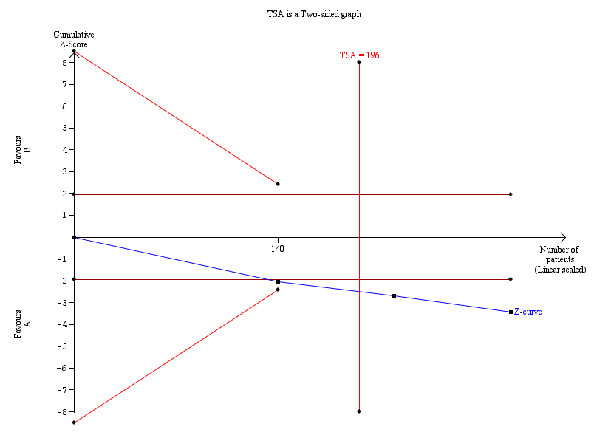
Fig. A.13 The results of the trial sequential analysis for MACE.
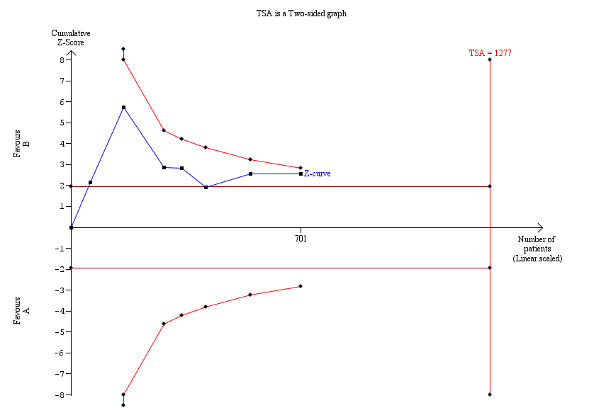
Fig. A.14 The results of the trial sequential analysis for the number of angina attacks.
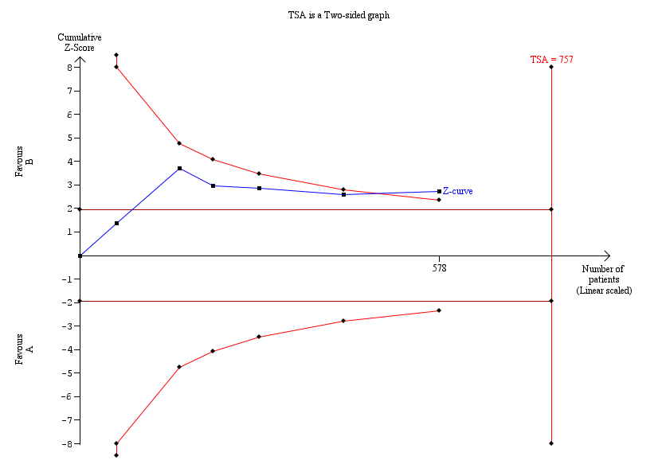
Fig. A.15 The results of the trial sequential analysis for the duration of angina attacks.
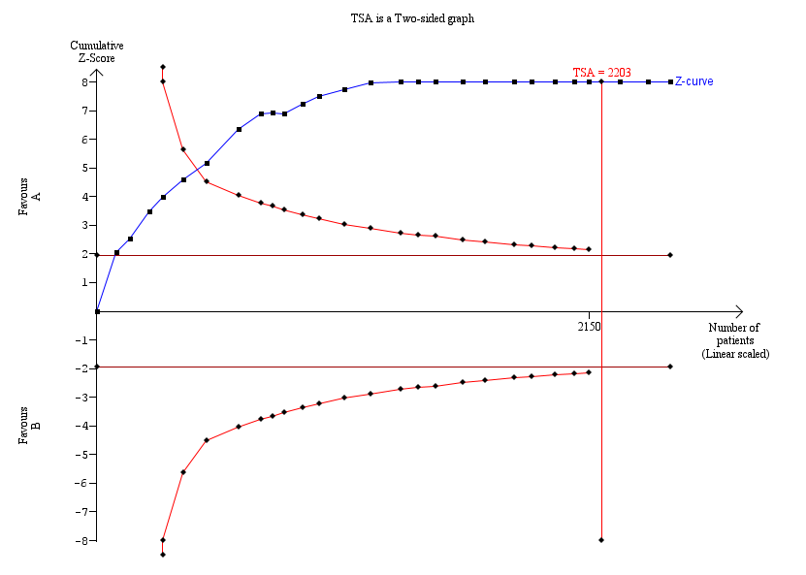
Fig. A.16 The results of the trial sequential analysis for total clinical efficacy.
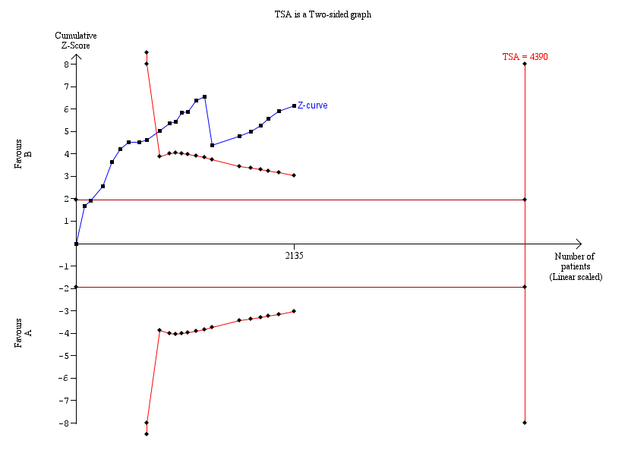
Fig. A.17 The results of the trial sequential analysis for electrocardiographic efficacy.
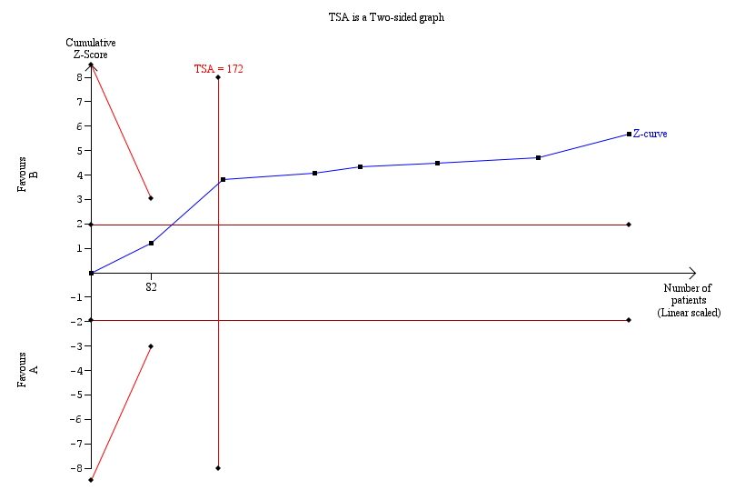
Fig. A.18 The results of the trial sequential analysis for TC.
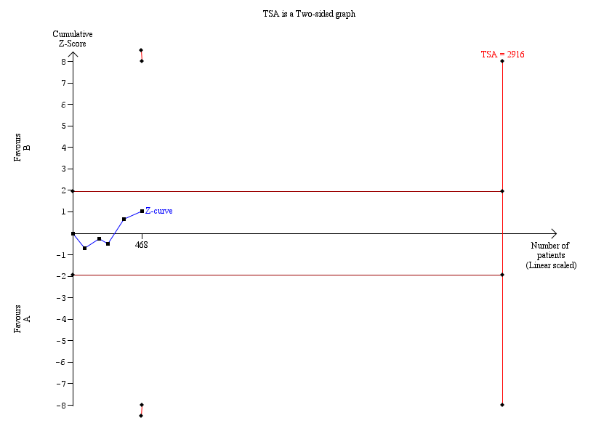
Fig. A.19 The results of the trial sequential analysis for TG.
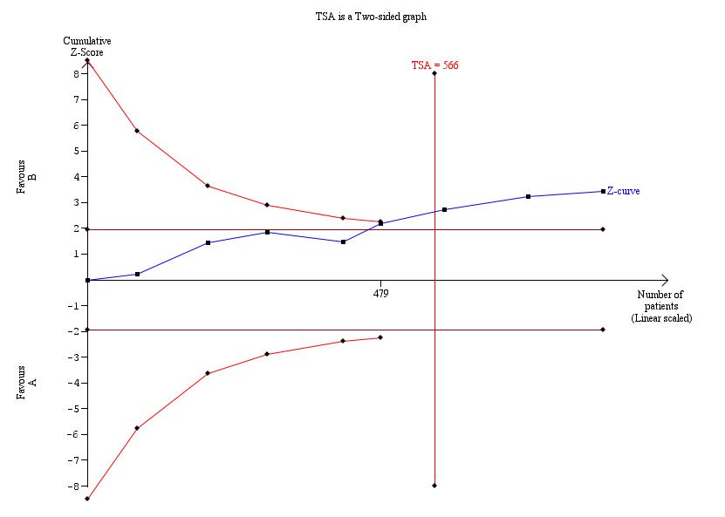
Fig. A.20 The results of the trial sequential analysis for LDL-C.
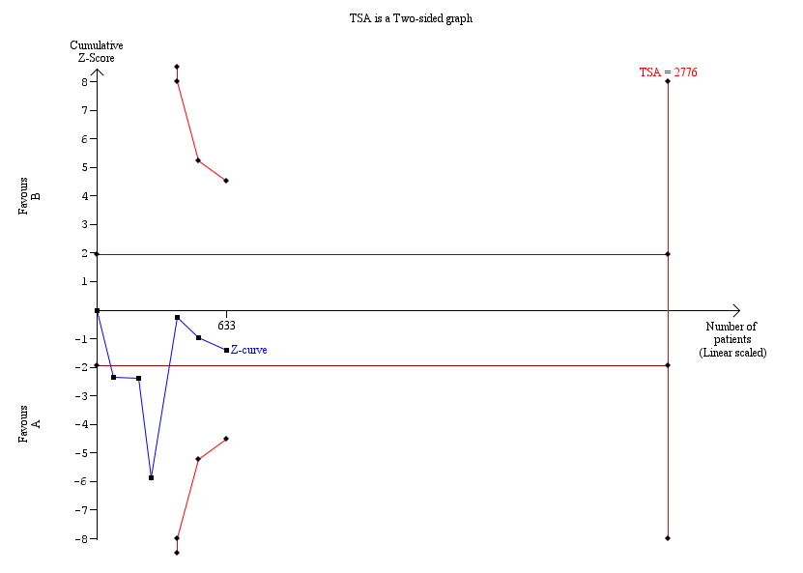
Fig. A.21 The results of the trial sequential analysis for HDL-C.

