A Calcium-Releasing Graphene Oxide Transwell Interface for Bidirectional Electrochemical Oxygen Sensing of Epidermal Differentiation

Cheol-Hwi Kim¹, Fu Nan Ju², Yun-Sik Eom¹, Jin-Kyu Wi³, Chang-Dae Kim¹, and
Tae-Hyung Kim^{1,4}*

¹ Department of Intelligent Precision Healthcare Convergence, Institute for Cross-disciplinary Studies (ICS), Sungkyunkwan University (SKKU), Suwon, Gyeonggi 16419, Republic of Korea
² School of Integrative Engineering, Chung-Ang University, Seoul 06974, Republic of Korea
³ Department of MetaBioHealth, SKKU, 2066 Seobu-ro, Jangan-gu, Suwon, Republic of Korea
⁴ Department of Biomedical Engineering, ICS, SKKU, Suwon, Gyeonggi 16419, Republic of Korea

*Corresponding author
Tae-Hyung Kim
Department of Intelligent Precision Healthcare Convergence, Institute for Cross-disciplinary Studies (ICS)
Sungkyunkwan University (SKKU), Suwon, Gyeonggi 16419, Republic of Korea
http://bestlab0000.hntcontentshub.com
*E-mail: thkim0512@skku.edu
Supporting Information
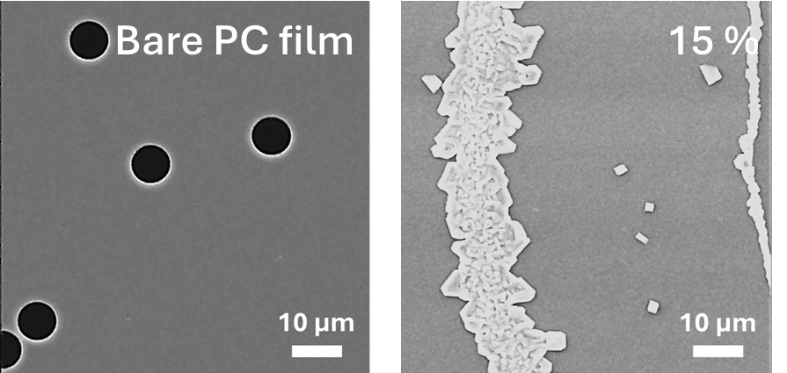
Figure S1. SEM images of uncoated PC film and PC film coated with GO-Gel-Ca suspension containing 15% gelatin type A.

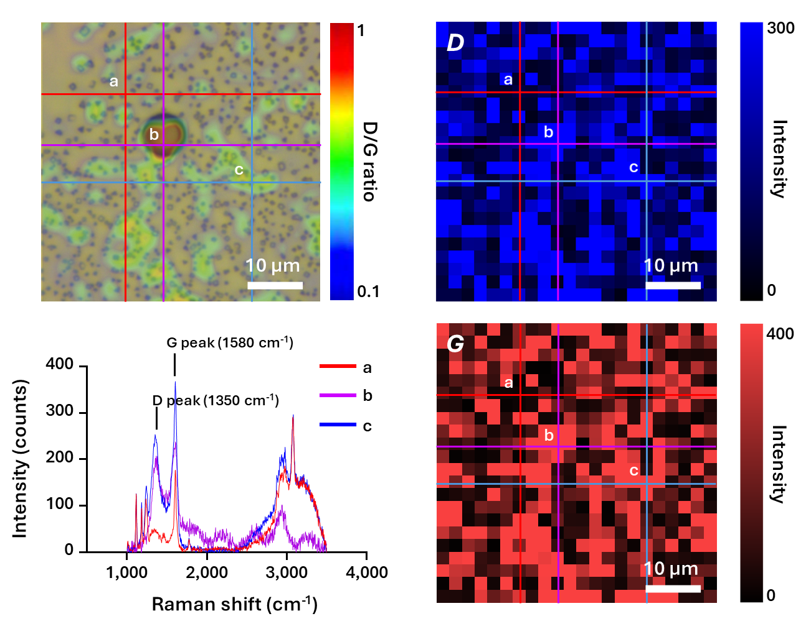
Figure S2. Raman spectroscopic analysis of GO-Gel-Ca-coated PC film and pores located on the film. The optical image, D peak mapping image, and G peak mapping image correspond to the same region shown in Figure 2e. Raman intensity spectra correspond to the symbols indicated in each image.

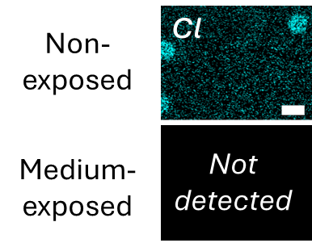
Figure S3. SEM-EDS images for analyzing residual Cl on the GO-Gel-Ca-coated PC film.
Scale bar = 10 μm.

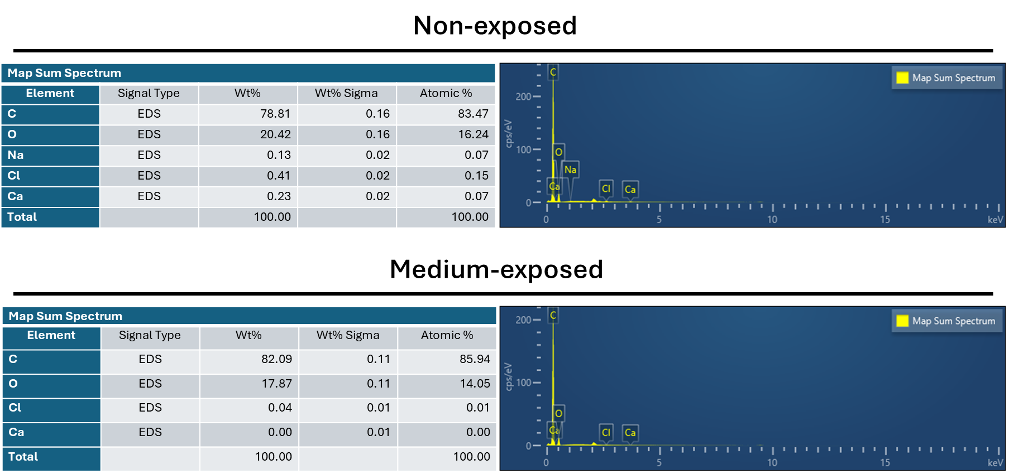
Figure S4. SEM-EDS map sum spectrum for analyzing residual O, C, Cl, and Ca on the GO-Gel-Ca-coated PC film.

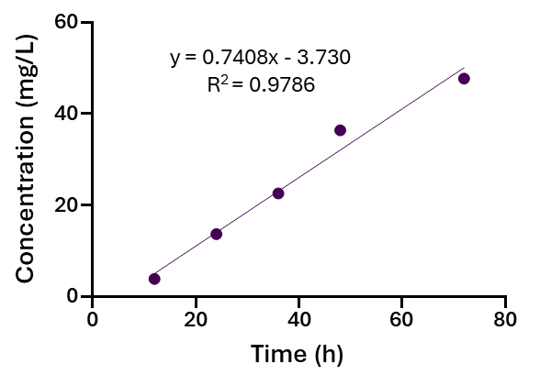
Figure S5. Calibration curve of calcium release from the GO-Gel-Ca-coated PC film according to exposure time in distilled water.

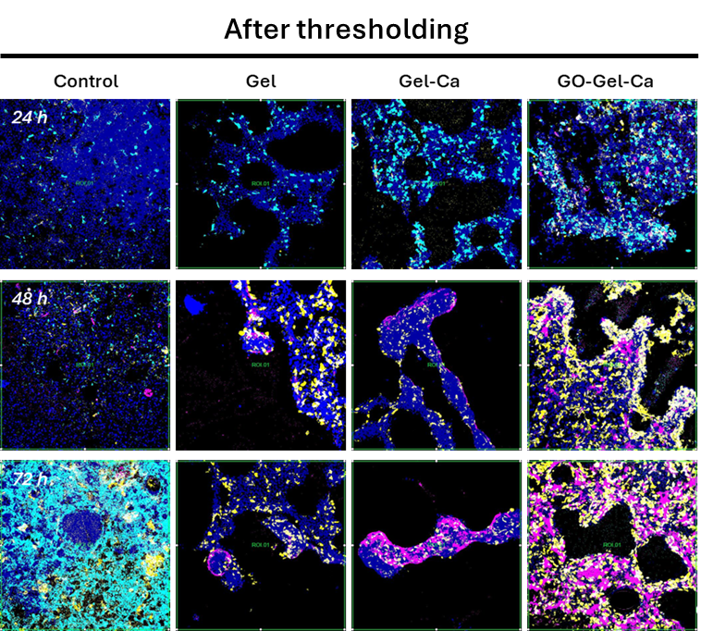
Figure S6. Fluorescence staining images of keratinocytes cultured on films prepared under different fabrication conditions and corresponding preprocessing results for image analysis. Thresholding was applied for fluorescence-positive area quantification.

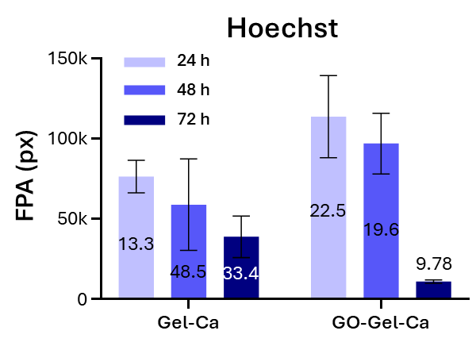
Figure S7. Culture time-dependent fluorescence-positive area (FPA) of Hoechst-positive keratinocytes quantified by computational image analysis. The values inserted above the graphs indicate the coefficient of variation (CV), defined as the ratio of the standard deviation to the mean.

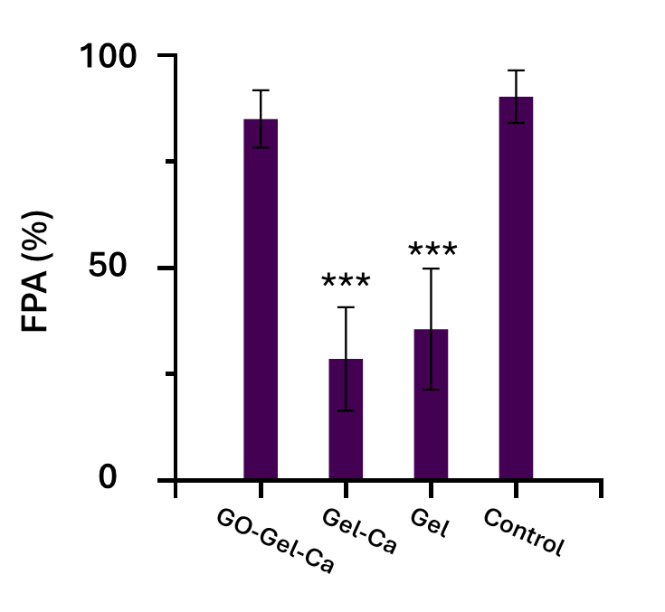
Figure S8. Image-based analysis of keratinocyte culture area according to film fabrication conditions. FPA was defined as the ratio of the fluorescence-positive area to the total analyzed area. Student’s t-test, n = 5, *p < 0.05, **p < 0.01, ***p < 0.001. n = 7.

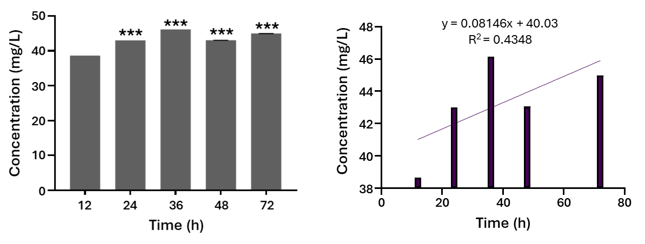
Figure S9. ICP-OES-based analysis of calcium release from the Gel-Ca film over time.

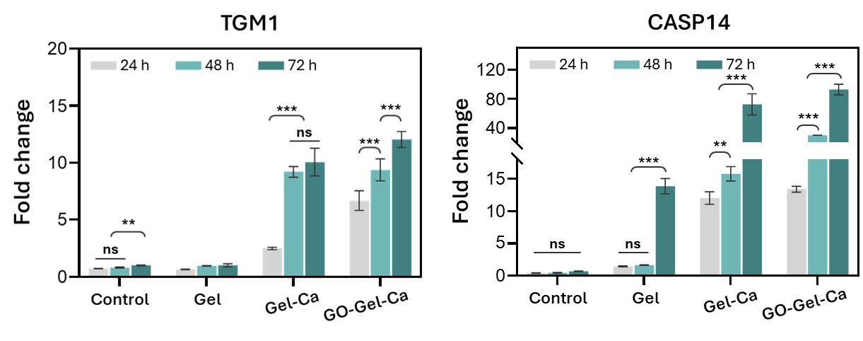
Figure S10. qPCR-based analysis of culture time-dependent expression levels of transglutaminase-1 (TGM-1) and caspase-14 (CASP14) in keratinocytes. Student’s t-test, n = 7, *p < 0.05, **p < 0.01, ***p < 0.001. ns indicates not significant.

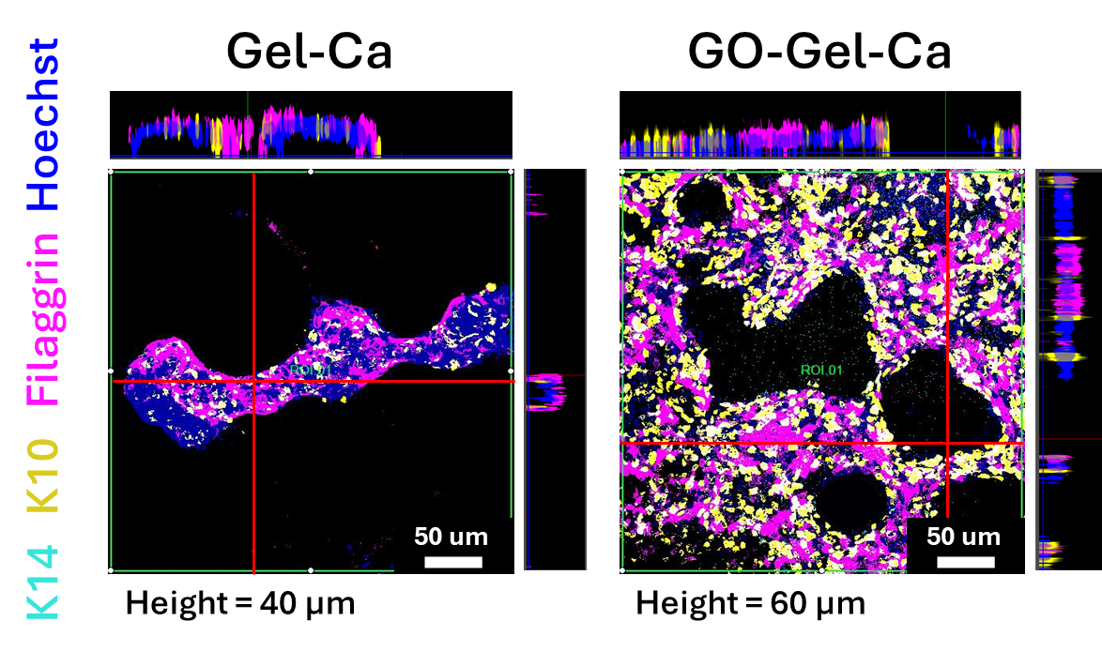
Figure S11. Confocal fluorescence microscopy-based z-sectional image analysis of keratinocytes cultured under different film fabrication conditions.
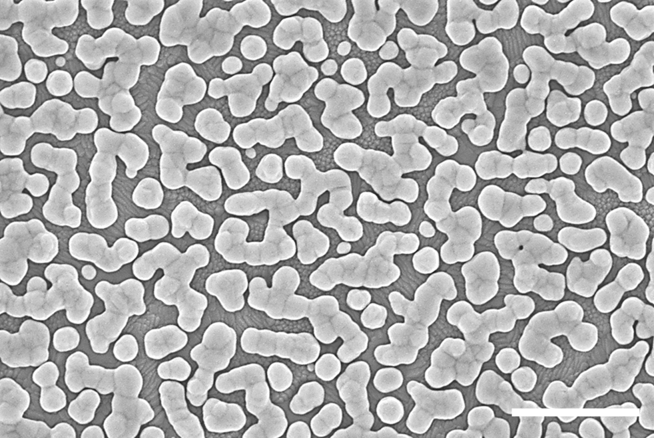
Figure S12. SEM image of the gold nanostructure-based working electrode in the bidirectional electrochemical oxygen depletion monitoring system. Scale bar = 500 nm.

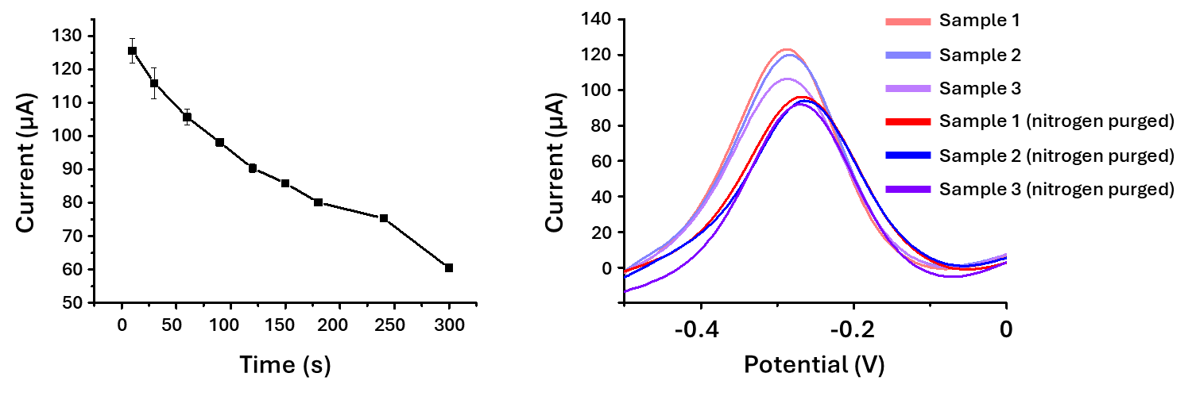
Figure S13. Analysis of signal reduction according to nitrogen purging time in Hanks’ balanced salt solution (HBSS)-based electrochemical monitoring solution and the corresponding oxygen-related signal calibration process.

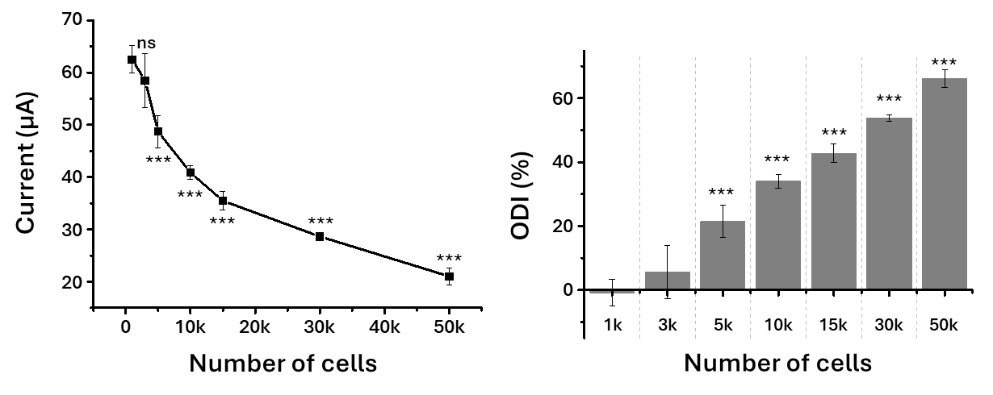
Figure S14. DPV signals and corresponding oxygen depletion index (ODI) of keratinocytes cultured on GO-Gel-Ca films for 24 h as a function of seeded cell number. Student’s t-test, n = 7, *p < 0.05, **p < 0.01, ***p < 0.001.

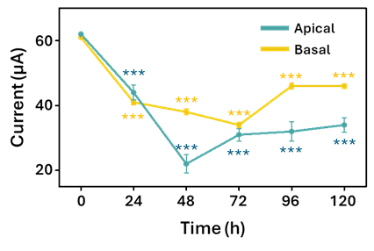
Figure S15. Quantitative analysis of DPV-based electrochemical oxygen dynamics.

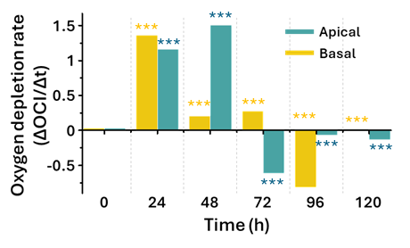
Figure S16. ODR analysis of keratinocytes cultured on the GO-Gel-Ca film according to culture time and detection direction. Student’s t-test, n = 7, *p < 0.05, **p < 0.01, ***p < 0.001.

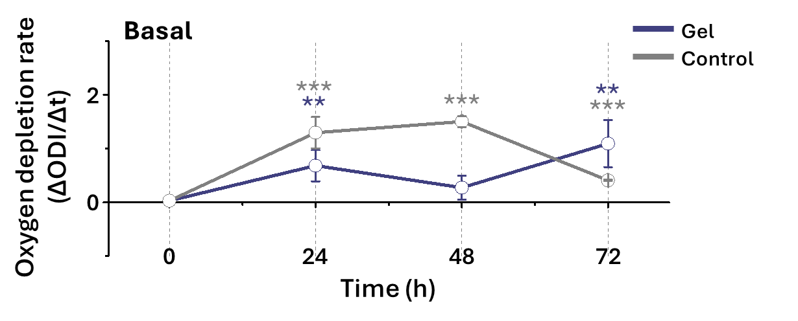
Figure S17. Oxygen depletion rate analysis according to sensing position and GO-Gel-Ca film fabrication condition. Student’s t-test, n = 5, *p < 0.05, **p < 0.01, ***p < 0.001. ns indicates not significant.

No. | Gene | Seq
1 | KRT14  (Keratin 14) | Fwd: TGGCAGAGATGAGGGAGCAGTA  Rev: GTGTTAGACGCCACCTCCTTGT
2 | KRT10  (Keratin 10) | Fwd: CCTGCTTCAGATCGACAATGCC  Rev: ATCTCCAGGTCAGCCTTGGTCA
3 | IVL  (Involucrin) | Fwd: ACAAGGGAAGAGAGAGCCACTG  Rev: TGTAGAGGGACAGAGTCAAGTTCA
4 | FLG  (Filaggrin) | Fwd: TGAAGCCTATGACACCACTGA  Rev: TCCCCTACGCTTTCTTGTCCT
5 | TGM1  (Trans Glutaminase 1) | Fwd: GAACGACTGCTGGATGAAGAGG  Rev: CTTGATGGACTCCACAGAGCAG
6 | CASP14  (Caspase 14) | Fwd: GGTGGATGTGTTCACGAAGAGG  Rev: CCTTCTTGAACCAGCTCTGCTTC
7 | CASP3  (Caspase 3) | Fwd: ATGGAGAACAATAAAACCT  Rev: CTAGTGATAAAAGTAGAGTTC
8 | TFAM  (Transcription Factor A, Mitochondrial) | Fwd: TGTTCACAATGGATAGGCAC  Rev: TCTGGGTTTTCCAAAGCAAG
9 | MT-CO1  (Mitochondrially Encoded Cytochrome C Oxidase I) | Fwd: GCCCCCGATATGGCGTTT  Rev: GTTCAACCTGTTCCTGCTCC
Table S1. Primer sequences for RT-qPCR

