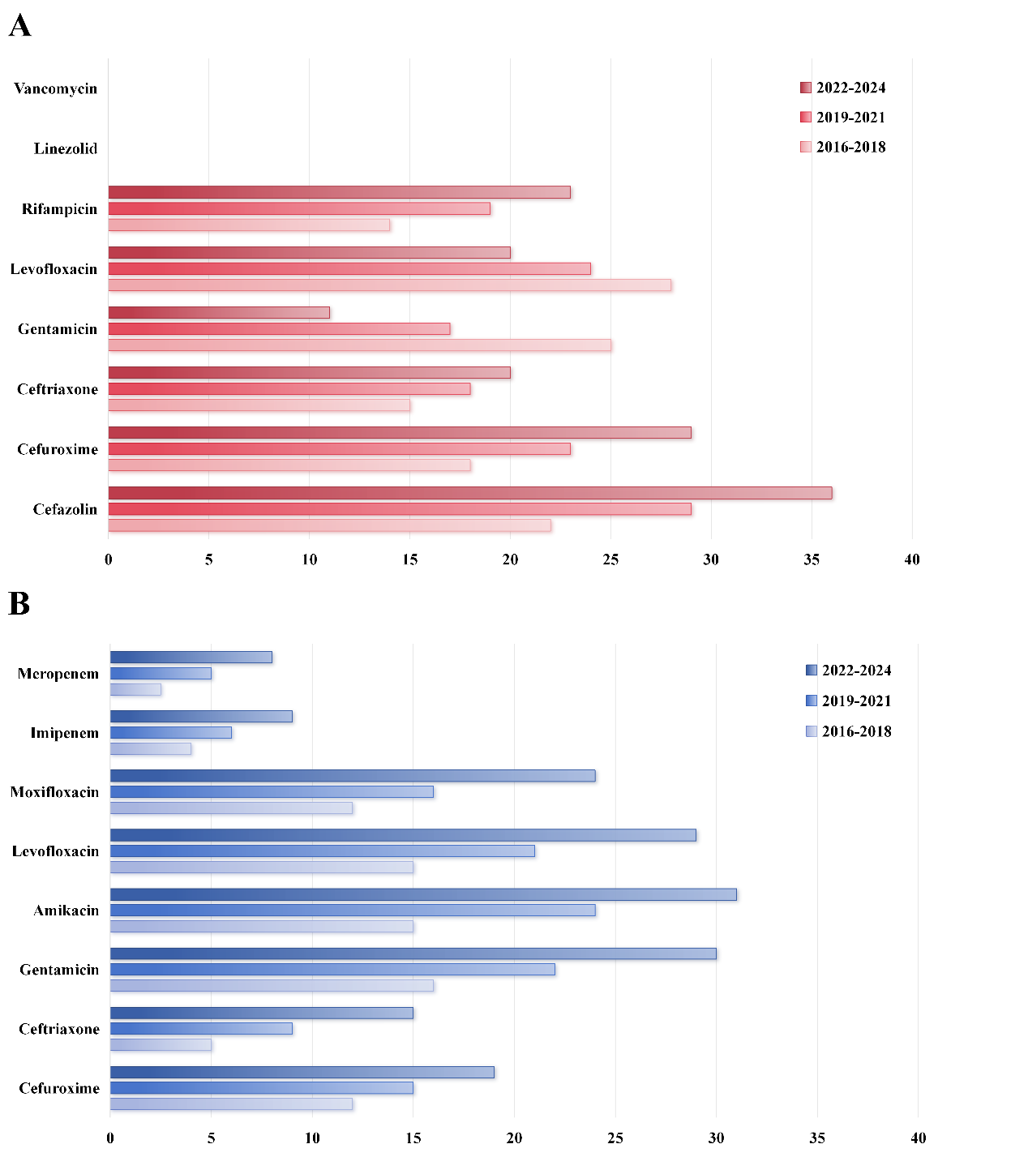
Figures S1 Variations in the Resistance Rates of Gram-Positive and Gram-Negative Bacteria to Common Antibiotics
A depicts the changes in resistance rates for Gram-positive bacteria, while B illustrates the changes for Gram-negative bacteria.

