Supplementary Information

Trends in the potential distribution of mangroves in the Eastern Pacific under climate change scenarios

Patricia González-Zamorano¹*, Felipe Andrés Toro-Cardona^{2,3,} Joaquín Rivera Rosas¹, Salvador Emilio Lluch-Cota¹, David Arturo Paz-García¹

¹ Centro de Investigaciones Biológicas del Noroeste (CIBNOR), La Paz, Baja California Sur, Mexico.
² Grupo de Ecología y Evolución de Vertebrados, Instituto de Biología, Facultad de Ciencias Exactas y Naturales, Universidad de Antioquia, Medellín, Colombia.
³ Laboratorio de Bioclimatología, Instituto de Ecología A.C., Xalapa, Veracruz, Mexico.

Tables

Table S1. Climate variable sets selected for each species after correlation filtering (r ≤ 0.8). Dashes (–) indicate that no equivalent variable set was selected for that species.

A. germinans | L. racemosa | R. mangle
BIO1, BIO2, BIO5, BIO6, BIO14 | BIO1, BIO2, BIO5, BIO6, BIO14 | BIO1, BIO2, BIO5, BIO6, BIO14
BIO1, BIO5, BIO6, BIO13, BIO14 | BIO1, BIO5, BIO6, BIO13, BIO14 | BIO1, BIO5, BIO6, BIO13, BIO14
BIO1, BIO5, BIO7, BIO13, BIO14 | BIO1, BIO5, BIO7, BIO13, BIO14 | BIO1, BIO5, BIO7, BIO13, BIO14
BIO2, BIO5, BIO6, BIO13, BIO14 | – | BIO2, BIO5, BIO6, BIO13, BIO14
BIO4, BIO5, BIO6, BIO13, BIO14 | – | BIO4, BIO5, BIO6, BIO13, BIO14

Note: Variables were obtained from the WorldClim v2.1 database [41]. BIO1 = Annual Mean Temperature (°C); BIO2 = Mean Diurnal Range (°C); BIO4 = Temperature Seasonality (°C); BIO5 = Maximum Temperature of the Warmest Month (°C); BIO6 = Minimum Temperature of the Coldest Month (°C); BIO7 = Annual Temperature Range (°C); BIO13 = Precipitation of the Wettest Month (mm); BIO14 = Precipitation of the Driest Month (mm).

Table S2. Selected models and evaluation metrics for each species. Model parameters include the regularization multiplier (Rm), feature classes (Fc), and variable set (Var set). Evaluation metrics include the AUC ratio (>1 indicates better-than-random performance), omission rate (<0.05), and dAIC (<2 indicates comparable models).

Species | Model parameters | AUC ratio (>1) | Omission rate (<0.05) | dAIC (<2)
A. germinans | Rm = 0.1  Fc = lqp  Var set = 01 | 1.46 | 0.037 | 0
L. racemosa | Rm = 0.1  Fc = lqp  Var set = 01 | 1.44 | 0.039 | 0
R. mangle | Rm = 0.1  Fc = lqp  Var set = 01 | 1.43 | 0.04 | 0

Table S3. Predictor variables used in the selected models for each species and their percentage contribution. Dashes (–) indicate that the variable was not included in the final model.

Variable | A. germinans | L. racemosa | R. mangle
Annual Mean Temperature (BIO1, °C) | 37.4 | 26.3 | 19.0
Mean Diurnal Range (BIO2, °C) | 20.6 | 22.9 | 22.4
Maximum Temperature of the Warmest Month (BIO5, °C) | 6.2 | – | –
Minimum Temperature of the Coldest Month (BIO6, °C) | 22.2 | 25.6 | 32.2
Precipitation of the Wettest Month (BIO13, mm) | 8.3 | 14.5 | 13.1
Precipitation of the Driest Month (BIO14, mm) | 5.2 | 5.9 | 6.7

Table S4. Effect of topographic correction on current and future species distribution models. Values represent potential distribution area (pixels) retained after applying the topographic filter (Climate ∩ Topography), representing the intersection between climatic conditions and topographic constraints defining effective habitat availability.

Model | A. germinans |  | L. racemosa |  | R. mangle
Model | Climate | Climate ∩ Topography | Climate | Climate ∩ Topography | Climate | Climate ∩ Topography
Current | 237,775 | 46,502 (19.6%) | 258,352 | 48,547 (18.8%) | 248,811 | 45,850 (18.4%)
SSP2–4.5 (2050) | 257,770 | 41,394 (16.1%) | 278,535 | 41,785 (15.0%) | 247,982 | 41,369 (16.7%)
SSP3–7.0 (2050) | 247,601 | 39,785 (16.1%) | 263,563 | 40,030 (15.2%) | 240,456 | 39,834 (16.6%)
SSP5–8.5 (2050) | 242,301 | 39,612 (16.3%) | 253,680 | 40,026 (15.8%) | 235,024 | 39,935 (17.0%)
SSP2–4.5 (2070) | 234,797 | 39,475 (16.8%) | 246,239 | 39,915 (16.2%) | 228,483 | 39,945 (17.5%)
SSP3–7.0 (2070) | 210,062 | 35,907 (17.1%) | 217,624 | 35,901 (16.5%) | 206,553 | 36,690 (17.8%)
SSP5–8.5 (2070) | 181,401 | 31,528 (17.4%) | 186,990 | 31,421 (16.8%) | 181,967 | 32,209 (17.7%)

Table S5. Change trends in potential distribution (Climate ∩ Topography) of A. germinans, L. racemosa, and R. mangle under six climate change scenarios in the Eastern Pacific. Values represent topographically constrained predicted distribution area (pixels) and percentage change relative to the current distribution.

 | A. germinans |  | L. racemosa |  | R. mangle
Model | Area (pixels) | Change (%) | Area (pixels) | Change (%) | Area (pixels) | Change (%)
Current | 46,502 | – | 48,547 | – | 45,850 | –
SSP2–4.5 (2050) | 41,394 | -11.0 | 41,785 | -13.9 | 41,369 | -9.8
SSP3–7.0 (2050) | 39,785 | -14.4 | 40,030 | -17.5 | 39,834 | -13.1
SSP5–8.5 (2050) | 39,612 | -14.8 | 40,026 | -17.6 | 39,935 | -12.9
SSP2–4.5 (2070) | 39,475 | -15.1 | 39,915 | -17.8 | 39,945 | -12.9
SSP3–7.0 (2070) | 35,907 | -22.8 | 35,901 | -26.0 | 36,690 | -20.0
SSP5–8.5 (2070) | 31,528 | -32.2 | 31,421 | -35.3 | 32,209 | -29.8

Table S6. Percentage change trends in potential distribution of A. germinans (Ag), L. racemosa (Lr), and R. mangle (Rm) under six climate change scenarios in the Eastern Pacific. Values represent the percentage of pixels classified as stability, loss, or gain relative to the total predicted distribution area for each scenario.

Trend | Spp | Scenarios 2050 |  |  | Scenarios 2070 |  |  | Average
Trend | Spp | SSP2–4.5 | SSP3–7.0 | SSP5–8.5 | SSP2–4.5 | SSP3–7.0 | SSP5–8.5 | Average
Stability | Ag | 65.4 | 65.4 | 61.2 | 61.0 | 55.9 | 52.2 | 60.2
Stability | Lr | 66.8 | 63.2 | 61.7 | 61.2 | 56.6 | 53.4 | 60.5
Stability | Rm | 59.1 | 55.6 | 54.3 | 54.2 | 49.8 | 48.8 | 53.6
Loss | Ag | 22.1 | 22.1 | 26.3 | 26.1 | 32.1 | 38.5 | 27.9
Loss | Lr | 22.8 | 26.2 | 26.9 | 27.3 | 33.4 | 39.7 | 29.4
Loss | Rm | 25.4 | 28.4 | 28.8 | 28.8 | 33.9 | 38.6 | 30.7
Gain | Ag | 12.5 | 12.5 | 13.3 | 12.9 | 12.0 | 9.3 | 12.1
Gain | Lr | 10.4 | 10.5 | 11.4 | 11.5 | 10.0 | 6.9 | 10.1
Gain | Rm | 15.5 | 16.0 | 16.9 | 17.0 | 16.3 | 12.6 | 15.7

Table S7. Percentage change in potential distribution of A. germinans (Ag), L. racemosa (Lr), and R. mangle (Rm) under climate change scenarios in Eastern Pacific provinces: Warm Temperate Northeast Pacific (WTNP), Tropical Eastern Pacific (TEP), and Galápagos (GLP). Avg. Spp represents the mean value for the three species.

Trend | Province | Spp | Scenarios 2050 |  |  | Scenarios 2070 |  |  | Avg
Trend | Province | Spp | SSP2–4.5 | SSP3–7.0 | SSP5–8.5 | SSP2–4.5 | SSP3–7.0 | SSP5–8.5 | Avg
Stability | WTNP | Ag | 81.7 | 81.7 | 79.2 | 80.2 | 77.0 | 71.2 | 78.5
Stability | WTNP | Lr | 78.7 | 75.5 | 76.2 | 76.4 | 74.6 | 70.5 | 75.3
Stability | WTNP | Rm | 74.1 | 70.4 | 71.1 | 71.3 | 68.8 | 69.6 | 70.9
Stability |  | Avg. Spp |  |  |  |  |  |  | 74.9
Stability | TEP | Ag | 49.7 | 49.7 | 42.4 | 42.0 | 35.5 | 34.8 | 42.3
Stability | TEP | Lr | 55.6 | 51.6 | 47.8 | 46.6 | 39.8 | 38.6 | 46.7
Stability | TEP | Rm | 45.6 | 42.1 | 38.8 | 38.2 | 32.4 | 31.5 | 38.1
Stability |  | Avg. Spp |  |  |  |  |  |  | 42.4
Stability | GLP | Ag | 100.0 | 100.0 | 100.0 | 100.0 | 100.0 | 100.0 | 66.7
Stability | GLP | Lr | 100.0 | 100.0 | 100.0 | 100.0 | 100.0 | 100.0 | 66.7
Stability | GLP | Rm | 100.0 | 100.0 | 100.0 | 100.0 | 100.0 | 100.0 | 66.7
Stability |  | Avg. Spp |  |  |  |  |  |  | 100
Loss | WTNP | Ag | 0.0 | 0.0 | 0.7 | 0.0 | 4.9 | 16.1 | 3.6
Loss | WTNP | Lr | 0.0 | 2.8 | 0.5 | 0.0 | 4.6 | 14.8 | 3.8
Loss | WTNP | Rm | 0.0 | 2.8 | 0.5 | 0.0 | 3.9 | 10.3 | 2.9
Loss |  | Avg. Spp |  |  |  |  |  |  | 3.4
Loss | TEP | Ag | 43.1 | 43.1 | 50.9 | 51.5 | 58.1 | 58.8 | 50.9
Loss | TEP | Lr | 43.8 | 48.0 | 51.9 | 53.1 | 59.8 | 61.1 | 52.9
Loss | TEP | Rm | 47.7 | 51.2 | 54.5 | 55.1 | 60.9 | 61.8 | 55.2
Loss |  | Avg. Spp |  |  |  |  |  |  | 53.0
Loss | GLP | Ag | 0.0 | 0.0 | 0.0 | 0.0 | 0.0 | 0.0 | 0.0
Loss | GLP | Lr | 0.0 | 0.0 | 0.0 | 0.0 | 0.0 | 0.0 | 0.0
Loss | GLP | Rm | 0.0 | 0.0 | 0.0 | 0.0 | 0.0 | 0.0 | 0.0
Loss |  |  |  |  |  |  |  |  | 0.0
Gain | WTNP | Ag | 18.3 | 18.3 | 20.2 | 19.8 | 18.1 | 12.7 | 17.9
Gain | WTNP | Lr | 21.3 | 21.8 | 23.3 | 23.6 | 20.8 | 14.7 | 20.9
Gain | WTNP | Rm | 25.8 | 26.8 | 28.5 | 28.6 | 27.4 | 20.1 | 26.2
Gain |  | Avg. Spp |  |  |  |  |  |  | 21.7
Gain | TEP | Ag | 7.2 | 7.2 | 6.7 | 6.5 | 6.4 | 6.4 | 6.7
Gain | TEP | Lr | 0.6 | 0.4 | 0.4 | 0.4 | 0.3 | 0.3 | 0.4
Gain | TEP | Rm | 6.7 | 6.7 | 6.7 | 6.7 | 6.7 | 6.7 | 6.7
Gain |  | Avg. Spp |  |  |  |  |  |  | 4.6
Gain | GLP | Ag | 0.0 | 0.0 | 0.0 | 0.0 | 0.0 | 0.0 | 0.0
Gain | GLP | Lr | 0.0 | 0.0 | 0.0 | 0.0 | 0.0 | 0.0 | 0.0
Gain | GLP | Rm | 0.0 | 0.0 | 0.0 | 0.0 | 0.0 | 0.0 | 0.0
Gain |  | Avg. Spp |  |  |  |  |  |  | 0

Table S8. Average trends in potential distribution areas (pixels) of A. germinans, L. racemosa, and R. mangle across Eastern Pacific ecoregions under six climate change scenarios.

Ecoregion | SSP2–4.5 (2050) |  |  | SSP3–7.0 (2050) |  |  | SSP5–8.5 (2050) |  |  | SSP2–4.5 (2070) |  |  | SSP3–7.0 (2070) |  |  | SSP5–8.5 (2070)
 | L | G | S | L | G | S | L | G | S | L | G | S | L | G | S | L | G | S
WTNP
SCB | 4 | 157 | 2,046 | 6 | 149 | 2,044 | 9 | 187 | 2,041 | 0 | 188 | 2,050 | 9 | 159 | 2,041 | 1 | 370 | 2,049
MAG | 0 | 135 | 1,637 | 0 | 134 | 1,637 | 0 | 159 | 1,637 | 0 | 123 | 1,637 | 0 | 139 | 1,637 | 0 | 230 | 1,637
COR | 0 | 5,239 | 16,175 | 469 | 5,406 | 15,706 | 131 | 5,913 | 16,044 | 7 | 5,963 | 16,168 | 1,126 | 5,338 | 15,049 | 3,247 | 3,133 | 12,928
TEP
MTP | 765 | 0 | 1,587 | 1,163 | 0 | 1,189 | 1,913 | 0 | 439 | 1,958 | 0 | 394 | 2,212 | 0 | 140 | 2,276 | 0 | 76
CHI-NIC | 7,912 | 0 | 843 | 7,916 | 0 | 839 | 7,923 | 0 | 831 | 7,923 | 0 | 831 | 8,742 | 0 | 12 | 8,754 | 0 | 0
NICO | 671 | 1 | 1,238 | 781 | 0 | 1,128 | 1,194 | 0 | 715 | 1,347 | 0 | 562 | 1,898 | 0 | 11 | 1,909 | 0 | 0
PAB | 3,284 | 131 | 895 | 3,501 | 112 | 678 | 3,694 | 61 | 485 | 3,708 | 42 | 471 | 3,864 | 30 | 315 | 3,893 | 30 | 283
GUA | 0 | 1,225 | 9,577 | 0 | 1,226 | 9,577 | 0 | 1,227 | 9,577 | 0 | 1,227 | 9,577 | 0 | 1,227 | 9,577 | 153 | 1,227 | 9,425
REV | 0 | 0 | 3 | 0 | 0 | 3 | 0 | 0 | 3 | 0 | 0 | 3 | 0 | 0 | 3 | 0 | 0 | 3
CLI | 0 | 0 | 0 | 0 | 0 | 0 | 0 | 0 | 0 | 0 | 0 | 0 | 0 | 0 | 0 | 0 | 0 | 0
COC | 0 | 0 | 0 | 0 | 0 | 0 | 0 | 0 | 0 | 0 | 0 | 0 | 0 | 0 | 0 | 0 | 0 | 0
GLP
NOR-G | 0 | 0 | 1 | 0 | 0 | 1 | 0 | 0 | 1 | 0 | 0 | 1 | 0 | 0 | 1 | 0 | 0 | 1
WES-G | 0 | 0 | 74 | 0 | 0 | 74 | 0 | 0 | 74 | 0 | 0 | 74 | 0 | 0 | 74 | 0 | 0 | 74
EAS-G | 0 | 0 | 254 | 0 | 0 | 254 | 0 | 0 | 254 | 0 | 0 | 254 | 0 | 0 | 254 | 0 | 0 | 254

Note: Values represent loss (L), gain (G), and stability (S) averaged for the three species. Ecoregions included: Southern California Bight (SCB), Magdalena Transition (MAG), Cortezian (COR), Mexican Tropical Pacific (MTP), Chiapas-Nicaragua (CHI-NIC), Nicoya (NICO), Panama Bight (PAB), Guayaquil (GUA), Revillagigedo (REV), Clipperton (CLI), Cocos Islands (COC), Northern Galápagos Islands (NOR-G), Western Galápagos Islands (WES-G), Eastern Galápagos Islands (EAS-G).
Figures
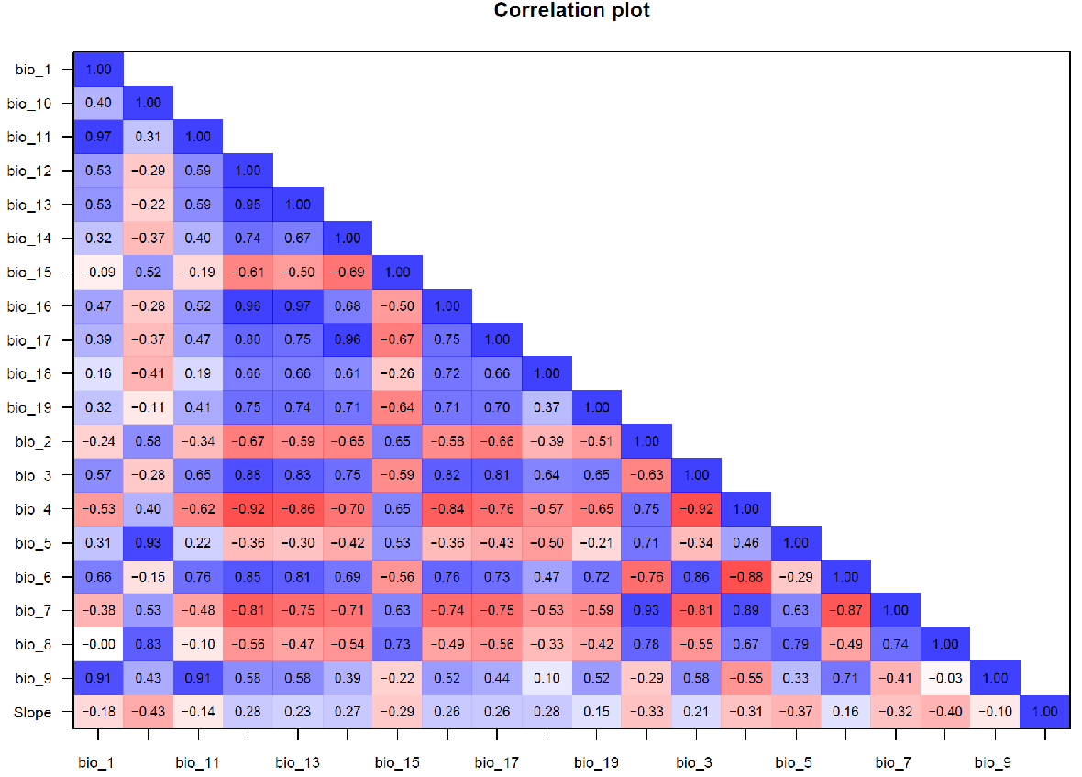

Fig. S1. Correlogram of environmental variables evaluated for the potential distribution models of A. germinans. Pearson correlation coefficients are shown.

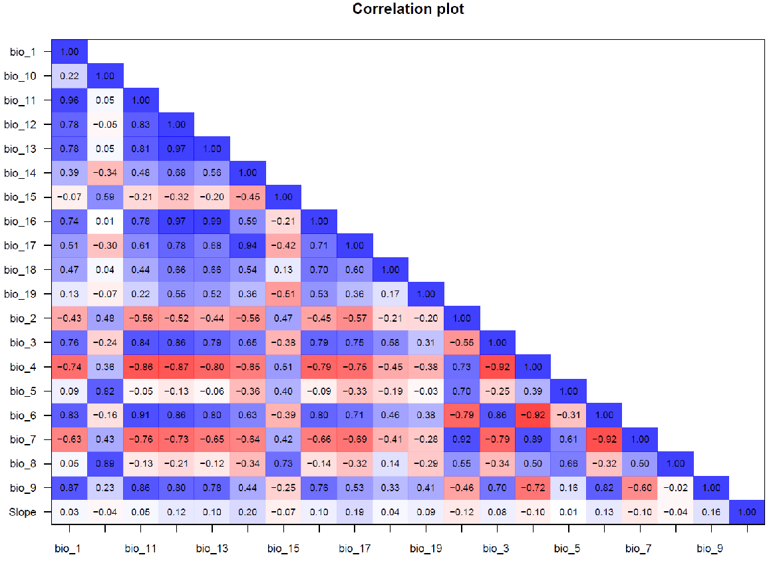

Fig. S2. Correlogram of environmental variables evaluated for the potential distribution models of L. racemosa. Pearson correlation coefficients are shown.

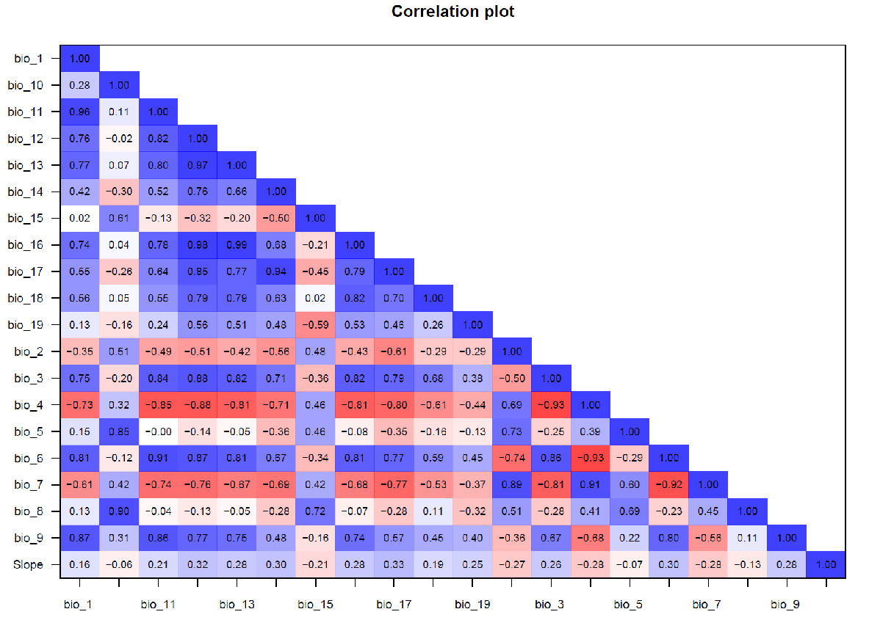

Fig. S3. Correlogram of environmental variables evaluated for the potential distribution models of R. mangle. Pearson correlation coefficients are shown

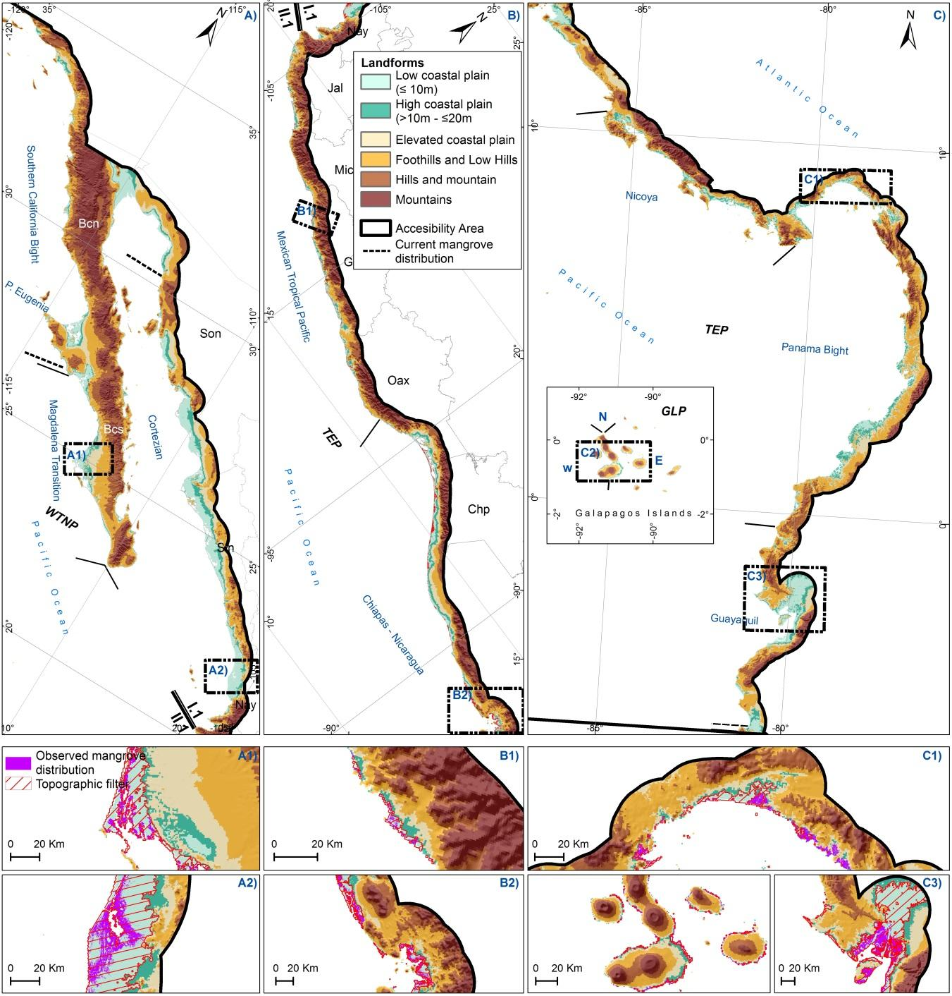
Fig. S4. Topographic heterogeneity across the Eastern Pacific provinces: A) Warm Temperate Northeast Pacific (WTNP), B) Tropical Eastern Pacific (TEP), and C) Galápagos Islands (GLP). The accessible area (M) includes low-elevation coastal plains interspersed with coastal relief. Insets illustrate representative mangrove systems, including the topographic filter and observed mangrove distribution [2]: A1) Bahía Magdalena, A2) Marismas Nacionales, and B1) San José Ixtapa–Juluchuca (Mexico); B2) Gulf of Fonseca (El Salvador); C1) Gulf of Panama (Panama); C2) Galápagos Islands and C3) Guayaquil Gulf (Ecuador).

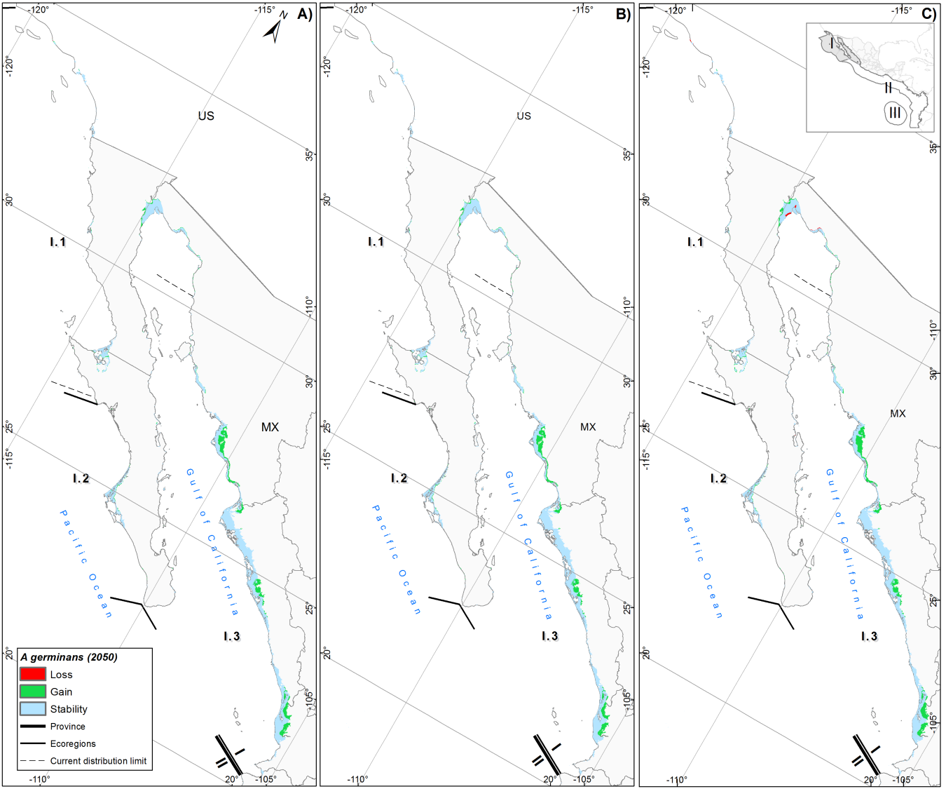

Fig. S5. Potential distribution of A. germinans in the Warm Temperate Northeast Pacific (WTNP) under three climate change scenarios for 2050: A) SSP2–4.5, B) SSP3–7.0, and C) SSP5–8.5. Ecoregions include: Southern California Bight (I.1), Magdalena Transition (I.2), and Cortezian (I.3).

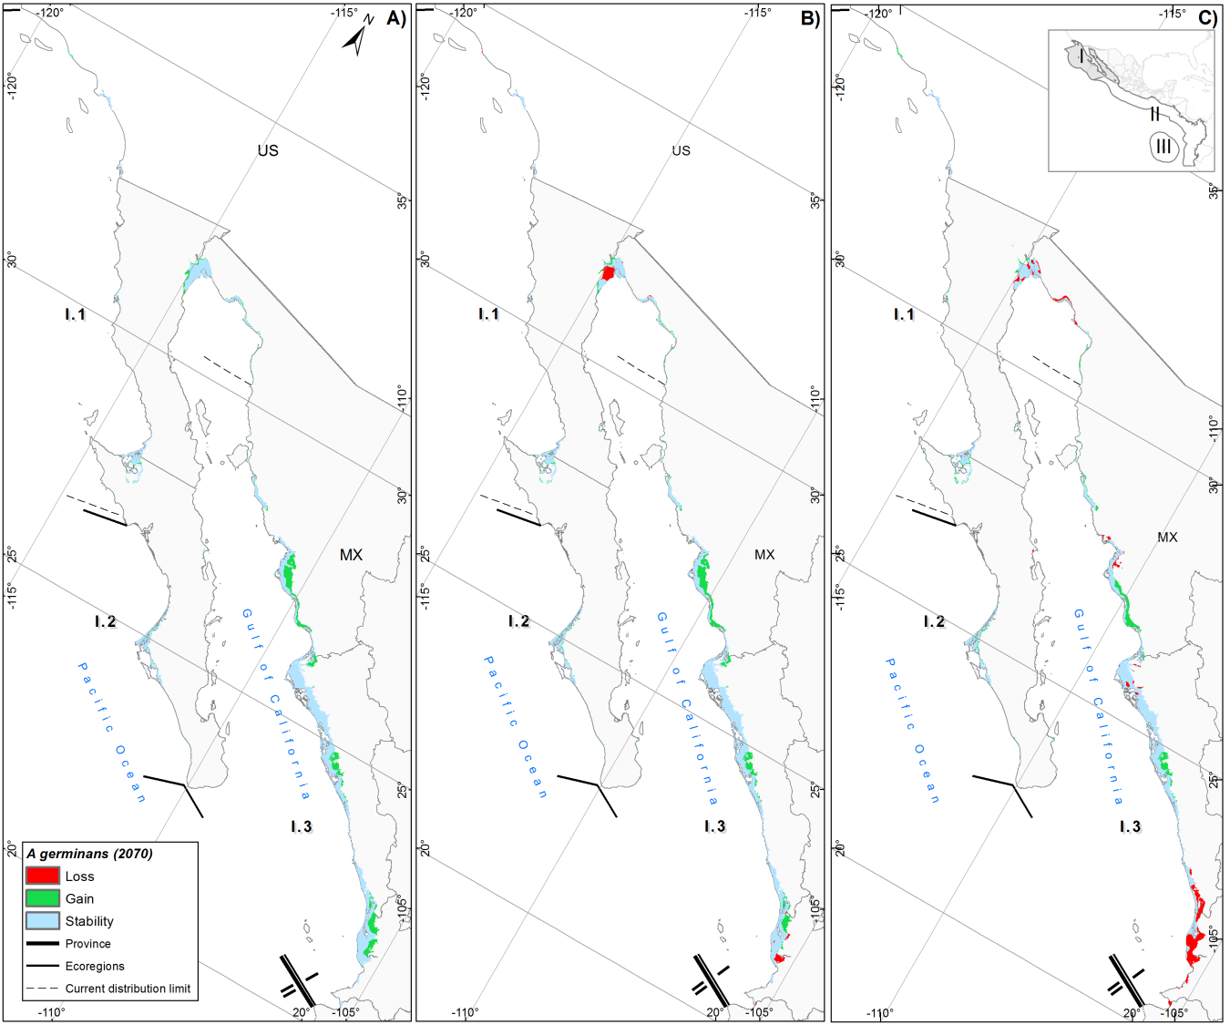

Fig. S6. Potential distribution of A. germinans in the Warm Temperate Northeast Pacific (WTNP) under three climate change scenarios for 2070: A) SSP2–4.5, B) SSP3–7.0, and C) SSP5–8.5. Ecoregions include Southern California Bight (I.1), Magdalena Transition (I.2), and Cortezian (I.3)

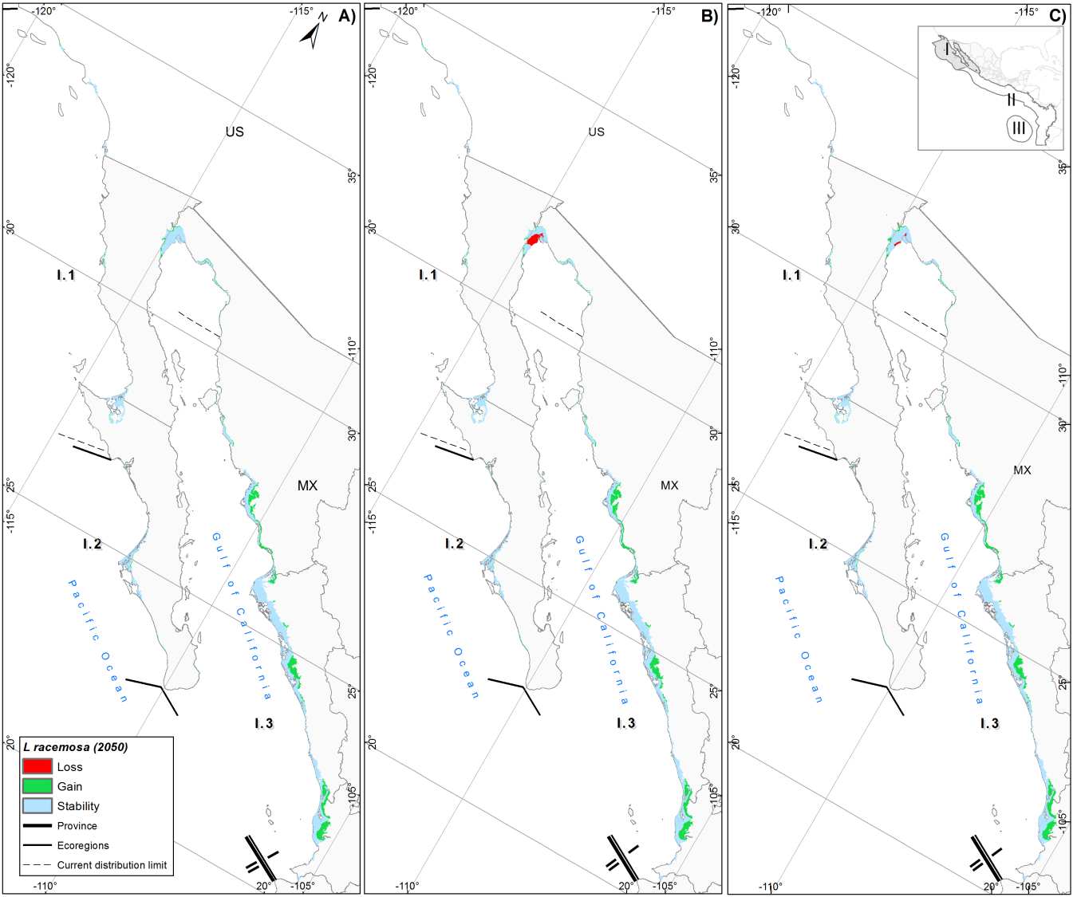

Fig. S7. Potential distribution of L. racemosa in Warm Temperate Northeast Pacific (WTNP) under three climate change scenarios for 2050: A) SSP2–4.5, B) SSP3–7.0, and C) SSP5–8.5. Ecoregions include: Southern California Bight (I.1), Magdalena Transition (I.2), and Cortezian (I.3).

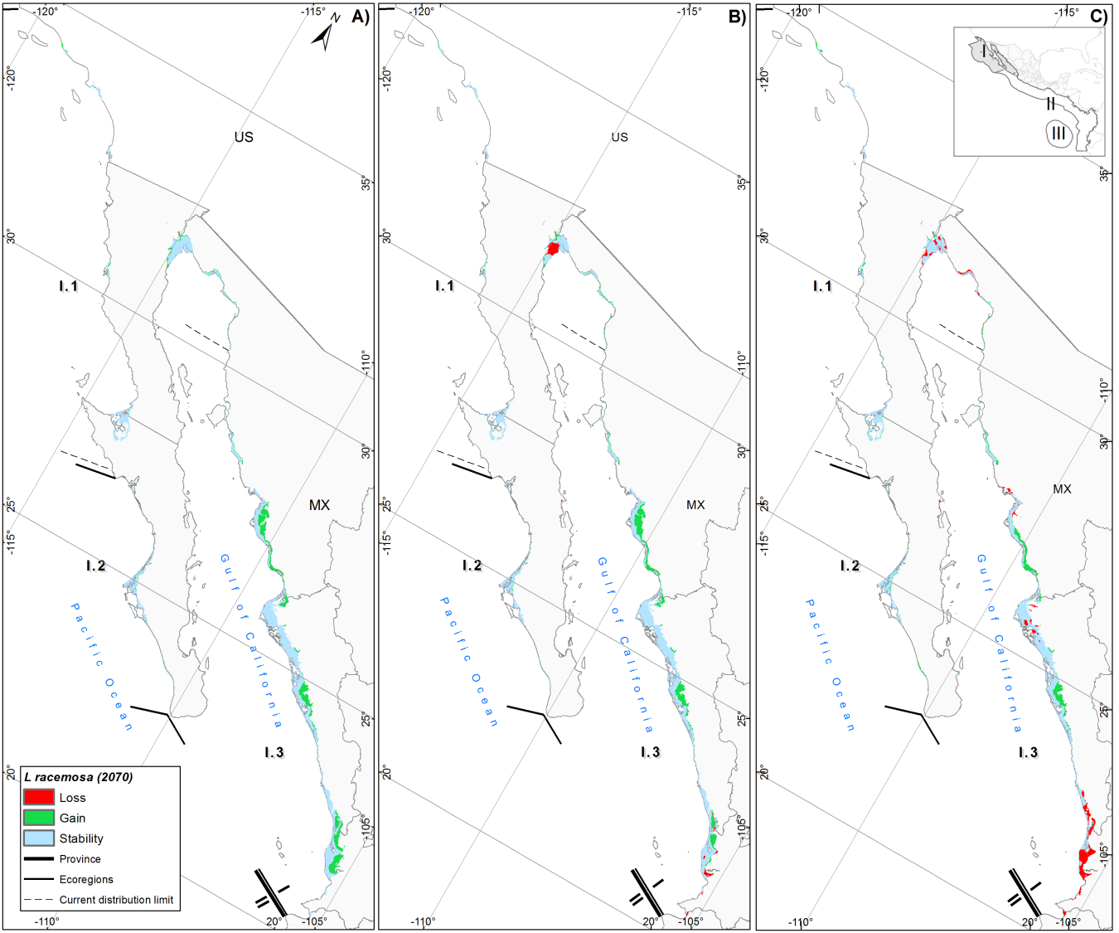

Fig. S8. Potential distribution of L. racemosa in Warm Temperate Northeast Pacific (WTNP) under three climate change scenarios for 2070: A) SSP2–4.5, B) SSP3–7.0, and C) SSP5–8.5. Ecoregions are indicated: Southern California Bight (I.1), Magdalena Transition (I.2), and Cortezian (I.3).

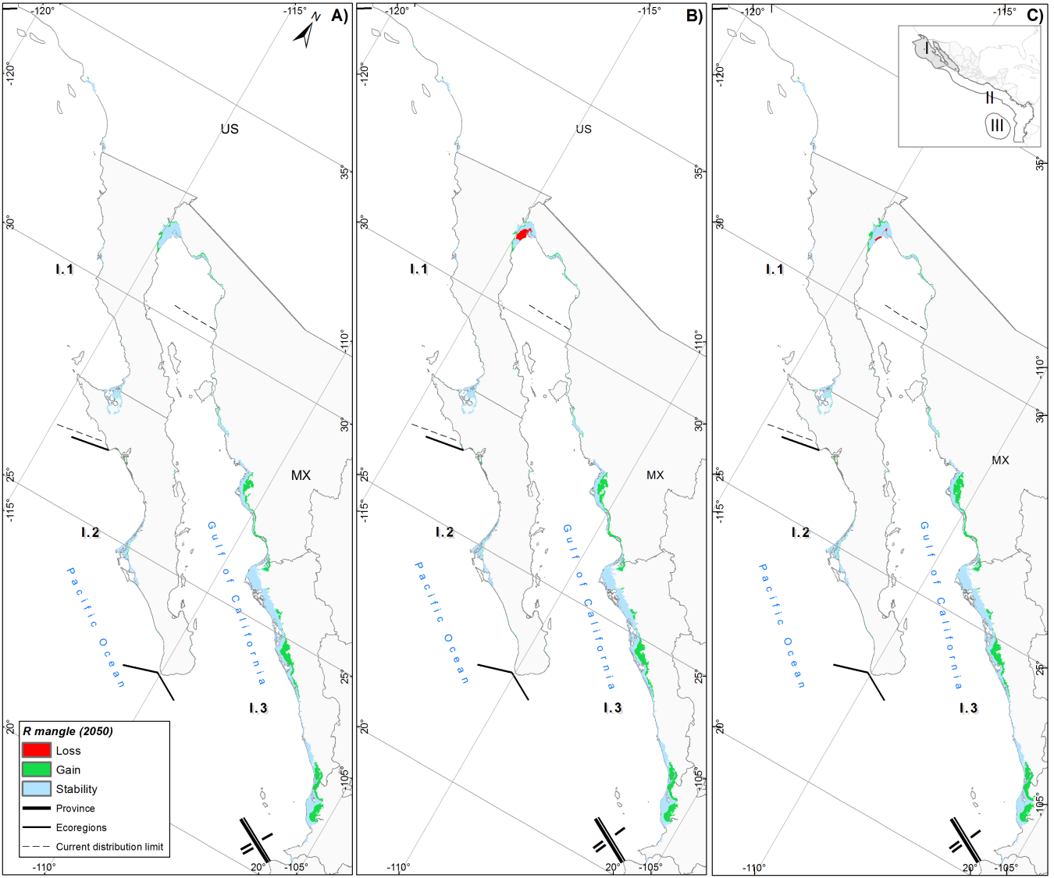

Fig. S9. Potential distribution of R. mangle in the Warm Temperate Northeast Pacific (WTNP) under three climate change scenarios for 2050: A) SSP2–4.5, B) SSP3–7.0, and C) SSP5–8.5. Ecoregions include: Southern California Bight (I.1), Magdalena Transition (I.2), and Cortezian (I.3).

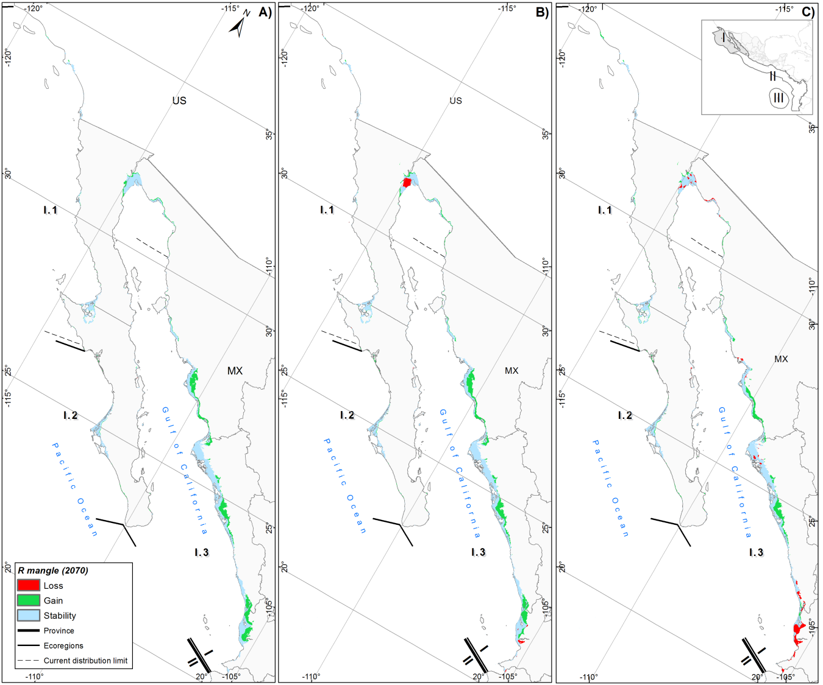

Fig. S10. Potential distribution of R. mangle in the Warm Temperate Northeast Pacific (WTNP) under three climate change scenarios for 2070: A) SSP2–4.5, B) SSP3–7.0, and C) SSP5–8.5. Ecoregions include: Southern California Bight (I.1), Magdalena Transition (I.2), and Cortezian (I.3).

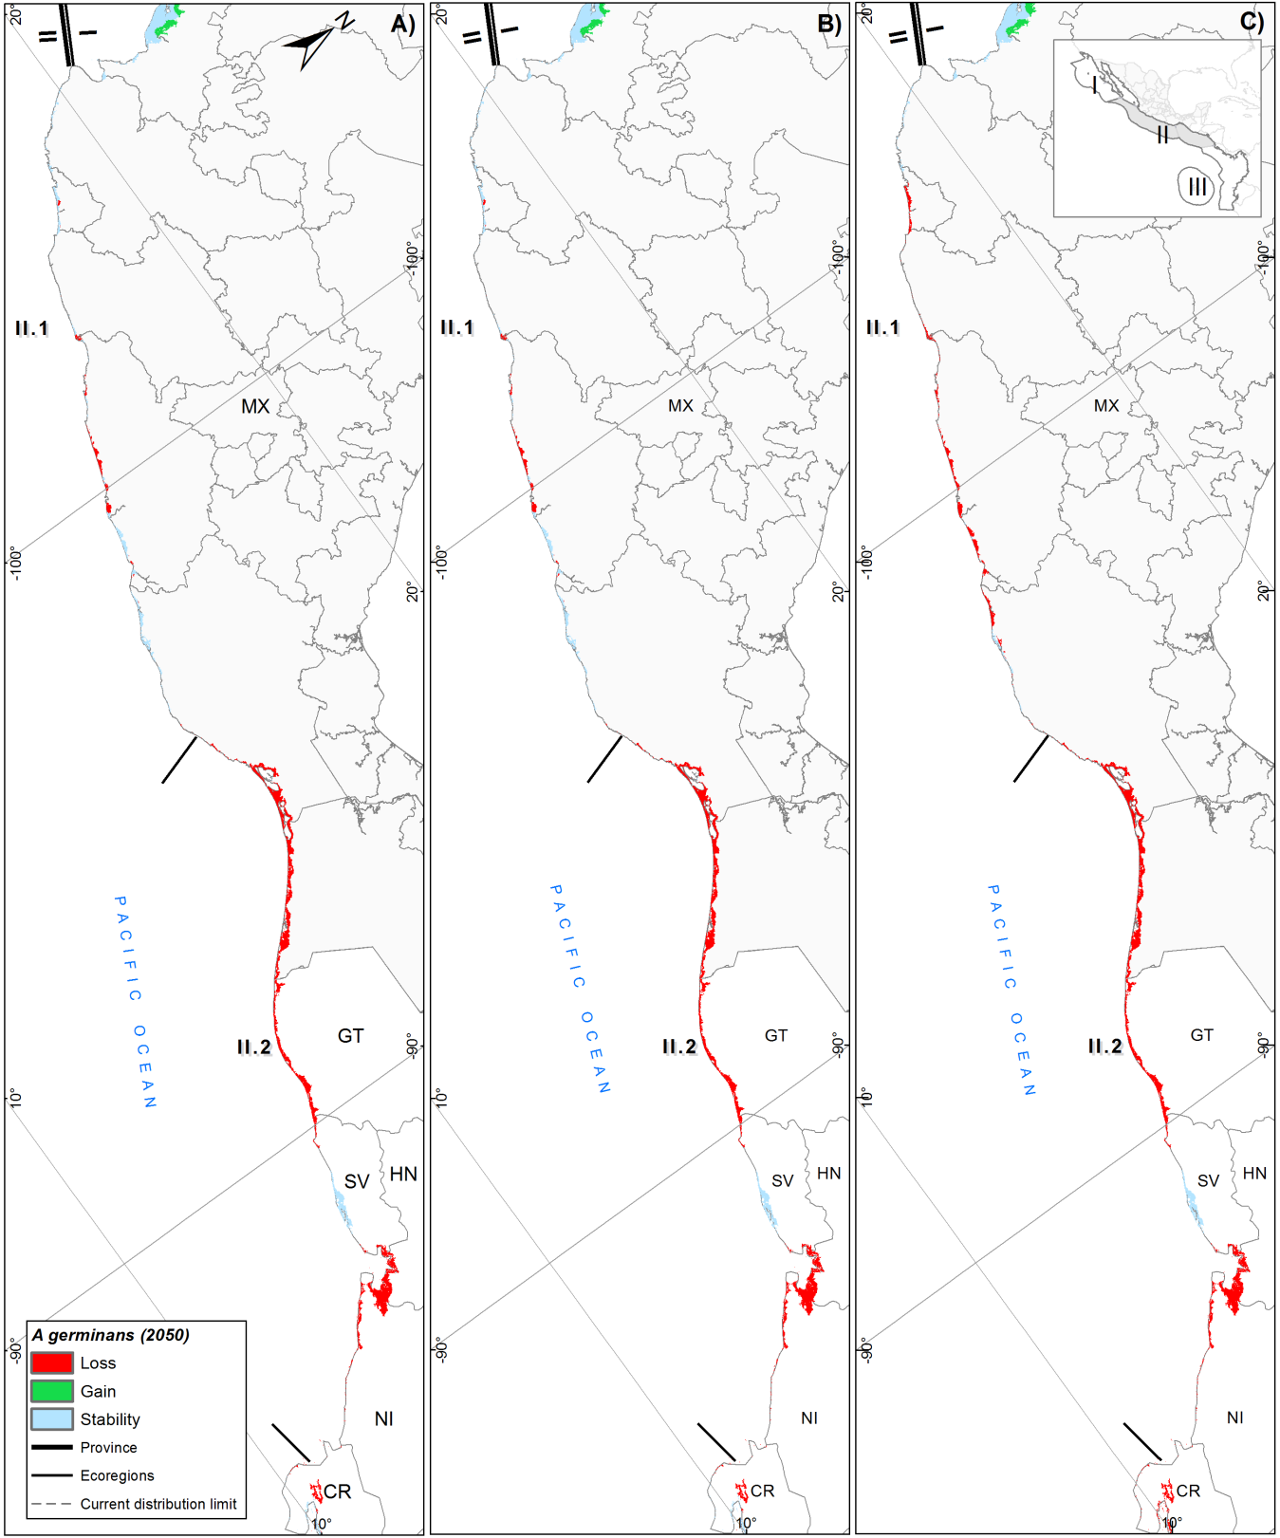

Fig. S11. Potential distribution of A. germinans in the Tropical Eastern Pacific (TEP) under three climate change scenarios for 2050: A) SSP2–4.5, B) SSP3–7.0, and C) SSP5–8.5. Ecoregions include: Mexican Tropical Pacific (II.1), Chiapas–Nicaragua (II.2).

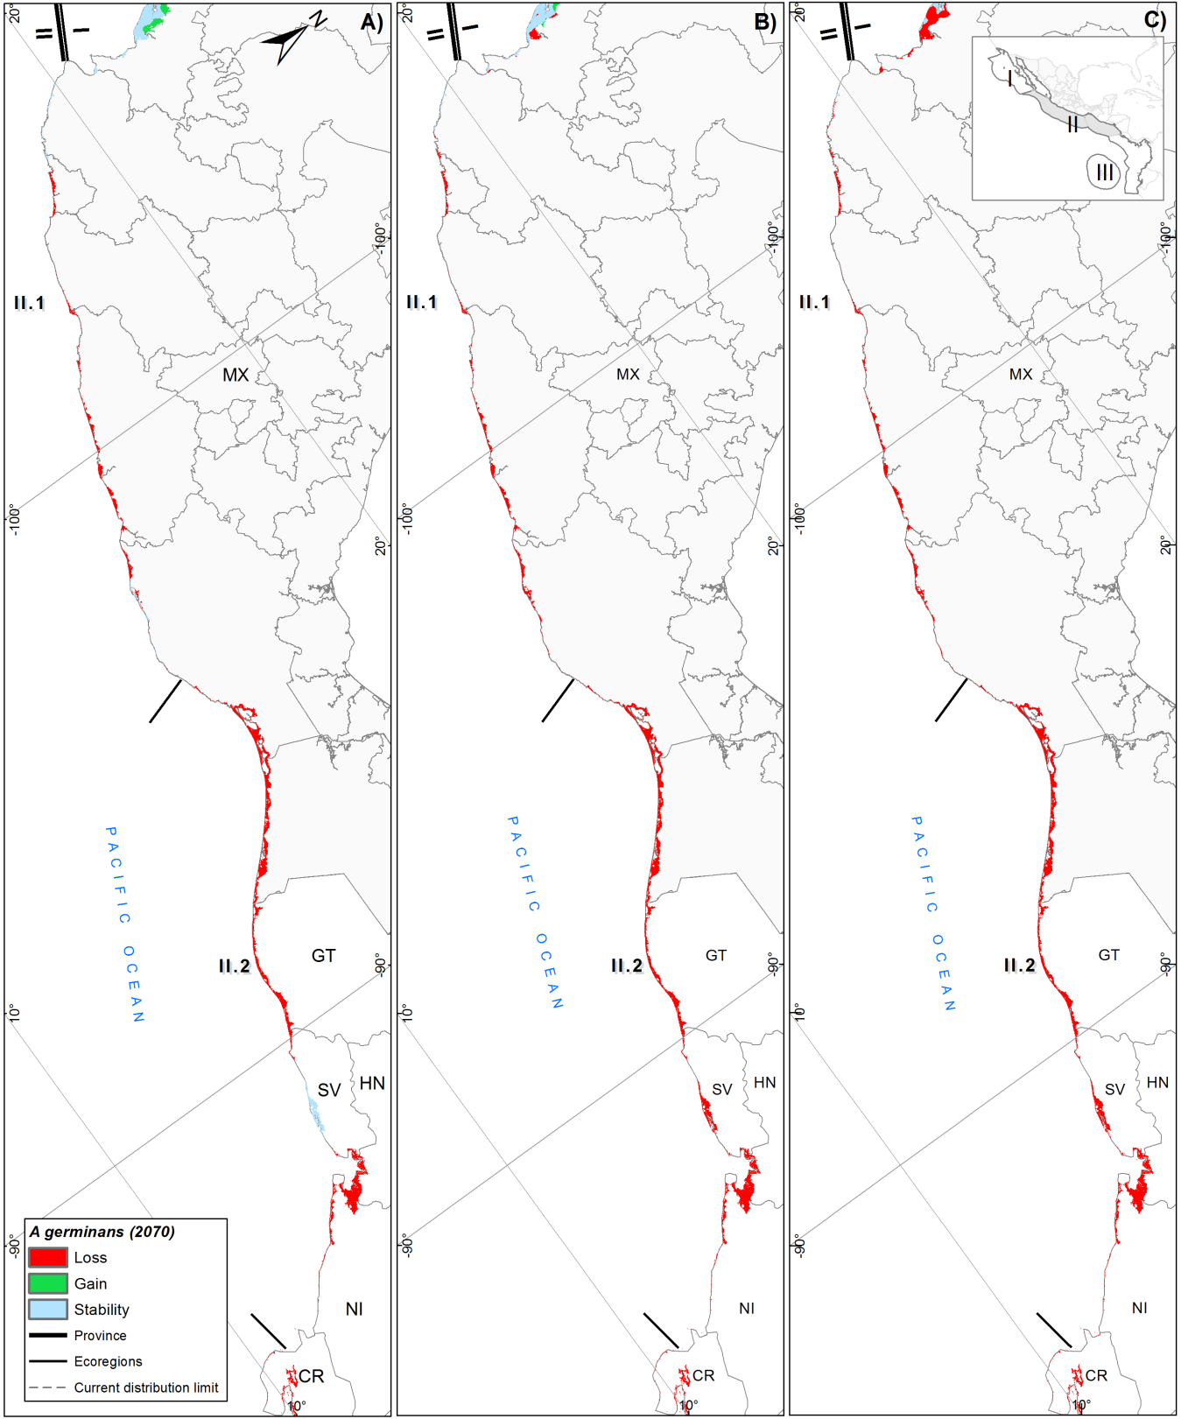

Fig. S12. Potential distribution of A. germinans in the Tropical Eastern Pacific (TEP) under three climate change scenarios for 2070: A) SSP2–4.5, B) SSP3–7.0, and C) SSP5–8.5. Ecoregions include: Mexican Tropical Pacific (II.1), Chiapas–Nicaragua (II.2).
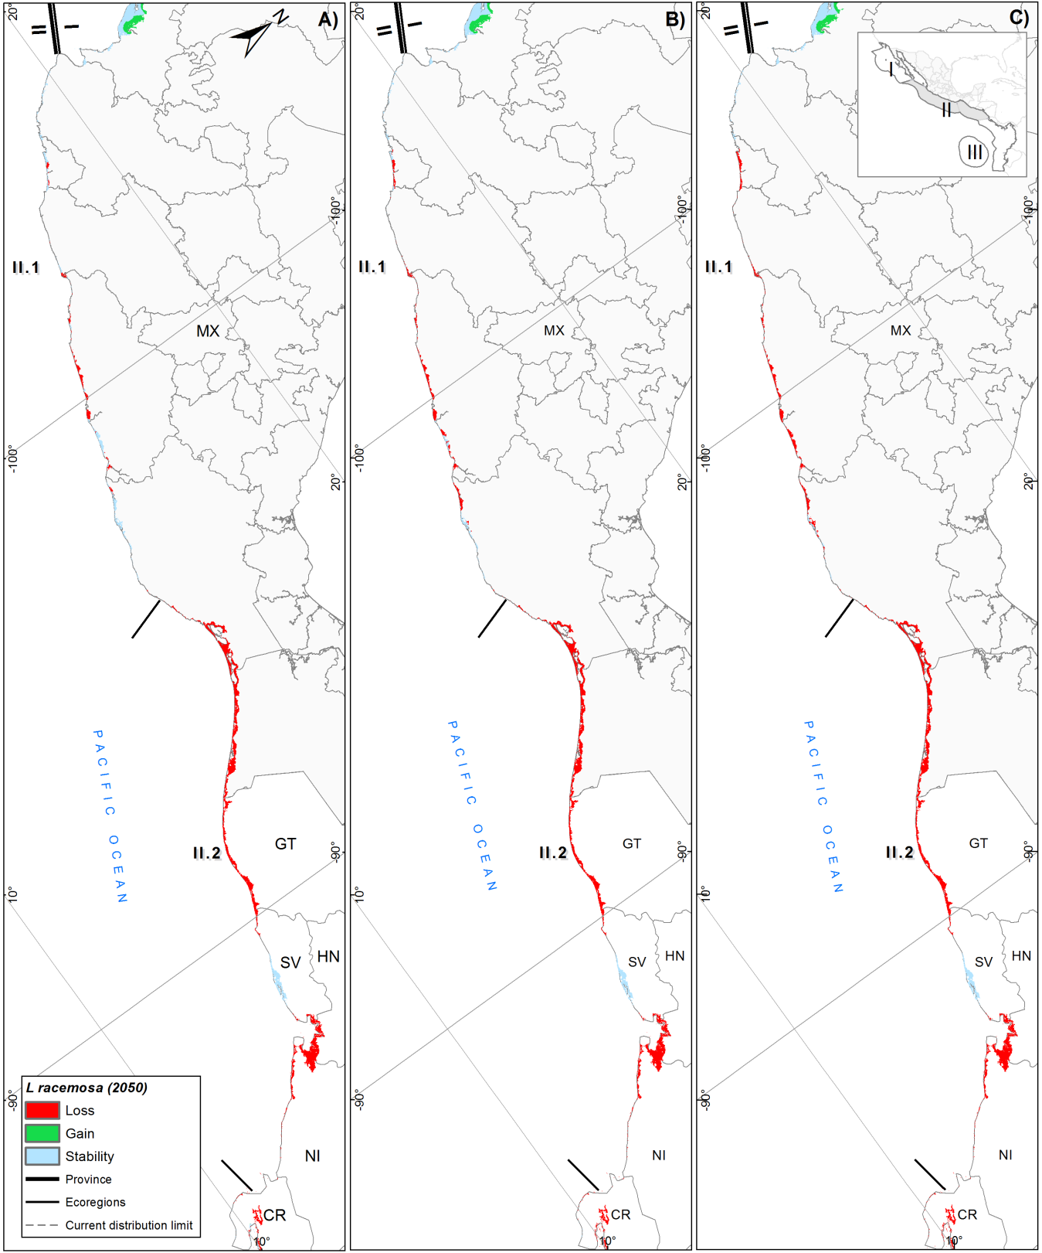

Fig. S13. Potential distribution of L. racemosa in the Tropical Eastern Pacific (TEP) under three climate change scenarios for 2050: A) SSP2–4.5, B) SSP3–7.0, and C) SSP5–8.5. Ecoregions include: Mexican Tropical Pacific (II.1), Chiapas–Nicaragua (II.2).
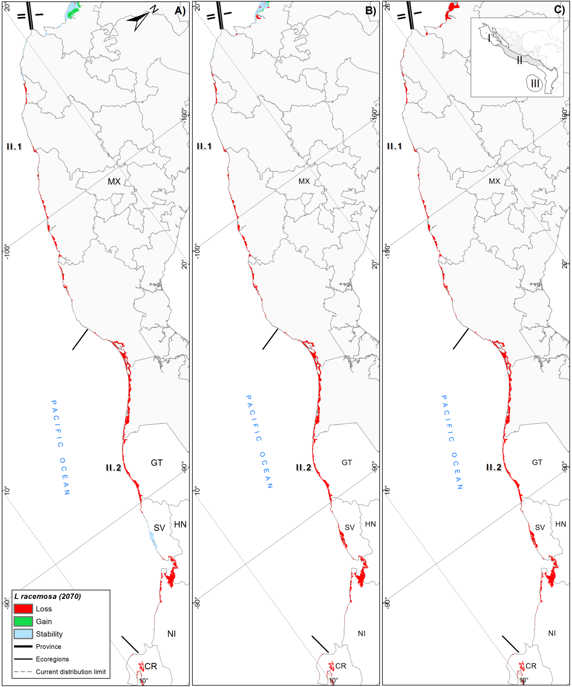

Fig. S14. Potential distribution of L. racemosa in the Tropical Eastern Pacific (TEP) under three climate change scenarios for 2070: A) SSP2–4.5, B) SSP3–7.0, and C) SSP5–8.5. Ecoregions include: Mexican Tropical Pacific (II.1), Chiapas–Nicaragua (II.2).
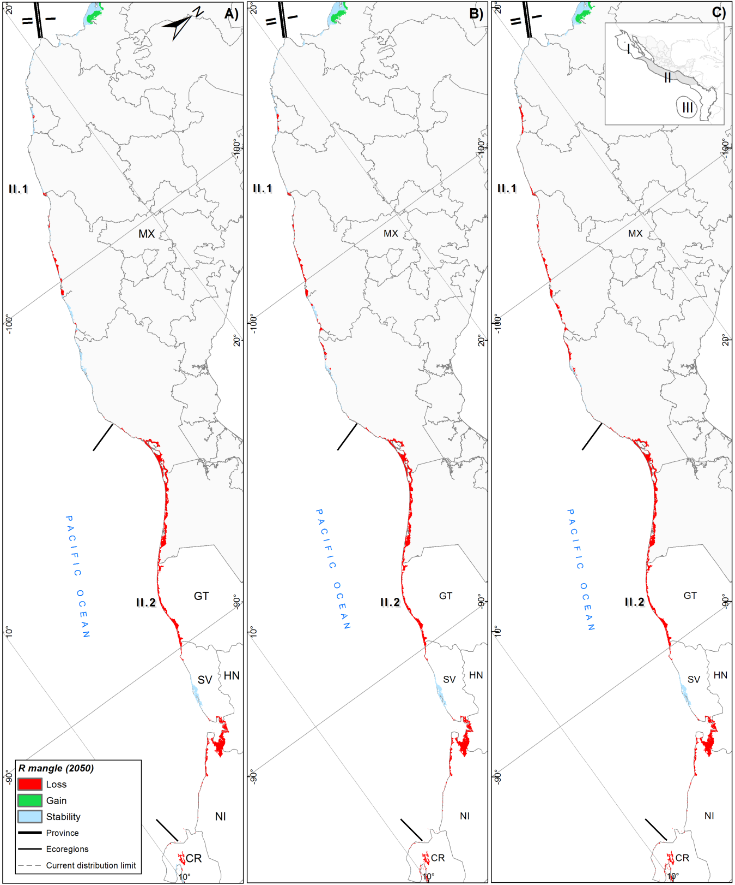

Fig. S15. Potential distribution of R. mangle in the Tropical Eastern Pacific (TEP) under three climate change scenarios for 2050: A) SSP2–4.5, B) SSP3–7.0, and C) SSP5–8.5. Ecoregions include: Mexican Tropical Pacific (II.1), Chiapas–Nicaragua (II.2).
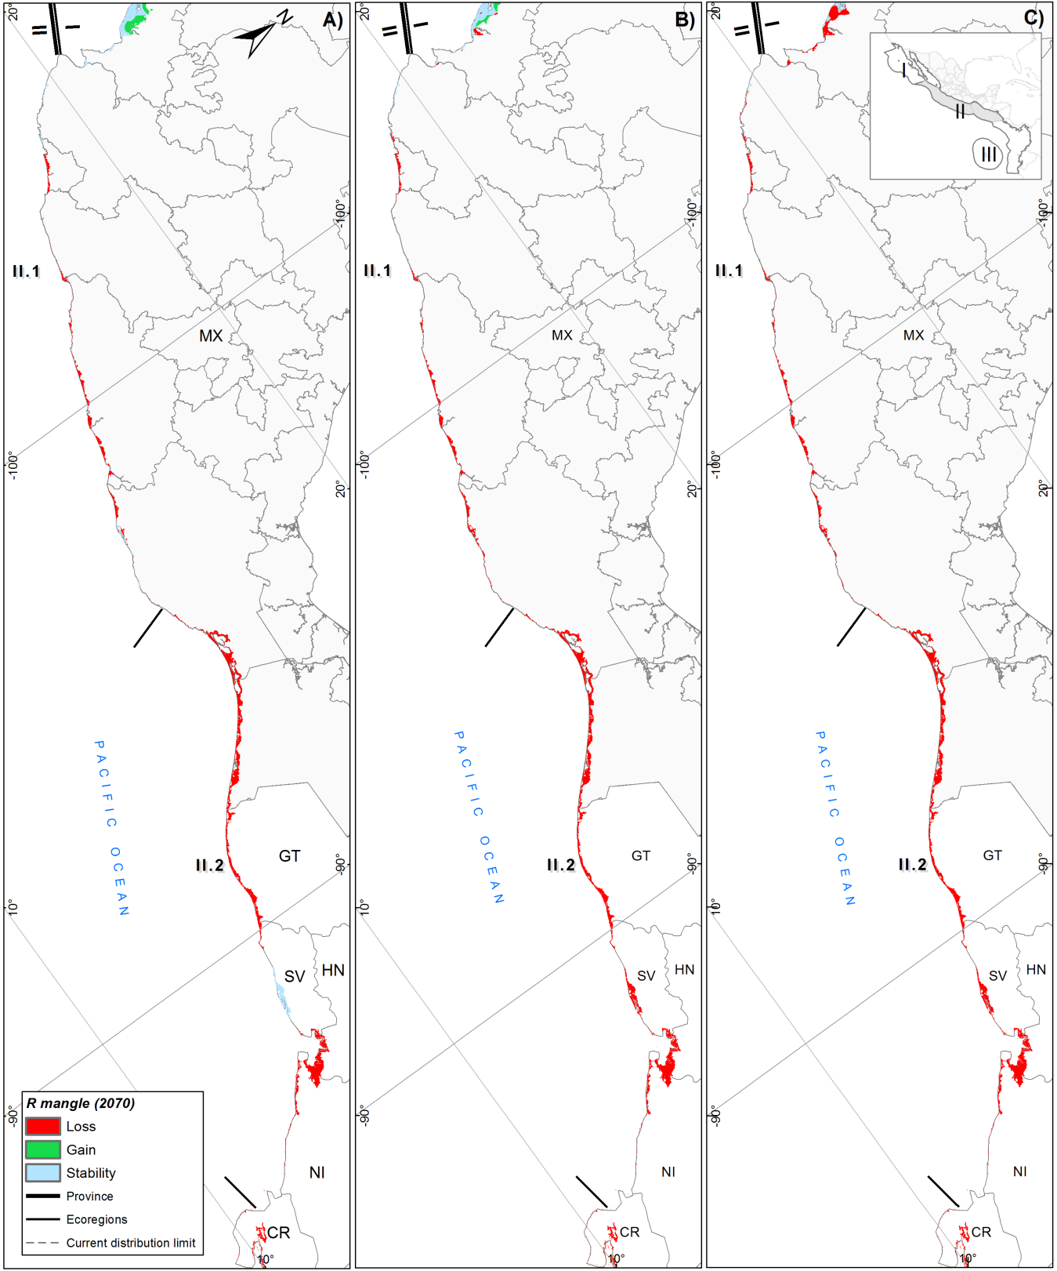

Fig. S16. Potential distribution of R. mangle in the Tropical Eastern Pacific (TEP) under three climate change scenarios for 2070: A) SSP2–4.5, B) SSP3–7.0, and C) SSP5–8.5. Ecoregions include: Mexican Tropical Pacific (II.1), Chiapas–Nicaragua (II.2).
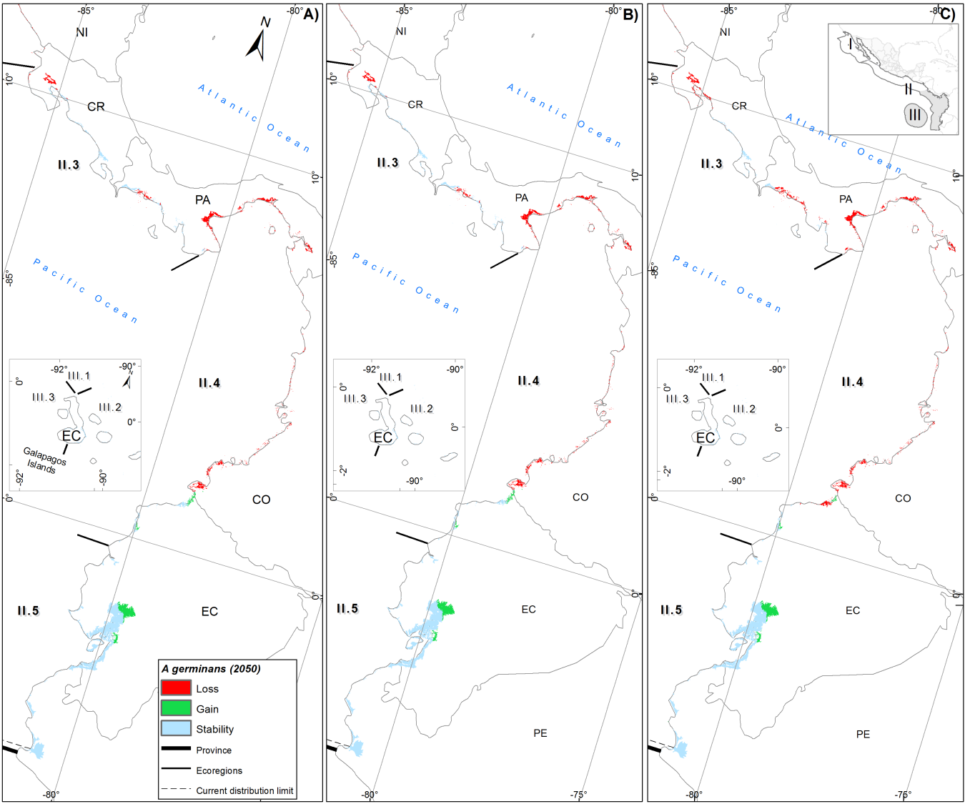

Fig. S17. Potential distribution of A. germinans in the Tropical Eastern Pacific (TEP), including the Galápagos Province inset (GLP), under three climate change scenarios for 2050: A) SSP2–4.5, B) SSP3–7.0, and C) SSP5–8.5. Ecoregions include: Nicoya (II.3), Panama Bight (II.4), and Guayaquil (II.5).

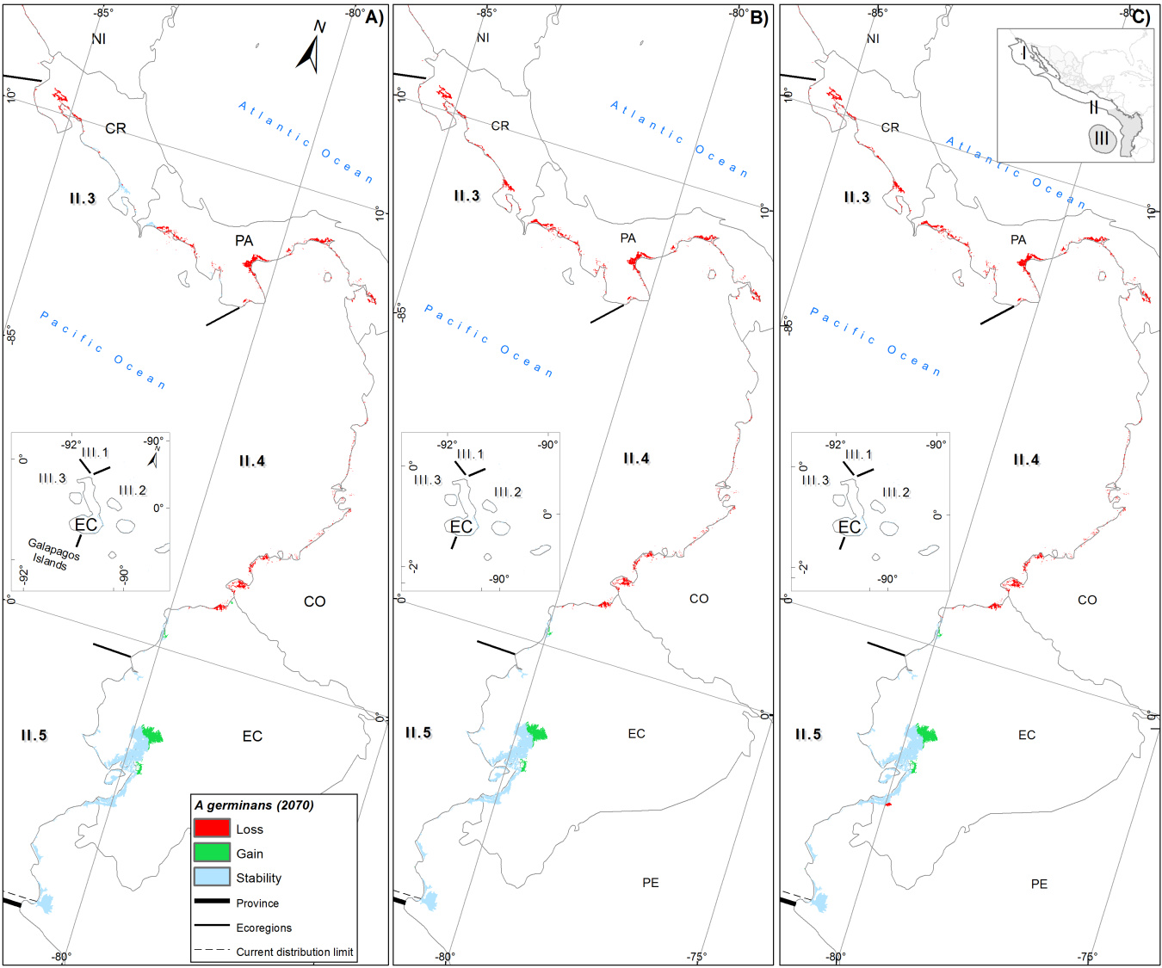

Fig. S18. Potential distribution of A. germinans in the Tropical Eastern Pacific (TEP), including the Galápagos Province inset (GLP), under three climate change scenarios for 2070: A) SSP2–4.5, B) SSP3–7.0, and C) SSP5–8.5. Ecoregions include: Nicoya (II.3), Panama Bight (II.4), and Guayaquil (II.5).

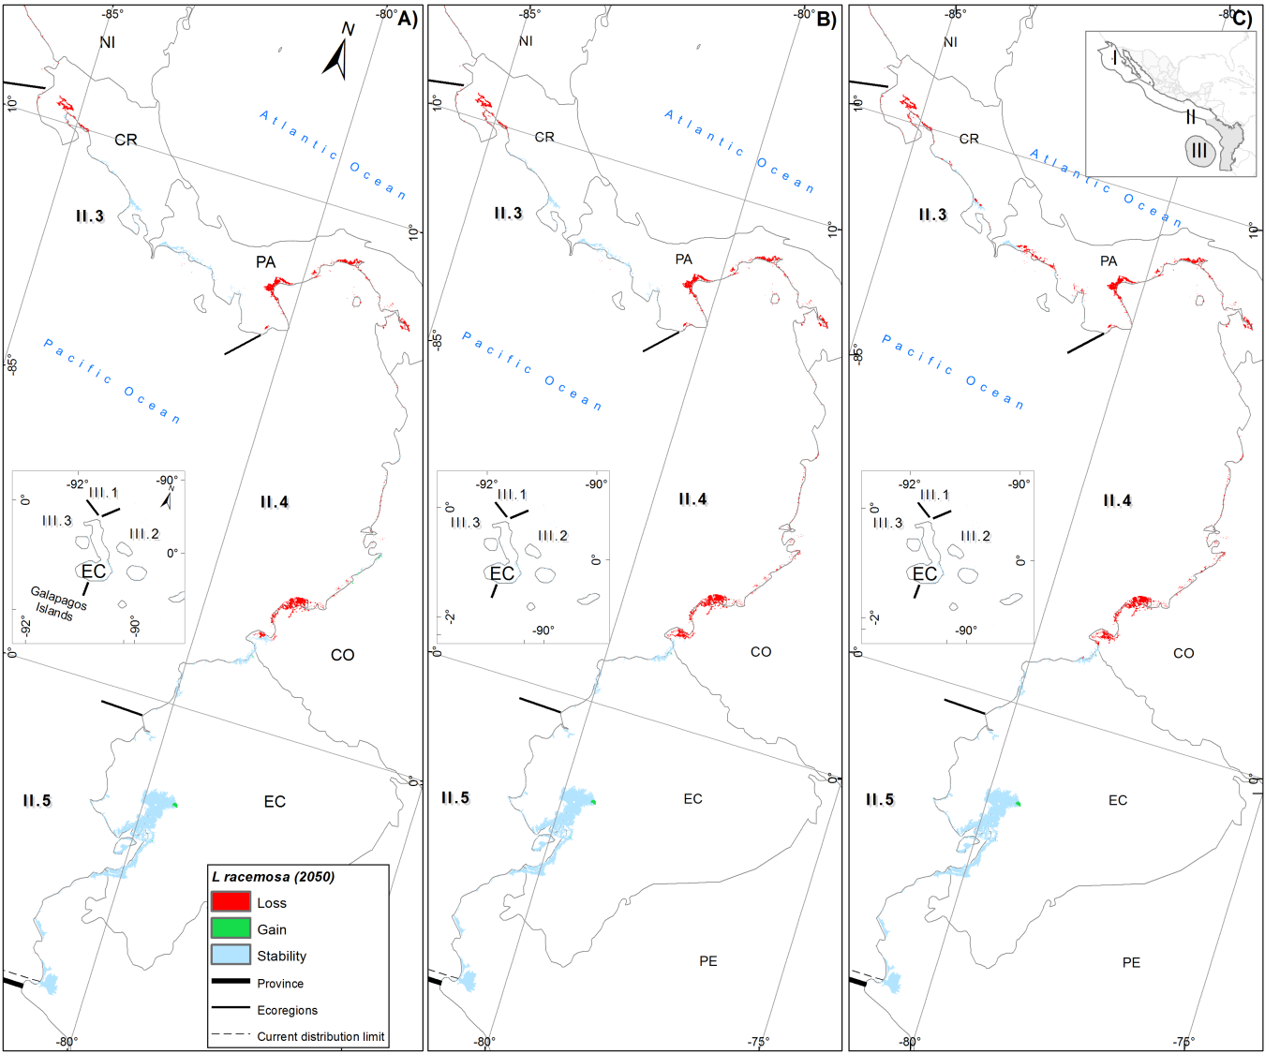

Fig. S19. Potential distribution of L. racemosa in the Tropical Eastern Pacific (TEP), including the Galápagos Province inset (GLP), under three climate change scenarios for 2050: A) SSP2–4.5, B) SSP3–7.0, and C) SSP5–8.5. Ecoregions include: Nicoya (II.3), Panama Bight (II.4), and Guayaquil (II.5).

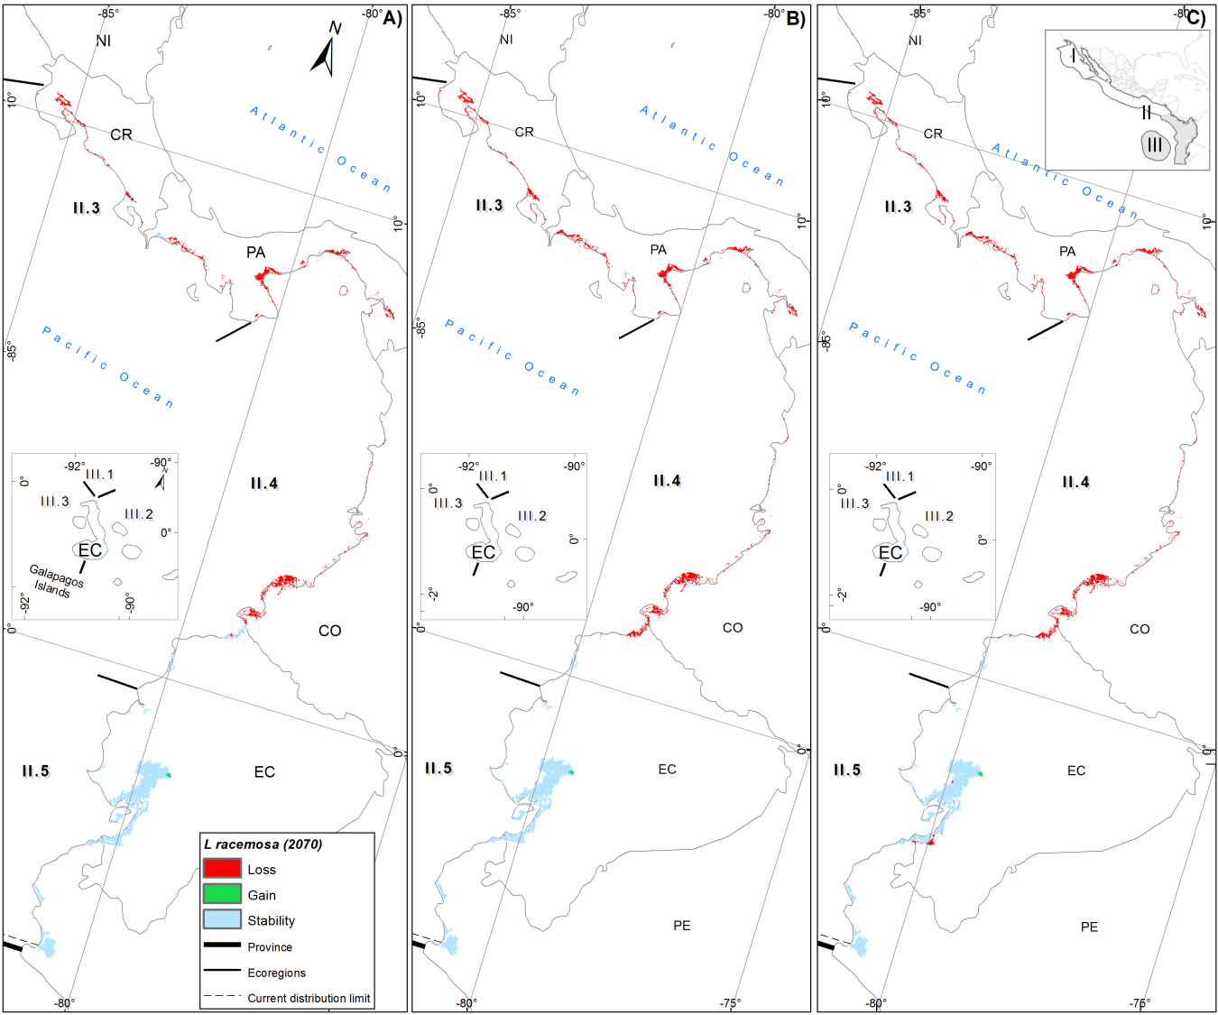

Fig. S20. Potential distribution of L. racemosa in the Tropical Eastern Pacific (TEP), including the Galápagos Province inset (GLP), under three climate change scenarios for 2070: A) SSP2–4.5, B) SSP3–7.0, and C) SSP5–8.5. Ecoregions include: Nicoya (II.3), Panama Bight (II.4), and Guayaquil (II.5).

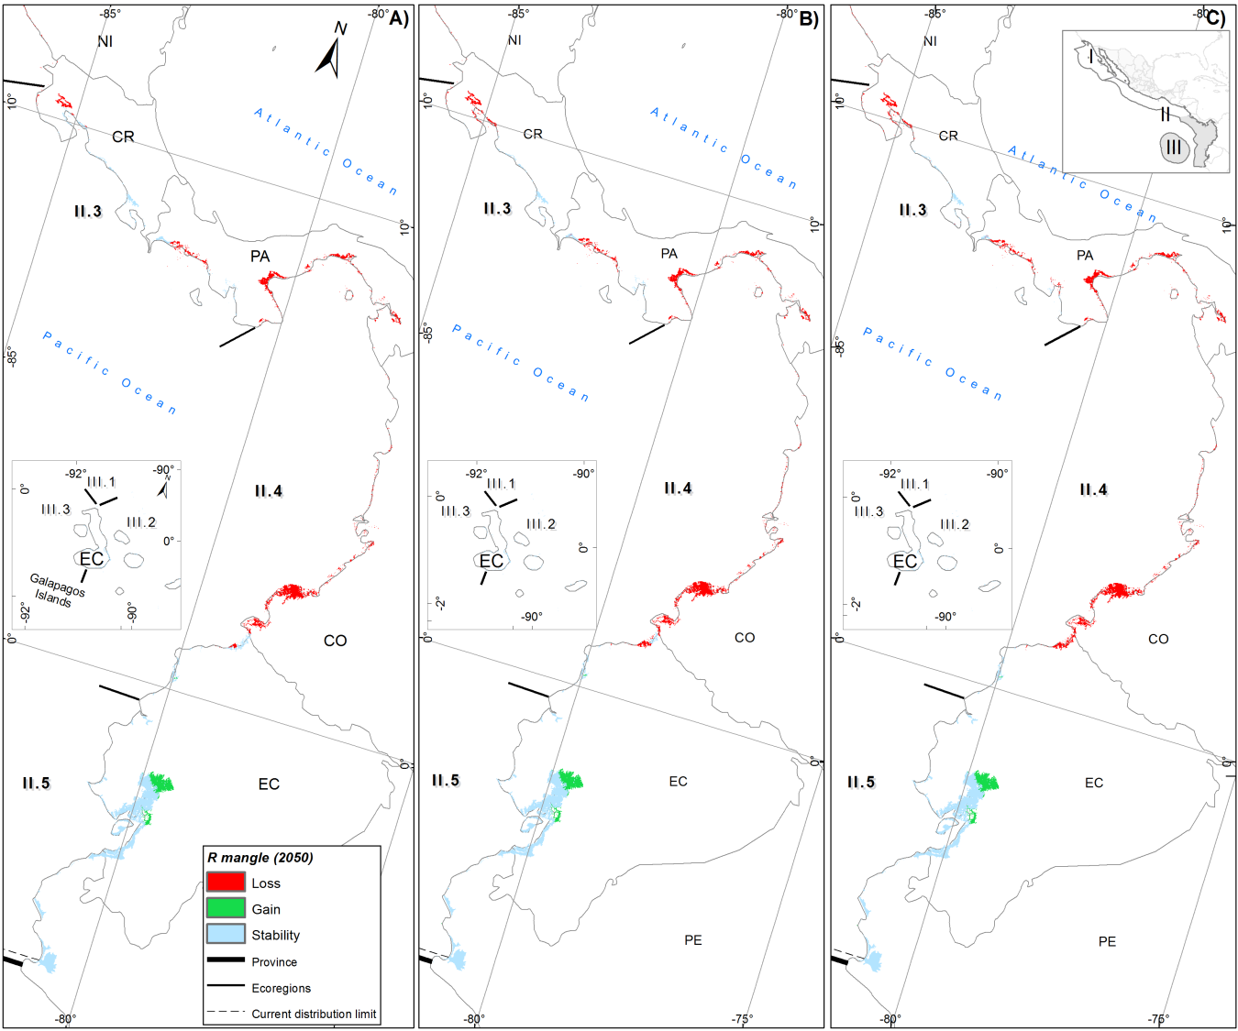

Fig. S21. Potential distribution of R. mangle in the Tropical Eastern Pacific (TEP), including the Galápagos Province inset (GLP), under three climate change scenarios for 2050: A) SSP2–4.5, B) SSP3–7.0, and C) SSP5–8.5. Ecoregions include: Nicoya (II.3), Panama Bight (II.4), and Guayaquil (II.5).

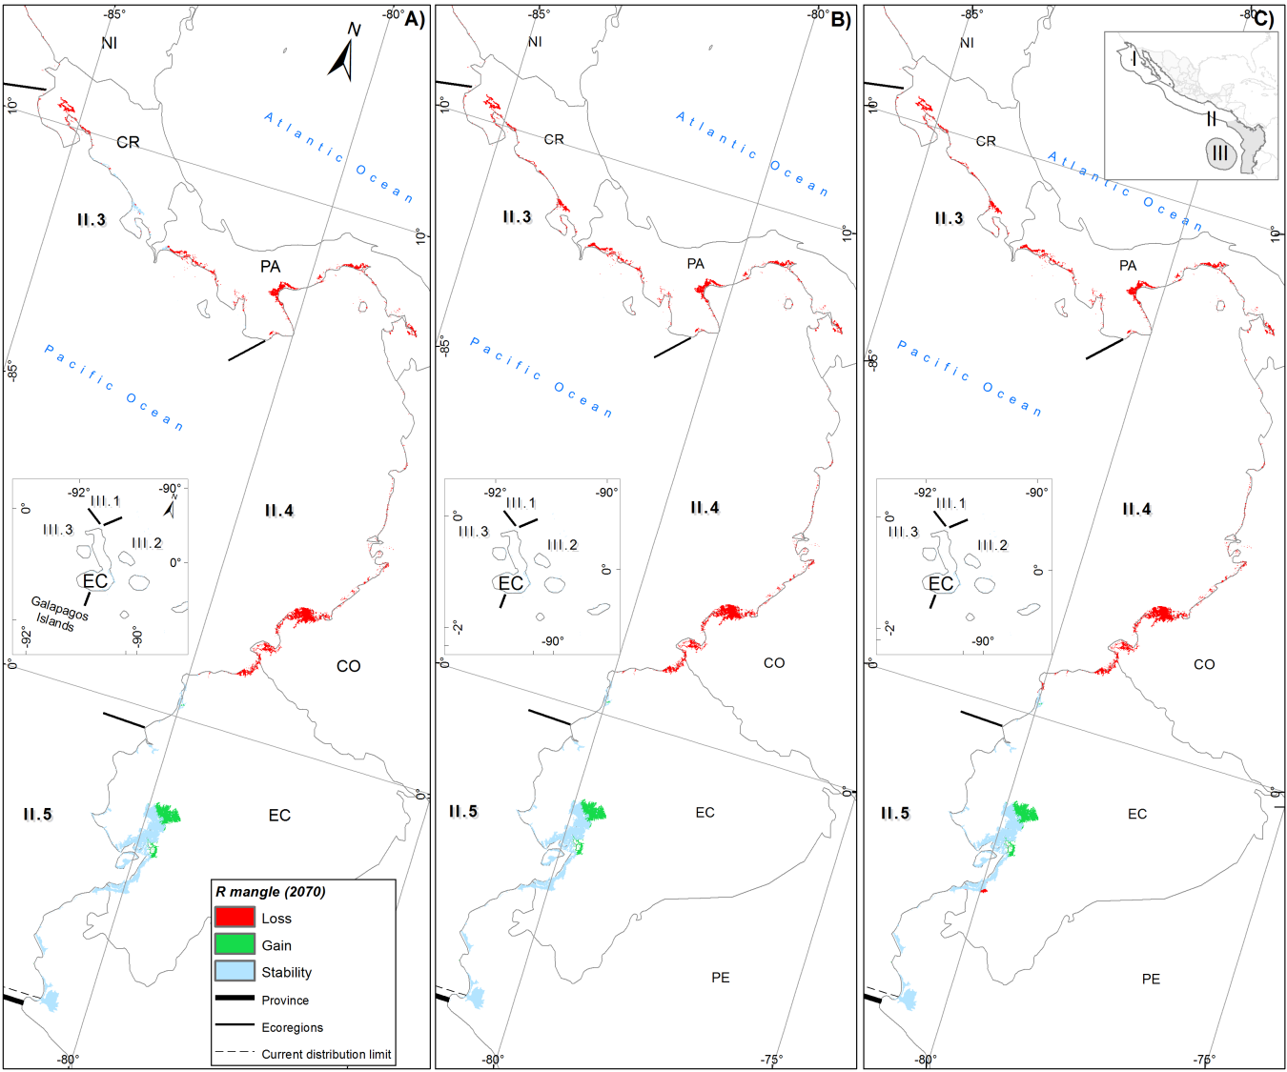

Fig. S22. Potential distribution of R. mangle in the Tropical Eastern Pacific (TEP), including the Galápagos Province inset (GLP), under three climate change scenarios for 2070: A) SSP2–4.5, B) SSP3–7.0, and C) SSP5–8.5. Ecoregions include: Nicoya (II.3), Panama Bight (II.4), and Guayaquil (II.5).

