Supplementary information for

Statistical evidence for the Mediterranean response to the 2012 North Atlantic great salinity anomaly

by

Gian Luca Eusebi Borzelli^{(1*)}, Sandro Carniel⁽²⁾, Ernesto Napolitano⁽³⁾, Cosimo Enrico Carniel⁽⁴⁾ Mauro Sclavo⁽²⁾

¹Center for Remote Sensing of the Earth (CeRSE), Rome Italy; ²CNR, Istituto di Scienze Polari, Venezia Italy; ³ENEA-SSP-CLIMAR-MSC, Via Anguillarese 301, Rome Italy; ⁴Institute for Atmospheric and Climate Sciences, ETH Zürich, Zurich, Switzerland.

This supplementary material contains three figures and provides details on the geographic locations mentioned in the text and statistical analysis complementary to those presented in the main text. Figure S1 shows the geography and main current patterns of the study regions. Figure S2 shows the lead-and-lag analysis between the PCs of the SVD analysis in the Mediterranean and SPNA. Figure S3 displays the statistical significance of the linear fitting (i.e. t-test for the halosteric and thermosteric coefficients).

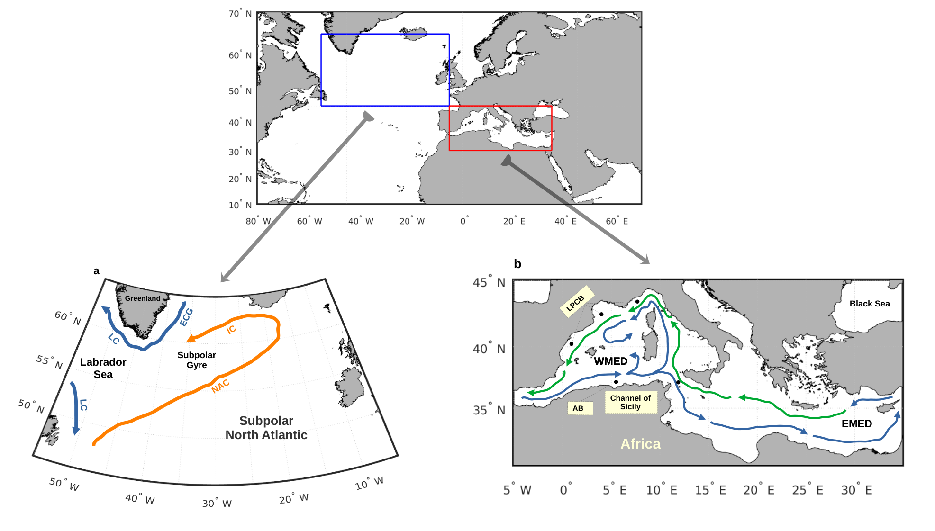
Figure S1. Geography and main current patterns of the study regions. a) Subpolar North Atlantic (SPNA); NAC, North Atlantic Current; IC, Irminger Current; ECG, East Greenland Current; LC, Labrador Current. b) Mediterranea Sea; WMED, Western Mediterranean; EMED, Eastern Mediterranean; AB, Algerian Basin; LPCB, Liguro-Provencal-Catalan basin. Blue arrow: route of Atlantic water; green arrow: route of Levantine water.

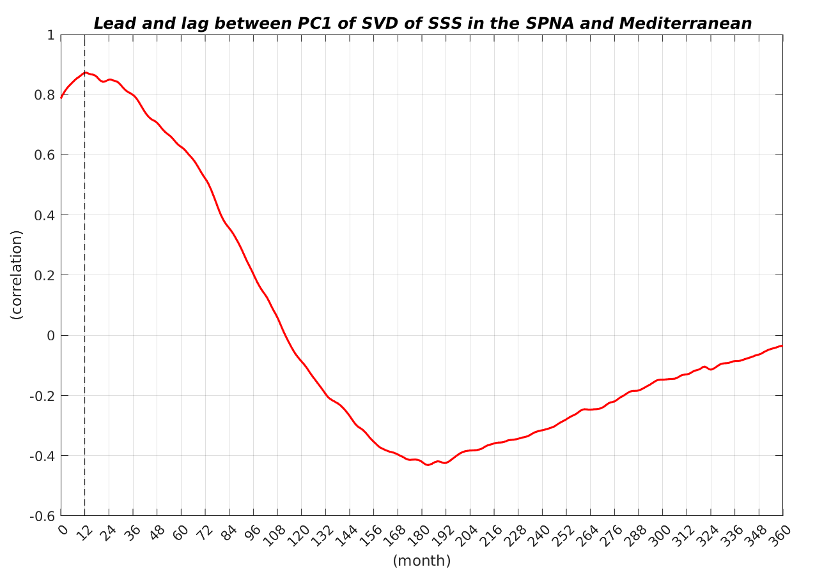
Figure S2. Lead-and-lag analysis between the PCs of the Mediterranean-SPNA SSS covariance matrix.
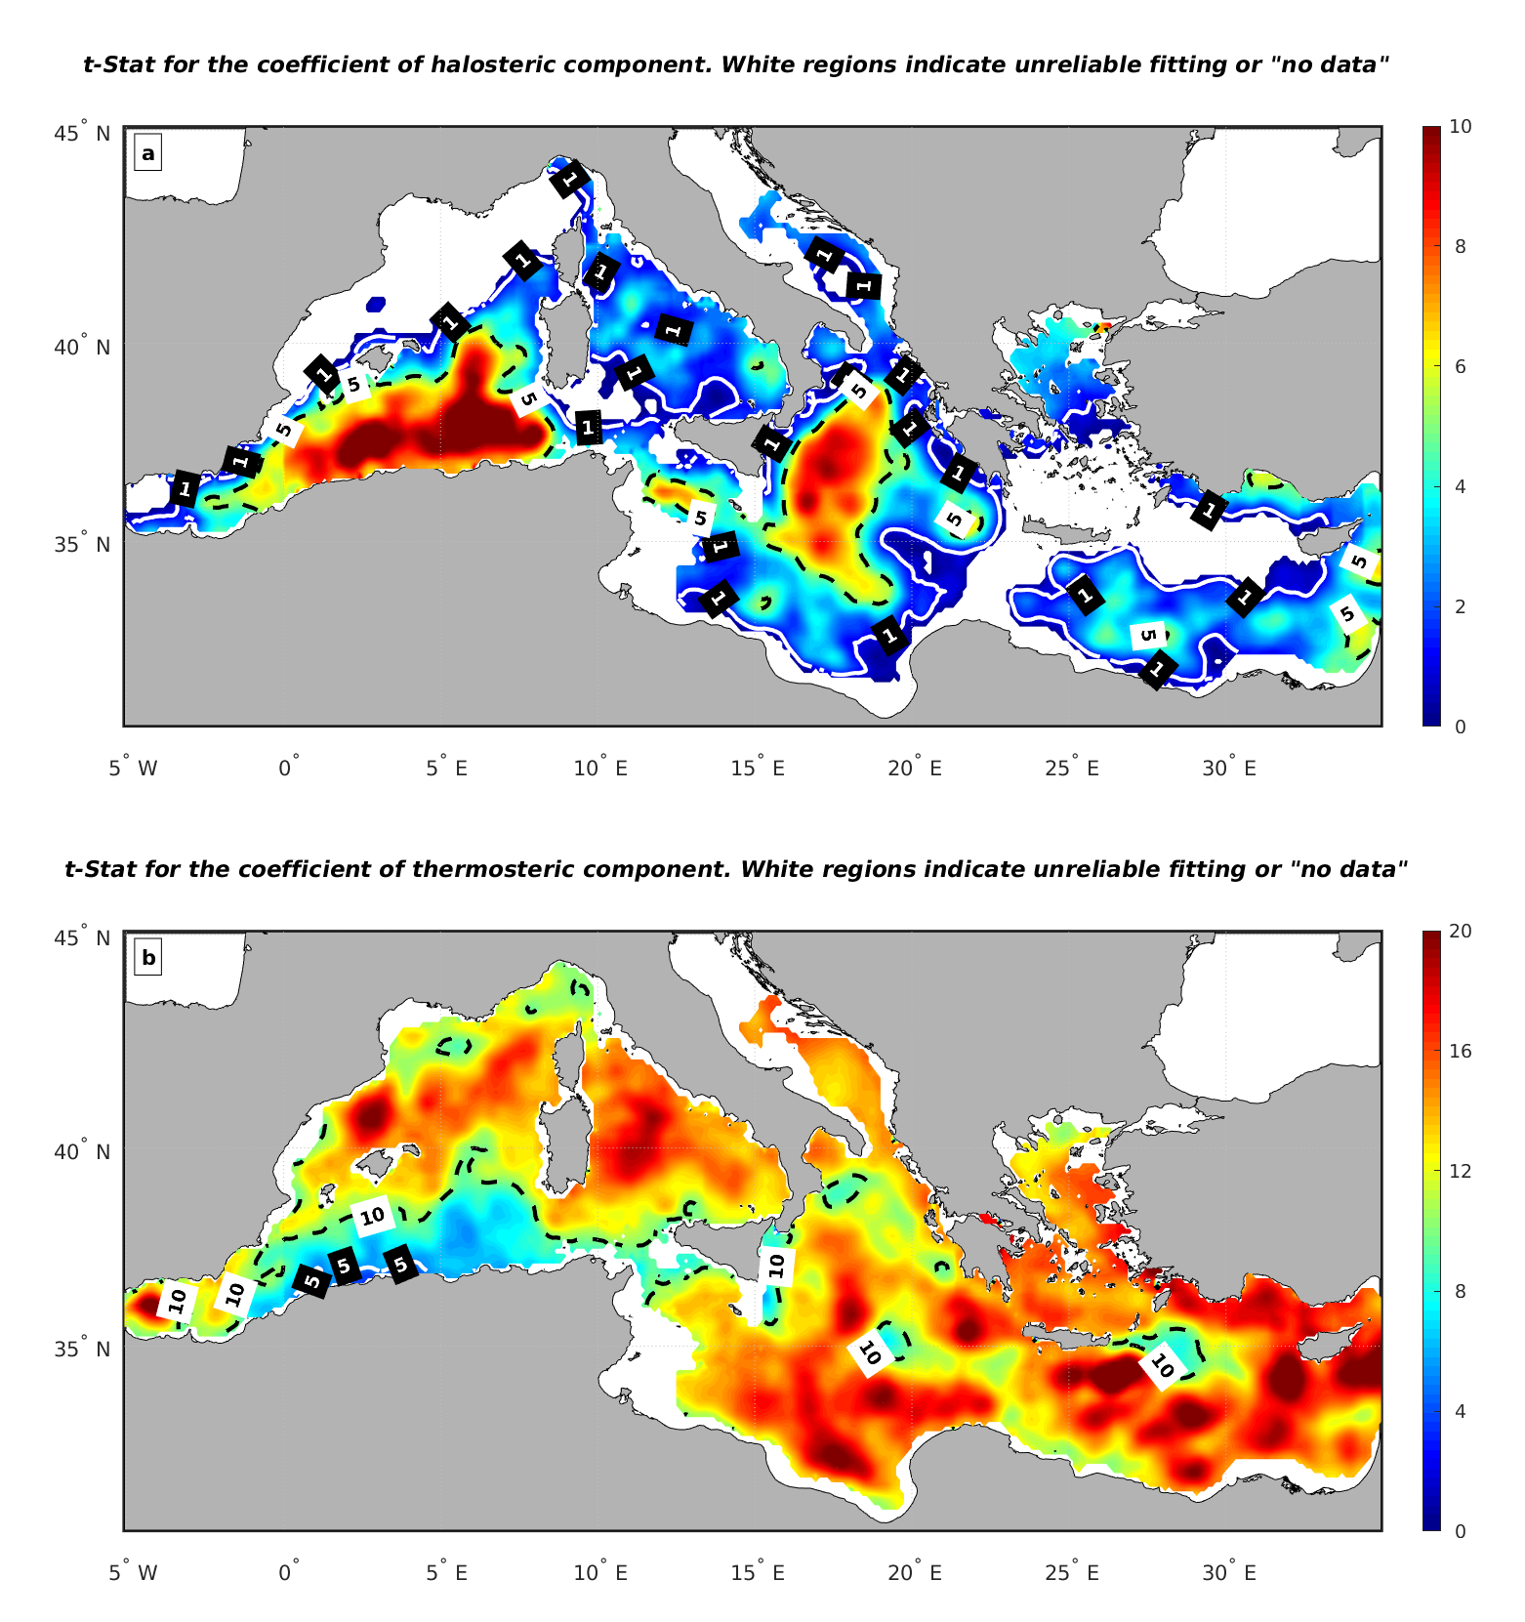
Figure S3. Significance test (t-value) for the coefficients of the linear fitting model between SSH, halosteric and thermosteric levels. a) t-value for the haline coefficient; b) t-value for the thermal coefficient.

