Supplementary Materials for
Structurally complex Al-Si eutectic structure to resist hydrogen embrittlement in 3D-printed Al alloy

Supplementary Table 1 Engineering the mechanical properties of AlSi10Mg.
 | Uncharged AlSi10Mg | Charged AlSi10Mg
Yield strength (MPa) | 264.46±1.93 | 241.19±2.57
UTS (MPa) | 440.45±2.56 | 410.09±4.93
Elongation (%) | 12.52±0.08 | 11.19±0.24

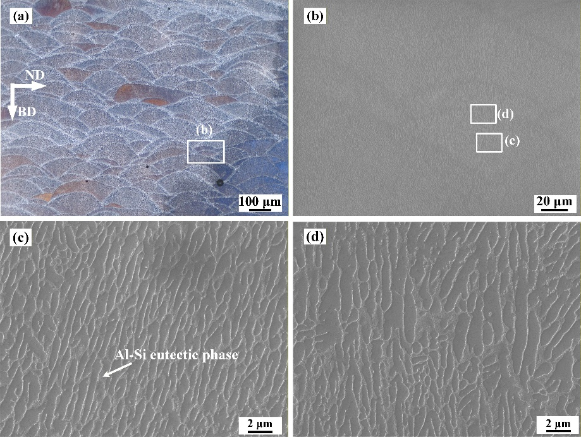
Supplementary Fig. 1 Microscopy image of AlSi10Mg. (a) Optical microscopy image, selective electron microscopy (SEM) image in (b) Overall morphology, (c) inner the molten pool, (d) molten pool boundary area. The average dendrite space is 0.73 μm, while 1.18 μm in the molten pool boundary area.

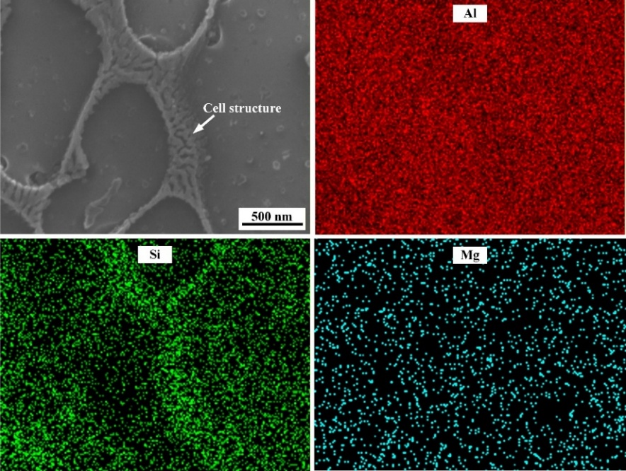
Supplementary Fig. 2 Energy-dispersive X-ray spectroscopy (EDS) mapping of the cell structure in AlSi10Mg.

Supplementary Note 1: Microstructure and strengthening mechanisms in 3D-printed AlSi10Mg
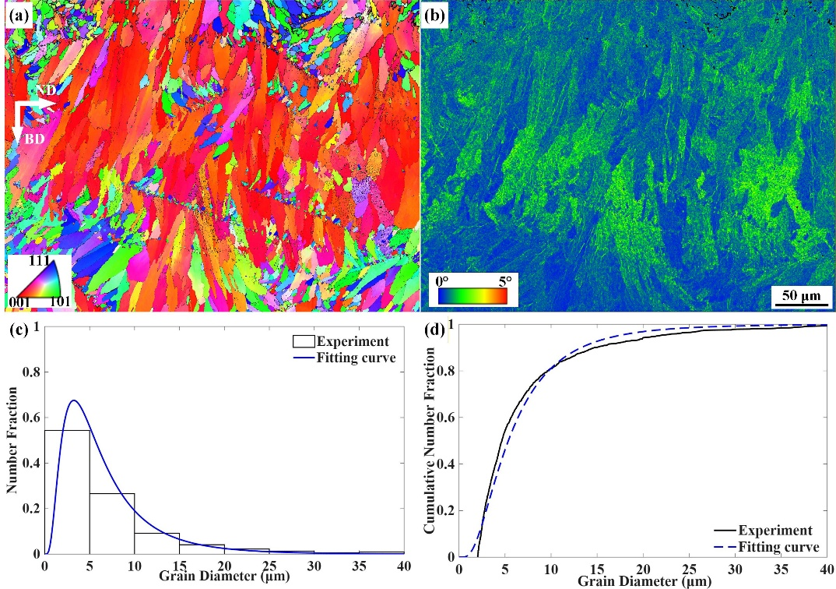
Supplementary Fig. 3 EBSD result of the AlSi10Mg sample. (a) BD (//<001>) inverse pole figure, (b) Kernel average misorientation, (c) log-normal grain size distribution, (d) cumulated grain size distribution.

Supplementary Table 2 Data extracted from the Supplementary Fig. 3.
Average grain size (μm) | 7.196
Average KAM value (°) | 0.7699
Grain size distribution, μ (μm) | 1.6784
Grain size distribution, σ (μm) | 0.7082

In LPBF AlSi10Mg, the strengthening mechanisms to yield strength include the grain boundary strengthening ($σ_{g}$), Al-Si cell structure strengthening ($σ_{C}$), solid solution strengthening ($σ_{ss}$), and dislocation strengthening ($σ_{d}$), as shown in Supplementary Fig. 4. It should be noted that the contributions of the different strengthening mechanisms should not be linearly superimposed, a coupling strength of 78.1 MPa is identified, arising from their synergistic interactions. The calculation processes are shown as follows:
As revealed by previous studies ¹, the Al-Si cell structure played a similar role as grain boundaries in strengthening, the $σ_{g}$ and $σ_{C}$ can be calculated by the Hall-Patch formula:
$\begin{aligned}σ=k_{1}d^{-1/2}\#\left(Equation 1\right)\end{aligned}1$
Where $k_{1}$ is ∼0.04 MPa∗m^{1/2} for Al-matrix grains ², and ∼0.05 MPa∗m^{1/2} for Al-Si eutectic cell structure ³. $d$ is the diameter of grains or the Al-Si cell structure. The average diameter of cell structure is 0.73 μm According to the calculation result, the $σ_{g}$ is 14.9 MPa, while $σ_{C}$ is 58.5 MPa. Therefore, the cell structure contributed more to the yield strength than the grain boundary in LPBF-fabricated AlSi10Mg.
As expressed by Yang et al.⁴, the $σ_{ss}$ can be calculated as⁵:
$\begin{aligned}σ_{ss}=∑C_{i}K_{i}\#\left(Equation 2\right)\end{aligned}$
Where $C_{i}$ is the concentration of the element, $K_{i}$ is constant depending on element category, which is 17 and 11 MPa wt%⁻¹ for Mg and Si, respectively. The energy-dispersive X-ray spectroscopy (EDX) result shows that the Mg and Si concentrations are 4.51 wt.% in the Al matrix, and they are undetectable for the Mg. Therefore, the $σ_{ss}$ is 49.6 MPa.
The $σ_{d}$ for AlSi10Mg can be expressed as ⁶:
$\begin{aligned}σ_{d}=MaGb\sqrt{(2θ_KAM)/bd}\#\left(Equation 3\right)\end{aligned}$
Where M (3.06) is the Taylor factor, $a$ is material constant as 0.16, G is the shear module as 26.5 GPa, b is the Burgers factor as 0.286 nm, d is the step size for EBSD image. $θ_{KAM}$ is the average KAM value extracted from Supplementary Table 2. In this study, the $σ_{d}$ is 63.4 MPa.
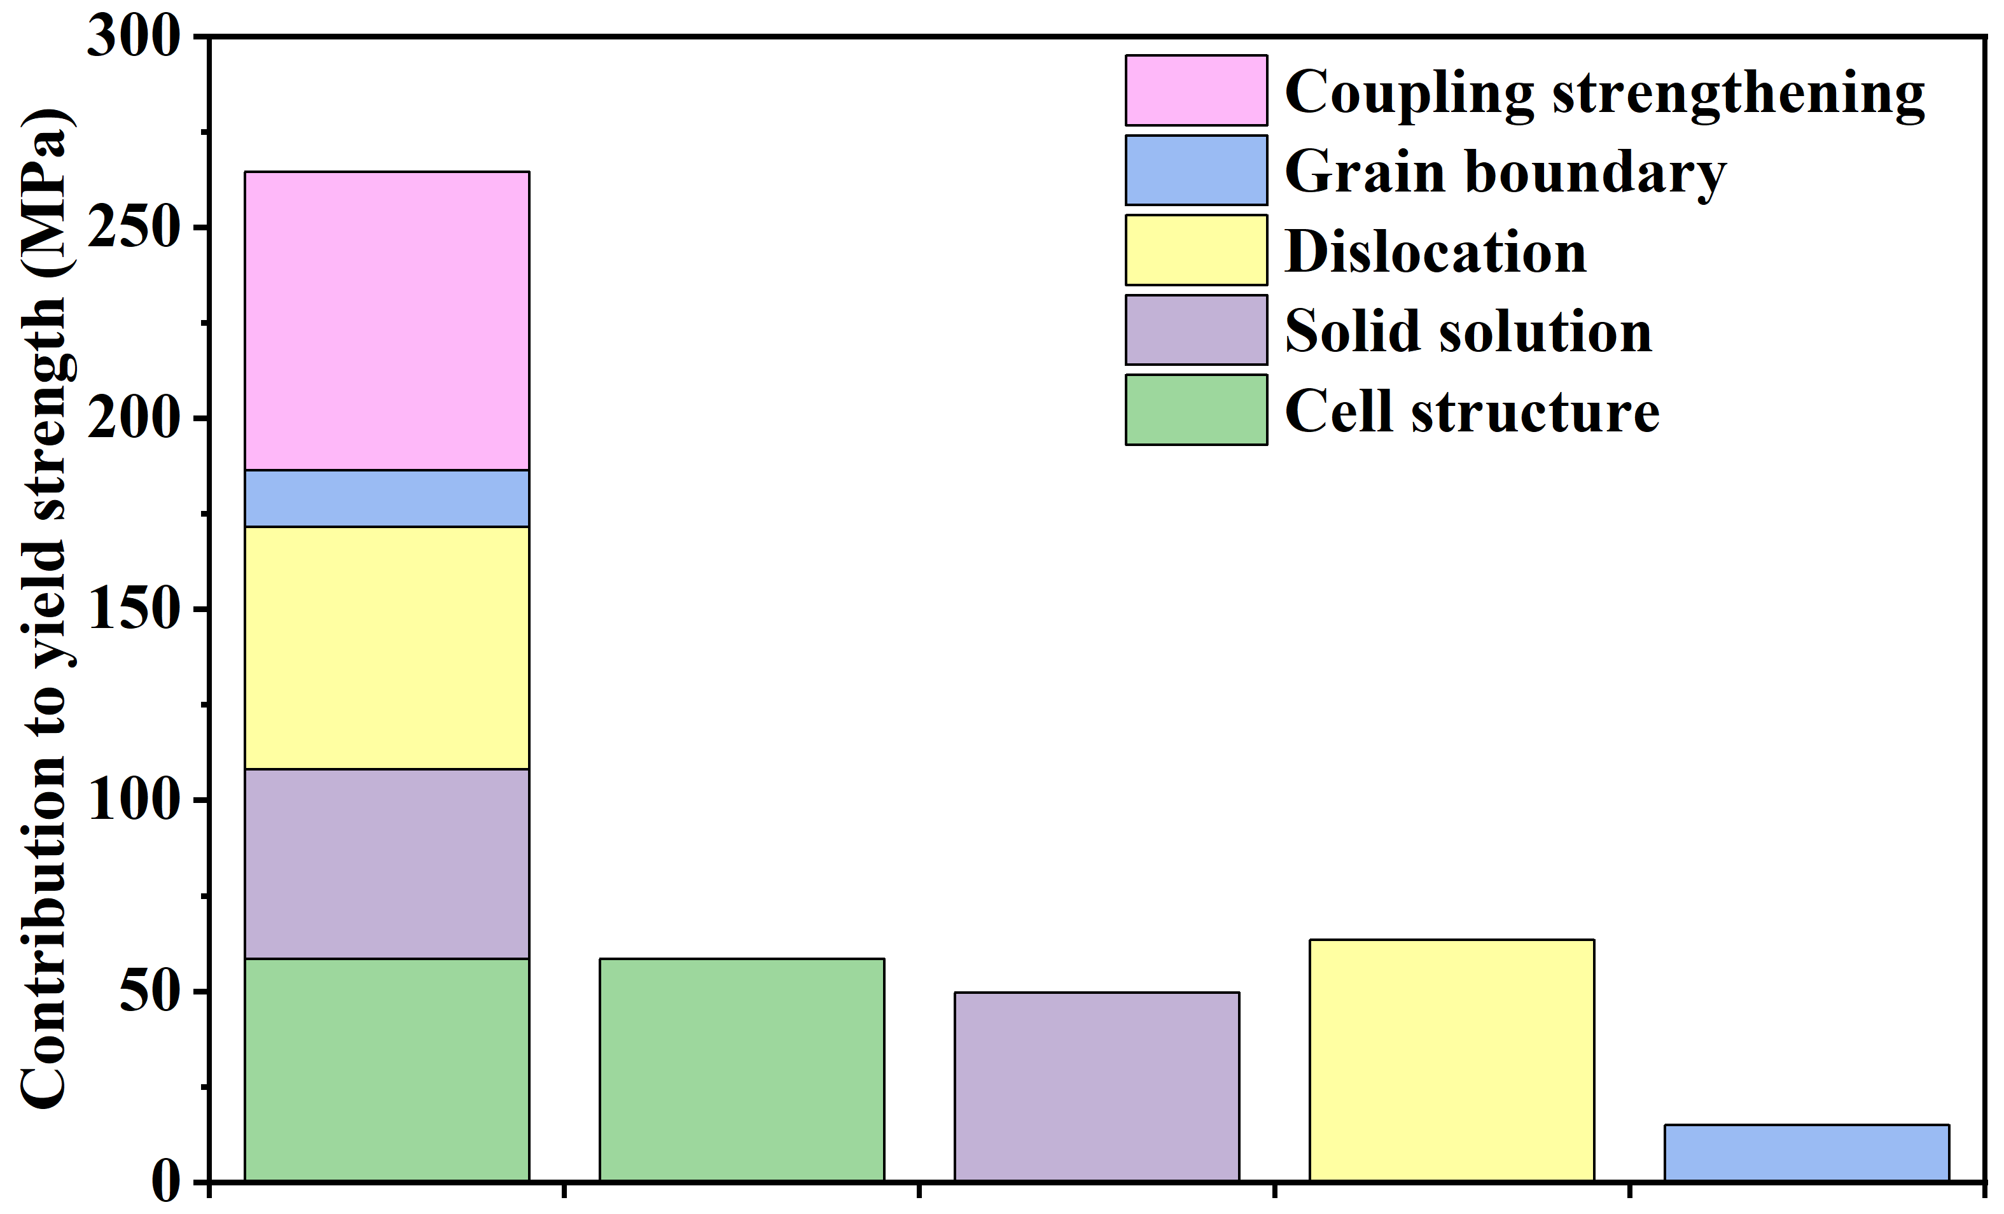
Supplementary Fig. 4 Contribution to the yield strength for different mechanisms.

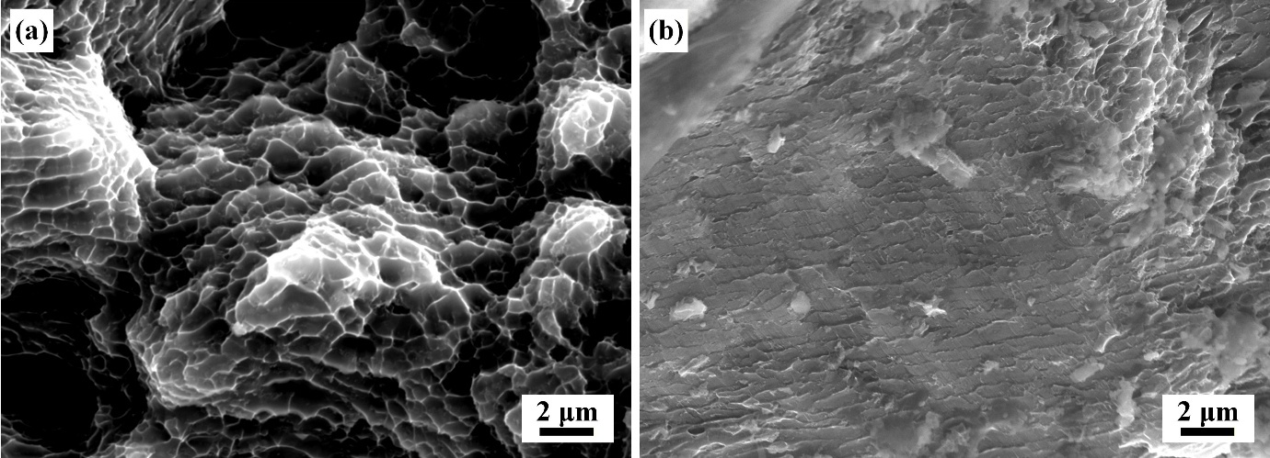
Supplementary Fig. 5 Enlarged view of Fig. 1

Supplementary Note 2: Analysis of thermal desorption spectrum (TDS) results

Supplementary Table 3 Peak temperature of TDS curves.
 | Peak temperature (K)
 | 15 K/s | 22 K/s | 28K/s
Peak 1 | 503.8 | 530.0 | 537.9
Peak 2 | 567.8 | 609.5 | 636.3
Peak 3 | 737.6 | 756.3 | 770.9

The activation energy $E_{a}$ of trap sites can be calculated using the Kissinger method ⁷:
$\begin{aligned}\ln\left(\frac{β}{T_{m}^{2}}\right)=\ln\left(\frac{AR}{E_{a}}\right)-\frac{E_{a}}{R*T_{m}}\#\left(Equation 4\right)\end{aligned}$
where $β$ is the heating rate, $T_{m}$ is the peak temperature (in Kelvin) of the trap site with different heating rates, $A$ is the pre-exponential factor, $R$ is the universal gas constant, 8.314J/(mol*K). By plotting the $\ln\left(\frac{β}{T_{m}^{2}}\right)$ vs $(-\frac{1}{T_{m}}$), the slope ($∇f$) can be obtained by linear fitting. Finally, the activation energy can be determined:
$\begin{aligned}E_{a}=∇f*R\#\left(Equation 5\right)\end{aligned}$
Supplementary Fig. 5 Kissinger plots and trap energy for the TDS results extracted from Fig.1.

Supplementary Table 4 Data used for comparison in Fig. 1e.
Materials | H content (wppm) | HEI (%) |  | Reference
Al-Mg–Sc-I | 7.0 | 45.3 | Jiang et al. ⁸
Al–Mg–Sc-II | 7.0 | 9.0
7XXX Al alloy | 2.5 | 24.4 | Hou et al. ⁹
Rolling Al-4.2Mg-0.75 Mn | 1.838 | 35.9 | Safyari et al.¹⁰
WAAM Al-4.2Mg-0.75 Mn | 4.3 | 2.2
Cr-added 7xxx alloy | 1.45 | 36.68 | Safyari et al.¹¹
Al-Cu-Mg alloy | 3.37 | 21.1 | Safyari et al. ¹²
AA 2024 Al alloy | 11 | 50.7 | Larigno et al. ¹³
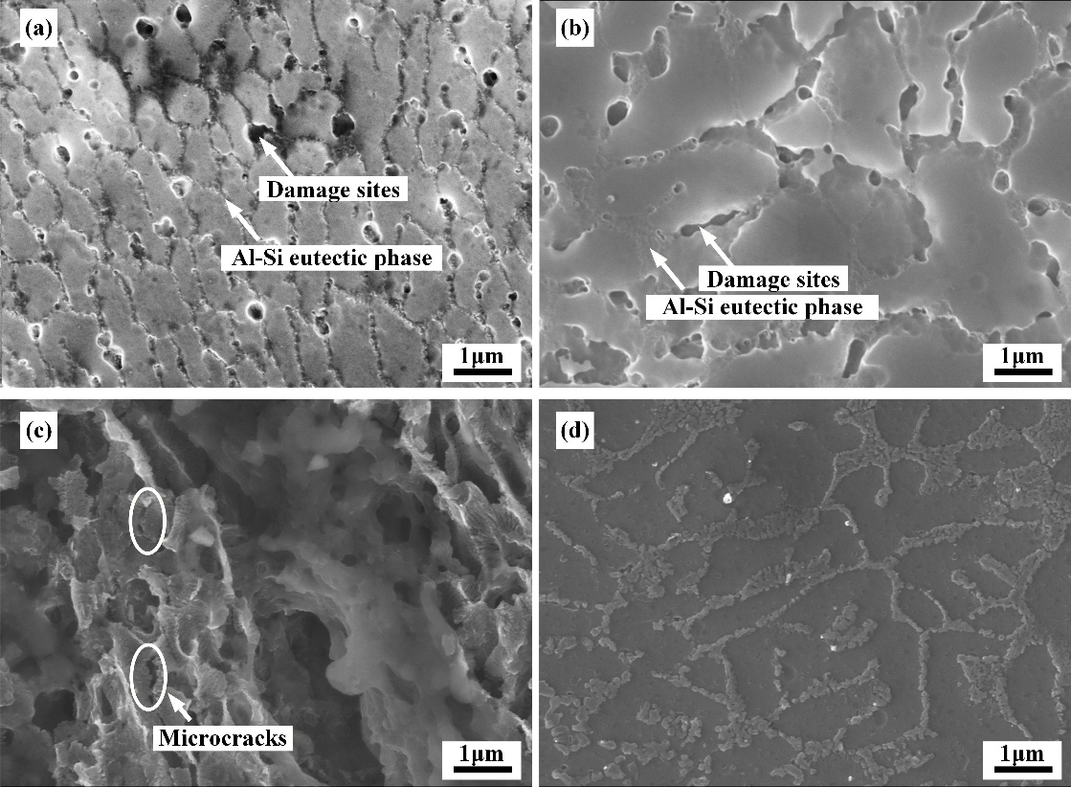
Supplementary Fig. 7 Enlarged view of Fig. 2. (a) Fig. 2c, (b) Fig. 2f, (a) Fig. 2i, (a) Fig. 2l.
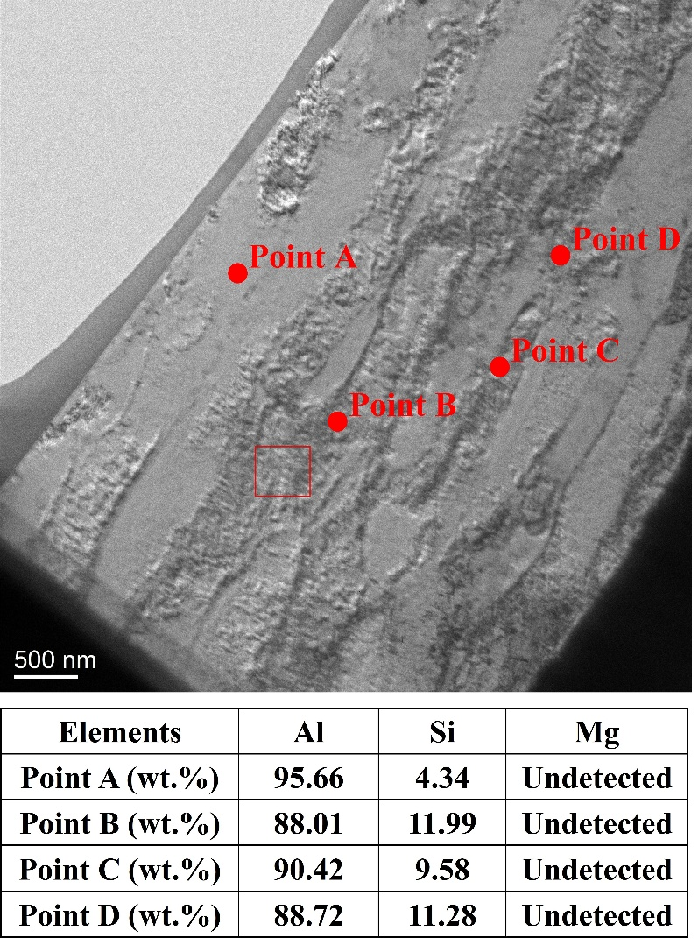
Supplementary Fig. 8 Point EDX result in TEM testing.

Supplementary Note 3: Details of Density functional theory (DFT) model
Density functional theory (DFT) calculations were performed using the Vienna Ab initio Simulation Package (VASP) based on the projector augmented-wave (PAW) method ^{14, 15, 16}. The exchange-correlation interactions were described using the generalized gradient approximation (GGA) within the Perdew-Burke-Ernzerhof (PBE) functional ¹⁷. A plane-wave cutoff energy of 450 eV was employed for all calculations. Subsequent structural optimizations were carried out using the conjugate gradient algorithm until the total energy and atomic force convergence criteria reached 10⁻⁵ eV and 0.02 eV/Å, respectively. For the melt-quench ab initio molecular dynamics (AIMD) simulations ^{18, 19}, electronic self-consistent calculations were performed using the Fast minimization scheme together with a Methfessel-Paxton smearing width of 0.2 eV ²⁰. Subsequent structural relaxations and hydrogen trapping optimizations were carried out using the Normal electronic minimization algorithm with a smearing width of 0.1 eV. Real-space projection operators were treated automatically to improve computational efficiency for the large amorphous supercell calculations. Symmetry constraints were disabled during amorphization and hydrogen trapping calculations to correctly describe the disordered atomic configurations. Due to the large size of the amorphous supercell, Brillouin zone sampling was performed using Γ-point-only sampling. Convergence tests confirmed that the calculated total energies were converged within approximately 0.01 eV.
The initial crystalline Al supercell was generated using the Atomsk package ²¹ from a face-centered cubic (FCC) Al unit cell with a lattice parameter of 4.041 Å using a 3×3×3 supercell expansion, resulting in a total of 108 atoms. To construct the Al₈₈​Si₁₂​​ alloy model, 13 Al atoms were randomly substituted by Si atoms, producing a composition consisting of 95 Al atoms and 13 Si atoms. The amorphous Al₈₈​Si₁₂​​ structure was generated using AIMD through a melt-quench procedure within the canonical (NVT) ensemble using the Nosé-Hoover thermostat ^{22, 23}. The alloy structure was initially heated to 1600 K to eliminate long-range crystalline order and subsequently cooled from 1600 K to 300 K through a stepwise melt-quench procedure with temperature decrements of 200 K. At each temperature stage, equilibration calculations were performed to ensure structural stabilization before proceeding to the next cooling step. Ionic motion was propagated using a time step of 1 fs under fixed-volume conditions. After quenching to 300 K, the optimized configuration exhibited characteristic amorphous behavior with homogeneous Si distribution throughout the Al matrix.
The trapping energy of hydrogen (E_{trap}) was calculated by placing one hydrogen atom at each site in the Al₈₈​Si₁₂ supercell followed by full structural optimization. The relaxed geometries were subsequently analyzed to determine energetically favorable trapping environments and local structural distortions induced by hydrogen incorporation. Atomic configurations were visualized using VESTA 3.5.8.

Supplementary Table 4 Calculated hydrogen trapping energies for thirteen independent insertion sites in amorphous Al₈₈Si₁₂.
Sites | Local Environment | Trapping Energy (eV)
S1 | Small free-volume | -0.27
S2 | Al-rich region | -0.304
S3 | Small Al-Si mixed | -0.313
S4 | Medium free-volume | -0.351
S5 | Si-neighboring region | -0.298
S6 | Al-rich cavity | -0.379
S7 | Medium free-volume | -0.422
S8 | Al-Si mixed environment | -0.453
S9 | Large free-volume | -0.55
S10 | Large Al-rich | -0.582
S11 | Large free-volume | -0.55
S12 | Large Al-Si | -0.572
S13 | Largest free-volume | -0.64

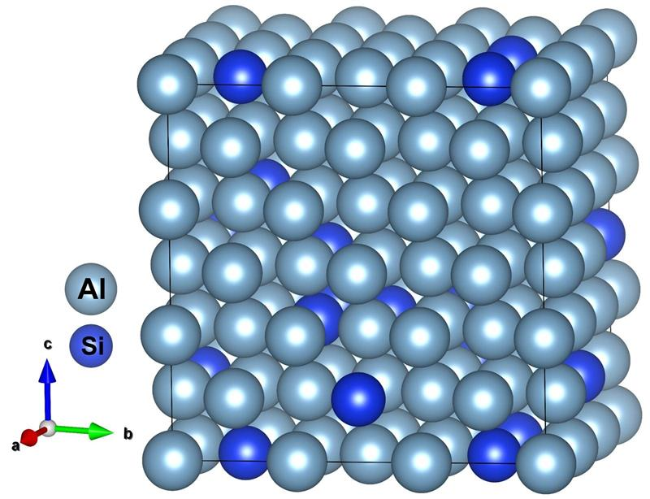
Supplementary Fig. 9 Atomic structures of (a) the crystalline FCC-derived Al₈₈Si₁₂ model prior to AIMD melt-quench simulations.

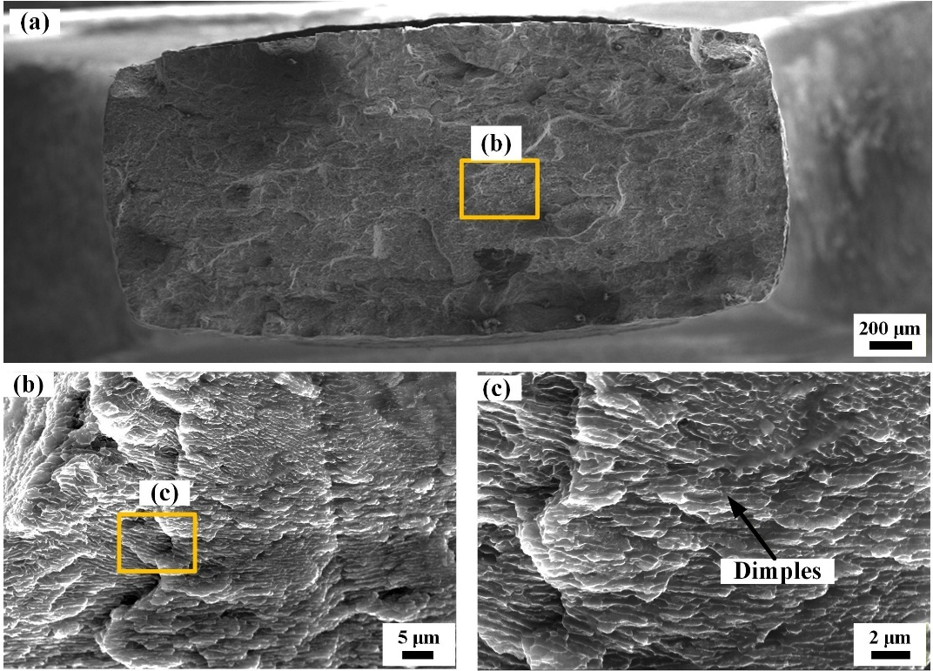
Supplementary Fig. 10 Fractography of hydrogen-charged AlSi10Mg in the middle area with less hydrogen ingress.

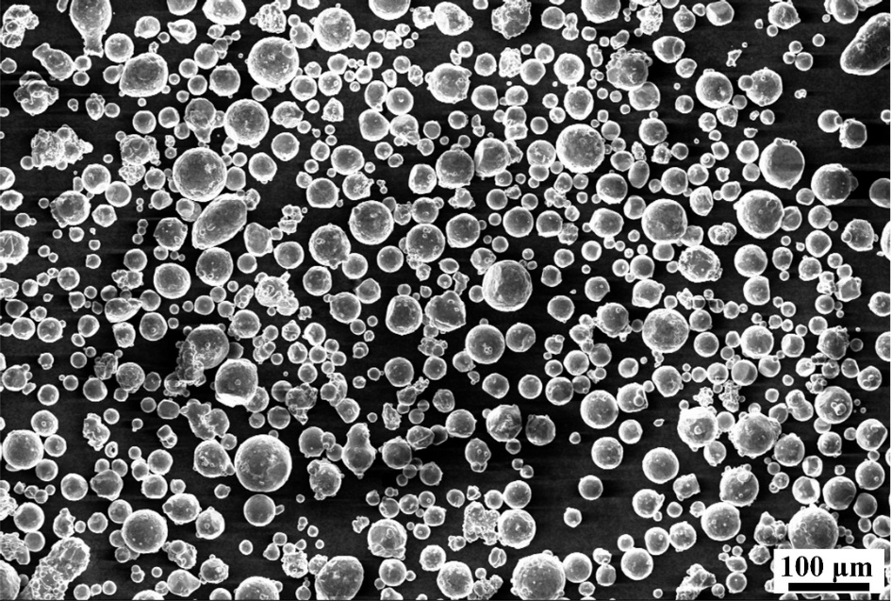
Supplementary Fig. 11 Morphology of AlSi10Mg powder for 3D-printing.
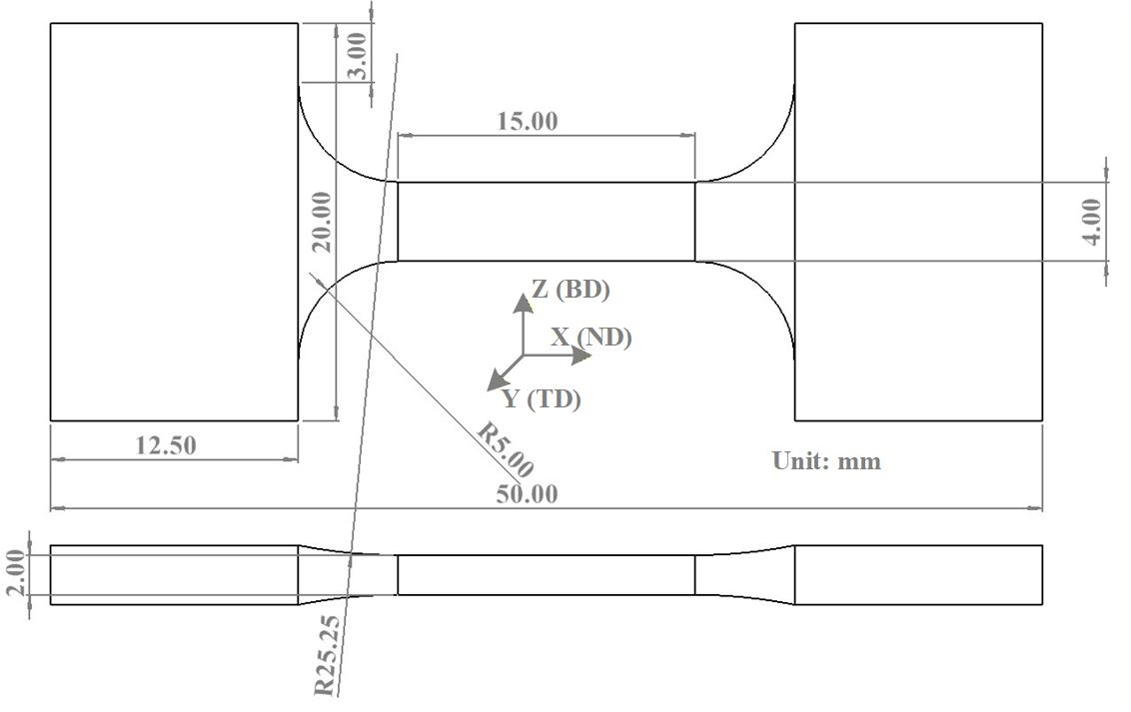
Supplementary Fig. 12 Morphology of tensile test coupons for SSRT. BD-Building direction. (a) Front view with coordination, (b) Top view.BD-Building direction, ND-Normal direction, TD-thickness direction.

References
1. Okulov IV, et al. Microstructure and mechanical properties of new composite structured Ti-V-Al-Cu-Ni alloys for spring applications. Mater Sci Eng A 603, 76–83 (2014).

2. Snopiński P, Woźniak A, Pagáč M. Microstructural evolution, hardness, and strengthening mechanisms in SLM AlSi10Mg Alloy subjected to equal-channel angular pressing (ECAP). Materials 14, (2021).

3. Fite J, Eswarappa Prameela S, Slotwinski J, Weihs TP. Enhanced mechanical properties by eutectic cells in AlSi10Mg - A promising paradigm for strengthening aluminum in additive manufacturing. Mater Charact 204, (2023).

4. Yang KV, Rometsch P, Davies CHJ, Huang A, Wu X. Effect of heat treatment on the microstructure and anisotropy in mechanical properties of A357 alloy produced by selective laser melting. Mater Des 154, 275–290 (2018).

5. Ghio E, Cerri E. Additive Manufacturing of AlSi10Mg and Ti6Al4V Lightweight Alloys via Laser Powder Bed Fusion: A Review of Heat Treatments Effects. Materials (Basel) 15, (2022).

6. Odnobokova M, Torganchuk V, Tikhonova M, Dolzhenko P, Kaibyshev R, Belyakov A. On the Strength of a 316L-Type Austenitic Stainless Steel Produced by Selective Laser Melting. Metals 13, (2023).

7. Blaine RL, Kissinger HE. Homer Kissinger and the Kissinger equation. Thermochim Acta 540, 1–6 (2012).

8. Jiang S, et al. Structurally complex phase engineering enables hydrogen-tolerant Al alloys. Nature 641, 358–364 (2025).

9. Hou Y, et al. Effects of hydrogen charging on the corrosion behavior and hydrogen embrittlement of 7xxx Al Alloys: An integrated experimental and multiscale simulation study. Corros Sci 257, (2025).

10. Safyari M, et al. Manipulating nanostructure during wire arc additive manufacturing defeats hydrogen embrittlement. Corros Sci 233, (2024).

11. Safyari M, Moshtaghi M, Hojo T, Akiyama E. Mechanisms of hydrogen embrittlement in high-strength aluminum alloys containing coherent or incoherent dispersoids. Corros Sci 194, 109895 (2022).

12. Safyari M, Moshtaghi M, Kuramoto S, Hojo T. Influence of microstructure-driven hydrogen distribution on environmental hydrogen embrittlement of an Al–Cu–Mg alloy. Int J Hydrogen Energy 46, 37502–37508 (2021).

13. Larignon C, Alexis J, Andrieu E, Odemer G, Blanc C. The contribution of hydrogen to the corrosion of 2024 aluminium alloy exposed to thermal and environmental cycling in chloride media. Corros Sci 69, 211–220 (2013).

14. Kresse G, Furthmüller J. Efficient iterative schemes for ab initio total-energy calculations using a plane-wave basis set. PhRvB 54, 11169–11186 (1996).

15. Kresse G, Joubert D. From ultrasoft pseudopotentials to the projector augmented-wave method. PhRvB 59, 1758–1775 (1999).

16. Blöchl PE. Projector augmented-wave method. PhRvB 50, 17953–17979 (1994).

17. Perdew JP, Burke K, Ernzerhof M. Generalized Gradient Approximation Made Simple. Physical Review Letters 77, 3865–3868 (1996).

18. Kresse G, Hafner J. Ab initio molecular dynamics for liquid metals. PhRvB 47, 558–561 (1993).

19. Kresse G, Hafner J. Ab initio molecular-dynamics simulation of the liquid-metal--amorphous-semiconductor transition in germanium. PhRvB 49, 14251–14269 (1994).

20. Methfessel M, Paxton AT. High-precision sampling for Brillouin-zone integration in metals. PhRvB 40, 3616–3621 (1989).

21. Hirel P. Atomsk: A tool for manipulating and converting atomic data files. Computer Physics Communications 197, 212–219 (2015).

22. Nosé S. A unified formulation of the constant temperature molecular dynamics methods. The Journal of Chemical Physics 81, 511–519 (1984).

23. Hoover WG. Canonical dynamics: Equilibrium phase-space distributions. Physical Review A 31, 1695–1697 (1985).

