Additional file 2. Comparison results between each COM-B, by care pathway, per country and per specialty.
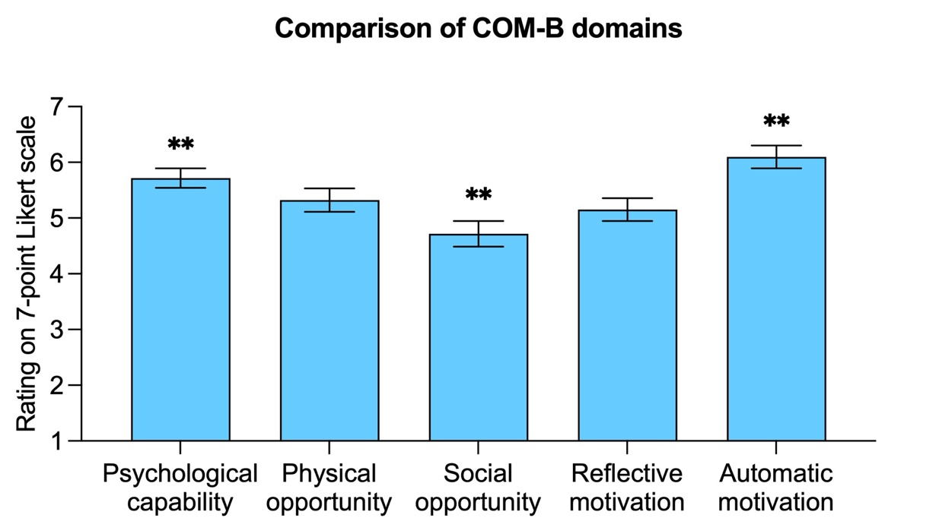
Figure S1. Comparison of the total rating attributed to each COM-B domain (n=112)
Psychological capability
Physical Opportunity
Social Opportunity
Reflective Motivation
Automatic Motivation
Rating on a 7-point Likert scale
Bars represent the mean, and whiskers are drawn up and down to denote the 95% confidence interval. Comparisons between the different domains were performed using analysis of variance (ANOVA). **Denotes a domain that significantly differs from the others (p<0.001).
Table S2. Comparison of the rating attributed to each category by care pathway (n=112)
 | Knowledge | Access to skils’ training | Communication skills
Genetic testing and diagnosis | 6.05 (5.83; 6.28)**§†† | 5.29 (4.94; 5.64)**§†† | 5.98 (5.75; 6.21)**§†
Surveillance procedures | 5.81 (5.59; 6.03)**§ | 5.13 (4.81; 5.46)**§ | 5.94 (5.72; 6.15)**§¥
Risk reduction surgeries | 5.65 (5.42; 5.88)**§ | 5.01 (4.69; 5.33)**§ | 5.61 (5.37; 5.85)**§
Early and advanced treatment options | 4.84 (4.57; 5.11)* | 4.09 (3.75; 4.43) | 4.86 (4.55; 5.16)*
Palliative care | 4.22 (3.89; 4.55) | 3.61 (3.26; 3.92) | 4.27 (3.94; 4.61)
Reproductive options | 5.45 (5.17; 5.73)** | 4.85 (4.5; 5.2)** | 5.5 (5.24; 5.77)**
Data are presented as mean (95% confidence interval). Within each category – knowledge, access to skills’ training, communication skills – analysis of variance (ANOVA) were used to compare the ratings between the different care pathways. *Denotes a statistically significant difference from palliative care (p<0.001). **Denotes a statistically significant difference from palliative care (p<0.0001). (p<0.001). §Denotes a statistically significant difference from early and advanced treatment options (p<0.0001). †Denotes a statistically significant difference from reproductive options (p<0.001). ††Denotes a statistically significant difference from reproductive options (p<0.0001). ¥Denotes a statistically significant difference from risk reduction surgeries (p<0.001).
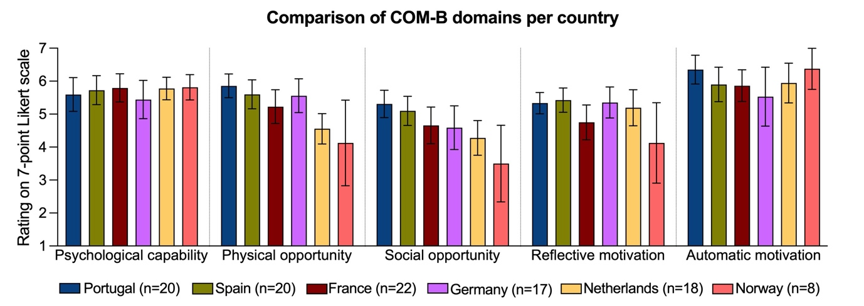
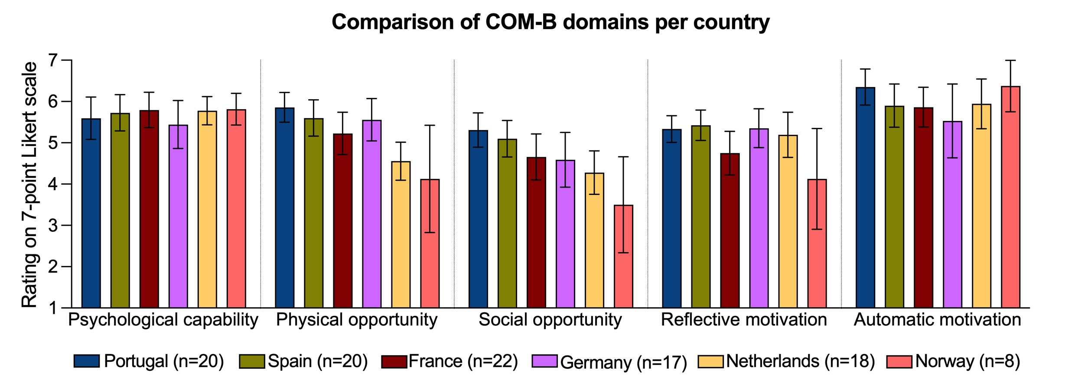
Figure S2. Comparison of the total rating attributed to each COM-B domain per country (n=115)
Portugal (n=20) Spain (n=20) France (n=22) Germany (n=17) Netherlands (n=18) Norway (n=8)

Psychological capability
Physical Opportunity
Social Opportunity
Reflective Motivation
Automatic Motivation
Rating on a 7-point Likert scale
Bars represent the mean, and whiskers are drawn up and down to denote the 95% confidence interval. Vertical dashed lines separate each COM-B domain. For each COM-B domain, comparisons between the different countries were performed using analysis of variance (ANOVA).
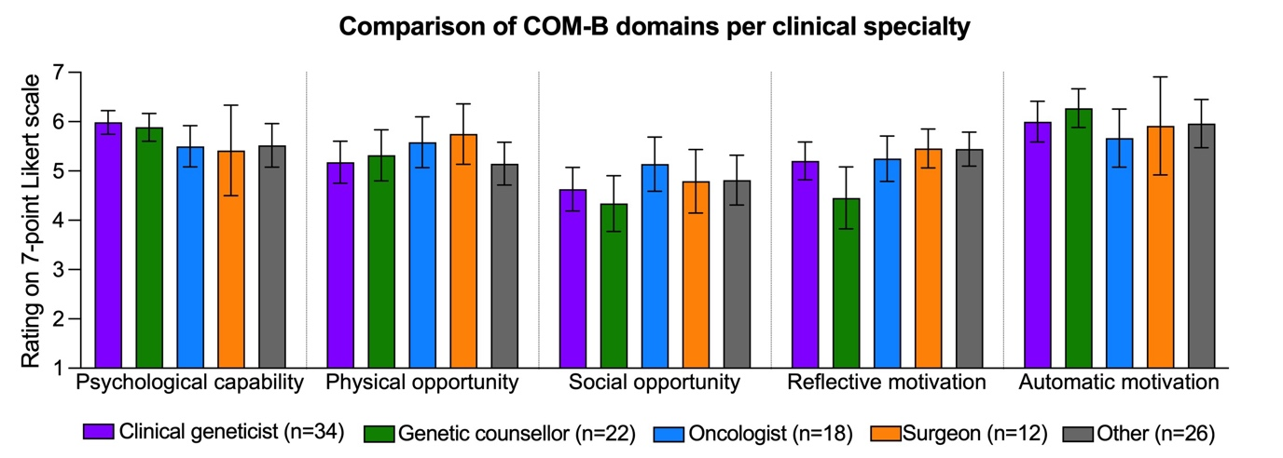
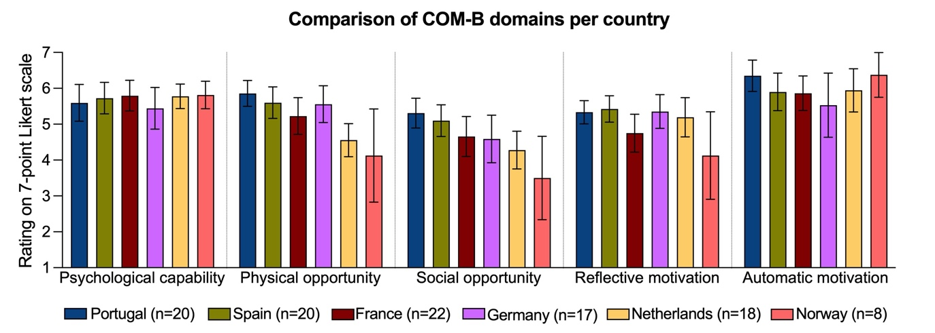
Figure S3. Comparison of the total rating attributed to each COM-B domain per clinical specialty (n=112)
Psychological capability
Physical Opportunity
Social Opportunity
Reflective Motivation
Automatic Motivation
Rating on a 7-point Likert scale
Clinical geneticist (n=34) Genetic counsellor (n=22) Oncologist (n=18) Surgeon (n=12) Other (n=26)
Bars represent the mean, and whiskers are drawn up and down to denote the 95% confidence interval. Vertical dashed lines separate each COM-B domain. For each COM-B domain, comparisons between the different clinical specialties were performed using analysis of variance (ANOVA).

