Table S1. Management practices in Kaweri coffee plantation provided by section managers.
Management practice | Kitagweta  (frequency / year) | Kitemba  (frequency / year) | Nonve  (frequency / year) | Luwunga  (frequency / year) | Kyamutuma  (frequency / year)
Pruning of shade trees | 1 | 1 | 2 | 1 | 1
Pruning of coffee shrubs | 2 | 2 | 2 | 1 | 1
Spraying fungicides mainly organic | 2 | 1 | 4 | 1 | 4
Spraying herbicides | 4 | 1 | 4 | 4 | 4
Slashing and weeding | 3 | 2 | 4 | 2 | 4
Fertilizer application (organic, inorganic)ª | 2 | 2 | 2 | 2 | 2
Lime application (2 tons per hectare) | 1  (every 5 years) | 1  (every 5 years) | 1  (every 5 years) | 1  (every 5 years) | 1  (every 5 years)
ª Quantity of fertilizer per shrub: NPK (22:6:12), 100 g; SA, 50 g; MOP, 70 g; TSP, 50 g

Table S3. Attributes of coffee varieties provided by section managers.
Variety code | Name | Yield | Disease tolerance  (RBD, CLR, and BES) | Cup Quality | Other Attributes
1s/2 | Variety A | High | Moderate | Moderate | Widely adapted traditional Ugandan Robusta clone
1s/3 | Variety B | Moderate | Moderate | High cup quality | Preferred for beverage quality
1s/6 | Variety D | Moderate | High | Moderate | More resilient under disease pressure
223/32 | Variety F | High | Moderate | Good cup quality | Productive and commercially attractive
257/53 | Variety G | Moderate | High | Moderate | Suitable for disease-prone areas
258s/24 (0) | Variety H | Moderate | Moderate | High cup quality | Appreciated for bean and beverage quality
Hybrid from  1s/2, 1s/3, 1s/6 | Variety C | Moderate to High | Mixed traits | Mixed quality traits | Mixed characteristics
Clone 251  (OP clone) | Open-pollinated clone 1 | High | Moderate | Moderate | Improved adaptability and resilience
Clone 252  (OP clone) | Open-pollinated clone 2 | Moderate to High | Moderate to High | Moderate | Suitable for disease management
Clone 253  (OP clone) | Open-pollinated clone 3 | High | Moderate | Moderate | Good yield performance

Table S4. Sampling replicates given sections and associated trees.
 | Mugavu  (n replicates) | Avocado  (n replicates) | Bark-cloth fig  (n replicates) | Jackfruit  (n replicates) | TOTAL
Kitagera | 6 | 4 | 4 | 4 | 18
Kitemba | 5 | 4 | 4 | 4 | 17
Kyamutuma | 4 | 4 | 5 | 4 | 17
Luwunga | 4 | 3 | 4 | 4 | 15
Nonve | 5 | 4 | 4 | 5 | 18
TOTAL | 24 | 19 | 21 | 21 | 85

Table S5. Top five models of shrub CWD incidence.
 |  |  | Fixed effect terms
p | Log-likelihood | AICc | At*D | Cv | Cv:D | Cv:At | Cv:D:At
4 | -142.2 | 316.7 | fixed | +
3 | -149.0 | 319.1 | fixed
5 | -141.2 | 326.3 | fixed | + | +
5 | -134.6 | 338.5 | fixed | + |  | +
6 | -119.8 | 367.7 | fixed | + | + | +
Models ranked from most parsimonious (lowest AICc) to less parsimonious (highest AICc), with their log-likelihood, number of parameters (p), corrected AIC (AICc). The terms included in each model are notified by the (+) sign. Cv = Coffee variety; D = Distance from associated tree; At = Associated tree. Models also include random effects based on the following structure: (1|Section of Kaweri/replicate of the associated tree). Model selected (bold) for the analysis with the lowest AIC and good residuals.

Table S6. Top five models of leaf BES incidence.
 |  |  |  |  | Fixed effect terms |  |  |  |  | Zi term | Disp term
p | Log-likelihood | AICc |  | At*D |  | Cv | Cv:D | Cv:AT | Cv:D:At
5 | -330.7 | 700.2 |  | locked |  |  |  |  |  | ~Cv | ~log(Tot)
6 | -328.6 | 702.5 |  | locked |  | + |  |  |  | ~Cv | ~log(Tot)
7 | -325.1 | 710.2 |  | locked |  | + | + |  |  | ~Cv | ~log(Tot)
7 | -315.8 | 713.2 |  | locked |  | + |  | + |  | ~Cv | ~log(Tot)
8 | -313.5 | 719.4 |  | locked |  | + | + | + |  | ~Cv | ~log(Tot)
Models ranked from most parsimonious (lowest AICc) to less parsimonious (highest AICc), with their log-likelihood, number of parameters (p), corrected AIC (AICc). The terms included in each model are notified by the (+) sign. Cv = Coffee variety; = Distance from associated tree; At = Associated tree; log(Tot) = Total number of leaves per branch log transform. Models also include random effects based on the following structure: (1|Section of Kaweri/replicate of the associated tree/coffee shrub). Model selected (bold) for the analysis with the lowest AIC and good residuals.

Table S7. Top five models of leaf CWD incidence.
 |  |  | Fixed effect terms |  |  |  |  | Zi term | Disp term
p | Log-likelihood | AICc | At*D | Cv | Cv:D | Cv:AT | Cv:D:At
3 | -266.3 | 559.1 | locked |  |  |  |  | ~1 | ~1
5 | -258.7 | 564.6 | locked | + | + |  |  | ~1 | ~1
4 | -264.7 | 566.1 | locked | + |  |  |  | ~1 | ~1
6 | -246.9 | 573.1 | locked | + | + | + |  | ~1 | ~1
5 | Convergence issue |  | locked | + |  | + |  | ~1 | ~1
Models ranked from most parsimonious (lowest AICc) to less parsimonious (highest AICc), with their log-likelihood, number of parameters (p), corrected AIC (AICc). The terms included in each model are notified by the (+) sign. Cv = Coffee variety; D = Distance from associated tree; At = Associated tree. Models also include random effects based on the following structure: (1|Section of Kaweri/replicate of the associated tree/coffee shrub). Model selected (bold) for the analysis with the lowest AIC and good residuals.

Table S8. Top five models of leaf CLR incidence level.
 |  |  | Fixed effect terms |  |  |  |  | Zi term | Disp term
p | Log-likelihood | AICc | AT*D | Cv | Cv:D | Cv:AT | Cv:D:At
6 | -88.4 | 226.1 | locked | + |  |  |  | ~Cv | ~log(Tot)
7 | -84.4 | 228.7 | locked | + | + |  |  | ~Cv | ~log(Tot)
7 | -80.9 | 243.3 | locked | + |  | + |  | ~Cv | ~log(Tot)
8 | -78.1 | 248.7 | locked | + | + | + |  | ~Cv | ~log(Tot)
5 | -110.2 | 259.3 | locked |  |  |  |  | ~Cv | ~log(Tot)
Models ranked from most parsimonious (lowest AICc) to less parsimonious (highest AICc), with their log-likelihood, number of parameters (p), corrected AIC (AICc). The terms included in each model are notified by the (+) sign. Cv = Coffee variety; D = Distance from associated tree; At = Associated tree; log(Tot) = Total number of leaves per branch log transform. Models also include random effects based on the following structure: (1|Section of Kaweri/replicate of the associated tree/coffee shrub). Model selected (bold) for the analysis with the lowest AIC and good residuals.

Table S9. Fruit load model selection.
 |  |  | Fixed effect terms
p | Log-likelihood | AICc | At*D | Cv | disease | Cv:D | Cv:At | disease:Cv
12 | -88.4 | 226.1 | locked | + | CLR+BES+CWD | + | + | CLR+BES+CWD
11 | -84.4 | 228.7 | locked | + | CLR+BES+CWD | + | + | BES+CWD
10 | -80.9 | 243.3 | locked | + | BES+CWD | + | + | BES+CWD
11 | -78.1 | 248.7 | locked | + | CLR+BES+CWD | + | + | CLR+CWD
11 | -110.2 | 259.3 | locked | + | CLR+BES+CWD |  | + | CLR+BES+CWD
Models ranked from most parsimonious (lowest AICc) to less parsimonious (highest AICc), with their log-likelihood, number of parameters (p), corrected AIC (AICc). The terms included in each model are notified by the (+) sign. Cv = Coffee variety; D = Distance from associated tree; At = Associated tree; CLR = incidence of CLR; BES = incidence of BES; CWD = incidence of CWD (all at the leaf level). Models also include random effects based on the following structure: (1|Section of Kaweri/replicate of the associated tree). Model selected (bold) for the analysis with the lowest AIC and good residuals.

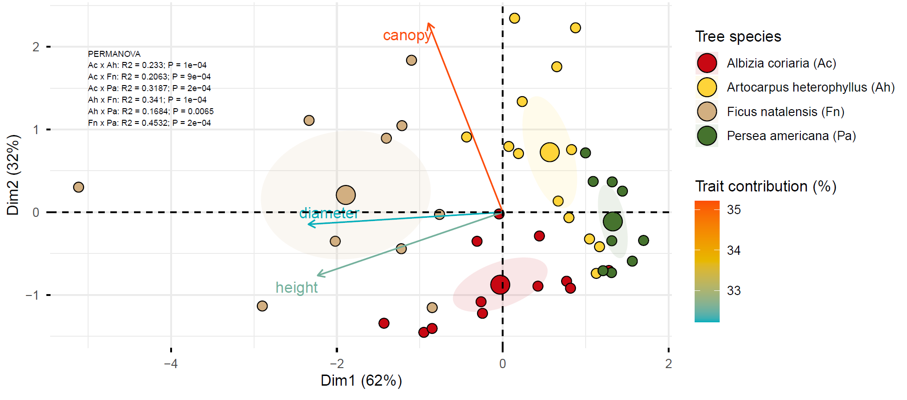
Fig. S1. Principal component analysis of traits related to associated trees. Ficus natalensis (Fn), Albizia coriaria (Ac), Persea americana (Pa), and Artocarpus heterophyllus (Ah). diameter, diameter at breast height.

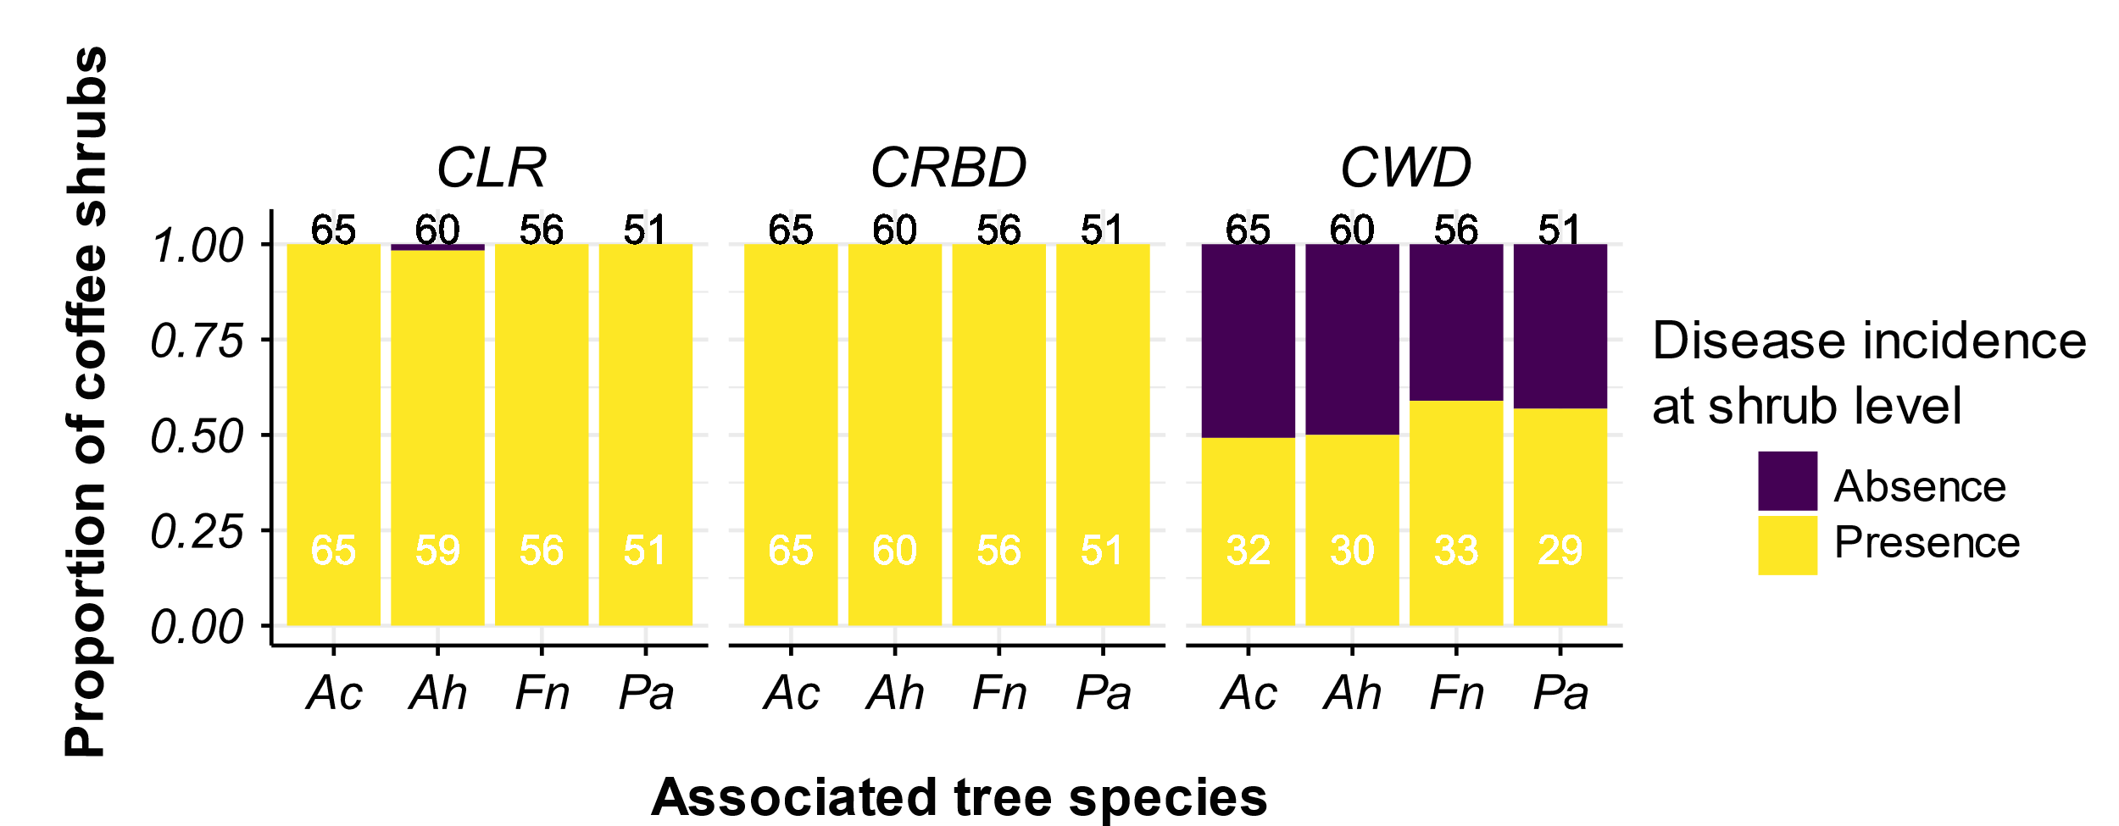
Fig. S2. Proportion of coffee shrubs with symptoms (presence = 1) or not (absence = 0) according to the proximity with an associated tree. CLR, coffee leaf rust each; BES, brown-eye spot; CWD, coffee wilt disease. The total number of coffee shrubs per category is indicated in black at the top of each bar chart, and in white for the number of coffee shrubs scored for disease. Ficus natalensis (Fn), Albizia coriaria (Ac), Persea americana (Pa), and Artocarpus heterophyllus (Ah).

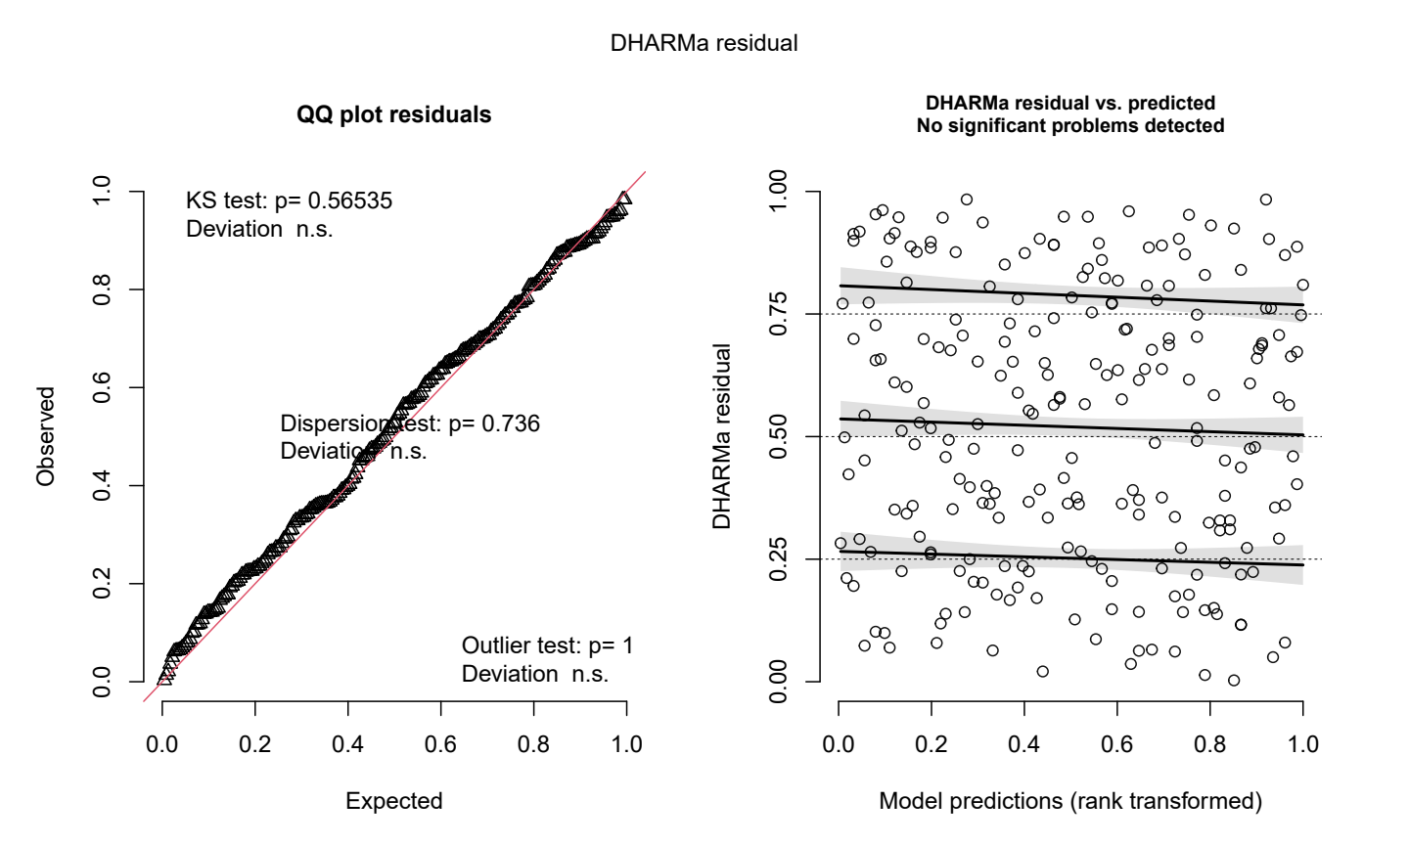
Fig. S3. Residuals of the selected model for shrub CWD incidence.

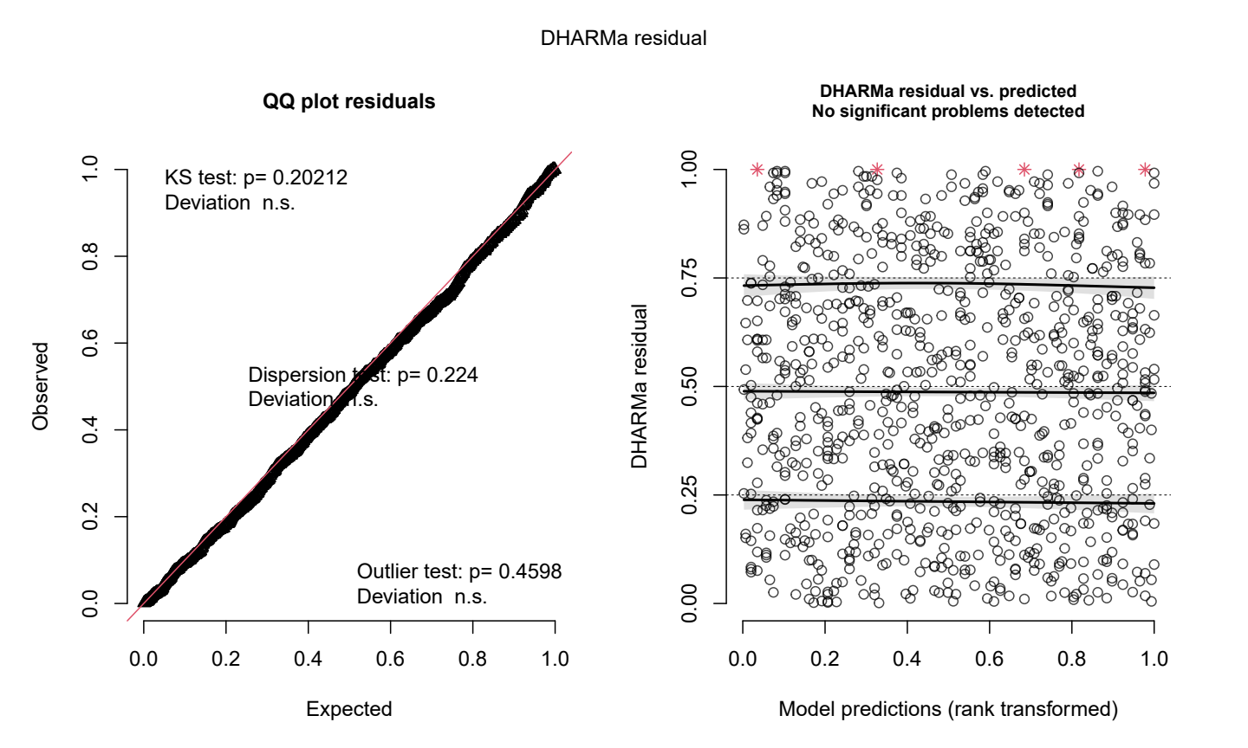
Fig. S4. Residuals of the selected model for leaf BES incidence.

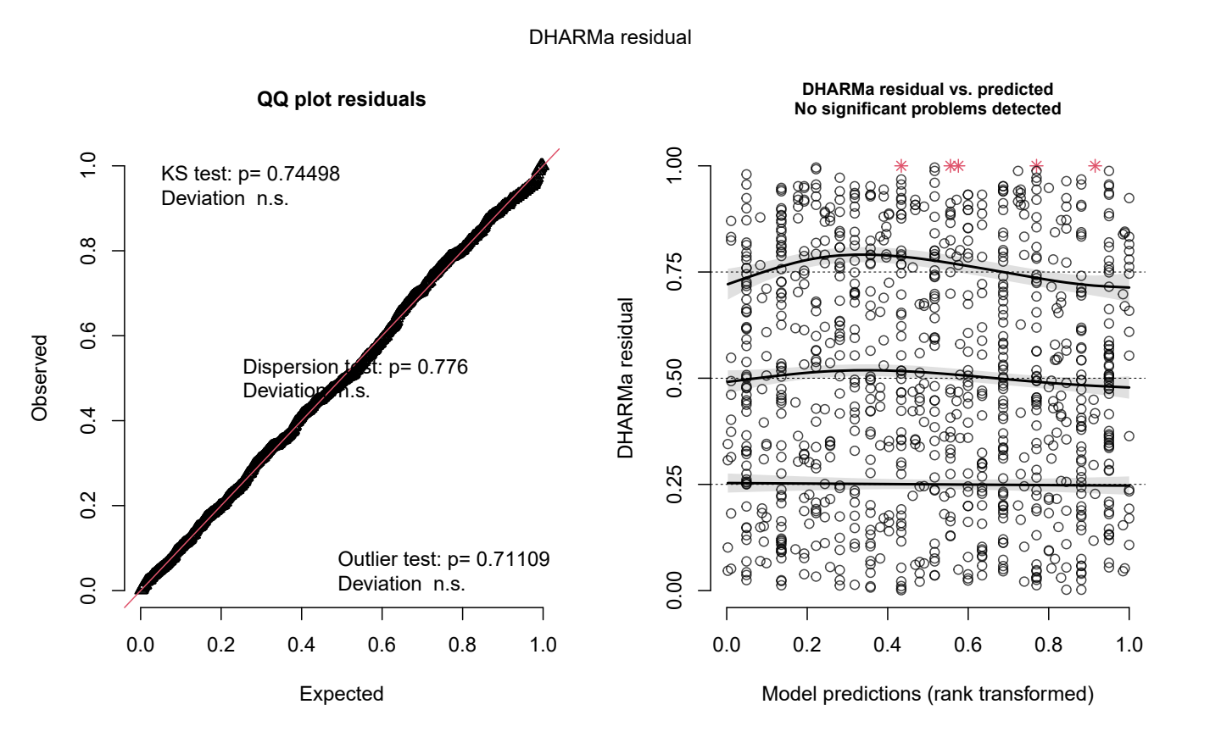
Fig. S5. Residuals of the selected model for leaf CWD incidence.

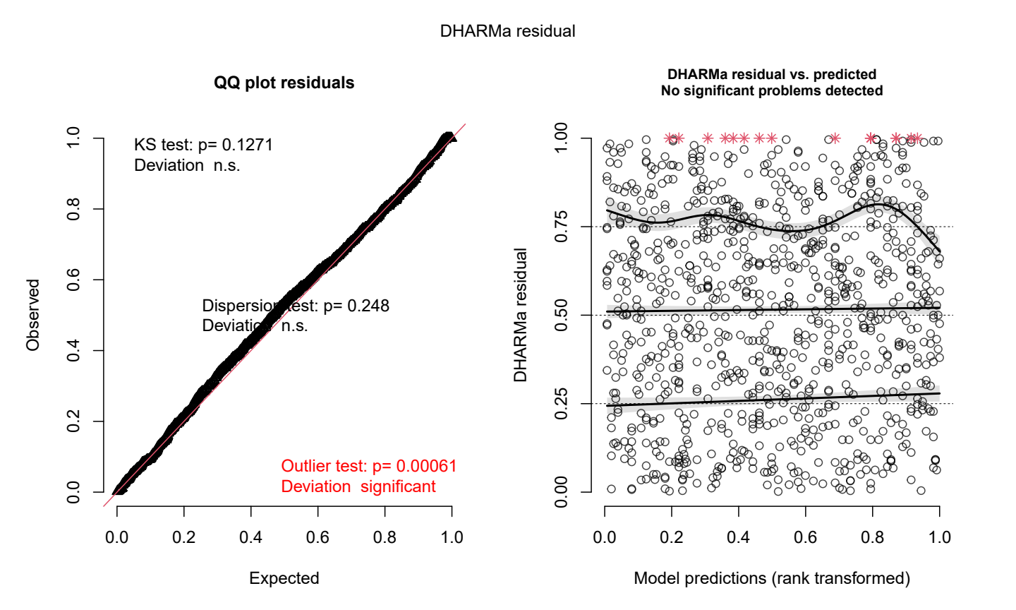
Fig. S6. Residuals of the selected model for leaf CLR incidence.

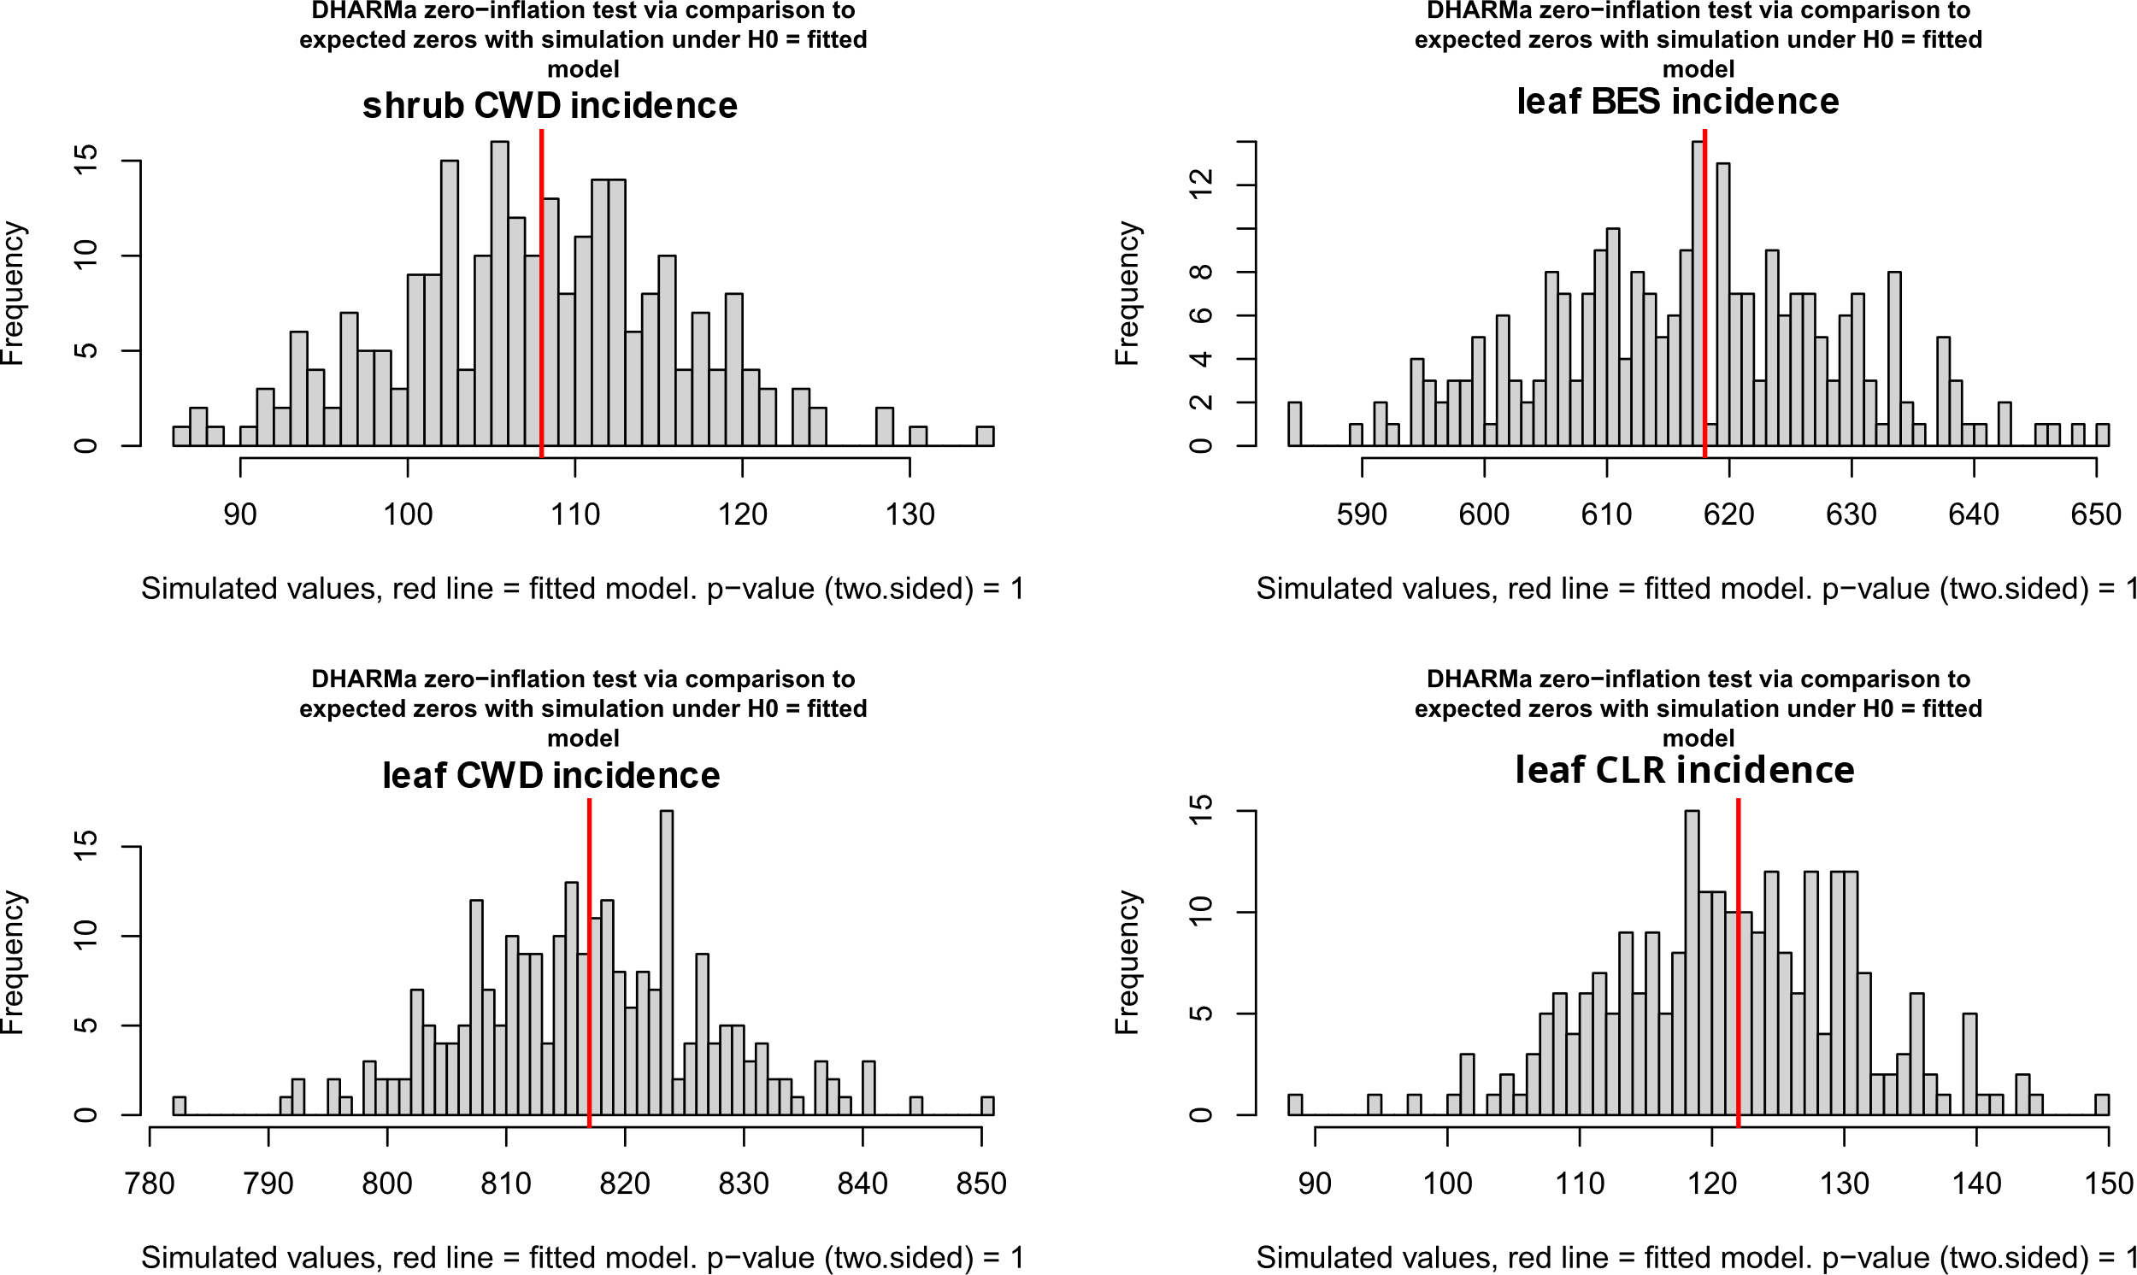

Fig. S7. Zero inflation tests of selected model for (A) shrub CWD incidence, (B) leaf BES incidence, (C) leaf CWD incidence and (D) leaf CLR incidence.

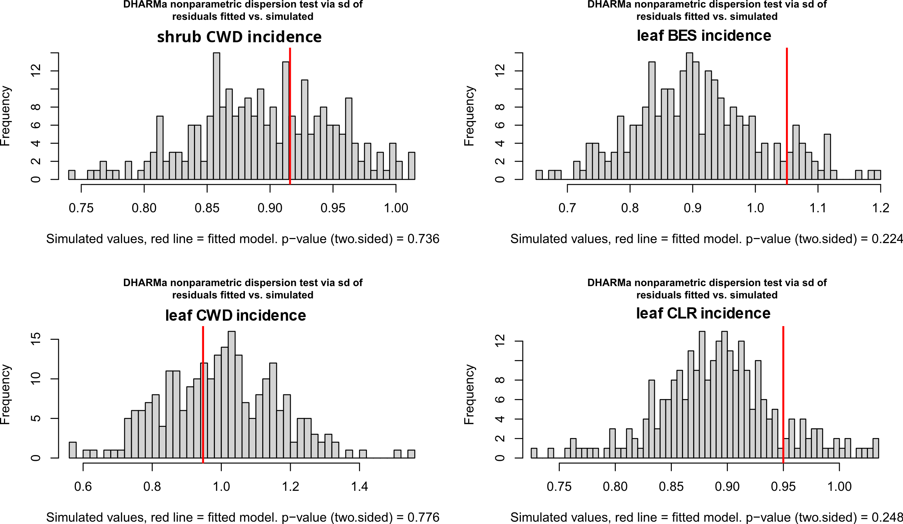

Fig. S8. Dispersion tests of selected model for (A) shrub CWD incidence, (B) leaf BES incidence, (C) leaf CWD incidence and (D) leaf CLR incidence.

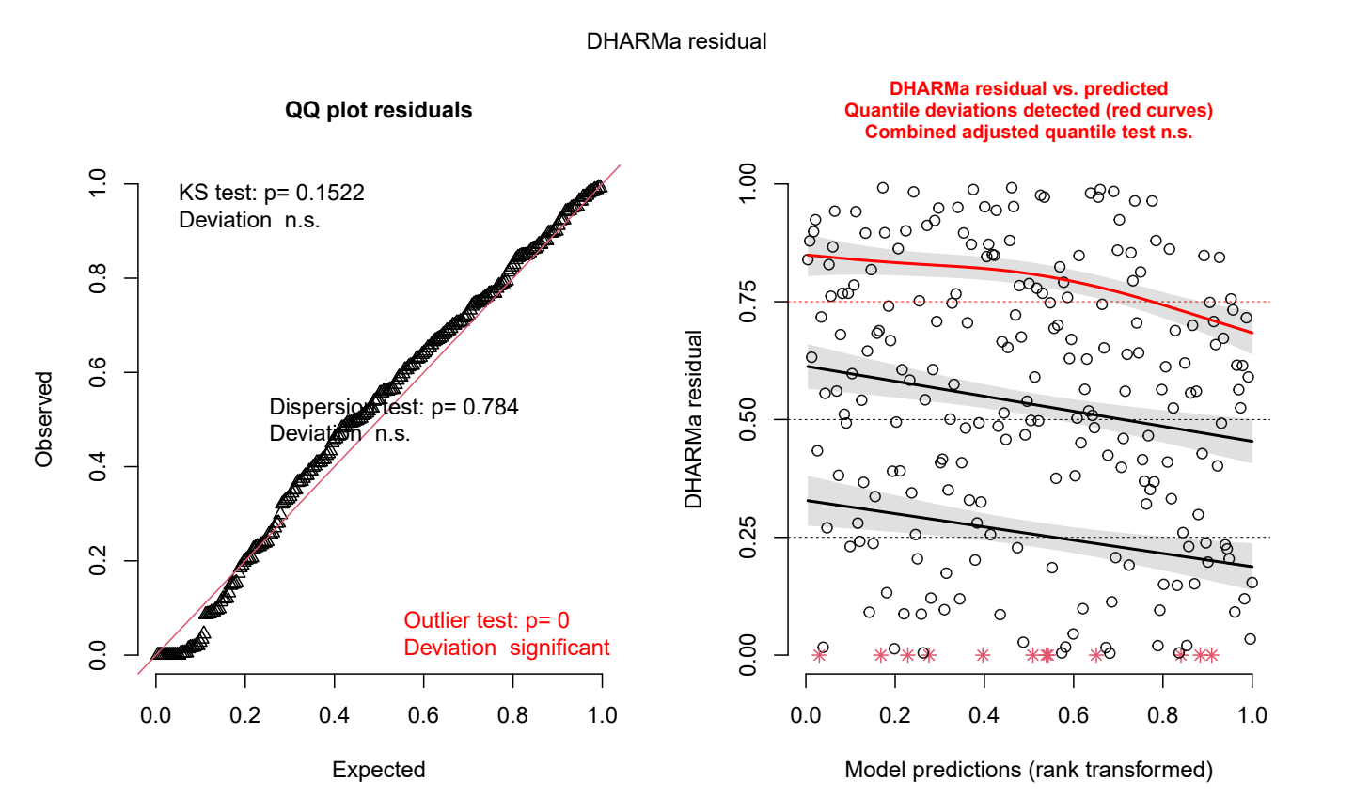
Fig. S9. Representation of residuals from the selected model for fruit load. The upper quantile deviation revealed a problem of homoscedasticity, but the model was kept because displaying the best models based on AICc compared to other models also showing a problem of homoscedasticity.

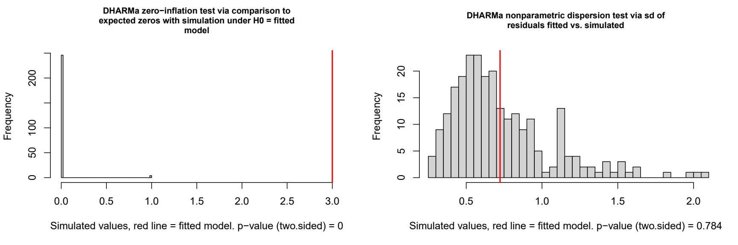
Fig. S10. (A) Zero inflation tests and (B) dispersion test of selected model for fruit load.

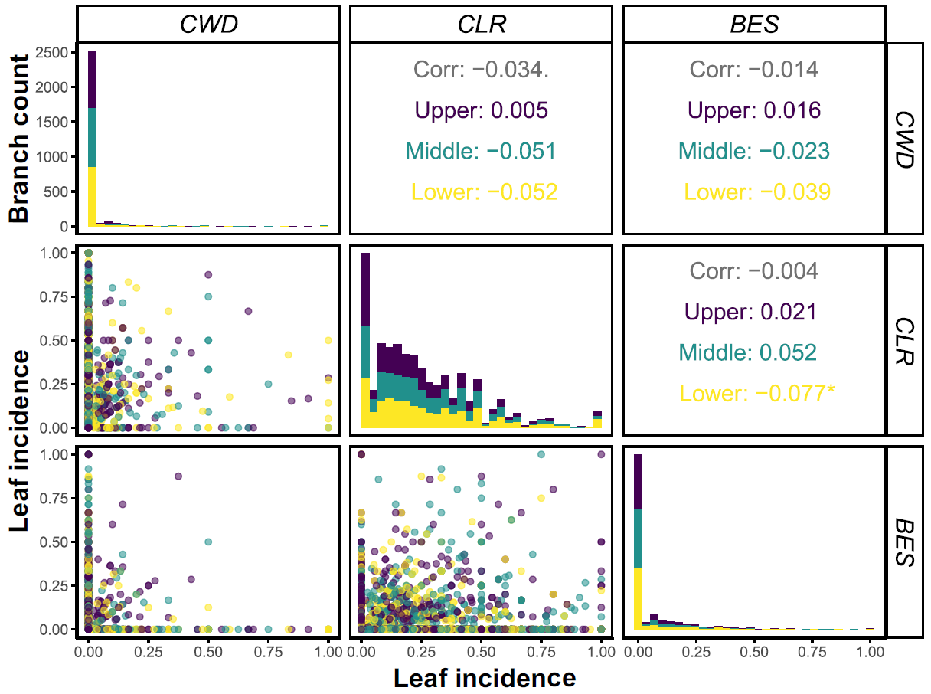 Fig. S11. Interaction between leaf incidence of coffee diseases (CWD, CLR and BES) and coffee shrub portions in the Kaweri Coffee Plantation.

