Supplementary Online Content

Age- and Sex-Specific Trends in Hospitalizations for Eating Disorders Among Children and Adolescents in France, 2016–2024

eMethods 1. Definition of eating disorders-related hospitalizations
eFigures 1A and 1B. Annual and monthly rates and trends of total ED-related hospitalizations among children aged 6 to 17 years in France
eTable1. Trend estimates of the monthly rates of total ED-related hospitalizations
eFigure 2. Distribution of age at admission for incident ED-related hospitalizations by sex in 2016 and 2024
eFigures 3A and 3B. Annual and monthly rates and trends of incident ED-related hospitalizations children 6 to 17 years in France
eTable2. Trend estimates of the monthly rates of incident ED-related hospitalizations

eMethods 1. Definition of Eating disorders related hospitalizations
In the PMSI database, medical diagnoses are extracted from the anonymous discharge summaries (Résumés de Sortie Anonyme, RSA) established at the end of each hospital stay and are classified as follows:
- Principal diagnoses (DP): medical reason justifying the hospitalization.
- Related diagnoses (DR): diagnosis specifying the DP
- Associated diagnoses (DA): morbidity associated to DP
One RSA contains one DP and as many DR or DA as needed to describe the patient’s medical condition during the hospital stay.
Hospitalizations related to eating disorders were defined as hospital stays (inpatient or day-hospital care) with at least one of the following ICD-10 (10th revision of the International Statistical Classification of Diseases and Related Health Problems) codes reported as DP:
- Eating disorder: F50 (these hospitalizations were further reclassified if a more precise eating disorders ICD-10 code was listed as DA)
- Anorexia nervosa: F50·0
- Atypical anorexia nervosa: F50·1
- Bulimia nervosa: F50·2
- Atypical bulimia nervosa: F50·3
- Overeating associated with other psychological disturbances: F50·4
- Vomiting associated with other psychological disturbances: F50·5
- Other eating disorders: F50·8
- Eating disorders, unspecified: F50·9 (these hospitalizations were further reclassified if a more precise eating disorders ICD-10 code was listed as DA)
- Feeding disorders of infancy and childhood: F98·2
- Pica of infancy and childhood: F98·3
We also included the following codes listed as DP with an eating disorders ICD-10 code reported as DA:
- Unspecified severe protein-energy malnutrition: E43
- Moderate protein-energy malnutrition: E44·0
- Mild protein-energy malnutrition: E44·1
- Unspecified protein-energy malnutrition: E46
These hospital stays were classified according to the eating disorders ICD-10 code reported as DA.

Further, eating-disorder hospitalizations were classified as follows based on ICD-10 codes:
- Anorexia nervosa-related:
  - Anorexia nervosa: F50·0
  - Atypical anorexia nervosa: F50·1
- Bulimia nervosa- related:
  - Bulimia nervosa: F50·2
  - Atypical bulimia nervosa: F50·3
  - Overeating associated with other psychological disturbances: F50·4
- Other eating disorders:
  - Vomiting associated with other psychological disturbances: F50·5
  - Feeding disorders of infancy and childhood: F98·2
  - Pica of infancy and childhood: F98·3
  - Unspecified eating disorders: F50; F50·8; F50·9

eFigure 1. Annual and monthly rates of total ED-related hospitalizations among children aged 6 to 17 years in France between Jan 1, 2016 and December 31,2024.
1A. Annual rates
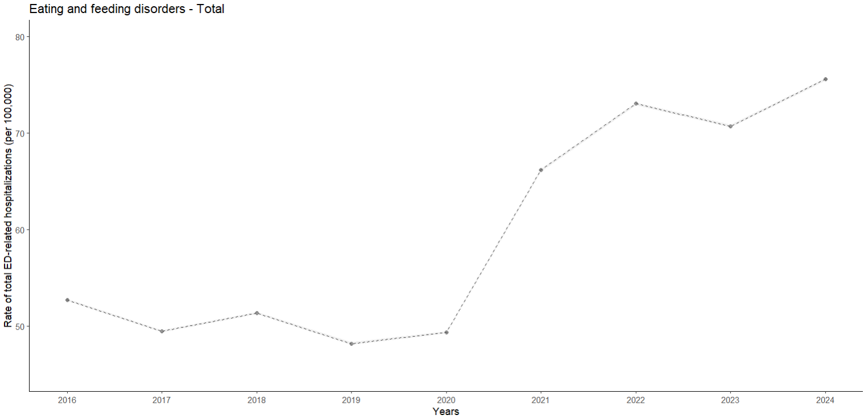 Black dots indicate the observed hospitalization rates per 100,000 children and adolescents

1B. Monthly rates
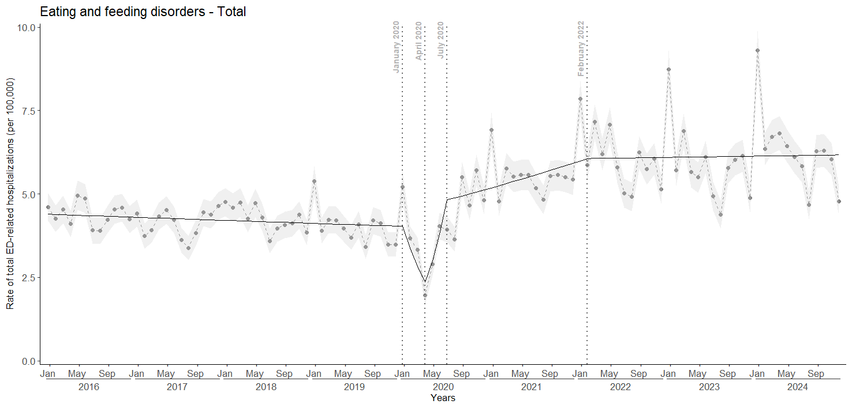
Black dots indicate the observed monthly hospitalization rates per 100,000 children and adolescents with 95%CI (shaded grey zone).
Black lines indicate monthly rates estimated by the model.
Dotted grey lines indicate the joinpoints identified by the model and delimit time segments with distinct trends.

eTable1. Trend estimates of the monthly rates of total ED-related hospitalizations in children aged 6 to 17 years
Segment | Monthly percent change (MPC) over segment (95% CI) | p-value
Jan 2016 - Jan 2020 | -0·2% (-0·3 ; -0·02%) | 0·04
Jan 2020 - Apr 2020 | -16·3% (-19·7 ; -7·1%) | 0·02
Apr 2020 - Jul 2020 | 26·9% (14·0 ; 32·4%) | 0·046
Jul 2020 - Feb 2022 | 1·2% (0·6 ; 4·9%) | <0·001
Feb 2022 - Dec 2024 | 0·1% (-0·6 ; 0·3%) | 0·74

eFigure 2. Distribution of age at admission for incident ED-related hospitalizations by sex in 2016 and 2024
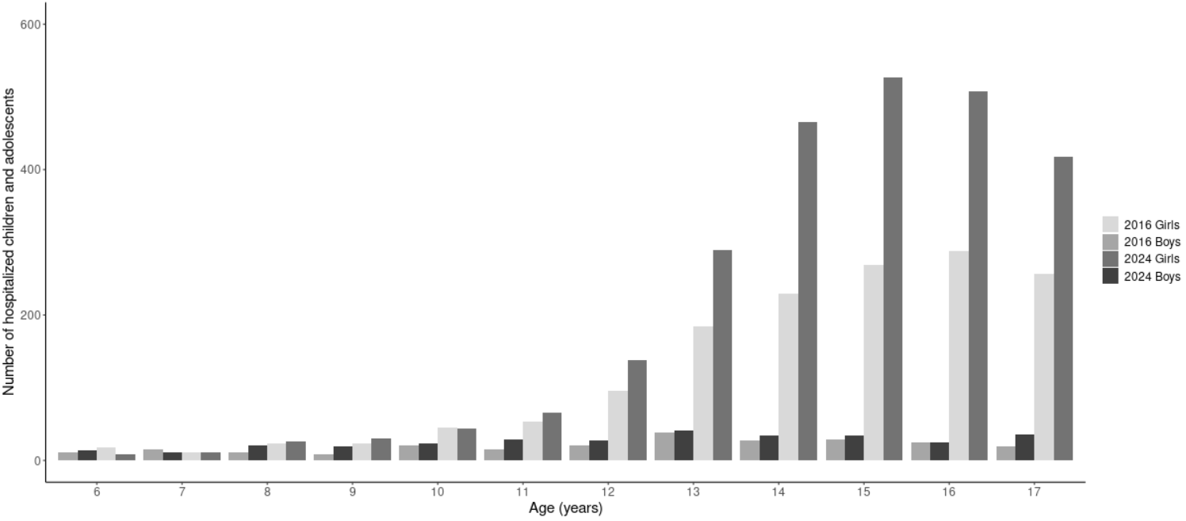

eFigures 3A and 3B. Annual and monthly rates and trends of incident ED-related hospitalizations among children aged 6 to 17 years in France
3A. Annual rates
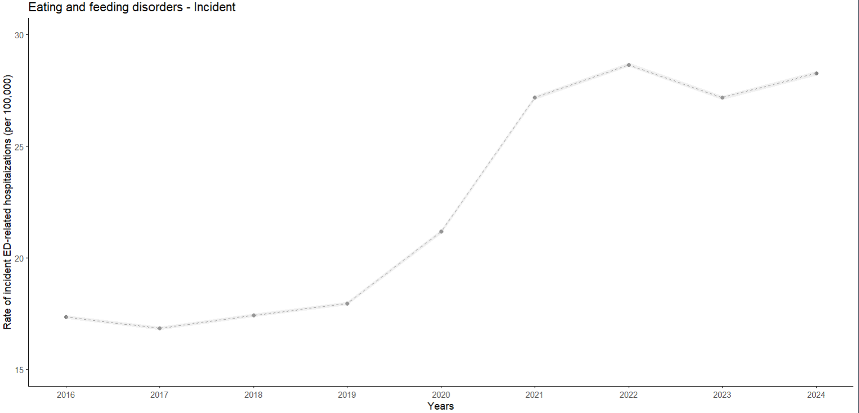
Black dots indicate the observed hospitalization rates per 100,000 children and adolescents

3B. Monthly rates
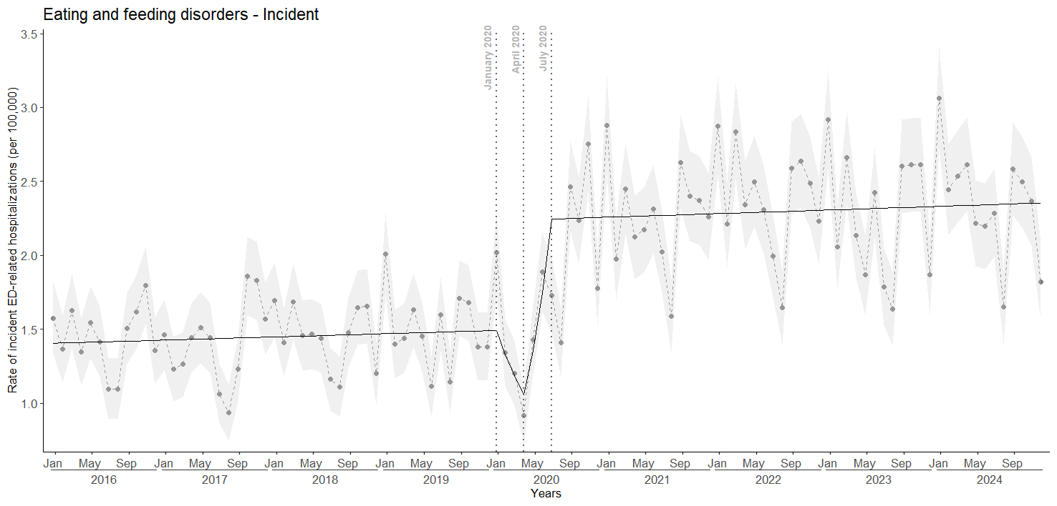
Black dots indicate the observed monthly hospitalization rates per 100,000 children and adolescents with 95%CI (shaded grey zone).
Black lines indicate monthly rates estimated by the model.
Dotted grey lines indicate the joinpoints identified by the model and delimit time segments with distinct trends.

eTable2. Trend estimates of the monthly rates of incident ED-related hospitalizations in children aged 6 to 17 years
Segment | Monthly percent change (MPC) over segment (95% CI) | p-value
Jan 2016 - Jan 2020 | 0·1% (-0·04 ; 0·3%) | 0·12
Jan 2020 - Apr 2020 | -10·9% (-14·8 ; -4·2%) | 0·002
Apr 2020 - Jul 2020 | 28·6% (18·9 ; 34·4%) | 0·002
Jul 2020 – Dec 2024 | 0·1% (-0·1 ; 0·2%) | 0·3

