Supplementary Information

Wearable 16-channel electroencephalography for 8-day continuous monitoring

Authors: Zongman Zhang^{1,2†}, Yi Liu^{1,2†}, Wenqing Yan^{1,2†}, Haoyang Wang^{3,4†}, Shihong Lin^{1,2}, Jiawei Yang^{1,2}, Zonglei Wang^{1,2}, Yuli Wang^{1,2}, Jiansheng Zhang^{5,6}, Yumiao Xu¹, Pengcheng Zhou^{1,2}, Yujie Zhang^{1,2}, Mingzhe Wang¹, Zichong Ji^{1,2}, Meiqiong Zheng^{1,2}, Shuaizhe Chen⁷, Yun Li^{5,6}, Tomoyuki Yokota³, Sunghoon Lee^{3,8}, Takao Someya^{3,8*} and Yan Wang^{1,2,9*}

†These authors contributed equally to this work.
*Corresponding author email: someya@ee.t.u-tokyo.ac.jp; wang.yan@technion.ac.il

Table of contents
Supplementary Note 1 | Systematic compositional optimization of gelatin hydrogel 4
Supplementary Note 2 | Effect of viscosity and stirring speed on macroporous morphology and permeability of the hydrogel 5
Supplementary Note 3 | Permeability mechanism in macroporous hydrogels 6
Supplementary Note 4 | Comparison of 24 h EEG monitoring and motion artefact analysis between hydrogel and commercial EEG paste electrodes in daily settings 7
Supplementary Note 5 | Activity paradigm decomposition and reproducible task assessment across 8 days 8
Supplementary Fig. 1 | Flexible and breathable 16-channel earhook wireless system. 11
Supplementary Fig. 2 | Lateral WVTR of encapsulating materials in the wireless module 12
Supplementary Fig. 3 | High skin adhesion and conformability of the hydrogel enabled by in situ gelation 13
Supplementary Fig. 4 | Thermally reversible phase transition properties of the hydrogel. 14
Supplementary Fig. 5 | Hydrogel properties with different compositions 15
Supplementary Fig. 6 | Effect of TA content on the properties of hydrogels. 16
Supplementary Fig. 7 | Effect of DA·HCl content on hydrogel properties. 17
Supplementary Fig. 8 | Effect of gelatin content on hydrogel properties 18
Supplementary Fig. 9 | Effect of glycerol content on the anti-drying performance and intrinsic impedance of hydrogels. 19
Supplementary Fig. 10 | Self-healing behavior of the hydrogel. 20
Supplementary Fig. 11 | Effect of water content on viscosity and macroporous structure of hydrogels. 21
Supplementary Fig. 12 | Gas permeance and WVTR of 1 mm-thick hydrogels prepared at stirring rates of 0 rpm (non-porous), 500 rpm, 1,000 rpm, and 1,500 rpm. 22
Supplementary Fig. 13 | Optical microscope images and SEM images of hydrogels prepared at stirring rates of 0 rpm (non-porous), 500 rpm, 1,000 rpm, and 1,500 rpm. 23
Supplementary Fig. 14 | Schematic illustration of air and water-vapor permeation mechanisms in macroporous hydrogel. 25
Supplementary Fig. 15 | SEM images of in situ formed and preformed hydrogel on hair-bearing skin (left) and interfacial toughness on hair-bearing and smooth skin (right) 26
Supplementary Fig. 16 | Schematic illustration of the hydrogel–skin interfacial adhesion mechanism 27
Supplementary Fig. 17 | FTIR spectra of different hydrogels: (i) GW, (ii) GGWT, (iii) GGWD, and (iv) GGWTD 28
Supplementary Fig. 18 | Comparison of interfacial adhesion between commercial EEG paste and hydrogel 29
Supplementary Fig. 19 | Quantitative comparison of interfacial toughness at the commercial EEG paste–electrode and hydrogel–electrode interfaces. 30
Supplementary Fig. 20 | Maintenance of macroporous structure after 24 h compression. 31
Supplementary Fig. 21 | Hydrogel durability under cyclic compression 32
Supplementary Fig. 22 | Hydrogel durability under cyclic stretching. 33
Supplementary Fig. 23 | Scalp contact impedance of commercial EEG paste and hydrogel electrodes 34
Supplementary Fig. 24 | Scalp contact impedance at 10 Hz before and after reheating on Day 8 35
Supplementary Fig. 25 | Shape molding of the hydrogel 36
Supplementary Fig. 26 | Reusability of the hydrogel. 37
Supplementary Fig. 27 | Easy removal of the hydrogel 38
Supplementary Fig. 28 | Simultaneous acquisition of 8.5 h EEG signals by PSG and the wireless system 39
Supplementary Fig. 29 | Motion artefact comparison between commercial EEG paste and hydrogel electrodes at P₄ channel during walking and running 40
Supplementary Fig. 30 | Motion artefact comparison between commercial EEG paste and hydrogel electrodes at F₄ channel during walking and running 41
Supplementary Fig. 31 | Motion artefact comparison between commercial EEG paste and hydrogel electrodes before and after exercise 42
Supplementary Fig. 32 | Comparison of 24 h daily EEG recordings using hydrogel and commercial EEG paste electrodes 43
Supplementary Fig. 33 | Representative 16-channel EEG signals during low- and high-attention activities 45
Supplementary Fig. 34 | Power ratio during low- and high-attention activities 46
Supplementary Fig. 35 | Eight-day time spectrum and ridgeline distribution of different activities 47
Supplementary Fig. 36 | Real-time attention assessment and task-specific discriminability on Day 1 in daily-life settings. 48
Supplementary Fig. 37 | Real-time attention assessment and task-specific discriminability on Day 2 in daily-life settings 50
Supplementary Fig. 38 | Real-time attention assessment and task-specific discriminability on Day 3 in daily-life settings. 52
Supplementary Fig. 39 | Real-time attention assessment and task-specific discriminability on Day 4 in daily-life settings. 54
Supplementary Fig. 40 | Real-time attention assessment and task-specific discriminability on Day 5 in daily-life settings 56
Supplementary Fig. 41 | Real-time attention assessment and task-specific discriminability on Day 6 in daily-life settings 58
Supplementary Fig. 42 | Real-time attention assessment and task-specific discriminability on Day 7 in daily-life settings. 60
Supplementary Fig. 43 | Real-time attention assessment and task-specific discriminability on Day 8 in daily-life settings 62
Supplementary Table 1 | Comparison of the breathable wireless system with commercial wearable EEG devices and recently reported wireless EEG systems 64
Supplementary Table 2 | Comparison of the scalp EEG electrodes from a continuous, long-term operation perspective 65
Supplementary Table 3 | Comparison of representative reported hydrogel electrode materials for EEG monitoring 66
Supplementary Table 4 | Detailed formulations of macroporous hydrogel samples with varying component compositions. 67
Supplementary Table 5 | Likert-scale items developed for self-reported attentional engagement 68
Supplementary Video 1 | Robust adhesion at the hydrogel–electrode interface 69
Supplementary Video 2 | Demonstration of hydrogel air permeability in water and soapy water 69
Supplementary Video 3 | Comparison of sleep monitoring using the wireless system and PSG 69
Supplementary Video 4 | Real-time wireless EEG monitoring and attention level assessment during a driving simulation 69
Supplementary Video 5 | Real-time wireless EEG monitoring and attention level assessment during daily activities 69
Supplementary Video 6 | Sleep monitoring with simultaneous wireless battery charging 69

References 70

Supplementary Note 1 | Systematic compositional optimization of gelatin hydrogel
In this work, gelatin exhibiting a thermally reversible phase transition was selected as the hydrogel matrix. The functional components included dopamine hydrochloride (DA·HCl) to enhance adhesion, tannic acid (TA) to provide ionic crosslinking and additional adhesion sites, and a water–glycerol binary solvent to ensure long-term moisture retention.
We systematically evaluated the effects of varying compositions on the hydrogel properties (Supplementary Table 4). We compared three baseline formulations: GGWD (composed of gelatin, glycerol, water, and DA·HCl), GGWT (composed of gelatin, glycerol, water, and TA), and GGWTD (composed of gelatin, glycerol, water, TA, and DA·HCl). As shown in Supplementary Fig. 5, the skin contact impedance of GGWD and GGWTD was slightly lower than that of GGWT. Among these, GGWTD exhibited superior adhesion strength and stretchability, and was therefore selected for further optimization.
To determine the optimal TA content, GGWT_{0.1}D, GGWT_{0.3}D, GGWT_{0.5}D, and GGWT_{1.0}D hydrogels were prepared with 0.1, 0.3, 0.5, and 1.0 g TA, respectively (Supplementary Fig. 6). The 1.0 g formulation failed to form a stable gel and was excluded. Adhesion performance peaked at 0.3 g TA. Hydrogels containing 0.3 g and 0.5 g TA exhibited comparable tensile strains (1,318.0% and 1,302.8%, respectively), whereas the 0.3 g sample sustained higher tensile stress, indicating improved elasticity. Consequently, 0.3 g TA was adopted for subsequent studies.
To optimize DA·HCl content, GGWTD hydrogels containing 0.1 g (GGWTD_{0.1}), 0.2 g (GGWTD_{0.2}), and 0.4 g (GGWTD_{0.4}) DA·HCl were fabricated (Supplementary Fig. 7). Increasing DA·HCl content progressively reduced skin contact impedance. The GGWTD_{0.4} formulation exhibited the highest interfacial adhesion (30.9 N cm⁻¹) at the hydrogel–electrode interface. Although mechanical strength slightly decreased at higher DA·HCl levels, GGWTD_{0.4} maintained excellent stretchability (1,063.6%). Therefore, 0.4 g DA·HCl was selected as optimal.
The influence of gelatin content was next examined using 1.5 g (G_{1.5}GWTD), 2.0 g (G_{2.0}GWTD), and 2.5 g (G_{2.5}GWTD) formulations (Supplementary Fig. 8). All compositions showed similar contact impedance and adhesion; however, mechanical strength increased with gelatin concentration while gelation time decreased. Based on these results, 2.5 g gelatin was chosen as the optimized amount.
Finally, the effect of glycerol content on water retention and electrical stability was investigated (Supplementary Fig. 9). Hydrogels containing 1.0 g (GG_{1.0}WTD), 3.0 g (GG_{3.0}WTD), and 6.0 g (GG_{6.0}WTD) glycerol were compared. Water–glycerol hydrogen bonding effectively suppressed evaporation. The initial intrinsic impedance increased with glycerol content, whereas low-glycerol samples showed a significant impedance rise after 24 h. Balancing electrical stability and water retention, 3.0 g glycerol was determined to be optimal.
Through systematic optimization of the key parameters, including electrical impedance, adhesion strength, tensile performance, gelation time, and long-term stability, the optimal hydrogel composition was determined to contain 0.4 g DA·HCl, 0.3 g TA, 2.5 g gelatin, and 3.0 g glycerol.

Supplementary Note 2 | Effect of viscosity and stirring speed on macroporous morphology and permeability of the hydrogel
Gas and water-vapor transport in macroporous hydrogels is governed primarily by pore morphology, with pore size and porosity serving as the most direct structural parameters, while pore size distribution and structural uniformity further modulate overall transport performance. These structural features are in turn dictated by the coupled effects of precursor rheology and shear-driven bubble dynamics. The water content modulates precursor viscosity, which in turn determines bubble formation and pore architecture. As shown in Supplementary Fig. 11, viscosity decreases with increasing water content. At low water content (GGW_{2.0}TD, 2 mL), the viscosity is excessively high to sustain a stable vortex, resulting in irregular bubble entrapment and a nonuniform pore structure. At intermediate water content (GGW_{4.0}TD, 4 mL), a balance between bubble stability and coalescence yields a uniform, densely interconnected macroporous network. Further dilution (GGW_{6.0}TD and GGW_{8.0}TD, 6 mL and 8 mL, respectively) lowers viscosity, causing bubble rupture and pore collapse. Accordingly, the GGW_{4.0}TD formulation was selected for subsequent optimization by varying stirring speed.
Shearing/stirring rate strongly influences pore size distribution, porosity, and gas/water-vapor transport. Optical and SEM micrographs reveal that increasing stirring speed from 500 to 1,500 rpm progressively reduces average pore diameter from 414.3 ± 212.9 µm to 79.4 ± 19.9 µm (Fig. 2c and Supplementary Fig. 13). At 500 rpm, pores are sparsely distributed and highly polydisperse, leading to low porosity and limited permeability (Supplementary Fig. 12). At 1,000 rpm, a homogeneous macroporous network forms with moderate pore size (304.6 ± 81.3 µm) and high porosity, facilitating efficient gas and vapor transport. Further increasing to 1,500 rpm slightly enhances porosity but drastically decreases pore size, constraining mass transport pathways.
As summarized in Fig. 2b, viscosity increases with stirring rate, reflecting enhanced shear-induced crosslinking, while porosity follows a similar upward trend. Gas permeance and WVTR peak at 1,000 rpm, corresponding to the optimally percolated pore network (Supplementary Fig. 12). Excessive shear at 1,500 rpm results in smaller, more tortuous pores that limit diffusivity, thereby reducing gas permeance. On this basis, a stirring rate of 1,000 rpm was identified as the optimal condition, balancing viscosity, pore morphology, and breathability.

Supplementary Note 3 | Permeability mechanism in macroporous hydrogels
Supplementary Fig. 14 elucidates the mechanisms underlying the markedly higher permeability of macroporous hydrogels compared with nonporous hydrogels and conventional dense polymer films such as parylene. The enhanced gas and water-vapor transport arises from 3 complementary effects: (i) Shortened diffusion path: Macropores serve as continuous channels that substantially shorten the transport distance through the hydrogel matrix. This reduction in path length lowers the overall diffusion resistance, leading to markedly improved water-vapor and gas permeance, as observed in Fig. 2d and Supplementary Fig. 12. (ii) Dissolution–diffusion through thin, highly hydrated and internally microporous interconnecting regions: These interconnecting regions do not act as dense barriers, but instead consist of hydrated polymer layers with internal microporous features, as supported by SEM images (Supplementary Fig. 13). The connecting regions facilitate molecular dissolution into the water phase, followed by rapid diffusion between adjacent pores. In contrast, nonporous hydrogels rely on transport through a continuous, thicker hydrated matrix, resulting in slower molecular flux and higher resistance. (iii) Internal fluidity of the polymer–water network: Hydrogels possess dynamic polymer chains and a mobile water phase that can locally reorganize, generating transient free volumes and low-resistance pathways for permeation. By contrast, parylene, a rigid, densely packed polymer used in traditional electrode encapsulation, remains structurally static and acts as an effective diffusion barrier. Consistent with these mechanisms, measurements of permeate-side pressure rise and gas permeance confirm that a 3 µm-thick nanomesh-reinforced hydrogel exhibits substantially higher gas permeance than a 3 µm-thick parylene film.

Supplementary Note 4 | Comparison of 24 h EEG monitoring and motion artefact analysis between hydrogel and commercial EEG paste electrodes in daily settings
To evaluate long-term stability and motion artefact resistance during daily activities, 24 h continuous EEG recordings were performed using the hydrogel electrodes and compared with commercial EEG paste electrodes (see Methods). As shown in Supplementary Fig. 32a, the hydrogel electrodes maintained stable, high-fidelity EEG signals throughout the entire 24 h recording period. In contrast, the commercial EEG paste electrodes exhibited progressive signal degradation, with signal quality declining markedly after approximately 11 h of use. This deterioration is further reflected in the STFT spectrograms, where the commercial paste showed rapid loss of frequency resolution and spectral structure, whereas the hydrogel preserved consistent time-frequency features.
Supplementary Fig. 32b schematically illustrates the dynamic instability of the hair-bearing scalp–commercial EEG paste/hydrogel interface over time. The commercial EEG paste progressively lost adhesion during motion (time point at 03:03, walking), leading to electrode slippage; partial contact was transiently restored during sleep (time point at 03:46) due to occasional body movements such as turning or waking, but complete drying and detachment occurred later (time point at 09:24). In contrast, the hydrogel electrode retained strong adhesion and structural integrity throughout (Supplementary Fig. 32c). Supplementary Fig. 32d presents representative EEG signals and corresponding FFT spectra during 4 fast walking workouts (5.0 km h⁻¹), showing minimal motion-induced contamination for the hydrogel electrodes, whereas the commercial EEG paste electrodes suffered severe artefacts.

Supplementary Note 5 | Activity paradigm decomposition and reproducible task assessment across 8 days
This Note expands the day-by-day analysis by decomposing naturalistic behavior into discrete activity paradigms to evaluate discriminability and cross-day reproducibility of the attention level readout. Across the 8-day dataset, multi-channel EEG signals largely overlapped in the time domain, limiting visual separability of behavioral states (Supplementary Figs. 36a–43a (top)). In contrast, the decoded per-second attention scores exhibited stable circadian modulation aligned with the sleep–wake cycle, reliably dissociating sleep from wakefulness and capturing graded differences in cognitive load across activities (Supplementary Figs. 36a–43a (bottom)). Ridgeline distributions further showed separable, activity-dependent attention profiles (Supplementary Figs. 36b–43b).
Across Days 1–8, we first analyzed the EEG recordings and decoded attention level trajectories on a day-by-day basis, and then selected one representative within-day or cross-day activity contrast for detailed analysis. This design allowed us to evaluate the discriminability of the attention readout within each day and its reproducibility across days under diverse naturalistic conditions.
Day 1: Cognitive activity number-search versus relaxing
EEG signals displayed increased higher frequency activity during task epochs and slow wave dominance during relaxing (Supplementary Fig. 36c). Magnified attention scores rose during the number-search task and decreased during relaxing (Supplementary Fig. 36d). Scalp topographies at selected time points revealed parietal β-band enhancement with concurrent suppression of θ- and α-band power during number-search task; the opposite pattern appeared during relaxing. The engagement index was consistently higher during task periods than during the relaxing state (Supplementary Fig. 36e).
Day 2: Exercise modalities
We contrasted stretching, cycling, and rowing. EEG signals showed slow wave predominance during stretching, stronger high frequency components during cycling, and an intermediate, mixed spectral pattern during rowing (Supplementary Fig. 37c). Attention scores followed a low–high–intermediate gradient (lowest for stretching, intermediate for rowing, and highest for cycling), and the second-by-second trajectories displayed pronounced moment-to-moment fluctuations whose amplitude and persistence scaled with task intensity, small and sporadic during stretching, large and sustained during cycling, and intermediate during rowing (Supplementary Fig. 37d). Scalp topographies at selected time points reflected relative β upregulation and α suppression during cycling; stretching featured dominant θ, α activity with suppressed β-band power; rowing showed regional β increases with modest α (Supplementary Fig. 37e). Correspondingly, engagement index values differed significantly across the three conditions, lowest for stretching, highest for cycling, and intermediate for rowing.
Day 3: Cognitive activity number-write versus relaxing
Alternating number-write–relaxing–number-write blocks produced step-like changes in both EEG and attention. EEG signals showed stronger high frequency activity during the writing numbers task and slower waves during relaxing (Supplementary Fig. 38c). The second-by-second attention trajectory rose sharply and plateaued during the writing numbers task, then dropped to near baseline during relaxing (Supplementary Fig. 38d). Scalp topographies showed parietal β enhancement with θ and α suppression during writing numbers, whereas low frequency activity predominated during relaxing. Engagement index values were significantly higher for writing numbers with stable cross-task reproducibility (Supplementary Fig. 38e).
Day 4: Low-arousal states (sleep, meditation, eyes-closed relaxing)
EEG signals exhibited slow wave dominance during sleep, prominent α rhythms during meditation, and relatively higher frequency components during eyes-closed relaxing (Supplementary Fig. 39c). Attention scores were lowest in sleep, intermediate in meditation, and relatively higher during eyes-closed relaxing (Supplementary Fig. 39d). Scalp topographies showed θ, α dominance with β suppression during sleep, widespread α during meditation, and regional β upregulation during eyes-closed relaxing. Engagement index values separated these states in a manner consistent with behavioral labeling (Supplementary Fig. 39e).
Day 5: Visually driven digital media (videos, casual smartphone use, gaming)
As task interactivity rose—from low (videos and casual smartphone use) to high (gaming), the EEG signals showed progressively stronger high frequency components, and attention trajectories increased accordingly, with gaming producing the highest and most sustained levels (Supplementary Figs. 40c and 40d). Scalp topographies displayed pronounced θ and parietal β enhancement with widespread α suppression during gaming, whereas video viewing and casual smartphone use were characterized by comparatively stronger frontal-central α with weaker β. The engagement index mirrored this pattern (Supplementary Fig. 40e).
Day 7: Intraday repeatability (casual smartphone use)
The same natural activity was repeated in the morning, afternoon, and evening. EEG signals exhibited a similar waveform structure with minor drift (Supplementary Fig. 42c). Attention scores were comparable across time points (Supplementary Fig. 42d), and scalp topographies showed increased α, θ with reduced β. Engagement index values did not differ significantly across sessions, supporting intraday stability and test–retest reliability (Supplementary Fig. 42e).
Day 8: Sleep continuity
Across different time points, EEG signals were dominated by slow waves (Supplementary Fig. 43c). Attention scores remained uniformly low (near 0) throughout (Supplementary Fig. 43d). Scalp topographies consistently showed θ, α enhancement with β suppression, and engagement index values were correspondingly minimal (Supplementary Fig. 43e), indicating sustained, low-arousal tracking.

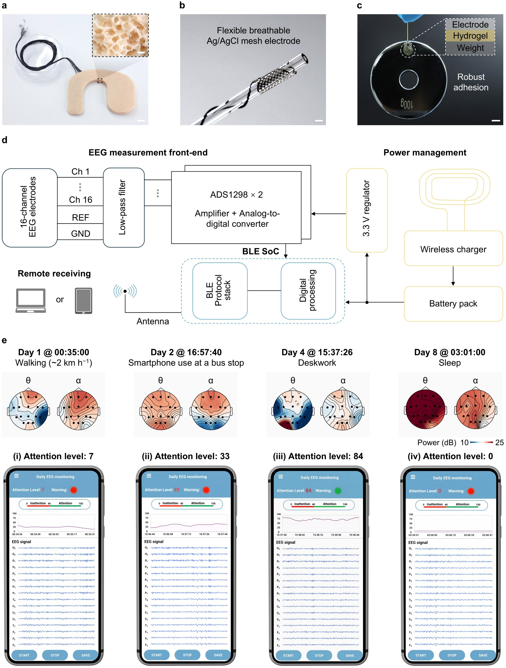

Supplementary Fig. 1 | Flexible and breathable 16-channel earhook wireless system. a, Photograph of the backside of the earhook wireless EEG system. Scale bar, 1 cm. Inset photograph: macroporous structure of the encapsulating Ecoflex layer. Scale bar, 500 μm. b, Photograph of a breathable Ag/AgCl mesh electrode wrapped around a capillary tube, demonstrating high flexibility and conformability. Scale bar, 2 mm. c, Photograph of a hydrogel electrode lifting a 100 g weight, 20,000 times its own mass, demonstrating robust adhesion at the weight–hydrogel–mesh electrode interface. Scale bar, 1 cm. d, Schematic illustration of the wireless module showing the end-to-end workflow from 16-channel EEG acquisition, amplification and digitization, power regulation and management, to wireless data transmission via BLE. e, Top: scalp topographies of θ- and α-band power during walking, casual smartphone use at a bus stop, deskwork, and sleep. Bottom: smartphone application screenshots displaying the corresponding real-time attention level (scale 0–100) and the instantaneous cognitive classification. Attention scores of 7 (walking), 33 (casual smartphone use), 84 (deskwork), and 0 (sleep) are shown. The system classifies levels below 40 as Inattention state (red alert) and 40–100 as Attention state (green light). This contrast highlights the higher cognitive demands of deskwork versus other activities, demonstrating the system's ability to monitor sustained focus and alert against mind-wandering.
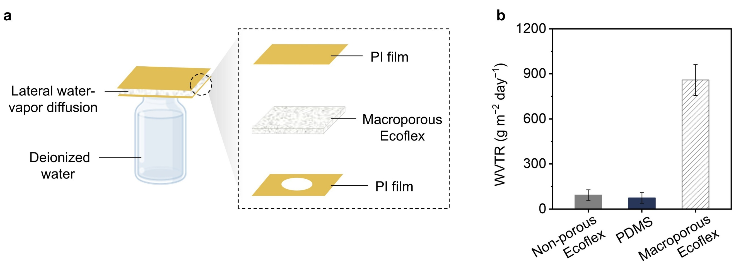

Supplementary Fig. 2 | Lateral WVTR of encapsulating materials in the wireless module. a, Schematic of the experimental setup for lateral WVTR measurement, illustrating the transport pathway of water-vapor. b, Comparison of lateral WVTR between 1 mm-thick non-porous Ecoflex and macroporous Ecoflex under 30% relative humidity at 25 °C; 1 mm-thick non-porous PDMS included as a reference material owing to its widespread use in soft encapsulation and well-established barrier properties. Error bars represent the SD of the measured values (n = 3).

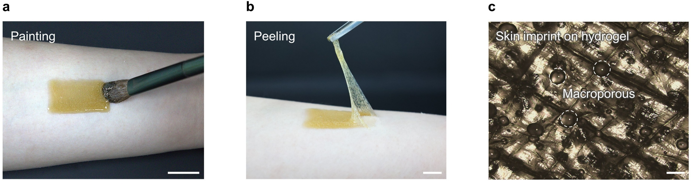

Supplementary Fig. 3 | High skin adhesion and conformability of the hydrogel enabled by in situ gelation. a, Photograph showing the hydrogel being painted onto human skin and in situ gelling. Scale bar, 1 cm. b, Photograph showing the hydrogel being peeled off from human skin. Scale bar, 1 cm. c, Optical microscope image of the hydrogel replicating skin topography, confirming conformal adaptation to microscale surface roughness. Scale bar, 200 μm.

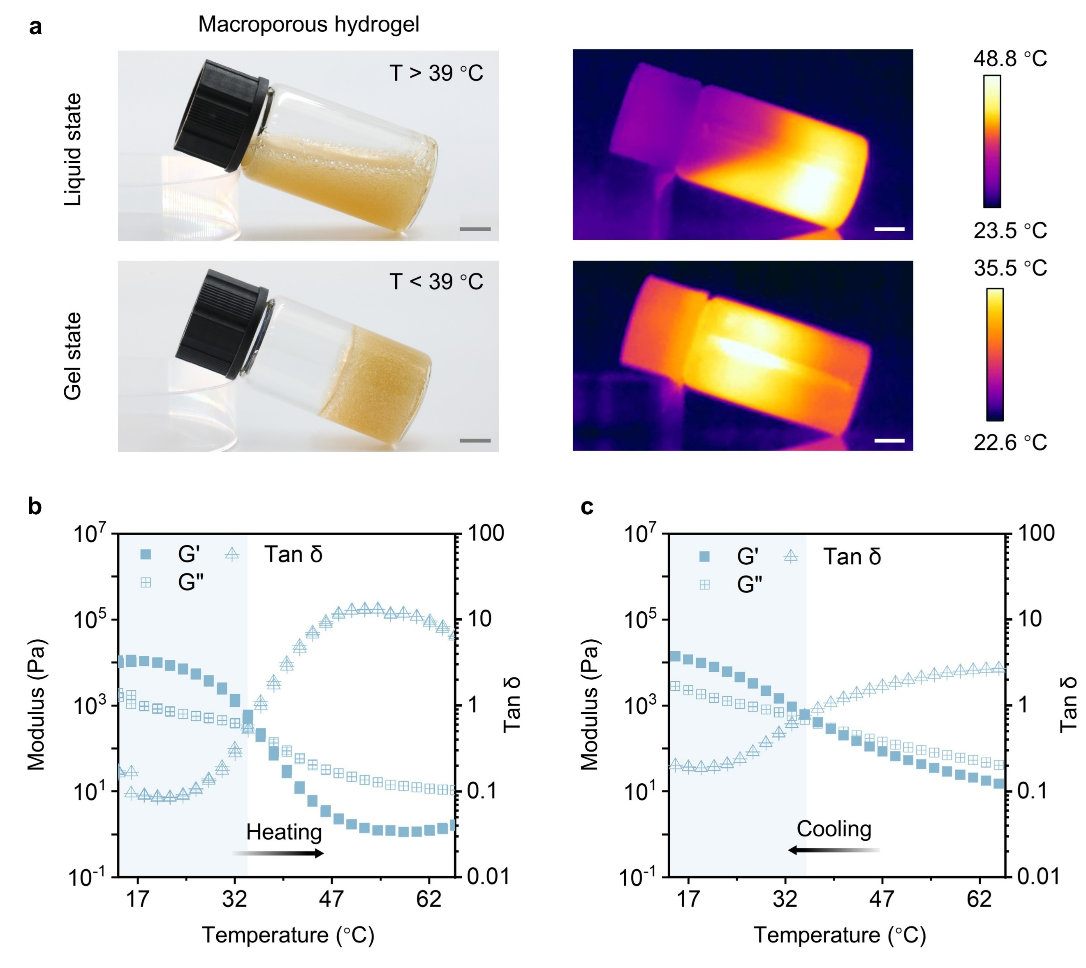

Supplementary Fig. 4 | Thermally reversible phase transition properties of the hydrogel. a, Photographs (left) and infrared camera images (right) of the hydrogel at high and room temperature, demonstrating its temperature-dependent phase transition. Scale bar, 1 cm. b, Storage modulus (G′), loss modulus (G″), and corresponding tan δ (G″/G′) during heating from 10 to 75 °C, showing the transition from a viscoelastic gel to a viscous liquid. c, Storage modulus (G′), loss modulus (G″), and corresponding tan δ (G″/G′) during cooling from 75 to 10 °C, showing the transition from a viscous liquid to a viscoelastic gel.
The photograph and infrared images (a) confirm that the hydrogel is in a liquid state at high temperature and forms a gel at room temperature. During heating (b), G′ and G″ gradually decrease, and tan δ increases above 1 at ~36.0 °C, indicating the gel-to-liquid transition. During cooling (c), G′ and G″ increase, and tan δ decreases below 1 at ~39.0 °C, indicating the liquid-to-gel transition. The sol–gel transition temperature of ~39 °C suggests that the hydrogel is well suited for skin applicability.

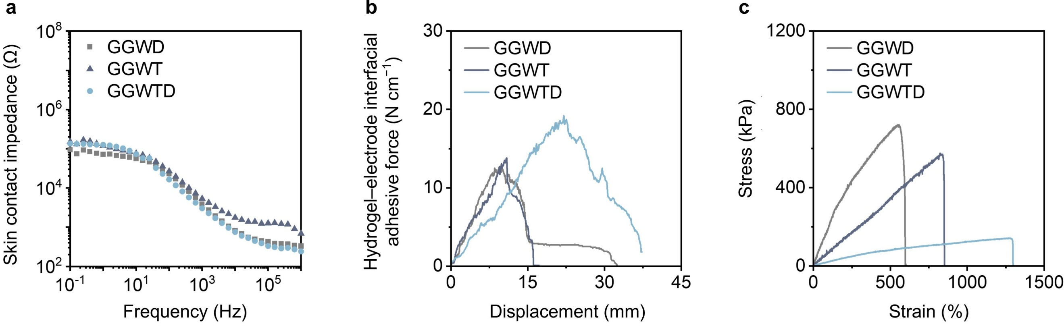

Supplementary Fig. 5 | Hydrogel properties with different compositions. a, Skin contact impedance of GGWD, GGWT, and GGWTD hydrogels. b, Hydrogel–electrode interfacial adhesion of GGWD, GGWT, and GGWTD hydrogels. c, Stretchability of GGWD, GGWT, and GGWTD hydrogels.

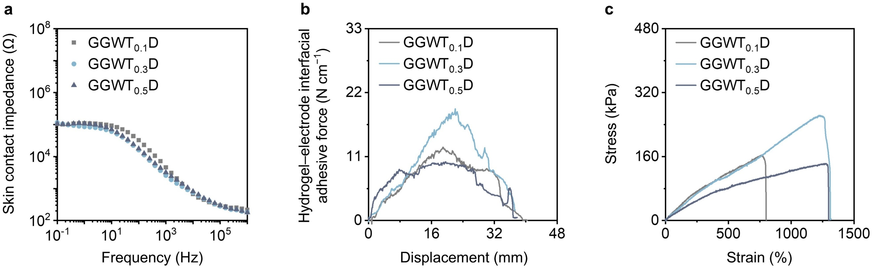

Supplementary Fig. 6 | Effect of TA content on the properties of hydrogels. a, Skin contact impedance of GGWTD hydrogels containing 0.1 g (GGWT_{0.1}D), 0.3 g (GGWT_{0.3}D), and 0.5 g (GGWT_{0.5}D) TA. b, Hydrogel–electrode interfacial adhesion of GGWT_{0.1}D, GGWT_{0.3}D, and GGWT_{0.5}D. c, Stress–strain curves for GGWT_{0.1}D, GGWT_{0.3}D, and GGWT_{0.5}D.

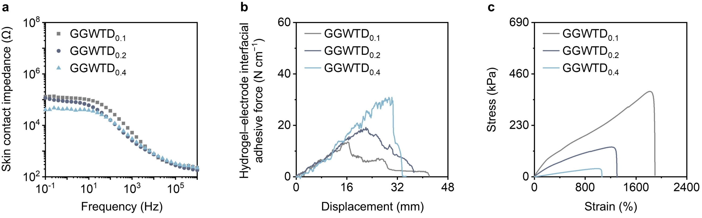

Supplementary Fig. 7 | Effect of DA·HCl content on hydrogel properties. a, Skin contact impedance of GGWTD hydrogels containing 0.1 g (GGWTD_{0.1}), 0.2 g (GGWTD_{0.2}), and 0.4 g (GGWTD_{0.4}) DA·HCl. b, Hydrogel–electrode interfacial adhesion of GGWTD_{0.1}, GGWTD_{0.2}, and GGWTD_{0.4}. c, Stress–strain curves for GGWTD_{0.1}, GGWTD_{0.2}, and GGWTD_{0.4}.

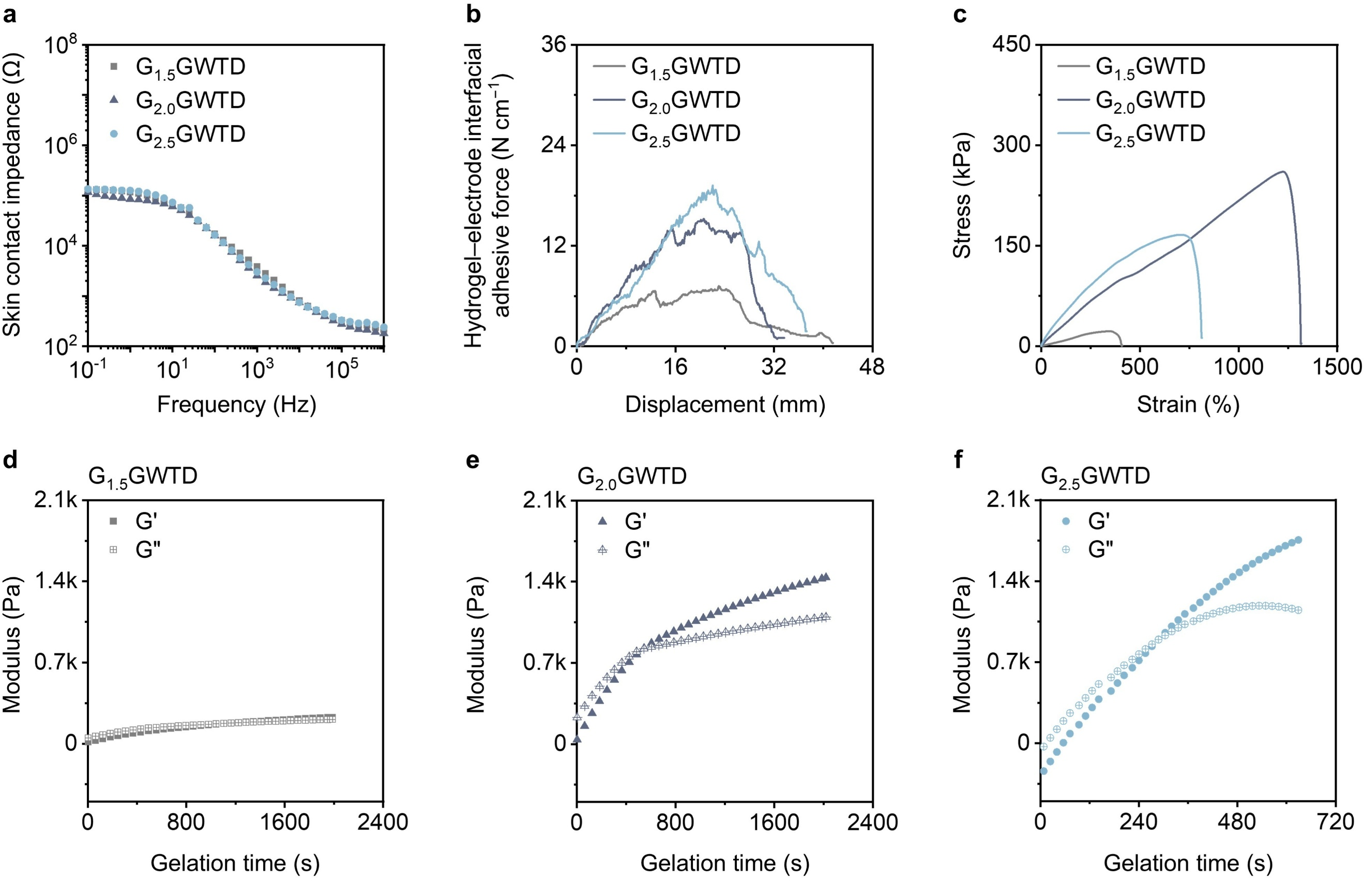

Supplementary Fig. 8 | Effect of gelatin content on hydrogel properties. a, Skin contact impedance of GGWTD hydrogels containing 1.5 g (G_{1.5}GWTD), 2.0 g (G_{2.0}GWTD), and 2.5 g (G_{2.5}GWTD) gelatin. b, Hydrogel–electrode interfacial adhesion of G_{1.5}GWTD, G_{2.0}GWTD, and G_{2.5}GWTD. c, Stress–strain curves for G_{1.5}GWTD, G_{2.0}GWTD, and G_{2.5}GWTD. d–f, Gelation time of G_{1.5}GWTD, G_{2.0}GWTD, and G_{2.5}GWTD at 35 °C.

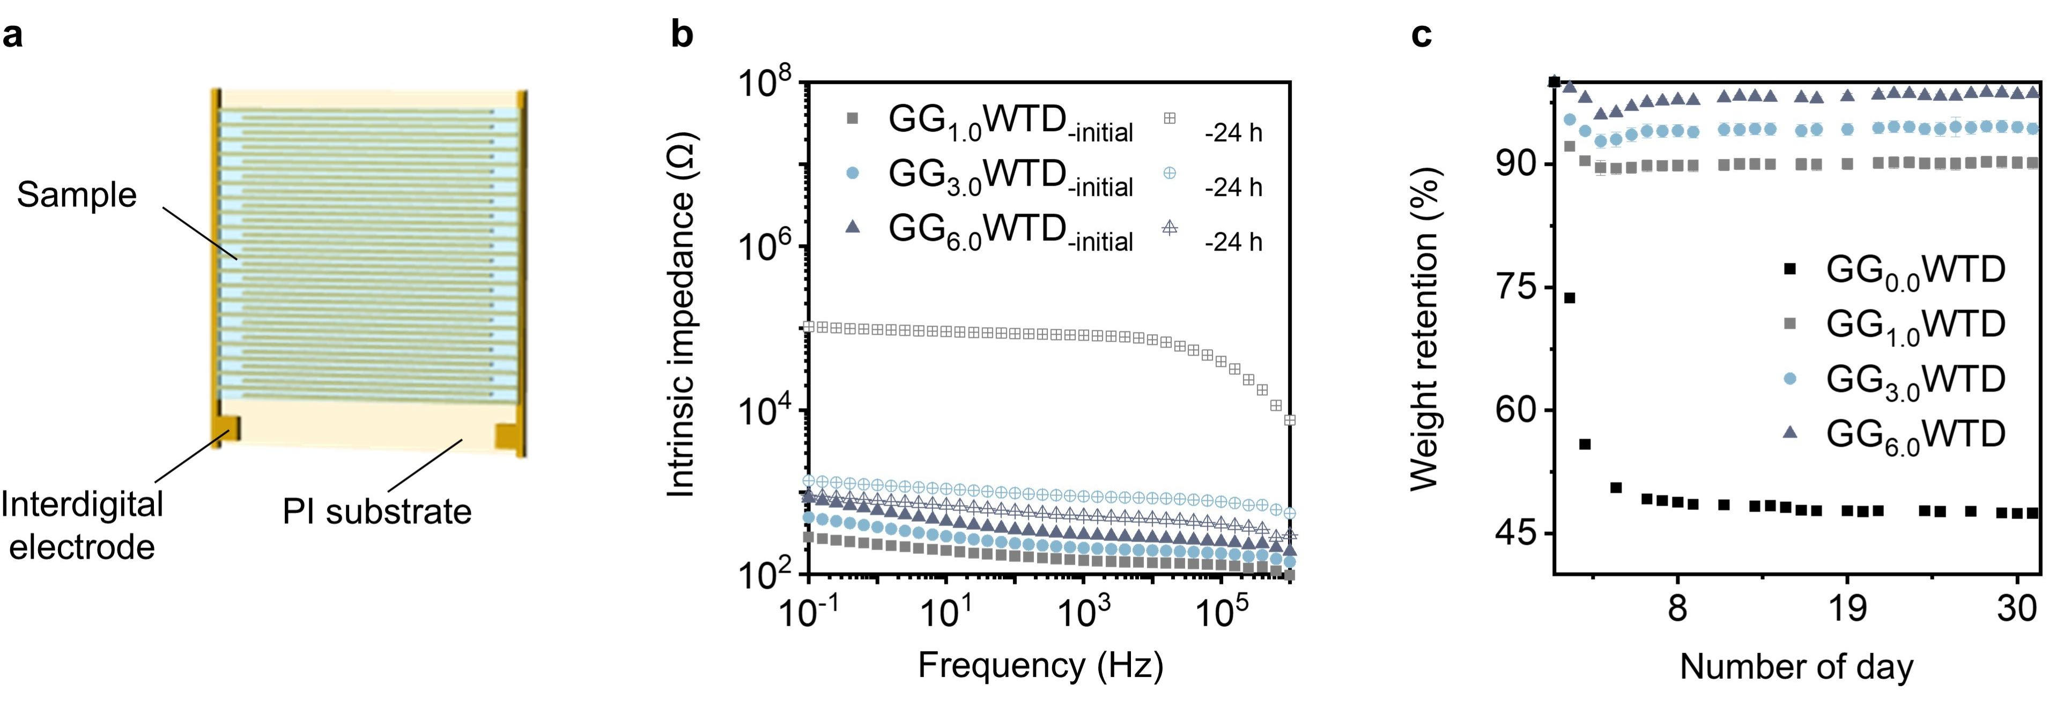

Supplementary Fig. 9 | Effect of glycerol content on the anti-drying performance and intrinsic impedance of hydrogels. a, Schematic illustration of the intrinsic impedance measurement setup using interdigitated electrodes. b, Intrinsic impedance of GGWTD hydrogels containing 1.0 g (GG_{1.0}WTD), 3.0 g (GG_{3.0}WTD), and 6.0 g (GG_{6.0}WTD) glycerol at the initial state and after 24 h of storage. c, Weight retention of GG_{1.0}WTD, GG_{3.0}WTD, and GG_{6.0}WTD hydrogels over 31 days.

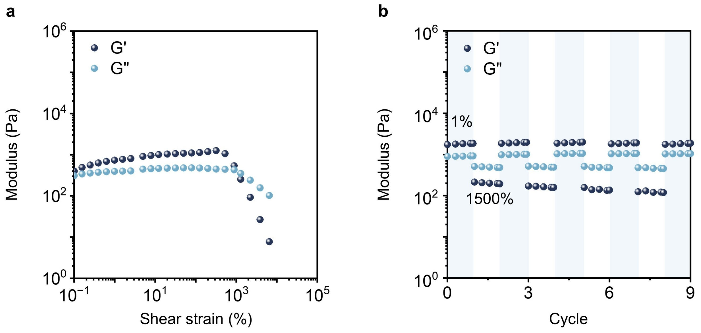

Supplementary Fig. 10 | Self-healing behavior of the hydrogel. a, Strain sweep curves of the hydrogel across a strain range of 0.1–1,500%. b, Five alternating strain sweep cycles between 1% and 1,500%, demonstrating stable recovery of the hydrogel network.

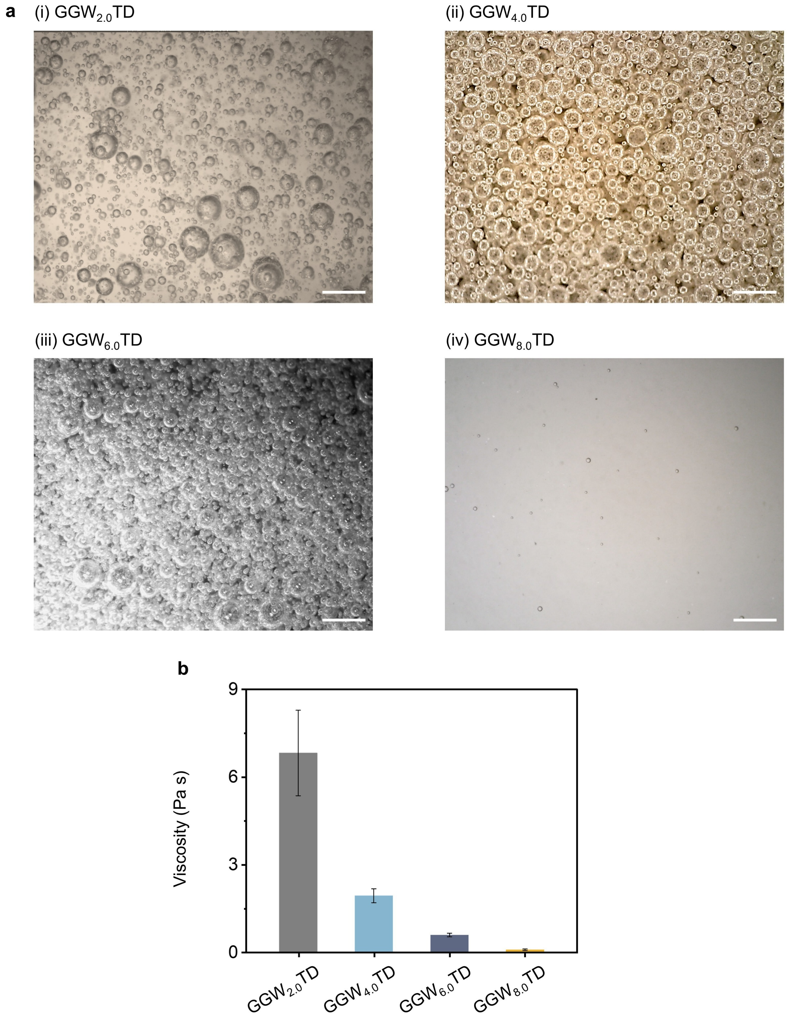

Supplementary Fig. 11 | Effect of water content on viscosity and macroporous structure of hydrogels. a, Optical microscope images of pore structures of GGWTD hydrogels at (i) 2 mL (GGW_{2.0}TD), (ii) 4 mL (GGW_{4.0}TD), (iii) 6 mL (GGW_{6.0}TD), and (iv) 8 mL (GGW_{8.0}TD) water content. Scale bar, 500 µm. b, Viscosity as a function of water content.

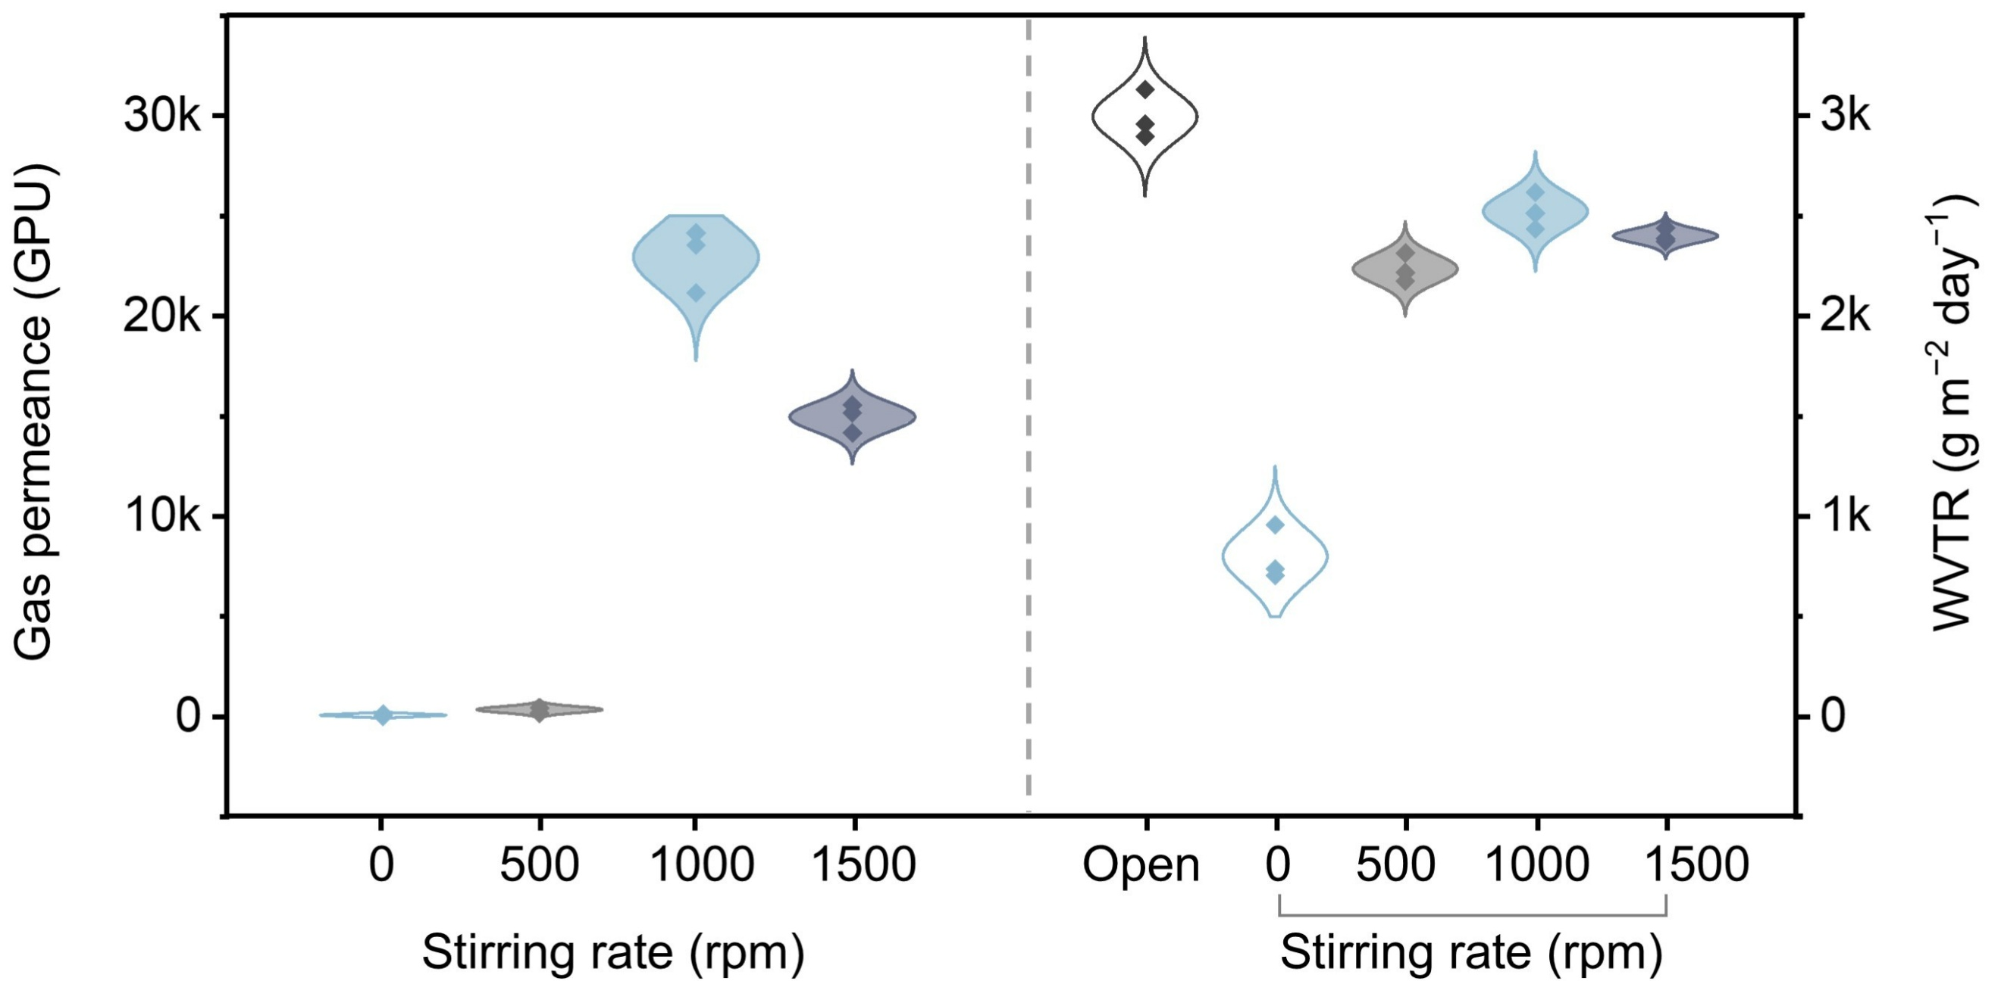

Supplementary Fig. 12 | Gas permeance and WVTR of 1 mm-thick hydrogels prepared at stirring rates of 0 rpm (non-porous), 500 rpm, 1,000 rpm, and 1,500 rpm.

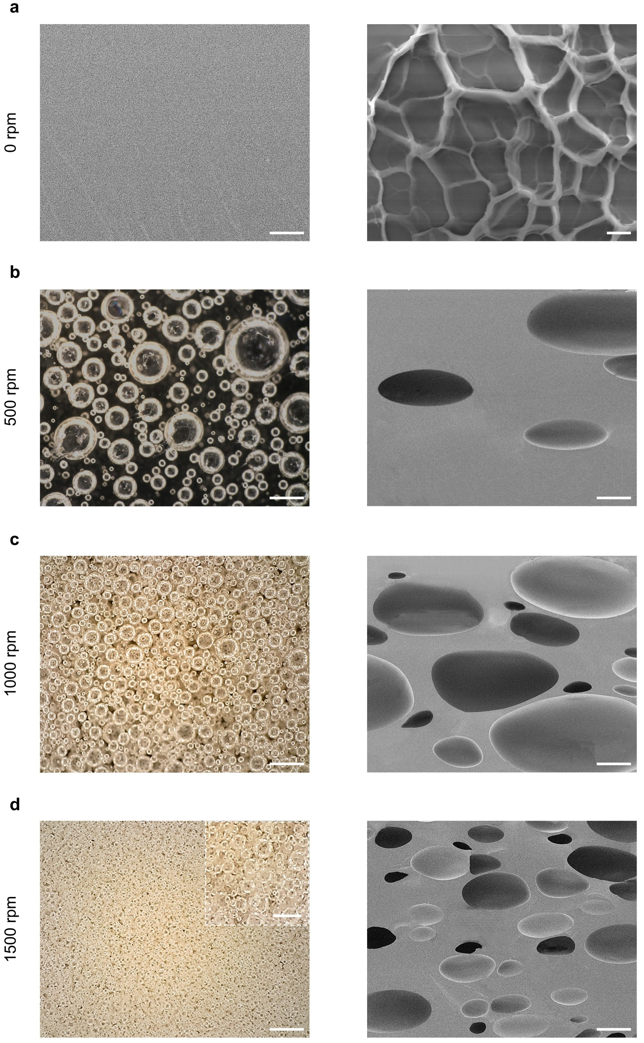

Supplementary Fig. 13 | Optical microscope images and SEM images of hydrogels prepared at stirring rates of 0 rpm (non-porous), 500 rpm, 1,000 rpm, and 1,500 rpm. a, Cross-sectional SEM images of hydrogel prepared at 0 rpm (non-porous hydrogels) (left) and the higher-magnification view of the non-porous network. Left scale bar, 20 μm; Right scale bar, 2 μm. b, Optical microscope images (left) and cross-sectional SEM images (right) of hydrogels prepared at 500 rpm. Left scale bar, 500 µm; Right scale bar, 50 μm. c, Optical microscope images (left) and cross-sectional SEM images (right) of hydrogels prepared at 1,000 rpm. Left scale bar, 500 µm; Right scale bar, 50 μm. d, Optical microscope images (left) and cross-sectional SEM images (right) of hydrogels prepared at 1500 rpm. Left scale bar, 500 µm; The insert scale bar, 200 μm; Right scale bar, 50 μm.
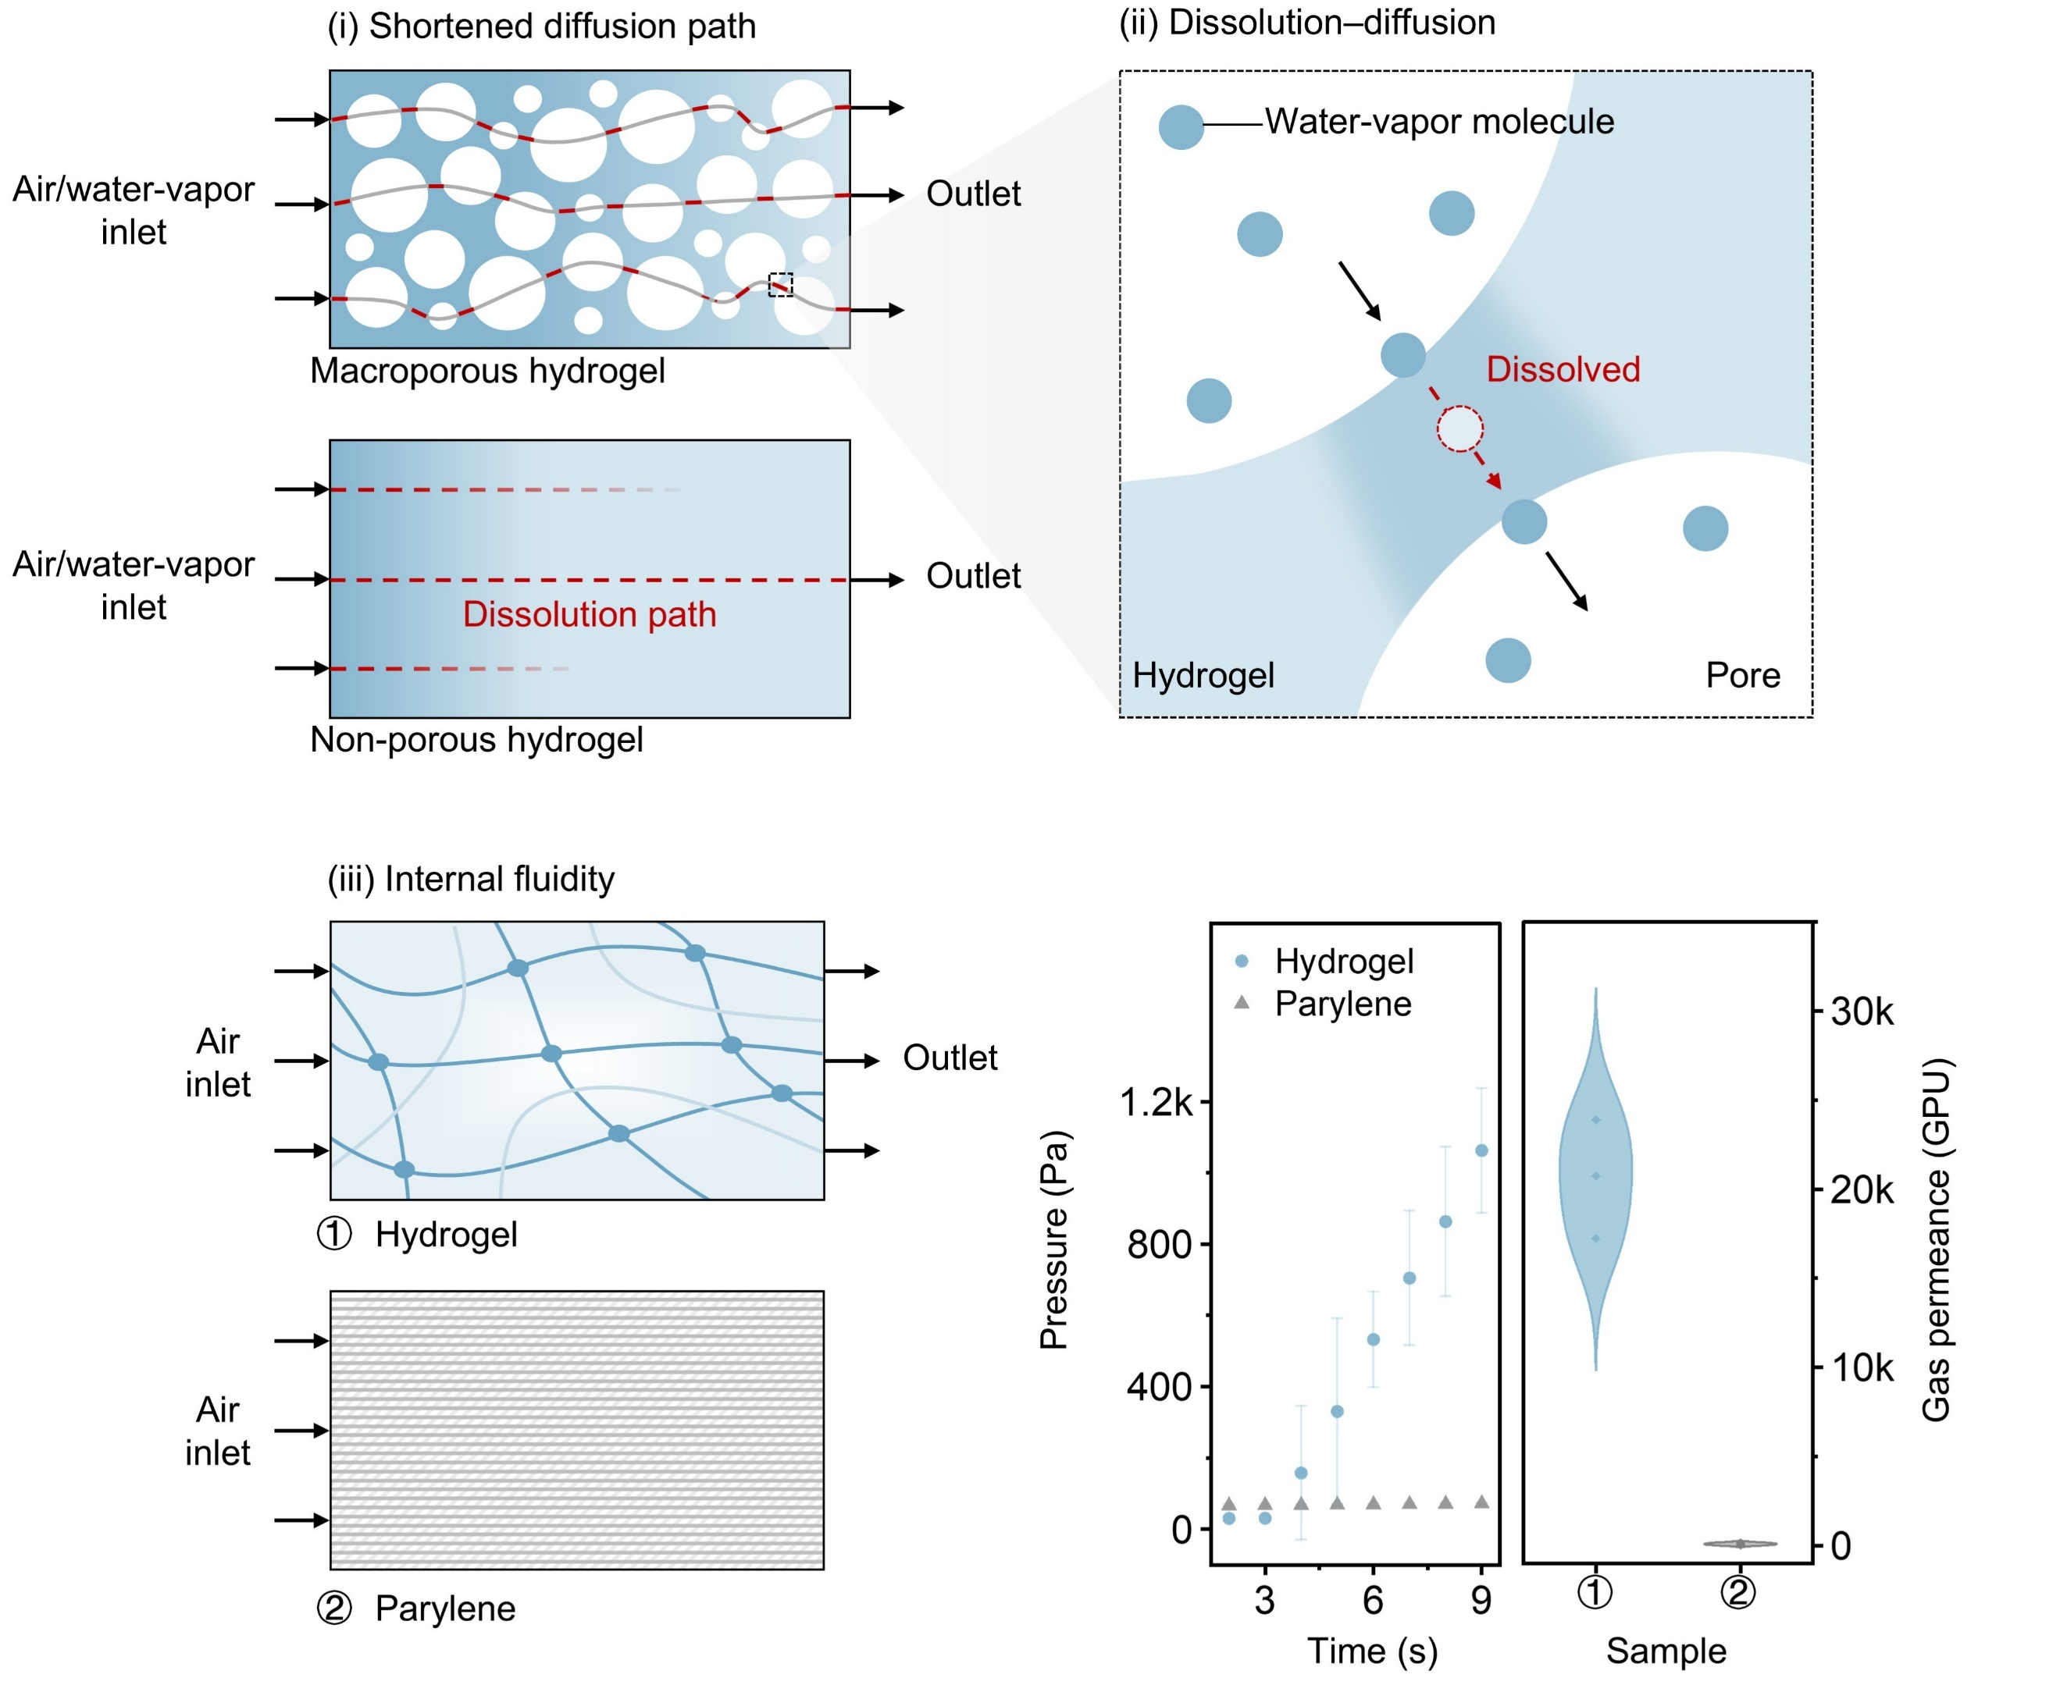

Supplementary Fig. 14 | Schematic illustration of air and water-vapor permeation mechanisms in macroporous hydrogel. (i) Macroporous hydrogel provides shortened diffusion paths compared with non-porous hydrogel. (ii) Dissolution–diffusion mechanism, in which water-vapor molecules first dissolve into the hydrogel matrix and subsequently diffuse through the pores (air bubbles). (iii) Left: schematic gas-transport pathways in the 3 µm-thick nanomesh reinforced hydrogel versus the 3 µm-thick parylene, highlighting the effect of internal fluidity. Right: permeate-side pressure rise rate for the hydrogel and parylene, and comparison of gas permeance between the two samples. More arrows indicate greater breathability.

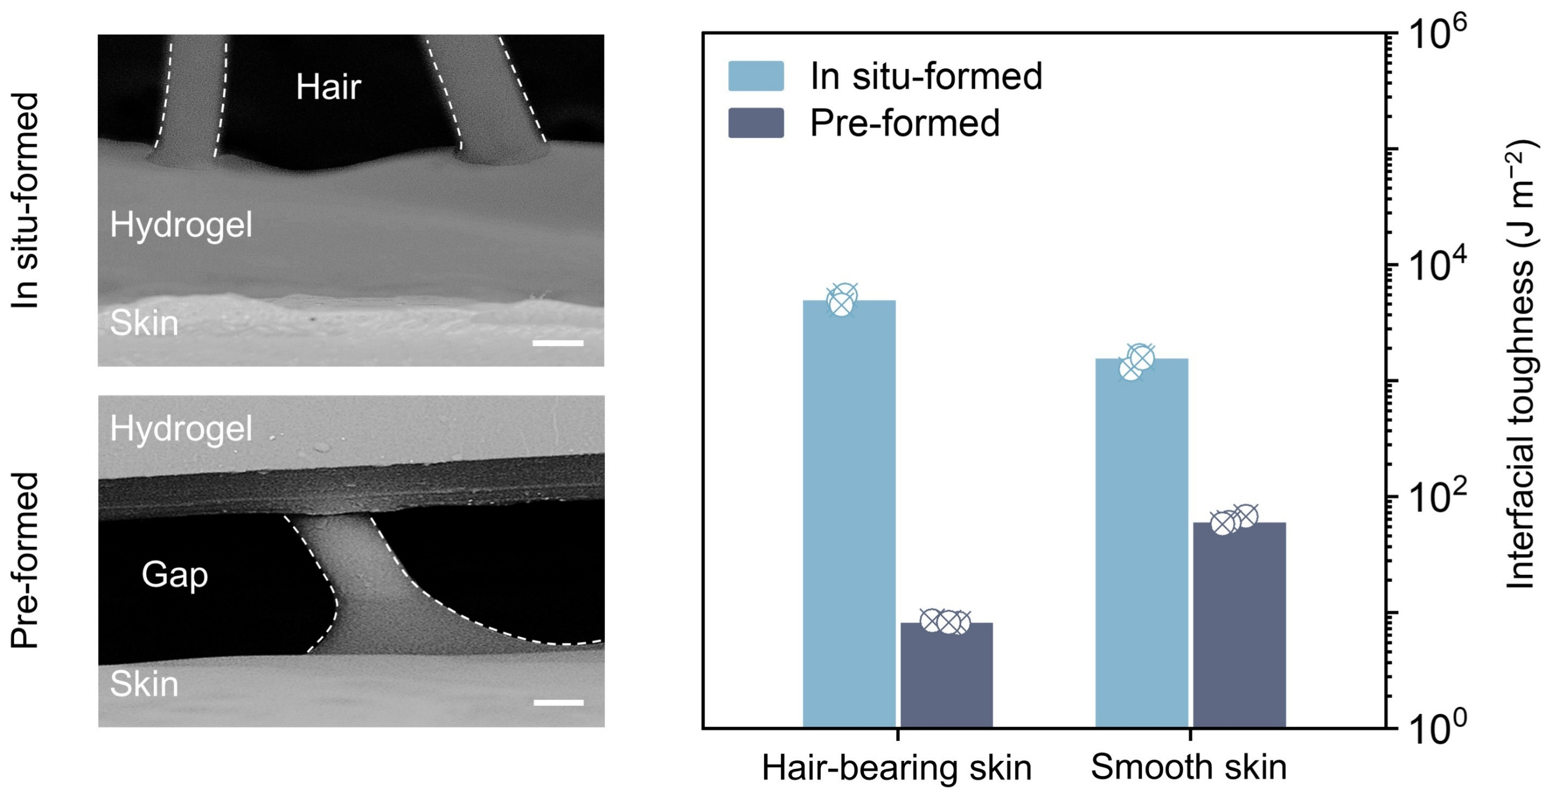

Supplementary Fig. 15 | SEM images of in situ formed and preformed hydrogel on hair-bearing skin (left) and interfacial toughness on hair-bearing and smooth skin (right). Scale bar, 100 μm.

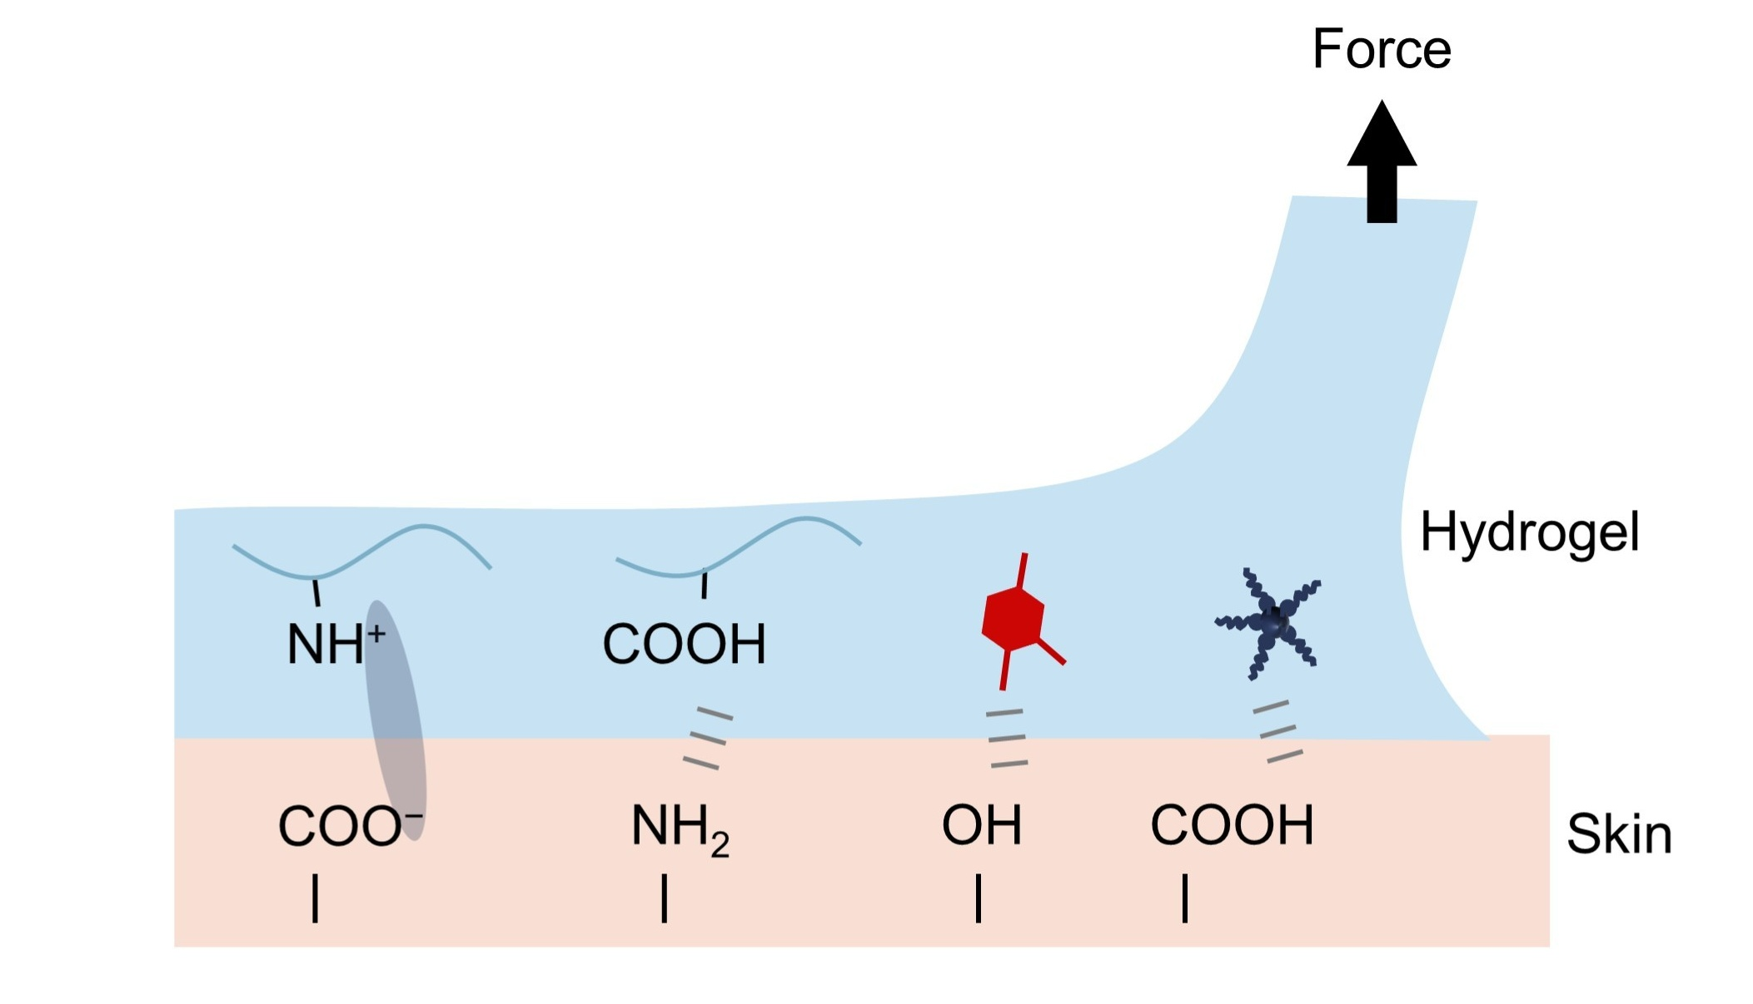

Supplementary Fig. 16 | Schematic illustration of the hydrogel–skin interfacial adhesion mechanism.
The schematic highlights multiple noncovalent interactions, including hydrogen bonding and electrostatic attraction, that contribute to strong and stable adhesion at the skin interface. Notably, on the hair-bearing scalp, the presence of hair further enhances adhesion by providing additional mechanical interlocking with the hydrogel.

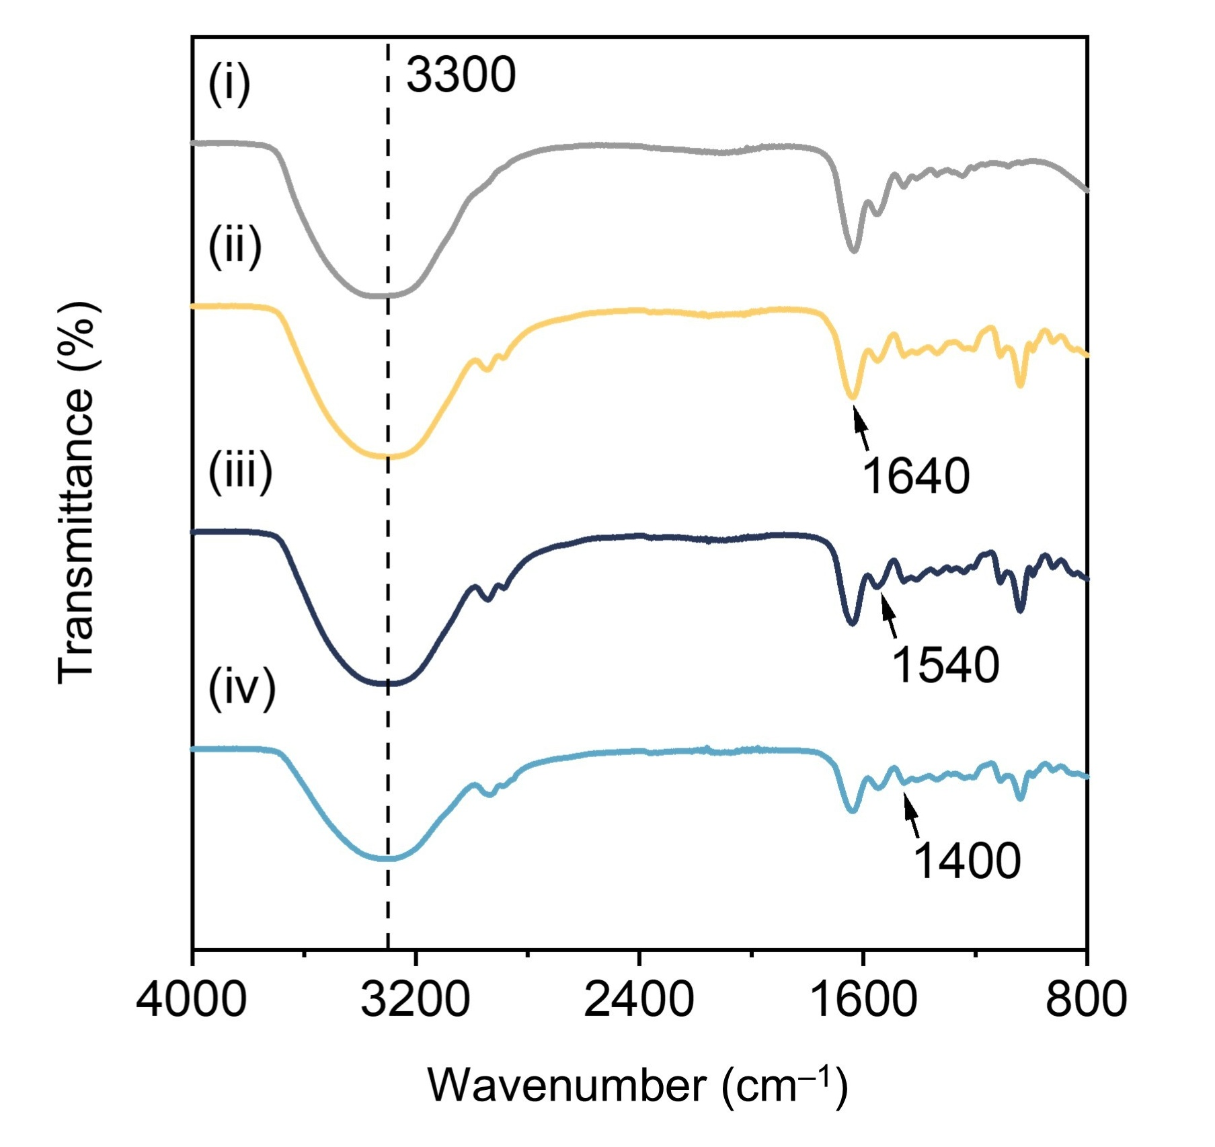

Supplementary Fig. 17 | FTIR spectra of different hydrogels: (i) GW, (ii) GGWT, (iii) GGWD, and (iv) GGWTD.
FTIR spectroscopy was performed to study hydrogels with different components. Compared with GW (only containing gelatin and water), the GGWT, GGWD, and GGWTD samples show a broader and more intense band at ~3,300 cm⁻¹ (O−H/N−H stretching), consistent with the formation of an extensive hydrogen-bonding network arising from glycerol, the phenolic hydroxyls of TA, and the catechol groups of DA·HCl. The amide I (~1,640 cm⁻¹, C=O stretching) and amide II (~1,540 cm⁻¹, N−H bending) bands are both attenuated in GGWTD, indicating strengthened interactions between gelatin and the additives, predominantly hydrogen bonding and electrostatic effects. An enhanced absorption at ~1,400 cm⁻¹, assigned to the symmetric stretching of carboxylate groups (COO⁻) and/or aromatic modes, suggests increased deprotonation of carboxylates and strengthened ionic interactions with polyphenols. Taken together, the spectral shifts and changes in band intensities indicate that incorporation of TA, DA·HCl, and glycerol markedly modifies the gelatin matrix, yielding a denser, more interactive polymer network through synergistic hydrogen bonding and electrostatic interactions.

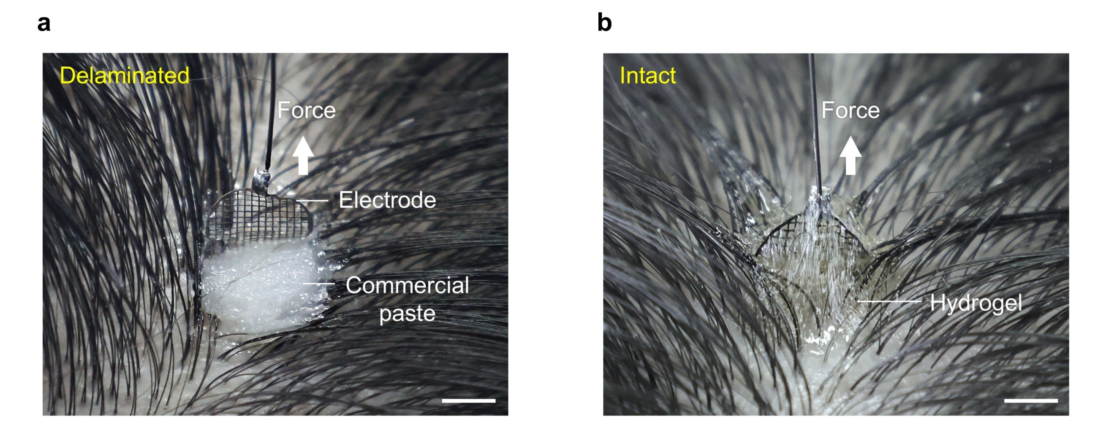

Supplementary Fig. 18 | Comparison of interfacial adhesion between commercial EEG paste and hydrogel. a, Photograph of an electrode-pulled commercial EEG paste detaching easily from the hair-bearing scalp, indicating weak hair-bearing scalp–paste–electrode adhesion. Scale bar, 1 cm. b, Photograph of an electrode-pulled hydrogel painted on the scalp, showing strong hair-bearing scalp–hydrogel–electrode adhesion. Scale bar, 1 cm.

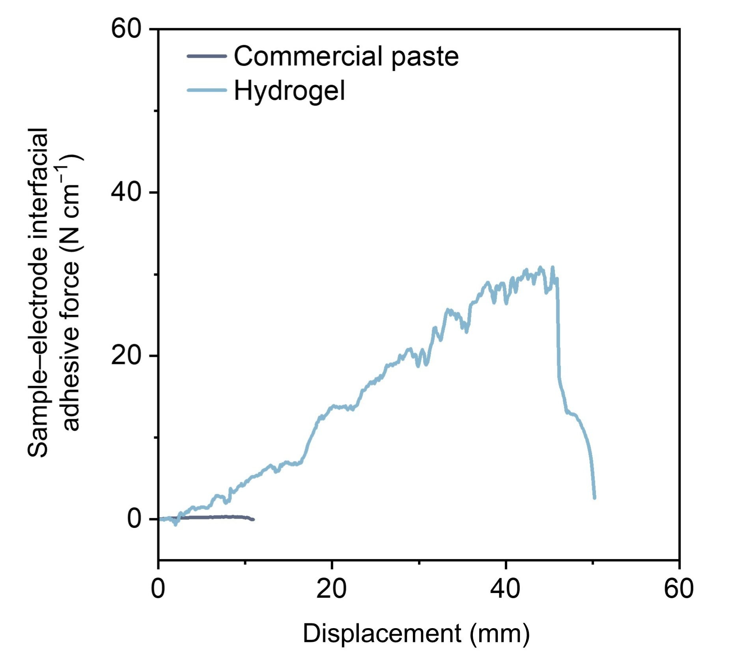

Supplementary Fig. 19 | Quantitative comparison of interfacial toughness at the commercial EEG paste–electrode and hydrogel–electrode interfaces. The hydrogel–electrode interface showed substantially greater interfacial adhesion force than the commercial EEG paste–electrode interface.

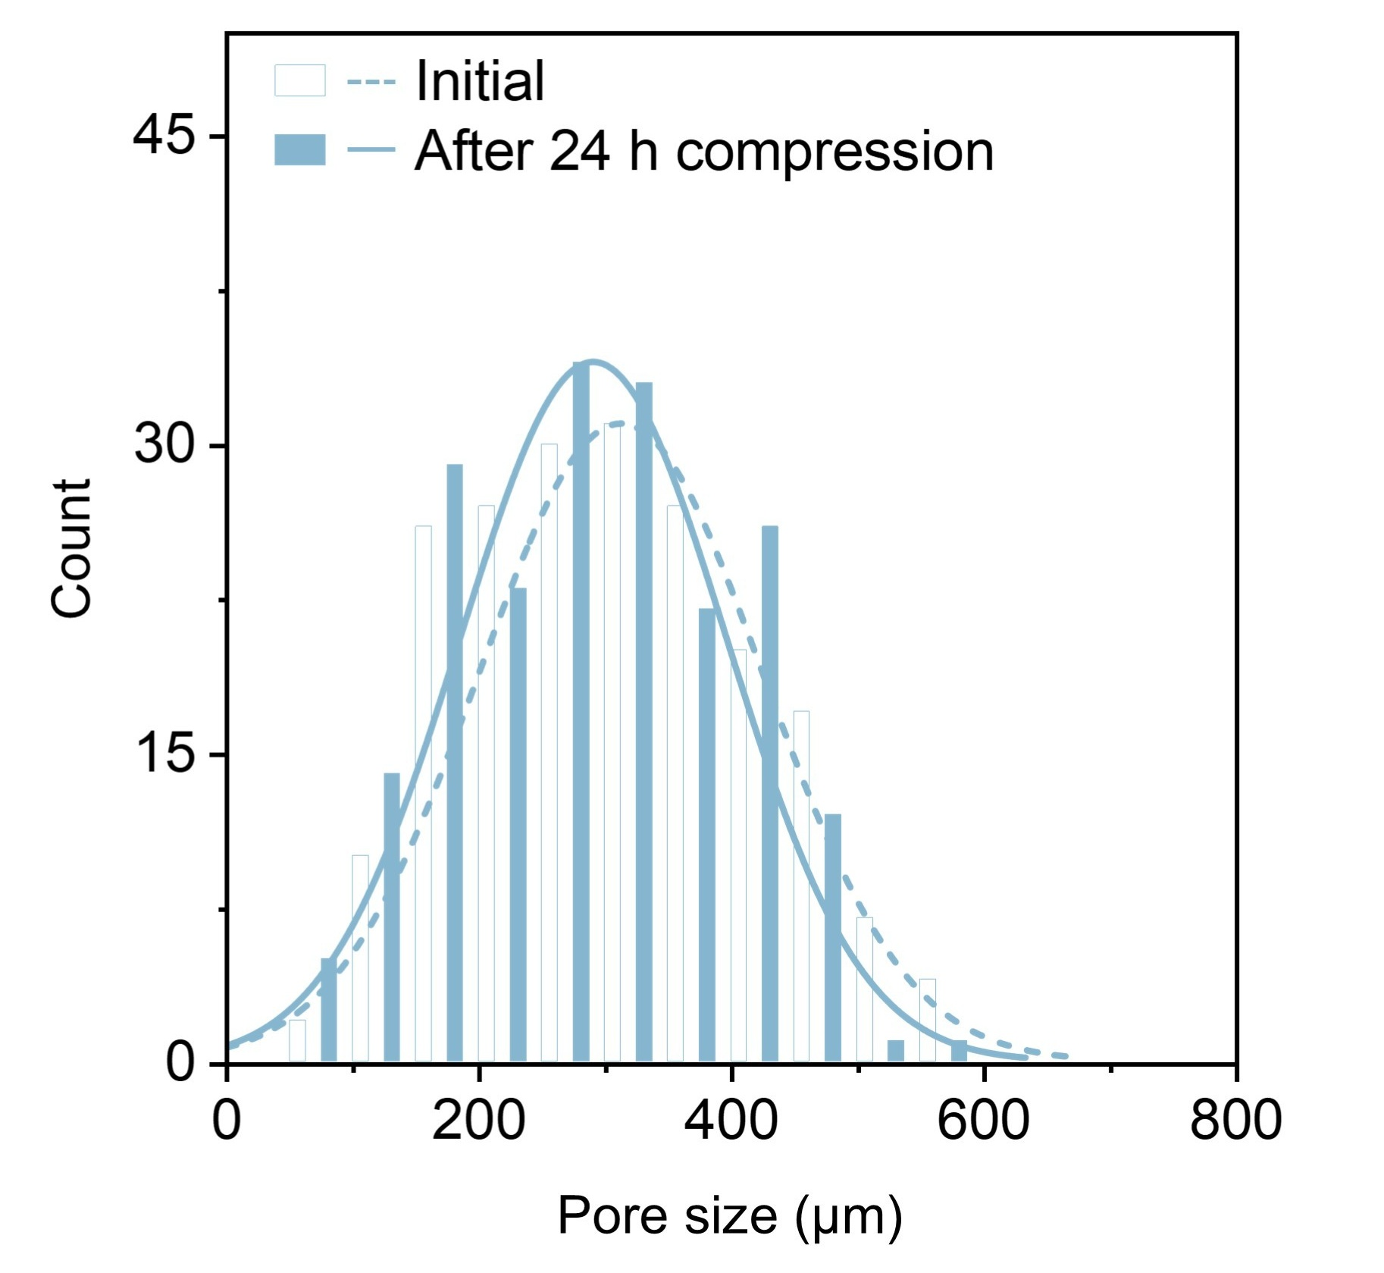

Supplementary Fig. 20 | Maintenance of macroporous structure after 24 h compression. Statistical analysis of pore size distribution from optical microscope images using ImageJ (N = 200). The average pore diameters of the hydrogel before compression and after 24 h of 500 g compression were 312.8 ± 112.9 μm and 290.9 ± 105.5 μm, respectively.

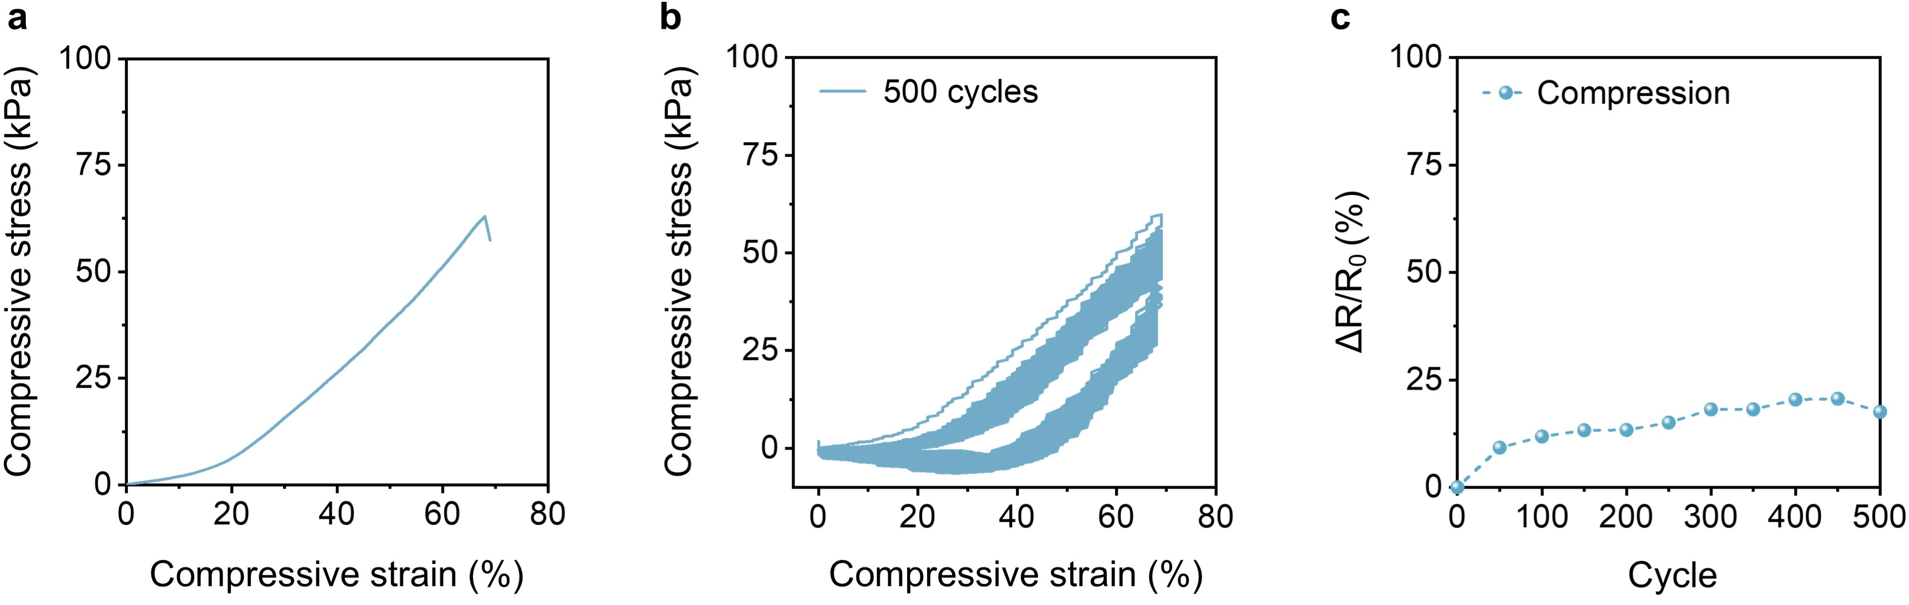

Supplementary Fig. 21 | Hydrogel durability under cyclic compression. a, Compressive stress–strain curves at 70% strain. b, Cyclic loading/unloading compression curves at 70% strain for 500 cycles. c, Resistance changes during 500 compression cycles.

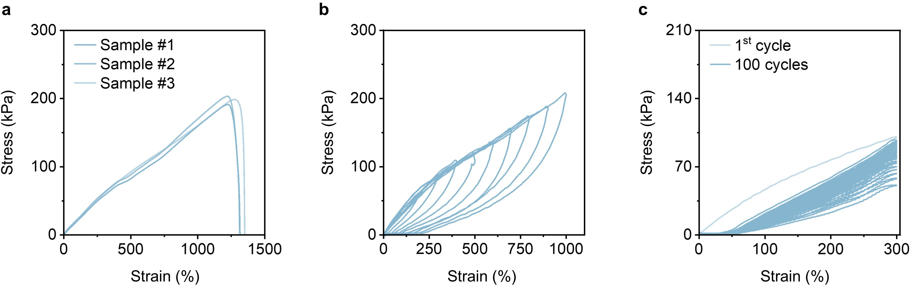

Supplementary Fig. 22 | Hydrogel durability under cyclic stretching. a, Stress–strain curves of three parallel samples. b, Loading/unloading curves of the hydrogel across 100–1,000% strain. c, Cyclic loading/unloading curves at 300% strain for 100 cycles.
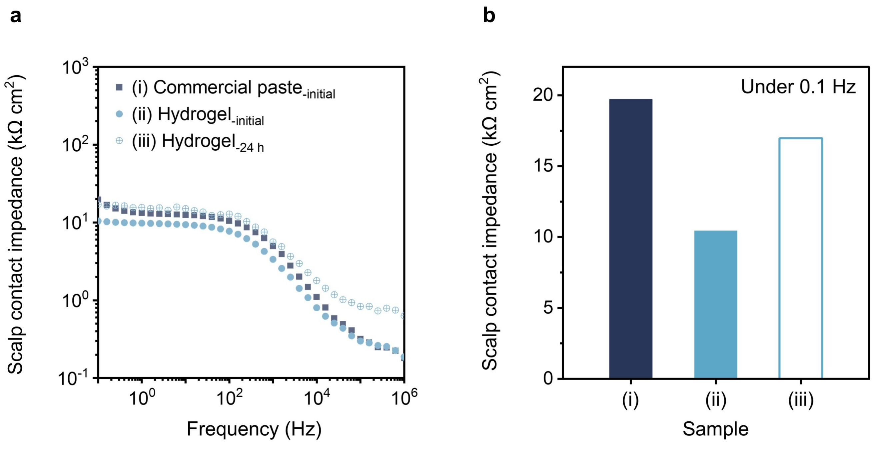

Supplementary Fig. 23 | Scalp contact impedance of commercial EEG paste and hydrogel electrodes. a, Frequency-dependent scalp contact impedance of commercial EEG paste and hydrogel electrodes at the initial state and after 24 h of continuous wear. b, Comparison of scalp contact impedance at 0.1 Hz corresponding to (a).
The hydrogel electrode remained stable and had low impedance after 24 h of continuous wear, whereas the commercial EEG paste electrode could not be measured owing to material detachment during long-term wear.

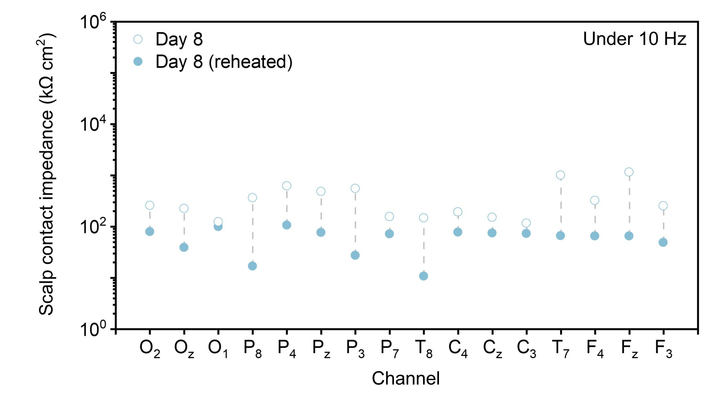

Supplementary Fig. 24 | Scalp contact impedance at 10 Hz before and after reheating on Day 8.
Simple reheating, enabled by the thermally reversible phase-change property of the hydrogel, restored low impedance contact after multi-day wear, overcoming degradation caused by hair regrowth and enabling electrode reuse.

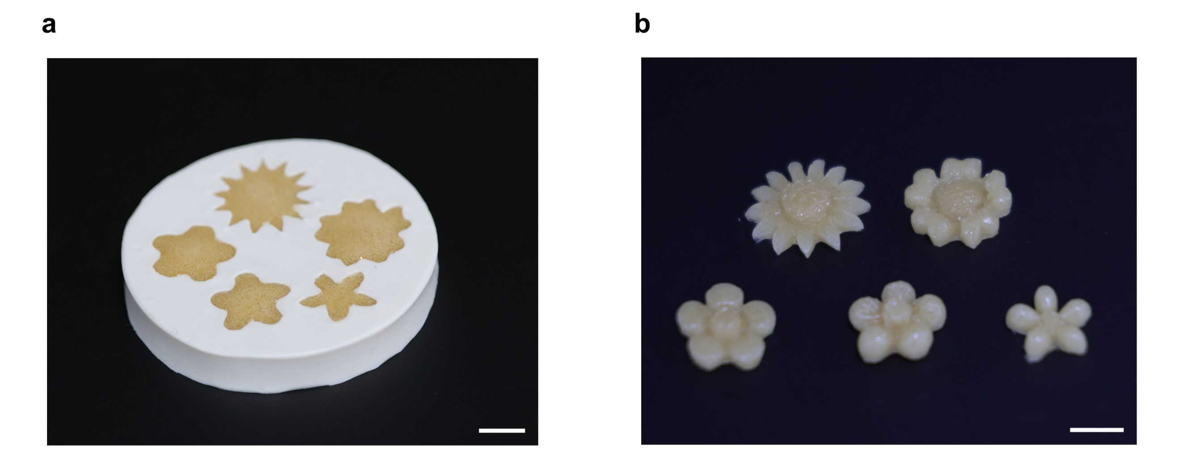

Supplementary Fig. 25 | Shape molding of the hydrogel. a, Photograph of hydrogel solution cast into molds of varying geometries. Scale bar, 1 cm. b, Photograph of hydrogel samples after molding into distinct shapes. Scale bar, 1 cm.

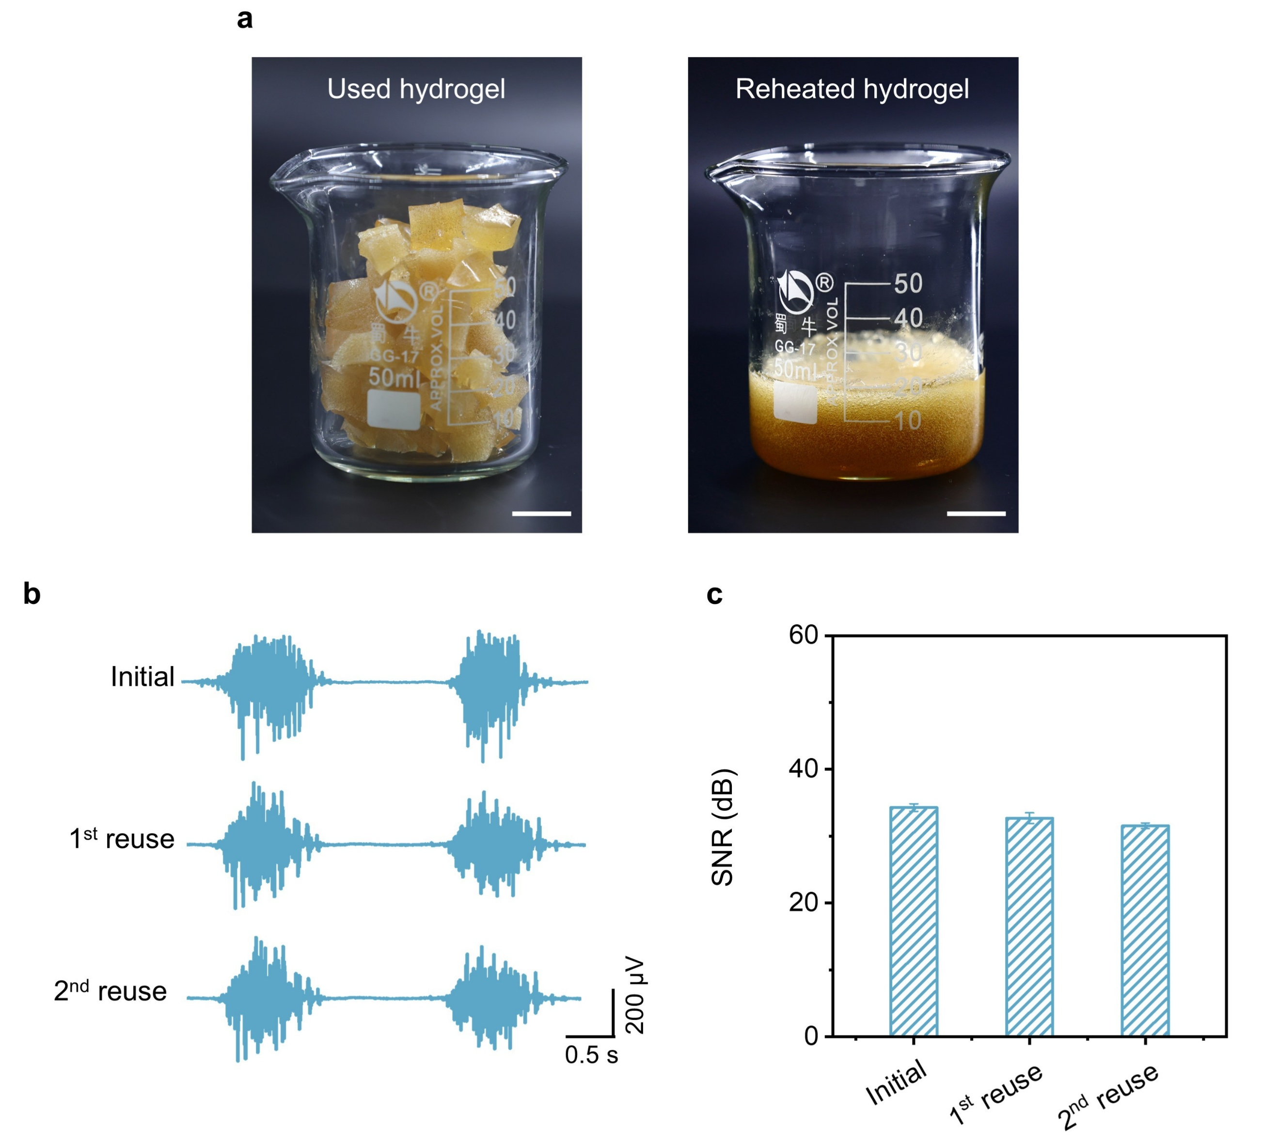

Supplementary Fig. 26 | Reusability of the hydrogel. a, Photographs of fragmented hydrogel pieces after use and the homogeneous hydrogel solution regenerated by reheating. Scale bar, 1 cm. b,c, Electromyography signals and corresponding SNR values recorded from the initial hydrogel, and after the first and second reuse cycles. EMG signals were recorded using signal recording system (MEB-2312C, NIHON KOHDEN, Japan) with a bandpass filter (0.02 to 50 Hz) during a 5 kg handgrip task, the hydrogel electrodes were attached to the brachioradialis muscles as reference electrodes, and another hydrogel was attached on the hand dorsum as a ground electrode.

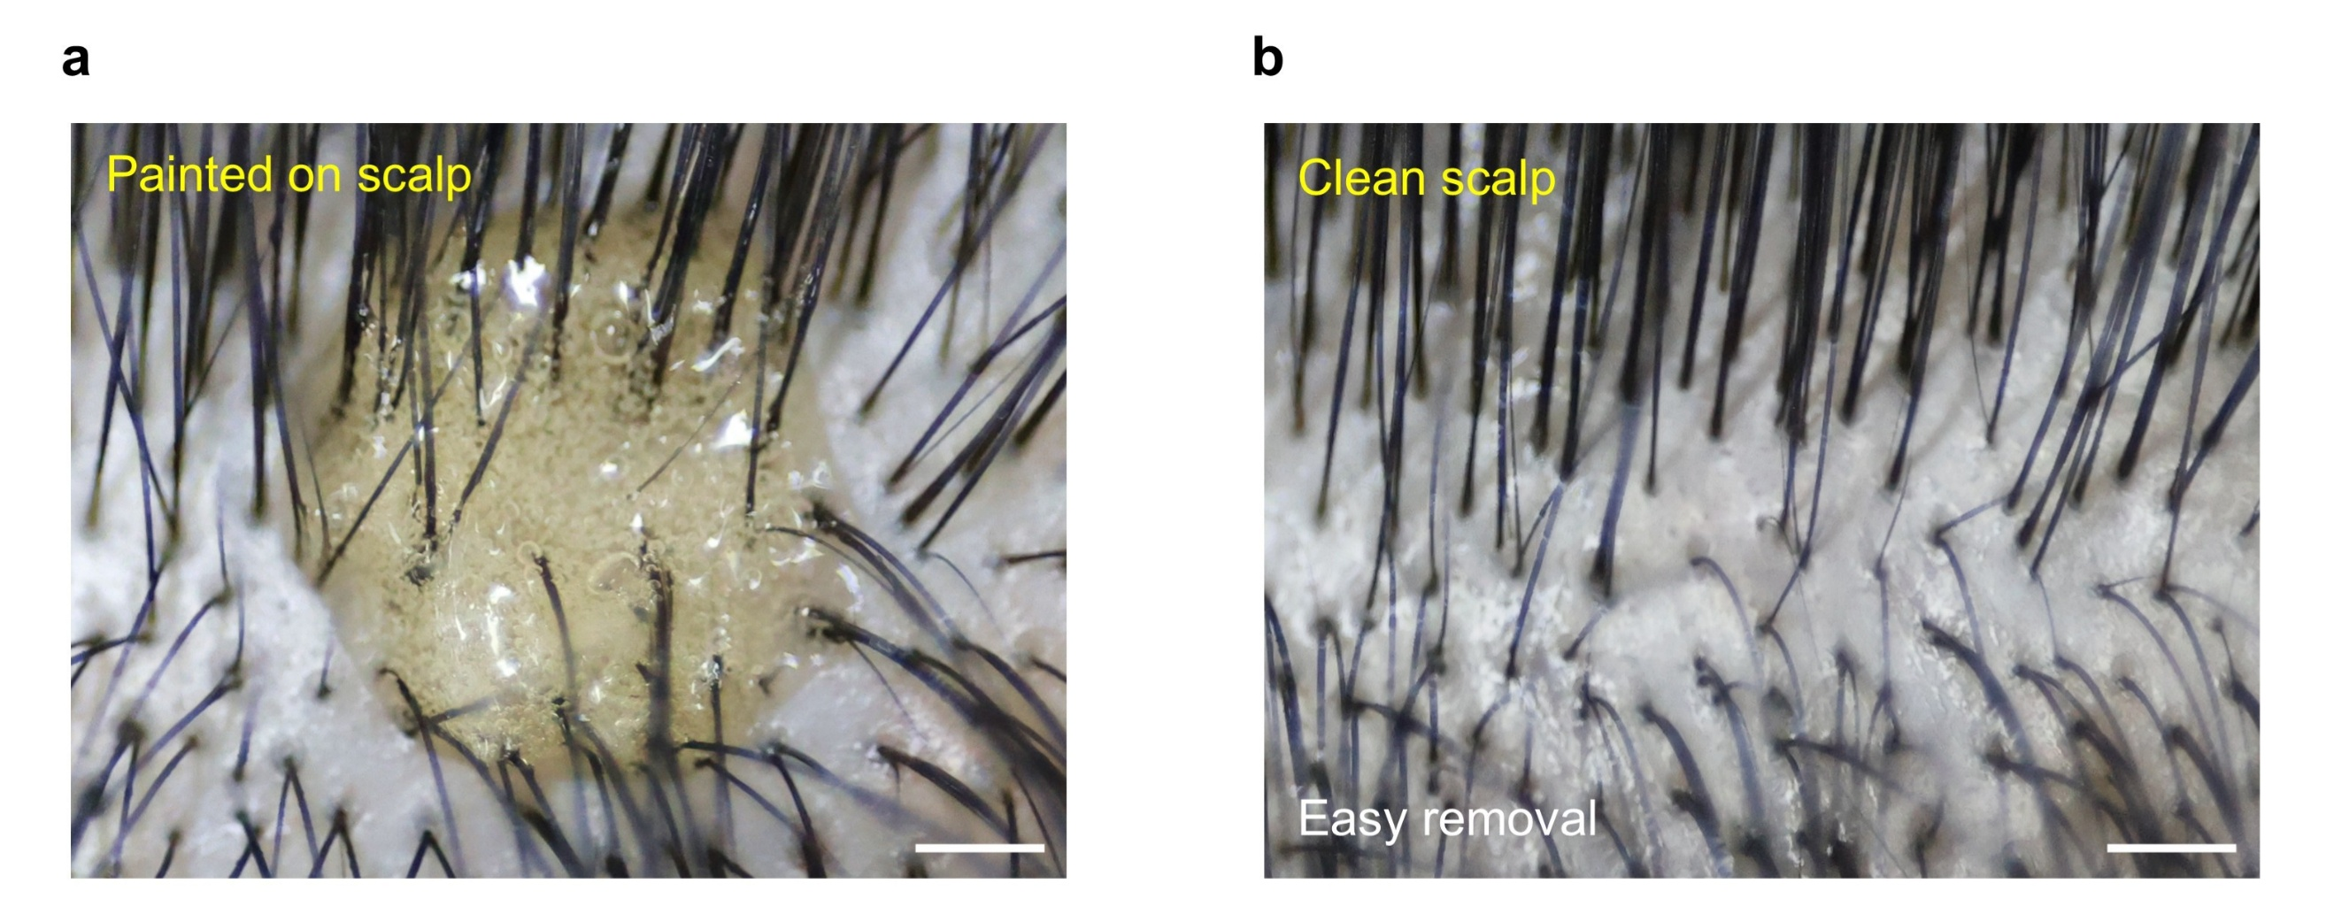

Supplementary Fig. 27 | Easy removal of the hydrogel. a, Photograph of macroporous hydrogel applied to the scalp. Scale bar, 1 cm. b, Photograph of the clean scalp after hydrogel removal by warm water rinsing. Scale bar, 1 cm.

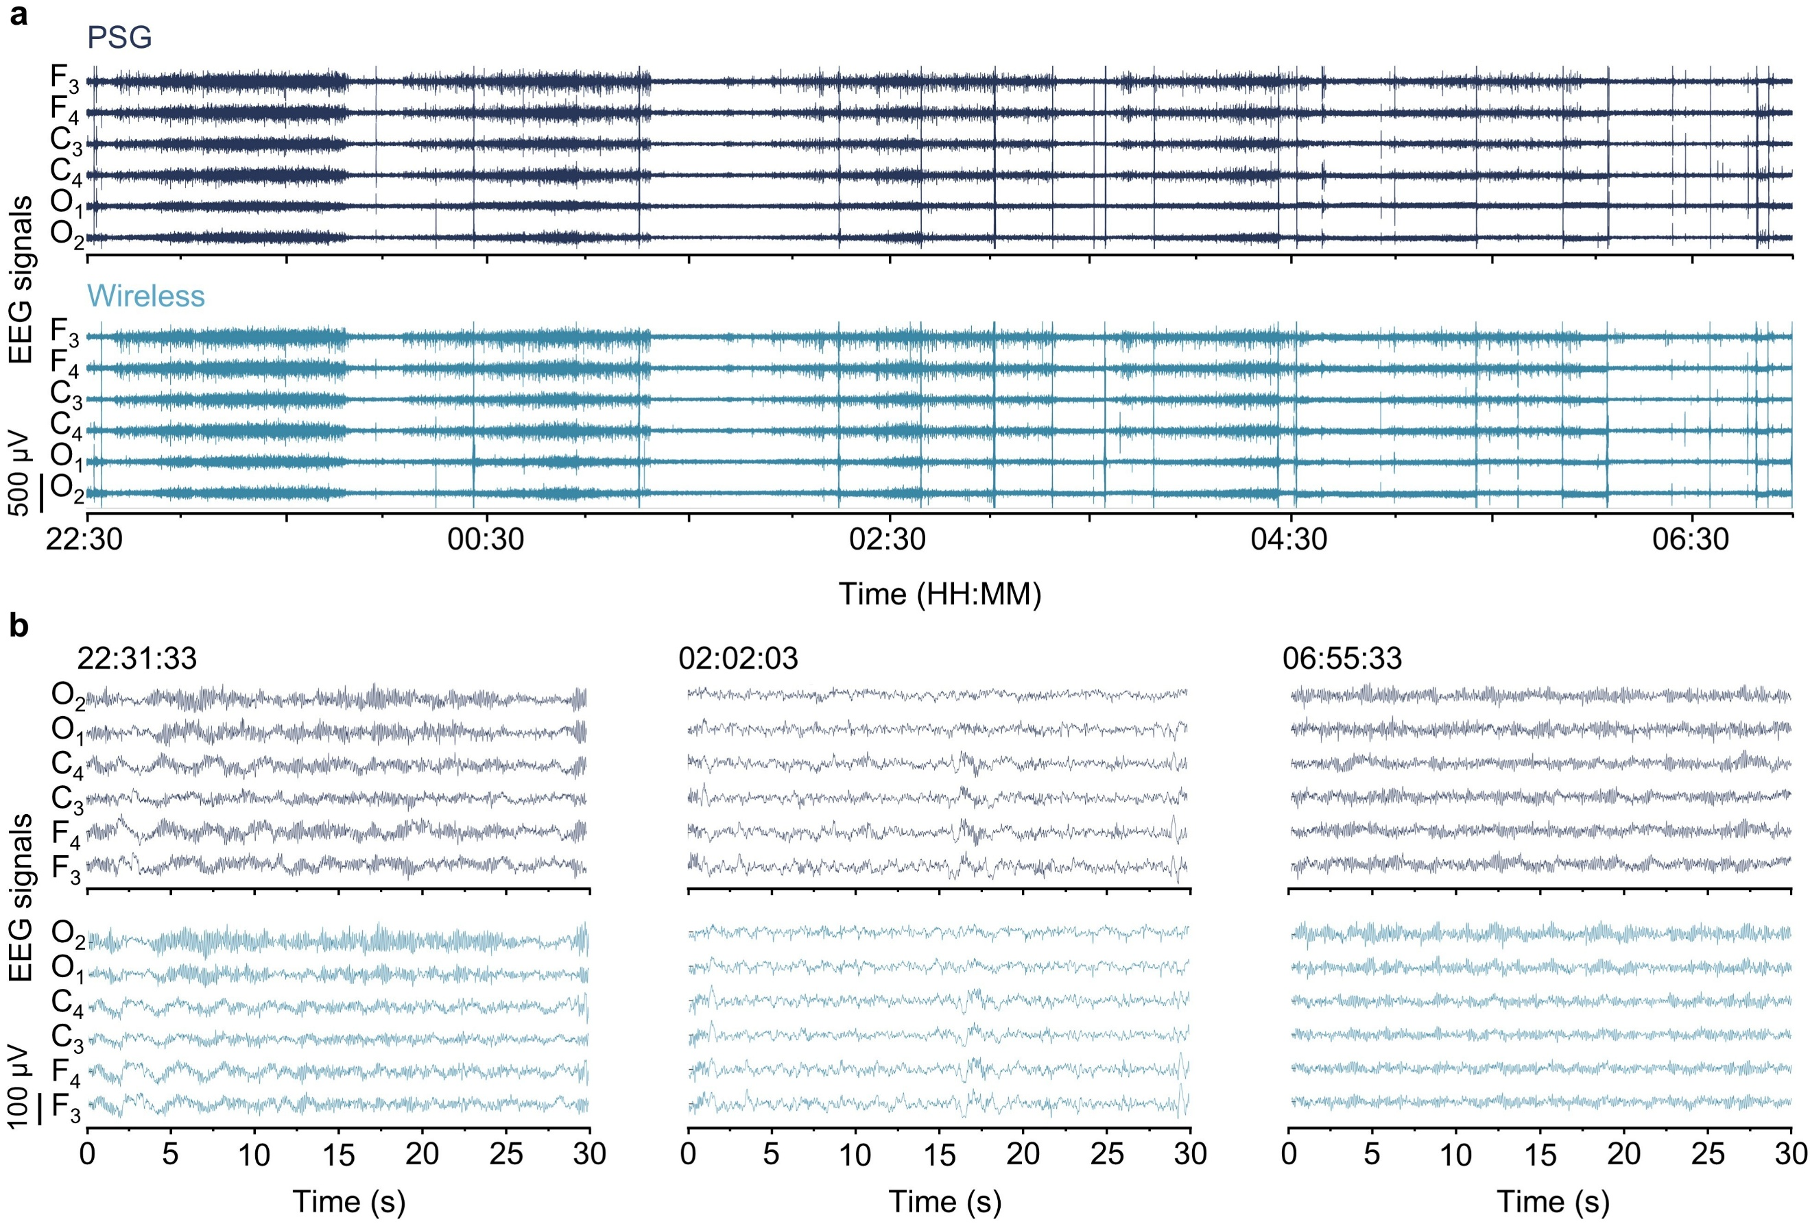

Supplementary Fig. 28 | Simultaneous acquisition of 8.5 h EEG signals by PSG and the wireless system. a, Continuous 8.5 h EEG signals recorded simultaneously using PSG and the wireless system. b, Enlarged segments of EEG signals from both systems at representative time points, showing high consistency.

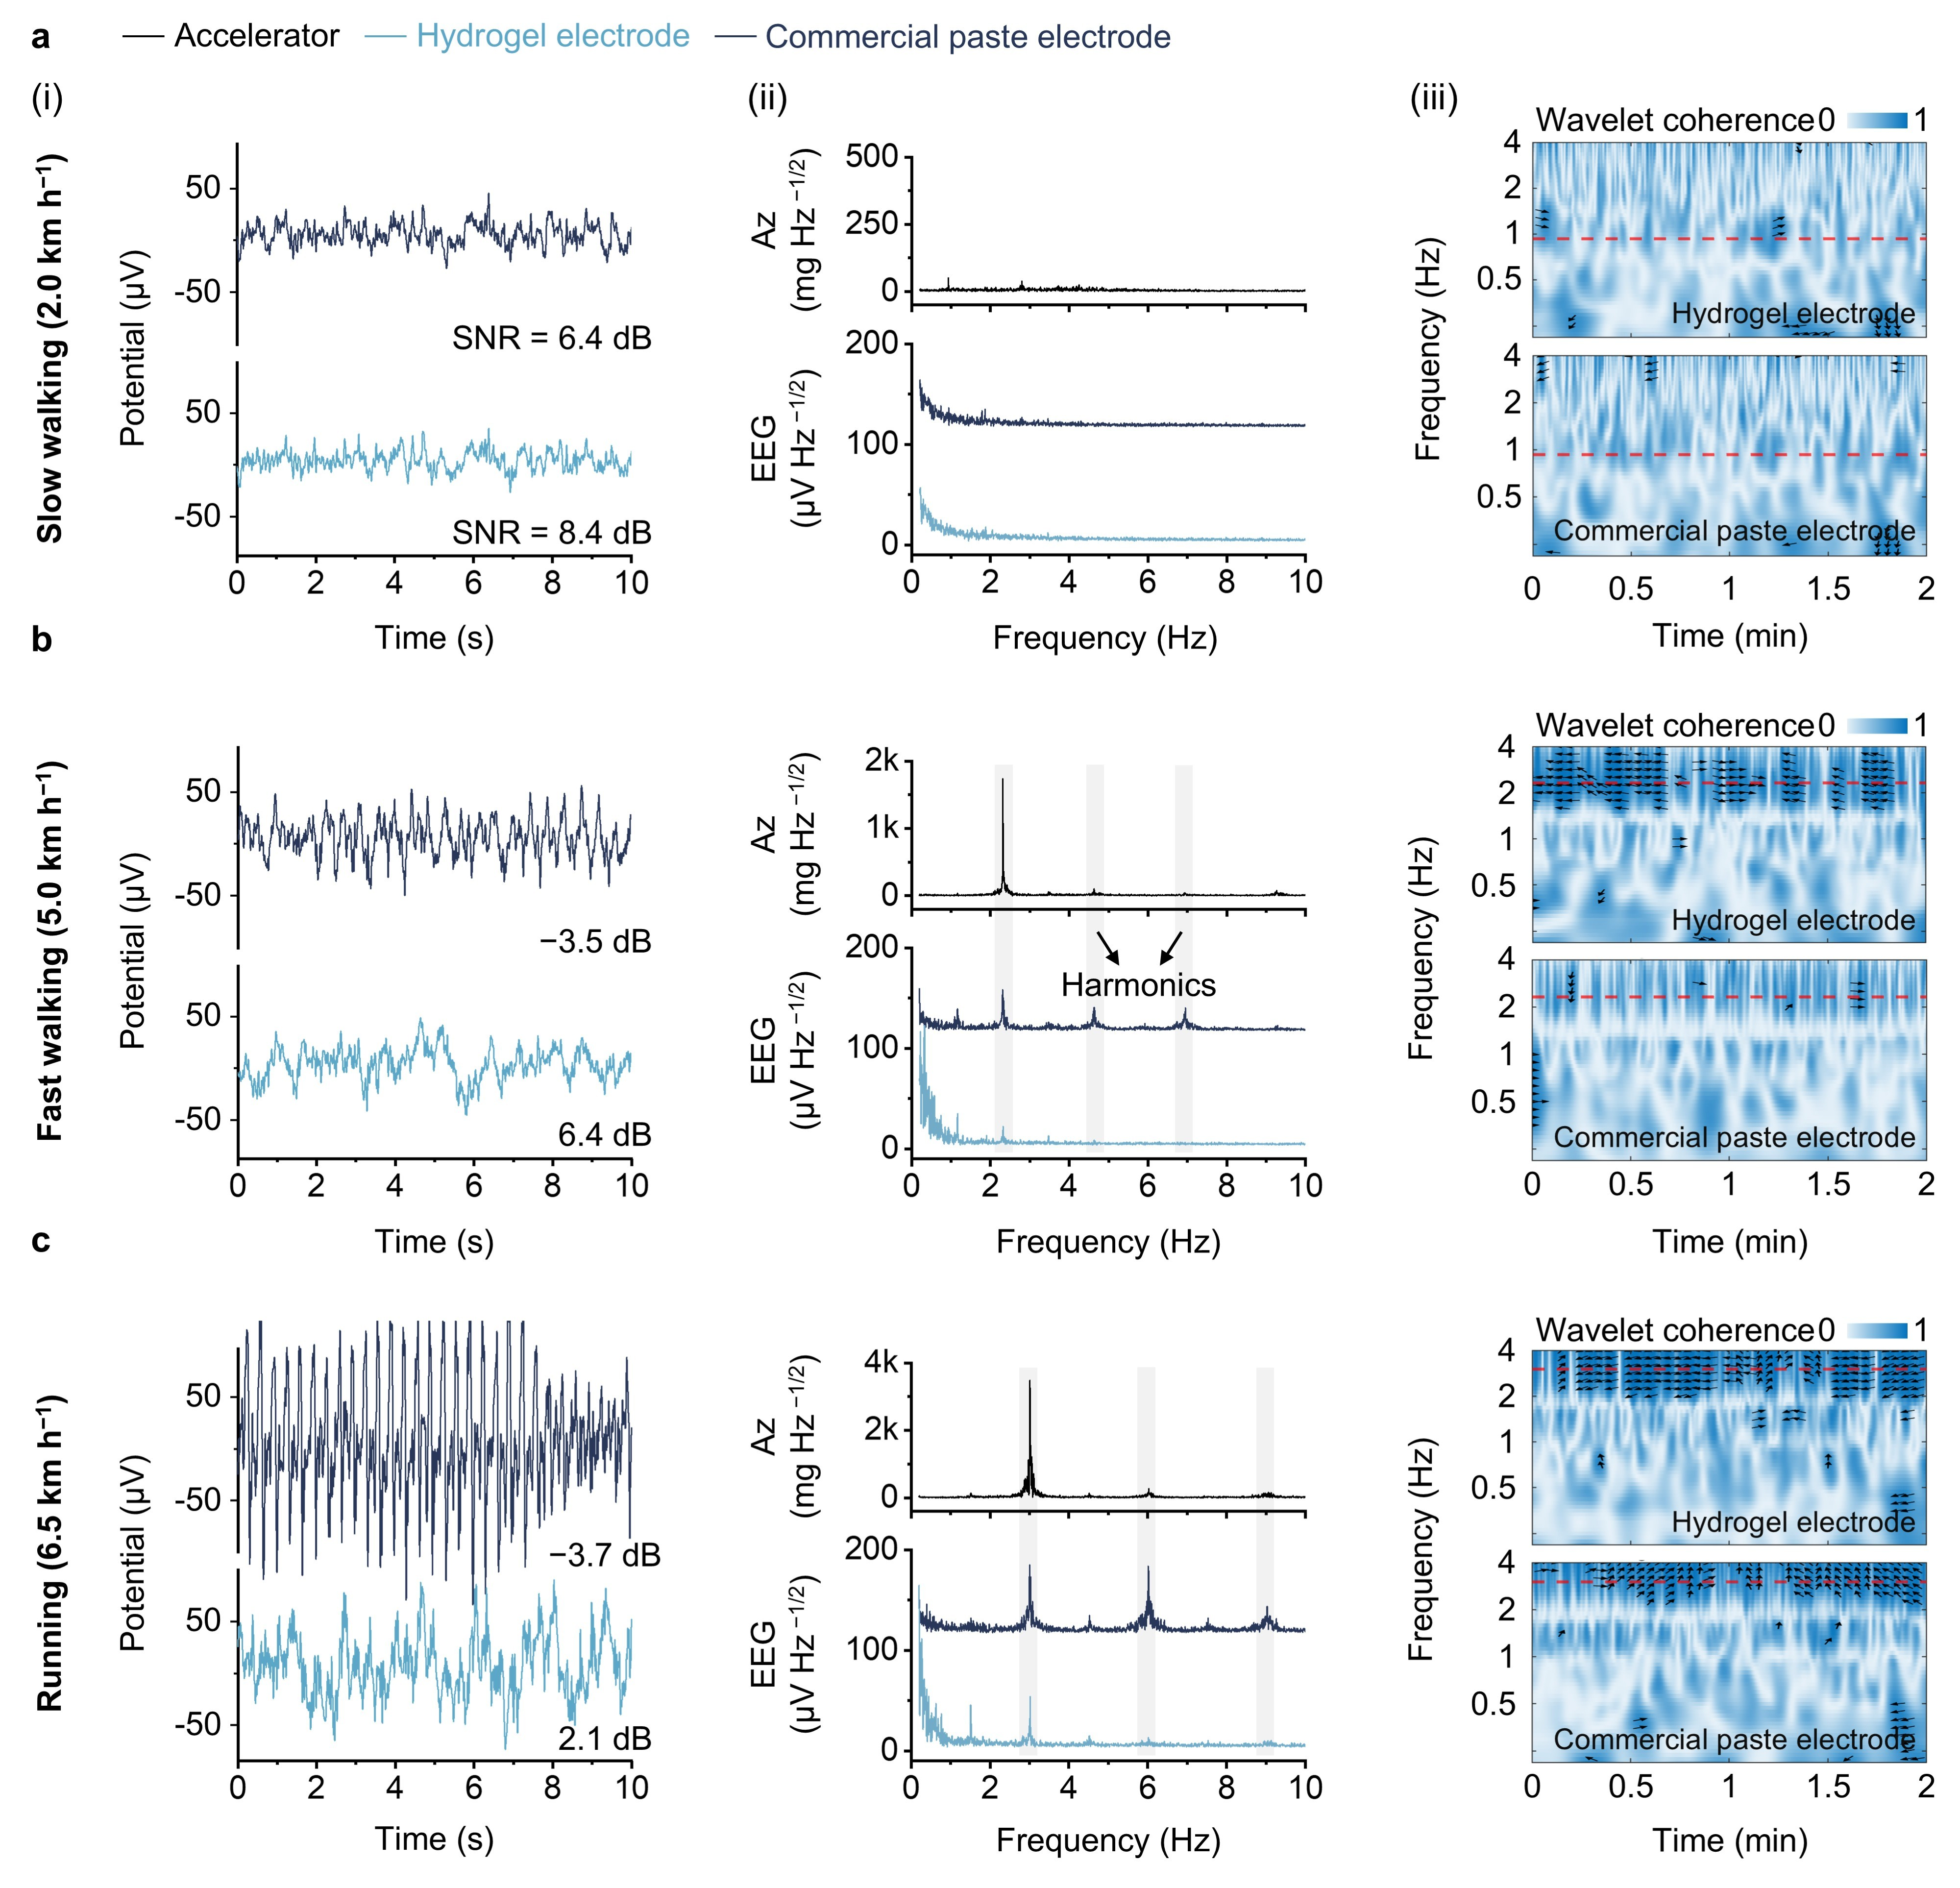

Supplementary Fig. 29 | Motion artefact comparison between commercial EEG paste and hydrogel electrodes at P₄ channel during walking and running. a–c, EEG recordings at P₄ channel during slow walking (2.0 km h⁻¹), fast walking (5.0 km h⁻¹), and running (6.5 km h⁻¹). (i) Representative EEG signals and SNR comparison. (ii) FFT amplitude spectra of the Az and the corresponding EEG signals. (iii) Wavelet coherence between Az and EEG signals. The red dashed line denotes step frequency; arrows indicate relative phase (right, in-phase; left, anti-phase; upward, EEG lagging acceleration by 90°; downward, EEG leading by 90°); coherence is shown only where > 0.75.

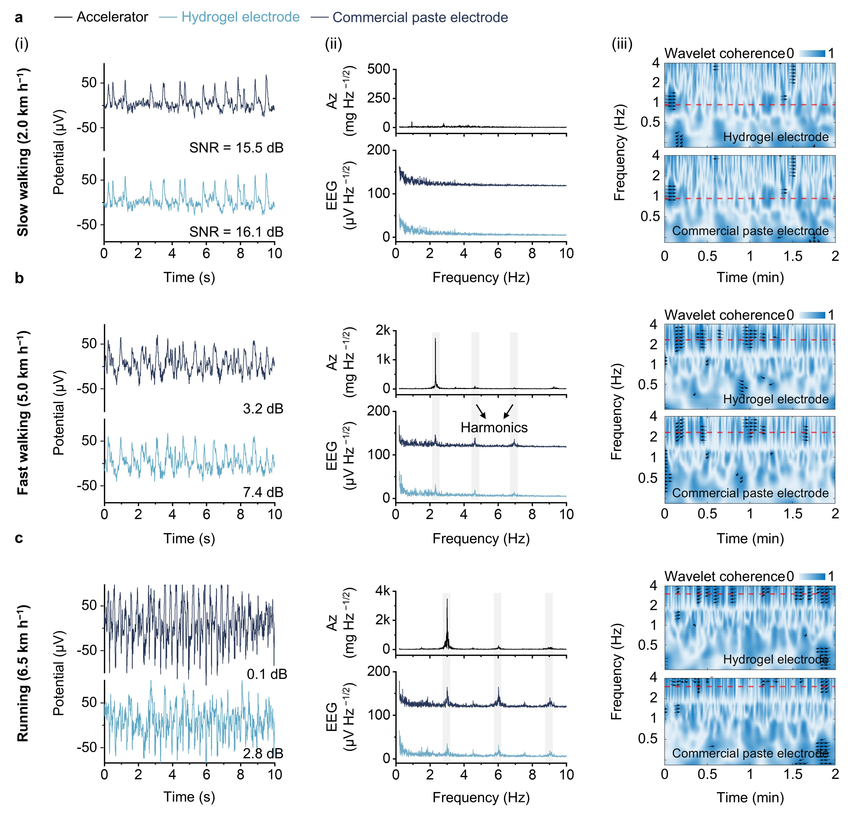

Supplementary Fig. 30 | Motion artefact comparison between commercial EEG paste and hydrogel electrodes at F₄ channel during walking and running. a–c, EEG recordings at F₄ channel during slow walking (2.0 km h⁻¹), fast walking (5.0 km h⁻¹), and running (6.5 km h⁻¹). (i) Representative EEG signals and SNR comparison. (ii) FFT amplitude spectra of the Az and the corresponding EEG signals. (iii) Wavelet coherence between Az and EEG signals. The red dashed line denotes step frequency; arrows indicate relative phase (right, in-phase; left, anti-phase; upward, EEG lagging acceleration by 90°; downward, EEG leading by 90°); coherence is shown only where > 0.75.

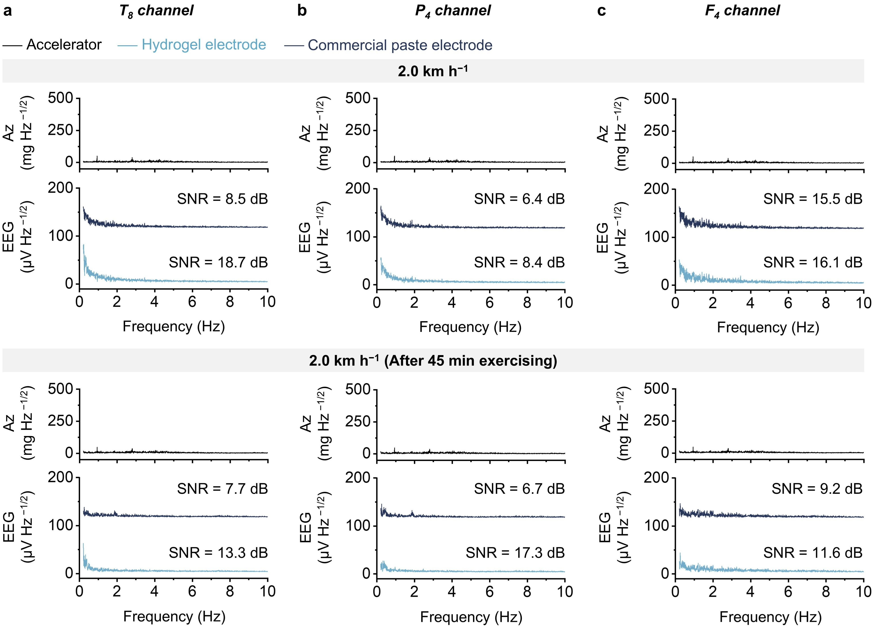

Supplementary Fig. 31 | Motion artefact comparison between commercial EEG paste and hydrogel electrodes before and after exercise. a–c, FFT amplitude spectra of the Az and the corresponding EEG signals at T₈, P₄, and F₄ channels at 2.0 km h⁻¹ conditions. Top, before exercise; bottom, after 45 min of high-intensity exercise.

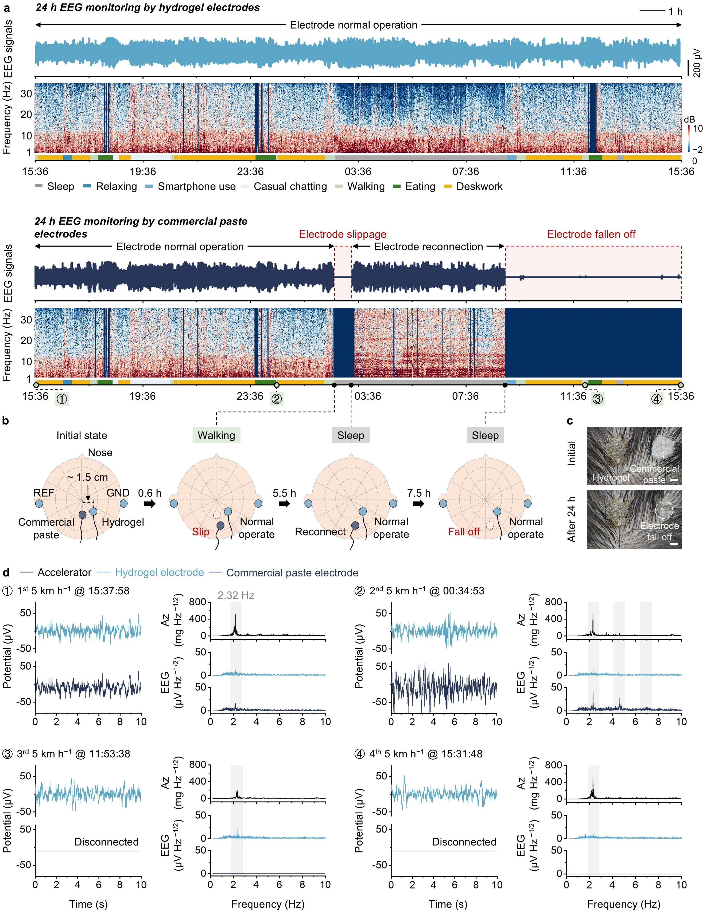

Supplementary Fig. 32 | Comparison of 24 h daily EEG recordings using hydrogel and commercial EEG paste electrodes. a, Continuous 24 h EEG data acquired by hydrogel and commercial EEG paste electrodes under daily conditions, with corresponding STFT-based time-frequency spectrograms highlighting activity-dependent, band-specific power. b, Schematic illustration of hair-bearing scalp–electrode contact conditions at representative time points: 15:36 (initial), 03:03 (walking), 03:46 (sleep), and 09:24 (sleep). c, Photographs of hair-bearing scalp–electrode interface initially and after 24 h of continuous wear. Commercial EEG paste electrodes show progressive material degradation and partial-to-complete detachment, whereas hydrogel electrodes maintain stable adhesion and morphology. Scale bar, 250 μm. d, Motion artefact evaluation. (i–iv) Left: ten-second EEG segments extracted from 4 fast walking workouts (5 km h⁻¹). Right: FFT amplitude spectra of Az and the corresponding EEG signals. Hydrogel electrodes demonstrate markedly reduced motion artefacts compared with commercial EEG paste electrodes.

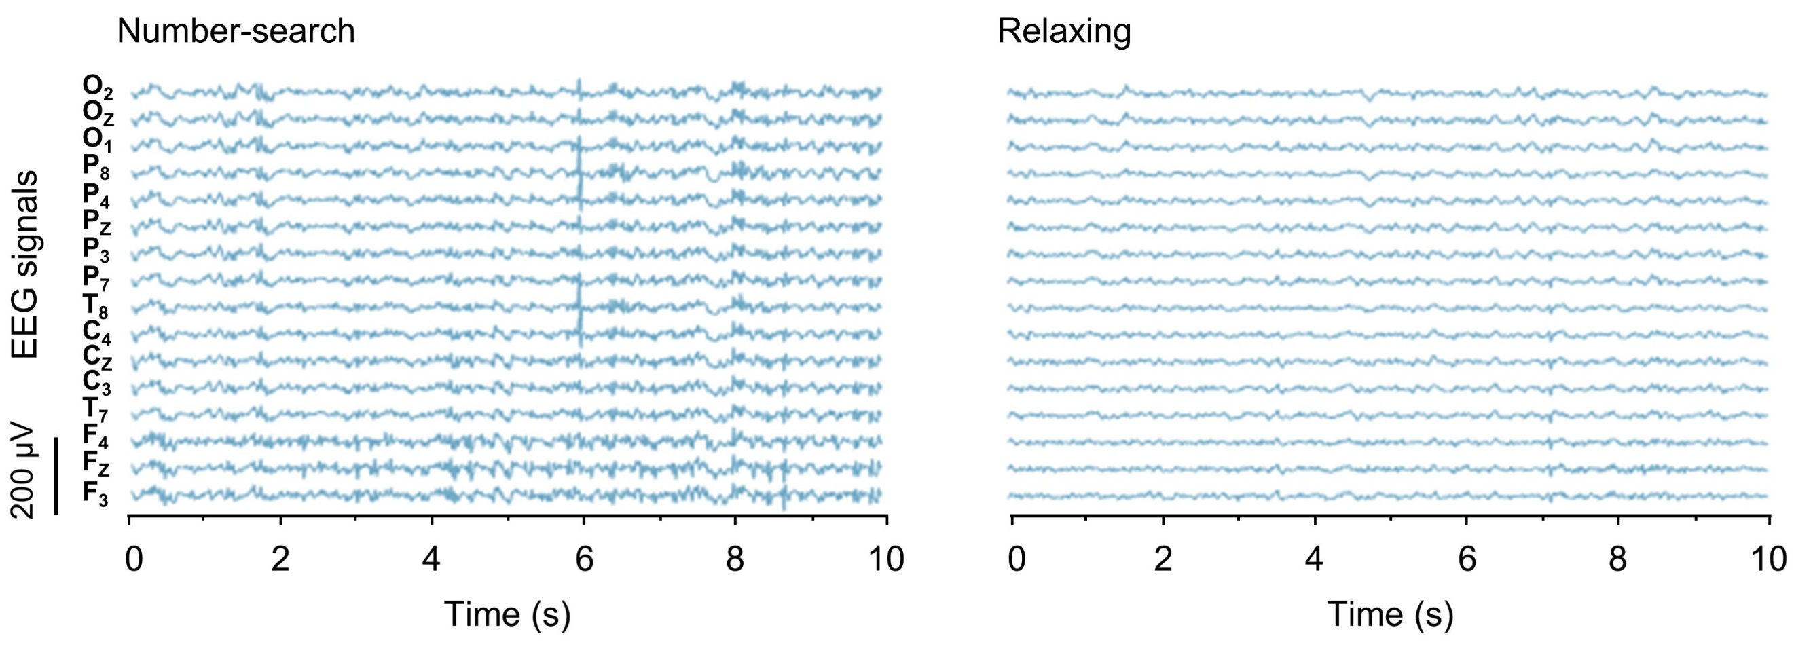

Supplementary Fig. 33 | Representative 16-channel EEG signals during low- and high-attention activities. EEG signals recorded with the wireless system during a high-attention number-search task and a low-attention relaxing state.

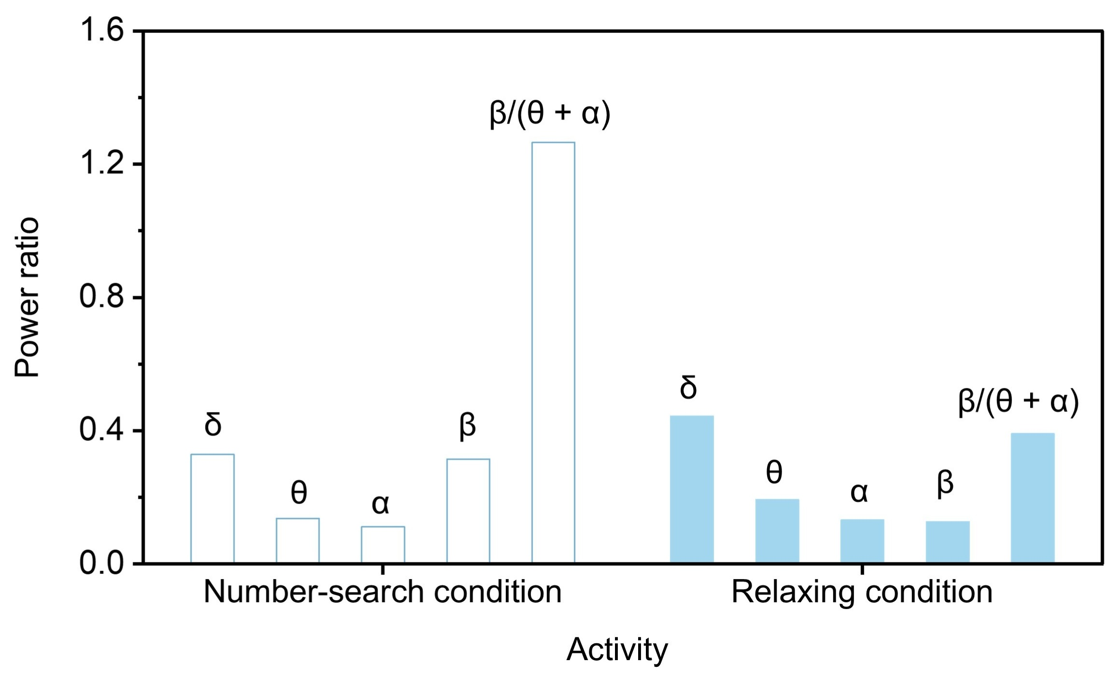

Supplementary Fig. 34 | Power ratio during low- and high-attention activities. Comparison of band-power ratios during a high-attention number-search task and a low-attention relaxing state. Engagement index = β/(θ + α).

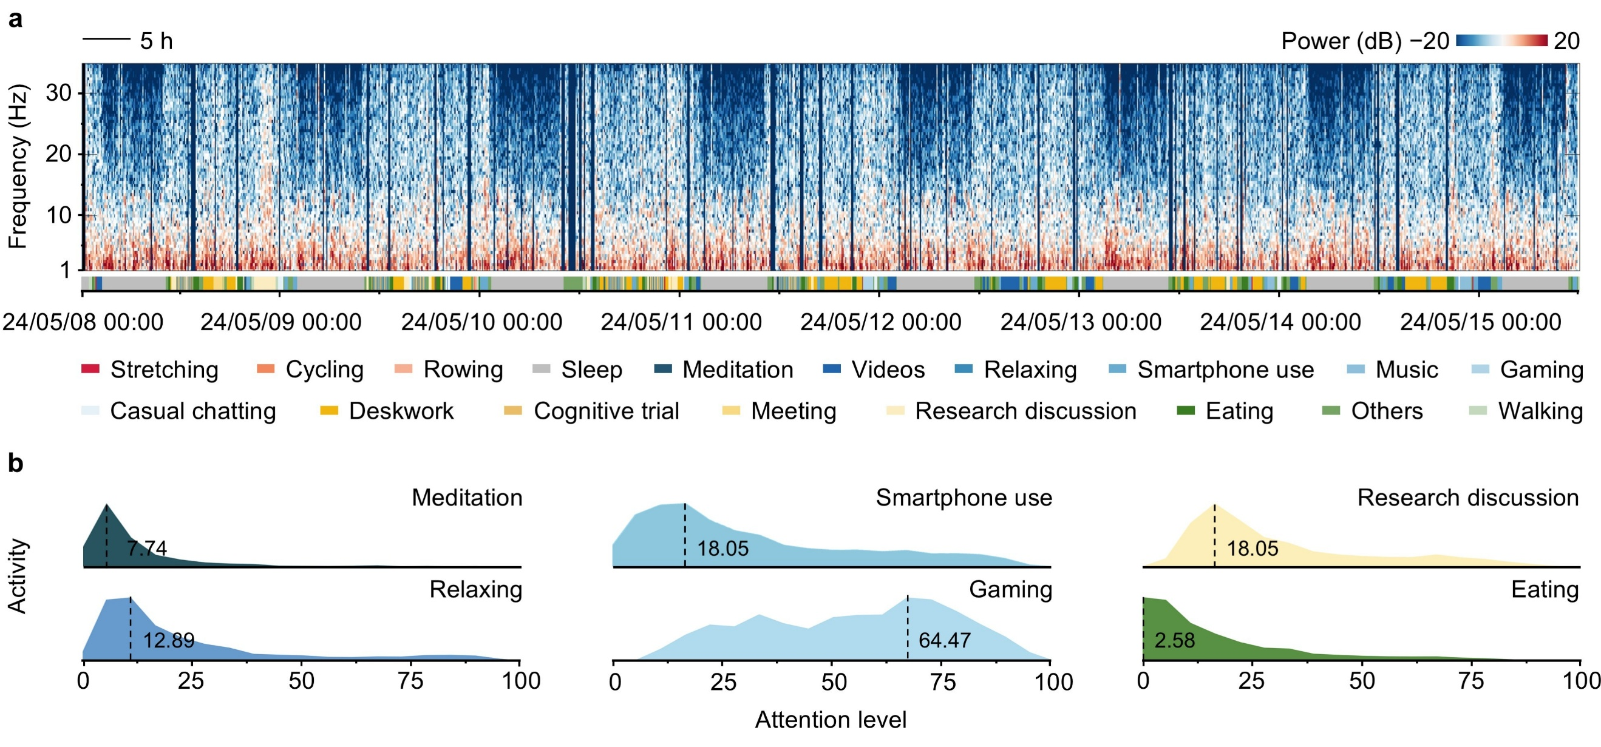

Supplementary Fig. 35 | Eight-day time spectrum and ridgeline distribution of different activities. a, Continuous time spectrum over eight consecutive days with activity annotations. b, Ridgeline distributions of attention level for additional activities over the same period, complementing Fig. 5b.

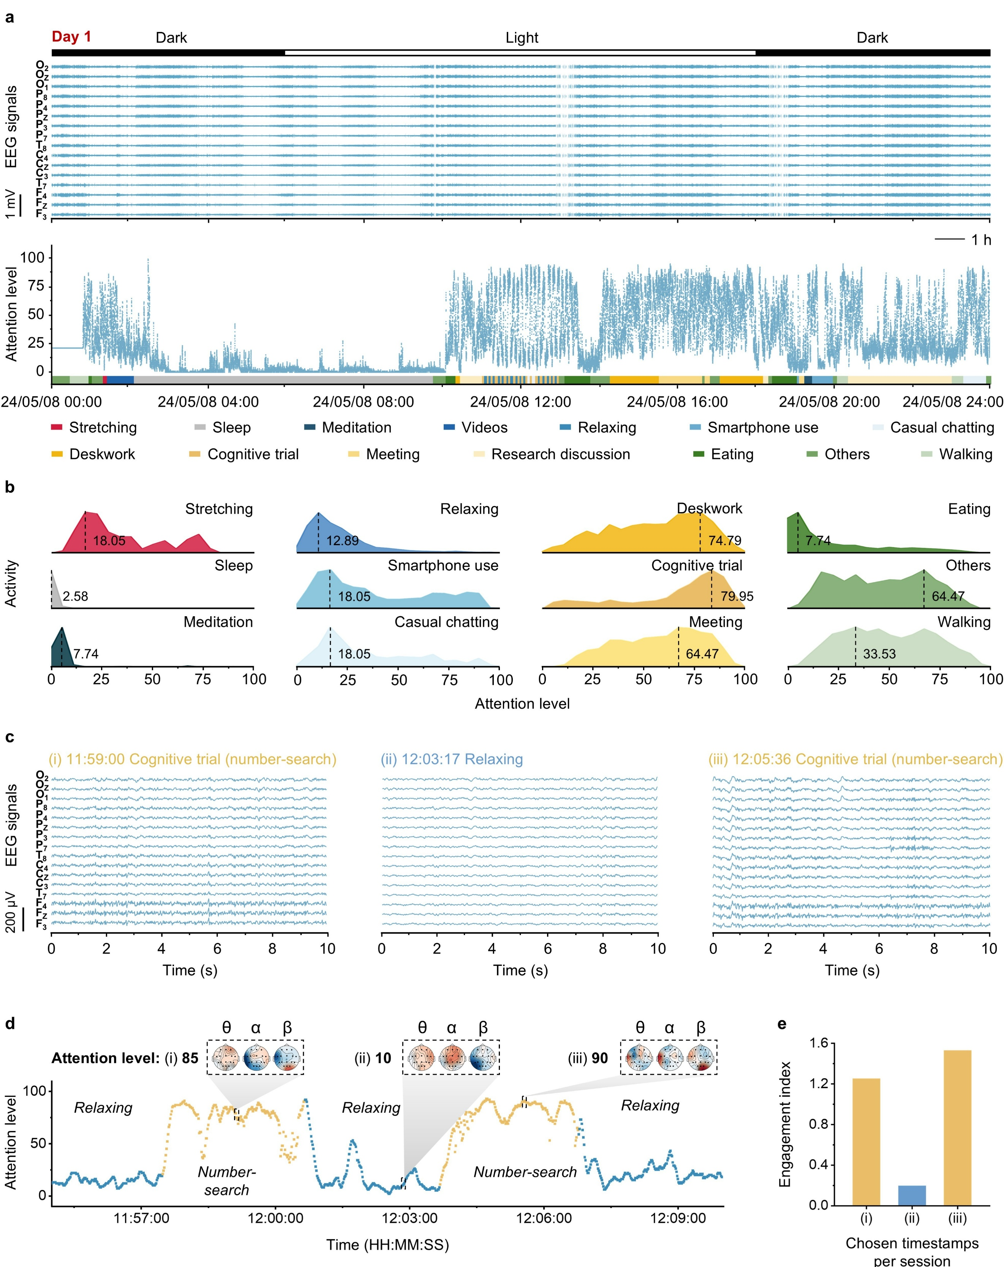

Supplementary Fig. 36 | Real-time attention assessment and task-specific discriminability on Day 1 in daily-life settings. a, Sixteen-channel EEG signals (top) and corresponding real-time attention level (bottom) continuously recorded on Day 1 under daily-life conditions; activity annotations shown below. b, Ridgeline distributions of attention level across activity categories derived from the Day 1 dataset. X-axis: attention level (0–100); Y-axis: relative count. Dashed lines indicate the histogram mode of attention level, with the corresponding numeric values label artefact ed. c, Ten-second EEG segments extracted from a number-search activity on Day 1 (11:59:00), a relaxing activity on Day 1 (12:03:17), and a number-search activity on Day 1 (12:05:36). d, Magnified attention trajectory corresponding to the same timestamps as in (c); insets show scalp topographies of band power at frequency bands of θ, α, and β, illustrating the spatial distribution of neural activity during cognitive load task at the selected moments (i–iii). e, Comparison of the engagement index at i–iii on Day 1.

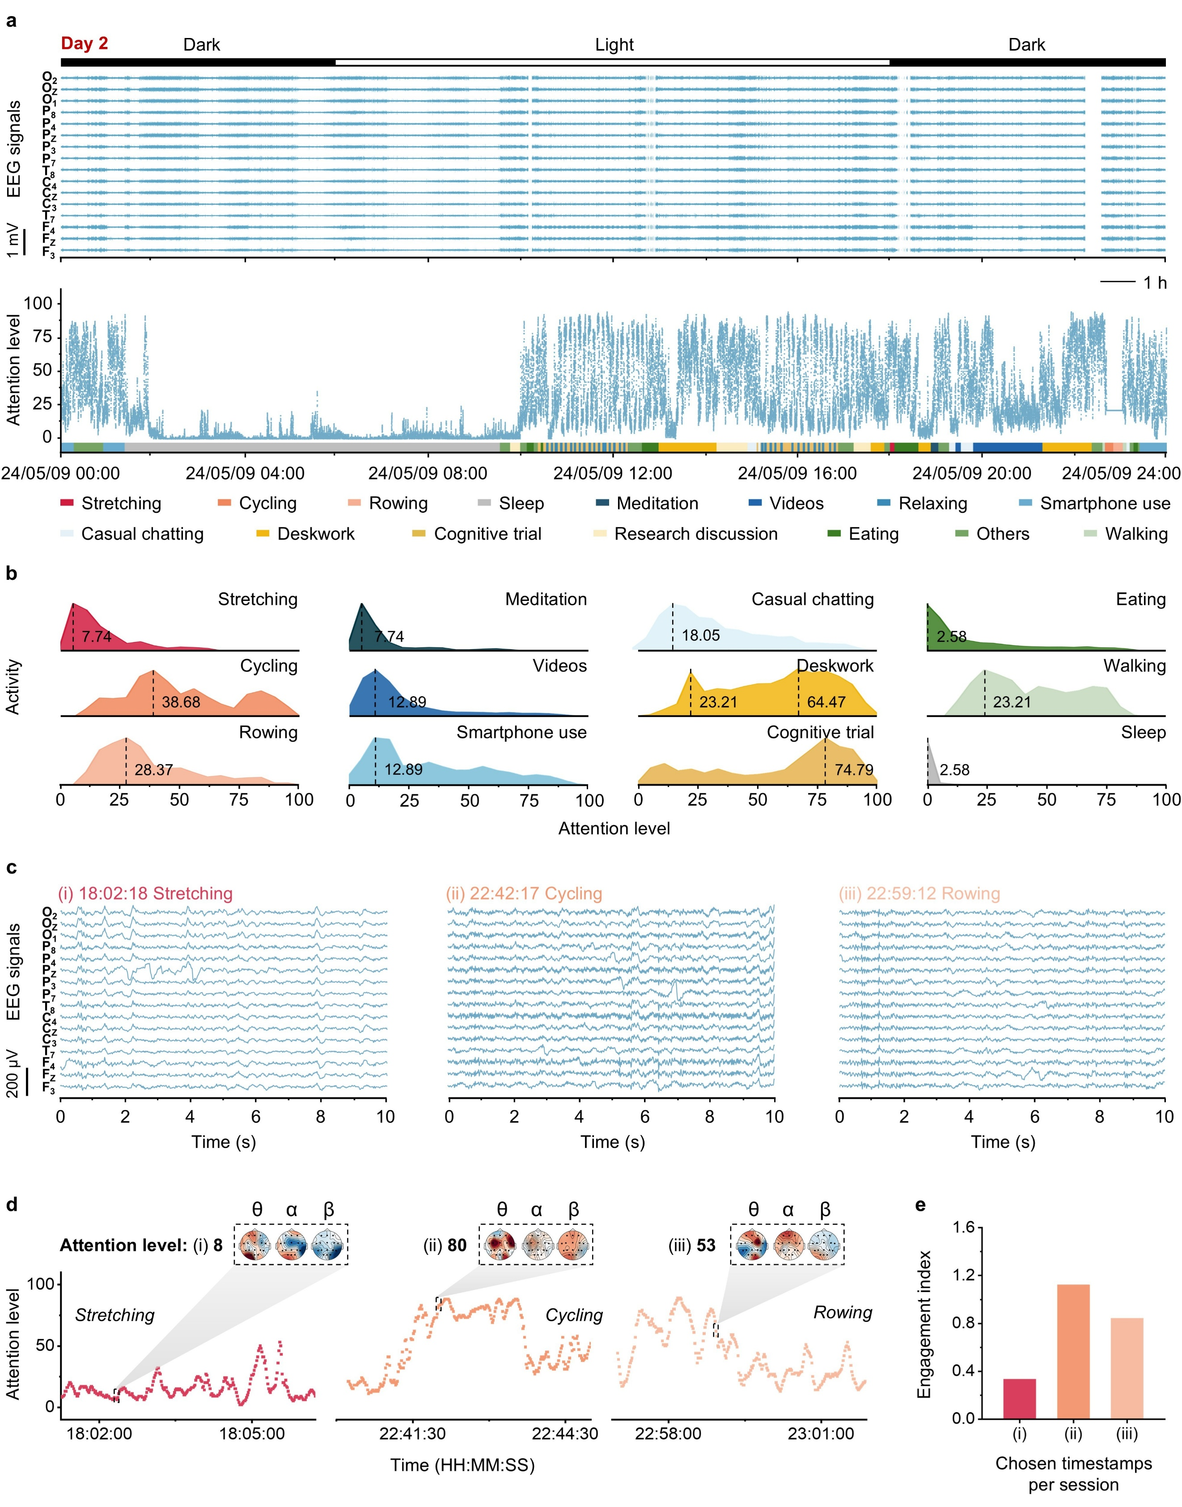

Supplementary Fig. 37 | Real-time attention assessment and task-specific discriminability on Day 2 in daily-life settings. a, Sixteen-channel EEG signals (top) and corresponding real-time attention level (bottom) continuously recorded on Day 2 under daily-life conditions; activity annotations shown below. b, Ridgeline distributions of attention levels across activity categories derived from the Day 2 dataset. X-axis: attention level (0–100); Y-axis: relative count. Dashed lines indicate the histogram mode of attention level, with the corresponding numeric values labeled. c, Ten-second EEG segments extracted from a stretching activity on Day 2 (18:02:18), a cycling activity on Day 2 (22:42:17), and a rowing activity on Day 2 (22:59:12). d, Magnified attention trajectory corresponding to the same timestamps as in (c); insets show scalp topographies of band power at frequency bands of θ, α, and β, illustrating the spatial distribution of neural activity during exercise modalities at the selected moments (i–iii). e, Comparison of the engagement index at i–iii on Day 2.

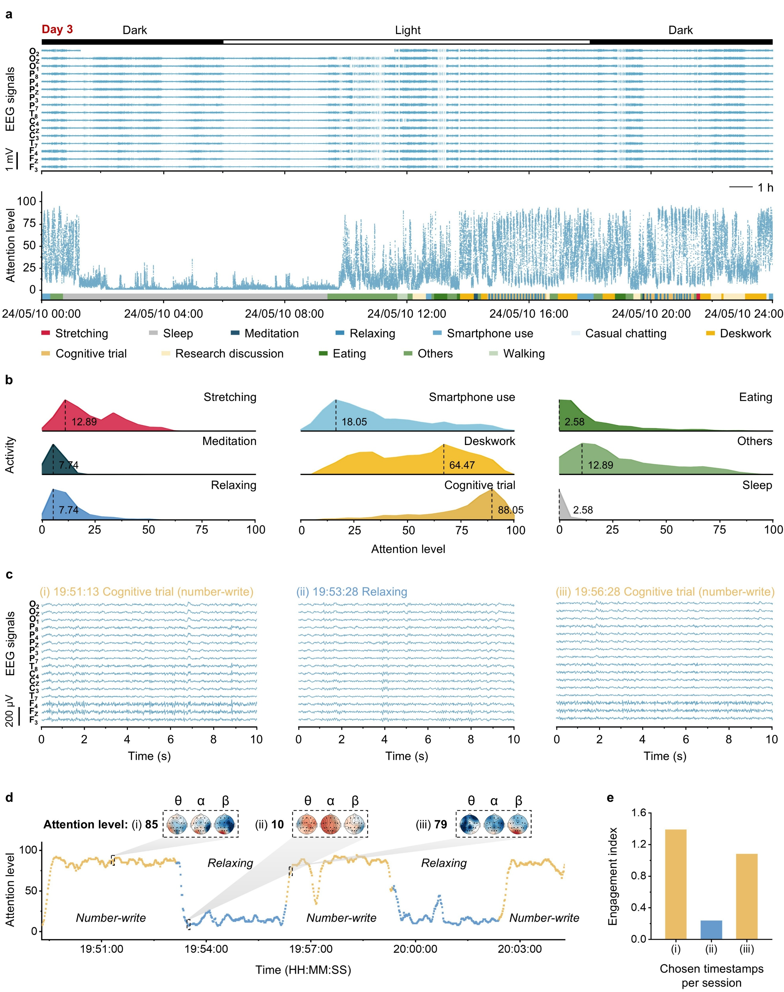

Supplementary Fig. 38 | Real-time attention assessment and task-specific discriminability on Day 3 in daily-life settings. a, Sixteen-channel EEG signals (top) and corresponding real-time attention level (bottom) continuously recorded on Day 3 under daily-life conditions; activity annotations shown below. b, Ridgeline distributions of attention levels across activity categories derived from the Day 3 dataset. X-axis: attention level (0–100); Y-axis: relative count. Dashed lines indicate the histogram mode of attention level, with the corresponding numeric values labeled. c, Ten-second EEG segments extracted from a number-write activity on Day 3 (19:51:13), a relaxing activity on Day 3 (19:53:28), and a number-write activity on Day 3 (19:56:28). d, Magnified attention trajectory corresponding to the same timestamps as in (c); insets show scalp topographies of band power at frequency bands of θ, α, and β, illustrating the spatial distribution of neural activity during cognitive load task at the selected moments (i–iii). e, Comparison of the engagement index at i–iii on Day 3.

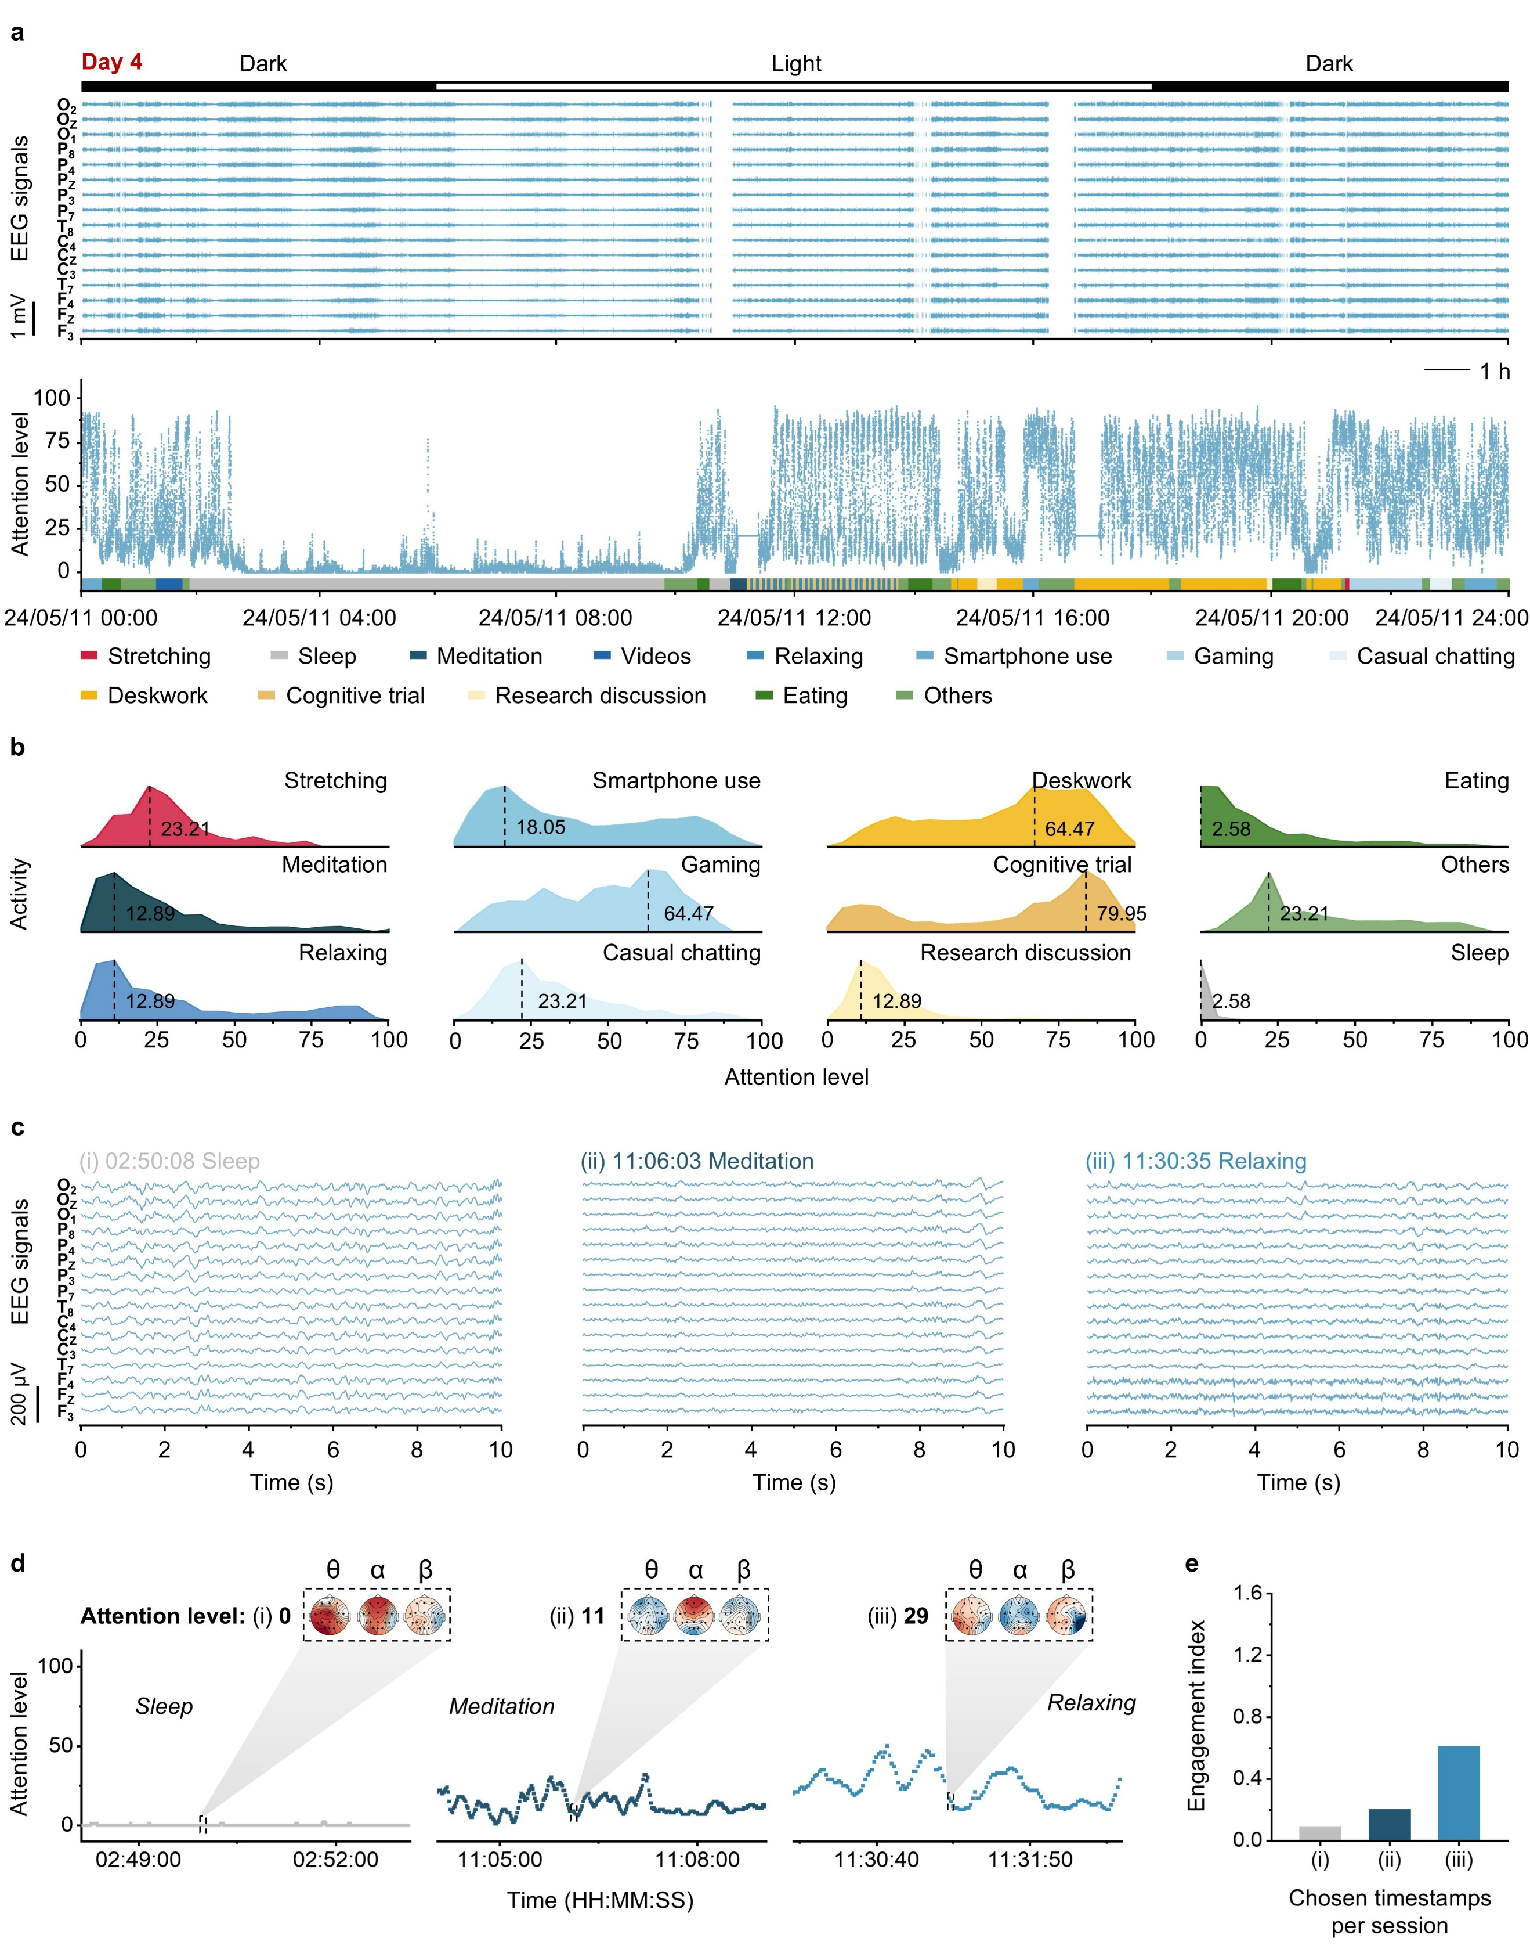

Supplementary Fig. 39 | Real-time attention assessment and task-specific discriminability on Day 4 in daily-life settings. a, Sixteen-channel EEG signals (top) and corresponding real-time attention level (bottom) continuously recorded on Day 4 under daily-life conditions; activity annotations shown below. b, Ridgeline distributions of attention levels across activity categories derived from the Day 4 dataset. X-axis: attention level (0–100); Y-axis: relative count. Dashed lines indicate the histogram mode of attention level, with the corresponding numeric values labeled. c, Ten-second EEG segments extracted from a sleep activity on Day 4 (02:50:08), a meditation activity on Day 4 (11:06:03), and a relaxing activity on Day 4 (11:30:35). d, Magnified attention trajectory corresponding to the same timestamps as in (c); insets show scalp topographies of band power at frequency bands of θ, α, and β, illustrating the spatial distribution of neural activity during low-arousal states at the selected moments (i–iii). e, Comparison of the engagement index at i–iii on Day 4.
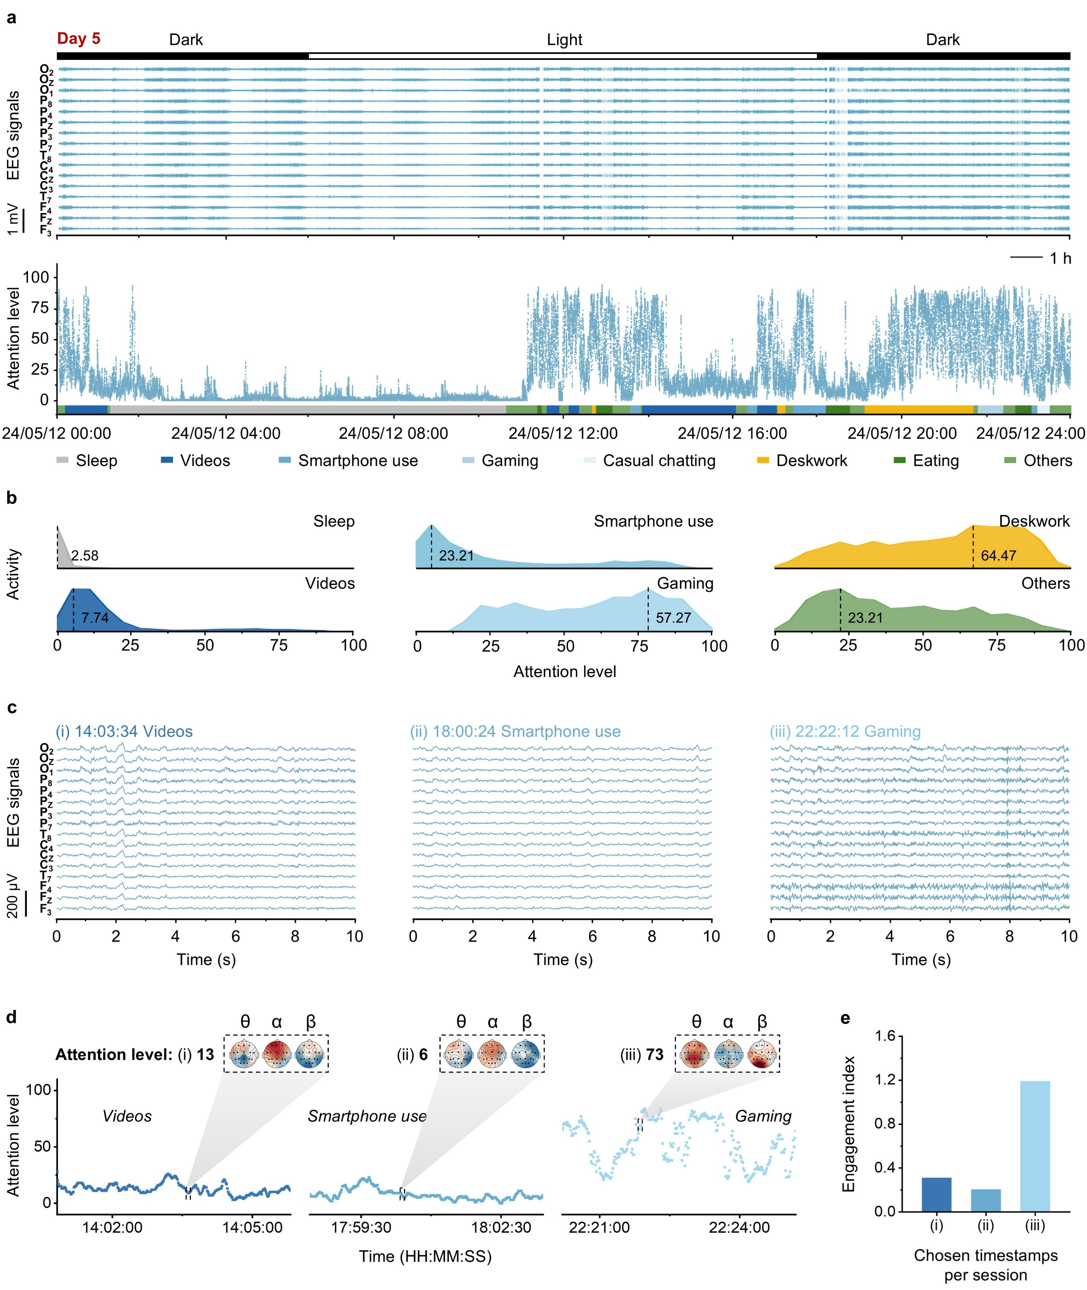

Supplementary Fig. 40 | Real-time attention assessment and task-specific discriminability on Day 5 in daily-life settings. a, Sixteen-channel EEG signals (top) and corresponding real-time attention level (bottom) continuously recorded on Day 5 under daily-life conditions; activity annotations shown below. b, Ridgeline distributions of attention levels across activity categories derived from the Day 5 dataset. X-axis: attention level (0–100); Y-axis: relative count. Dashed lines indicate the histogram mode of attention level, with the corresponding numeric values labeled. c, Ten-second EEG segments extracted from a video activity on Day 5 (14:03:34), casual smartphone use activity on Day 5 (18:00:24), and a gaming activity on Day 5 (22:22:12). d, Magnified attention trajectory corresponding to the same timestamps as in (c); insets show scalp topographies of band power at frequency bands of θ, α, and β, illustrating the spatial distribution of neural activity during visually driven digital media activity at the selected moments (i–iii). e, Comparison of the engagement index at i–iii on Day 5.
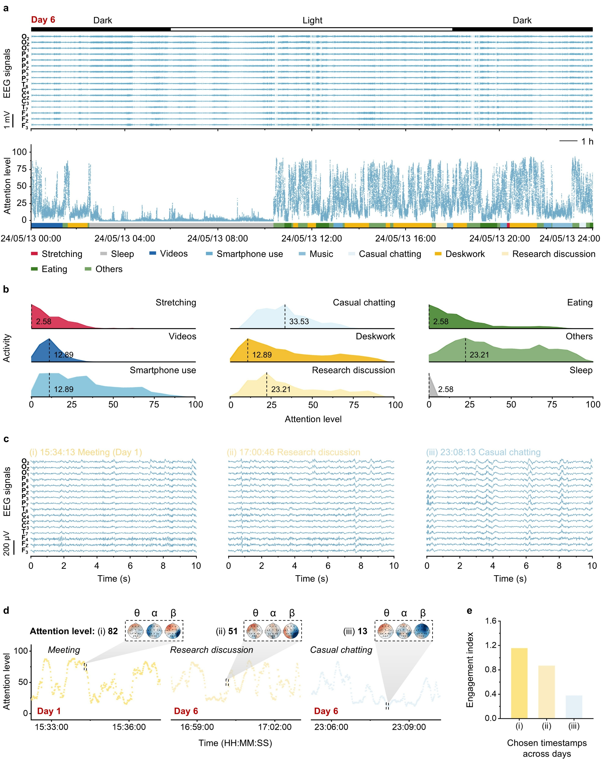

Supplementary Fig. 41 | Real-time attention assessment and task-specific discriminability on Day 6 in daily-life settings. a, Sixteen-channel EEG signals (top) and corresponding real-time attention level (bottom) continuously recorded on Day 6 under daily-life conditions; activity annotations shown below. b, Ridgeline distributions of attention levels across activity categories derived from the Day 6 dataset. X-axis: attention level (0–100); Y-axis: relative count. Dashed lines indicate the histogram mode of attention level, with the corresponding numeric values labeled. c, Ten-second EEG segments extracted from a meeting recorded on Day 1 (15:34:13), a research discussion on Day 6 (17:00:46), and a chatting activity on Day 6 (23:08:13). d, Magnified attention trajectory corresponding to the same timestamps as in (c). Insets show scalp topographies of band power at frequency bands of θ, α, and β, illustrating the spatial distribution of neural activity during verbal-communication tasks at the selected moments (i–iii). e, Comparison of the engagement index at i–iii on Day 6.

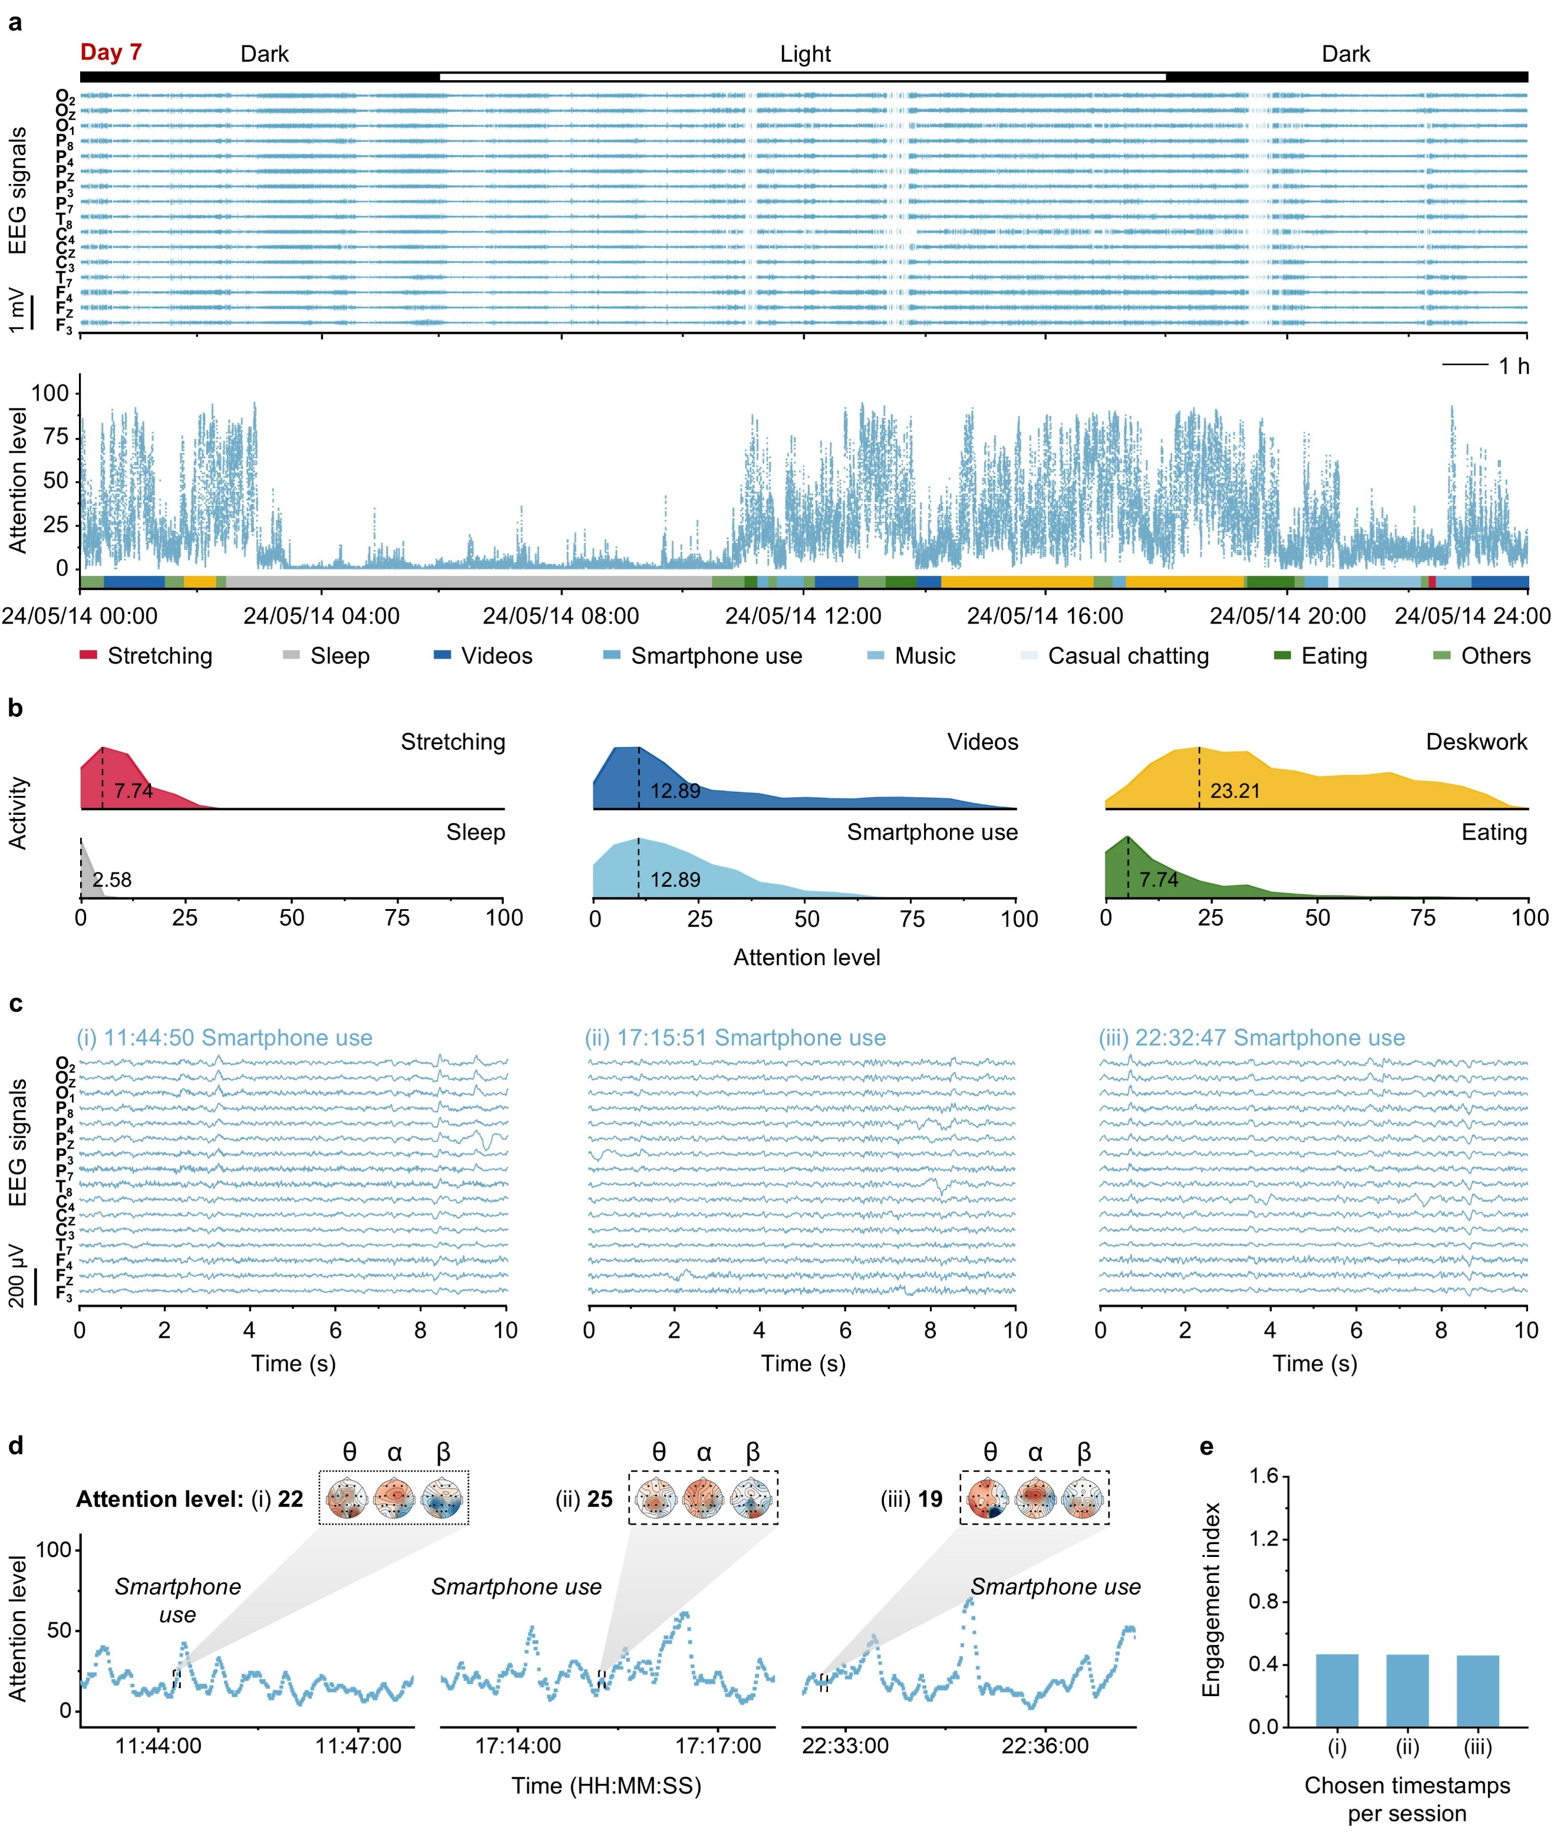

Supplementary Fig. 42 | Real-time attention assessment and task-specific discriminability on Day 7 in daily-life settings. a, Sixteen-channel EEG signals (top) and corresponding real-time attention level (bottom) continuously recorded on Day 7 under daily-life conditions; activity annotations shown below. b, Ridgeline distributions of attention levels across activity categories derived from the Day 7 dataset. X-axis: attention level (0–100); Y-axis: relative count. Dashed lines indicate the histogram mode of attention level, with the corresponding numeric values labeled. c, Ten-second EEG segments extracted from a casual smartphone use activity on Day 7 (11:44:50, 17:15:51, and 22:32:47, respectively). d, Magnified attention trajectory corresponding to the same timestamps as in (c); insets show scalp topographies of band power at frequency bands of θ, α, and β, illustrating the spatial distribution of neural activity during casual smartphone use at the selected moments (i–iii). e, Comparison of the engagement index at i–iii on Day 7.
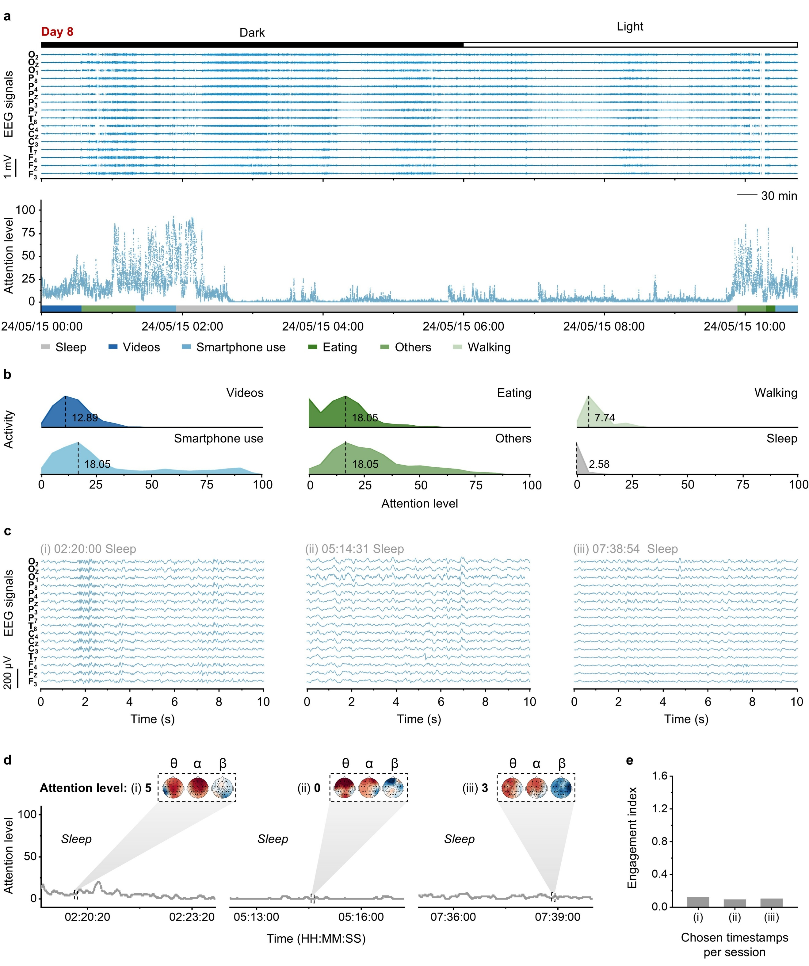

Supplementary Fig. 43 | Real-time attention assessment and task-specific discriminability on Day 8 in daily-life settings. a, Sixteen-channel EEG signals (top) and corresponding real-time attention level (bottom) continuously recorded on Day 8 under daily-life conditions; activity annotations shown below. b, Ridgeline distributions of attention levels across activity categories derived from the Day 8 dataset. X-axis: attention level (0–100); Y-axis: relative count. Dashed lines indicate the histogram mode of attention level, with the corresponding numeric values labeled. c, Ten-second EEG segments extracted from a sleep activity on Day 8 (02:20:00, 05:14:31, and 07:38:54, respectively). d, Magnified attention trajectory corresponding to the same timestamps as in (c); insets show scalp topographies of band power at frequency bands of θ, α, and β, illustrating the spatial distribution of neural activity during continuous sleep period at the selected moments (i–iii). e, Comparison of the engagement index at i–iii on Day 8.

Supplementary Table 1 | Comparison of the breathable wireless system with commercial wearable EEG devices and recently reported wireless EEG systems. Summary of device properties, including system breathability, form factor of acquisition equipment, channel number, power source, power consumption, battery life, system flexibility, data transmission method, interconnect strategy, electrode (skin-interfaced material), EEG frequency bands, and signal quality during motion. “N.R.” indicates not reported. The earhook system uniquely combines system breathability, high wearability, stable long-term operation, and on-device data analytics for broadband EEG recording over 8 consecutive days. It is worth noting that the 8–13 Hz frequency range used for motion artefact evaluation does not include the motion frequencies commonly observed during walking (2 km h⁻¹) or running (6 km h⁻¹).
Note: [i] https://brainbit.com/hardware-solutions/brainbit-headband/; [ii] https://www.brainproducts.com/solutions/cgx-quick/; [iii] https://brainbit.com/hardware-solutions/brainbit-headphones/.
System |  | Setup  image | System  breath-ability | Form  factor | Channel  number | Power  source | Power con-  sumption | Battery  life | System  flexibility | Data trans-mission | Interconnect | Electrode | Band  (continuous monitoring duration) | Online data processing | Motion artefact evaluation
Commercial devices | BrainBit Headband^{[i]} | 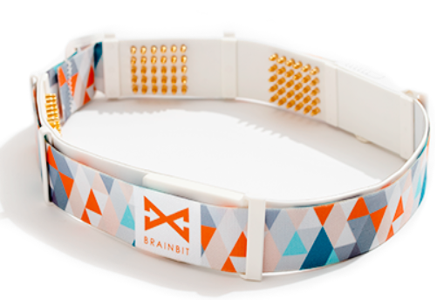 | No | Headband | 4 | Battery | N.R. | 12 h | Yes | BLE | N.R. | Rigid dry electrode | δ, θ, α, β, γ  (12 h) | No | N.R.
Commercial devices | CGX Quick systems^{[ii]} | 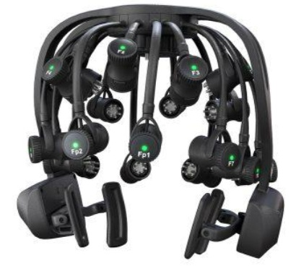 | No | Headset | 32 | Battery | N.R. | 8 h | No | BLE | N.R. | Rigid dry electrode | δ, θ, α, β, γ  (N.R.) | No | N.R.
Commercial devices | BrainBit Headphones^{[iii]} | 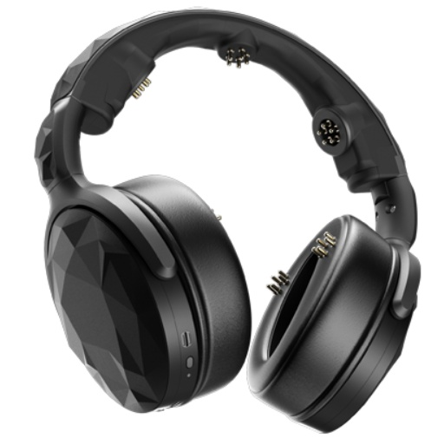 | No | Headphone | 4 | Battery | N.R. | 8 h | No | BLE | N.R. | Rigid dry electrode | δ, θ, α, β, γ  (N.R.) | No | N.R.
Research articles | Chin-Teng Lin et al., 2014⁽¹⁾ | 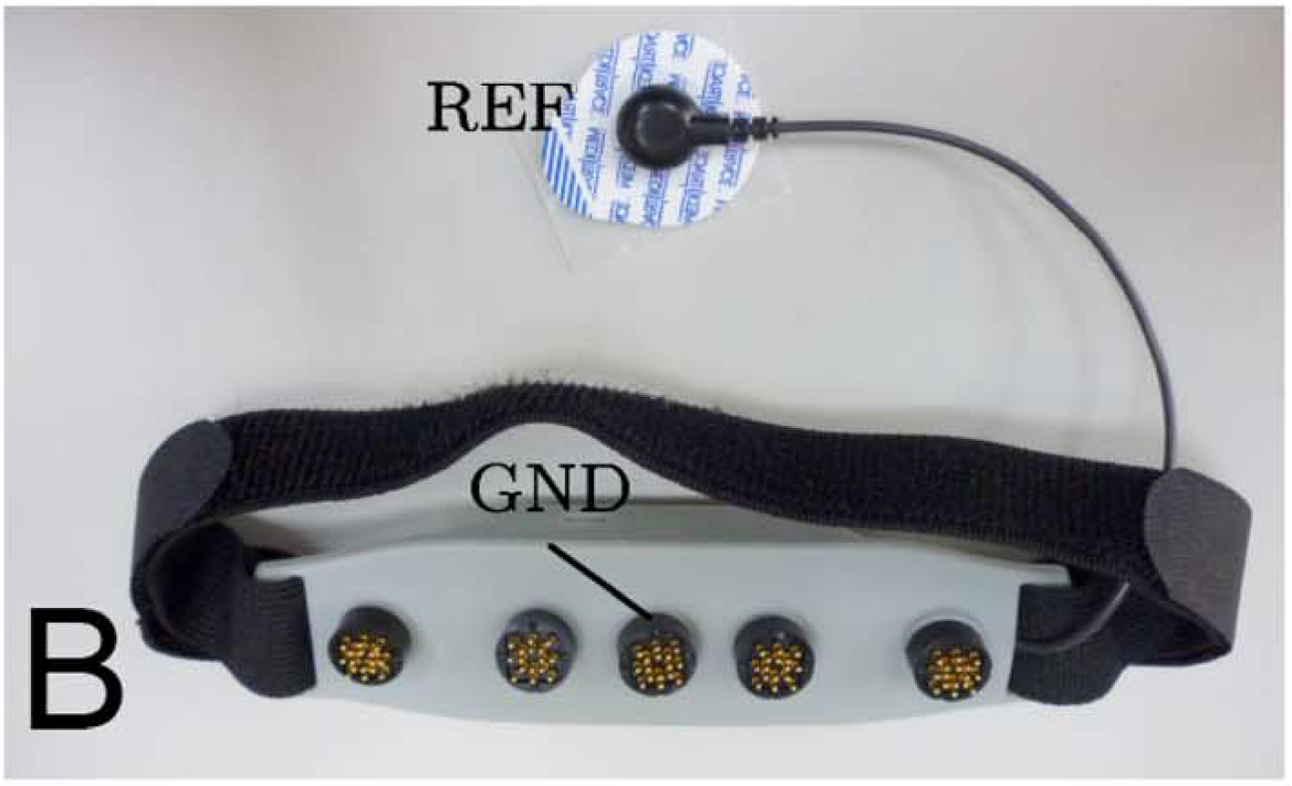  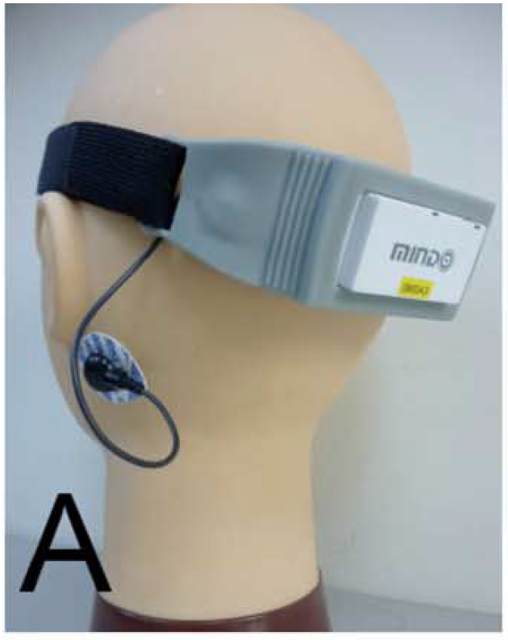 | No | Headband | 4 | Battery | N.R. | 23 h | No | Bluetooth | N.R. | Rigid dry electrode | δ, θ, α, β  (90 min) | Yes | N.R.
Research articles | Musa Mahmood et al., 2019⁽²⁾ | 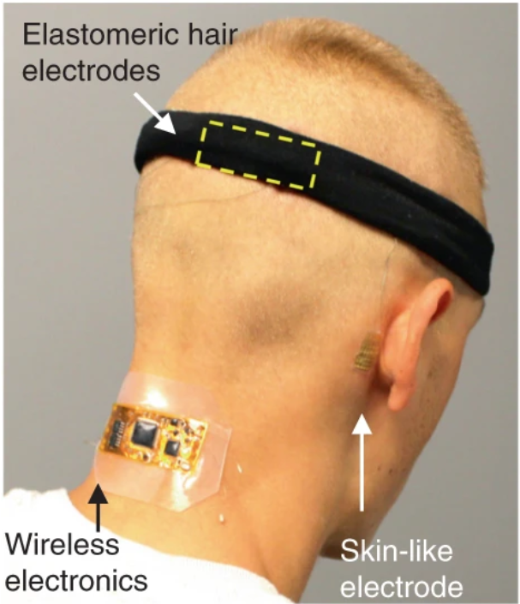  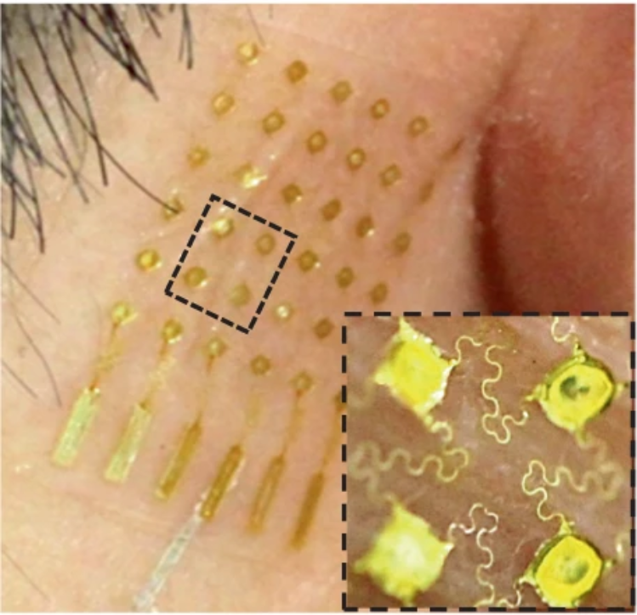  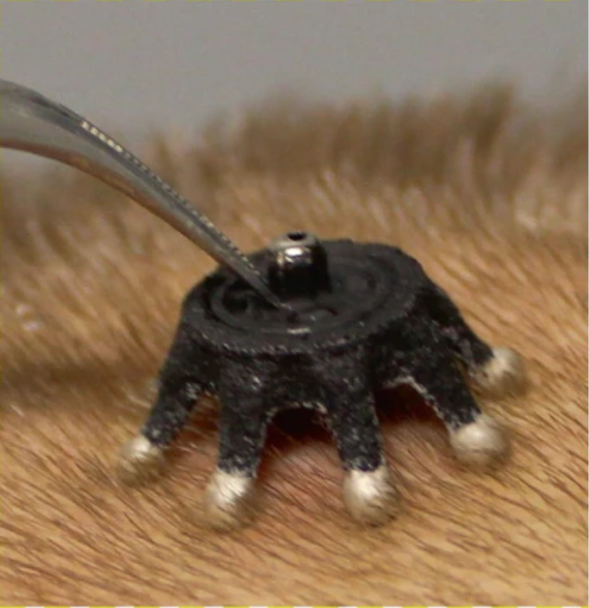 | No | Headband | 2 | N.R. | N.R. | N.R. | Yes | BLE | Film cable | Flexible dry electrode | α  (N.R.) | Yes | N.R.
Research articles | Musa Mahmood et al., 2021⁽³⁾ | 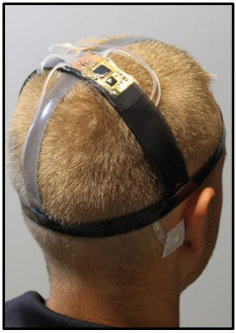  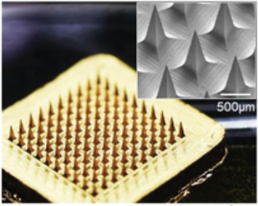  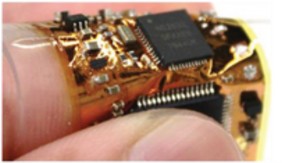 | No | Headset | 6 | N.R. | N.R. | N.R. | Yes | BLE | Serpentine connector | Invasive dry electrode | α  (4 min) | Yes | N.R.
Research articles | Joo Hwan Shin et al., 2022⁽⁴⁾ | 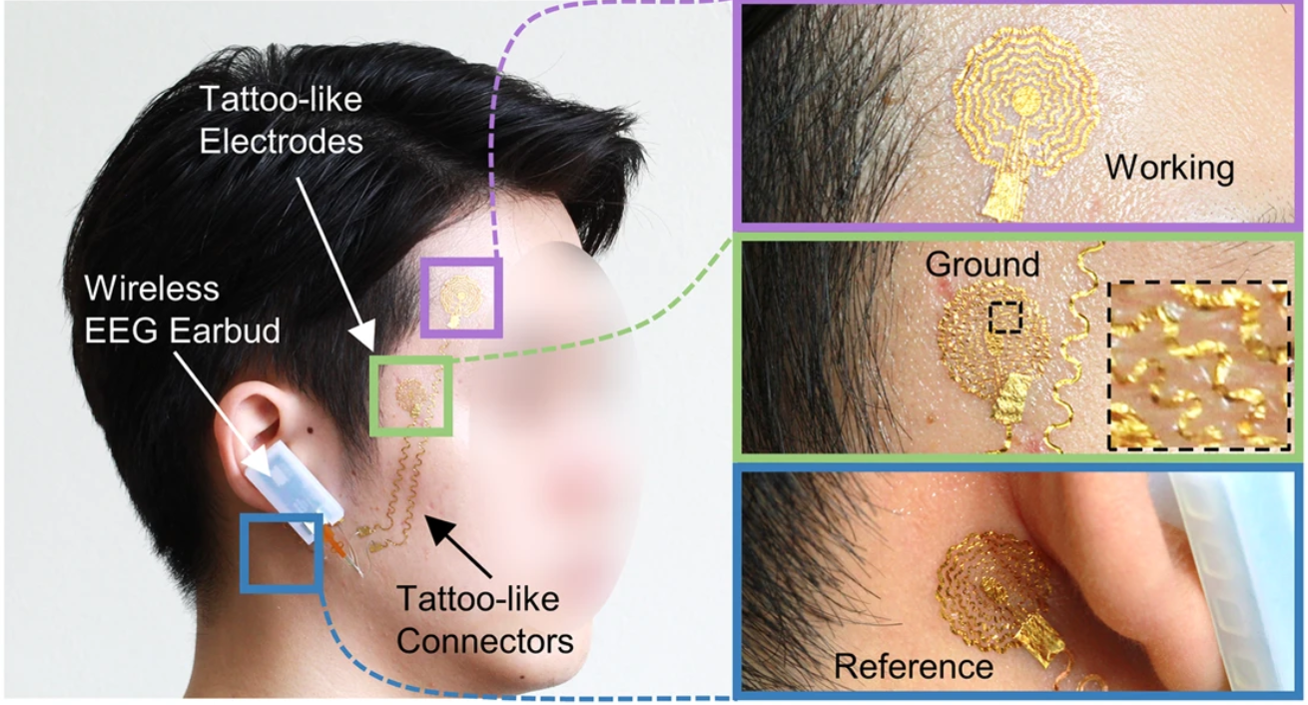 | No | Earbud | 1 | Battery | N.R. | 8 h | No | BLE | Serpentine connector | Flexible dry electrode | α  (8 h) | Yes | N.R.
Research articles | Shinjae Kwon et al., 2023⁽⁵⁾ | 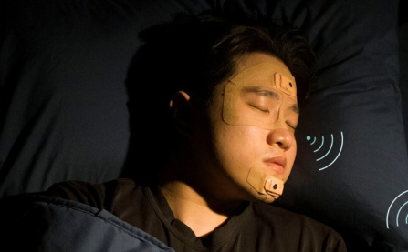  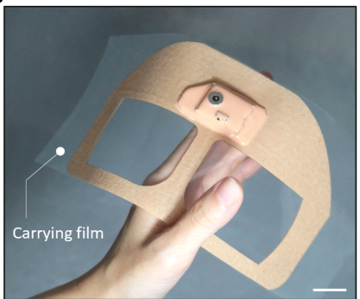 | No | Forehead patch | 2 | Battery | 52.6 mW | 10.6 h | Yes | BLE | Serpentine connector | Flexible dry electrode | θ, α, β  (~8 h) | No | N.R.
Research articles | Yuchen Xu et al., 2023⁽⁶⁾ | 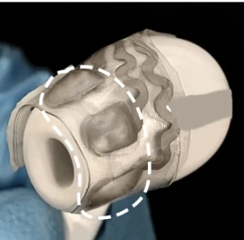  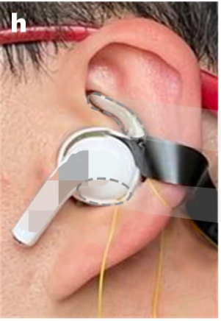 | No | In-ear | 6 | N.R. | N.R. | N.R. | No | BLE | N.R. | Flexible dry electrode | θ, α, β  (25 min) | No | N.R.
Research articles | Qingquan Han et al., 2023⁽⁷⁾ | 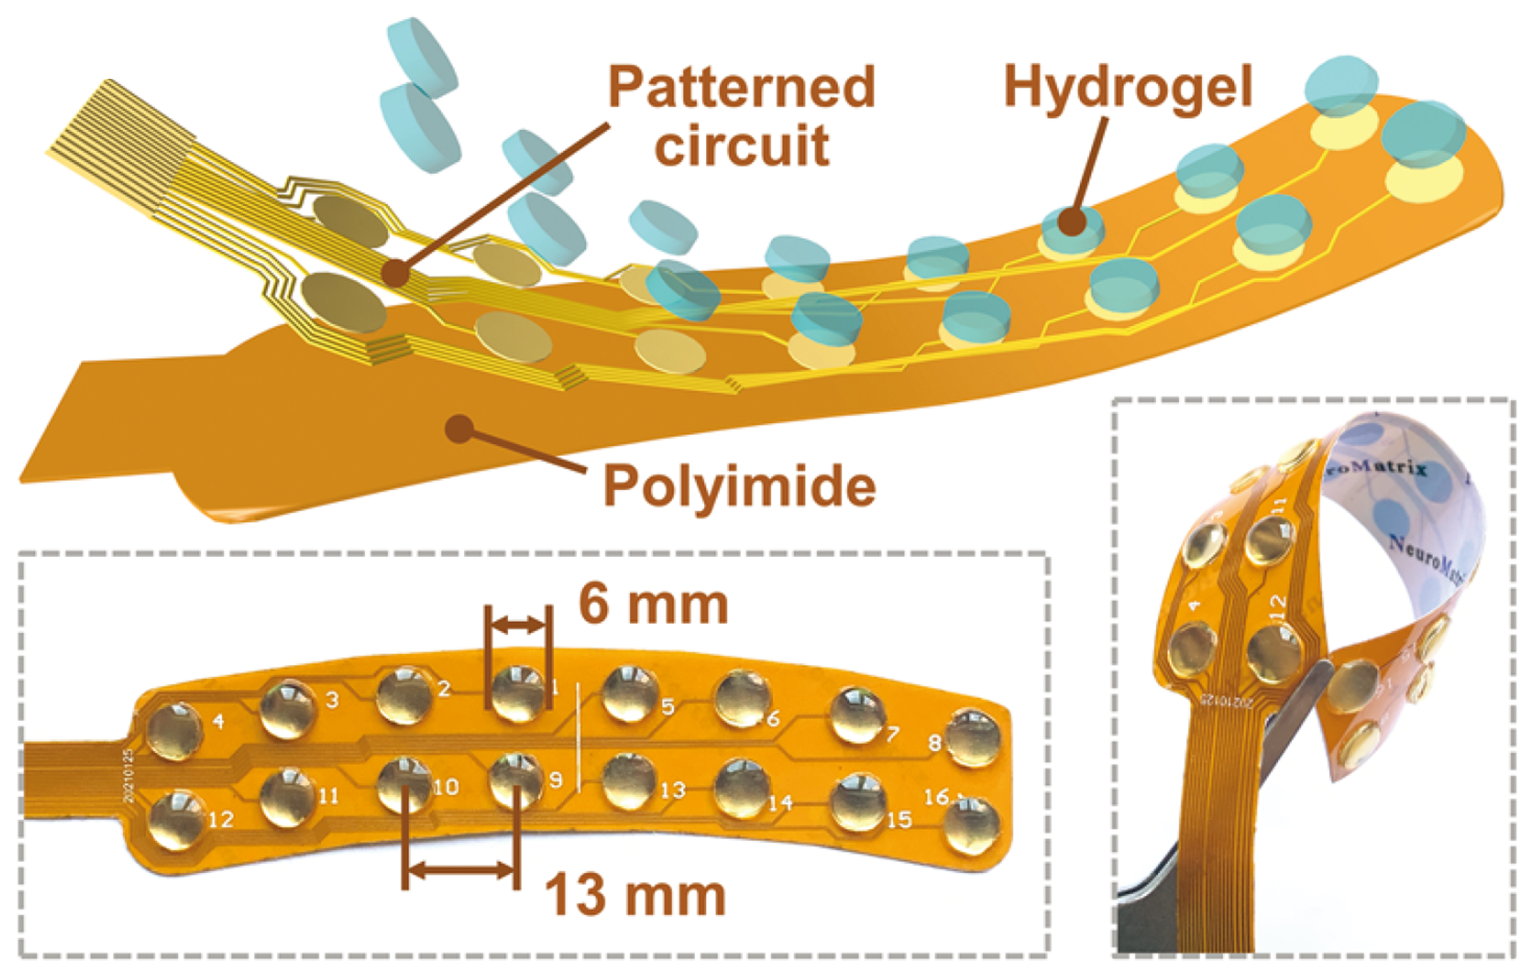 | No | Forehead patch | 4 | N.R. | N.R. | N.R. | Yes | Bluetooth | Patterned  circuit | Wet electrode | δ, θ, α, β  (N.R.) | Yes | N.R.
Research articles | Ryan Kaveh et al., 2024⁽⁸⁾ | 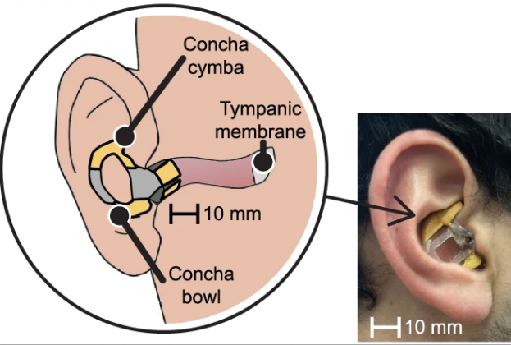 | No | Earpiece | 11 | Battery | 46.0 mW | ~44 h | No | BLE | N.R. | Flexible dry electrode | δ, θ, α, β, γ  (~50 min) | No | N.R.
Research articles | Heeyong Huh et al., 2025⁽⁹⁾ | 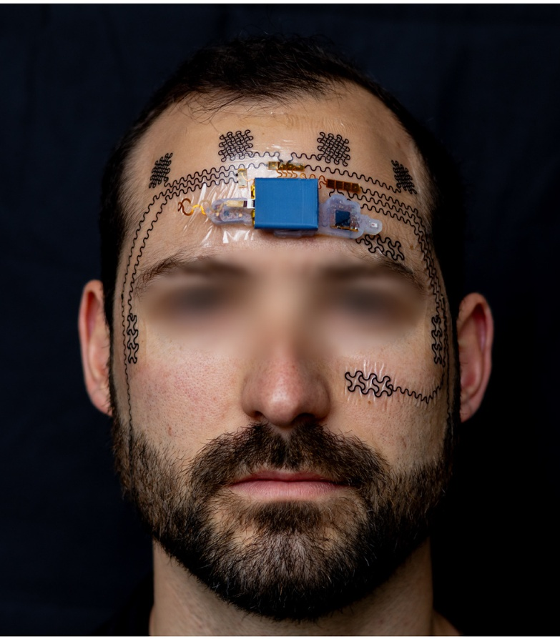  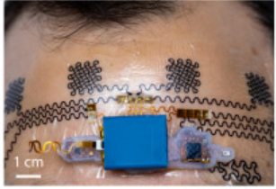  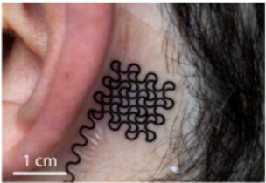  0 | No | Forehead e-tattoo | 4 | Battery | N.R. | 28.5 h | Yes | BLE | Serpentine connector | Flexible dry electrode | δ, θ, α, β, γ  (2.5 h) | No | N.R.
Research articles | Hodam Kin et al., 2025⁽¹⁰⁾ | 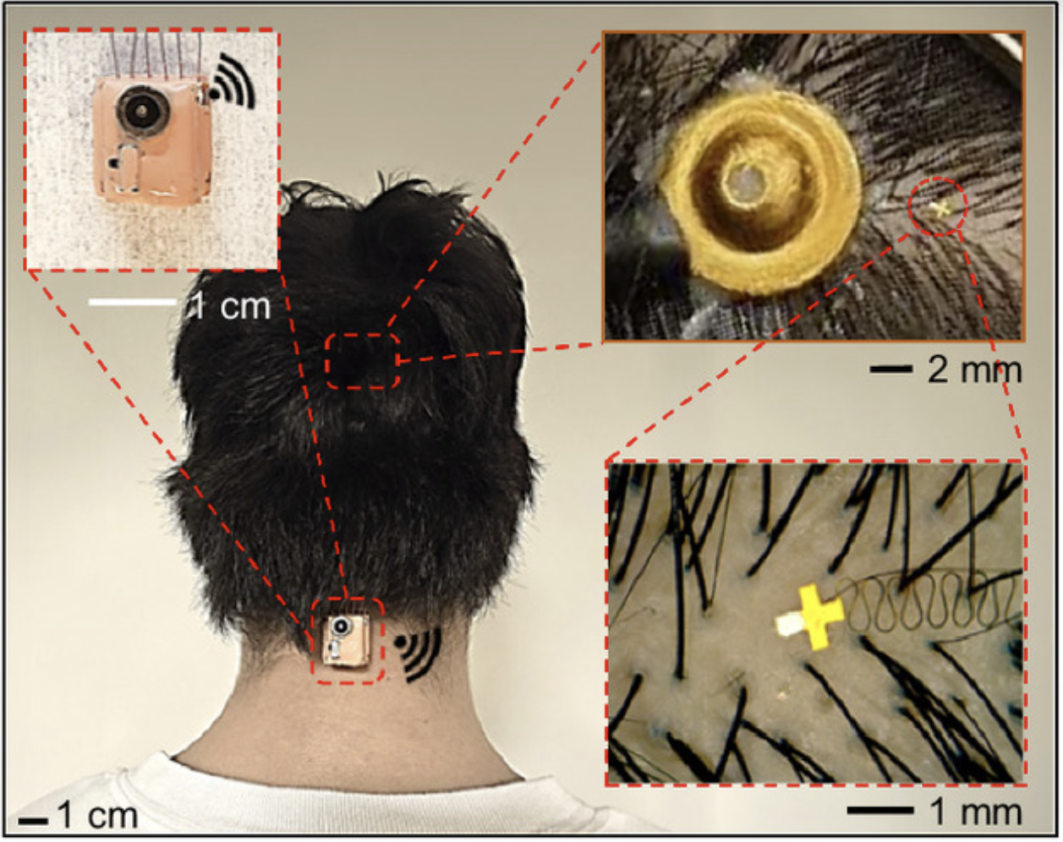  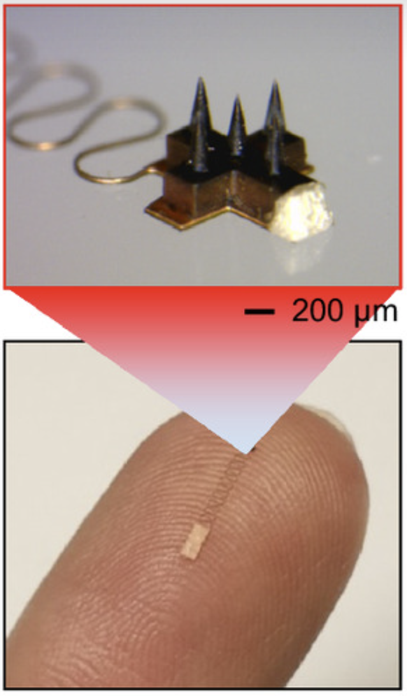 | No | On-neck | 3 | Battery | N.R. | 11.3 h | No | BLE | Serpentine connector | Invasive dry electrode | α  (N.R.) | Yes | 21.2 dB at 3.0 km h⁻¹  17.1 dB at 6.0 km h⁻¹  (8−13 Hz)
This work |  | 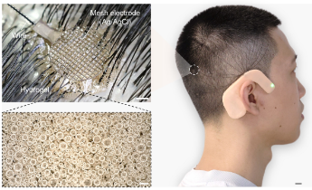 | Yes | Earhook | 16 | Battery/  wireless charger | 26.4 mW | Unlimited | Yes | BLE | Flexible thin wire | Macroporous hydrogel + breathable Ag/AgCl mesh | δ, θ, α, β  (8 days) | Yes | 18.7 dB at 2.0 km h⁻¹  5.1 dB at 5.0 km h⁻¹  2.9 dB at 6.5 km h⁻¹  (1.5−30 Hz)

Supplementary Table 2 | Comparison of the scalp EEG electrodes from a continuous, long-term operation perspective. Advantages and disadvantages of traditional dry, semi-dry, and wet electrodes with respect to contact impedance, signal quality, stability, comfort, and ease of use.
EEG electrode types | Advantages | Disadvantages
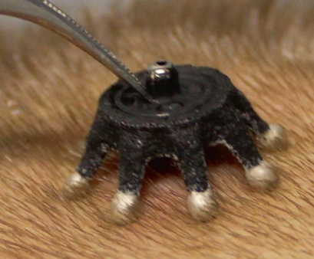  Dry electrode⁽²⁾ | Ease of use; user comfort; rapid setup; suitability for home testing. | High contact impedance; interface instability; low signal quality; requirement for external fixation.
Semi-dry electrode⁽¹¹⁾  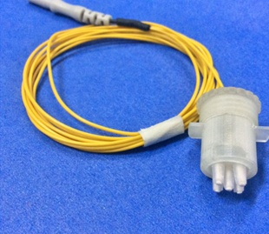 | Low contact impedance; high signal quality. | Time consumption; process complexity; frequent refilling; user discomfort; risk of scalp irritation or damage; requirement for external fixation.
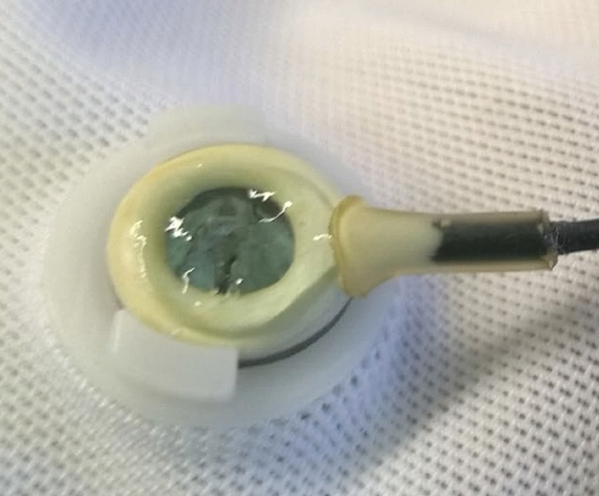  Wet electrode⁽¹²⁾  Gel  Cap | Low contact impedance; inherent adhesion (no external fixation required); interface stability; high signal quality. | Time consumption; process complexity; dehydration tendency; user discomfort; risk of scalp irritation, inflammation, or damage.

Supplementary Table 3 | Comparison of representative reported hydrogel electrode materials for EEG monitoring. Summary of key electrode properties, including breathability, interfacial toughness, contact impedance, friction resistance, stretchability, hair compatibility, anti-drying property, and continuous monitoring duration. Here, hair compatibility denotes the capability to penetrate hairs and reach the scalp.
Materials | Breath-ability | Interfacial toughness | Contact impedance | Friction resis-tance | Stretch-ability | Hair compati-bility | Anti-drying property | Continuous monitoring duration | Ref.
PEDOT:PSS/PAMPS/  LiCl/nonionic surfactant/glycerol | N.R. | N.R. | < 30 kΩ  (on hair-bearing scalp at 31 Hz) | N.R. | N.R. | No | 80% weight retention after 21 days | N.R. | Ju-Chun Hsieh et al., 2022⁽¹³⁾
PDMA/PAAM/  NaCl/glycerol | N.R. | 22.0 N cm–1  (on porcine skin) | N.R. | N.R. | ~1,250% strain | No | ~35% weight retention after 60 days | N.R. | Lanlan Liu et al., 2022⁽¹⁴⁾
PAAM/PSBMA/TA/  glycerol/Laponite/  Stearyl methacrylate/  CaCl₂/AlCl₃ | N.R. | 59.7 N m–1  (on porcine skin) | ~100 kΩ  (on skin at 20 Hz) | N.R. | 690% strain | No | 88% weight retention after 24 h | N.R. | Ganguang Yang et al., 2022⁽¹⁵⁾
PVA/branched PEI/CaCl₂ | N.R. | 49.0 J m^{–2}  (on skin) | N.R. | N.R. | 1,291% strain | No | N.R. | N.R. | Ying Liu et al., 2022⁽¹⁶⁾
Gelatin/glycerol/  sodium citrate/NaCl | N.R. | 0.8 N cm–1  (on skin) | ~7 kΩ  (on hair-bearing scalp at 10 Hz) | N.R. | ~500% strain | Yes | ~70% weight retention after 96 h | N.R. | Chunya Wang et al., 2022⁽¹⁷⁾
PVA/PEG/NaCl | N.R. | ~45 kPa  (on porcine skin) | N.R. | N.R. | ~300% strain | No | 91% weight retention after 48 h | N.R. | Guoqiang Ren et al., 2024⁽¹⁸⁾
Hyaluronic acid/  graphite nanoparticles/  glycerol/KCl/NaCl | N.R. | ~0.1 N cm–2  (on PI film) | ~1 kΩ  (on skin at 1k Hz) | N.R. | N.R. | No | ~18% water retention after 72 h | N.R. | Hengjie Su et al., 2024⁽¹⁹⁾
PAAM/NaCl/ethylene glycol/TA/Ag nanoparticles | N.R. | > 20 kPa  (on skin) | N.R. | N.R. | N.R. | No | N.R. | N.R. | Jiabei Luo et al., 2024⁽²⁰⁾
PNAGA/HACC/  KCl/glycerol | N.R. | N.R. | ~16 kΩ  (on hair-bearing scalp) | N.R. | N.R. | No | 75% after 6 weeks | N.R. | Dongyang Wang et al., 2025⁽²¹⁾
PAAM/PVP/  gelatin/EGaIn | N.R. | 104.7 kPa  (on porcine skin) | 71 Ω  (on skin at 100 Hz) | N.R. | 1,643% strain | No | N.R. | N.R. | Kai Zheng et al., 2025⁽²²⁾
Gelatin/glycerol/  vanillin/LiCl | 1252  g m–2 day–1 | 384.1 μJ cm–2  (on skin) | < 55 kΩ  (on skin at 100 Hz) | N.R. | 238% strain | No | 98% weight retention after 12 days | 15 min | Yuli Wang et al., 2025⁽²³⁾
Gelatin/TA/  DA·HCl/glycerol | 2,522  g m–2 day–1 | 1,485.1 J m–2  (on skin) | 10 kΩ cm2  (on hair-bearing scalp at 0.1 Hz) | 50 g, 1,000 cycles | 1,250% strain | Yes | 94% weight retention after 31 days | 8 days | This work
Abbreviations: PEDOT:PSS, poly(3,4-ethylenedioxythiophene):poly(styrenesulfonate); PAMPS, poly(2-acrylamido-2-methyl-1-propanesulfonic acid); PDMA, poly(dopamine methacrylamide); PAAm, poly(acrylamide); PSBMA, poly[2-(methacryloyloxy)ethyl]dimethyl-(3-sulfopropyl)ammonium hydroxide; PVA, poly(vinyl alcohol); PEI, poly(ethyleneimine); PEG, poly(ethylene glycol); PNAGA, poly(N-acryloyl glycinamide); HACC, hydroxypropyltrimethyl ammonium chloride chitosan; PVP, poly(vinyl pyrrolidone).

Supplementary Table 4 | Detailed formulations of macroporous hydrogel samples with varying component compositions.
Sample ID | Gelatin (g) | Glycerol (g) | Water (mL) | TA (g) | DA·HCl (g)
GW | 2 | – | 4 | – | –
GGWT | 2 | 3 | 4 | 0.3 | –
GGWD | 2 | 3 | 4 | – | 0.2
GGWT_{0.1}D | 2 | 3 | 4 | 0.1 | 0.2
GGWT_{0.3}D | 2 | 3 | 4 | 0.3 | 0.2
GGWT_{0.5}D | 2 | 3 | 4 | 0.5 | 0.2
GGWT_{1.0}D | 2 | 3 | 4 | 1.0 | 0.2
GGWTD_{0.1} | 2 | 3 | 4 | 0.3 | 0.1
GGWTD_{0.2} | 2 | 3 | 4 | 0.3 | 0.2
GGWTD_{0.4} | 2 | 3 | 4 | 0.3 | 0.4
G_{1.5}GWTD | 1.5 | 3 | 4 | 0.3 | 0.4
G_{2.0}GWTD | 2 | 3 | 4 | 0.3 | 0.4
G_{2.5}GWTD | 2.5 | 3 | 4 | 0.3 | 0.4
GG_{1.0}WTD | 2.5 | 1 | 4 | 0.3 | 0.4
GG_{3.0}WTD | 2.5 | 3 | 4 | 0.3 | 0.4
GG_{6.0}WTD | 2.5 | 6 | 4 | 0.3 | 0.4
GGW_{2.0}TD | 2.5 | 3 | 2 | 0.3 | 0.4
GGW_{4.0}TD | 2.5 | 3 | 4 | 0.3 | 0.4
GGW_{6.0}TD | 2.5 | 3 | 6 | 0.3 | 0.4
GGW_{8.0}TD | 2.5 | 3 | 8 | 0.3 | 0.4

Supplementary Table 5 | Likert-scale items developed for self-reported attentional engagement.
Item | Statement | Scale | Scoring rule
1 | I was able to maintain sustained focus during the activity. | 1 = strongly disagree; 5 = strongly agree | Direct scored
2 | I experienced difficulty maintaining my attention during the activity. | 1 = strongly disagree; 5 = strongly agree | Reverse scored
3 | My mind wandered away from the activity. | 1 = strongly disagree; 5 = strongly agree | Reverse scored
4 | My thinking was clear and well-organized during the activity. | 1 = strongly disagree; 5 = strongly agree | Direct scored
5 | I felt fully engaged and immersed in the activity. | 1 = strongly disagree; 5 = strongly agree | Direct scored
Note: Self-reported attentional engagement was assessed immediately after each experimental condition using a five-item questionnaire rated on a 5-point Likert scale 1 (strongly disagree) to 5 (strongly agree). The items probed sustained focus, attentional difficulty, mind wandering, cognitive clarity and subjective engagement. Items 2 and 3 were reverse-scored (reversed score = 6 − raw score). Item scores were then averaged to yield a composite attentional engagement score, with higher values indicating greater self-reported attentional engagement. For ease of interpretation, the composite score was linearly rescaled to a 0–100 range using the formula: converted score = (mean item score − 1) × 25.

Supplementary Video 1 | Robust adhesion at the hydrogel–electrode interface.

Supplementary Video 2 | Demonstration of hydrogel air permeability in water and soapy water.

Supplementary Video 3 | Comparison of sleep monitoring using the wireless system and PSG.

Supplementary Video 4 | Real-time wireless EEG monitoring and attention level assessment during a driving simulation.

Supplementary Video 5 | Real-time wireless EEG monitoring and attention level assessment during daily activities.

Supplementary Video 6 | Sleep monitoring with simultaneous wireless battery charging.

References
1 Lin, C.-T. et al. Wireless and wearable EEG system for evaluating driver vigilance. IEEE Trans. Biomed. Circuits Syst. 8, 165–176 (2014).
2 Mahmood, M. et al. Fully portable and wireless universal brain–machine interfaces enabled by flexible scalp electronics and deep learning algorithm. Nat. Mach. Intell. 1, 412–422 (2019).
3 Mahmood, M. et al. Wireless soft scalp electronics and virtual reality system for motor imagery‐based brain–machine interfaces. Adv. Sci. 8, 2101129 (2021).
4 Shin, J. H. et al. Wearable EEG electronics for a brain–AI closed-loop system to enhance autonomous machine decision-making. npj Flex. Electron. 6, 32 (2022).
5 Kwon, S. et al. At-home wireless sleep monitoring patches for the clinical assessment of sleep quality and sleep apnea. Sci. Adv. 9, eadg9671 (2023).
6 Xu, Y. et al. In-ear integrated sensor array for the continuous monitoring of brain activity and of lactate in sweat. Nat. Biomed. Eng. 7, 1307–1320 (2023).
7 Han, Q. et al. Hydrogel nanoarchitectonics of a flexible and self‐adhesive electrode for long‐term wireless electroencephalogram recording and high‐accuracy sustained attention evaluation. Adv. Mater. 35, 2209606 (2023).
8 Kaveh, R. et al. Wireless ear EEG to monitor drowsiness. Nat. Commun. 15, 6520 (2024).
9 Huh, H. et al. A wireless forehead e-tattoo for mental workload estimation. Device 3, 100781 (2025).
10 Kim, H. et al. Motion artifact–controlled micro–brain sensors between hair follicles for persistent augmented reality brain–computer interfaces. Proc. Natl. Acad. Sci. U.S.A. 122, e2419304122 (2025).
11 Wang, F. et al. Novel semi-dry electrodes for brain–computer interface applications. J. Neural Eng. 13, 046021 (2016).
12 Casson, A. J. Wearable EEG and beyond. Biomed. Eng. Lett. 9, 53–71 (2019).
13 Hsieh, J.-C. et al. A highly stable electrode with low electrode-skin impedance for wearable brain-computer interface. Biosens. Bioelectron. 218, 114756 (2022).
14 Liu, L. et al. Stable and low-resistance polydopamine methacrylamide-polyacrylamide hydrogel for brain-computer interface. Sci. China Mater. 65, 2298–2308 (2022).
15 Yang, G. et al. Adhesive and hydrophobic bilayer hydrogel enabled on‐skin biosensors for high‐fidelity classification of human emotion. Adv. Funct. Mater. 32, 2200457 (2022).
16 Liu, Y. et al. Body temperature enhanced adhesive, antibacterial, and recyclable ionic hydrogel for epidermal electrophysiological monitoring. Adv. Healthcare Mater. 11, 2200653 (2022).
17 Wang, C. et al. On-skin paintable biogel for long-term high-fidelity electroencephalogram recording. Sci. Adv. 8, eabo1396 (2022).
18 Ren, G. et al. MRI and CT compatible asymmetric bilayer hydrogel electrodes for EEG-based brain activity monitoring. Microsyst. Nanoeng. 10, 156 (2024).
19 Su, H. et al. A complementary dual‐mode ion‐electron conductive hydrogel enables sustained conductivity for prolonged electroencephalogram recording. Adv. Sci. 11, 2405273 (2024).
20 Luo, J. et al. A selective frequency damping and Janus adhesive hydrogel as bioelectronic interfaces for clinical trials. Nat. Commun. 15, 8478 (2024).
21 Wang, D. et al. A tough semi-dry hydrogel electrode with anti-bacterial properties for long-term repeatable non-invasive EEG acquisition. Microsyst. Nanoeng. 11, 105 (2025).
22 Zheng, K. et al. Machine learning enabled reusable adhesion, entangled network-based hydrogel for long-term, high-fidelity EEG recording and attention assessment. Nano-Micro Lett. 17, 281 (2025).
23 Wang, Y. et al. A 2.7-μm-thick robust, permeable, and antifreezing hydrogel electrode for long-term ambulatory health monitoring. Sci. Adv. 11, eadt2286 (2025).

