SUPPLEMENTARY MATERIAL
A Prototype Digital Twin of Milos Island's Road Network: Peak-Season Traffic Simulation, Validation, and Intervention Evaluation

This document contains the supplementary appendices submitted alongside the main manuscript. It includes data tables, approval records, the POI list, observation window schedule, and Smart Count Dashboard overview that support the methods and results. All simulation scripts are deposited in the project research repository (Supplementary Code Repository, SCR) and are not reproduced here.

Contents and Citation Update Guide
Use the table below to update all in-text appendix references in the manuscript before submission.

Appendix | Title
A | Data Permission Letters
B | POI List (full, 61 entries)
C | Ferry & Rental Demand Aggregates
D | Resident Demand Hourly Profile
E | Observation Window Randomisation
F | Smart Count Dashboard
SCR | Simulation Code Repository Note

Appendix A. Data Permission Letters
Written approval was obtained from all organisations that provided primary data. The table below summarises each source. Scanned copies of all signed permission letters and email approvals are retained by the corresponding author and are available to editors and reviewers on request. Company names are anonymised per data-sharing agreements.

Organisation | Data Provided | Figures
Hellenic Coast Guard – Port Authority of Milos | Ferry arrival/departure schedules; vessel class data | A12, A13
Car Rental Company (Small) | Daily pickup and return volumes by hour, vehicle class | A1, A2
Car Rental Company (Medium) | Daily pickup and return volumes by hour | A3, A4
Car Rental Company (Large) | Daily pickup and return volumes by hour | A5, A6

Figure A12. Email sent to Hellenic Coast Guard Authority – Milos.


Figure A13. Approval from Hellenic Coast Guard – Milos.
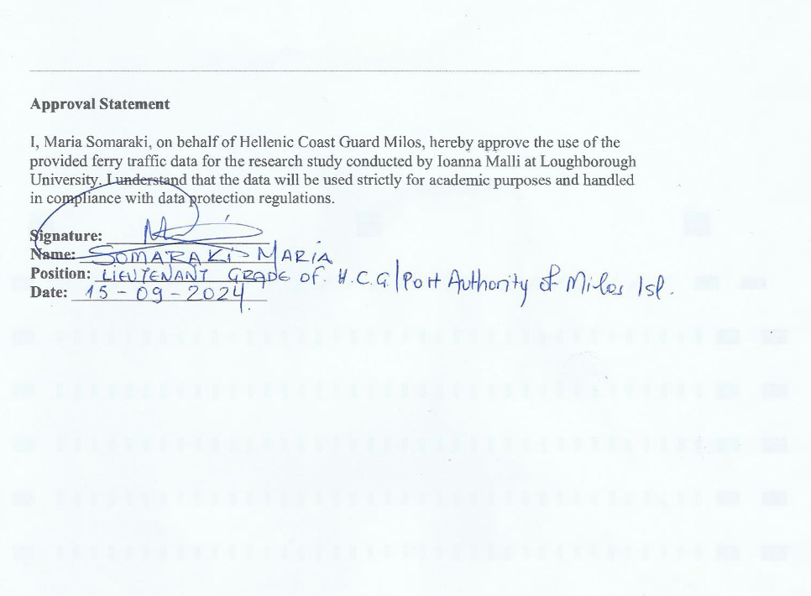

Figure A1. Email sent to small rental company.


Figure A2. Approval from small rental company.
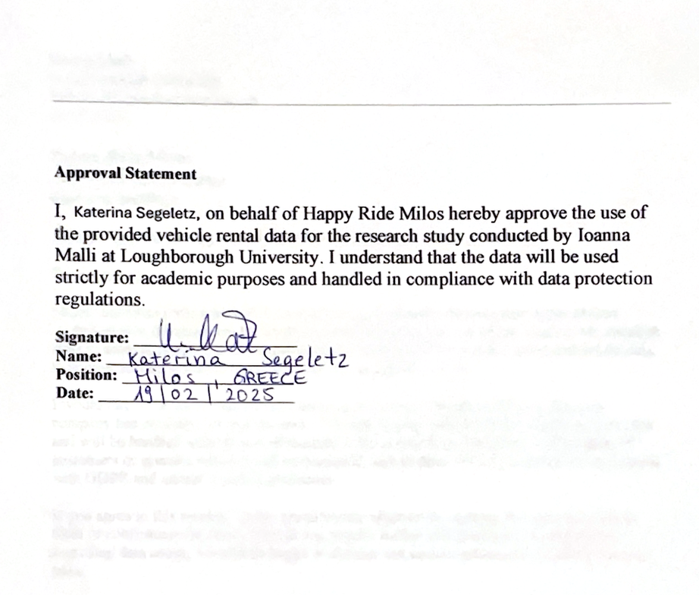

Figure A3. Email sent to medium rental company.


Figure A4. Approval from medium rental company.
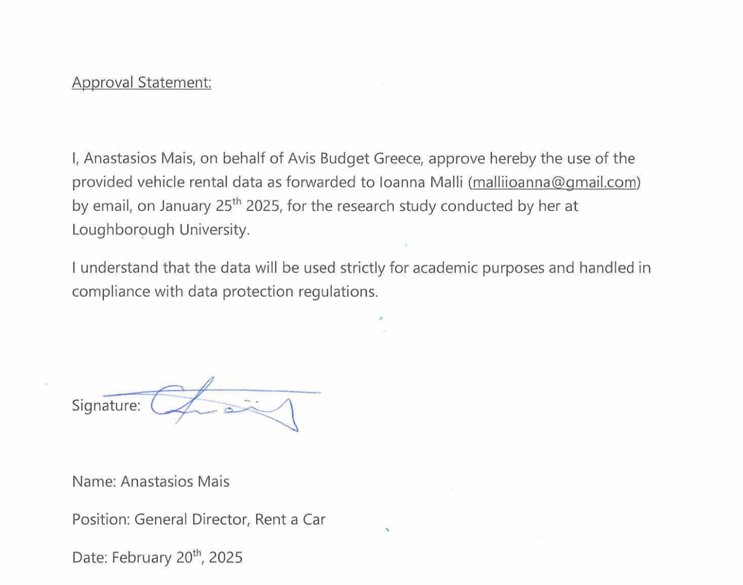

Figure A5. Email sent to large rental company.


Figure A6. Approval from large rental company.


Appendix B. Points of Interest (POI) List

The following table reproduces the full 61-entry POI checklist used for OD pair generation. Each POI is mapped to one or more valid SUMO network edges and assigned a priority score reflecting tourist popularity and road accessibility (see Section 3.3.4 of the main manuscript). Priority weights: Very Very High = 8, Very High = 6, High = 4, Medium = 3, Mid = 3, Lower = 2, Low = 1.

Supplementary Table B1. Full POI list used for OD pair generation
Type | Name | Priority | Primary Edge(s)
Beach | Sarakiniko | Very Very High | -305271338#1, 305271338#1, -305271338#0, 305271338#0
Beach | Firiplaka | Very High | -351931808#7, 351931808#7
Beach | Achivadolimni | Very High | -173167461#6, 173167461#6
Beach | Provatas | Very High | -237033959#7, 237033959#7
Beach | Tsigrado | Very High | -173077164#1, 173077164#1
Beach | Paleochori | Very High | 173067570#25, -236418096, 236418096
Beach | Papafragas | Very High | -199267209#25, 199267209#25, -199267209#26, 199267209#26
Beach | Chamos | Very High | 237033993#2, -237033993#2
Beach | Agia Kiriaki | Mid | -236017454, 236017000
Beach | Pollonia Beach | Mid | -239441243#13, 239441243#13
Beach | Lagada | Mid | -E7, E7
Beach | Plathiena | Very High | -172684982#2, 172684982#2
Beach | Apollonia Back Beach | Lower | -512965039, 512965000
Restaurant | Mandrakia | Very High | -305530021#11, 305530021#11, -305530021#9, 305530021#9
Restaurant | Apollonia Car Park 1 | Very High | -199267209#35, 199267209#35, -199267209#34, 199267209#34
Restaurant | Apollonia Car Park 2 | Very High | -239441243#11, 239441243#11, -239252521#2, 239252521#2
Restaurant | Adamas Car Park 1 | Very High | -E2, E2
Restaurant | Adamas Car Park 2 | Very High | -346395285#0, 346395285#0
Restaurant | Adamas Car Park 3 | Very High | -144327411#5, 144327411#5
Restaurant | Klima Village | Very High | -293626954#0, 293626954#0
Restaurant | Plaka Village Car Park | Very High | -235395003#8, 235395003#8
Restaurant | Tripiti Car Park | Mid | -1082735388, 1082735388, -235395003#1, 235395003#1
Restaurant | Chamos Car Park | Mid | -237033993#3, 237033993#3
General | Airport | Very Very High | -172637791#0, 172637791#0, -172637791#1, 172637791#1, -199267209#7, 199267209#7
Hotel | Domes White Coast Milos | High | -490215010#3, 490215010#3, -490215010#0, 490215010#0
Hotel | Santa Maria Village Resort & Spa | High | -344046549#1, 344046549#1, -344046545#1, 344046545#1
Hotel | Artemis Seaside Resort | High | -236418097#0, 236418097#0
Hotel | Alexandros Village | High | -305530056#6, 305530056#6, -305530056#7, 305530056#7
Hotel | Milos Hotel | High | -292921854#1, 292921854#1, -144327411#0, 144327411#0
Hotel | Milos Breeze Boutique Hotel | Medium | -476749283, 476749000
Hotel | Portiani Hotel Milos | Medium | -172431738#0, 172431738#0
Hotel | PELEKOUDA HOTELS | Very High | -239252514#1, 239252514#1, -788843476#2, 788843476#2
Hotel | Milos Cove | Medium | -512976544#0, 512976544#0
Hotel | En Milo Studios and Suites | Medium | -788843477, 788843000
Car Rental | Avance – Port | High | -E3, E3
Car Rental | Avance – Pollonia | High | -239441243#11, 239441243#11, -239252521#2, 239252521#2
Car Rental | Avance – Airport | High | -172951842#3, 172951842#3
Car Rental | Giourgas | Medium | -144327406#1, 144327406#1
Car Rental | Avis – Adamas | Medium | -355217081#7, 355217081#7
Car Rental | Avis – Airport | Medium | -172951842#2, 172951842#2
Car Rental | Unique | Medium | -355759312#1, 355759312#1
Car Rental | HappyRide | Small | -E5, E5
Car Rental | Melian | Small | -292921854#2, 292921854#2
Residential – Adamas | Adamas (Church) | High | 355759308#0, 172440272#2, -172440272#2, E9, -E9, E14, -E14
Residential – Adamas | Adamas (Environmental Museum) | High | -172809289#2, 172809289#2, -172809289#3, 172809289#3
Residential – Adamas | Adamas (Behind Ice Monkey) | High | -344071430#0, 344071430#0, 344071430#1, -344071430#1
Residential – Adamas | Adamas (Nikos House) | High | -296120522#2, 296120522#2, 296120522#1, 296120522#0
Residential – Adamas | Adamas (School) | High | -355815343, 355815343, -172363204#3, 172363204#3
Residential – Tripiti | Tripiti (Karodoromos) | High | -175349683#0, 175349683#0, -175349683#1, 175349683#1
Residential – Tripiti | Tripiti (Towards Klima) | High | -174398889#6, 174398889#6, -26256753#2, 26256753#2
Residential – Tripiti | Tripiti (Zois) | High | -175344569#4, 175344569#4, -175344569#5, 175344569#5
Residential – Tripiti | Tripiti (Car Park/Bakery) | High | -175347503#1, 175347503#1, -175347503#2, 175347503#2
Residential – Tripiti | Tripiti (Klimatovouni) | Mid | -353735531#3, 353735531#3
Residential – Tripiti | Tripiti (From Behind) | High | 27191736#11, 353735530#0
Residential – Plaka | Plaka (School) | High | -175349690#0, 175349690#0
Residential – Plaka | Plaka (Residential Behind) | Medium | -294366062#0, 294366062#0, -26256754#1, 26256754#1
Residential – Plaka | Plaka (EPAL) | High | 174394209#3
Residential – Apollonia | Apollonia (Agios Nikolais) | Very High | 239441243#8, -239441243#8, -788843484, 788843484
Residential – Apollonia | Apollonia (Granny's House) | Mid | -27191032, 27191030
Residential – Klima | Klima | High | 293626954#0, -293626954#0, -293626954#2, 293626954#2
Port | Adamas Port | Very High | E4, 353548005

Appendix C. Ferry and Rental Demand Aggregates
The three tables below reproduce the hourly fixed-demand counts used to generate ferry and rental-car trips in the simulation. Ferry data were obtained from the Hellenic Coast Guard. Rental data were obtained from three operating companies (anonymised as small, medium, and large). All values represent peak-season weekday averages.

Supplementary Table C1 (Part a). Hourly ferry and rental counts — Avance company
Hour | Ferry IN | Ferry OUT | Avance Port IN | Avance Port OUT | Avance Pollonia IN | Avance Pollonia OUT | Avance Airport IN | Avance Airport OUT
11am–12pm | 56 | 29 | 5 | 6 | 1 | 1 | 0 | 0
12pm–1pm | 17 | 11 | 1 | 7 | 0 | 1 | 2 | 0
1pm–2pm | 53 | 25 | 1 | 2 | 0 | 1 | 1 | 3
2pm–3pm | 29 | 20 | 2 | 3 | 0 | 0 | 1 | 3
3pm–4pm | 13 | 11 | 3 | 1 | 0 | 0 | 1 | 2
4pm–5pm | 6 | 26 | 3 | 5 | 0 | 0 | 0 | 1
5pm–6pm | 6 | 17 | 2 | 3 | 0 | 0 | 1 | 1
6pm–7pm | 14 | 8 | 1 | 3 | 1 | 0 | 1 | 0
7pm–8pm | 13 | 20 | 1 | 2 | 1 | 0 | 1 | 1

Supplementary Table C2 (Part b). Hourly counts — Giourgas, Unique, and Avis companies
Hour | Giourgas IN | Giourgas OUT | Giourgas Airport IN | Giourgas Airport OUT | Unique IN | Unique OUT | Unique Airport IN | Unique Airport OUT | Avis Adamas IN | Avis Adamas OUT | Avis Airport IN | Avis Airport OUT
11am–12pm | 5 | 7 | 2 | 1 | 1 | 2 | 1 | 2 | 1 | 1 | 1 | 1
12pm–1pm | 2 | 8 | 3 | 1 | 1 | 4 | 2 | 1 | 1 | 3 | 1 | 1
1pm–2pm | 0 | 4 | 0 | 3 | 0 | 1 | 0 | 3 | 0 | 0 | 0 | 2
2pm–3pm | 2 | 4 | 0 | 4 | 1 | 0 | 1 | 0 | 0 | 0 | 1 | 1
3pm–4pm | 6 | 2 | 2 | 2 | 0 | 0 | 1 | 0 | 0 | 0 | 1 | 1
4pm–5pm | 1 | 6 | 0 | 1 | 0 | 0 | 1 | 0 | 0 | 0 | 1 | 1
5pm–6pm | 3 | 1 | 1 | 0 | 0 | 0 | 0 | 1 | 0 | 1 | 1 | 1
6pm–7pm | 1 | 4 | 0 | 0 | 0 | 0 | 0 | 1 | 0 | 1 | 0 | 1
7pm–8pm | 1 | 3 | 0 | 0 | 0 | 1 | 0 | 0 | 0 | 1 | 0 | 1

Supplementary Table C3 (Part c). Hourly counts — HappyRide, Melian companies, and background trips
Hour | HappyRide IN | HappyRide OUT | HappyRide Port IN | HappyRide Port OUT | Melian IN | Melian OUT | Melian Port IN | Melian Port OUT | Melian Airport IN | Melian Airport OUT | Background Trips
11am–12pm | 1 | 1 | 1 | 1 | 1 | 2 | 2 | 1 | 0 | 0 | 533
12pm–1pm | 0 | 1 | 0 | 1 | 0 | 1 | 1 | 1 | 0 | 1 | 1037
1pm–2pm | 0 | 0 | 0 | 0 | 0 | 0 | 1 | 0 | 0 | 0 | 895
2pm–3pm | 0 | 0 | 0 | 0 | 0 | 0 | 0 | 0 | 0 | 0 | 762
3pm–4pm | 0 | 0 | 0 | 0 | 0 | 0 | 0 | 0 | 0 | 0 | 710
4pm–5pm | 0 | 0 | 0 | 0 | 0 | 0 | 0 | 0 | 0 | 0 | 576
5pm–6pm | 0 | 0 | 0 | 0 | 0 | 0 | 0 | 0 | 0 | 0 | 929
6pm–7pm | 0 | 0 | 0 | 0 | 0 | 0 | 0 | 0 | 0 | 0 | 600
7pm–8pm | 0 | 0 | 0 | 0 | 0 | 0 | 0 | 0 | 0 | 0 | 900

Background Trips = combined resident and additional rental background trips per hour. Source: Hellenic Coast Guard (ferry); car rental companies (rental). Company names anonymised.

Appendix D. Resident Demand Hourly Profile
Resident background trip demand was distributed across the simulation window (11:00–20:00) using the hourly proportions below. Proportions were derived from observed behaviour patterns and local knowledge of Milos activity rhythms during peak summer season. Total daily resident trip budget was estimated from approximately 2,000 registered vehicles, each making three trips per day.

Supplementary Table D1. Background traffic distribution — local vehicles and additional rental cars
Hour Range | % of Daily Trips | Trips from Local Cars | Trips from Rental Cars | Total Background Traffic
11am–12pm | 4 | 256 | 277 | 533
12pm–1pm | 3 | 192 | 845 | 1037
1pm–2pm | 3 | 192 | 703 | 895
2pm–3pm | 7 | 448 | 314 | 762
3pm–4pm | 7 | 448 | 262 | 710
4pm–5pm | 6 | 384 | 192 | 576
5pm–6pm | 5 | 320 | 609 | 929
6pm–7pm | 4 | 256 | 344 | 600
7pm–8pm | 3.5 | 224 | 676 | 900

Appendix E. Observation Window Randomisation
Manual 30-minute traffic counts were conducted at 16 locations across Milos Island. To minimise temporal bias, the observation window at each location was assigned using a random-number generator (seed 42). The table reproduces the full randomisation schedule, including GPS coordinates, SUMO edge IDs, and calibration (C) or validation (V) designation.

Supplementary Table E1. Randomly assigned observation windows at all 16 count locations
Location | Lat, Lon | Edge ID(s) | Assigned Slot | Dir. | Role
Pollonia (Deck) | 36.763442, 24.525976 | 199267209#35 / -199267209#35 | 16:00–16:30 | E+W | V
Adamas (Gregory's) | 36.725381, 24.446815 | 292921860#4 / -292921860#4 | 17:30–18:00 | E+W | V
Chamos (Beach Side) | 36.721980, 24.458470 | 237033993#2 / -237033993#2 | 13:00–13:30 | E+W | V
Moto Xristos (Opp.) | 36.739400, 24.435161 | 305530056#17 / -305530056#17 | 14:30–15:00 | E+W | C
Milors | 36.724348, 24.445603 | E3 / -E3 | 12:30–13:00 | E+W | C
Aragosta Coffee | 36.727365, 24.447093 | 355217081#7 / -355217081#7 | 15:00–15:30 | E+W | C
Bakery Karodoromos | 36.741164, 24.432748 | 175349683#2 / -175349683#2 | 13:30–14:00 | E+W | C
LIKEIO (Opp.) | 36.743595, 24.426088 | 235395002#8 / -235395002#8 | 18:30–19:00 | E+W | V
Mouratos | 36.736361, 24.442998 | 1096129848#0 / 1096129848#1 | 13:30–14:00 | E+W | V
Klima Sign | 36.735717, 24.428794 | 293626954#4 / -293626954#4 | 18:30–19:00 | E+W | C
Zefiria School | 36.701040, 24.487313 | 26248436#11 / -26248436#11 | 13:00–13:30 | E+W | V
Provatas Sign | 36.684781, 24.449235 | 1083006692#0 / -1083006692#0 | 14:00–14:30 | E+W | V
Achivadolimni (Opp.) | 36.685638, 24.447947 | 173167461#3 / -173167461#3 | 14:00–14:30 | E+W | V
EKO (Opp.) | 36.732808, 24.470314 | 343584572#32 / -343584572#32 | 17:00–17:30 | E+W | V
Moraitis (Alkioni) | 36.733887, 24.469437 | 305283015#12 / -305283015#12 | 17:00–17:30 | E+W | C
Pachaina (Charalabakis) | 36.749721, 24.497178 | 199267209#20 / -199267209#20 | 17:30–18:00 | E+W | V

C = calibration site (n = 6); V = validation site (n = 10). Random seed: 42. Each window = 30 minutes. E+W = both inbound and outbound flows recorded.

Appendix F. Smart Count Dashboard
A web-based Smart Count Dashboard was developed to present calibration and validation data to non-technical stakeholders. The dashboard is a static HTML interface requiring no server. Key features include:
• Interactive map of all 32 directional count locations, colour-coded by role (calibration = blue; validation = orange).
• Pop-up panels showing observed counts, SUMO edge IDs, direction, and time window for each location.
• Embedded street-level imagery (Google Street View or researcher-captured photographs where coverage is unavailable).
• CSV export of raw count data at each location.
• Bidirectional count display with separate inbound and outbound flow records.

The dashboard HTML file is included in the research repository. Figures F1–F3 below illustrate the main interface views.

Figure F1. Full overview of all count locations on Milos Island.

Figure F2. Pop-up view for the “Milors” location, showing bidirectional count data, Google Maps integration, and edge ID metadata.

Figure F3. Example interface at Zefiria School count location, showing bidirectional count data, street video integration, and edge ID metadata.

