SUPLEMENTARY FIGURES

Supplementary figure 1: Raw unique ORFs called by the Ribo-seq pipeline for each experiment (108 experiments from 78 independent studies). The biotype of the ORFs is that of RiboTIE⁴⁰.
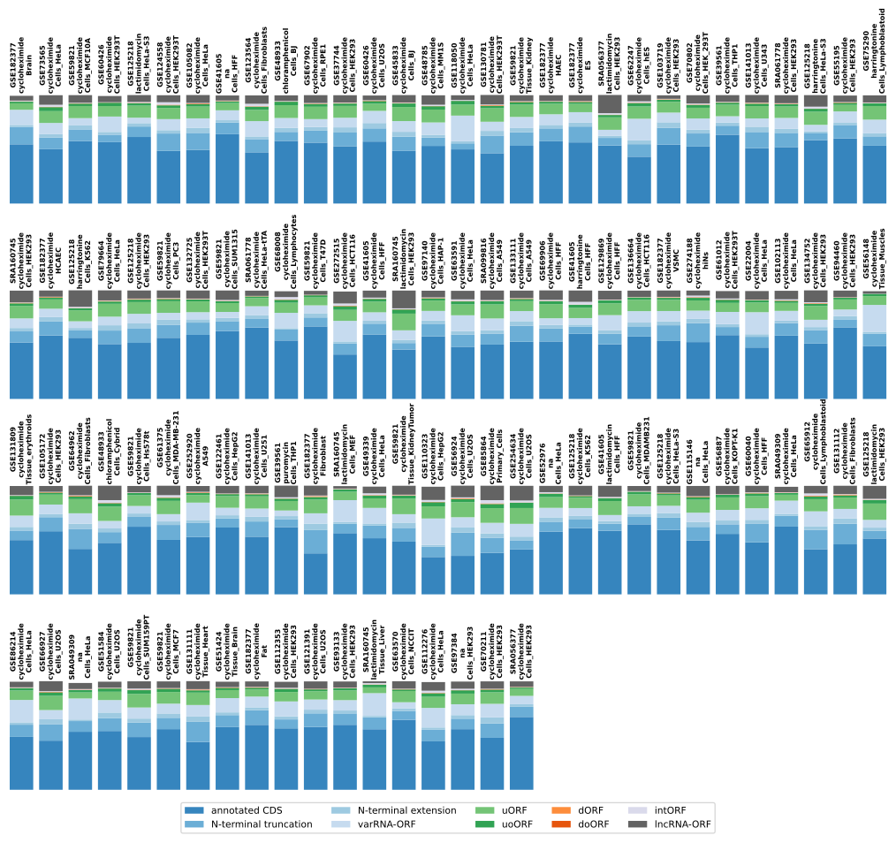

Supplementary figure 2: Distribution of Ribo-seq ORFs and TIS. (A, B) The number and fraction of unique calls for annotated CDSs, CDS isoforms, and ncORFs (A) or annotated CDSs and CDS isoforms (i.e., N-terminal extensions and truncations) (B) obtained in this study or RiboTIE are displayed in a stacked bar plot. (C) Bar plot displaying the number and fraction of different types of ncORFs called in this study by RiboTIE or TransCODE v35. (D) Bar plot displaying the number and fraction of different types of TISs identified in this study by RiboTIE or TransCODE v35.
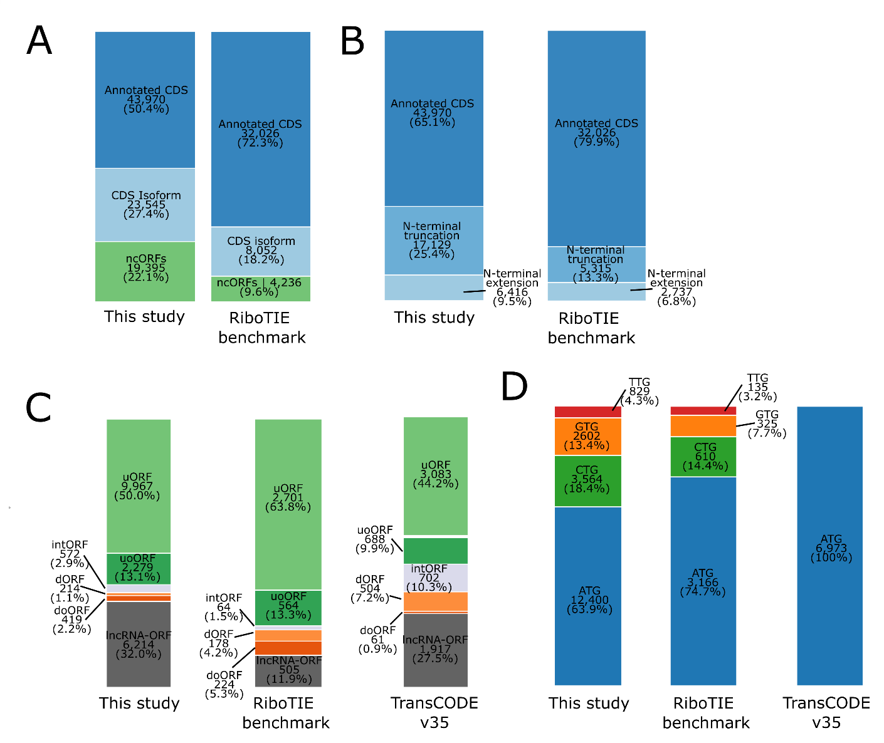

Supplementary figure 3: Mirror plots of PSMs that returned with a better MaxQuant score after searching the Swiss-Prot/MicroProt database. Top MS2: Search with Swiss-Prot. Bottom MS2: search with Swiss-Prot/MicroProt.

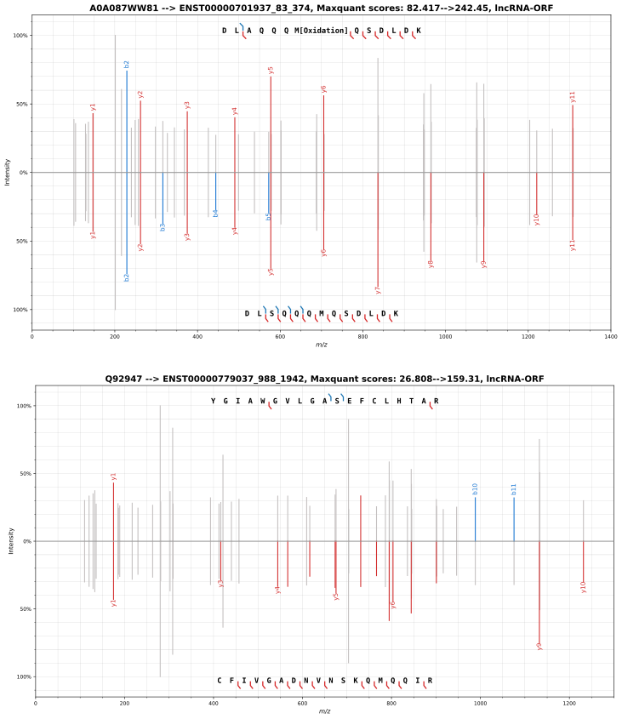

Supplementary figure 4: Examples of PSMs for peptides matching microproteins encoded by different classes of ncORFs, as indicated. Two PSMs are shown for each class. The MaxQuant leading protein associated with the PSMs, and its gene are shown followed by the USI and the MaxQuant score
dORF
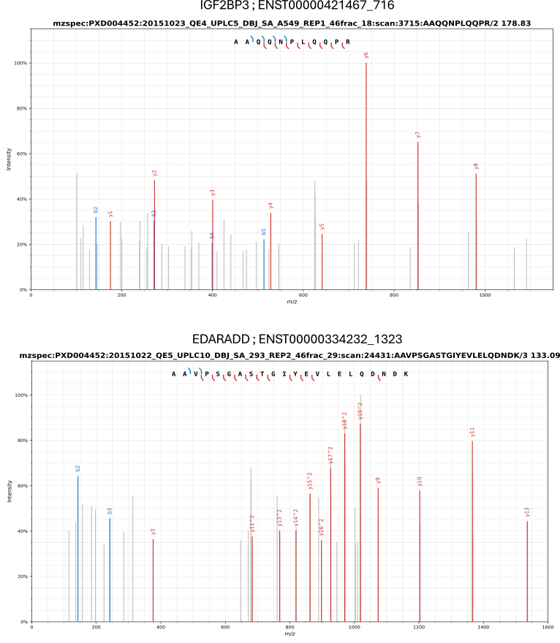
LncRNA-ORF
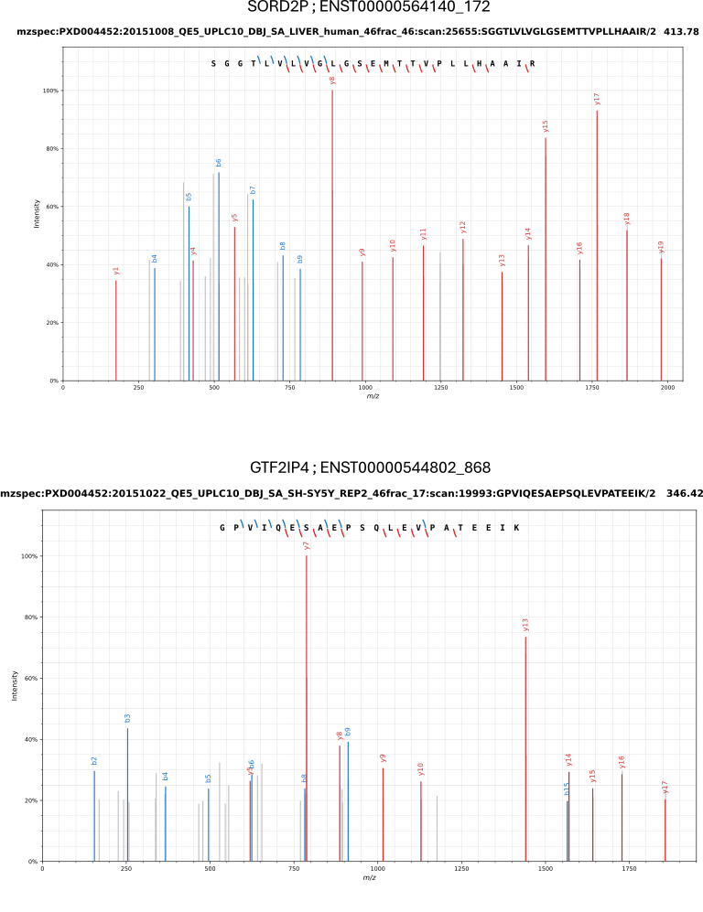

doORF
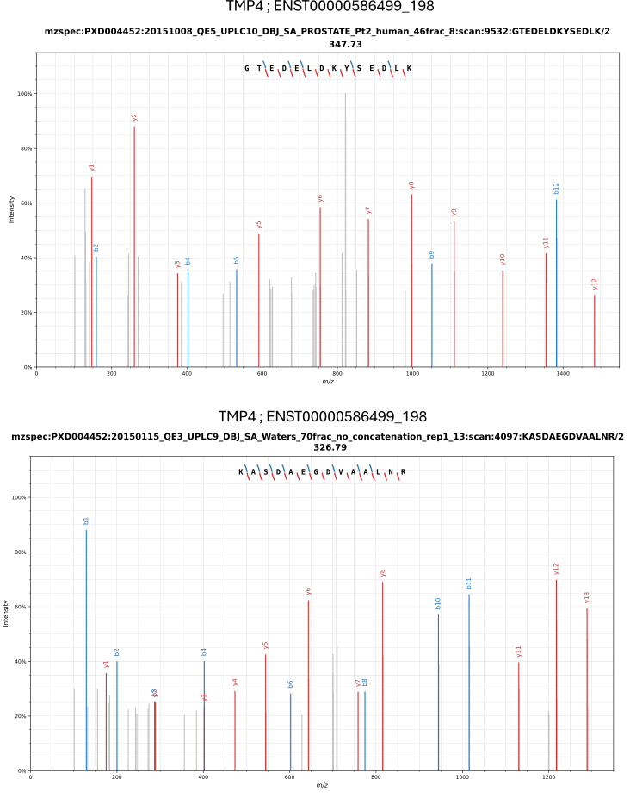

uORF
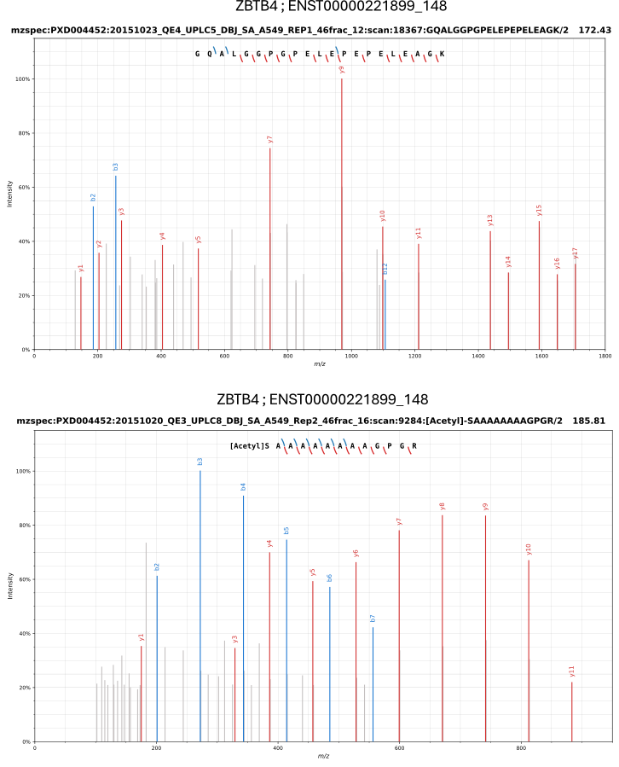

uoORF
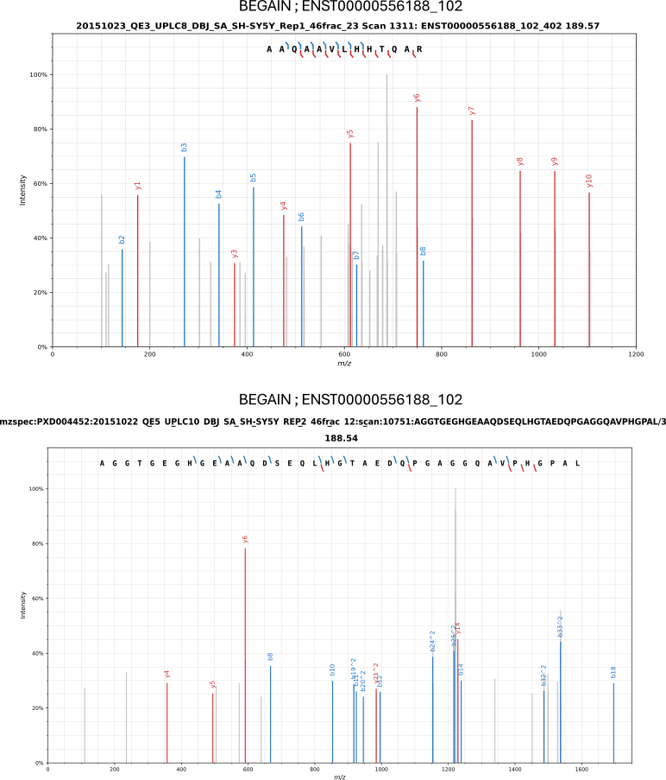

intORF
