Supplementary information
A UAV-based real-time detection system of flowering nectar plants using a lightweight deep learning model
Mingzhu Du, João Valente, Coby van Dooremalen, Cao Zhen, Jiwen Huang, Shengping Liu, Zhao-liang Li, Lammert Kooistra

Contents
Section S1. Hardware parameters Nvidia Jetson Xavier NX 2
Section S2. Loss functions and optimization via backpropagation 2
Section S3. Multi-threaded CPU/GPU pipeline scheduling 4

Section S1. Hardware parameters Nvidia Jetson Xavier NX
For the hardware construction (system design) we used the Nvidia Jetson Xavier NX. For more information, see the following website: https://www.nvidia.com/en-us/autonomous-machines/embedded-systems/jetson-xavier-nx/. In Table S1 we give the parameters of this edge computing device.

Table S1. Hardware parameters of the edge computing device Nvidia Jetson Xavier NX
Parameters | NVIDIA Jetson Xavier NX
Supplier | NVIDIA
Version | v1.0 (release date: 6 November 2019)
Size | 69.6 mm × 45 mm × 8.5 mm
Weight | 24 g
CPU | 6-core NVIDIA Carmel ARM@v8.2 64-bit CPU 6 MB L2+4MBL3
GPU | NVIDIA Volta" framework, carrying 384 NVIDIA CUDA cores with 48 Tensor cores
Memory | 8GB 128-bit LPDDR4x  1600MHz 51.2GB/s
Storage | 16GB eMMC 5.1
Network | 10/100/1000 BASE-T Ethernet
USB | USB 3.1 + (3x) USB 2.0
I/O | UART, SPI, I2C, I2S, GPIOs  Single CAN bus controller
Power | 10/15W/20W
Power input | 5V
Working temperature | -25°C to 80°C
Operating  system | Linux
AI computing power | 21TOPs
Price | ¥ 4898.00

Section S2. Flowering Real-time Detection Model Strategies
Fig.S1 illustrates the structure of the improved multi-scale detection head: Backbone (inside the blue dashed box), multi-scale feature fusion (inside the yellow dashed box), and output (inside the grey dashed box). After enhancement, the 160×160, 80×80, and 40×40 feature maps are utilized to detect small, medium, and large targets, respectively (highlighted in red dashed lines).
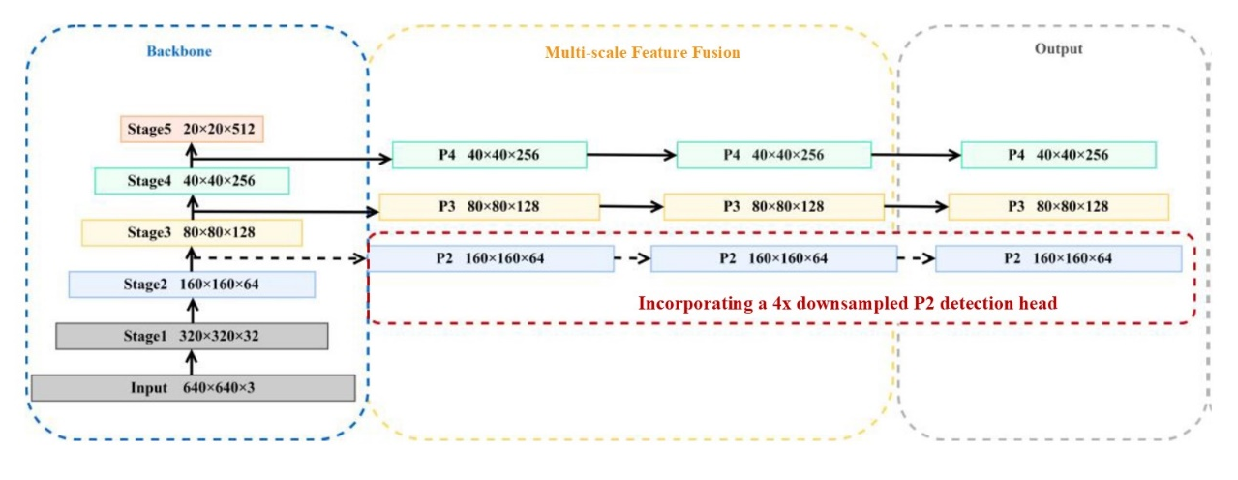
Fig.S1 The structure of the improved multi-scale detection head.

Table S2 compares the redesigned anchor box sizes with those from the original COCO dataset.
Table S2. Comparison of anchor size between COCO dataset and nectar plant flower dataset
Feature map level/Down-sampling ratio | P5/32 | P4/16 | P3/8 | P2/4
Anchor box sizes of COCO dataset | (116,90) | (30,61) | (0,13) | -
Anchor box sizes of COCO dataset | (156,198) | (62,45) | (16,30) | -
Anchor box sizes of COCO dataset | (373,326) | (59,119) | (33,23) | -
Anchor box sizes of nectar plant flower dataset (unit: pixels) | - | (28,31) | (21,17) | (10,10)
 | - | (38,36) | (20,23) | (14,13)
 | - | (50,52) | (26,24) | (15,18)

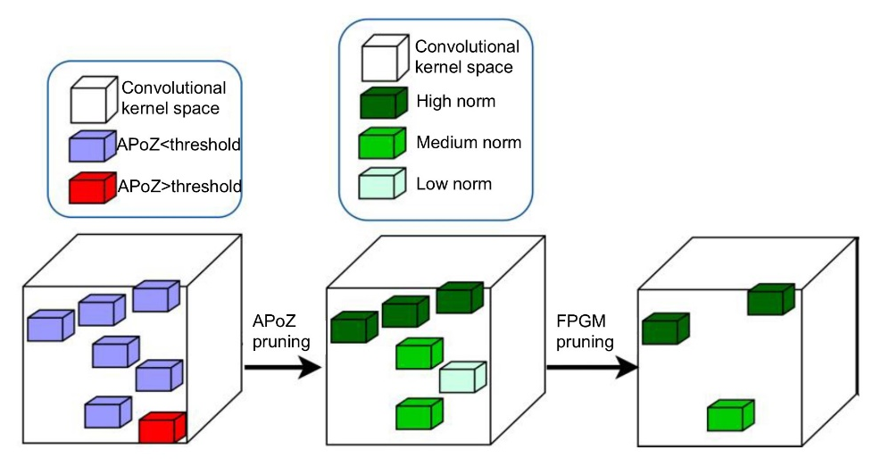
Fig.S2 Diagram of the activation-based FPGM pruning algorithm

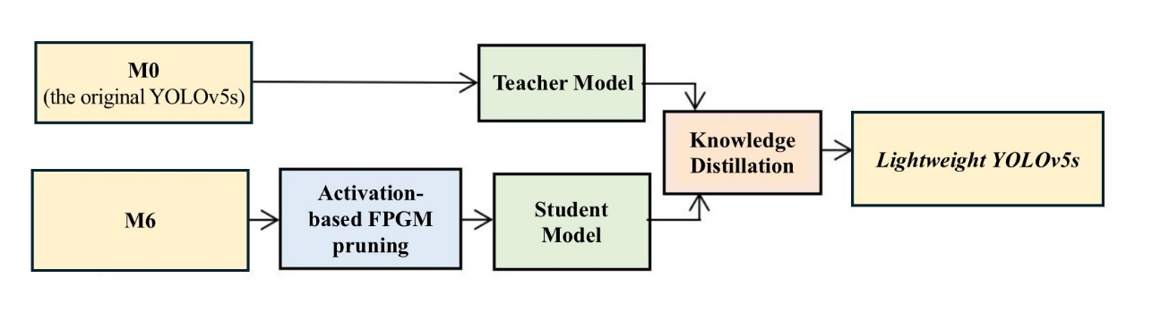
Fig.S3 Model compression process with a fine-tuning strategy based on knowledge distillation.

Section S3. Loss functions and optimization via backpropagation
Additional details on the knowledge distillation framework used in the regression network. In particular, it elaborates on how the discrepancy between teacher and student outputs is incorporated into the regression loss during training. The full formulation of the loss functions, along with their optimization via backpropagation, is presented in Figure S1 and S2 and Equation S1 and S2 to support the main text and ensure reproducibility.
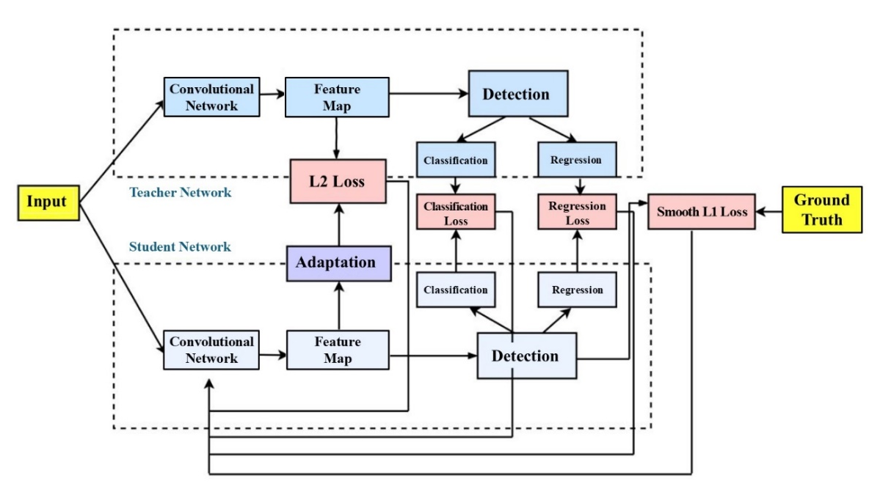
Fig. S4 Architecture diagram of the knowledge distillation framew bork.
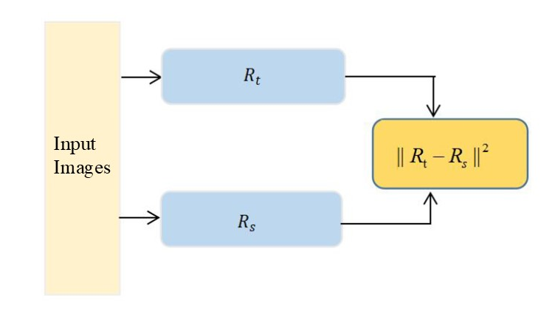
Fig.S5 Schematic diagram of the regression loss computation.

$L_{reg}=L_{sL1}\left(R_{s},y_{reg}\right)+vL_{b}\left(R_{s},R_{t}\right)$ (Equation S1)
$L_{b}\left(R_{s},R_{t}\right)={\left\|R_{t}-R_{s}\right\|}^{2}$ (Equation S2)
Among them, $L_{sL1}$ represents the bounding box loss of the student network, calculated using Smooth L1 loss. Specifically, when the regression result of the student network deviates significantly from the teacher network, the teacher regression loss $L_{b}$, calculated using L2 loss, is introduced to guide the optimization process. $R_{t}$ represents the regression outputs of the teacher network, $R_{s}$ represent those of the student network, $L_{b}$ represents the bounding box regression loss, and $v$ is the associated weighting coefficient.

Section S4. Model Deployment Process
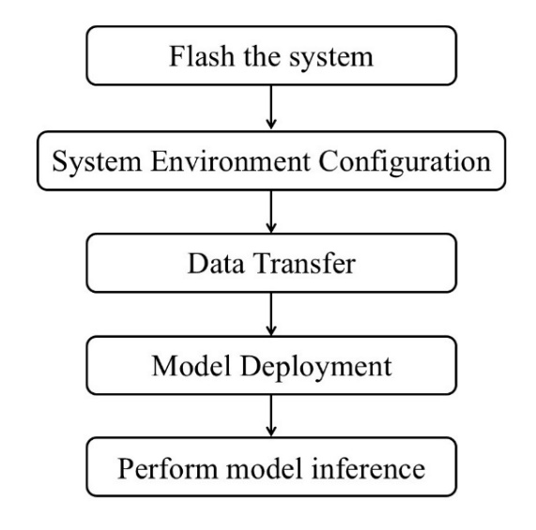
Fig.S6 Flower detection model deployment process

Section S5. Multi-threaded CPU/GPU pipeline scheduling
The computation process in the embedded edge system involves reading the image, detecting the object using the model, completing the detection, and returning the result. Specifically, model loading and image preprocessing are executed on the CPU, while the lightweight YOLOv5s model inference is performed on the GPU, and post-processing and result output are subsequently handled by the CPU (Figure S3).
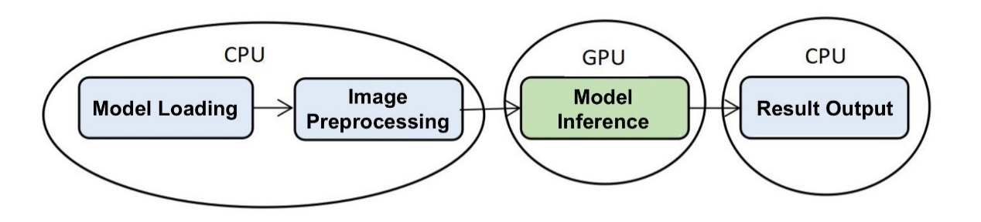
Fig.S7 Task allocation between CPU and GPU during detection
Using a time detection function, execution time for each stage of single-threaded CPU and GPU was measured (Figure S4). The analysis revealed that most of the time is consumed during CPU image preprocessing and GPU network calculation, while the time required for the CPU to output results is minimal and nearly negligible. In a single-threaded setup, the total processing time per frame is approximately 30ms, equivalent to 33 frames per second, with the CPU taking ~12ms and the GPU ~18ms per frame.
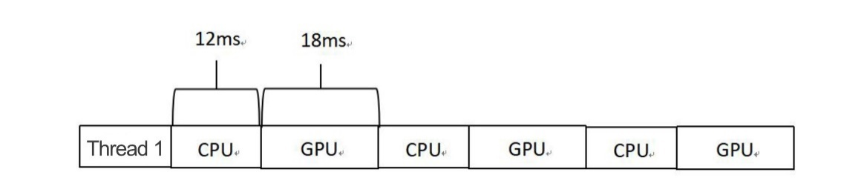
Fig.S8 Operational status of single-threaded CPU and GPU
To maximize GPU computing performance on the Xavier NX, which features a multi-core CPU, a multi-threaded CPU/GPU pipeline scheduling method was developed (Figure S5). In this approach, while one thread executes GPU operations, another simultaneously performs CPU tasks such as image reading and preprocessing. Once GPU calculations for the current image are completed, the second thread immediately begins GPU operations for the next image. This design synchronizes GPU computations for one image with CPU preprocessing for the subsequent image, effectively reducing preprocessing time. The number of threads can be adjusted based on the dataset and input requirements. This multi-threaded CPU/GPU pipeline fully leverages the capabilities of multi-core CPUs and GPUs, significantly improving model inference speed and enabling efficient nectar plant detection.
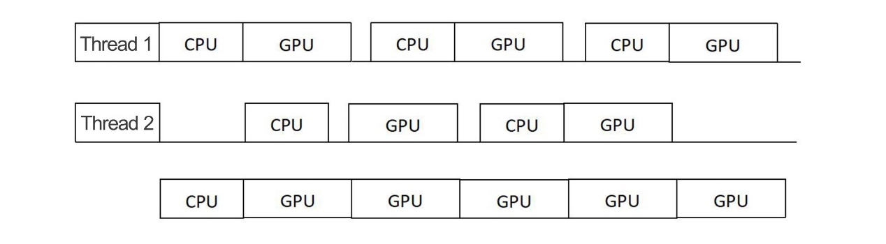
Fig.S9 Operational status of multi-threaded CPU and GPU

